**European comparative data on Europe 2020 & People with disabilities**

Final report prepared by Stefanos Grammenos from Centre for European Social and Economic Policy (CESEP ASBL) on behalf of the Academic Network of European Disability Experts (ANED)

January 2017



  CESEP Asbl

**CENTRE FOR EUROPEAN SOCIAL AND ECONOMIC POLICY Centre de politique sociale et économique européenne Asbl (CESEP)**

**ANED – Academic Network of European Disability Experts**

*European comparative data on*

*Europe 2020 & People with disabilities*

Final report

January 2017

|  |  |
| --- | --- |
| **BY:** | **FOR:** |
| **Stefanos Grammenos**  **CESEP ASBL**  **Rue de la Pacification, 67**  **BE-1000 BRUXELLES**  **Tel.: 02/230.63.96**  **Fax: 02/230.63.96**  **Email:** [**cesep@skynet.be**](mailto:cesep@skynet.be)  **Website:** [**www.cesep.eu**](http://www.cesep.eu) | **Client:**  **ANED (European Commission)**  **Contract reference:**  **European Commission VC/2015/0255**  **Contracting party:**  **Human European Consultancy B.V. and**  **Centre for Disability Studies – Leeds University** |

Disclaimer:

This report, while making use of official EU statistics and with the financial support of the Commission, does not represent a Commission position.

Contents

Summary and Conclusions 6

Introduction 13

European and international policy context 13

Objectives of the study 14

PART I: Population of persons with disabilities 16

I.1 Number of persons with disabilities 16

1. Relevance to EU policy / Strategy 16

2. Headline findings 16

3. Data 28

4. Data sources 39

5. Methodology 39

6. Notes 40

PART II: Europe 2020 and Related Indicators 41

II.1 Employment rate 41

1. Relevance to EU policy / Strategy 41

2. Headline findings 41

3. Data 59

4. Data source 75

5. Methodology 75

6. Notes 75

II.2 Unemployment rate 77

1. Relevance to EU policy / Strategy 77

2. Headline findings 77

3. Data 88

4. Data source 106

5. Methodology 107

6. Notes 107

II.3 Activity rate 108

1. Relevance to EU policy / Strategy 108

2. Headline findings 108

3. Data 115

4. Data source 133

5. Methodology 133

6. Notes 133

II.4 Early leavers from education and training 135

1. Relevance to EU policy / Strategy 135

2. Headline findings 135

3. Data 150

4. Data source 160

5. Methodology 160

6. Notes 162

II.5 Persons who have completed a tertiary or equivalent edcuation 163

1. Relevance to EU policy / Strategy 163

2. Headline findings 163

3. Data 174

4. Data source 186

5. Methodology 186

6. Notes 187

II.6 People living in households with very low work intensity 188

1. Relevance to EU policy / Strategy 188

2. Headline findings 188

3. Data 195

4. Data source 208

5. Methodology 208

6. Notes 209

II.7 People at-risk-of-poverty after social transfers 210

1. Relevance to EU policy / Strategy 210

2. Headline findings 210

3. Data 225

4. Data source 244

5. Methodology 244

6. Notes 244

II.8 Severely materially deprived people 245

1. Relevance to EU policy / Strategy 245

2. Headline findings 245

3. Data 256

4. Data source 276

5. Methodology 276

6. Notes 276

II.9 People at-risk-of-poverty or social exclusion (union of the three indicators ABOVE) 277

1. Relevance to EU policy / Strategy 277

2. Headline findings 277

3. Data 289

4. Data source 307

5. Methodology 307

6. Notes 307

Methodological note on EU-SILC 308

Sources of data 311

List of tables 312

# Summary and Conclusions

**Introduction**

The Academic Network of European Disability Experts (ANED), funded by the European Commission, aims to maintain a pan-European academic network in the disability field. The philosophy and aims focus on research that supports implementation of the United Nations Convention on the Rights of Persons with Disabilities (UNCRPD) and the European Disability Strategy 2010-2020 towards the goal of full participation and equal opportunities for all disabled people.

In this framework, the ANED work programme provides for the collection and analysis of data. The report on comparative disability data relevant to the Europe 2020 strategy aims to contribute at the assessment of the situation of persons with disabilities with respect to the Europe 2020 headline targets and scorecard on employment, education and poverty.

We use the latest available EU-SILC cross-sectional micro-data covering 2014 and we discuss any methodological differences with Labour Force Survey (LFS) data. For the analysis of dynamic aspects, we use the longitudinal micro-data.

**PART I: POPULATION OF PERSONS WITH DISABILITIES**

In 2014, about 27.1% of persons aged 16 and over declared an activity limitation (26.9% in 2013). The prevalence of disability is higher among women mainly due to the age composition. We may observe a small increasing trend since 2005 and some fluctuations following the financial crisis of 2008-2009. The EU-SILC definition does not take into account, directly, any “interactions with barriers”, which is the base of modern approaches to disability, including the UN CRPD, but Eurostat has run complementary European surveys where efforts have been developed to take into account this important dimension.

At the EU level, about 8.6% of persons aged 16 and over declare a severe disability (strongly limited) and about 18.5% declare a moderate disability. This amounts to an estimated 75.5 million persons with a moderate disability aged 16 and over living in private households and 34.9 million with a severe disability. At the EU level, the disability prevalence among elderly people aged 65+ is about 54.6% compared to 19.1% among persons aged 16 to 64. This represents approximately 60 million disabled persons aged 16 to 64 and 50 million disabled persons aged 65 and over, living in private households.

The analysis of longitudinal data during two consecutive periods (years) indicates that 65.9% of persons aged 16+, and present in consecutive years, declare no limitation in both years, 6.9% leave the disability status, 8.4% enter the disability status and 18.8% declare a disability in both years. The percentage of those entering the disability status is higher compared to those exiting, leading to an increase of the overall disability prevalence.[1]

Alternatively, we may define persons with disabilities as those persons who consider themselves to be part of a minority in terms of disability and/or have personally having felt discriminated against or harassed on grounds of disability. At the EU level, the Eurobarometer 2015 special survey on discrimination reported that 4.5% consider themselves to be disabled in one or other of these categories.

**PART II: EUROPE 2020 AND RELATED INDICATORS**

II.1 EMPLOYMENT RATE

At European level, about 48.7% of persons with disabilities are employed (48.5 in 2013) compared to 72.5% of persons without disabilities (71.4 in 2013). The total employment rate at the EU level is 67.8%. The Europe 2020 target for EU 28 is 75%. The employment rate of people with disabilities is about 23.8 percentage points lower compared to people without disabilities (22.9 in 2013). There is an employment gap in all Member States and, at the EU level, this gap is 23.8 percentage points. Concerning people with disabilities, the female employment rate is 45.7% and the male employment rate is 52.3%. An important factor affecting the employment rate is the degree of disability.

The situation across Member States varies significantly. According to EU-SILC, the employment rate of people with disabilities (for both sexes) appears very low in Greece, Malta, Ireland, Croatia and Bulgaria but appears relatively high in the UK, Luxembourg and Germany.

Globally, we can say that the recent financial crisis did not deteriorate significantly the employment situation of persons with disabilities at the EU level. But this is an average for a broad and diverse group, which might hide changes affecting certain age groups in opposite directions. The relative stability of persons with disabilities overall might be, at least partly, explained by an age composition effect. Persons with disabilities in the EU-SILC 2014 sample are often older persons. In fact, either because they have acquired certain security and rights after a long work history, or because national laws protect the employment of older workers, older workers with disabilities might present smaller variations through time than younger workers do.

The employment rate of young people, both with and without disabilities, deteriorated between 2008 and 2013. From 2013 to 2014, the employment rate of young persons with disabilities continued to deteriorate while, for the first time, the employment rate of young without disabilities increased.

Persons with disabilities are overrepresented among persons holding part-time work. Health reasons might require flexible working hours and part-time work might be a strong incentive for persons with disabilities. In fact, a certain number of persons with disabilities declare that they do not want to work more hours. However, in certain cases, part-time might be the result of a lack of work accommodations.

The employment rate increases significantly with educational attainment both for persons with and without disabilities. Furthermore, the educational level decreases the difference between persons with and without disabilities.

The special Eurobarometer 2015 survey on discrimination reveals that disabled people are the most disadvantaged group in the labour market.

II.2 UNEMPLOYMENT RATE

The EU unemployment rate of people with disabilities aged 20-64 is 19.6% (19.0% in 2013) compared to 11.3% (11.8% in 2013) of people without disabilities of the same age group. The total unemployment rate is 12.7% (12.9% in 2013). The degree of disability increases unemployment rate. Persons with a severe disability experience an average unemployment rate of 29.8%, persons with a moderate disability 17.3% and persons without disabilities 11.3%.

At the EU level, we note an increase of the unemployment rate for persons with disabilities and a small decrease for persons without disabilities between 2013 and 2014. National evolutions vary sharply across Member States. In 10 Member States we observe a decrease of the unemployment rate of persons with disabilities.

II.3 ACTIVITY RATE

At the EU level, 60.6% (59.8% in 2013) of persons with disabilities participated in the labour market (employed or unemployed) compared to 81.7% (81.0% in 2013) of persons without disabilities. The total rate is 77.5% (76.8% in 2013). At the EU level, the activity gap amounts to 21.1 percentage points (similar in 2013). There is a significant gap between persons with and without limitations in the activity rates in all Member States.

The data indicates that countries with similar activity rates for non-disabled people present big differences in the activity rate of people with disabilities. This indicates that there is a potential to increase the activity rate of people with disabilities by the transfer of experience from one country to another.

On average, persons with a moderate disability and persons without disabilities exhibit similar behaviours and react in a similar way to exogenous factors in the labour market. On the contrary, persons with a severe disability and persons without disabilities react differently to the same (national) environment. This means that general policies might not reach persons with severe disabilities unless they offer sufficient adaptations to the needs of that sub-group.

II.4 EARLY LEAVERS FROM EDUCATION AND TRAINING

In 2014, at the EU level, 22.5% of young disabled aged 18-24 were early school leavers compared to 11.2% for non-disabled young persons. The EU average rate is 12.2%. Due to sampling limitations, the national estimations concerning persons with disabilities ought to be interpreted with caution but, at the EU level, there is a gap between persons with and without disabilities of about 11.3 percentage points.

At the EU level, young women aged 18-24 have better achievements (lower share of early school leavers) compared to young men aged 18-24. This applies also for young women with disabilities in comparison to young men with disabilities. This is confirmed by data for the enlarged age group 18-29.

Young people with a severe disability experience a particularly disadvantaged position. A persistent high level of early school leavers means that this group often enter the labour market without high level skills. In fact, the unemployment rate among early school leavers is much higher compared to non-early school leavers. This holds both for persons with and without disabilities.

II.5 PERSONS WHO HAVE COMPLETED A TERTIARY OR EQUIVALENT EDUCATION

At the European level, 41.2% of persons aged 30-34 have completed a tertiary or equivalent education. The number of persons with disabilities who have completed a tertiary or equivalent education is 29.7%. We may observe that certain countries with good achievements for persons without disabilities appear to present very low performances for persons with disabilities.

At the EU level, the percentage of women with disabilities aged 30-34 who completed tertiary or equivalent education is 34%. This rate for women without disabilities is 45%. The equivalent rates for men are 21% (disabled) and 36% (non-disabled).

Education increases significantly the chances to get a job. Persons with disabilities who complete post-secondary non-tertiary education double their employment rate in comparison to those with a primary education level. Furthermore, education decreases the employment gap between persons with and without disabilities. Persons with a lower secondary education have been affected by the financial crisis much more than more educated persons.

II.6 PEOPLE LIVING IN HOUSEHOLDS WITH VERY LOW WORK INTENSITY

At the EU level, 25.1% of persons with disabilities live in households with low work intensity (<20%) compared to 8.7% of persons without disabilities. This represents a difference of about 16.4 percentage points. Similar differences were observed in previous years. This indicator and those following have to be treated with care as work intensity is estimated at the household level and the same value is then attributed to all household members.

At the EU level, we observe that since the onset of the financial crisis in 2008/2009, the rate of persons living in households with very low work intensity has increased. This evolution is similar for persons with and without disabilities.

II.7 PEOPLE AT-RISK-OF-POVERTY AFTER SOCIAL TRANSFERS

The data indicate that people with a disability face a higher risk of poverty after social transfers when compared to people without disabilities. At the EU level, in 2014, 19.7% of persons with disabilities aged 16 and over faced a risk of poverty compared to 15.3% of persons without disabilities of the same age group. The percentage for all persons aged 16 and over is 16.5%. At the EU level, there are about 67 million persons aged 16 and over living in private households at risk of financial poverty. This number includes an estimated 21.7 million persons with disabilities and 45 million persons without disabilities

The data indicate that the difference between people with and without disabilities is significantly smaller for this indicator compared to work related measures. We conclude that the welfare state is correcting for labour market failures and inequalities, to some extent. However, it is important to note that these results might underestimate poverty rates among persons with disabilities. For example, special allowances aiming to ensure autonomy or to pay extra medical expenses might artificially increase income and push certain people with disabilities over the threshold. In fact, such allowances do not constitute a ‘disposable’ income as they are aimed to meet specific expenses related to disability and often overcome barriers. Also, pension schemes in the EU decrease the risk of relative poverty.

Comparing the situation between 2013 and 2014, we may observe a deterioration of the poverty risk situation of persons with disabilities at the EU level.

In an alternative approach, we take the 2008 poverty threshold as base for comparison. We focus on 2008 and 2014. While the EU 2020 methodology provides relatively small changes between 2008 and 2014, the alternative approach provides quite different results at national level (notably for Greece, Cyprus, Hungary and Ireland). However, concerning the comparison between persons with and without disabilities, the alternative method provides a significant positive correlation of respective changes.

II.8 SEVERELY MATERIALLY DEPRIVED PEOPLE

In 2014, about 12.1% (12.6% in 2013) of people with disabilities aged 16 and over were living in households experiencing severe material deprivation compared to 7.3% (8.0% in 2013) of people without disabilities. The total is 8.6% (9.2%).

There is a wide diversity of situations in the Member States. The share of severely materially deprived persons is about 1% in Sweden but reaches 32% in Bulgaria. Concerning people with disabilities, the percentage of severely materially deprived persons ranges from 2% in Sweden to 46% in Bulgaria. The countries with the highest rates are notably Greece, Hungary, Romania and Bulgaria. The range of variation across Member States is much bigger compared to other poverty indicators. In fact, the characteristic of a group of persons in one country is not compared to a national average or indicator. Here, the reference is the same for all Member States: deprivation in at least four items out of nine.

Concerning the situation of persons with disabilities aged 16 and over, an improvement took place in the majority of Member States in 2014.

The EU-SILC 2014 module on material deprivation examines additional deprivation items. The items “Get-together with friends/family (relatives) for a drink/meal at least once a month” and “Regularly participate in a leisure activity” have a special importance for persons with disabilities. In fact, they capture part of the disadvantage related to disability (barriers). Consequently, the inclusion of these two items in any revision of the EU 2020 indicator could add a new material deprivation dimension, at least partly related to barriers, and ought to be included in the new definition.

II.9 PEOPLE AT-RISK-OF-POVERTY OR SOCIAL EXCLUSION (UNION OF THE THREE INDICATORS ABOVE)

In 2014, at the European level, 30.1% (same in 2013) of people with disabilities aged 16 and over lived in households at risk of poverty or social exclusion, compared to 21.4% (21.5% in 2013) of persons without a disability of the same age group. The percentage for all persons aged 16 and over was 23.8% (23.8% in 2013).

However, the aggregation of all age groups might be misleading. The risk of poverty or social exclusion is lower among elderly people (65+) compared to persons aged 16-64. People aged 16-64 and people aged 65 and over do not follow the same evolutions. Furthermore, the statistical indicator is not calculated in the same way for both groups (work intensity plays an important role for persons aged 16 to 59 but is not relevant to retired people). Also, poverty among economically active persons does not require the same policies as for elderly people. For persons aged 16 to 64, the dominant instrument to take people out of poverty or social exclusion is employment. For persons aged 65 and over, policies concerning retirement pensions are more relevant.

The degree of disability increases significantly the risk of poverty or social exclusion in all Member states. At the EU level, 36.7% of persons with a severe disability aged 16 and over are at risk of poverty or social exclusion. The equivalent rate for persons with a moderate disability is 27.0% and for persons without disabilities, 21.4%.

We may observe a cyclical fluctuation of the poverty rates. Since 2008/2009, we note an increase with a stabilisation during the last two years. The progression of relative household poverty has been higher for persons without disabilities since the financial crisis. The relatively lower progression of the rate for persons with disabilities, since the financial crisis of 2008/2009, can be explained by social protection schemes, lower unemployment changes among older workers with disabilities and an age composition effect (pension schemes).

As expected persons aged 20-64 who are not in employment experience very high rates of poverty or social exclusion. Still, we find persons who are at risk of poverty and social exclusion among those in employment, but this concerns mainly part-time jobs. Education seems to be an important factor for reducing the risk of poverty or social exclusion. As we have noted above, there is also a strong positive relation between employment and education and this might explain the role of education as an important factor for reducing poverty. However, the difference of poverty rates between persons with and without disabilities is high at all educational levels. Educational and training policies alone cannot eliminate discrimination.

**SUMMARY OF MAIN INDICATORS FOR THE EU\***

The table has been updated with final estimations each time this was possible, notably for early years.

|  |  |  |  |  |  |  |  |  |  |
| --- | --- | --- | --- | --- | --- | --- | --- | --- | --- |
|  | | **2008** | | **2009** | **2010** | **2011** | **2012** | **2013** | **2014** |
| **Persons with limitations 16+** | | 25.1% | | 25.7% | 25.0% | 25.9% | 26.1% | 26.9% | 27.1% |
|  | | | | | | | | |  |
| **Europe 2020 objectives and other indicators** | | | | | | | | | |
|  | | **2008** | | **2009** | **2010** | **2011** | **2012** | **2013** | **2014** |
| **Employment** | | 75 % of the population, aged 20-64, should be employed. | | | | | | | |
| Persons with lim. | | 46.4% | | 46.1% | 46.0% | 46.9% | 47.9% | 48.5% | 48.7% |
| Total | | 68.7% | | 67.6% | 67.3% | 67.3% | 67.0% | 66.8% | 67.7% |
|  | |  | |  |  |  |  |  |  |
| **Unemployment rate (20-64)** | | | | | | |  | |  |
| Persons with lim. | | 15.9% | | 17.3% | 18.0% | 17.4% | 18.1% | 19.0% | 19.6% |
| Total | | 8.4% | | 10.2% | 10.9% | 11.2% | 12.2% | 12.9% | 12.6% |
|  | |  | |  |  |  |  |  |  |
| **Activity rate (20-64)** | | | | | | |  |  |  |
| Persons with lim. | | 55.1% | | 55.8% | 56.1% | 56.7% | 58.5% | 59.8% | 60.6% |
| Total | | 75.0% | | 75.2% | 75.5% | 75.8% | 76.3% | 76.8% | 77.5% |
|  | |  | |  |  |  |  |  |  |
| **Early school leavers** | The share of early school leavers should be under 10% (Persons aged 18-24 with at most lower secondary education and not in further education or training). *Indicative data.* New classification in 2014. | | | | | | | | |
| Persons with lim. | | 25.1% | | 23.0% | 21.6% | 18.9% | 21.8% | 21.5% | *22.5%* |
| Total | | 13.2% | | 13.1% | 12.7% | 11.6% | 11.2% | 10.7% | *12.2%* |
|  | |  | |  |  |  |  |  |  |
| **Tertiary education** | | 40% of persons aged 30-34 ought to have completed a tertiary or equivalent education. *Indicative data.* New classification in 2014. | | | | | | | |
| Persons with lim. | | 20.4% | | 21.6% | 22.8% | 27.1%% | 27.8% | 28.0% | *29.7%* |
| Total | | 31.6% | | 33.9% | 35.5% | 36.0% | 38.1% | 39.3% | *41.2%* |
|  | |  | |  |  |  |  |  |  |
| **Very low work intensity** | | People living in households where the adults work less than 20% of their total work potential during the past year. Age 16-59. Work intensity (WI): <20. In () data cover <60 | | | | | | | |
| Persons with lim. | | 23.2% | | 22.8% | 24.2% | 24.5% | 23.9% | 24.1% | 25.1% |
| Total | | (9.1%) | | (9.1%) | 10.2% | 10.4% | 10.8% | 11.2% | 11.6% |
|  | |  | |  |  |  |  |  |  |
| **At risk of poverty after social transfers** | | A person lives in a household with a household equivalised disposable income less than 60% of the median national household equivalised disposable income (after social transfers). Age 16+ | | | | | | | |
| Persons with lim. | | 20.1% | | 19.6% | 18.9% | 19.3% | 19.1% | 18.7% | 19.7% |
| Total (ALL)** | | 15.8% | | 15.7% | 15.6% | 16.1% | 16.1% | 15.9% | 16.5% |
|  | |  | |  |  |  |  |  |  |
| **Severely materially deprived** | | Inability to afford for certain goods or services (It covers economic strain, durables, housing and environment of the dwelling). Age 16+ | | | | | | | |
| Persons with lim. | | 11.2% | | 10.5% | 11.2% | 12.1% | 12.8% | 12.6% | 12.1% |
| Total | | 8.6% | | 7.8% | 7.8% | 8.5% | 9.5% | 9.3% | 8.6% |
|  | |  | |  |  |  |  |  |  |
| **At risk of poverty or exclusion** | | | Persons at-risk-of-poverty after social transfers, severe material deprivation, or people living in households with very low work intensity. Age 16+. | | | | | | |
| Persons with lim. | | 30.9% | | 29.7% | 29.6% | 30.5% | 30.3% | 30.1% | 30.1% |
| Total (ALL in (.)) | | (23.3%) | | (22.7%) | 22.7% | 23.6% | 24.1% | 23.8% | 23.8% |

**\*:** It covers EU 27 till 2009 and EU 28 afterwards. See the text and the tables in the main report for more information.

**\*\*:** **Total:** It includes only persons for which we do have information on disability status. **ALL**: It includes all persons, including those for which we do not have information on disability status. The two might be different but the difference is always marginal. It affects only the first decimal by 1 or 2 units.

**Source of data**: Eurostat & EU-SILC UDB. See the text and the tables in the main report for more information.

# Introduction

The Academic Network of European Disability Experts (ANED), established following a tender procedure in December 2007, and is funded by the European Commission.

ANED aims to maintain a Pan-European academic network in the disability field by engaging the expertise of existing networks, disability research centres and individual experts in Europe, and external advisors in partnership with European organisations representing disabled people and older people.

The general purpose of the network is to provide independent scientific advice, analysis and information to the commission that is of quality and reliable to serve as input and support its policy making in the disability field.

The philosophy and aims focus on research that supports implementation of the United Nations Convention on the Rights of Persons with Disabilities (UNCRPD)[2] and the European Disability Strategy 2010-2020 towards the goal of full participation and equal opportunities for all disabled people.

Given the diverse topics to be covered, ANED includes experts not only in social matters in the disability field but also in the disability related issues in EU policies that are relevant for people with disabilities as identified in the Strategy and the UNCRPD.

Furthermore, the network provides notably every year an informed analysis on national policy situation and developments in relation to the areas covered by Europe 2020 contributing to the European Semester. This advice is based on scientific evidence, data and statistics, and aim to support the Commission policy and decision making processes in the field of disability.

In this framework, Task 2 provides for the collection and analysis of data. The aim is to collect and analyse existing data, to understand and illustrate the situation of people with disabilities in Europe, with a focus on disability statistics and examples of good practice.

## European and international policy context

Europe 2020

Europe 2020 is a strategy for the EU to develop as a smarter, knowledge based, greener economy, and delivering high levels of employment, productivity and social cohesion.[3] It was designed as the successor to the Lisbon Strategy.

Monitoring achievements through statistics is integral part of the Europe 2020 strategy. The headline indicators measure the progress made by the EU and the Member States towards achieving the headline targets of the strategy.

Five headline targets have been set for the EU to achieve by the end of 2020. These targets cover employment; research and development; climate/energy; education; social inclusion and poverty reduction. Those related to employment, education and poverty risk are particularly relevant to the situation of persons with disabilities.

The European Disability Strategy 2010-2020

The European Disability Strategy 2010-2020 was adopted on 15 November 2010.[4] Persons with disabilities have the right to participate fully and equally in society and economy. Denial of equal opportunities is a breach of human rights.

By concluding the United Nations Convention on the Rights of Persons with Disabilities (UNCRPD), the EU and all its EU countries have committed themselves to create a barrier-free Europe. Even though the EU countries have the main responsibilities, EU action is needed to complement national efforts.

The Strategy for the period 2010-2020 is a comprehensive framework committing the Commission to empowerment of people with disabilities to enjoy their full rights, and to removing everyday barriers in life. The Strategy builds on the UNCRPD and takes into account the experience of the Disability Action Plan (2004-2010).

The European Disability Strategy focusses in eight priority areas: Accessibility, Participation, Equality, Employment, Education and training, Social protection, Health and External action.

UN Convention

The UN Convention on the Rights of Persons with Disabilities (UNCRPD) entered into force for the EU in January 2011. By June 2014, twenty-five (25) Member States have ratified the UNCRPD and the three remaining are finalising the ratification process.

The purpose of the UNCRPD is to promote, protect and ensure the full and equal enjoyment of all human rights and fundamental freedoms by all persons with disabilities. This has shifted the EU approach towards a Human Rights perspective.

Article 31 of the Convention refers to statistics and data collection. It provides that States Parties undertake to collect appropriate information, including statistical and research data, to enable them to formulate and implement policies to give effect to the present Convention. Furthermore, Article 33 treating national implementation and monitoring provides notably that States Parties shall maintain a framework to promote and monitor implementation of the Convention.

## Objectives of the study

The Commission monitors the situation each year by undertaking a detailed analysis of EU Member States' programmes of economic and structural reforms that shows overall progress towards the Europe 2020 headline targets. The Commission produces an annual growth survey and assesses country reports and stability /convergence programmes.

This report aims to contribute at the assessment of the situation of persons with disabilities with respect to the Europe 2020 headline targets on employment, poverty and education, using EU comparative data. Also, the work programme aims to update and extend ANED’s core indicator set to ensure continuity and comparability with existing data, notably in relation to the Europe 2020 targets.

The development of this task includes notably, the provision of data, indicators and statistical analysis. It focusses on EU 2020 indicators but provides also information on related issues (e.g. disability prevalence, unemployment, etc.). Furthermore, it provides the latest available data helping policy makers to monitor national and European policies concerning disability prevalence, employment, education and poverty reduction.

This report complements previous annual ANED reports on Europe 2020. In addition, a specific focus was given on methodological issues and the evolution since 2005. At this end, at the beginning of each indicator, the reader will find a non-technical discussion of methodological issues of interest to policy makers. Also, the analysis of each indicator concludes the discussion with the evolution since 2005. This helps us to analyse the impact of the recent financial crisis.

**Presentation of the results**

The output format for each Europe 2020 and other related indicators includes:

1. Its relevance to EU policy/strategy;
2. A non-technical discussion of methodological issues of interest to policy makers;
3. Headline finding by Member State, gender, age and degree of disability. Relevant charts illustrate the analysis;
4. Analysis of the evolution since 2005, the impact of the financial crisis and the identification of trends;
5. Tables with the data;
6. A brief note describing the methodology applied;
7. Presentation of the data sources;
8. Any statistical or exception note that is required for clarity.

For priority items, additional interpretations, analysis and commentary are added to illustrate, for example, difference between groups of disabled people or tests of reliability. A systematic research of correlations and interactions between the Europe 2020 targets and the characteristics of people with disabilities complete the analysis.

This report presents the analysis of latest available EU-SILC micro-data. They cover 2014 and a detailed description of the EU-SILC survey can be found at the end of this report.

# PART I: Population of persons with disabilities

## I.1 Number of persons with disabilities

### 1. Relevance to EU policy / Strategy

The EU Disability Strategy 2010-2020 is a comprehensive framework committing the Commission to empowerment of people with disabilities to enjoy their full rights, and to removing everyday barriers in life. The Strategy builds on the UNCRPD and takes into account the experience of the Disability Action Plan (2004-2010).

The Commission notes that EU action will supplement the collection of periodic disability-related statistics with a view to monitoring the situation of persons with disabilities. Also, the recently published guidelines on the treaty-specific document, to be submitted by States' Parties under Article 35, require comparative specific data disaggregated by sex, age, type of disability and other relevant categories to be produced on an annual basis.

Article 31 of the UN Convention on “Statistics and data collection” provides that “1. States Parties undertake to collect appropriate information, including statistical and research data, to enable them to formulate and implement policies to give effect to the present Convention”.

The following statistic aims to give an estimation of the number of the target group and its main characteristics.

### 2. Headline findings

2.1 Prevalence of disability

The data on limitation in activities due to health problems refer to self-evaluation by the respondents of the extent of which they are limited in activities people usually do, because of health problems, for at least the last 6 months.

The answer distinguishes: strongly limited, limited and not limited. In the following, we use the general term disability in order to cover both “strongly limited” and “limited”.

The survey covers all individuals aged 16 years old and over living in private households. Persons living in collective households and in institutions are generally excluded from the target population. Below, we give an estimation of persons with disabilities in institutions.

For comparison, we may note that the UN Convention states that “persons with disabilities include those who have long-term physical, mental, intellectual or sensory impairments which in interaction with various barriers may hinder their full and effective participation in society on an equal basis with others”.

The EU-SILC definition does not take into account any “interactions with barriers” which is the base of modern approaches to disability. However, Eurostat has run complementary European surveys where efforts have been developed to take into account this important dimension.

The European Health and Social Integration Survey (EHSIS)[5] presents statistics on barriers in 10 areas (% of “disabled” who face barriers). It covered notably mobility, transport and accessibility to buildings. The Labour Force Survey (LFS)[6] ad hoc module 2011 covered limitations in the number of hours that a person can work in a week, type of work and getting to and from work. It enlarged its approach by taking into account special equipment or needs, workplace adaptations, etc. However, the LFS ad hoc module focuses on labour market issues only. The Special Eurobarometer 437 (Discrimination in the EU in 2015)[7] included a question on whether a person considers to be part of a minority in terms of disability. This definition is different from the one adopted from the majority of other surveys and does not enable us to make comparisons with these surveys. A general question focussed on experienced discriminations.

The EU-SILC definition of limitations requires a period of at least six months. In this report, we use the annual EU-SILC cross-sectional micro-data but the longitudinal EU-SILC data enable us to consider longer periods. If we require a disability duration of more than one year, the disability rate is reduced significantly (see below).

In 2014, about 27.1% of persons aged 16 and over declared an activity limitation (26.9% in 2013). In comparison to 2013, there is an increase of about 0.2 percentage points. The overall rate represents about 110 million people aged 16 and over living in private households in the EU (109 million in 2013). However, we ought to interpret this number with caution. First, it includes elderly people with limitations. Second, it might be seen as a target for prevention purposes. In fact, this rate and trend indicate potential needs and thus constitute a source of possible future demands for policy action. The distinction drawn below between moderate and severe disability (limitation) might be particularly relevant for immediate policy initiatives.

The prevalence rate is low in Malta (10%), Ireland (18%) and Bulgaria (18%). On the other hand, the prevalence rate is high in Latvia (37%), Germany (36%), and Portugal (35%). Four Member States (United Kingdom, France, Italy and Germany) share about 57% of all persons with disabilities in the EU aged 16 and over living in private households (about 62.4 million).

**Figure 1: Percent of people with disabilities by Member State; 2013 and 2014**

As a % of the same age group; age: 16+

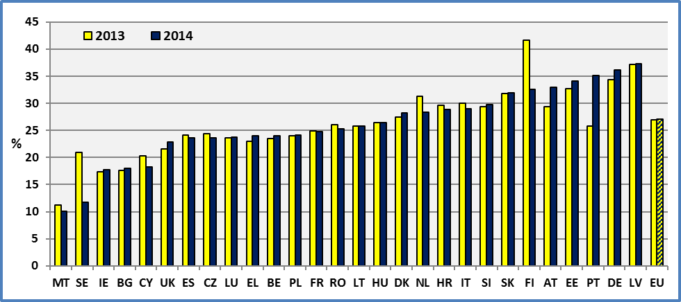

**Note:** We observe a discontinuity in the data concerning Finland and Sweden**.** The analysis of the longitudinal data (see below on transition probabilities) indicates that in Finland, Malta and Sweden a much higher number of persons pass from a status of “limitation” to “no limitation” in comparison to EU average.

**Data source :** EU-SILC UDB 2013 & 2014.

2.2 Prevalence of disability by gender

At the EU level, about 29.5% of women aged 16 and over declare an activity limitation compared to 24.5% of men of the same age group.

The prevalence of disability is higher among women mainly due to the age composition (see below). Furthermore, the ageing of the European population may explain the increasing rate, notably among women. However, other personal factors and socio-economic characteristics might contribute too in explaining the difference between men and women.

**Figure 2: Percent of people with disabilities by Member State and gender; 2014**

As a % of the same age group; age: 16+

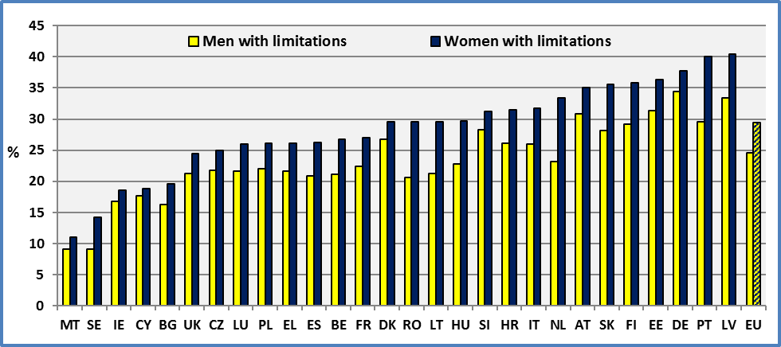

**Data source:** EU-SILC UDB 2014

2.3 Degree of impairment/disability

At the EU level, about 8.6% (8.7% in 2013) of persons aged 16 and over declare a severe disability (strongly limited). About 18.5% (18.3% in 2013) declare a moderate disability. This amounts to 75.5 million persons with a moderate disability aged 16 and over living in private households (73.9 million in 2013) and 34.9 million with a severe disability (35.1 million on 2013).

Concerning the degree of disability, we may note that the variation of percentage covering severe disability across Member States at a given year is smaller than the variation of moderate disability prevalence across Member States[8].

**Figure 3: Percent of people with disabilities by Member State and degree of disability; 2014**

As a % of the same age group; age: 16+

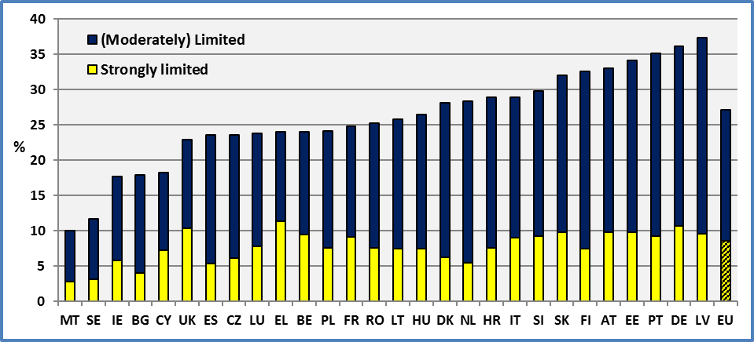

**Data source:** EU-SILC UDB 2014

2.4 Disability prevalence by age group

Disability prevalence increases steadily with age. Biological and socio-economic factors might explain this continuous increase at each age. We may assume that the progression of disability prevalence by age depends mainly on biological factors and technical progress (e.g. medical advances). Consequently, we do not expect significant changes in the short run of this progression. In the medium and long term, technical progress and socio-economic factors might affect this progression.

At the EU level, the disability prevalence among elderly people aged 65 and over is about 54.6% compared to 19.1% among persons aged 16 to 64. Similar rates were reported for 2013. This represents 60 million disabled persons aged 16 to 64 living in private households and 50 million disabled persons aged 65 and over.

Malta, Sweden and Bulgaria share a particularly low disability rate for persons aged 65 and over.

**Figure 4: Percent of persons with disabilities by age group, 2014**

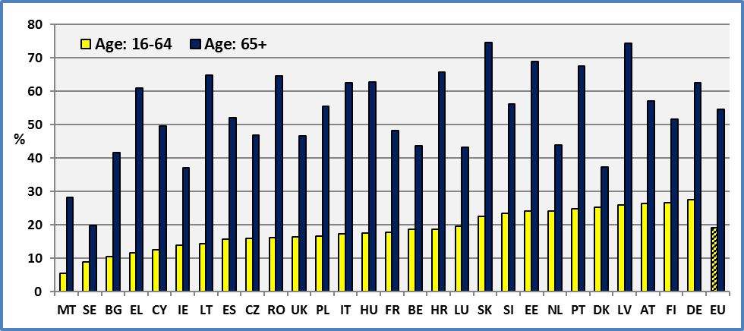

**Data source:** EU-SILC UDB 2014

The following graph presents the distribution by degree and age group of the number of persons with disabilities aged 16 and over living in private households.

**Figure 5: Population of persons with disabilities by degree of disability and age group, EU 2014**

Persons living in private households aged 16+; in millions

|  |  |
| --- | --- |
|  |  |

**Data source:** EU-SILC UDB 2014

Among people with disabilities, elderly disabled people represent 45.5% of all people with disabilities (aged 16 and over living in private households).

**Figure 6: Distribution of people with disabilities by age group, 2014**

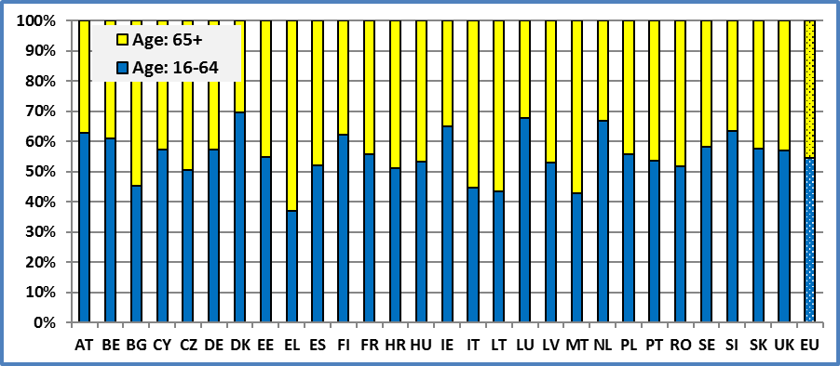

**Data source:** EU-SILC UDB 2014

2.5 Evolution of disability prevalence

Disability prevalence estimates vary sharply across Member States but at the EU level, the variation across time is relatively small. We may observe a small increasing trend since 2005 and some fluctuations following the financial crisis of 2008-2009.

Generally, one could expect a decreasing trend due to technical progress in the medium and long term. However, as the rates reported here are crude rates and not standardised by a reference population, an increasing trend reflects at least partly an ageing population. This latter factor dominates any technological and medical innovations. This issue was discussed in previous reports.

Another factor which might have affected disability prevalence might be the socio-economic deterioration following a financial crisis, notably in 2008/2009. The economic deterioration might have affected adversely living conditions and health. In fact, the economic crisis may affect morbidity and chronic illness notably through: direct effects (it might increase stress), income effects (malnutrition and unmet medical needs), education and lifestyle effects (risky behaviours) and social capital (isolation and reduction of external resources). The duration of an economic crisis might be a significant factor, turning temporary health problems into a permanent disadvantage. In the medium term and with an average lag of two years this might lead to an increased disability rate. This might be notably true for older workers and elderly people who are more vulnerable compared to younger people. This issue was discussed in previous reports.

**Figure 7: Evolution of disability prevalence. Percent of people with disabilities by degree**

As a % of the same age group; age: 16+

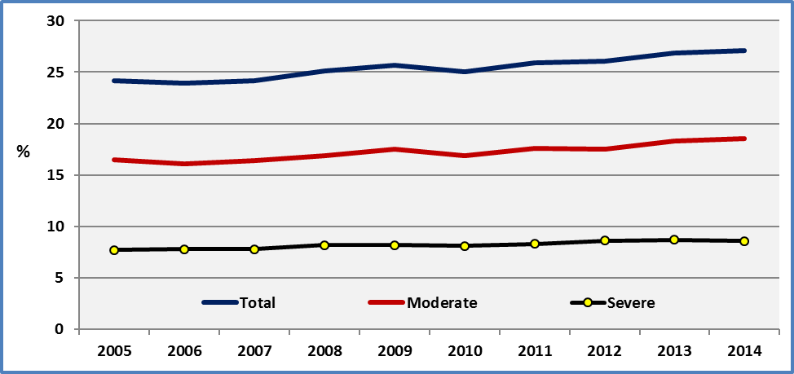

**Data source:** Eurostat & EU SILC UDB 2014

2.6 Dynamics of disability status

The EU-SILC longitudinal data enable us to report transition probabilities (the change in one categorical variable over time).

The following table indicates that among persons without limitations aged 16 and over in a specific year, about 88.7% declare no limitation and 11.3% declare a limitation in the following year. Among persons declaring a limitation in one year, about 26.9% declare no limitation and 73.1% declare a limitation in the following year.

In terms of disability prevalence for persons aged 16 and over, 65.9% declare no limitation in both years, 6.9% leave the disability status, 8.4% enter the disability status and 18.8% declare a disability in both years. The percentage of those entering the disability status is higher compared to those going out of the disability status so that, during the observed period, we have an increase of the disability prevalence.

**Table 1: Transition probabilities between year t and t+1 and between different disability status, EU 24**

|  |  |  |  |  |  |  |
| --- | --- | --- | --- | --- | --- | --- |
|  | **YEAR t+1** | | | | | |
| **YEAR t** | **No limitation** | **Limitation** | **Total** | **No limitation** | **Limitation** | **Total** |
|  | **Age : 16+** | | | | | |
|  | **Transition probabilities** | | | **Distribution by disability status** | | |
| **No limitation** | 88.7 | 11.3 | 100 | 65.9 | 8.4 | 74.3 |
| **Limitation** | 26.9 | 73.1 | 100 | 6.9 | 18.8 | 25.7 |
| **Total** | 72.1 | 27.9 | 100 | 72.8 | 27.2 | 100 |
|  | **Age : 16-64** | | | | | |
| **No limitation** | 91.4 | 8.6 | 100 | 74,9 | 7,0 | 81,9 |
| **Limitation** | 34.1 | 65.9 | 100 | 6,2 | 11,9 | 18,1 |
| **Total** | 80.8 | 19.2 | 100 | 81,1 | 18,9 | 100,0 |
|  | **Age : 65+** | | | | | |
| **No limitation** | 73.7 | 26.3 | 100 | 35,6 | 12,7 | 48,3 |
| **Limitation** | 18.7 | 81.3 | 100 | 9,6 | 42,0 | 51,7 |
| **Total** | 44.5 | 55.5 | 100 | 45,3 | 54,7 | 100,0 |

**Note:** The longitudinal data 2011-2014 of the version used here cover 24 Member States. The age is the age at the end of the income reference period. Unlike other tables and figures, the data here are unweighted and cover only 24 Member States.

**Source:** EU-SILC UDB 2014

The data indicate that among elderly people a person with a disability has more chances to remain in the next period. Furthermore, the percentage of persons aged 16-64 with a long-term disability (two consecutive years) is 11.9%. The same rate for persons aged 65 and over is 42.0%.

2.7 Persons in institutions

EU-SILC covers persons living in private households. If we have to take into account persons living in institutions, we ought to bring a correction of one percentage point for persons aged less than 65 but five (5) to six (6) percentage points for elderly people.

In fact, a review[9] of available data indicates that in the age group 60-64 about 1% live in institutions. After the age of 65, this rate is rising quickly to achieve 30% (France, UK and Austria) to 50% (Netherlands and Sweden) for persons aged 90 and over. However, not all persons living in institutions are dependent persons. We estimate that about 80% of persons aged 65 and over living in institutions are dependent persons.

About 6% to 7% of all persons aged 65 and over live in institutions. This rate varies sharply between countries. It is low in Austria, Spain and France but very high in the Netherland, Finland and Sweden. As noted, not all of these persons are dependent persons.

The above data mean that about 5% to 6% percent of all persons aged 65 and over are dependent persons living in institutions.

Consequently, in order to take into account disabled persons living in institutions, we could add a maximum of one (1) percentage point to the estimations presented above for persons aged less than 65 and about 5% to 6% for persons aged 65 and over.

2.8 Disability prevalence among persons aged less than 16 years

As noted the EU-SILC survey covers persons aged 16 or over. In the following graph we provide estimation disability prevalence for persons aged less than 16 years.

The estimation is just an extrapolation of the fitted cubic parabola. The fit is on the estimated prevalence by age in years. This is a polynomial curve with degree equal to 3. A simple inspection indicates that the disability prevalence is equal to about 7%. A logistic regression using the micro-data provides a lower estimation for children aged less than 16 years. The disability prevalence ranges from 3% (for children aged 5 years) to 5% (for children aged 15 years).

For comparison, the French survey “Disability-Health” (Enquête Handicap-santé) 2008-2009 finds that about 6% of children aged 0-19 years report activity limitations due to a health problem[10]. From a different perspective, the Family Resource Survey 2004/2005, indicates that 7.3% of UK children aged 0-18 were reported as disabled according to the DDA definition[11].

Also, we may note a recent US survey covering civilian non-institutionalized population. It finds that about 5.2 % of school-aged children (aged 5 to 17) had a disability in 2010. A disability means having vision, hearing, cognitive, ambulatory, self-care, or independent living difficulty[12].

The EU-SILC 2017 ad hoc module will cover health and children's health[13]. This module will provide notably information on general health and limitation in activities for each child aged 0-15.

**Figure 8: Persons with disabilities by age and projections for younger age groups, 2013**

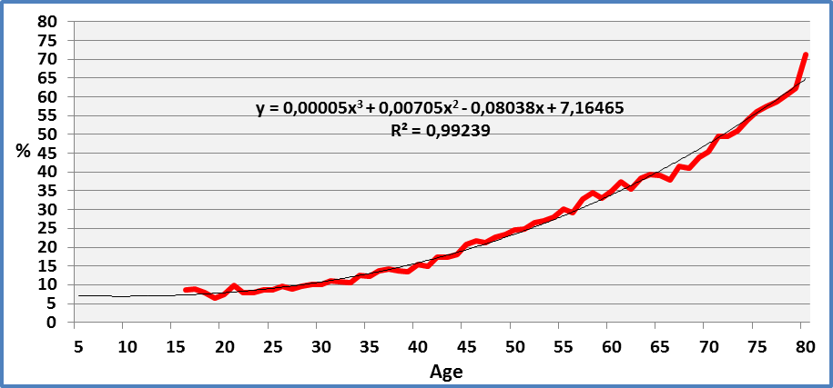

**Note:** The year “80” covers persons aged 80 and over. This explains the sharp upward movement of disability prevalence.

**Data source**: EU-SILC UDB 2013

2.9 Alternative definitions of disability

As noted above a special Eurobarometer in 2015 focussed on discrimination. The methodology notes that “discrimination is understood to mean when a person or group is treated less favourably than others because of personal characteristics”. The survey covers persons aged 15 and over living in private households.

A question (QC2) asks: “in the past 12 months have you personally felt discriminated against or harassed on disability”. At the EU level, about 2.8% of persons aged 15 and over declare that they have felt discriminated against or harassed on disability.

Another question (SD2) asks: “Where you live, do you consider yourself to be part of a minority in terms of disability”? At the EU level, about 2.6% of persons aged 15 and over declare that you consider themselves to be part of a minority in terms of disability.

We define below as persons with disabilities, persons who consider themselves to be part of a minority in terms of disability and / or have personally having felt discriminated against or harassed on disability (even if they don’t consider themselves to be member of a minority group). In fact, certain persons declare to have experienced discrimination on disability ground but do not feel member of a disability minority group.

At the EU level, 4.5% consider themselves to be part of a minority in terms of disability and / or have personally having felt discriminated against or harassed on disability. For comparison, the EU-SILC provided 8.6% with a severe limitation and 18.5% with a moderate limitation.

The estimations of the percentage of persons with disabilities in the EU Member States defined here are loosely correlated with the estimations of the percentage of persons with disabilities (limitations) provided by the EU-SILC 2014 (R²=0,11). Consequently, any conclusions drawn from the EU-SILC data may not be extended to the population of persons with disabilities as they are defined in the Eurobarometer survey.

**Figure 9: Percent of persons who consider themselves to be part of a minority in terms of disability and / or have personally having felt discriminated against or harassed on disability; Age: 15+, 2015**

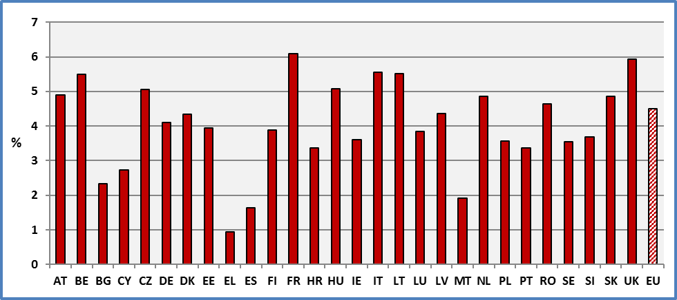

**Source of data**: Eurobarometer 83.4 (2015)

An importance difference, between populations of persons with disabilities based on limitations (due to health) and persons considering themselves to be part of a minority in terms of disability and / or have personally having felt discriminated against or harassed on disability, refers to the evolution through the life cycle. In the case of definitions based on health (limitations), disability prevalence increases sharply with age. On the contrary, definitions based on social perceptions (minority group and discrimination) provide an almost constant rate through the life cycle.

Both the percentage of persons considering themselves to be part of a minority in terms of disability and the percentage of persons who have personally felt discriminated against or harassed on disability remain stable (with small fluctuations). In both cases (minority group and felt discriminated), the rates vary generally between 2% and 3% through the life cycle. Generally, the two rates (minority group and felt discriminated) are close but reveal a difference at the age group 55-64. In fact, for this age group the percentage of persons felt discriminated is 3.4% and the percentage of persons who feel part of a minority group based on disability is 2.6%. This might be due to discrimination on the labour market.

**Figure 10: Percent of persons with a disability by age group (Different definitions of disability)**

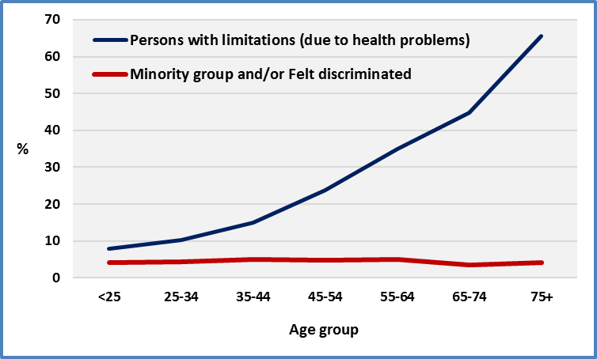

**Source of data**: Eurobarometer 83.4 (2015) and EU-SILC UDB 2014

2.10 Type of interview

The EU-SILC survey uses different types of interview (see methodology). A question arises whether the interview method affects the results concerning disability estimations. An interesting question is whether “proxy interview” may affect the results. Eurostat notes that proxy interview refers to personal interview with another member of the household.

We have grouped the different interview methods into direct interview and proxy interview (interview with another member of the household). About 18.3% of interviews are based on proxy interviews. This rate decreases steadily with age. It is about 44.6% for persons aged 16-19 and 10.5% for persons aged 70-74. Clearly, young persons are not often at home and the interviewer uses other household members to collect the information. The proxy interview rate increases slightly for the age group 80 and over (14.7%) due notably to hospitalisation, cognitive problems, etc.

The percentage of persons with limitations among persons who answer for themselves is 27.6% and this rate is 23.6% among persons reported by proxies. Given that proxies more often represent younger persons, compared to direct interviews, the difference might be due to age structure.

In a more elaborated analysis, we have included age, gender, education, family status, economic status and poverty as explanatory variables for the probability to declare a limitation. A binary variable was constructed to represent a proxy (1) and a not-proxy (0) interview. The results of the analysis indicate that the proxy variable is not a significant factor affecting the probability to report a limitation unlike other variables noted above[14]. We may conclude that the type of interview and notably the use of proxy or not does not appear to affect the estimated disability rate significantly. As noted in previous ANED reports, age, education, family status, economic status and different poverty dimensions are the main determinants affecting the probability to report a limitation.

2.11 Confidence intervals

In order to assess the power of our disability prevalence estimations, we present below the confidence intervals. We adopt the traditional 95% confidence interval reflecting a significance level of 0.05. A larger national sample size normally will lead to a better estimate of the population parameter. Consequently, confidence intervals for countries with relatively big samples are expected to display relatively smaller confidence intervals compared to countries with relatively smaller sample sizes.

The following graph indicates that the standard error estimates for the disability prevalence varies between 0.2 (Italy) and 0.6 (Denmark) percentage point (at 95% confidence). Also, the evolution presented and explained above is very stable but is affected, as expected, by socio-economic changes. However, any change in the design of the national sample or of the questionnaire may affect the estimations significantly from one year to the next.

Overall, the standard errors and consequently the confidence intervals are small.

For the calculation of confidence intervals, in this chapter and in the following, we have used STATA/SE 14.2. This programme accepts analytic weights for the estimation.

**Figure 11: Disability prevalence – Confidence intervals 95% (Weighted results); age 16+**

**Data source**: EU-SILC UDB 2014

### 3. Data

**Table 2: Percent of people with disabilities by Member State**

As a % of the same age group; age: 16+

|  |  |  |  |  |  |  |  |  |  |  |  |  |  |  |  |  |
| --- | --- | --- | --- | --- | --- | --- | --- | --- | --- | --- | --- | --- | --- | --- | --- | --- |
|  | **2005** | | **2006** | | **2007** | | **2008** | | **2009** | | **2010** | | **2011** | | **2012** | |
| **AT** | 28,2 |  | 27,8 |  | 27,8 |  | 29,1 | b | 27,8 |  | 28,5 |  | 28,8 |  | 27,1 |  |
| **BE** | 23,7 | b | 23,1 |  | 22,6 |  | 22,8 |  | 23,1 |  | 23,3 |  | 23,8 |  | 22,0 |  |
| **BG** | : |  | 6,4 |  | 4,6 |  | 16,1 | b | 16,8 |  | 15,5 |  | 17,4 |  | 18,5 |  |
| **CY** | 24,4 |  | 19,4 | b | 20,1 |  | 19,1 |  | 18,6 |  | 19,1 |  | 23,5 |  | 20,4 |  |
| **CZ** | 26,3 |  | 26,3 |  | 21,5 | b | 22,3 |  | 23,3 |  | 22,2 |  | 23,5 | u | 23,7 | u |
| **DE** | 36,0 |  | 30,6 | b | 30,6 |  | 33,0 | b | 32,3 |  | 31,8 |  | 32,3 |  | 34,0 |  |
| **DK** | 14,6 |  | 16,3 |  | 16,8 |  | 24,8 | b | 25,5 |  | 24,8 |  | 25,8 |  | 27,6 |  |
| **EE** | 37,4 |  | 35,0 |  | 34,5 |  | 30,7 | b | 28,5 |  | 30,3 |  | 31,2 |  | 32,6 |  |
| **EL** | 17,8 |  | 17,3 |  | 18,0 |  | 19,8 | b | 18,9 |  | 18,9 |  | 20,1 |  | 22,7 |  |
| **ES** | 22,6 |  | 22,5 |  | 23,6 |  | 22,7 | b | 24,6 |  | 22,9 |  | 21,3 |  | 21,8 |  |
| **FI** | 38,8 |  | 38,1 |  | 31,5 | b | 29,8 |  | 30,8 |  | 31,2 |  | 32,2 |  | 34,3 |  |
| **FR** | 22,4 |  | 22,6 |  | 22,2 |  | 23,2 |  | 24,2 |  | 25,3 |  | 24,9 |  | 25,1 |  |
| **HR** | : |  | : |  | : |  | : |  | : |  | 34,1 | u | 31,6 | u | 23,0 | b |
| **HU** | 33,4 |  | 29,7 |  | 28,9 |  | 29,2 |  | 28,9 |  | 28,5 |  | 27,6 |  | 25,4 |  |
| **IE** | 19,8 |  | 19,5 |  | 18,7 |  | 19,7 |  | 19,8 |  | 18,0 |  | 17,0 |  | 16,7 |  |
| **IT** | 19,1 |  | 23,1 |  | 26,3 | b | 27,5 |  | 26,7 |  | : |  | 28,0 |  | 29,2 |  |
| **LT** | 31,2 |  | 28,6 |  | 26,6 |  | 25,5 |  | 23,9 |  | 22,7 |  | 24,5 |  | 25,8 |  |
| **LU** | 22,6 |  | 23,6 |  | 22,0 |  | 20,6 |  | 20,2 |  | 20,0 |  | 18,7 |  | 19,5 |  |
| **LV** | 33,0 |  | 34,2 |  | 32,2 |  | 33,3 |  | 32,2 |  | 31,5 |  | 32,2 |  | 29,5 |  |
| **MT** | 12,1 |  | 12,7 |  | 11,7 |  | 11,0 |  | 12,5 |  | 13,0 |  | 12,7 |  | 10,7 |  |
| **NL** | 21,0 |  | 21,8 |  | 20,8 |  | 26,9 | b | 27,4 |  | 27,4 |  | 27,3 |  | 28,1 |  |
| **PL** | 16,1 |  | 21,3 | b | 23,0 |  | 21,5 |  | 23,2 |  | 23,9 |  | 23,1 |  | 23,5 |  |
| **PT** | 29,4 | b | 28,7 |  | 30,2 |  | 30,2 |  | 32,0 |  | 31,4 |  | 29,5 |  | 24,9 | b |
| **RO** | : |  | : |  | 18,1 |  | 18,9 |  | 20,8 |  | 25,9 | b | 27,0 |  | 25,5 |  |
| **SE** | 23,5 |  | 19,7 |  | 19,6 |  | 16,5 | b | 15,3 |  | 21,1 | b | 21,5 |  | : |  |
| **SI** | 27,3 |  | 26,6 |  | 24,5 |  | 25,8 |  | 25,8 |  | 35,6 | b | 36,0 |  | 33,4 |  |
| **SK** | 27,0 |  | 29,6 |  | 28,2 |  | 34,1 | b | 33,6 |  | 34,0 |  | 34,5 |  | 33,2 |  |
| **UK** | 22,5 |  | 22,1 |  | 21,8 |  | 20,2 |  | 22,0 |  | 21,2 |  | 21,5 |  | 21,8 |  |
| **EU** | **24,2** | **\*** | **23,9** | **\*** | **24,2** | **\*** | **25,1** | **\*** | **25,7** | **\*** | **25,0** | **e** | **25,9** |  | **26,1** |  |
| **CH** | : |  | : |  | 22,4 |  | 22,5 |  | 23,4 |  | 23,2 |  | 22,2 |  | 19,0 |  |
| **IS** | 19,5 |  | 18,5 |  | 12,3 | b | 13,6 |  | 15,2 |  | 16,6 |  | 17,2 |  | 17,0 |  |
| **NO** | 16,9 |  | 21,8 |  | 19,5 |  | 15,9 | b | 16,8 |  | 16,2 |  | : |  | 13,6 |  |
| **RS** | : |  | : |  | : |  | : |  | : |  | : |  | : |  | : |  |

**Notes:** **b**: break in time series; **e**: estimated; **u**: low reliability; “**:**” means not available; **\***: EU 27.

**Data source**: 2005-2012: Eurostat (<http://ec.europa.eu/eurostat/data/database>), Extracted on 02.10.15

2013: EUSILC UDB 2013 – version 2 of August 2015

**Table 3: Percent of people with disabilities by Member State**

As a % of the same age group; age: 16+

|  |  |  |  |  |
| --- | --- | --- | --- | --- |
|  | **2013** | | **2014** | |
| **AT** | 29,4 |  | 33,0 |  |
| **BE** | 23,5 |  | 24,0 |  |
| **BG** | 17,7 |  | 18,0 |  |
| **CY** | 20,3 |  | 18,3 |  |
| **CZ** | 24,3 | u | 23,6 | u |
| **DE** | 34,4 |  | 36,2 |  |
| **DK** | 28,4 |  | 28,2 |  |
| **EE** | 32,8 |  | 34,1 |  |
| **EL** | 23,0 |  | 24,0 |  |
| **ES** | 24,1 |  | 23,6 |  |
| **FI** | 41,6 |  | 32,6 | b |
| **FR** | 24,7 |  | 24,8 |  |
| **HR** | 29,6 | b | 28,9 |  |
| **HU** | 26,5 |  | 26,5 |  |
| **IE** | 17,3 |  | 17,7 |  |
| **IT** | 30,0 |  | 29,0 |  |
| **LT** | 25,7 |  | 25,8 |  |
| **LU** | 23,6 |  | 23,8 |  |
| **LV** | 37,2 | b | 37,4 |  |
| **MT** | 11,2 |  | 10,1 |  |
| **NL** | 31,3 |  | 28,4 |  |
| **PL** | 24,1 |  | 24,2 |  |
| **PT** | 25,8 |  | 35,2 |  |
| **RO** | 26,1 |  | 25,3 |  |
| **SE** | 20,9 |  | 11,7 | b |
| **SI** | 29,4 |  | 29,8 |  |
| **SK** | 31,8 |  | 32,0 |  |
| **UK** | 21,6 |  | 22,9 |  |
| **EU** | **26,9** |  | **27,1** |  |
| **CH** | 29,3 |  | 29,3 |  |
| **IS** | 16,8 |  | 16,8 |  |
| **NO** | 16,4 |  | 16,4 |  |
| **RS** | 18,3 |  | 18,3 |  |

**Notes:** **b**: break in time series; **e**: estimated; **u**: low reliability;

**Data source**: EUSILC UDB 2013 & 2014

**Table 4: Percent of people with disabilities by Member State and gender: Males**

As a % of the same age group; age: 16+

|  |  |  |  |  |  |  |  |  |  |  |
| --- | --- | --- | --- | --- | --- | --- | --- | --- | --- | --- |
|  | **2005** | **2006** | **2007** | **2008** | **2009** | **2010** | **2011** | **2012** | **2013** | **2014** |
| **AT** | 26,1 | 26,4 | 26,5 | 27,3 | 25,8 | 26,6 | 26,5 | 26,1 | 27,4 | 30,9 |
| **BE** | 20,6 | 20,2 | 19,8 | 20,3 | 20,1 | 19,9 | 21,1 | 19,8 | 20,9 | 21,2 |
| **BG** | : | 5,6 | 4,6 | 14,1 | 14,5 | 13,7 | 15,6 | 16,2 | 15,8 | 16,2 |
| **CY** | 22,0 | 17,5 | 18,3 | 17,6 | 17,1 | 17,0 | 22,0 | 19,4 | 19,3 | 17,7 |
| **CZ** | 24,1 | 24,2 | 19,3 | 20,4 | 21,4 | 20,7 | 21,4 | 21,9 | 22,5 | 21,8 |
| **DE** | 33,2 | 27,2 | 27,4 | 31,4 | 30,7 | 30,2 | 30,8 | 32,5 | 32,3 | 34,5 |
| **DK** | 11,2 | 12,6 | 13,6 | 21,2 | 22,5 | 21,6 | 21,0 | 25,8 | 25,9 | 26,8 |
| **EE** | 34,5 | 32,0 | 32,1 | 27,7 | 25,4 | 27,4 | 27,9 | 29,5 | 29,5 | 31,3 |
| **EL** | 16,1 | 15,6 | 16,0 | 17,2 | 16,4 | 17,1 | 17,7 | 20,2 | 20,6 | 21,6 |
| **ES** | 19,4 | 19,0 | 20,2 | 19,5 | 21,1 | 19,5 | 18,4 | 19,7 | 20,9 | 20,9 |
| **FI** | 36,2 | 34,7 | 29,4 | 27,2 | 28,3 | 27,4 | 29,1 | 30,5 | 38,0 | 29,2 |
| **FR** | 20,7 | 20,1 | 20,1 | 21,2 | 21,4 | 23,1 | 22,5 | 22,9 | 22,6 | 22,4 |
| **HR** | : | : | : | : | : | 33,6 | 30,4 | 20,6 | 27,6 | 26,1 |
| **HU** | 30,0 | 26,7 | 26,0 | 26,7 | 25,7 | 25,4 | 24,1 | 21,7 | 22,8 | 22,8 |
| **IE** | 18,5 | 18,2 | 18,2 | 18,7 | 18,8 | 17,1 | 16,7 | 16,4 | 17,0 | 16,8 |
| **IT** | 16,6 | 19,4 | 22,2 | 23,5 | 22,8 | : | 24,2 | 26,0 | 26,7 | 25,9 |
| **LT** | 26,5 | 24,5 | 22,7 | 22,4 | 20,3 | 19,5 | 21,0 | 22,4 | 21,9 | 21,2 |
| **LU** | 20,8 | 21,8 | 21,0 | 18,2 | 18,6 | 18,9 | 17,2 | 17,7 | 21,9 | 21,6 |
| **LV** | 28,5 | 28,4 | 27,3 | 28,4 | 28,4 | 27,3 | 27,8 | 25,7 | 32,0 | 33,4 |
| **MT** | 11,0 | 11,1 | 10,5 | 10,3 | 11,4 | 11,5 | 11,3 | 9,2 | 9,8 | 9,1 |
| **NL** | 16,8 | 17,6 | 17,0 | 22,5 | 23,8 | 24,5 | 22,1 | 23,4 | 26,1 | 23,2 |
| **PL** | 15,3 | 19,7 | 21,2 | 19,8 | 21,4 | 22,0 | 21,7 | 21,6 | 22,3 | 22,0 |
| **PT** | 24,7 | 23,7 | 25,8 | 25,5 | 26,9 | 26,0 | 24,3 | 19,9 | 21,1 | 29,5 |
| **RO** | : | : | 15,2 | 16,2 | 17,4 | 21,2 | 22,1 | 21,2 | 21,2 | 20,7 |
| **SE** | 20,0 | 17,4 | 16,4 | 13,6 | 12,1 | 18,5 | 18,3 | : | 18,1 | 9,1 |
| **SI** | 25,7 | 25,2 | 22,7 | 23,4 | 22,8 | 32,8 | 33,1 | 30,0 | 27,6 | 28,3 |
| **SK** | 23,8 | 24,8 | 23,7 | 29,5 | 29,3 | 29,6 | 30,3 | 28,4 | 27,2 | 28,2 |
| **UK** | 21,5 | 20,0 | 20,8 | 19,2 | 21,0 | 19,7 | 19,4 | 19,8 | 19,9 | 21,3 |
| **EU** | **\*21,8** | **\*21,0** | **\*21,5** | **\*22,6** | **\*23,1** | **22,5** | **23,2** | **23,7** | **24,3** | **24,5** |
| **CH** | : | : | 19,5 | 19,2 | 19,8 | 19,9 | 19,3 | 16,4 | 25,3 | 27,3 |
| **IS** | 16,1 | 15,0 | 9,5 | 11,1 | 13,0 | 13,7 | 14,6 | 13,7 | 12,1 | 13,4 |
| **NO** | 13,8 | 18,0 | 16,3 | 12,0 | 13,7 | 13,7 | : | 10,7 | 13,0 | 11,5 |
| **RS** | : | : | : | : | : | : | : | : | 16,0 | 14,5 |

**Notes:** “**:**” means not available; **\***: EU 27.

**Data source**: 2005-2012: Eurostat (<http://ec.europa.eu/eurostat/data/database>), Extracted on 02.10.15

2013 & 2014: EUSILC UDB 2013 & 2014

**Table 5: Percent of people with disabilities by Member State and gender: Females**

As a % of the same age group; age: 16+

|  |  |  |  |  |  |  |  |  |  |  |
| --- | --- | --- | --- | --- | --- | --- | --- | --- | --- | --- |
|  | **2005** | **2006** | **2007** | **2008** | **2009** | **2010** | **2011** | **2012** | **2013** | **2014** |
| **AT** | 30,1 | 29,1 | 29,0 | 30,8 | 29,6 | 30,3 | 31,0 | 28,1 | 31,3 | 35,0 |
| **BE** | 26,7 | 25,8 | 25,1 | 25,1 | 26,0 | 26,6 | 26,3 | 24,1 | 25,9 | 26,8 |
| **BG** | : | 7,1 | 4,6 | 17,8 | 18,9 | 17,1 | 19,0 | 20,6 | 19,4 | 19,6 |
| **CY** | 26,6 | 21,2 | 21,8 | 20,4 | 19,9 | 21,0 | 24,9 | 21,3 | 21,2 | 18,9 |
| **CZ** | 28,2 | 28,1 | 23,5 | 23,8 | 24,8 | 23,4 | 25,2 | 25,0 | 25,7 | 25,0 |
| **DE** | 38,6 | 33,7 | 33,7 | 34,6 | 33,7 | 33,3 | 33,7 | 35,6 | 36,3 | 37,8 |
| **DK** | 18,0 | 19,8 | 19,9 | 28,1 | 28,3 | 27,9 | 30,5 | 29,4 | 30,8 | 29,5 |
| **EE** | 39,8 | 37,5 | 36,5 | 33,2 | 31,1 | 32,6 | 33,9 | 35,1 | 35,4 | 36,4 |
| **EL** | 19,4 | 18,9 | 19,8 | 22,3 | 21,2 | 20,6 | 22,4 | 25,1 | 25,4 | 26,2 |
| **ES** | 25,7 | 25,9 | 26,8 | 25,8 | 27,9 | 26,2 | 24,0 | 23,8 | 27,2 | 26,2 |
| **FI** | 41,3 | 41,0 | 33,3 | 32,1 | 33,1 | 34,7 | 35,1 | 37,7 | 44,9 | 35,9 |
| **FR** | 24,0 | 25,0 | 24,2 | 25,2 | 26,7 | 27,4 | 27,2 | 27,0 | 26,7 | 27,0 |
| **HR** | : | : | : | : | : | 34,5 | 32,5 | 25,2 | 31,4 | 31,5 |
| **HU** | 36,4 | 32,4 | 31,4 | 31,3 | 31,7 | 31,3 | 30,7 | 28,6 | 29,7 | 29,7 |
| **IE** | 21,0 | 20,7 | 19,2 | 20,7 | 20,8 | 18,8 | 17,2 | 17,0 | 17,6 | 18,6 |
| **IT** | 21,5 | 26,5 | 30,0 | 31,3 | 30,4 | : | 31,5 | 32,2 | 33,1 | 31,8 |
| **LT** | 35,1 | 32,0 | 29,9 | 27,9 | 26,6 | 25,3 | 27,4 | 28,5 | 28,8 | 29,6 |
| **LU** | 24,3 | 25,3 | 22,9 | 23,0 | 21,9 | 21,1 | 20,2 | 21,3 | 25,3 | 26,0 |
| **LV** | 36,7 | 38,8 | 36,1 | 37,3 | 35,2 | 34,8 | 35,7 | 32,4 | 41,2 | 40,5 |
| **MT** | 13,1 | 14,3 | 12,9 | 11,8 | 13,7 | 14,4 | 14,0 | 12,1 | 12,6 | 11,1 |
| **NL** | 24,9 | 25,7 | 24,4 | 30,9 | 30,7 | 30,2 | 32,1 | 32,6 | 36,5 | 33,5 |
| **PL** | 16,9 | 22,8 | 24,7 | 23,1 | 24,8 | 25,6 | 24,4 | 25,2 | 25,6 | 26,1 |
| **PT** | 33,7 | 33,4 | 34,1 | 34,5 | 36,8 | 36,4 | 34,3 | 29,2 | 29,9 | 40,1 |
| **RO** | : | : | 20,8 | 21,5 | 23,9 | 30,2 | 31,6 | 29,2 | 30,7 | 29,6 |
| **SE** | 26,8 | 21,9 | 22,8 | 19,4 | 18,5 | 23,6 | 24,6 | : | 23,6 | 14,2 |
| **SI** | 28,8 | 27,9 | 26,2 | 28,0 | 28,5 | 38,1 | 38,6 | 36,7 | 31,2 | 31,2 |
| **SK** | 29,7 | 33,6 | 32,0 | 38,0 | 37,5 | 38,0 | 38,4 | 37,6 | 36,0 | 35,5 |
| **UK** | 23,4 | 24,0 | 22,6 | 21,2 | 22,8 | 22,6 | 23,5 | 23,6 | 23,2 | 24,4 |
| **EU** | **\*26,4** | **\*26,7** | **\*26,8** | **\*27,4** | **\*28,0** | **27,4** | **28,4** | **28,4** | **29,4** | **29,5** |
| **CH** | : | : | 25,1 | 25,6 | 27,0 | 26,4 | 25,0 | 21,5 | 33,1 | 35,7 |
| **IS** | 22,9 | 22,0 | 15,1 | 16,2 | 17,3 | 19,4 | 19,8 | 20,2 | 21,4 | 22,5 |
| **NO** | 20,1 | 25,4 | 22,8 | 19,9 | 20,0 | 18,9 | : | 16,7 | 20,3 | 20,0 |
| **RS** | : | : | : | : | : | : | : | : | 20,2 | 17,8 |

**Notes:** “**:**” means not available; **\***: EU 27.

**Data source**: 2005-2012: Eurostat (<http://ec.europa.eu/eurostat/data/database>), Extracted on 02.10.15

2013 & 2014: EUSILC UDB 2013 & 2014

**Table 6: Percent of people with disabilities by Member State and by degree: Moderate (Limited)**

As a % of the same age group; age: 16+

**Moderate (Limited)**

|  |  |  |  |  |  |  |  |  |  |  |
| --- | --- | --- | --- | --- | --- | --- | --- | --- | --- | --- |
|  | **2005** | **2006** | **2007** | **2008** | **2009** | **2010** | **2011** | **2012** | **2013** | **2014** |
| **AT** | 18,0 | 18,4 | 17,6 | 18,8 | 18,1 | 19,0 | 19,1 | 17,6 | 19,8 | 23,2 |
| **BE** | 15,1 | 15,3 | 15,2 | 15,9 | 15,6 | 15,5 | 15,3 | 14,4 | 15,4 | 14,6 |
| **BG** | : | 3,9 | 2,1 | 11,4 | 12,2 | 11,7 | 13,3 | 14,6 | 13,9 | 14,0 |
| **CY** | 13,7 | 10,9 | 11,9 | 12,2 | 11,9 | 11,5 | 13,2 | 12,5 | 12,4 | 11,0 |
| **CZ** | 19,0 | 19,4 | 16,2 | 16,7 | 17,1 | 16,2 | 17,5 | 17,5 | 18,0 | 17,4 |
| **DE** | 27,5 | 22,3 | 22,4 | 22,5 | 22,1 | 21,6 | 22,3 | 23,2 | 24,0 | 25,4 |
| **DK** | 14,6 | 16,3 | 16,8 | 17,3 | 17,9 | 17,0 | 18,2 | 20,8 | 21,6 | 22,0 |
| **EE** | 24,5 | 25,5 | 25,2 | 20,8 | 20,9 | 22,4 | 22,7 | 22,8 | 23,5 | 24,3 |
| **EL** | 11,6 | 11,2 | 11,2 | 11,6 | 10,9 | 10,8 | 11,5 | 12,6 | 12,4 | 12,7 |
| **ES** | 13,7 | 14,0 | 14,4 | 17,3 | 18,9 | 17,5 | 16,5 | 16,7 | 18,8 | 18,2 |
| **FI** | 26,6 | 26,1 | 22,6 | 21,9 | 22,8 | 23,3 | 24,4 | 27,1 | 33,2 | 25,1 |
| **FR** | 15,8 | 16,3 | 16,2 | 14,7 | 15,2 | 15,7 | 15,6 | 16,3 | 15,8 | 15,7 |
| **HR** | : | : | : | : | : | 22,8 | 23,9 | 17,7 | 21,7 | 21,4 |
| **HU** | 18,6 | 16,2 | 16,1 | 18,9 | 20,4 | 19,9 | 19,5 | 17,5 | 18,7 | 19,0 |
| **IE** | 13,1 | 13,3 | 12,9 | 14,3 | 14,4 | 12,8 | 12,0 | 11,8 | 11,8 | 11,9 |
| **IT** | 12,9 | 16,0 | 18,6 | 19,4 | 18,8 | : | 19,2 | 19,8 | 20,4 | 20,0 |
| **LT** | 19,9 | 18,3 | 17,2 | 17,9 | 16,3 | 15,8 | 16,5 | 17,7 | 17,6 | 18,3 |
| **LU** | 16,3 | 16,6 | 15,3 | 13,7 | 14,0 | 14,0 | 12,7 | 13,7 | 15,8 | 16,0 |
| **LV** | 22,0 | 23,8 | 23,1 | 25,2 | 25,3 | 24,0 | 25,5 | 22,4 | 27,1 | 27,8 |
| **MT** | 8,2 | 8,7 | 8,4 | 8,5 | 8,8 | 9,1 | 8,7 | 7,6 | 8,1 | 7,3 |
| **NL** | 13,2 | 13,6 | 12,9 | 21,1 | 22,0 | 21,9 | 21,1 | 22,3 | 25,6 | 22,9 |
| **PL** | 13,9 | 15,0 | 16,1 | 14,9 | 15,9 | 16,0 | 15,8 | 16,1 | 16,1 | 16,6 |
| **PT** | 17,2 | 17,1 | 17,2 | 18,2 | 21,2 | 22,1 | 20,3 | 15,9 | 16,5 | 26,0 |
| **RO** | : | : | 11,0 | 12,2 | 14,1 | 18,8 | 18,9 | 17,5 | 17,8 | 17,7 |
| **SE** | 12,3 | 11,4 | 11,8 | 9,5 | 9,2 | 13,4 | 14,1 | : | 13,9 | 8,5 |
| **SI** | 17,8 | 18,2 | 16,6 | 16,1 | 15,3 | 23,5 | 23,0 | 22,0 | 20,0 | 20,5 |
| **SK** | 16,8 | 18,5 | 17,8 | 22,9 | 22,8 | 23,5 | 24,3 | 23,2 | 22,2 | 22,2 |
| **UK** | 13,2 | 13,0 | 12,8 | 11,4 | 12,4 | 12,0 | 12,4 | 11,1 | 11,4 | 12,5 |
| **EU** | **\*16,5** | **\*16,1** | **\*16,4** | **\*16,9** | **\*17,5** | **16,9** | **17,6** | **17,5** | **18,3** | **18,5** |
| **CH** | : | : | 15,8 | 17,3 | 17,7 | 17,2 | 15,8 | 13,2 | 24,1 | 26,3 |
| **IS** | 12,2 | 12,7 | 6,6 | 5,2 | 6,4 | 7,0 | 6,8 | 6,8 | 7,1 | 7,8 |
| **NO** | 10,9 | 13,0 | 12,1 | 9,7 | 11,3 | 10,5 | : | 9,3 | 10,8 | 10,8 |
| **RS** | : | : | : | : | : | : | : | : | 13,1 | 11,2 |

**Notes:** “**:**” means not available; **\***: EU 27.

**Data source**: 2005-2012: Eurostat (<http://ec.europa.eu/eurostat/data/database>), Extracted on 02.10.15

2013 & 2014: EUSILC UDB 2013 & 2014

**Table 7: Percent of people with disabilities by Member State and by degree: Severe (Strongly limited)**

As a % of the same age group; age: 16+

**Severe (Strongly limited)**

|  |  |  |  |  |  |  |  |  |  |  |
| --- | --- | --- | --- | --- | --- | --- | --- | --- | --- | --- |
|  | **2005** | **2006** | **2007** | **2008** | **2009** | **2010** | **2011** | **2012** | **2013** | **2014** |
| **AT** | 10,2 | 9,4 | 10,2 | 10,3 | 9,7 | 9,5 | 9,7 | 9,6 | 9,6 | 9,8 |
| **BE** | 8,7 | 7,8 | 7,4 | 6,9 | 7,6 | 7,9 | 8,4 | 7,6 | 8,1 | 9,5 |
| **BG** | : | 2,5 | 2,5 | 4,7 | 4,5 | 3,8 | 4,1 | 3,9 | 3,8 | 4,0 |
| **CY** | 10,7 | 8,5 | 8,2 | 6,9 | 6,7 | 7,6 | 10,3 | 7,9 | 7,9 | 7,3 |
| **CZ** | 7,4 | 6,8 | 5,4 | 5,6 | 6,2 | 6,0 | 6,1 | 6,2 | 6,4 | 6,2 |
| **DE** | 8,5 | 8,3 | 8,2 | 10,6 | 10,1 | 10,2 | 10,0 | 10,9 | 10,4 | 10,7 |
| **DK** | : | : | : | 7,5 | 7,7 | 7,8 | 7,7 | 6,8 | 6,7 | 6,2 |
| **EE** | 13,0 | 9,5 | 9,3 | 9,9 | 7,7 | 7,9 | 8,6 | 9,8 | 9,2 | 9,8 |
| **EL** | 6,2 | 6,1 | 6,8 | 8,2 | 8,0 | 8,1 | 8,6 | 10,1 | 10,7 | 11,3 |
| **ES** | 9,0 | 8,5 | 9,1 | 5,4 | 5,7 | 5,4 | 4,7 | 5,1 | 5,4 | 5,4 |
| **FI** | 12,2 | 12,0 | 8,8 | 7,8 | 8,0 | 7,9 | 7,7 | 7,1 | 8,4 | 7,5 |
| **FR** | 6,6 | 6,3 | 6,1 | 8,6 | 9,0 | 9,6 | 9,3 | 8,8 | 8,9 | 9,1 |
| **HR** | : | : | : | : | : | 11,4 | 7,7 | 5,3 | 7,9 | 7,6 |
| **HU** | 14,9 | 13,5 | 12,8 | 10,3 | 8,5 | 8,6 | 8,1 | 7,9 | 7,7 | 7,5 |
| **IE** | 6,7 | 6,1 | 5,9 | 5,5 | 5,4 | 5,2 | 4,9 | 4,9 | 5,5 | 5,8 |
| **IT** | 6,3 | 7,1 | 7,6 | 8,2 | 7,9 | : | 8,8 | 9,5 | 9,7 | 9,0 |
| **LT** | 11,3 | 10,3 | 9,4 | 7,6 | 7,6 | 7,0 | 8,0 | 8,2 | 8,2 | 7,5 |
| **LU** | 6,3 | 6,9 | 6,7 | 6,9 | 6,2 | 6,0 | 6,0 | 5,8 | 7,8 | 7,8 |
| **LV** | 11,1 | 10,3 | 9,1 | 8,2 | 6,9 | 7,5 | 6,7 | 7,1 | 10,0 | 9,6 |
| **MT** | 3,9 | 4,0 | 3,3 | 2,6 | 3,7 | 3,9 | 4,0 | 3,1 | 3,2 | 2,8 |
| **NL** | 7,8 | 8,2 | 8,0 | 5,8 | 5,4 | 5,5 | 6,2 | 5,8 | 5,8 | 5,5 |
| **PL** | 2,3 | 6,3 | 6,9 | 6,6 | 7,4 | 7,9 | 7,3 | 7,5 | 8,0 | 7,6 |
| **PT** | 12,2 | 11,6 | 12,9 | 12,0 | 10,9 | 9,4 | 9,3 | 9,0 | 9,2 | 9,2 |
| **RO** | : | : | 7,1 | 6,7 | 6,7 | 7,1 | 8,2 | 8,0 | 8,3 | 7,6 |
| **SE** | 11,2 | 8,2 | 7,8 | 7,0 | 6,1 | 7,7 | 7,4 | : | 7,0 | 3,2 |
| **SI** | 9,6 | 8,4 | 7,9 | 9,7 | 10,5 | 12,1 | 13,0 | 11,5 | 9,4 | 9,2 |
| **SK** | 10,2 | 11,1 | 10,4 | 11,2 | 10,8 | 10,4 | 10,2 | 10,0 | 9,6 | 9,8 |
| **UK** | 9,4 | 9,2 | 9,0 | 8,8 | 9,6 | 9,2 | 9,1 | 10,6 | 10,2 | 10,4 |
| **EU** | **\*7,7** | **\*7,8** | **\*7,8** | **\*8,2** | **\*8,2** | **8,1** | **8,3** | **8,6** | **8,7** | **8,6** |
| **CH** | : | : | 6,6 | 5,2 | 5,7 | 5,9 | 6,4 | 5,8 | 5,2 | 5,3 |
| **IS** | 7,3 | 5,8 | 5,7 | 8,3 | 8,7 | 9,6 | 10,4 | 10,2 | 9,7 | 10,2 |
| **NO** | 6,0 | 8,8 | 7,4 | 6,2 | 5,6 | 5,7 | : | 4,3 | 5,6 | 4,8 |
| **RS** | : | : | : | : | : | : | : | : | 5,2 | 5,0 |

**Notes:** “**:**” means not available; **\***: EU 27.

**Data source**: 2005-2012: Eurostat (<http://ec.europa.eu/eurostat/data/database>), Extracted on 02.10.15

2013: EUSILC UDB 2013 – version 2 of August 2015

**Table 8: Percent of people with disabilities by Member State and by age group: age group 16-64**

As a % of the same age group

**Age group 16-64**

|  |  |  |  |  |  |  |  |  |  |  |
| --- | --- | --- | --- | --- | --- | --- | --- | --- | --- | --- |
|  | **2005** | **2006** | **2007** | **2008** | **2009** | **2010** | **2011** | **2012** | **2013** | **2014** |
| **AT** | 19,7 | 19,7 | 19,9 | 21,3 | 20,5 | 21,3 | 21,6 | 20,8 | 23,1 | 26,4 |
| **BE** | 18,0 | 17,1 | 16,9 | 17,1 | 17,5 | 17,2 | 17,4 | 16,5 | 18,2 | 18,7 |
| **BG** | : | 4,0 | 2,2 | 9,6 | 9,9 | 8,9 | 10,6 | 11,6 | 10,5 | 10,6 |
| **CY** | 16,9 | 13,3 | 14,1 | 12,3 | 12,4 | 12,8 | 16,1 | 13,7 | 14,2 | 12,5 |
| **CZ** | 19,3 | 19,7 | 15,4 | 15,2 | 16,7 | 15,8 | 16,5 | 16,4 | 16,9 | 15,9 |
| **DE** | 28,0 | 23,3 | 23,2 | 24,8 | 23,8 | 23,4 | 23,6 | 25,1 | 25,9 | 27,5 |
| **DK** | 12,6 | 14,3 | 15,2 | 23,0 | 23,1 | 23,0 | 24,6 | 25,0 | 26,3 | 25,4 |
| **EE** | 27,3 | 24,9 | 23,9 | 19,2 | 18,5 | 20,5 | 21,8 | 22,9 | 23,2 | 24,1 |
| **EL** | 10,2 | 9,9 | 10,0 | 10,5 | 7,4 | 8,0 | 9,2 | 11,9 | 11,0 | 11,8 |
| **ES** | 15,8 | 15,9 | 17,6 | 15,4 | 17,0 | 15,1 | 13,1 | 13,2 | 16,0 | 15,7 |
| **FI** | 32,5 | 31,8 | 25,7 | 23,5 | 24,9 | 25,4 | 25,8 | 28,6 | 36,1 | 26,6 |
| **FR** | 14,6 | 14,7 | 15,3 | 15,5 | 16,2 | 17,7 | 17,5 | 17,7 | 17,6 | 17,9 |
| **HR** | : | : | : | : | : | 23,9 | 21,4 | 14,4 | 19,4 | 18,8 |
| **HU** | 25,6 | 21,3 | 20,9 | 21,9 | 20,8 | 20,2 | 19,3 | 17,3 | 17,8 | 17,6 |
| **IE** | 15,2 | 15,1 | 14,5 | 15,4 | 15,5 | 13,8 | 12,6 | 12,8 | 13,3 | 13,8 |
| **IT** | 10,7 | 13,3 | 15,6 | 16,2 | 15,3 | : | 16,3 | 17,8 | 18,7 | 17,4 |
| **LT** | 22,2 | 19,9 | 17,1 | 16,4 | 14,1 | 12,8 | 14,1 | 14,5 | 14,7 | 14,5 |
| **LU** | 17,5 | 18,2 | 17,1 | 16,6 | 15,9 | 16,3 | 14,9 | 15,9 | 19,4 | 19,6 |
| **LV** | 24,6 | 24,2 | 22,3 | 23,6 | 22,4 | 21,4 | 21,3 | 19,3 | 25,7 | 26,0 |
| **MT** | 7,3 | 7,3 | 6,5 | 5,6 | 7,7 | 7,7 | 7,1 | 5,8 | 6,3 | 5,4 |
| **NL** | 17,1 | 18,4 | 17,5 | 22,4 | 23,0 | 22,2 | 22,6 | 23,5 | 26,5 | 24,2 |
| **PL** | 10,9 | 15,0 | 15,8 | 14,6 | 16,0 | 16,6 | 16,4 | 16,4 | 16,5 | 16,7 |
| **PT** | 19,3 | 19,2 | 20,3 | 20,1 | 22,3 | 21,6 | 19,6 | 16,6 | 17,8 | 24,8 |
| **RO** | : | : | 11,4 | 12,1 | 13,2 | 16,9 | 17,6 | 16,4 | 17,0 | 16,1 |
| **SE** | 18,4 | 17,2 | 16,6 | 12,8 | 11,6 | 17,2 | 17,1 | : | 17,4 | 9,0 |
| **SI** | 21,7 | 21,3 | 20,0 | 20,8 | 20,9 | 29,6 | 29,9 | 27,1 | 22,6 | 23,4 |
| **SK** | 19,9 | 20,9 | 19,5 | 24,5 | 24,8 | 25,2 | 25,8 | 24,3 | 23,6 | 22,5 |
| **UK** | 17,4 | 16,6 | 16,6 | 15,0 | 16,3 | 16,0 | 16,5 | 15,9 | 15,6 | 16,5 |
| **EU** | **\*17,3** | **\*16,9** | **\*17,2** | **\*17,5** | **\*17,8** | **17,4** | **18,0** | **18,1** | **19,0** | **19,1** |
| **CH** | : | : | 19,1 | 18,8 | 19,7 | 19,2 | 18,7 | 16,0 | 24,8 | 26,5 |
| **IS** | 16,4 | 16,1 | 11,1 | 10,9 | 12,0 | 14,1 | 14,9 | 14,5 | 15,3 | 16,3 |
| **NO** | 13,3 | 18,2 | 16,6 | 13,8 | 14,2 | 14,7 | : | 12,2 | 14,6 | 13,9 |
| **RS** | : | : | : | : | : | : | : | : | 11,7 | 10,3 |

**Notes:** “**:**” means not available; **\***: EU 27.

**Data source**: 2005-2012: Eurostat (<http://ec.europa.eu/eurostat/data/database>), Extracted on 02.10.15

2013 & 2014: EUSILC UDB 2013 & 2014

**Table 9: Percent of people with disabilities by Member State and by age group: age group 65+**

As a % of the same age group; age: 16+

**Age group 65+**

|  |  |  |  |  |  |  |  |  |  |  |
| --- | --- | --- | --- | --- | --- | --- | --- | --- | --- | --- |
|  | **2005** | **2006** | **2007** | **2008** | **2009** | **2010** | **2011** | **2012** | **2013** | **2014** |
| **AT** | 61,9 | 59,4 | 57,9 | 59,0 | 55,1 | 55,8 | 56,2 | 50,5 | 52,6 | 57,1 |
| **BE** | 46,2 | 46,0 | 45,0 | 44,8 | 45,0 | 47,1 | 47,6 | 42,7 | 43,1 | 43,7 |
| **BG** | : | 14,5 | 13,4 | 39,3 | 42,2 | 39,5 | 41,7 | 41,6 | 41,3 | 41,6 |
| **CY** | 64,9 | 53,5 | 53,2 | 54,1 | 51,0 | 52,3 | 61,9 | 54,6 | 50,8 | 49,5 |
| **CZ** | 57,3 | 56,4 | 48,9 | 51,5 | 48,9 | 46,9 | 48,5 | 48,2 | 47,6 | 46,9 |
| **DE** | 63,7 | 55,5 | 54,7 | 60,0 | 59,2 | 58,5 | 59,7 | 62,3 | 60,6 | 62,5 |
| **DK** | 22,9 | 24,6 | 23,3 | 31,5 | 34,5 | 31,5 | 30,5 | 36,7 | 35,4 | 37,4 |
| **EE** | 76,7 | 74,3 | 75,0 | 74,1 | 66,8 | 67,5 | 67,4 | 68,9 | 69,0 | 69,0 |
| **EL** | 44,2 | 42,5 | 45,7 | 52,4 | 58,0 | 55,0 | 54,6 | 57,3 | 60,6 | 60,9 |
| **ES** | 50,0 | 49,3 | 47,9 | 52,3 | 55,0 | 53,6 | 52,8 | 54,3 | 54,1 | 52,2 |
| **FI** | 64,6 | 62,7 | 53,9 | 53,9 | 53,1 | 53,1 | 54,6 | 53,9 | 59,9 | 51,6 |
| **FR** | 51,8 | 52,6 | 51,2 | 52,0 | 53,5 | 53,4 | 51,7 | 50,8 | 49,3 | 48,3 |
| **HR** | : | : | : | : | : | 61,0 | 56,8 | 53,6 | 66,3 | 65,8 |
| **HU** | 66,6 | 65,8 | 64,3 | 62,0 | 63,6 | 64,0 | 62,1 | 59,7 | 62,2 | 62,8 |
| **IE** | 46,8 | 45,4 | 44,1 | 45,6 | 43,9 | 40,8 | 39,1 | 37,4 | 38,1 | 37,0 |
| **IT** | 46,8 | 53,4 | 59,3 | 62,0 | 61,5 | : | 62,6 | 62,8 | 63,1 | 62,6 |
| **LT** | 69,2 | 64,0 | 65,1 | 61,2 | 59,4 | 59,3 | 60,7 | 64,4 | 63,7 | 64,7 |
| **LU** | 46,5 | 49,3 | 44,8 | 40,0 | 41,4 | 38,7 | 37,4 | 37,2 | 44,7 | 43,2 |
| **LV** | 64,6 | 71,1 | 67,8 | 68,5 | 67,0 | 67,5 | 69,9 | 64,0 | 75,5 | 74,3 |
| **MT** | 36,4 | 41,9 | 38,0 | 37,9 | 35,3 | 36,7 | 36,5 | 30,9 | 31,3 | 28,3 |
| **NL** | 39,3 | 37,7 | 35,8 | 46,7 | 46,2 | 48,8 | 46,4 | 46,2 | 49,7 | 43,8 |
| **PL** | 42,4 | 52,9 | 58,6 | 55,7 | 57,0 | 58,2 | 54,0 | 56,0 | 56,7 | 55,5 |
| **PT** | 66,9 | 63,9 | 66,7 | 66,7 | 66,9 | 65,7 | 63,4 | 50,7 | 51,3 | 67,6 |
| **RO** | : | : | 49,0 | 49,5 | 54,4 | 65,7 | 68,8 | 66,1 | 66,6 | 64,7 |
| **SE** | 43,0 | 29,0 | 30,5 | 30,1 | 27,8 | 33,6 | 35,9 | : | 31,8 | 19,8 |
| **SI** | 52,3 | 48,8 | 45,6 | 47,8 | 46,6 | 61,8 | 64,1 | 61,6 | 59,4 | 56,2 |
| **SK** | 66,0 | 75,0 | 72,5 | 81,8 | 79,1 | 79,6 | 78,9 | 78,5 | 74,0 | 74,6 |
| **UK** | 41,6 | 43,4 | 41,5 | 39,5 | 41,0 | 40,8 | 40,8 | 44,3 | 43,8 | 46,7 |
| **EU** | **\*50,9** | **\*50,8** | **\*51,1** | **\*53,6** | **\*54,2** | **52,8** | **54,4** | **54,5** | **54,5** | **54,6** |
| **CH** | : | : | 37,6 | 37,8 | 38,9 | 39,5 | 36,4 | 30,8 | 46,7 | 51,0 |
| **IS** | 36,8 | 32,4 | 19,1 | 28,9 | 32,6 | 29,7 | 29,3 | 29,6 | 24,6 | 26,0 |
| **NO** | 33,3 | 36,8 | 32,9 | 24,9 | 28,1 | 22,5 | : | 19,0 | 23,4 | 22,2 |
| **RS** | : | : | : | : | : | : | : | : | 39,2 | 37,6 |

**Notes:** “**:**” means not available; **\***: EU 27.

**Data source**: 2005-2012: Eurostat (<http://ec.europa.eu/eurostat/data/database>), Extracted on 02.10.15

2013 & 2014: EUSILC UDB 2013 & 2014

**Table 10 : Distribution of persons with disabilities by age group**

|  |  |  |  |  |  |  |  |  |  |
| --- | --- | --- | --- | --- | --- | --- | --- | --- | --- |
|  | **2010** | | | **2011** | | | **2012** | | |
|  | **Age: 16-64** | **Age: 65+** | **All** | **Age: 16-64** | **Age: 65+** | **All** | **Age: 16-64** | **Age: 65+** | **All** |
| **AT** | 59,2 | 40,8 | 100 | 59,6 | 40,4 | 100 | 60,7 | 39,3 | 100 |
| **BE** | 58,8 | 41,2 | 100 | 58,1 | 41,9 | 100 | 59,3 | 40,7 | 100 |
| **BG** | 45,4 | 54,6 | 100 | 48,0 | 52,0 | 100 | 48,5 | 51,5 | 100 |
| **CY** |  |  |  | 56,2 | 43,8 | 100 | 56,2 | 43,8 | 100 |
| **CZ** | 56,7 | 43,3 | 100 | 54,8 | 45,3 | 100 | 53,7 | 46,3 | 100 |
| **DE** | 56,0 | 44,0 | 100 | 55,9 | 44,1 | 100 | 56,1 | 43,9 | 100 |
| **DK** | 70,2 | 29,8 | 100 | 75,0 | 25,0 | 100 | 70,7 | 29,3 | 100 |
| **EE** | 54,0 | 46,0 | 100 | 55,5 | 44,5 | 100 | 56,0 | 44,0 | 100 |
| **EL** | 32,9 | 67,1 | 100 | 34,9 | 65,1 | 100 | 39,8 | 60,2 | 100 |
| **ES** | 52,4 | 47,6 | 100 | 49,0 | 51,0 | 100 | 48,2 | 51,8 | 100 |
| **FI** | 59,8 | 40,2 | 100 | 63,0 | 37,0 | 100 | 65,3 | 34,7 | 100 |
| **FR** | 55,3 | 44,7 | 100 | 55,5 | 44,5 | 100 | 55,1 | 44,9 | 100 |
| **HR** |  |  |  | 47,7 | 52,3 | 100 | 44,4 | 55,6 | 100 |
| **HU** | 57,6 | 42,4 | 100 | 56,6 | 43,4 | 100 | 55,4 | 44,6 | 100 |
| **IE** |  |  |  |  |  |  | 64,7 | 35,3 | 100 |
| **IT** | 40,8 | 59,2 | 100 | 43,7 | 56,3 | 100 | 45,5 | 54,5 | 100 |
| **LT** | 46,6 | 53,4 | 100 | 46,6 | 53,4 | 100 | 44,3 | 55,8 | 100 |
| **LU** | 67,8 | 32,2 | 100 | 66,1 | 33,9 | 100 | 68,2 | 31,8 | 100 |
| **LV** | 54,8 | 45,2 | 100 | 52,2 | 47,8 | 100 | 51,0 | 49,0 | 100 |
| **MT** | 47,1 | 52,9 | 100 | 45,1 | 54,9 | 100 | 43,8 | 56,2 | 100 |
| **NL** | 62,0 | 38,0 | 100 | 66,4 | 33,6 | 100 | 66,6 | 33,4 | 100 |
| **PL** | 57,3 | 42,7 | 100 | 58,6 | 41,4 | 100 | 57,3 | 42,8 | 100 |
| **PT** | 53,8 | 46,2 | 100 | 51,7 | 48,3 | 100 | 51,0 | 49,0 | 100 |
| **RO** | 53,7 | 46,3 | 100 | 53,2 | 46,8 | 100 | 53,6 | 46,4 | 100 |
| **SE** | 55,2 | 44,8 | 100 | 60,7 | 39,3 | 100 | 62,0 | 38,1 | 100 |
| **SI** | 60,0 | 40,0 | 100 | 68,2 | 31,8 | 100 | 66,3 | 33,7 | 100 |
| **SK** | 62,4 | 37,6 | 100 | 62,7 | 37,3 | 100 | 61,5 | 38,5 | 100 |
| **UK** | 60,6 | 39,4 | 100 | 61,2 | 38,8 | 100 | 58,3 | 41,7 | 100 |
|  |  |  |  |  |  |  |  |  |  |
| **EU** | **54,9** | **45,1** | **100** | **54,6** | **45,4** | **100** | **54,4** | **45,6** | **100** |
|  |  |  |  |  |  |  |  |  |  |
| **CH** |  |  |  |  |  |  | 67,5 | 32,5 | 100 |
| **IS** |  |  |  |  |  |  | 71,4 | 28,6 | 100 |
| **NO** |  |  |  |  |  |  | 72,3 | 27,7 | 100 |
| **RS** |  |  |  |  |  |  |  |  |  |

**Data source :** EU-SILC UDB

**Table 11 : Distribution of persons with disabilities by age group**

|  |  |  |  |  |  |  |
| --- | --- | --- | --- | --- | --- | --- |
|  | **2013** | | | **2014** | | |
|  | **Age 16-64** | **Age 65+** | **All** | **Age: 16-64** | **Age: 65+** | **All** |
| **AT** | 61,9 | 38,1 | 100 | 62,8 | 37,2 | 100 |
| **BE** | 61,0 | 39,0 | 100 | 61,1 | 38,9 | 100 |
| **BG** | 45,7 | 54,3 | 100 | 45,2 | 54,8 | 100 |
| **CY** | 58,4 | 41,6 | 100 | 57,4 | 42,6 | 100 |
| **CZ** | 52,5 | 47,5 | 100 | 50,5 | 49,6 | 100 |
| **DE** | 57,1 | 42,9 | 100 | 57,3 | 42,7 | 100 |
| **DK** | 71,9 | 28,1 | 100 | 69,5 | 30,5 | 100 |
| **EE** | 56,1 | 43,9 | 100 | 54,9 | 45,2 | 100 |
| **EL** | 36,1 | 63,9 | 100 | 36,9 | 63,2 | 100 |
| **ES** | 52,3 | 47,7 | 100 | 52,0 | 48,0 | 100 |
| **FI** | 67,0 | 33,0 | 100 | 62,2 | 37,8 | 100 |
| **FR** | 55,0 | 45,0 | 100 | 55,7 | 44,3 | 100 |
| **HR** | 51,3 | 48,7 | 100 | 51,0 | 49,0 | 100 |
| **HU** | 54,1 | 45,9 | 100 | 53,4 | 46,7 | 100 |
| **IE** | 64,2 | 35,8 | 100 | 65,0 | 35,1 | 100 |
| **IT** | 46,4 | 53,6 | 100 | 44,7 | 55,3 | 100 |
| **LT** | 44,3 | 55,7 | 100 | 43,5 | 56,5 | 100 |
| **LU** | 68,5 | 31,5 | 100 | 67,7 | 32,3 | 100 |
| **LV** | 53,1 | 46,9 | 100 | 53,1 | 46,9 | 100 |
| **MT** | 45,2 | 54,8 | 100 | 42,8 | 57,3 | 100 |
| **NL** | 66,7 | 33,3 | 100 | 66,9 | 33,1 | 100 |
| **PL** | 55,7 | 44,3 | 100 | 55,8 | 44,3 | 100 |
| **PT** | 52,9 | 47,1 | 100 | 53,6 | 46,4 | 100 |
| **RO** | 52,9 | 47,1 | 100 | 51,8 | 48,2 | 100 |
| **SE** | 63,0 | 37,0 | 100 | 58,2 | 41,8 | 100 |
| **SI** | 62,4 | 37,6 | 100 | 63,5 | 36,5 | 100 |
| **SK** | 62,1 | 37,9 | 100 | 57,7 | 42,3 | 100 |
| **UK** | 57,4 | 42,7 | 100 | 56,9 | 43,2 | 100 |
|  |  |  |  |  |  |  |
| **EU** | **55,0** | **45,1** | **100** | **54,5** | **45,5** | **100** |
|  |  |  |  |  |  |  |
| **CH** | 67,4 | 32,6 | 100 | 66,6 | 33,4 | 100 |
| **IS** | 76,0 | 24,0 | 100 | 75,8 | 24,2 | 100 |
| **NO** | 70,8 | 29,2 | 100 | 70,0 | 30,1 | 100 |
| **RS** | 48,3 | 51,7 | 100 | 49,5 | 50,5 | 100 |

**Data source :** EU-SILC UDB

**Table 12: Number of people with disabilities living in private households by degree. EU 2014**

Million

|  |  |  |  |  |
| --- | --- | --- | --- | --- |
|  | **No limitations** | **Moderate limitations** | **Severe limitations** | **Total** |
| **Age: 16-64** | 255.4 | 43.4 | 16.9 | 315.6 |
| **Age: 65+** | 41.7 | 32.2 | 18.0 | 91.9 |
|  |  |  |  |  |
| **Total** | **297.1** | **75.5** | **34.9** | **407.5** |

**Note:** The estimation does not include persons for which we do not possess information on disability status.

**Data source :** EU-SILC UDB 2014

**Table 13: Percent of persons who consider themselves to be part of a minority in terms of disability and / or have personally having felt discriminated against or harassed on disability; Age: 15+, 2015**

|  |  |  |  |
| --- | --- | --- | --- |
|  | **Non-disabled persons** | **Disabled persons** | **Total** |
| **AT** | 95,1 | 4,9 | 100 |
| **BE** | 94,5 | 5,5 | 100 |
| **BG** | 97,7 | 2,3 | 100 |
| **CY** | 97,3 | 2,7 | 100 |
| **CZ** | 94,9 | 5,1 | 100 |
| **DE** | 95,9 | 4,1 | 100 |
| **DK** | 95,7 | 4,3 | 100 |
| **EE** | 96,1 | 4,0 | 100 |
| **EL** | 99,1 | 0,9 | 100 |
| **ES** | 98,4 | 1,6 | 100 |
| **FI** | 96,1 | 3,9 | 100 |
| **FR** | 93,9 | 6,1 | 100 |
| **HR** | 96,6 | 3,4 | 100 |
| **HU** | 94,9 | 5,1 | 100 |
| **IE** | 96,4 | 3,6 | 100 |
| **IT** | 94,5 | 5,6 | 100 |
| **LT** | 94,5 | 5,5 | 100 |
| **LU** | 96,2 | 3,8 | 100 |
| **LV** | 95,6 | 4,4 | 100 |
| **MT** | 98,1 | 1,9 | 100 |
| **NL** | 95,2 | 4,9 | 100 |
| **PL** | 96,4 | 3,6 | 100 |
| **PT** | 96,6 | 3,4 | 100 |
| **RO** | 95,4 | 4,6 | 100 |
| **SE** | 96,5 | 3,5 | 100 |
| **SI** | 96,3 | 3,7 | 100 |
| **SK** | 95,1 | 4,9 | 100 |
| **UK** | 94,1 | 5,9 | 100 |
|  |  |  |  |
| **EU** | **95,5** | **4,5** | **100** |

**Source of data**: Eurobarometer 83.4 (2015)

### 4. Data sources

1. EU-SILC UDB 2008 - version 3 of March 2011
2. EU-SILC UDB 2009 - version 1 of March 2011
3. EU-SILC UDB 2010 - version 1 of March 2012
4. EU-SILC UDB 2011 - version 2 of August 2013
5. EUSILC UDB 2012 – version 2 of August 2014
6. EUSILC UDB 2013 – version 2 of August 2015
7. EUSILC UDB 2014 – version 2 of August 2016
8. EU-SILC LONGITUDINAL UDB 2014 – version 4 of August 2016
9. Eurostat : <http://ec.europa.eu/eurostat/data/database>
10. Eurobarometer 83.4 (May-June 2015). GESIS ARCHIVE VERSION & DATE 1.0.0 (2015-11-23)

### 5. Methodology

The European Statistics of Income and Living Condition (EU-SILC) survey contains a small module on health, including three questions on general health status.

The questions on the general health status represent the so called Minimum European Health Module (MEHM) and are proposed to be used in any EU health survey or survey module, in order to link results among surveys. These three (3) questions are: self-perceived health, chronic (longstanding) illnesses or conditions and limitation in activities due to health problems.

The data on limitation in activities due to health problems refer to the auto-evaluation by the respondents of the extent of which they are limited in activities people usually do because of health problems for at least the last 6 months. The exact question is “Limitation in activities people usually do because of health problems for at least the last 6 months” and possible answers are:

1. yes, strongly limited
2. yes, limited
3. no, not limited

The survey covers all individuals aged 16 years and over living in private households. Persons living in collective households and in institutions are generally excluded from the target population.

The EUSILC UDB 2014 (version 2 of August 2016) includes a sample of 512,523 observations. It covers the EU 28 Member States, Switzerland, Iceland, Norway and Serbia. The EU 28 sample covers 461 734 persons. It includes persons aged 16 and over living in private households.

The question concerning health and limitations covered only 455,411 persons of whom 415,857 persons in the EU 28. In fact, Denmark, Finland, Iceland, Netherlands, Norway, Sweden and Slovenia put the questions relative to health and limitations to selected respondents and not all current household members aged 16 and over. The item non-response concerning limitations (question ph030) for the EU is 2.1%.

The information included in the EU-SILC project can either be extracted from registers or be collected from interviews. In case of interviews, five modes of data collection are possible: 1. Face-to-face personal interview (PAPI); 2. Face-to-face personal interview (CAPI); 3. Telephone interview (CATI);

4. Self-administered by respondent; 5. Proxy interview. In the EU-SILC legal basis, priority is given to face-to-face personal interviews (PAPI or CAPI) over the other modes of data collection.

From 2014 onwards, the survey distinguishes: 1) Face to face interview-PAPI, 2) Face to face interview-CAPI, 3) CATI, telephone interview, 4) Self-administered by respondent, 5) Computer assisted web interviewing-CAWI, 6) Face to face interview-PAPI with proxy, 7) Face to face interview-CAPI with proxy, 8) CATI, telephone interview with proxy, 9) Self-administered by respondent with proxy and 10) Computer assisted web interviewing-CAWI with proxy.

For data distinguishing limited and not limited people in Denmark, Finland, Netherland, Sweden and Slovenia[15], we have used personal cross sectional weights for selected persons (pb060). Otherwise, we have used personal cross sectional weights (pb040).

We have used “age at the date of interview” for indicators concerning the prevalence rate, labour market and educational issues. We have used “age at the end of the income reference” period for income related indicators as well as for labour intensity.

### 6. Notes

EU-SILC estimators may underestimate the number of people with disabilities. In fact, persons living in collective households and in institutions are generally excluded from the sample.

The different annual versions of the micro-data analysed here do not cover always all the Member States. This is due to two factors: 1. the first versions of the micro-data delivered by Eurostat might be incomplete (missing countries) and 2. Croatia is included in the micro-data from 2011 onwards. However, the inclusion or absence of Croatia changes only marginally the EU aggregates. The statistical indicators covering EU 27 and EU 28 are generally equal, at least when numbers are rounded to the first decimal.

Similarly, changes between different versions of the micro-data delivered by Eurostat (March version, August version and subsequent updates for a specific year) might change only marginally the estimations but in a limited number of national indicators, the change might be relatively significant. Consequently, the statistical indicators presented here for previous years might present marginal differences compared to previous ANED tables.

# PART II: Europe 2020 and Related Indicators

## II.1 Employment rate

### 1. Relevance to EU policy / Strategy

The Lisbon European Council (March 2000) noted that the overall aim of the employment policy should be to raise the employment rate from an average of 61% in the year 2000 to as close as possible to 70% by 2010 and to increase the number of women in employment from an average of 51% to more than 60% by 2010.

Europe 2020 is expected to turn the EU into a smart, sustainable and inclusive economy, delivering high levels of employment, productivity and social cohesion. Employment rate is one of the headline indicators in this new strategy. Europe 2020 objective requires that 75 % of the population aged 20-64 should be employed. This rate covers all people (disabled and non-disabled).

Furthermore, the European Disability Strategy 2010-2020[16] was adopted on 15 November 2010. It is a comprehensive framework committing the Commission to empowerment of people with disabilities to enjoy their full rights, and to removing everyday barriers in life. The Strategy builds on the UNCRPD and takes into account the experience of the Disability Action Plan (2004-2010). Its objectives are pursued by actions in eight priority areas. One area covers employment. The aim is to raise significantly the share of persons with disabilities working in the open labour market.

The European Disability Strategy 2010-2020 aims notably to exploit the full potential of the Europe 2020 Strategy and its Agenda for new skills and jobs by providing Member States with analysis, political guidance, information exchange and other support.

Article 27 of the UN Convention treats “Work and employment”. It provides notably that “States Parties recognize the right of persons with disabilities to work, on an equal basis with others; this includes the right to the opportunity to gain a living by work freely chosen or accepted in a labour market and work environment that is open, inclusive and accessible to persons with disabilities”.

### 2. Headline findings

2.1 Comparison between LFS and EU-SILC estimations for total employment rate

It is relevant to note some clarifications before presenting the employment estimations for persons with disabilities. Eurostat uses the results of the LFS survey in order to monitor Europe 2020 indicators. These indicators are seasonally adjusted. However, the harmonised core of the EU-LFS survey does not provide information on disability status (although a small number of national LFS questionnaires do collect this data). Consequently, we have to use the EU-SILC survey.

In 2014, the EU-SILC indicates an employment rate for all persons aged 20-64 of 67.8%. This rate is based on self-defined status (Survey question pl031). The LFS survey gives an estimate of 69.2% based on the ILO definition. We note a difference of 1.4 percentage points (1.6 pp in 2013). Similar differences were found in previous years. These differences require a further investigation as Eurostat uses the LFS survey in order to monitor Europe 2020.

In fact, when we compare the employment rates (age 20-64) at the EU level between the LFS and the EU-SILC surveys, we observe that the LFS presents always a higher percentage compared to the EU-SILC but the evolution is strongly correlated. In a similar way, the cross-national employment rates of the two surveys for a given year are strongly correlated. In previous ANED reports, we have reported similar results of high correlation between national employment rates between the two surveys.

Still, there is a systematic difference which ought to be explained. As we can observe in the following graph, the LFS survey tends to report higher employment rates. This difference amounts to about 1.4 percentage points since 2009, when the new classification concerning employment was adopted by the EU-SILC survey.

**Figure 12: Evolution of the employment rates by survey (LFS and EU-SILC)**

|  |  |
| --- | --- |
| **EU employment rates 20-64, 2006-2015**    R²=0,75 (F=21). If we insert a dummy in order to take into account a break in EU-SILC series, R²=0,97 (F=113). | **National employment rates 20-64, 2014**    The estimates (and the standard errors in parenthesis) are: 0.88 (0.08) and 10.22 (5.13). F=132 |

**Source of data:** Eurostat and EU-SILC UDB

This systematic difference may stem from different sources. We have analysed in previous reports a certain number of them.

We noted that sampling differences and seasonal factors might explain part of these differences between the two surveys. In fact, the EU-SILC survey presents estimations for a specific date of the year, while the EU 2020 data based on LFS present an annual average. Consequently, seasonal factors might explain part of these differences. However, seasonal factors constitute a small share of the difference between the two surveys observed in some Member States.

Methodological differences might be another explanatory factor. In fact, the two surveys use different classifications concerning the employment status. In fact, the EU-SILC asks the self-defined current ‘main activity status’. Employment includes: 1. Employee working full-time; 2. Employee working part-time; 3. Self-employed working full-time (including family worker); and 4. Self-employed working part-time. Other possible answers are unemployed, pupil/student, in retirement or in early retirement, permanently disabled or/and unfit to work, in compulsory military community or service, fulfilling domestic tasks, and other inactive. The LFS survey uses the ILO definition and asks the labour status during the reference week. Employed population consists of those persons who during the reference week did any work for pay or profit for at least one hour, or were not working but had jobs from which they were temporarily absent. Other categories include: was not working but had a job from which he/she was absent during the reference week, was not working because on lay-off, was a conscript on compulsory military or community service, and other who neither worked nor had a job during the reference week.

Eurostat notes that in the EU-SILC the indicator captures the person’s own perception of their main activity at present[17]. Many people who would regard themselves as full-time students may be classified as ILO-employed if they have a part-time job. In this case, they will be included among employed in the LFS and among students in the EU-SILC. Similarly, persons receiving a retirement pension but working a few hours might be classified as employed in the LFS and as retired in the EU-SILC. Consequently, a systematic difference might arise between the LFS and the EU-SILC surveys concerning employment rates. In summary, certain persons might be classified as students or retired in the EU-SILC but be included among employed in the LFS if they have worked a few hours during the reference week. We may conclude that an important share of the difference between the two surveys arises from the use of different definitions. This explains why these differences are repeated each year in a systematic way.

Concerning national employment rates, for the population as a whole, both surveys produce similar results except for Austria, Denmark, Croatia, Hungary, Ireland and Slovenia where the difference is higher than 5 percentage points. Similar differences were found in 2013. However, a certain number of countries provide information on persons who worked at least one hour during the previous week in the EU-SILC survey (Question pl035). If we include all these persons among employed persons following the ILO definition, the difference between the EU-SILC and the LFS estimates are reduced for certain countries. At the EU level, the employment rate for all persons aged 20-64 amounts to 68.6% (67.8% for self-defined economic status). The information on persons who worked at least one hour during the previous week is provided by a small number of countries (14 Member States). For coherence and comparability reasons across countries, we use the self-defined status[18].

Finally, the EU-SILC presents another indicator called work activity. This concept is based on the number of months spend in employment, unemployment, retirement, studying and other inactivity during the previous months. The main activity in a month is ''work'' if the respondent worked (or was in paid apprenticeship or training) the majority of the weeks of the month. The indicator is constructed if we possess information for 7 months or more. A person is classified as employed if the ratio of work is higher than 50% of the total time calendar. This indicator provides very close results to those provided by the employment rate. This indicator does not bring new information and consequently, we will not retain it in our analysis.

2.2 Interpreting the EU-SILC data

As noted, for 2014, the EU-SILC provides a total population employment rate of 67.8% and the LFS a rate of 69.2%. The overall correlation between the two surveys is very good (see previous figure). However, the differences for some Member States amounted to more than five (5) percentage points.

As noted above, these differences arise from different definitions used by the two surveys concerning employment and in a lesser extend from seasonal fluctuations. These differences are systematic and present in certain Member States. This does not raise questions concerning the statistical robustness of the estimators as the two surveys provide coherent and consistent estimators across countries and through time for the specific definition of employment rate.

However, the target Europe 2020 relies on the approach adopted by the LFS survey. Consequently, the LFS estimators provide the relevant policy indicator. But, if we have to estimate the policy gap with the EU-SILC survey, we have to take into account of a “definitional” gap of about 1.4 percentage points at the EU level.

The comparison between national Europe 2020 targets and the national EU-SILC estimates is more problematic, since this gap is specific to each country. As shown above it depends on the number of persons identifying themselves as students or retired but having a part-time job. Consequently, we consider that the EU-SILC estimators ought not to be used in order to measure the gap between national targets and achievements.

Given the statistical robustness and coherence of the EU-SILC estimators, we can use them in order to assess differences across specific groups and the evolution through time.

**Figure 13: Employment rate by type of survey and Member State (age 20-64), 2014**

The EU-SILC uses a more restricted definition of employment than the LFS. The EU-SILC estimators are not seasonally adjusted. The differences are not due to sampling errors.

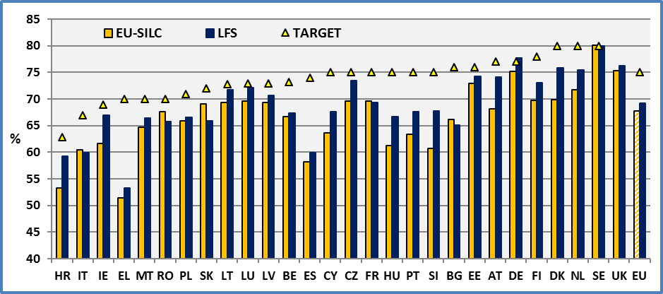

**UK**: The United Kingdom did not set any national targets for employment, R&D, tertiary education and early-school leaving.

**Data source:** EU-SILC 2014 and Eurostat

Concerning further comparison of global EU-SILC and LFS estimations, we may note that at the EU level, the LFS for 2014 gives an employment gender gap of 11.5 percentage points which is close to the gender gap provided by the EU-SILC survey (11.3). Furthermore, most national employment gender gaps delivered by the two surveys are very close.

2.3 General comments

In the following, we discuss the EU-SILC estimations for persons with and without disabilities (limitations). We may observe an important employment gap between people with and without disabilities.

At European level, the employment rate of people with disabilities is about 23.8 percentage points lower than the employment rate for people without disabilities (22.9 in 2013). In fact, about 48.7% of persons with disabilities are employed (48.5 in 2013) compared to 72.5% of persons without disabilities (71.4 in 2013). The employment rate at the EU level is 67.8%. Europe 2020 target for EU 28 is 75%. The situation across Member States differs significantly. According to EU-SILC, the employment rate of people with disabilities (for both sexes) is very low in Greece (27.8%), Malta (28.2%), Ireland (28.3%), Croatia (28.3%) and Bulgaria (33.5%). Conversely, this same rate is relatively high in the UK (47.3%), Luxembourg (57.8%) and Germany (59.7%).

**Figure 14: Employment rate by disability status and Member State (age 20-64), 2014**

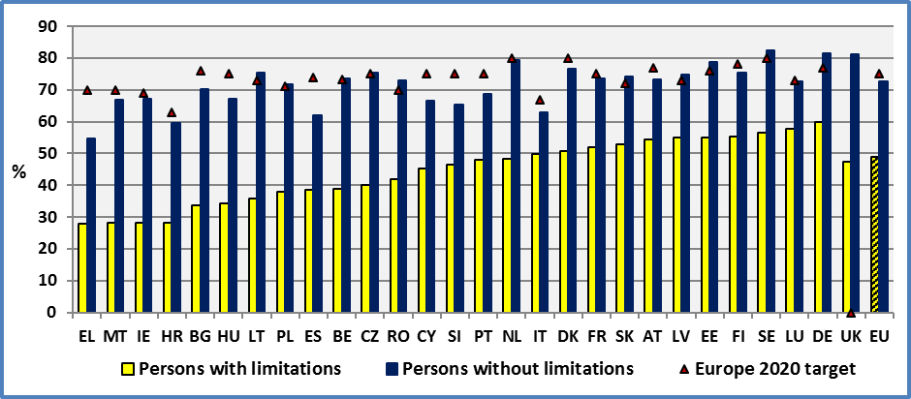

**Note:** The EU-SILC estimations and Europe 2020 use slightly different definition of employment.

**Data source:** EU-SILC UDB 2014 and Eurostat

We may note that countries with similar employment rates for non-disabled people present big and persistent differences for people with disabilities. This suggests that there is a potential for increasing the employment rate of people with disabilities.

There is a significant difference between persons with and without disabilities in all Member States. While in the majority of Member States the employment rate for people without disabilities is higher than 70%, the employment rate of people with disabilities is lower than 50% in the majority of the Member States.

There is an employment gap in all Member States. At the EU level, the gap is 23.8 percentage points. The highest gap can be found in Malta (39 pp), Ireland (39 pp) and Lithuania (40 pp). On the other side, we find Italy (13 pp), Luxembourg (15 pp) and Slovenia (19 pp).

**Figure 15: The employment gap between persons with and without disabilities (age 20-64), 2014**

Gap = % Persons without limitations - % Persons with limitations

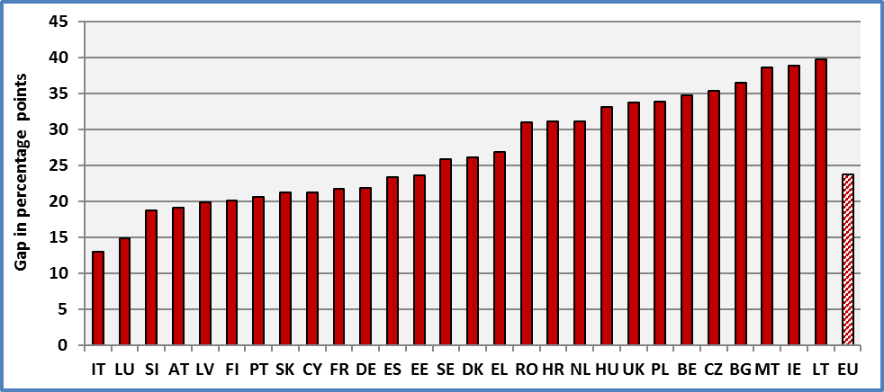

**Data source:** EU-SILC UDB 2014

There are a number of active Labour Market Policies (LMP) followed by the Member States. Eurostat[19] presents LMP expenditure by type of action, notably for, 1. Labour market services; 2. Employment incentives; and 3. Supported employment and rehabilitation. The expenditure is expressed as a percentage of gross domestic product (GDP).

In previous reports, we ran simple cross-national OLS regressions. The dependent variable was the employment rate (in percentages) and the explanatory (independent) variable was expenditure on Labour Market Policies (as a percentage of GDP). This latter ought to measure national efforts for employment creation and support. We have run separate regressions for persons with and without disabilities for each type of measure. Given the low robustness of data on LMP expenditure and probable errors in variables, we have used the average national values for 2010-2013. For employment rates, we used data for 2013.

Regressions with cross-national data indicated that expenditure on labour market services, as a percentage of GDP, was significantly correlated with employment of persons aged 20-64. This relation seems to be stronger in the case of the employment rate of persons without disabilities than those with disabilities. In both cases (persons with and without limitations), a high expenditure on labour market services is associated with a high employment rate. This suggests that better labour market services might increase the employment rate of persons with disabilities.

However, the causality might run on the opposite direction. In fact, high employment rates might imply a high capacity to collect income taxes and hence a high capacity to finance new actions. Further analysis is required in order to assess whether past values of expenditure help us to better predict employment rates or the other way round.

2.4 Gender

In the following tables, we compare the employment rates of persons with and without disabilities by gender. We observe that the employment rate of women with disabilities is significantly lower compared to women without disabilities in all Member States.

At the EU level, the employment rate of women with disabilities is 45.7% and the rate for women without disabilities is 66.7%.

Also, there are big differences across countries. The employment rate of women with disabilities is low in Malta (17.8%), Greece (22.1%) and Ireland (26.2%). On the contrary, relatively high rates can be found in Finland (56.6%), Estonia (56.9) and Germany (56%).

**Figure 16: Female employment rate by disability status and Member State (age 20-64), 2014**

The employment rate is calculated by dividing the number of persons aged 20 to 64 in employment by the total population of the same sex and age group.

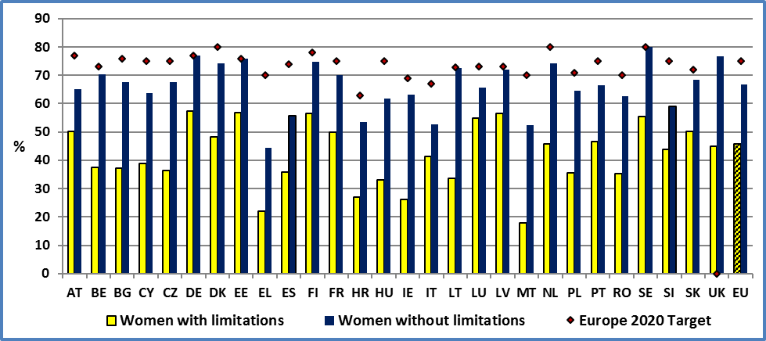

**Data source:** EU-SILC UDB 2014

The employment rate of men with disabilities is significantly lower compared to men without disabilities in all Member States. At the EU level, the employment rate of men with disabilities is 52.3% and the rate for persons without disabilities is 7.3%.

The employment rate of men with disabilities is low in Croatia, Bulgaria and Ireland. On the contrary, it is high in Italy, Luxembourg and Germany.

**Figure 17: Male employment rate by disability status and Member State (age 20-64), 2014**

The employment rate is calculated by dividing the number of persons aged 20 to 64 in employment by the total population of the same sex and age group.

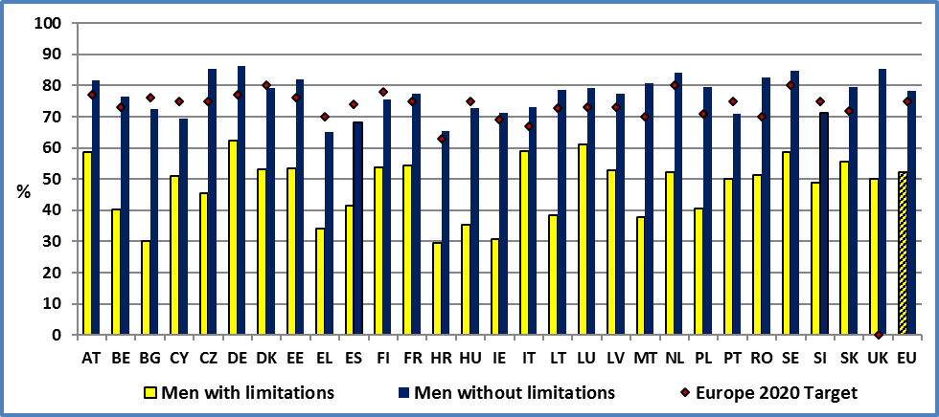

**Data source:** EU-SILC UDB 2014

Concerning people with disabilities, the female employment rate is 45.7% and the male employment rate is 52.3%. We observe a gender gap of 6.7 percentage points (7 pp in 2013).

The highest gender gaps can be found in Romania, Italy and Malta. On the other hand, the employment rate of women with disabilities appears higher than for men with disabilities in Finland, Estonia, Latvia and Bulgaria.

**Figure 18: Employment rate of persons with disabilities by gender and Member State (age 20-64), 2014**

The employment rate is calculated by dividing the number of persons aged 20 to 64 in employment by the total population of the same sex and age group

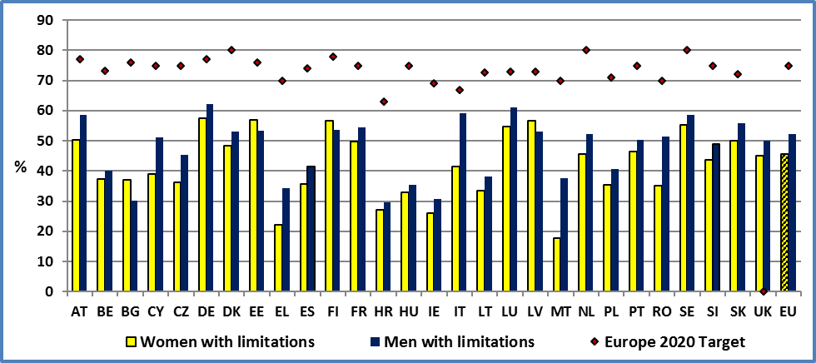

**Data source:** EU-SILC UDB 2014

At the EU level, a marginal improvement took place for women with disabilities (+0.3 percentage points) compared to a significant improvement (+1.4 pp) for women without disabilities.

The evolution of men with disabilities was marginal (+0.2 pp). On the contrary, the employment rate of men without disabilities increased by 0.9 percentage points.

Despite the fact that EU-SILC indicators might underestimate the employment rate compared to the LFS survey, we may observe that the gap between Europe 2020 target and achievements is high for persons with disabilities and women. Consequently, we may conclude that women (with and without disabilities) as well as men with disabilities ought to be a priority group of national employment policies.

2.5 Degree of disability

An important factor affecting the employment rate is the degree of disability. At the EU level, the employment rate of severely disabled people is 28% (29% in 2013), for persons with a moderate disability it is 57% (56% in 2013) and for non-disabled, it is 73% (71% in 2013). There is a difference of 28 percentage points (28 pp in 2012) between persons with severe disabilities and moderate disabilities.

The employment rate of persons with severe disabilities is relatively low in Bulgaria (10%), Lithuania (13%) and Romania (14%). On the other hand, it is relatively high in Portugal (35%), France (36%) and Luxembourg (44%).

**Figure 19: Employment rate of persons with disabilities by degree of disability and MS (age 20-64), 2014**

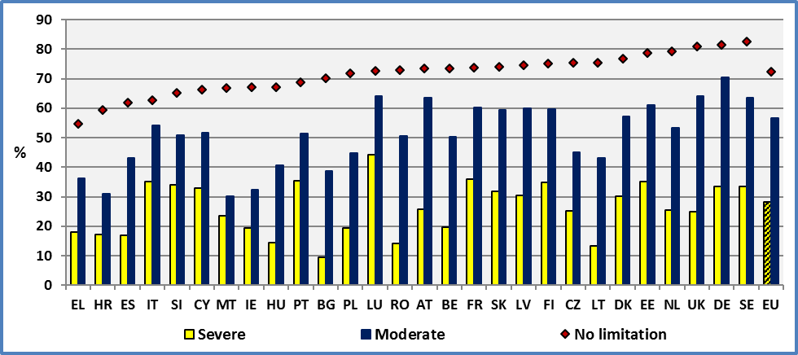

**Data source:** EU-SILC UDB 2014

The employment rate of people with a moderate disability is correlated with the employment rate of persons without a disability (R²=0.49; n=28). On the contrary, the employment rate of people with a severe disability is loosely related to the employment rate of people without disabilities (R²=0.09; n=28). This means that a general improvement of the economic situation will not affect significantly the employment rate of people with a severe disability. Measures which are aimed to affect the general population are not expected to have a significant impact on people with a severe disability.

We will complete the above discussion in the next chapter treating the unemployment rate.

2.6 Employment rate by age group

In this section, we analyse the employment rate by age group. The analysis will cover persons aged 16 to 64. The previous discussion was covering persons aged 20-64 as defined by the EU 2020 target.

The shape of the employment life-cycle appears similar for all persons (disabled and non-disabled). It increases with age but decreases at the end of the work lifecycle, partly due to early retirement.

However, the employment rate of persons with disabilities is lower compared to persons without disabilities at each age-group. This difference increases till the age of 45-54, notably for persons with severe disabilities.

The decrease of employment rate begins at an earlier age for persons with disabilities compared to persons without disabilities. The same path was observed in previous year. This might be an indication of lack of technical aids, work adaptations and flexibility in work arrangements. This might be notably true for persons with severe disabilities.

Persons with severe disabilities reach the highest level of employment rate at the age of 35-44. Afterwards, we observe a continuous decline. However, this might be partly due to deteriorating health problems.

**Figure 20: Employment rate by degree of disability. Age 16-64, EU 2014**

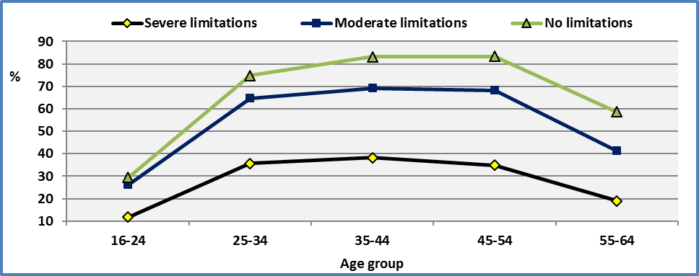

**Data source:** EU-SILC UDB 2014

2.7 Evolution of employment rates

Since 2010, we observe a continuous small increase of the employment rate of persons with disabilities at the EU level. The increase between 2013 and 2014 amounted to 0.3 percentage points (0.6 pp between 2012 and 2013). For comparison, the employment rate of persons without disabilities increased by 1.1 percentage point between 2013 and 2014 but experienced a marginal decrease between 2012 and 2013 (-0.1) at the EU level. However, small changes ought to be treated with care.

Globally, we can say that the recent financial crisis did not deteriorate significantly the employment situation of persons with disability at the EU level. But this is an average for a broad group and might hide changes affecting certain age groups in opposite directions.

**Figure 21: Evolution of the employment rate of people with and without disabilities, EU, age: 20-64**

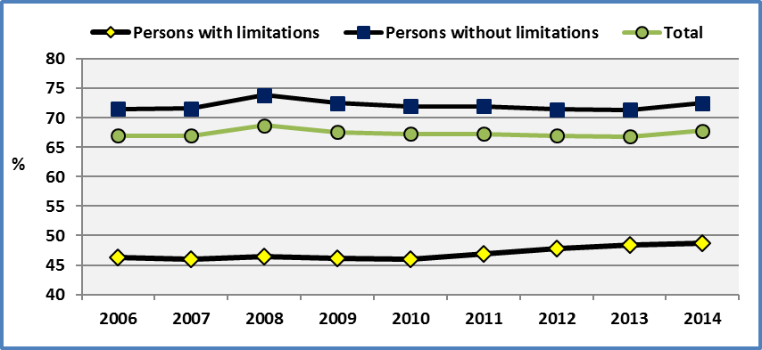

**Note:** The different years do not cover the same countries. See tables and data sources. However, this problem is marginal.

**Data source:** EU-SILC UDB

As indicated in previous ANED reports, the relative stability of persons with disabilities might be at least partly explained by an age composition effect. Persons with disabilities in the EU-SILC 2014 sample are often older persons. For the age group studied here (aged 20-64), the average age for persons with disabilities is 48.5 (weighted) in the sample and for persons without disabilities it is 41.0 years. This has important implications for employment variations. In fact, either because they have acquired certain rights after a long work history, either because national laws protect the employment of older workers, older workers with disabilities might present smaller variations through time. In fact, persons with limitations aged 20-64 have an average of 24 years (weighted) of experience (number of years spent in paid work) compared to 19 years for persons without disabilities in the population covered here[20]. This means that older workers who report a limitation might dominate the sample of people with disabilities. These workers might be better protected than workers with fewer years in a company, in case of firings and redundancies.

Consequently, in an ageing workforce the employment rate of persons with disabilities might increase (artificially). This is due to the combined effect of two characteristics. Disability prevalence increases with age and the employment rate increases with age, at least till the age of 45-54 (older workers with disabilities have a more important weight compared to younger disabled people). For this reason, we present below the evolution of employment rate by age group.

The majority of Member States experienced an increase of the employment rate of persons with disabilities. At the EU level, this represented 0.3 percentage points compared to 1.0 for persons without disabilities. As noted above this change ought to be interpreted with care.

**Figure 22: Employment rate of people with disabilities, age: 20-64**

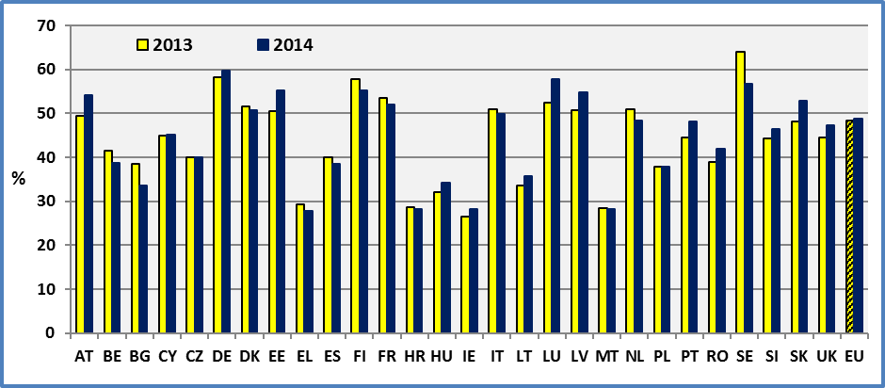

**Note:** The data for Finland and Sweden present a break between 2013 and 2014. Consequently, they are not comparable.

**Data source:** EU-SILC 2013 (revised version 2016) & 2014

This small change of the employment rate of persons with disabilities, at the EU level between two years, contrasts with the big differences observed across Member States. There was a decrease of employment of persons with disabilities notably in Bulgaria, Belgium and the Netherlands.

We may note that there is no relation between the evolution of national employment rates (change between 2013 and 2014) between persons with and without disabilities. In fact, there is no contemporaneous relation between the two cross-national employment variations (2014-2013) (R²=0.05). This means that a general improvement of the economic situation will not improve automatically the employment situation of persons with disabilities.

**Figure 23: Change in the employment rate of people with and without disabilities**

Change = Employment rate of 2013-Employment rate of 2012; Age 20-64

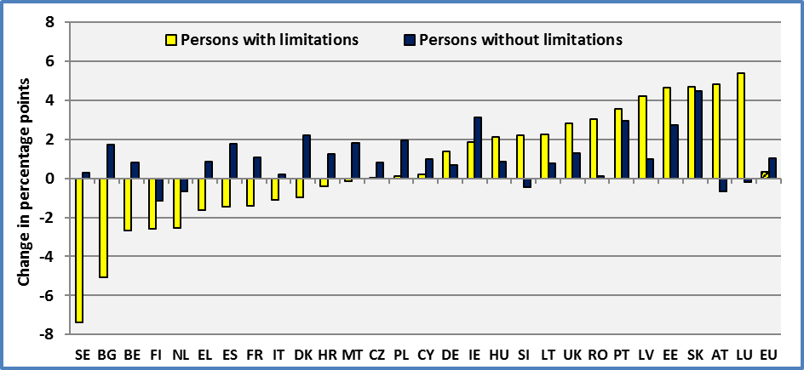

**Note:** The data for Finland and Sweden present a break between 2013 and 2014. Consequently, they are not comparable.

**Data source:** EU-SILC UDB 2013 (revised version 2016) & 2014

2.8 Evolution of employment rates by age group

It is interesting to study the evolution of employment rates by age group. A given global employment rate may hide important differences across age groups. In the following figure, we present the evolution between 2008 and 2014.

We may observe three evolutions:

* the employment rate of persons 25-54 has remained relatively stable for both persons with and without disabilities. As noted, this group benefits the advantage of work experience and certain rights related to seniority;
* recent policies to eradicate early retirement and increase the employment rate of older workers have pushed upward the employment rate of this group. To this may add a cohort effect: the shift of an ageing work force;
* young persons have experienced a significant deterioration of their employment rate, notably persons with disabilities.

Between 2008 and 2014, the employment rate of persons with disabilities decreased by 9.6 percentage points compared to 5.3 pp for persons without disabilities.

**Figure 24: Employment rate by age group by disability status, EU**

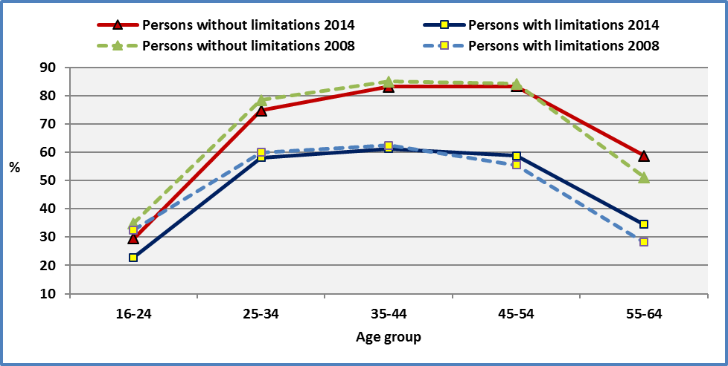

**Note:** 2008 covers EU 27.

**Data source :** EU-SILC UDB 2008 & 2014

2.9 Evolution of youth employment rates

As noted above, when we compare the employment rate of all persons aged 20-64, we miss the specific characteristics of certain smaller age groups. In this section, we will focus on the employment rate of young persons with disabilities.

It is common to define youth as persons aged 16-24. However, for young persons with disabilities, this measure presents some statistical problems. In this group, the number of observations of persons with disabilities is relatively small. In fact, disability prevalence is small in this age group. Consequently, we have to enlarge the age group in order to increase the probability to have more persons with disabilities in the sample. One possibility is to put the upper limit at 29 years.

Furthermore, we propose to exclude persons aged less than 20 years, in order to avoid the noise in the data generated by different educational systems in the Member States. In fact, the age of compulsory education varies across Member States and in a certain number of cases a given education curriculum is organised across a longer period of time for persons with disabilities compared to persons without disabilities. For these reasons, we propose to study the age group 20 to 29.

The employment rate of both young people with and without disabilities was deteriorating between 2008 and 2013. Frome 2013 to 2014, the employment rate of young persons with disabilities continued to deteriorate (-3.1) while for the first time the employment rate of persons without disabilities increased (+1.5)[21].

**Figure 25: Employment rate of young people with and without disabilities, EU, age: 20-29**

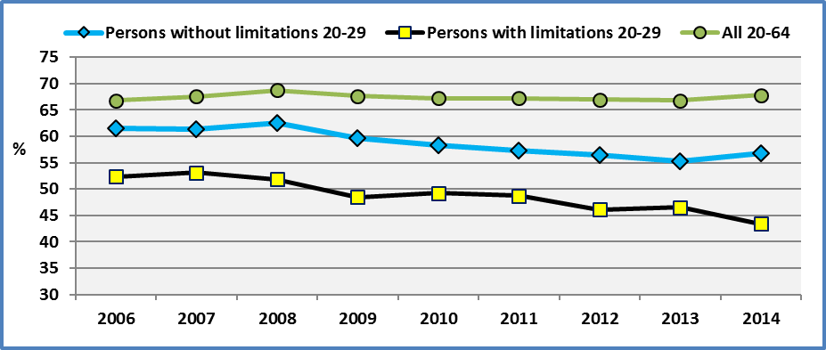

**Note:** The different years do not cover the same countries. See tables and data sources. However, this problem is marginal.

**Data source:** EU-SILC UDB

2.10 The importance of part-time work

As noted in previous reports (ANED 2013), concerning persons active on the labour force, persons with disabilities are overrepresented among persons holding part-time work. The table below indicates that this is true both for employed and self-employed persons.

Part-time jobs might be attractive to persons with disabilities. Health reasons might require flexible working hours and part-time work might be a strong incentive for persons with disabilities. As indicated in previous reports, a certain number of persons with disabilities declare that they do not want to work more hours.

However, in certain cases, part-time might be the result of a lack of work accommodations. In fact, the absence of appropriate work adaptations might be a serious barrier for some of them to access full-time jobs. In fact, as noted in previous ANED reports, among persons with disabilities working less than 30 hours, some declare that they want to work more hours but cannot find. This discussion will be followed further in the analysis of activity rates.

**Table 14: Number of persons aged 20-64 by type of economic status**

1: Persons without limitations; 2: Persons with limitations; 3: Total.

**In 1.000.000**

|  |  |  |  |  |  |  |  |  |
| --- | --- | --- | --- | --- | --- | --- | --- | --- |
|  | **2013** | | | **2014** | | | **Labour force (%)** | |
| **EU-SILC** | **1** | **2** | **3** | **1** | **2** | **3** | **1** | **2** |
| **Employee FT** | 120.3 | 18.0 | **138.3** | 122.9 | 18.0 | **140.9** | 63 | 50 |
| **Employee PT** | 25.3 | 6.4 | **31.7** | 25.5 | 6.7 | **32.2** | 13 | 19 |
| **Self-employed FT** | 19.8 | 3.1 | **22.9** | 20.1 | 3.1 | **23.1** | 10 | 9 |
| **Self-employed PT** | 3.7 | 0.9 | **4.6** | 3.5 | 0.9 | **4.5** | 2 | 3 |
| **Unemployed** | 22.7 | 6.6 | **29.3** | 21.9 | 7.0 | **28.8** | 11 | 20 |
| **Pupil/Student** | 14.0 | 1.1 | **15.1** | 13.9 | 1.2 | **15.1** |  |  |
| **Inactive** | 31.2 | 22.3 | **53.5** | 29.5 | 21.9 | **51.4** |  |  |
|  |  |  |  |  |  |  |  |  |
| **Total** | **236.9** | **58.4** | **295.3** | **237.2** | **58.7** | **295.9** | **100** | **100** |

**Note:** FT: Full-time, PT: Part-time. The data cover only persons living in private households.

**Source of data:** EU-SILC UDB

2.11 The importance of education

Human capital enhances employment prospects and the probability to find a job. The employment rate increases significantly with educational attainment both for persons with and without disabilities. Furthermore, the educational level decreases the difference between persons with and without disabilities. At the lowest level of persons with no education (Pre-primary), the employment rates are 17.5% for persons with disabilities and 47.5% for persons without disabilities. We observe a difference of 30 percentage points. At the highest level of persons with a tertiary education, the respective employment rates are 68.2% and 82.5%. This represents a gap of 14.3 percentage points. Consequently, education not only favours employment opportunities but also reduces any discrimination gap.

Education will be discussed further below.

**Figure 26: Employment rate by education level and disability status, EU, age: 20-64, 2014**

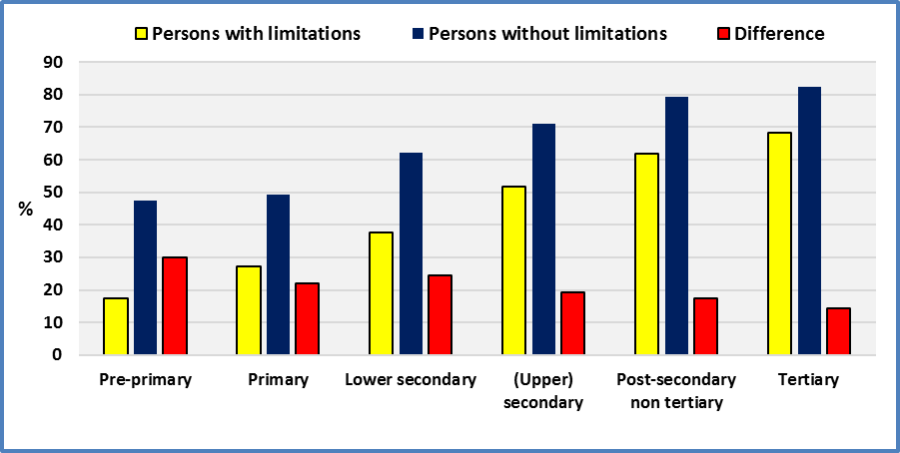

**Source of data:** EU-SILC UDB 2014

2.12 Employment and discrimination

The special Eurobarometer 2015 on discrimination asked (QC2): “In the past 12 months have you personally felt discriminated against or harassed on one or more of the following grounds”? The person may report several grounds. The different grounds are:

* Ethnic origin,
* Gender,
* Sexual orientation (being gay, lesbian or bisexual),
* Being over 55 years old,
* Being under 30 years old,
* Religion or beliefs,
* Disability,
* Gender identity (being transgender or transsexual),
* For another reason,
* No.

In the following graph, we present the employment rate of persons aged 20-64 who have personally felt discriminated against or harassed on one or more of the different grounds. The employment rate among persons who have personally felt discriminated against or harassed on disability ground about 48.3% are employed compared to 68.6%. This provides an employment gap of 21.0 percentage points. For comparison, the EU-SILC 2014 provides respectively: 48.7%, 72.5% and a gap of 23.8 percentage points. Despite the use of different definitions concerning disabled persons and sampling differences, the estimations are very close. As noted, Eurobarometer focusses on “felt discrimination … on disability ground” while the EU-SILC refers to limitations due to health problems.

The following figure reveals that disabled people are the most disadvantaged group on the labour market.

The above definition of disability might be considered as very restrictive. For comparison, we may adopt a broader definition of disability. As in the discussion of disability prevalence, we define again persons with disabilities as persons who consider themselves to be part of a minority in terms of disability and / or have personally having felt discriminated against or harassed on disability (even if they don’t consider themselves to be member of a minority group). At the EU level, about 49.9% of disabled persons (extended definition including minority view and experienced discrimination) are employed compared to 68.9% of non-disabled persons. The employment gap between persons with and without disabilities is about 19.0 percentage points. Again, we find a very important employment gap.

**Figure 27: Employment rate of persons aged 20-64 who have personally felt discriminated against or harassed by ground of discrimination; EU, 2015**

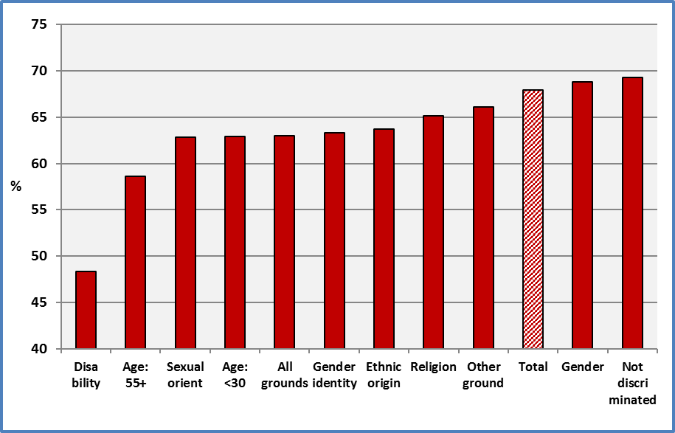

**Note:** The different grounds are: 1) Ethnic origin, 2) Gender, 3) Sexual orientation (being gay, lesbian or bisexual), 4) Being over 55 years old, 5) Being under 30 years old, 6) Religion or beliefs, 7) Disability, 8) Gender identity (being transgender or transsexual), 9) For another reason and 10) No.

“All grounds” include persons who have felt discriminated for at least one ground.

“Not discriminated” includes persons not discriminated on any ground.

**Source of data**: Eurobarometer 83.4 (2015)

2.13 Employment rate of of persons aged 20 to 64 and confidence intervals at 95%

In the following, we present standard error estimates and the resulting confidence intervals for the employment rate indicator (age 20-64).

The standard error and hence the confidence intervals for persons with disabilities are larger compared to persons without disabilities as the number of sample units concerning persons with limitations is lower compared to persons without limitations. The average of the national standard errors is 0.5 percentage point for persons without limitations and 1.2 for persons with limitations.

We may note that in all Member States, there is a significant difference between the employment rate of persons with and without limitations aged 20-64.

However, if we want to compare national employment rates for persons aged 20-29, the average of the national standard errors is 1.3 percentage points for persons without limitations and 4.7 for persons with limitations. This explains why we present above only aggregated estimates at the EU level of employment rates. This relatively high standard error for the employment rate of persons with limitations is explained mainly by the very low disability rate among young persons and hence the presence of a limited number of observations for this group.

It is important to note that concerning persons aged 20-29, the standard error of the EU estimate is not the average of national standard errors. In fact, it is 0.2 for persons without limitations and 0.8 percentage points for persons with limitations. Consequently, the EU employment estimates presented above convey a useful and statistically significant information.

**Figure 28: Employment rate of persons aged 20-64 and confidence interval at 95%**

N: Persons without limitations and L: Persons with limitations

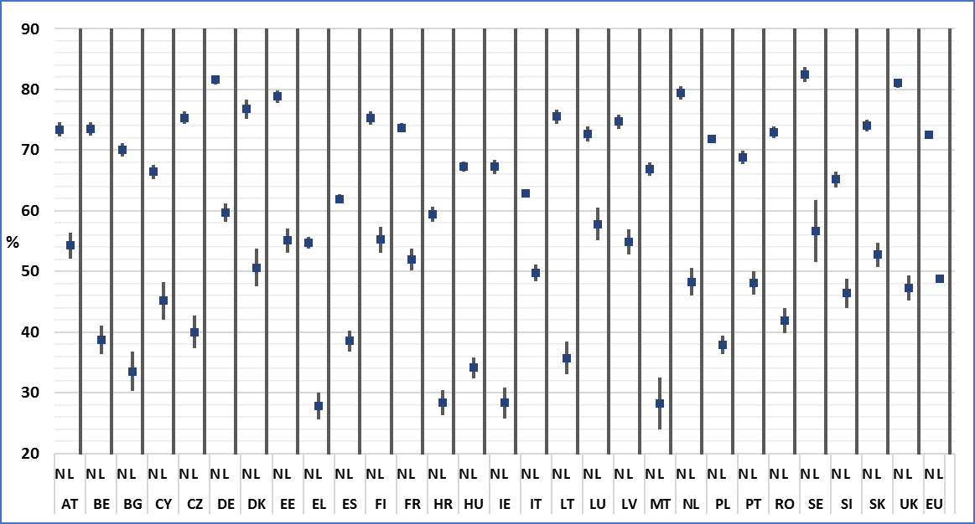

**Source of data:** EU-SILC UDB 2014

### 3. Data

**Table 15: Employment rate by disability status and Member State (age 20-64)**

The employment rate is calculated by dividing the number of persons aged 20 to 64 in employment by the total population of the same age group.

The EU-SILC data are not seasonally adjusted

|  |  |  |  |  |  |  |  |  |  |  |
| --- | --- | --- | --- | --- | --- | --- | --- | --- | --- | --- |
|  | **2008** | | | | | **2009** | | | | |
|  | **Men + Women** | | | | | **Men + Women** | | | | |
|  | **Disability** | | | **All** | **LFS** | **Disability** | | | **All** | **LFS** |
|  | **Yes** | **No** | **Total** |  |  | **Yes** | **No** | **Total** |  |  |
| **AT** | 49,9 | 74,1 | 68,5 | **68,5** | *75,1* | 48,2 | 73,3 | 67,8 | **67,8** | *74,7* |
| **BE** | 38,8 | 73,3 | 67,2 | **67,2** | *68,0* | 42,6 | 72,4 | 66,9 | **66,9** | *67,1* |
| **BG** | 38,2 | 73,3 | 69,8 | **69,8** | *70,7* | 39,0 | 72,1 | 68,7 | **68,7** | *68,8* |
| **CY** | 55,1 | 74,7 | 72,3 | **72,3** | *76,5* | 53,3 | 73,1 | 70,6 | **70,7** | *75,7* |
| **CZ** | 37,5 | 74,6 | 69,1 | **69,1** | *72,4* | 38,6 | 74,3 | 68,1 | **68,9** | *70,9* |
| **DE** | 54,2 | 76,8 | 70,6 | **70,6** | *74,0* | 53,9 | 76,4 | 70,8 | **70,5** | *74,8* |
| **DK** | 52,9 | 81,3 | 74,6 | **73,9** | *79,7* | 56,3 | 81,1 | 75,2 | **74,9** | *77,8* |
| **EE** | 52,8 | 81,7 | 75,7 | **75,7** | *77,0* | 50,7 | 74,8 | 70,1 | **70,1** | *69,9* |
| **EL** | 34,7 | 69,8 | 65,9 | **65,9** | *66,5* | 31,4 | 68,1 | 65,2 | **65,2** | *65,8* |
| **ES** | 43,7 | 72,9 | 68,2 | **68,2** | *68,3* | 42,9 | 67,9 | 63,5 | **63,5** | *63,7* |
| **FI** | 55,8 | 78,5 | 72,8 | **72,0** | *75,8* | 55,5 | 77,2 | 71,6 | **70,8** | *73,5* |
| **FR** | (49,5) | (73,0) | (69,2) | **(69,2)** | *70,4* | 49,8 | 72,1 | 68,3 | **68,3** | *69,5* |
| **HR** |  |  |  |  |  |  |  |  |  |  |
| **HU** | 31,3 | 68,5 | 60,0 | **60,0** | *61,9* | 32,1 | 68,8 | 60,7 | **61,0** | *60,5* |
| **IE** | 33,1 | 70,9 | 64,6 | **64,6** | *72,3* | 29,0 | 65,1 | 59,2 | **59,2** | *66,7* |
| **IT** | 45,7 | 65,9 | 62,5 | **62,5** | *63,0* | 44,7 | 64,0 | 60,9 | **60,9** | *61,7* |
| **LT** | 45,1 | 80,0 | 73,6 | **73,6** | *72,0* | 38,2 | 73,2 | 68,1 | **68,0** | *67,2* |
| **LU** | 54,1 | 72,6 | 69,5 | **69,5** | *68,8* | 55,8 | 69,7 | 67,4 | **67,6** | *70,4* |
| **LV** | 55,4 | 78,9 | 73,1 | **73,1** | *75,8* | 45,1 | 70,0 | 64,3 | **64,3** | *67,1* |
| **MT** | (21,6) | (60,7) | (58,4) | **(58,5)** | *59,1* | 32,0 | 61,6 | 59,2 | **59,2** | *58,7* |
| **NL** | 53,1 | 79,3 | 73,3 | **73,9** | *78,9* | 54,0 | 79,6 | 73,6 | **74,1** | *78,8* |
| **PL** | 31,9 | 69,3 | 63,5 | **63,5** | *65,0* | 33,3 | 70,3 | 64,1 | **64,1** | *64,9* |
| **PT** | 50,4 | 77,7 | 72,0 | **72,0** | *73,1* | 46,4 | 75,1 | 68,5 | **68,5** | *71,2* |
| **RO** | 28,9 | 69,3 | 64,0 | **64,0** | *64,4* | 29,4 | 69,6 | 63,9 | **63,9** | *63,5* |
| **SE** | 57,5 | 84,5 | 80,8 | **80,3** | *80,4* | 52,8 | 82,6 | 78,9 | **79,1** | *78,3* |
| **SI** | 50,4 | 70,8 | 66,4 | **65,8** | *73,0* | 51,2 | 70,5 | 66,3 | **65,3** | *71,9* |
| **SK** | 53,0 | 78,2 | 71,6 | **71,6** | *68,8* | 52,2 | 74,8 | 68,9 | **68,9** | *66,4* |
| **UK** | 47,3 | 81,3 | 75,9 | **75,9** | *75,2* | 44,3 | 79,5 | 73,8 | **73,7** | *73,9* |
|  |  |  |  |  |  |  |  |  |  |  |
| **EU** | 46,4 | 73,9 | 68,7 | **68,7** | *70,3* | 46,1 | 72,5 | 67,6 | **67,6** | *69,1* |

**LFS data:** <http://epp.eurostat.ec.europa.eu/portal/page/portal/europe_2020_indicators/headline_indicators>

**All:** It includes observations for which we do not dispose information on disability status.

**Data source:** EU-SILC UDB 2008 & 2009

**Table 16: Employment rate by disability status and Member State (age 20-64)**

The employment rate is calculated by dividing the number of persons aged 20 to 64 in employment by the total population of the same age group.

|  |  |  |  |  |  |  |  |  |  |  |
| --- | --- | --- | --- | --- | --- | --- | --- | --- | --- | --- |
|  | **2010** | | | | | **2011** | | | | |
|  | **Men + Women** | | | | | **Men + Women** | | | | |
|  | **Disability** | | | **All** | **LFS** | **Disability** | | | **All** | **LFS** |
|  | **Yes** | **No** | **Total** |  |  | **Yes** | **No** | **Total** |  |  |
| **AT** | 48,8 | 73,2 | 67,7 | **67,7** | *74,9* | 50,3 | 73,4 | 68,3 | **68,3** | *75,2* |
| **BE** | 40,7 | 71,9 | 66,3 | **66,3** | *67,6* | 38,4 | 72,4 | 66,3 | **66,3** | *67,3* |
| **BG** | 32,5 | 70,8 | 67,2 | **67,2** | *65,4* | 33,9 | 69,4 | 65,5 | **65,5** | *62,9* |
| **CY** | (51,0) | (74,1) | (71,0) | **(71,0)** |  | 55,3 | 74,4 | 71,3 | **71,4** | *73,4* |
| **CZ** | 37,4 | 72,3 | 71,7 | **67,4** | *70,4* | 38,7 | 71,8 | 66,2 | **67,6** | *70,9* |
| **DE** | 54,4 | 77,4 | 73,5 | **71,4** | *74,9* | 56,9 | 79,3 | 73,7 | **73,3** | *76,3* |
| **DK** | 56,0 | 78,9 | 65,2 | **73,4** | *75,8* | 53,3 | 78,4 | 72,1 | **72,2** | *75,7* |
| **EE** | 46,4 | 70,3 | 64,2 | **65,2** | *66,7* | 47,5 | 74,9 | 68,7 | **68,7** | *70,4* |
| **EL** | 38,2 | 66,5 | 62,5 | **64,2** | *64,0* | 30,2 | 57,0 | 54,4 | **54,4** | *59,9* |
| **ES** | 41,1 | 66,5 | 67,7 | **62,5** | *62,5* | 35,6 | 63,7 | 59,9 | **59,9** | *61,6* |
| **FI** | 53,7 | 72,6 | 67,3 | **67,3** | *73,0* | 51,7 | 74,3 | 68,3 | **68,0** | *73,8* |
| **FR** | 49,9 | 71,2 | 59,6 | **67,3** | *69,1* | 51,6 | 72,5 | 68,7 | **68,7** | *69,2* |
| **HR** |  |  |  |  |  | 19,7 | 53,0 | 45,5 | **50,0** | *57,0* |
| **HU** | 33,5 | 66,7 | 71,7 | **59,6** | *60,4* | 32,0 | 66,2 | 59,2 | **59,3** | *60,7* |
| **IE** | (27,6) | (62,3) | (57,3) | **(57,3)** | *64,6* | (27,1) | (61,9) | (57,3) | **(57,3)** | *63,8* |
| **IT** | 43,2 | 63,3 | 61,0 | **60,8** | *61,1* | 45,9 | 64,1 | 61,0 | **61,0** | *61,2* |
| **LT** | 35,3 | 69,5 | 65,0 | **64,7** | *64,4* | 32,3 | 70,9 | 65,3 | **65,1** | *67,0* |
| **LU** | 52,2 | 72,6 | 69,1 | **69,2** | *70,7* | 52,1 | 72,7 | 69,5 | **69,6** | *70,1* |
| **LV** | 40,5 | 66,2 | 60,6 | **60,7** | *65,0* | 43,2 | 67,9 | 62,5 | **62,5** | *66,3* |
| **MT** | 25,6 | 61,7 | 58,9 | **58,9** | *60,1* | 31,7 | 62,3 | 60,1 | **60,1** | *61,5* |
| **NL** | 51,6 | 79,6 | 73,3 | **73,5** | *76,8* | 51,1 | 80,3 | 73,6 | **73,4** | *77,0* |
| **PL** | 35,8 | 69,8 | 63,9 | **63,9** | *64,6* | 36,6 | 69,9 | 64,2 | **64,2** | *64,8* |
| **PT** | 42,3 | 74,4 | 67,2 | **67,2** | *70,5* | 45,3 | 73,9 | 68,1 | **68,1** | *69,1* |
| **RO** | 37,6 | 71,1 | 65,1 | **65,1** | *63,3* | 38,4 | 71,7 | 65,5 | **65,5** | *62,8* |
| **SE** | 60,1 | 82,8 | 80,0 | **79,9** | *78,7* | 58,7 | 83,2 | 80,0 | **79,9** | *79,4* |
| **SI** | 49,2 | 70,3 | 64,0 | **63,2** | *70,3* | 47,6 | 68,7 | 62,3 | **61,9** | *68,4* |
| **SK** | 50,4 | 71,5 | 65,9 | **65,9** | *64,6* | 50,0 | 71,2 | 65,4 | **65,4** | *65,0* |
| **UK** | 41,9 | 79,5 | 73,3 | **73,1** | *73,6* | 46,4 | 79,8 | 74,0 | **73,8** | *73,6* |
|  |  |  |  |  |  |  |  |  |  |  |
| **EU** | 46,0 | 72,0 | 67,3 | **67,2** | *68,6* | 46,9 | 72,0 | 67,3 | **67,2** | *68,5* |

**LFS data:** <http://epp.eurostat.ec.europa.eu/portal/page/portal/europe_2020_indicators/headline_indicators>

**All:** It includes observations for which we do not dispose information on disability status.

**Note:** The LFS estimation for EU 2011 refers to EU 28. Previous years refer to EU 27.

**Data source:** EU-SILC UDB 2010 & 2011

**Table 17: Employment rate by disability status and Member State (age 20-64)**

The employment rate is calculated by dividing the number of persons aged 20 to 64 in employment by the total population of the same age group.

|  |  |  |  |  |  |  |  |  |  |  |  |
| --- | --- | --- | --- | --- | --- | --- | --- | --- | --- | --- | --- |
|  | **2012** | | | | | **EU 2020** | **2013** | | | | |
|  | **Men + Women** | | | | |  | **Men + Women** | | | | |
|  |  | | | **All** | **LFS** | **Target** |  |  |  | **All** | **LFS** |
|  | **Yes** | **No** | **Total** |  |  |  | **Yes** | **No** | **Total** |  |  |
| AT | 49,6 | 74,4 | 69,0 | **69,0** | *75,6* | (77-78) 77 | 49,4 | 74,1 | 68,1 | **68,1** | *74,6* |
| **BE** | 36,1 | 73,3 | 66,9 | **66,9** | *67,2* | 73,2 | 41,4 | 72,7 | 66,7 | **66,7** | *67,2* |
| **BG** | 41,0 | 68,1 | 64,9 | **64,9** | *63,0* | 76 | 38,6 | 68,3 | 65,1 | **65,1** | *63,5* |
| **CY** | 50,1 | 71,3 | 68,3 | **68,3** | *70,2* | (75-77) 75 | 45,0 | 65,5 | 62,4 | **62,4** | *67,2* |
| **CZ** | 38,5 | 73,1 | 67,2 | **68,5** | *71,5* | 75 | 40,0 | 74,5 | 68,6 | **69,4** | *72,5* |
| **DE** | 57,9 | 79,7 | 73,9 | **73,5** | *76,7* | 77 | 58,3 | 80,9 | 74,7 | **74,3** | *77,3* |
| **DK** | 49,7 | 75,3 | 68,6 | **68,8** | *75,4* | 80 | 49,7 | 74,1 | 67,7 | **66,8** | *75,6* |
| **EE** | 49,2 | 75,6 | 69,3 | **69,3** | *72,2* | 76 | 50,5 | 76,1 | 69,9 | **69,9** | *73,3* |
| **EL** | 32,9 | 56,9 | 54,0 | **54,0** | *55,3* | 70 | 29,4 | 53,8 | 51,0 | **51,0** | *52,9* |
| **ES** | 35,2 | 60,1 | 56,7 | **56,7** | *59,6* | 74 | 40,0 | 60,2 | 56,8 | **56,8** | *58,6* |
| **FI** | 56,3 | 74,9 | 69,4 | **68,3** | *74,0* | 78 | 57,8 | 76,4 | 69,5 | **68,3** | *73,3* |
| **FR** | 53,6 | 72,6 | 69,1 | **69,1** | *69,4* | 75 | 54,0 | 71,8 | 68,5 | **68,5** | *69,6* |
| **HR** | 24,4 | 58,1 | 53,3 | **53,4** | *55,4* | 62,9 | 28,7 | 58,2 | 52,2 | **52,3** | *57,2* |
| **HU** | 28,3 | 66,2 | 59,3 | **59,3** | *62,1* | 75 | 32,0 | 66,4 | 60,0 | **60,0** | *63,0* |
| **IE** | 27,9 | 63,0 | 58,3 | **58,3** | *63,7* | (69-71) 69 | 26,5 | 64,1 | 58,8 | **58,8** | *65,5* |
| **IT** | 50,1 | 63,0 | 60,6 | **60,5** | *61,0* | (67-69) 67 | 51,0 | 62,6 | 60,4 | **60,4** | *59,7* |
| **LT** | 33,2 | 72,3 | 66,2 | **66,3** | *68,5* | 72,8 | 33,5 | 74,7 | 68,3 | **68,4** | *69,9* |
| **LU** | 53,7 | 72,9 | 69,7 | **69,7** | *71,4* | 73 | 52,4 | 72,8 | 68,7 | **68,6** | *71,1* |
| **LV** | 45,8 | 69,9 | 65,0 | **65,0** | *68,1* | 73 | 50,7 | 73,7 | 67,6 | **67,6** | *69,7* |
| **MT** | 21,4 | 64,4 | 61,8 | **61,8** | *63,1* | 70 | 28,4 | 65,0 | 62,6 | **62,6** | *64,8* |
| **NL** | 53,3 | 79,7 | 73,4 | **73,4** | *77,2* | 80 | 50,8 | 80,1 | 72,2 | **71,8** | *76,5* |
| **PL** | 36,8 | 70,3 | 64,6 | **64,6** | *64,7* | 71 | 37,8 | 69,9 | 64,4 | **64,4** | *64,9* |
| **PT** | 42,2 | 68,5 | 63,9 | **63,9** | *66,5* | 75 | 44,5 | 65,8 | 61,9 | **61,9** | *65,4* |
| **RO** | 39,5 | 71,7 | 65,9 | **65,9** | *63,8* | 70 | 38,8 | 72,8 | 66,7 | **66,7** | *64,7* |
| **SE** | 61,4 | 83,5 | 80,5 | **80,6** | *79,4* | 80 | 64,0 | 82,2 | 79,0 | **78,7** | *79,8* |
| **SI** | 46,4 | 67,4 | 61,5 | **61,4** | *68,3* | 75 | 44,2 | 65,6 | 60,7 | **61,0** | *67,2* |
| **SK** | 48,0 | 71,1 | 65,2 | **65,2** | *65,1* | 72 | 48,1 | 69,5 | 64,2 | **64,2** | *65,0* |
| **UK** | 45,9 | 80,1 | 74,4 | **74,4** | *74,2* | - | 44,5 | 79,7 | 74,1 | **74,1** | *74,8* |
|  |  |  |  |  |  |  |  |  |  |  |  |
| **EU** | **47,9** | **71,5** | **67,0** | **67,0** | ***68,4*** | **75** | 48,5 | 71,4 | 66,9 | **66,8** | *68,4* |
|  |  |  |  |  |  |  |  |  |  |  |  |
| **CH** | 66,2 | 81,7 | 79,1 | **79,1** | *82,0* |  | 70,2 | 81,1 | 78,3 | 78,3 | *82,1* |
| **IS** | 47,5 | 78,3 | 73,7 | **73,1** | *81,8* |  | 49,4 | 80,6 | 75,7 | 74,9 | *82,8* |
| **NO** | 48,3 | 85,8 | 81,3 | **79,8** | *79,9* |  | 54,3 | 86,8 | 81,9 | 80,7 | *79,6* |
| **RS** |  |  |  |  |  |  | 24,7 | 52,7 | 49,3 | 50,8 |  |

**Data source:** EU-SILC UDB 2012 and Eurostat

**Table 18: Employment rate by disability status and Member State (age 20-64)**

The employment rate is calculated by dividing the number of persons aged 20 to 64 in employment by the total population of the same age group.

|  |  |  |  |  |  |  |  |
| --- | --- | --- | --- | --- | --- | --- | --- |
|  | **2014** | | | | | | **EU 2020** |
|  | **Men + Women** | | | | | |  |
|  |  | | | **All** | **All** | **LFS** | **Target** |
|  | **Yes** | **No** | **Total** |  | **ILO\*** |  |  |
| **AT** | 54,2 | 73,4 | 68,1 | **68,1** | 70,7 | *74,2* | (77-78) 77 |
| **BE** | 38,7 | 73,5 | 66,7 | **66,7** | 66,7 | *67,3* | 73,2 |
| **BG** | 33,5 | 70,1 | 66,1 | **66,1** | 66,1 | *65,1* | 76 |
| **CY** | 45,2 | 66,4 | 63,6 | **63,7** |  | *67,6* | (75-77) 75 |
| **CZ** | 40,0 | 75,3 | 69,6 | **70,2** |  | *73,5* | 75 |
| **DE** | 59,7 | 81,6 | 75,2 | **74,7** | 78,7 | *77,7* | 77 |
| **DK** | 50,6 | 76,7 | 69,9 | **68,5** |  | *75,9* | 80 |
| **EE** | 55,1 | 78,8 | 72,9 | **72,9** |  | *74,3* | 76 |
| **EL** | 27,8 | 54,7 | 51,4 | **51,4** | 51,4 | *53,3* | 70 |
| **ES** | 38,5 | 62,0 | 58,1 | **58,2** |  | *59,9* | 74 |
| **FI** | 55,2 | 75,3 | 69,8 | **68,6** |  | *73,1* | 78 |
| **FR** | 52,0 | 73,7 | 69,6 | **69,6** | 69,6 | *69,4* | 75 |
| **HR** | 28,3 | 59,4 | 53,3 | **53,4** | 55,6 | *59,2* | 62,9 |
| **HU** | 34,2 | 67,3 | 61,2 | **61,2** | 62,6 | *66,7* | 75 |
| **IE** | 28,3 | 67,2 | 61,6 | **61,6** | 61,6 | *67* | (69-71) 69 |
| **IT** | 49,8 | 62,8 | 60,5 | **60,4** | 61,1 | *59,9* | (67-69) 67 |
| **LT** | 35,7 | 75,5 | 69,4 | **69,4** |  | *71,8* | 72,8 |
| **LU** | 57,8 | 72,7 | 69,6 | **69,6** | 69,6 | *72,1* | 73 |
| **LV** | 54,9 | 74,7 | 69,3 | **69,3** |  | *70,7* | 73 |
| **MT** | 28,2 | 66,8 | 64,6 | **64,6** |  | *66,4* | 70 |
| **NL** | 48,3 | 79,4 | 71,8 | **71,6** |  | *75,4* | 80 |
| **PL** | 37,9 | 71,8 | 65,9 | **65,9** | 66,6 | *66,5* | 71 |
| **PT** | 48,1 | 68,8 | 63,4 | **63,4** | 63,4 | *67,6* | 75 |
| **RO** | 41,9 | 72,9 | 67,7 | **67,7** |  | *65,7* | 70 |
| **SE** | 56,6 | 82,5 | 80,1 | **79,7** |  | *80* | 80 |
| **SI** | 46,4 | 65,2 | 60,7 | **61,3** |  | *67,7* | 75 |
| **SK** | 52,8 | 74,0 | 69,1 | **69,0** |  | *65,9* | 72 |
| **UK** | 47,3 | 81,0 | 75,3 | **75,3** | 75,3 | *76,2* | - |
|  |  |  |  |  |  |  |  |
| **EU** | 48,7 | 72,5 | 67,8 | **67,7** | 68,6 | *69,2* | **75** |
|  |  |  |  |  |  |  |  |
| **CH** | 70,4 | 81,5 | 78,5 | 78,7 | 83,7 | *82,3* |  |
| **IS** | 51,2 | 79,2 | 74,5 | 75,6 | 82,8 | *84,9* |  |
| **NO** | 52,3 | 86,4 | 81,4 | 79,3 | 83,7 | *79,6* |  |
| **RS** | 25,8 | 50,8 | 48,2 | 48,2 | 53,8 |  |  |

**\*ILO:** A certain number of countries report information on persons who worked at least one hour during the previous week (pl035). We have included all among employed persons.

**Data source:** EU-SILC UDB 2014 and Eurostat

**Table 19: Employment rate by disability status, gender and Member State (age 20-64)**

**Dis**: Disabled, **No**: Non-disabled, **T**: Total

The employment rate is calculated by dividing the number of persons aged 20 to 64 in employment by the total population of the same age group and gender.

|  |  |  |  |  |  |  |  |  |  |  |  |  |  |
| --- | --- | --- | --- | --- | --- | --- | --- | --- | --- | --- | --- | --- | --- |
|  | **2008** | | | | | | | **2009** | | | | | |
|  | **Females** | | | | **Males** | | | **Females** | | | **Males** | | |
|  |  | | | |  | | |  | | |  | | |
|  | Dis | No | T | | Dis | No | T | Dis | No | T | Dis | No | T |
| **AT** | 43,9 | 64,0 | **59,5** | 55,8 | | 84,1 | **77,6** | 43,1 | 65,4 | **60,5** | 53,5 | 81,1 | **75,2** |
| **BE** | 33,8 | 66,7 | **60,5** | 44,3 | | 79,8 | **73,8** | 41,0 | 65,6 | **60,7** | 44,4 | 78,9 | **73,0** |
| **BG** | 34,2 | 66,6 | **63,3** | 42,4 | | 80,2 | **76,4** | 36,6 | 66,4 | **63,1** | 41,7 | 77,8 | **74,3** |
| **CY** | 44,5 | 67,5 | **64,8** | 65,2 | | 82,2 | **80,1** | 46,5 | 66,5 | **64,1** | 59,9 | 79,9 | **77,3** |
| **CZ** | 32,5 | 64,4 | **59,1** | 43,8 | | 86,1 | **79,4** | 31,9 | 65,0 | **59,0** | 47,5 | 85,3 | **79,0** |
| **DE** | 50,0 | 70,8 | **65,0** | 58,4 | | 82,7 | **76,3** | 50,8 | 70,9 | **65,8** | 57,3 | 82,0 | **75,9** |
| **DK** | 47,0 | 78,0 | **69,9** | 60,7 | | 84,5 | **79,6** | 55,6 | 80,0 | **73,6** | 57,1 | 82,2 | **76,9** |
| **EE** | 53,2 | 77,5 | **72,7** | 52,4 | | 86,4 | **79,2** | 53,9 | 73,9 | **70,1** | 47,4 | 75,9 | **70,1** |
| **EL** | 27,2 | 57,3 | **53,6** | 43,8 | | 82,1 | **78,2** | 24,7 | 56,9 | **54,1** | 39,6 | 79,1 | **76,4** |
| **ES** | 38,3 | 62,9 | **58,6** | 49,8 | | 82,3 | **77,5** | 37,0 | 59,4 | **55,1** | 49,8 | 76,0 | **71,8** |
| **FI** | 56,7 | 74,7 | **69,9** | 54,9 | | 82,1 | **75,7** | 54,5 | 74,8 | **69,4** | 56,5 | 79,5 | **73,9** |
| **FR** |  |  |  |  | |  |  | 48,4 | 68,2 | **64,6** | 51,5 | 75,9 | **72,1** |
| **HR** |  |  |  |  | |  |  |  |  |  |  |  |  |
| **HU** | 28,7 | 61,2 | **53,6** | 34,2 | | 76,1 | **66,6** | 30,0 | 61,6 | **54,3** | 34,6 | 76,2 | **67,4** |
| **IE** | 28,6 | 64,2 | **58,2** | 37,8 | | 77,7 | **71,1** | 26,7 | 58,4 | **53,2** | 31,4 | 71,9 | **65,2** |
| **IT** | 37,3 | 52,8 | **49,9** | 56,0 | | 78,5 | **75,1** | 36,7 | 51,2 | **48,7** | 54,5 | 76,4 | **73,3** |
| **LT** | 44,2 | 76,8 | **70,4** | 46,3 | | 83,6 | **77,2** | 41,8 | 72,3 | **67,5** | 33,4 | 74,3 | **68,9** |
| **LU** | 47,1 | 62,4 | **59,6** | 62,4 | | 82,4 | **79,3** | 50,1 | 57,9 | **56,5** | 62,1 | 81,1 | **78,2** |
| **LV** | 54,3 | 74,2 | **69,0** | 56,8 | | 84,0 | **77,5** | 46,9 | 70,4 | **64,8** | 43,1 | 69,5 | **63,7** |
| **MT** |  |  |  |  | |  |  | 21,4 | 42,0 | **40,4** | 42,1 | 80,7 | **77,5** |
| **NL** | 49,2 | 71,2 | **65,3** | 58,8 | | 87,2 | **81,6** | 49,3 | 72,7 | **66,5** | 60,5 | 86,2 | **81,1** |
| **PL** | 27,6 | 59,9 | **55,0** | 36,0 | | 78,9 | **72,1** | 28,8 | 62,6 | **57,0** | 38,1 | 78,7 | **71,7** |
| **PT** | 47,3 | 71,5 | **65,9** | 54,3 | | 83,8 | **78,3** | 44,2 | 69,7 | **63,0** | 49,4 | 80,2 | **74,1** |
| **RO** | 26,5 | 58,7 | **54,1** | 31,8 | | 79,7 | **74,1** | 27,2 | 58,5 | **53,6** | 32,3 | 80,6 | **74,5** |
| **SE** | 55,5 | 82,1 | **77,9** | 60,4 | | 86,5 | **83,7** | 52,2 | 80,8 | **76,4** | 53,8 | 84,2 | **81,3** |
| **SI** | 46,5 | 64,8 | **60,9** | 54,3 | | 76,8 | **72,0** | 46,1 | 65,8 | **61,2** | 56,8 | 74,8 | **71,2** |
| **SK** | 47,8 | 71,9 | **65,0** | 60,0 | | 84,6 | **78,8** | 46,8 | 68,7 | **62,5** | 59,0 | 80,7 | **75,6** |
| **UK** | 46,0 | 75,8 | **70,9** | 48,8 | | 87,5 | **81,6** | 42,6 | 74,0 | **68,8** | 46,2 | 84,9 | **78,9** |
|  |  |  |  |  | |  |  |  |  |  |  |  |  |
| **EU** | **42,0** | **65,6** | **60,9** | **51,3** | | **82,2** | **76,7** | **42,5** | **65,4** | **60,9** | **50,3** | **79,5** | **74,5** |

**Data source:** EU-SILC UDB 2008 & 2009

**Table 20: Employment rate by disability status, gender and Member State (age 20-64)**

**Dis**: Disabled, **No**: Non-disabled, **T**: Total

The employment rate is calculated by dividing the number of persons aged 20 to 64 in employment by the total population of the same age group and gender.

|  |  |  |  |  |  |  |  |  |  |  |  |  |  |
| --- | --- | --- | --- | --- | --- | --- | --- | --- | --- | --- | --- | --- | --- |
|  | **2010** | | | | | | | **2011** | | | | | |
|  | **Females** | | | | **Males** | | | **Females** | | | **Males** | | |
|  |  | | | |  | | |  | | |  | | |
|  | Dis | No | T | | Dis | No | T | Dis | No | T | Dis | No | T |
| **AT** | 41,9 | 65,0 | **59,8** | 55,8 | | 81,4 | **75,7** | 46,8 | 65,1 | **60,9** | 54,3 | 81,6 | **75,8** |
| **BE** | 39,3 | 65,9 | **60,7** | 42,4 | | 77,7 | **72,0** | 37,0 | 67,8 | **61,8** | 39,9 | 76,8 | **70,7** |
| **BG** | 30,8 | 65,7 | **62,4** | 34,2 | | 75,9 | **72,1** | 29,0 | 66,1 | **61,9** | 39,1 | 72,8 | **69,2** |
| **CY** |  |  |  |  | |  |  | 48,6 | 69,6 | **66,2** | 62,5 | 79,6 | **76,8** |
| **CZ** | 33,5 | 63,4 | **58,4** | 42,4 | | 83,3 | **76,7** | 36,7 | 62,8 | **58,2** | 41,4 | 82,9 | **76,3** |
| **DE** | 51,4 | 72,0 | **66,8** | 57,8 | | 82,7 | **76,9** | 54,2 | 73,1 | **68,1** | 59,9 | 85,5 | **79,5** |
| **DK** | 54,0 | 77,6 | **71,4** | 58,5 | | 80,1 | **75,6** | 48,8 | 76,3 | **68,2** | 59,5 | 80,3 | **76,0** |
| **EE** | 49,4 | 69,5 | **65,3** | 43,3 | | 71,3 | **65,1** | 50,0 | 73,1 | **67,9** | 44,8 | 76,8 | **69,5** |
| **EL** | 32,3 | 57,0 | **54,9** | 44,3 | | 76,1 | **73,5** | 23,4 | 47,7 | **45,4** | 37,4 | 66,2 | **63,5** |
| **ES** | 36,2 | 58,6 | **54,7** | 47,0 | | 73,9 | **70,1** | 32,0 | 55,9 | **52,4** | 39,6 | 71,3 | **67,2** |
| **FI** | 57,1 | 68,1 | **65,0** | 49,6 | | 76,7 | **70,4** | 52,6 | 70,5 | **65,5** | 50,6 | 77,7 | **71,0** |
| **FR** | 47,2 | 67,6 | **63,7** | 53,0 | | 74,8 | **71,0** | 49,3 | 68,9 | **65,2** | 54,1 | 76,1 | **72,2** |
| **HR** |  |  |  |  | |  |  | 18,1 | 48,5 | **42,1** | 21,6 | 59,3 | **50,0** |
| **HU** | 32,9 | 60,5 | **54,3** | 34,1 | | 73,1 | **65,2** | 30,6 | 60,5 | **54,1** | 33,7 | 71,9 | **64,6** |
| **IE** |  |  |  |  | |  |  |  |  |  |  |  |  |
| **IT** | 36,7 | 50,5 | **48,8** | 51,0 | | 75,8 | **73,2** | 38,4 | 52,1 | **49,6** | 54,4 | 75,9 | **72,5** |
| **LT** | 36,9 | 70,6 | **66,0** | 33,5 | | 68,3 | **63,8** | 34,4 | 69,5 | **64,3** | 29,8 | 72,4 | **66,4** |
| **LU** | 47,6 | 63,7 | **60,9** | 57,1 | | 81,4 | **77,4** | 47,0 | 64,5 | **61,7** | 57,1 | 80,7 | **77,1** |
| **LV** | 42,5 | 64,9 | **59,8** | 38,2 | | 67,6 | **61,4** | 45,1 | 66,4 | **61,5** | 41,0 | 69,5 | **63,5** |
| **MT** | 19,5 | 44,2 | **42,2** | 31,8 | | 78,8 | **75,2** | 16,2 | 45,5 | **43,5** | 46,4 | 78,7 | **76,4** |
| **NL** | 44,4 | 73,0 | **66,0** | 60,7 | | 86,1 | **80,9** | 47,7 | 74,4 | **67,1** | 56,6 | 85,9 | **80,5** |
| **PL** | 32,3 | 62,2 | **57,0** | 39,7 | | 78,0 | **71,3** | 32,2 | 62,0 | **57,0** | 41,1 | 78,7 | **72,0** |
| **PT** | 40,4 | 69,3 | **61,8** | 45,0 | | 79,2 | **72,7** | 44,2 | 68,8 | **63,1** | 46,8 | 78,8 | **73,2** |
| **RO** | 33,1 | 60,1 | **54,6** | 43,7 | | 81,4 | **75,7** | 32,6 | 61,0 | **54,9** | 46,5 | 81,6 | **76,2** |
| **SE** | 59,0 | 80,4 | **77,2** | 61,7 | | 84,9 | **82,8** | 58,5 | 80,8 | **77,3** | 58,9 | 85,2 | **82,6** |
| **SI** | 45,9 | 66,3 | **59,8** | 52,9 | | 74,1 | **68,0** | 45,7 | 64,4 | **58,4** | 49,6 | 72,7 | **66,1** |
| **SK** | 46,6 | 65,8 | **60,3** | 55,1 | | 77,0 | **71,7** | 45,5 | 66,0 | **60,1** | 55,3 | 76,2 | **71,0** |
| **UK** | 41,4 | 74,0 | **68,3** | 42,4 | | 85,0 | **78,4** | 45,0 | 74,3 | **68,7** | 48,2 | 85,2 | **79,4** |
|  |  |  |  |  | |  |  |  |  |  |  |  |  |
| **EU** | **42,7** | **65,0** | **60,8** | **49,8** | | **78,9** | **74,0** | **43,7** | **65,2** | **60,8** | **50,7** | **78,9** | **73,9** |

**Data source:** EU-SILC UDB 2010 & 2011

**Table 21: Employment rate by disability status, gender and Member State (age 20-64)**

**Dis**: Disabled (Limited), **No**: Non-disabled (Not-limited), **T**: Total

The employment rate is calculated by dividing the number of persons aged 20 to 64 in employment by the total population of the same age group and gender.

|  |  |  |  |  |  |  |  |  |  |  |  |  |
| --- | --- | --- | --- | --- | --- | --- | --- | --- | --- | --- | --- | --- |
|  | **2012** | | | | | | **2013** | | | | | |
|  | **Females** | | | **Males** | | | **Females** | | | **Males** | | |
|  |  | | |  | | |  | |  |  | |  |
|  | Dis | No | **T** | Dis | No | **T** | Dis | No | **T** | Dis | No | **T** |
| **AT** | 44,9 | 65,7 | **61,2** | 54,1 | 83,4 | **76,9** | 45,7 | 65,8 | **60,8** | 53,3 | 82,1 | **75,4** |
| **BE** | 31,9 | 69,2 | **62,5** | 40,7 | 77,2 | **71,3** | 40,1 | 69,3 | **63,4** | 42,9 | 76,0 | **70,1** |
| **BG** | 37,8 | 65,0 | **61,6** | 44,4 | 71,1 | **68,1** | 39,1 | 65,5 | **62,6** | 38,1 | 71,1 | **67,6** |
| **CY** | 46,4 | 67,2 | **64,3** | 54,0 | 75,6 | **72,5** | 40,7 | 62,2 | **59,0** | 49,5 | 69,0 | **66,1** |
| **CZ** | 35,2 | 65,4 | **60,2** | 42,9 | 82,8 | **76,3** | 36,7 | 66,5 | **61,3** | 44,5 | 85,1 | **78,3** |
| **DE** | 54,6 | 74,6 | **69,1** | 61,6 | 84,8 | **78,9** | 55,7 | 75,7 | **69,9** | 61,5 | 86,1 | **79,8** |
| **DK** | 44,8 | 71,2 | **63,7** | 55,4 | 79,1 | **73,5** | 49,9 | 71,1 | **65,0** | 49,4 | 76,9 | **70,4** |
| **EE** | 50,2 | 72,1 | **67,0** | 48,2 | 79,4 | **71,9** | 52,4 | 72,7 | **67,8** | 48,2 | 79,7 | **72,2** |
| **EL** | 26,0 | 47,1 | **44,4** | 40,1 | 66,7 | **63,5** | 25,7 | 44,4 | **42,2** | 33,4 | 63,1 | **59,8** |
| **ES** | 31,2 | 53,1 | **50,1** | 39,2 | 66,9 | **63,2** | 37,0 | 54,2 | **51,1** | 43,5 | 65,9 | **62,4** |
| **FI** | 58,9 | 70,8 | **67,0** | 53,1 | 78,6 | **71,8** | 58,0 | 73,9 | **67,6** | 57,6 | 78,7 | **71,4** |
| **FR** | 51,3 | 69,0 | **65,6** | 56,2 | 76,3 | **72,8** | 50,8 | 68,4 | **65,0** | 57,8 | 75,2 | **72,2** |
| **HR** | 23,3 | 52,5 | **48,3** | 25,5 | 63,8 | **58,4** | 26,5 | 52,6 | **47,4** | 30,9 | 63,9 | **57,1** |
| **HU** | 26,7 | 59,8 | **53,4** | 30,2 | 72,6 | **65,6** | 30,6 | 60,4 | **54,5** | 33,7 | 72,5 | **65,8** |
| **IE** | 28,2 | 59,7 | **55,5** | 27,7 | 66,6 | **61,2** | 24,7 | 60,9 | **55,8** | 28,3 | 67,4 | **62,0** |
| **IT** | 41,5 | 52,0 | **50,0** | 59,7 | 73,8 | **71,3** | 43,6 | 52,3 | **50,5** | 59,5 | 72,8 | **70,3** |
| **LT** | 33,7 | 71,1 | **65,4** | 32,5 | 73,7 | **67,2** | 33,3 | 72,1 | **66,0** | 33,7 | 77,6 | **70,9** |
| **LU** | 50,4 | 65,6 | **62,9** | 57,2 | 79,9 | **76,3** | 48,1 | 65,4 | **61,7** | 57,1 | 79,8 | **75,4** |
| **LV** | 48,7 | 68,4 | **64,3** | 42,4 | 71,5 | **65,8** | 51,2 | 72,2 | **66,2** | 49,9 | 75,4 | **69,1** |
| **MT** | 15,4 | 48,0 | **46,0** | 27,3 | 80,5 | **77,2** | 20,7 | 49,2 | **47,3** | 35,8 | 80,5 | **77,5** |
| **NL** | 48,7 | 73,9 | **66,8** | 60,2 | 85,1 | **80,2** | 46,7 | 75,9 | **66,5** | 56,9 | 83,7 | **77,8** |
| **PL** | 32,3 | 62,4 | **57,3** | 41,6 | 78,7 | **72,3** | 35,1 | 62,3 | **57,7** | 40,7 | 78,0 | **71,6** |
| **PT** | 40,2 | 65,7 | **60,6** | 45,0 | 71,3 | **67,5** | 42,7 | 63,2 | **58,8** | 47,2 | 68,4 | **65,1** |
| **RO** | 33,3 | 60,5 | **54,9** | 48,4 | 82,5 | **77,4** | 33,3 | 62,2 | **56,1** | 47,0 | 82,6 | **77,5** |
| **SE** | 60,0 | 81,8 | **78,3** | 63,2 | 85,0 | **82,6** | 63,4 | 80,7 | **77,2** | 64,8 | 83,6 | **80,7** |
| **SI** | 44,4 | 62,8 | **57,3** | 48,5 | 71,8 | **65,7** | 42,8 | 61,5 | **57,1** | 45,6 | 69,6 | **64,1** |
| **SK** | 44,3 | 65,9 | **59,8** | 52,7 | 76,0 | **70,7** | 43,6 | 63,3 | **57,9** | 53,7 | 75,6 | **70,7** |
| **UK** | 44,6 | 75,3 | **69,9** | 47,4 | 84,9 | **79,1** | 43,5 | 74,1 | **68,9** | 45,6 | 85,4 | **79,4** |
|  |  |  |  |  |  |  |  |  |  |  |  |  |
| **EU** | **44,2** | **65,2** | **61,0** | **52,1** | **77,8** | **73,2** | 45,4 | 65,3 | **61,1** | 52,1 | 77,4 | **72,8** |
|  |  |  |  |  |  |  |  |  |  |  |  |  |
| **CH** |  |  |  |  |  |  | 63,4 | 73,2 | **70,4** | 79,0 | 88,3 | **86,2** |
| **IS** |  |  |  |  |  |  | 48,6 | 76,7 | **71,1** | 50,9 | 84,1 | **80,4** |
| **NO** |  |  |  |  |  |  | 53,5 | 84,8 | **78,9** | 55,5 | 88,3 | **84,4** |
| **RS** |  |  |  |  |  |  | 20,7 | 46,0 | **42,8** | 29,8 | 60,2 | **56,7** |

**Data source:** EU-SILC UDB 2012

**Table 22: Employment rate by disability status, gender and Member State (age 20-64)**

**Dis**: Disabled (Limited), **No**: Non-disabled (Not-limited), **T**: Total

The employment rate is calculated by dividing the number of persons aged 20 to 64 in employment by the total population of the same age group and gender.

|  |  |  |  |  |  |  |
| --- | --- | --- | --- | --- | --- | --- |
|  | **2014** | | | | | |
|  | **Females** | | | **Males** | | |
|  |  | | |  | | |
|  | Dis | No | **T** | Dis | No | **T** |
| **AT** | 50,2 | 65,1 | **60,9** | 58,5 | 81,6 | **75,4** |
| **BE** | 37,5 | 70,4 | **63,4** | 40,2 | 76,4 | **70,0** |
| **BG** | 37,2 | 67,6 | **64,3** | 30,1 | 72,5 | **67,8** |
| **CY** | 39,0 | 63,8 | **60,7** | 51,1 | 69,3 | **66,8** |
| **CZ** | 36,4 | 67,5 | **62,2** | 45,5 | 85,4 | **79,4** |
| **DE** | 57,5 | 77,0 | **71,1** | 62,2 | 86,2 | **79,5** |
| **DK** | 48,3 | 74,3 | **67,1** | 53,2 | 79,1 | **72,7** |
| **EE** | 56,9 | 75,9 | **71,2** | 53,4 | 81,9 | **74,7** |
| **EL** | 22,1 | 44,3 | **41,4** | 34,2 | 65,0 | **61,4** |
| **ES** | 35,8 | 55,7 | **52,3** | 41,6 | 68,0 | **64,0** |
| **FI** | 56,6 | 74,9 | **69,5** | 53,7 | 75,7 | **70,1** |
| **FR** | 49,9 | 70,0 | **66,0** | 54,5 | 77,3 | **73,3** |
| **HR** | 27,1 | 53,5 | **48,2** | 29,6 | 65,4 | **58,4** |
| **HU** | 33,0 | 61,7 | **56,2** | 35,5 | 72,9 | **66,4** |
| **IE** | 26,2 | 63,2 | **57,6** | 30,8 | 71,4 | **65,9** |
| **IT** | 41,5 | 52,6 | **50,5** | 59,0 | 73,0 | **70,6** |
| **LT** | 33,5 | 72,6 | **66,4** | 38,3 | 78,6 | **72,6** |
| **LU** | 54,8 | 65,7 | **63,4** | 61,0 | 79,3 | **75,7** |
| **LV** | 56,5 | 72,1 | **67,9** | 53,0 | 77,5 | **70,9** |
| **MT** | 17,8 | 52,5 | **50,6** | 37,7 | 80,6 | **78,1** |
| **NL** | 45,7 | 74,1 | **65,8** | 52,2 | 84,1 | **77,7** |
| **PL** | 35,5 | 64,5 | **59,4** | 40,6 | 79,6 | **72,9** |
| **PT** | 46,6 | 66,5 | **60,6** | 50,2 | 71,0 | **66,4** |
| **RO** | 35,2 | 62,7 | **57,2** | 51,4 | 82,5 | **78,1** |
| **SE** | 55,4 | 80,0 | **77,0** | 58,7 | 84,8 | **83,0** |
| **SI** | 43,8 | 58,9 | **55,3** | 48,9 | 71,2 | **65,9** |
| **SK** | 50,1 | 68,4 | **63,9** | 55,7 | 79,5 | **74,2** |
| **UK** | 44,9 | 76,7 | **70,9** | 50,1 | 85,4 | **79,8** |
|  |  |  |  |  |  |  |
| **EU** | **45,7** | **66,7** | **62,2** | **52,3** | **78,3** | **73,5** |
|  |  |  |  |  |  |  |
| **CH** | 64,7 | 73,8 | **71,1** | 77,7 | 88,4 | **85,9** |
| **IS** | 49,0 | 76,6 | **70,7** | 55,2 | 81,5 | **78,3** |
| **NO** | 52,0 | 83,9 | **77,8** | 52,8 | 88,6 | **84,8** |
| **RS** | 22,4 | 44,7 | **42,3** | 29,5 | 57,0 | **54,1** |

**Data source:** EU-SILC UDB 2014

**Table 23: Employment rate by age group and Member State (age 16-64)**

The employment rate is calculated by dividing the number of persons in employment of a given age group by the total population of the same age group.

|  |  |  |  |  |  |  |  |  |  |  |  |  |
| --- | --- | --- | --- | --- | --- | --- | --- | --- | --- | --- | --- | --- |
|  | **2012** | | | | | | | | | | | |
|  | **Persons with disabilities** | | | | | | **All persons** | | | | | |
|  | **16-24\*** | **25-34** | **35-44** | **45-54** | **55-64** | **16-64** | **16-24** | **25-34** | **35-44** | **45-54** | **55-64** | **16-64** |
| **AT** | 41,4 | 56,7 | 64,2 | 62,2 | 27,3 | **49,0** | 49,3 | 70,3 | 82,8 | 82,2 | 39,1 | **66,4** |
| **BE** | 16,3 | 49,2 | 50,0 | 38,8 | 22,6 | **35,3** | 23,4 | 77,6 | 80,7 | 77,1 | 41,2 | **62,4** |
| **BG** | 31,7 | 44,7 | 60,8 | 55,5 | 25,6 | **40,2** | 23,4 | 68,6 | 78,7 | 77,3 | 48,5 | **61,6** |
| **CY** | 12,3 | 58,2 | 63,9 | 58,3 | 39,4 | **48,9** | 24,6 | 77,2 | 82,9 | 74,6 | 51,5 | **63,5** |
| **CZ** | 24,7 | 53,5 | 59,1 | 48,9 | 22,7 | **38,1** | 27,4 | 71,3 | 83,2 | 83,3 | 39,7 | **64,9** |
| **DE** | 39,4 | 60,2 | 71,3 | 64,3 | 46,2 | **57,3** | 39,3 | 72,2 | 85,2 | 82,7 | 61,0 | **70,4** |
| **DK** | 28,3 | 61,1 | 63,4 | 53,6 | 33,3 | **47,9** | 27,3 | 68,8 | 83,4 | 78,8 | 56,2 | **64,4** |
| **EE** | 26,4 | 58,5 | 62,8 | 59,1 | 37,8 | **48,1** | 30,5 | 72,8 | 80,4 | 81,1 | 56,7 | **65,7** |
| **EL** | .. | 41,3 | 49,5 | 43,3 | 20,9 | **32,7** | 11,1 | 57,7 | 69,0 | 65,5 | 32,2 | **51,1** |
| **ES** | 15,6 | 35,1 | 45,7 | 42,1 | 24,7 | **34,7** | 16,2 | 62,8 | 66,5 | 63,1 | 40,4 | **54,0** |
| **FI** | 30,1 | 62,0 | 71,0 | 68,0 | 39,1 | **55,1** | 31,7 | 72,8 | 81,3 | 81,5 | 54,2 | **66,5** |
| **FR** | 21,5 | 67,9 | 72,6 | 70,4 | 29,8 | **52,0** | 29,5 | 80,0 | 85,1 | 84,6 | 39,7 | **65,1** |
| **HR** | (13,5) | 44,3 | 37,7 | 27,8 | 13,1 | **24,0** | 18,2 | 64,3 | 67,1 | 60,4 | 29,6 | **50,2** |
| **HU** | 10,9 | 43,2 | 46,5 | 38,1 | 18,4 | **27,8** | 21,3 | 67,1 | 76,4 | 75,2 | 37,9 | **55,6** |
| **IE** | 8,5 | 32,9 | 32,1 | 33,0 | 20,8 | **26,9** | 22,2 | 62,9 | 68,7 | 62,8 | 44,5 | **53,4** |
| **IT** | 20,5 | 59,4 | 66,2 | 62,6 | 30,8 | **49,2** | 18,2 | 61,6 | 74,7 | 72,4 | 41,0 | **57,9** |
| **LT** | 2,3 | 25,4 | 43,9 | 47,1 | 24,9 | **32,6** | 22,4 | 75,3 | 77,6 | 76,3 | 49,5 | **61,5** |
| **LU** | 29,4 | 75,0 | 71,1 | 63,9 | 22,8 | **52,4** | 27,9 | 83,0 | 85,1 | 79,3 | 33,0 | **65,3** |
| **LV** | 23,3 | 59,6 | 55,1 | 52,2 | 33,5 | **44,5** | 27,5 | 72,6 | 76,7 | 71,6 | 50,0 | **61,1** |
| **MT** | .. | (18,2) | 31,8 | 32,7 | 13,0 | **21,4** | 57,3 | 79,4 | 73,5 | 60,1 | 31,5 | **60,0** |
| **NL** | 35,1 | 68,6 | 65,2 | 63,1 | 32,8 | **52,6** | 37,5 | 81,9 | 84,4 | 80,9 | 56,9 | **71,2** |
| **PL** | 17,6 | 58,9 | 53,6 | 49,0 | 19,6 | **36,1** | 27,9 | 77,1 | 82,2 | 73,6 | 35,8 | **60,9** |
| **PT** | 18,7 | 52,0 | 60,7 | 49,0 | 27,1 | **41,4** | 24,0 | 73,7 | 77,6 | 70,5 | 41,1 | **60,5** |
| **RO** | 14,1 | 61,4 | 64,7 | 49,1 | 22,6 | **38,8** | 23,5 | 77,8 | 82,8 | 75,2 | 38,3 | **61,6** |
| **SE** | 24,7 | 66,8 | 73,3 | 65,4 | 54,4 | **59,7** | 33,9 | 79,9 | 90,3 | 89,6 | 75,8 | **75,1** |
| **SI** | 9,8 | 61,7 | 76,1 | 62,1 | 16,1 | **45,2** | 13,9 | 74,4 | 86,4 | 77,6 | 22,9 | **58,5** |
| **SK** | 15,4 | 58,5 | 66,0 | 66,7 | 28,5 | **46,7** | 18,9 | 74,4 | 83,0 | 81,5 | 41,2 | **60,1** |
| **UK** | 29,5 | 50,0 | 53,1 | 51,1 | 36,8 | **44,6** | 44,3 | 80,0 | 80,1 | 82,9 | 60,5 | **70,5** |
|  |  |  |  |  |  |  |  |  |  |  |  |  |
| **EU** | **26,1** | **57,0** | **62,7** | **57,6** | **32,0** | **47,0** | **30,0** | **72,7** | **79,4** | **77,4** | **47,1** | **63,6** |

**\*:** The estimations are indicative. The number of observations in the sample is small in several countries.

**Data source:** EU-SILC UDB 2012

**Table 24: Employment rate by age group and Member State (age 16-64)**

The employment rate is calculated by dividing the number of persons in employment of a given age group by the total population of the same age group.

|  |  |  |  |  |  |  |  |  |  |  |  |  |
| --- | --- | --- | --- | --- | --- | --- | --- | --- | --- | --- | --- | --- |
|  | **2013** | | | | | | | | | | | |
|  | **Persons with disabilities** | | | | | | **All persons** | | | | | |
|  | **16-24\*** | **25-34** | **35-44** | **45-54** | **55-64** | **16-64** | **16-24** | **25-34** | **35-44** | **45-54** | **55-64** | **16-64** |
| **AT** | 42,3 | 57,3 | 67,0 | 59,9 | 26,4 | **48,8** | 47,4 | 71,8 | 82,0 | 80,6 | 40,7 | **65,8** |
| **BE** | 21,1 | 59,8 | 51,1 | 48,2 | 23,1 | **40,2** | 22,8 | 78,0 | 79,9 | 77,0 | 44,3 | **62,5** |
| **BG** | (10,6) | 49,1 | 54,6 | 47,4 | 25,9 | **37,6** | 24,2 | 66,4 | 78,5 | 77,4 | 50,9 | **62,0** |
| **CY** | 18,1 | 52,1 | 57,9 | 54,1 | 32,4 | **43,9** | 18,5 | 70,8 | 77,5 | 71,2 | 45,8 | **58,2** |
| **CZ** | (32,3) | 52,3 | 58,4 | 49,4 | 25,5 | **39,7** | 23,7 | 74,6 | 84,1 | 84,0 | 47,4 | **65,5** |
| **DE** | 34,9 | 60,0 | 70,9 | 65,7 | 46,2 | **57,2** | 37,1 | 74,0 | 85,6 | 82,6 | 60,9 | **70,4** |
| **DK** | 20,8 | 57,5 | 66,9 | 55,2 | 34,7 | **47,1** | 22,1 | 68,4 | 85,0 | 78,9 | 57,5 | **63,6** |
| **EE** | 33,1 | 60,9 | 56,5 | 63,7 | 36,4 | **49,4** | 31,7 | 74,5 | 80,0 | 79,9 | 56,4 | **66,0** |
| **EL** | (0,0) | 24,8 | 41,3 | 41,8 | 20,1 | **29,2** | 10,4 | 52,9 | 66,9 | 61,8 | 31,4 | **48,3** |
| **ES** | 14,0 | 48,6 | 51,4 | 44,2 | 28,1 | **39,4** | 13,8 | 62,5 | 66,3 | 62,8 | 43,2 | **54,0** |
| **FI** | 30,5 | 63,1 | 72,0 | 71,1 | 41,6 | **56,8** | 32,5 | 72,1 | 80,8 | 81,9 | 53,1 | **65,7** |
| **FR** | 26,3 | 71,9 | 71,4 | 69,2 | 30,2 | **52,6** | 27,4 | 77,4 | 85,6 | 83,7 | 41,0 | **64,4** |
| **HR** | 15,7 | 48,9 | 38,9 | 38,7 | 16,2 | **28,3** | 18,0 | 63,8 | 67,8 | 60,0 | 28,7 | **49,3** |
| **HU** | 7,9 | 43,4 | 50,7 | 47,2 | 20,4 | **31,5** | 19,6 | 67,2 | 76,8 | 77,1 | 41,4 | **56,7** |
| **IE** | (16,7) | 40,0 | 34,5 | 28,8 | 15,6 | **25,4** | 21,6 | 67,2 | 68,4 | 63,6 | 43,6 | **53,8** |
| **IT** | 24,8 | 59,1 | 64,3 | 61,3 | 32,9 | **50,1** | 16,4 | 60,6 | 73,6 | 71,6 | 44,1 | **57,5** |
| **LT** | (8,3) | 42,7 | 39,5 | 46,0 | 23,4 | **32,8** | 24,2 | 77,3 | 80,5 | 78,4 | 51,3 | **63,7** |
| **LU** | 32,5 | 75,3 | 69,7 | 59,8 | 23,6 | **51,6** | 25,3 | 83,7 | 85,1 | 77,6 | 34,1 | **64,2** |
| **LV** | 31,4 | 47,9 | 63,9 | 59,9 | 38,5 | **49,8** | 30,0 | 75,0 | 77,9 | 75,0 | 52,9 | **63,9** |
| **MT** | (12,4) | (47,5) | (49,6) | 32,3 | 20,4 | **27,8** | 46,5 | 81,1 | 73,9 | 63,8 | 33,0 | **59,9** |
| **NL** | 29,9 | 59,0 | 60,5 | 56,2 | 39,0 | **50,3** | 35,3 | 81,8 | 82,5 | 78,4 | 59,3 | **70,1** |
| **PL** | 20,6 | 53,9 | 51,2 | 51,1 | 23,1 | **37,1** | 26,1 | 75,1 | 81,2 | 73,6 | 39,3 | **60,9** |
| **PT** | 15,3 | 58,4 | 63,6 | 50,3 | 28,3 | **43,6** | 24,6 | 69,1 | 77,0 | 69,0 | 38,7 | **58,5** |
| **RO** | 27,9 | 53,5 | 59,2 | 52,4 | 22,9 | **38,2** | 21,2 | 76,5 | 83,4 | 78,5 | 39,3 | **62,8** |
| **SE** | 32,3 | 64,2 | 74,6 | 74,1 | 52,4 | **60,9** | 33,5 | 78,4 | 90,1 | 89,2 | 72,9 | **74,2** |
| **SI** | 15,2 | 57,2 | 73,4 | 61,1 | 15,7 | **43,0** | 14,3 | 70,6 | 86,1 | 78,9 | 21,3 | **57,5** |
| **SK** | 17,6 | 56,6 | 63,9 | 65,6 | 30,3 | **47,0** | 17,9 | 71,8 | 80,6 | 80,8 | 43,0 | **59,5** |
| **UK** | 25,0 | 49,9 | 49,6 | 49,0 | 37,6 | **43,0** | 43,2 | 80,0 | 80,5 | 81,0 | 59,5 | **70,0** |
|  |  |  |  |  |  |  |  |  |  |  |  |  |
| **EU** | 26,2 | 57,7 | 61,6 | 57,9 | 33,2 | **47,4** | 28,3 | 72,1 | 79,2 | 76,9 | 48,3 | **63,3** |
|  |  |  |  |  |  |  |  |  |  |  |  |  |
| **CH** | 57,4 | 78,2 | 75,2 | 75,6 | 58,8 | **69,3** | 54,3 | 81,2 | 82,8 | 86,3 | 69,8 | **76,4** |
| **IS** | 22,0 | 49,1 | 56,8 | 52,9 | 50,8 | **46,9** | 34,1 | 67,7 | 81,9 | 86,9 | 82,8 | **70,8** |
| **NO** | (29,5) | 64,0 | 62,9 | 58,6 | 43,6 | **53,5** | 36,6 | 84,4 | 90,4 | 88,6 | 75,4 | **77,6** |
| **RS** | (12,5) | 38,3 | 41,1 | 31,4 | 15,5 | **24,6** | 15,2 | 55,8 | 68,1 | 62,8 | 31,3 | **47,9** |

**\*:** The estimations are indicative. The number of observations in the sample is small in several countries.

**Data source:** EU-SILC UDB 2013

**Table 25: Employment rate by age group and Member State (age 16-64)**

The employment rate is calculated by dividing the number of persons in employment of a given age group by the total population of the same age group.

|  |  |  |  |  |  |  |  |  |  |  |  |  |  |
| --- | --- | --- | --- | --- | --- | --- | --- | --- | --- | --- | --- | --- | --- |
|  | **2014** | | | | | | | | | | | | |
|  | **Persons with disabilities** | | | | | | **Persons without disabilities** | | | | | | **All** |
|  | **16-24\*** | **25-34** | **35-44** | **45-54** | **55-64** | **16-64** | **16-24** | **25-34** | **35-44** | **45-54** | **55-64** | **16-64** | **16-64** |
| **AT** | 47,4 | 62,5 | 66,9 | 65,8 | 31,5 | **53,8** | 46,0 | 73,2 | 85,7 | 87,4 | 50,5 | **69,7** | 65,5 |
| **BE** | 17,5 | 44,9 | 51,9 | 43,0 | 27,5 | **38,0** | 21,9 | 81,8 | 87,2 | 84,4 | 56,4 | **68,3** | 62,7 |
| **BG** | 15,0 | 35,6 | 43,2 | 42,1 | 26,3 | **32,6** | 25,9 | 70,9 | 82,3 | 81,6 | 57,5 | **66,8** | 63,1 |
| **CY** | 9,1 | 64,2 | 57,8 | 51,1 | 31,7 | **44,1** | 21,2 | 75,0 | 81,1 | 74,2 | 50,3 | **61,1** | 59,0 |
| **CZ** | (42,1) | 53,1 | 60,3 | 45,1 | 25,9 | **39,8** | 33,3 | 72,7 | 85,5 | 92,5 | 53,7 | **73,1** | 67,8 |
| **DE** | 33,6 | 62,4 | 69,9 | 67,8 | 48,8 | **58,7** | 35,8 | 77,2 | 89,6 | 92,2 | 75,9 | **75,8** | 71,1 |
| **DK** | 15,9 | 51,2 | 62,4 | 58,9 | 41,4 | **48,7** | 24,1 | 73,2 | 91,5 | 92,7 | 72,4 | **71,3** | 65,6 |
| **EE** | 27,4 | 68,1 | 58,2 | 63,6 | 45,4 | **54,0** | 34,3 | 78,7 | 87,2 | 90,3 | 74,1 | **74,4** | 69,5 |
| **EL** | (8,7) | 19,3 | 38,2 | 38,0 | 20,7 | **27,5** | 11,7 | 57,5 | 68,3 | 64,2 | 36,5 | **51,6** | 48,8 |
| **ES** | 13,1 | 43,3 | 48,2 | 45,9 | 26,4 | **38,1** | 14,6 | 65,1 | 72,0 | 68,6 | 52,1 | **58,6** | 55,4 |
| **FI** | 30,4 | 60,9 | 71,7 | 66,6 | 39,1 | **54,0** | 35,0 | 73,6 | 84,7 | 88,5 | 65,7 | **71,1** | 66,6 |
| **FR** | 15,9 | 65,4 | 67,8 | 68,0 | 30,5 | **50,4** | 29,5 | 80,4 | 87,5 | 88,6 | 49,7 | **68,4** | 65,2 |
| **HR** | (17,6) | 43,8 | 42,5 | 36,9 | 16,7 | **28,0** | 19,3 | 66,0 | 71,7 | 69,0 | 40,2 | **55,4** | 50,3 |
| **HU** | 14,2 | 51,0 | 54,6 | 46,0 | 22,7 | **33,6** | 21,7 | 69,3 | 81,8 | 85,7 | 52,2 | **63,2** | 58,0 |
| **IE** | 10,2 | 37,8 | 42,8 | 28,0 | 18,6 | **27,0** | 27,1 | 72,3 | 75,3 | 72,0 | 59,0 | **61,7** | 56,9 |
| **IT** | 15,1 | 58,1 | 61,1 | 62,5 | 34,1 | **49,0** | 15,2 | 61,2 | 74,7 | 73,8 | 51,8 | **59,1** | 57,3 |
| **LT** | (17,2) | 50,2 | 40,6 | 47,7 | 25,6 | **35,7** | 29,3 | 77,6 | 88,1 | 84,7 | 67,4 | **69,9** | 65,0 |
| **LU** | 36,8 | 75,9 | 75,3 | 64,1 | 31,6 | **56,7** | 27,1 | 82,1 | 89,9 | 84,2 | 40,8 | **68,0** | 65,8 |
| **LV** | 28,3 | 57,8 | 64,3 | 60,7 | 47,3 | **54,2** | 32,3 | 75,0 | 83,6 | 84,7 | 68,8 | **70,0** | 65,9 |
| **MT** | (3,0) | (36,4) | (48,1) | 33,2 | 21,7 | **27,8** | 47,3 | 81,1 | 77,7 | 67,9 | 40,0 | **63,7** | 61,8 |
| **NL** | 14,7 | 59,4 | 60,7 | 50,8 | 41,1 | **47,7** | 38,8 | 83,3 | 90,5 | 87,5 | 70,7 | **76,7** | 69,7 |
| **PL** | 20,4 | 56,6 | 55,7 | 47,8 | 24,1 | **37,3** | 28,9 | 79,3 | 86,0 | 80,5 | 49,6 | **67,7** | 62,6 |
| **PT** | 12,0 | 62,6 | 68,3 | 55,9 | 30,1 | **47,0** | 22,2 | 72,3 | 82,7 | 76,6 | 51,2 | **64,1** | 59,9 |
| **RO** | (30,9) | 52,2 | 66,1 | 58,3 | 24,7 | **41,3** | 21,2 | 77,7 | 86,1 | 86,0 | 52,7 | **68,4** | 64,0 |
| **SE** | (33,8) | 70,3 | 59,2 | 59,1 | 48,9 | **55,5** | 34,2 | 80,2 | 91,7 | 93,2 | 82,7 | **77,5** | 75,5 |
| **SI** | 8,3 | 62,2 | 71,9 | 63,8 | 18,5 | **45,2** | 16,5 | 70,1 | 88,8 | 84,0 | 29,4 | **61,9** | 58,0 |
| **SK** | 9,9 | 64,5 | 70,8 | 71,5 | 33,5 | **52,0** | 24,8 | 75,1 | 84,0 | 89,5 | 63,8 | **69,7** | 65,7 |
| **UK** | 24,4 | 58,6 | 52,8 | 52,8 | 37,0 | **45,5** | 47,3 | 82,3 | 87,2 | 90,2 | 70,7 | **76,3** | 71,3 |
|  |  |  |  |  |  |  |  |  |  |  |  |  |  |
| **EU** | **22,8** | **58,0** | **61,2** | **58,7** | **34,5** | **47,8** | **29,5** | **74,7** | **83,1** | **83,3** | **58,7** | **68,1** | **64,2** |
|  |  |  |  |  |  |  |  |  |  |  |  |  |  |
| **CH** | 52,5 | 81,9 | 79,0 | 76,1 | 54,8 | **68,9** | 54,3 | 84,1 | 85,1 | 89,3 | 74,9 | **79,0** | 76,3 |
| **IS** | (33,7) | 42,7 | 63,8 | 54,4 | 47,8 | **49,6** | 32,2 | 71,6 | 86,9 | 91,5 | 90,6 | **73,9** | 69,9 |
| **NO** | 23,8 | 55,2 | 62,7 | 59,2 | 41,6 | **51,0** | 30,6 | 87,9 | 94,5 | 95,0 | 85,2 | **80,4** | 76,4 |
| **RS** | 19,5 | 40,9 | 42,8 | 33,1 | 14,2 | **25,4** | 15,1 | 54,6 | 66,9 | 62,0 | 32,6 | **47,8** | 45,5 |

**\*:** The estimations are indicative. The number of observations in the sample is small in several countries.

**Data source:** EU-SILC UDB 2014

**Table 26: Employment rate by degree of disability and Member State (age 20-64)**

The employment rate is calculated by dividing the number of persons aged 20 to 64 in employment by the total population of the same age group.

|  |  |  |  |  |  |  |  |  |
| --- | --- | --- | --- | --- | --- | --- | --- | --- |
|  | **2008** | | | | **2009** | | | |
|  | **Disability** | | | **Total** | **Disability** | | | **Total** |
|  | **Severe** | **Moderate** | **No** |  | **Severe** | **Moderate** | **No** |  |
| **AT** | 27,2 | 60,4 | 74,1 | **68,5** | 24,3 | 58,7 | 73,3 | **67,8** |
| **BE** | 22,8 | 45,2 | 73,3 | **67,2** | 23,5 | 51,5 | 72,4 | **66,9** |
| **BG** | 15,3 | 45,7 | 73,3 | **69,8** | 12,1 | 46,0 | 72,1 | **68,7** |
| **CY** | 34,5 | 64,8 | 74,7 | **72,3** | 28,2 | 64,5 | 73,1 | **70,7** |
| **CZ** | 18,8 | 42,7 | 74,6 | **69,1** | 26,7 | 42,3 | 74,3 | **68,9** |
| **DE** | 31,9 | 64,1 | 76,8 | **70,6** | 28,5 | 64,8 | 76,4 | **70,5** |
| **DK** | 35,9 | 60,7 | 81,3 | **74,6** | 49,3 | 59,2 | 81,1 | **75,2** |
| **EE** | 18,6 | 62,8 | 81,7 | **75,7** | 29,8 | 55,9 | 74,8 | **70,1** |
| **EL** | 24,0 | 40,7 | 69,8 | **65,9** | 10,8 | 42,1 | 68,1 | **65,2** |
| **ES** | 27,8 | 47,5 | 72,9 | **68,2** | 23,8 | 47,3 | 67,9 | **63,5** |
| **FI** | 31,6 | 62,6 | 78,5 | **72,8** | 36,2 | 60,6 | 77,2 | **71,5** |
| **FR** |  |  |  |  | 37,2 | 55,5 | 72,1 | **68,3** |
| **HR** |  |  |  |  |  |  |  |  |
| **HU** | 18,9 | 36,8 | 68,5 | **60,0** | 18,0 | 36,7 | 68,8 | **61,0** |
| **IE** | 17,2 | 39,1 | 70,9 | **64,6** | 15,9 | 34,2 | 65,1 | **59,2** |
| **IT** | 28,4 | 51,3 | 65,9 | **62,5** | 26,5 | 50,3 | 64,0 | **60,9** |
| **LT** | 12,8 | 54,4 | 80,0 | **73,6** | 14,0 | 48,2 | 73,2 | **68,0** |
| **LU** | 42,9 | 58,8 | 72,6 | **69,5** | 36,3 | 63,8 | 69,7 | **67,6** |
| **LV** | 26,2 | 62,5 | 78,9 | **73,1** | 20,7 | 49,7 | 70,0 | **64,3** |
| **MT** | 21,9 | 60,4 | 79,3 |  | 28,5 | 33,3 | 61,6 | **59,2** |
| **NL** |  |  |  | **73,3** | 24,8 | 60,4 | 79,6 | **73,5** |
| **PL** | 14,3 | 37,6 | 69,3 | **63,5** | 19,7 | 38,2 | 70,3 | **64,1** |
| **PT** | 26,5 | 61,7 | 77,7 | **72,0** | 23,1 | 55,4 | 75,1 | **68,5** |
| **RO** | 11,9 | 36,5 | 69,3 | **64,0** | 7,9 | 37,6 | 69,6 | **63,9** |
| **SE** | 43,0 | 68,2 | 84,5 | **80,8** | 36,8 | 63,3 | 82,6 | **78,9** |
| **SI** | 41,3 | 55,2 | 70,8 | **66,4** | 42,6 | 56,0 | 70,5 | **66,3** |
| **SK** | 28,6 | 60,9 | 78,2 | **71,6** | 26,3 | 60,7 | 74,8 | **68,9** |
| **UK** | 27,5 | 60,9 | 81,3 | **75,9** | 24,6 | 57,4 | 79,5 | **73,7** |
|  |  |  |  |  |  |  |  |  |
| **EU** | **26,9** | **54,1** | **73,9** | **68,7** | **26,6** | **53,7** | **72,5** | **67,6** |

**Data source:** EU-SILC UDB 2009 & 2010

**Table 27: Employment rate by degree of disability and Member State (age 20-64)**

The employment rate is calculated by dividing the number of persons aged 20 to 64 in employment by the total population of the same age group.

|  |  |  |  |  |  |  |  |  |
| --- | --- | --- | --- | --- | --- | --- | --- | --- |
|  | **2010** | | | | **2011** | | | |
|  | **Disability** | | | **Total** | **Disability** | | | **Total** |
|  | **Severe** | **Moderate** | **No** |  | **Severe** | **Moderate** | **No** |  |
| **AT** | 27,4 | 56,9 | 73,2 | **67,7** | 30,5 | 57,6 | 73,4 | **68,3** |
| **BE** | 23,0 | 48,5 | 71,9 | **66,3** | 22,5 | 46,6 | 72,4 | **66,3** |
| **BG** | 12,7 | 38,0 | 70,8 | **67,2** | 12,8 | 39,0 | 69,4 | **65,5** |
| **CY** |  |  |  |  | 43,4 | 62,1 | 74,4 | **71,3** |
| **CZ** | 21,2 | 42,5 | 72,3 | **66,6** | 21,1 | 44,0 | 71,8 | **66,2** |
| **DE** | 30,6 | 65,0 | 77,4 | **71,7** | 31,3 | 68,2 | 79,3 | **73,7** |
| **DK** | 47,0 | 60,2 | 78,9 | **73,5** | 36,7 | 60,5 | 78,4 | **72,1** |
| **EE** | 24,6 | 51,4 | 70,3 | **65,2** | 22,7 | 54,0 | 74,9 | **68,7** |
| **EL** | 23,2 | 46,5 | 66,5 | **64,2** | 24,4 | 34,1 | 57,0 | **54,4** |
| **ES** | 24,0 | 45,3 | 66,5 | **62,5** | 15,1 | 40,2 | 63,7 | **59,9** |
| **FI** | 32,8 | 59,6 | 72,6 | **67,7** | 26,7 | 57,5 | 74,3 | **68,3** |
| **FR** | 33,8 | 57,7 | 71,2 | **67,3** | 35,8 | 59,6 | 72,5 | **68,7** |
| **HR** |  |  |  |  | 10,2 | 21,9 | 53,0 | **45,5** |
| **HU** | 20,2 | 38,2 | 66,7 | **59,6** | 17,2 | 37,1 | 66,2 | **59,2** |
| **IE** |  |  |  |  |  |  |  |  |
| **IT** | 26,9 | 48,2 | 63,3 | **61,0** | 30,1 | 51,0 | 64,1 | **61,0** |
| **LT** | 8,3 | 44,6 | 69,5 | **65,0** | 8,2 | 42,8 | 70,9 | **65,3** |
| **LU** | 40,6 | 56,9 | 72,6 | **69,1** | 39,1 | 57,7 | 72,7 | **69,5** |
| **LV** | 21,6 | 44,5 | 66,2 | **60,6** | 18,4 | 47,6 | 67,9 | **62,5** |
| **MT** | 20,1 | 27,4 | 61,7 | **58,9** | 23,8 | 34,5 | 62,3 | **60,1** |
| **NL** | 24,8 | 58,0 | 79,6 | **73,3** | 21,6 | 60,0 | 80,3 | **73,6** |
| **PL** | 21,9 | 40,9 | 69,8 | **63,9** | 21,6 | 42,1 | 69,9 | **64,2** |
| **PT** | 19,2 | 50,2 | 74,4 | **67,2** | 23,6 | 52,5 | 73,9 | **68,1** |
| **RO** | 11,2 | 44,3 | 71,1 | **65,1** | 14,8 | 45,9 | 71,7 | **65,5** |
| **SE** | 42,5 | 71,6 | 82,8 | **80,0** | 41,6 | 69,6 | 83,2 | **80,0** |
| **SI** | 39,9 | 53,3 | 70,3 | **64,0** | 36,5 | 52,7 | 68,7 | **62,3** |
| **SK** | 24,0 | 58,8 | 71,5 | **65,9** | 23,0 | 58,2 | 71,2 | **65,4** |
| **UK** | 20,8 | 56,3 | 79,5 | **73,3** | 26,9 | 59,1 | 79,8 | **74,0** |
|  |  |  |  |  |  |  |  |  |
| **EU** | **26,7** | **53,7** | **72,0** | **67,3** | **27,7** | **54,7** | **72,0** | **67,3** |

**Data source:** EU-SILC UDB 2010 & 2011

**Table 28: Employment rate by degree of disability and Member State (age 20-64)**

The employment rate is calculated by dividing the number of persons aged 20 to 64 in employment by the total population of the same age group.

|  |  |  |  |  |  |  |  |  |
| --- | --- | --- | --- | --- | --- | --- | --- | --- |
|  | **2012** | | | | **2013** | | | |
|  | **Disability** | | | **Total** | **Disability** | | | **Total** |
|  | **Severe** | **Moderate** | **No** |  | **Severe** | **Moderate** | **No** |  |
| **AT** | 28,1 | 59,3 | 74,4 | **69,0** | 27,6 | 57,7 | 74,1 | **68,1** |
| **BE** | 14,6 | 47,8 | 73,3 | **66,9** | 21,5 | 51,1 | 72,6 | **66,7** |
| **BG** | 12,4 | 46,2 | 68,1 | **64,9** | 10,8 | 44,3 | 68,3 | **65,1** |
| **CY** | 35,7 | 57,6 | 71,3 | **68,3** | 29,6 | 52,9 | 65,5 | **62,4** |
| **CZ** | 21,3 | 43,9 | 73,1 | **67,2** | 25,3 | 44,5 | 74,5 | **68,6** |
| **DE** | 31,6 | 69,1 | 79,7 | **73,9** | 32,4 | 69,0 | 80,9 | **74,7** |
| **DK** | 27,6 | 57,8 | 75,3 | **68,6** | 24,7 | 58,0 | 74,1 | **67,7** |
| **EE** | 27,9 | 56,0 | 75,6 | **69,3** | 34,0 | 55,4 | 76,1 | **69,9** |
| **EL** | 28,8 | 35,9 | 56,9 | **54,0** | 23,1 | 33,7 | 53,8 | **51,0** |
| **ES** | 16,0 | 39,6 | 60,1 | **56,7** | 21,3 | 43,8 | 60,2 | **56,8** |
| **FI** | 27,7 | 62,4 | 74,9 | **69,4** | 34,2 | 62,2 | 76,4 | **69,5** |
| **FR** | 37,1 | 60,5 | 72,6 | **69,1** | 39,7 | 60,8 | 71,8 | **68,5** |
| **HR** | 14,1 | 26,8 | 58,1 | **53,3** | 15,6 | 32,3 | 58,2 | **52,2** |
| **HU** | 16,8 | 32,8 | 66,2 | **59,3** | 16,8 | 37,1 | 66,4 | **60,0** |
| **IE** | 13,1 | 33,5 | 63,0 | **58,3** | 16,2 | 30,5 | 64,1 | **58,8** |
| **IT** | 38,1 | 54,1 | 63,0 | **60,6** | 36,0 | 55,6 | 62,6 | **60,4** |
| **LT** | 12,2 | 41,3 | 72,3 | **66,2** | 10,6 | 41,8 | 74,7 | **68,3** |
| **LU** | 39,8 | 58,7 | 72,9 | **69,7** | 38,7 | 58,6 | 72,8 | **68,7** |
| **LV** | 22,2 | 50,6 | 69,9 | **65,0** | 30,6 | 55,3 | 73,7 | **67,6** |
| **MT** | 17,9 | 22,7 | 64,4 | **61,8** | 24,8 | 29,8 | 65,0 | **62,6** |
| **NL** | 27,0 | 59,6 | 79,7 | **73,4** | 18,6 | 57,2 | 80,1 | **72,1** |
| **PL** | 20,6 | 43,1 | 70,3 | **64,6** | 22,0 | 44,2 | 69,9 | **64,3** |
| **PT** | 31,1 | 46,6 | 68,5 | **63,9** | 29,7 | 50,8 | 65,8 | **61,9** |
| **RO** | 13,0 | 48,1 | 71,7 | **65,9** | 15,8 | 47,1 | 72,8 | **66,7** |
| **SE** | 46,8 | 71,2 | 83,5 | **80,5** | 50,8 | 70,7 | 82,2 | **79,0** |
| **SI** | 36,2 | 50,8 | 67,4 | **61,5** | 33,1 | 48,8 | 65,6 | **60,7** |
| **SK** | 26,5 | 55,2 | 71,1 | **65,2** | 26,3 | 54,9 | 69,5 | **64,2** |
| **UK** | 23,7 | 65,2 | 80,1 | **74,4** | 21,9 | 62,1 | 79,7 | **74,1** |
|  |  |  |  |  |  |  |  |  |
| **EU** | 28,0 | 56,0 | 71,5 | **67,0** | 28,6 | 56,2 | 71,4 | **66,8** |
|  |  |  |  |  |  |  |  |  |
| **CH** |  |  |  |  | 50,4 | 74,3 | 81,1 | **78,3** |
| **IS** |  |  |  |  | 37,3 | 65,7 | 80,6 | **75,7** |
| **NO** |  |  |  |  | 35,4 | 62,5 | 86,8 | **81,9** |
| **RS** |  |  |  |  | 9,7 | 30,0 | 52,7 | **49,3** |

**Data source:** EU-SILC UDB 2012 & 2013

**Table 29: Employment rate by degree of disability and Member State (age 20-64)**

The employment rate is calculated by dividing the number of persons aged 20 to 64 in employment by the total population of the same age group.

|  |  |  |  |  |
| --- | --- | --- | --- | --- |
|  | **2014** | | | |
|  | **Disability** | | | **Total** |
|  | **Severe** | **Moderate** | **No** |  |
| **AT** | 25,7 | 63,5 | 73,4 | **68,1** |
| **BE** | 19,6 | 50,3 | 73,5 | **66,7** |
| **BG** | 9,5 | 38,7 | 70,1 | **66,1** |
| **CY** | 33,0 | 51,6 | 66,4 | **63,6** |
| **CZ** | 25,3 | 45,1 | 75,3 | **69,6** |
| **DE** | 33,6 | 70,6 | 81,6 | **75,2** |
| **DK** | 30,0 | 57,3 | 76,7 | **69,9** |
| **EE** | 35,0 | 61,1 | 78,8 | **72,9** |
| **EL** | 18,1 | 36,2 | 54,7 | **51,4** |
| **ES** | 17,1 | 43,1 | 62,0 | **58,1** |
| **FI** | 34,9 | 59,6 | 75,3 | **69,8** |
| **FR** | 36,0 | 60,2 | 73,7 | **69,6** |
| **HR** | 17,3 | 30,9 | 59,4 | **53,3** |
| **HU** | 14,4 | 40,5 | 67,3 | **61,2** |
| **IE** | 19,4 | 32,5 | 67,2 | **61,6** |
| **IT** | 35,1 | 54,1 | 62,8 | **60,5** |
| **LT** | 13,3 | 43,2 | 75,5 | **69,4** |
| **LU** | 44,1 | 64,0 | 72,7 | **69,6** |
| **LV** | 30,3 | 59,9 | 74,7 | **69,3** |
| **MT** | 23,6 | 30,1 | 66,8 | **64,6** |
| **NL** | 25,5 | 53,2 | 79,4 | **71,8** |
| **PL** | 19,4 | 44,8 | 71,8 | **65,9** |
| **PT** | 35,4 | 51,4 | 68,8 | **63,4** |
| **RO** | 14,3 | 50,7 | 72,9 | **67,7** |
| **SE** | 33,6 | 63,6 | 82,5 | **80,1** |
| **SI** | 34,0 | 51,0 | 65,2 | **60,7** |
| **SK** | 31,7 | 59,5 | 74,0 | **69,1** |
| **UK** | 25,0 | 64,2 | 81,0 | **75,3** |
|  |  |  |  |  |
| **EU** | **28,3** | **56,7** | **72,5** | **67,8** |
|  |  |  |  |  |
| **CH** | 44,4 | 75,5 | 81,5 | **78,5** |
| **IS** | 37,5 | 68,5 | 79,2 | **74,5** |
| **NO** | 29,4 | 61,2 | 86,4 | **81,4** |
| **RS** | 17,3 | 29,0 | 50,8 | **48,2** |

**Data source:** EU-SILC UDB 2014

**Table 30: Employment rate by education level and disability status. Age: 20-64, EU, 2014**

|  |  |  |
| --- | --- | --- |
|  | **Persons with limitations** | **Persons without limitations** |
| Pre-primary | 17,5 | 47,5 |
| Primary | 27,3 | 49,2 |
| Lower secondary | 37,7 | 62,1 |
| (Upper) secondary | 51,8 | 71,1 |
| Post-secondary non tertiary | 61,7 | 79,2 |
| Tertiary | 68,2 | 82,5 |
| **Total** | **48,8** | **72,5** |

**Data source:** EU-SILC UDB 2014

**Table 31: Employment rate by ground of discrimination (age 20-64), EU, 2015**

The different grounds are: 1) Ethnic origin, 2) Gender, 3) Sexual orientation (being gay, lesbian or bisexual), 4) Being over 55 years old, 5) Being under 30 years old, 6) Religion or beliefs, 7) Disability, 8) Gender identity (being transgender or transsexual), 9) For another reason and 10) No.

|  |  |
| --- | --- |
|  | **% Employed** |
| Disabled | 48,3 |
| Age: 55+ | 58,6 |
| Sexual orientation | 62,8 |
| Age: <30 | 62,9 |
| Gender identity | 63,3 |
| Ethnic origin | 63,7 |
| Religion | 65,1 |
| Other ground | 66,1 |
| Gender | 68,8 |
| All grounds | 63,0 |
| Not discriminated | 69,3 |
| **Total** | **67,9** |

**Note:** “All grounds” include persons who have felt discriminated for at least one ground.

“Not discriminated” includes persons not discriminated on any ground.

**Source of data**: Eurobarometer 83.4 (2015)

### 4. Data source

1. EUSILC UDB 2009 – version 1 of March 2011
2. EU-SILC UDB 2010 - version 1 of March 2012
3. EU-SILC UDB 2011 - version 2 of August 2013
4. EUSILC UDB 2012 – version 2 of August 2014
5. EUSILC UDB 2013 – version 2 of August 2015
6. EUSILC UDB 2014 – version 2 of August 2016
7. Eurostat : <http://ec.europa.eu/eurostat/data/database>
8. Eurobarometer 83.4 (May-June 2015). GESIS ARCHIVE VERSION & DATE 1.0.0 (2015-11-23)

### 5. Methodology

The EU-SILC question (PL031) on ‘Self-defined current economic status’ provides the following possible answers (since 2009):

1. Employee working full-time
2. Employee working part-time
3. Self-employed working full-time (including family worker)
4. Self-employed working part-time (including family worker)
5. Unemployed
6. Pupil, student, further training, unpaid work experience
7. In retirement or in early retirement or has given up business
8. Permanently disabled or/and unfit to work
9. In compulsory military community or service
10. Fulfilling domestic tasks and care responsibilities
11. Other inactive person

The employment indicator includes: 1.Employee working full-time, 2.Employee working part-time, 3.Self-employed working full-time and 4.Self-employed working part-time. The age group includes persons aged 20-64.

The employment rate is calculated by dividing the number of persons in employment by the total population of the same age group.

For comparison, the LFS survey uses the ILO definition and asks the labour status during the reference week. Employed population consists of those persons who during the reference week did any work for pay or profit for at least one hour, or were not working but had jobs from which they were temporarily absent. Other categories include: was not working but had a job from which he/she was absent during the reference week, was not working because on lay-off, was a conscript on compulsory military or community service, and other who neither worked nor had a job during the reference week.

For data distinguishing limited and not limited people in Denmark, Finland, Netherland, Sweden and Slovenia we have used personal cross sectional weights for selected persons (pb060). This holds for Iceland and Norway too. Otherwise, we have used personal cross sectional weights (pb040).

### 6. Notes

EU-SILC estimators may overestimate the percentage of people with disabilities in employment. In fact, persons living in collective households and in institutions are generally excluded from the sample.

## II.2 Unemployment rate

### 1. Relevance to EU policy / Strategy

The EU strategy for the period 2010-2020 is a comprehensive framework committing the Commission to empowerment of people with disabilities to enjoy their full rights, and to removing everyday barriers in life. The Strategy builds on the UNCRPD and takes into account the experience of the Disability Action Plan (2004-2010).

This Strategy identifies actions at EU level to supplement national ones, and it determines the mechanisms needed to implement the UN Convention at EU level, including inside the EU institutions. This Strategy focuses on eliminating barriers. The Commission has identified eight main areas for action: Accessibility, Participation, Equality, Employment, Education and training, Social protection, Health, and External Action.

The aim is to raise significantly the share of persons with disabilities working in the open labour market. This implies a reduction of unemployment. EU action is expected to support and supplement national efforts to: analyse the labour market situation of people with disabilities; fight those disability benefit cultures and traps that discourage them from entering the labour market; develop active labour market policies; make workplaces more accessible and develop services for job placement.

Unemployment may lead to poverty and social exclusion. Consequently, the reduction of unemployment is considered to be a privileged way to social inclusion and participation.

Furthermore, the UN Convention in Article 27 treating “Work and employment” stress the promotion of “employment opportunities and career advancement for persons with disabilities in the labour market, as well as assistance in finding, obtaining, maintaining and returning to employment”.

### 2. Headline findings

2.1 Comparison between LFS and EU-SILC survey

Eurostat is using the results of the Labour Force Survey (LFS) in order to monitor unemployment rate in the EU. In this approach, unemployed persons are persons who were without work during the reference week, were currently available for work and were either actively seeking work in the past four weeks or had already found a job to start within the next three months. The EU-SILC reports the self-declared current ‘main activity status’. Both series are quasi-perfectly correlated for the estimators at the EU-level (R²=0,96). However, there is a significant systematic difference between the two surveys.

For 2014, the LFS survey reports an unemployment rate of 10.0% for persons aged 20-64. The equivalent rate delivered by the EU-SILC survey is 12.6%. The first uses the ILO definition while the second reports self-declared economic status. But, the EU-SILC includes two questions concerning whether the unemployed persons are available for work in the next two weeks (Question: pl025) and if they are actively looking for a job (Question: pl020). These questions enable us to construct an indicator of unemployment rate close to the ILO definition. We present here the results and comparisons with LFS.

First, we analyse whether the unemployed persons are available for work in the next two weeks and how this affects the EU-SILC estimations. At the EU level, in 2014, concerning unemployed persons aged 20-64 who are not available for work (in the next two weeks), about 6.7% of unemployed disabled declare not available compared to 2.8% of non-disabled unemployed. The higher rate for persons with disabilities might be due to health reasons.

If we exclude from unemployed persons those who are not available for work, the estimated unemployment rates based on EU-SILC are reduced. At the EU level, this definition provides an unemployment rate of 12.3% for all persons aged 20-64. The respective rates for persons with and without disabilities are 19.0% and 11.1%.

Furthermore, if we exclude those who are not actively looking for a job (Actively looking for a job in the previous four weeks), the unemployment rates are modified significantly. In fact, the percentage of persons with disabilities aged 20-64 who declare unemployed and are not actively looking for a job is relatively high compared to persons without disabilities. It is 39.6% for persons with disabilities compared to 25.2% for persons without disabilities. The higher rate for persons with disabilities might be due to health reasons and/or a disincentive effect due to lower expectations to find a job. In fact, during the first months of unemployment the search intensity (percent actively looking) is similar for both persons with and without disabilities, aged 20-64. But after the fifth month, the percentage of unemployed disabled persons actively looking for a job is reduced significantly.

In the EU-SILC survey, if we exclude from persons declaring unemployed those who are not available for work and/or are not actively searching for a job, we obtain significantly lower unemployment rates. This approach implies that 39.6% of disabled unemployed aged 20-64 will be considered as voluntarily economically inactive compared to 25.2 of the equivalent group of non-disabled persons. Following this new definition, about 9.0% of all persons aged 20-64 are unemployed. The equivalent rate delivered by the LFS survey is 10.0%. The rate is 12.1% for persons with disabilities and 8.5% for persons without disabilities.

We may note that this definition which is close to the ILO definition (and hence to the LFS survey) reduces drastically the unemployment rate of persons with disabilities. In fact, this definition considers that unemployed persons who are not actively searching for a job do not participate on the labour market. Consequently, they are treated as voluntarily economically inactive persons.

When we pass from a self-declaration approach to the ILO definition of unemployment, we get a reduction of unemployed persons (aged 20-64) of approximately nine (9) million persons. This number includes about three (3) million of persons with disabilities and six (6) million of persons without disabilities. This decreases the unemployment rate of persons with disabilities from 19.6% to 12.1% and excludes from the analysis an important number of unemployed persons with disabilities. The choice of the methodology and its impact on the estimated unemployment rates needs further analysis.

**Table 32: Economic status of persons living in private households, aged 20-64. EU, 2014[22]**

|  |  |  |  |  |  |
| --- | --- | --- | --- | --- | --- |
|  | **Employed** | **Unemployed** | **Inactive** | **Total** | **Unemployment** |
|  | Millions | | | | % |
| **Self-declarations** | | | | | |
| Persons without limitations | 172.0 | 21.9 | 43.4 | **237.2** | 11.3 |
| Persons with limitations | 28.6 | 7.0 | 23.1 | **58.7** | 19.6 |
| **Total** | **200.6** | **28.8** | **66.5** | **296.0** | **12.6** |
|  | | | | | |
| **Self-declarations adjusted for ILO definition of unemployment** | | | | | |
| Persons without limitations | 172.0 | 15.9 | 49.3 | **237.2** | 8.5 |
| Persons with limitations | 28.6 | 3.9 | 26.2 | **58.7** | 12.1 |
| **Total** | **200.6** | **19.8** | **75.5** | **296.0** | **9.0** |

**Data source:** EU-SILC UDB 2014

The ILO definition excludes from the analysis an important number of unemployed persons with disabilities, notably those which might have the biggest need work adaptations and new skills in order to increase their employment prospects and hence encourage an active search for a job. There is a need to analyse the needs of those who are excluded from the official unemployment rates and see whether they need work adaptations, new skills, assistance and guidance, etc.

2.2 General comments

In the following, we analyse the results of EU-SILC based on self-declarations concerning the economic status.

The EU unemployment rate of people with disabilities aged 20-64 is 19.6% (19.0% in 2013) compared to 11.3% (11.8% in 2013) of people without disabilities of the same age group. The total unemployment rate is 12.7% (12.9% in 2013).

The unemployment rate of persons with disabilities is relatively low in Romania (5.1%), the UK (10.4%) and Estonia (10.5%). On the contrary, it is relatively high in Spain (38.1%), Croatia (39.1%) and Greece (40.2%). These last three countries experienced high unemployment rates for persons with disabilities in 2012 and 2013 too.

**Figure 29: Unemployment rate by disability status and Member State (age 20-64), 2014**

The unemployment rate represents unemployed persons as a percentage of the labour force.

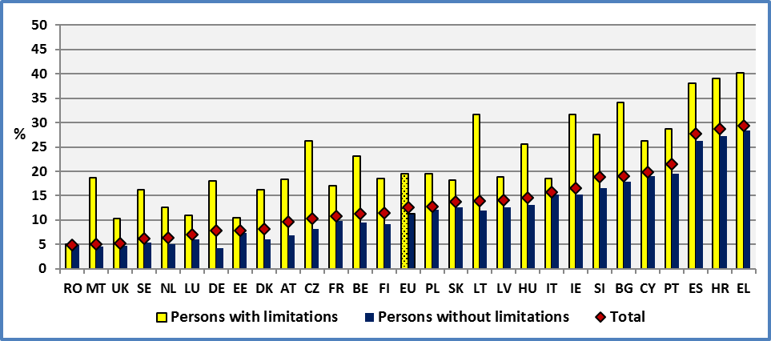

**Data source:** EU-SILC UDB 2014

At the EU level, there is un unemployment gap 8.3 percentage points (7.1% percentage points in 2013).

Between 2012 and 2014, the difference between people with and without disabilities is steadily increasing in a certain number of countries. The disadvantage of persons with limitations is continuously increasing in nine Member States. On the other hand, this difference is continuously decreasing in two Member States (Austria and Slovenia). In this case, the relative position of persons with disabilities is improving. In the remaining Member States, the difference is fluctuating and no clear trend can be observed.

**Figure 30: Disadvantage of people with disabilities concerning unemployment. Age: 20-64, 2012-2014**

Disadvantage = (Unemployment rate of people with disabilities) – (unemployment rate of people without disabilities)

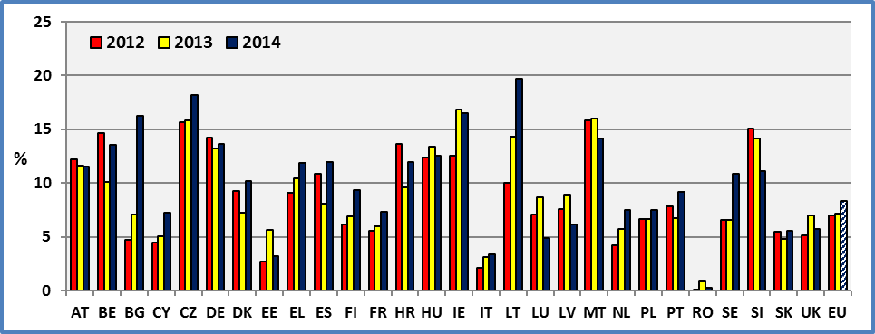

**Data source:** EU-SILC

2.3 Gender

First, we compare men and women with disabilities. This is the gender gap among persons with disabilities. At the EU level, the unemployment rate of women with disabilities is 18.9% and of men with disabilities 20.3%. One might expect an inverse relation, disabled women having a higher unemployment rate compared to men with disabilities. But a certain number of factors might explain this result. First, a discouragement effect (due to low chances to find a job) might push unemployed women out of the labour force. Secondly, young girls with disabilities have lower early school drops. Finally, the traditional distribution of role pushing disabled women into inactivity (fulfilling domestic tasks and care responsibilities) might also be a factor.

The unemployment rate of women with disabilities is low in Malta, Romania, Estonia and the United Kingdom. On the contrary, it is high in Spain, Croatia and Greece.

The disability related gaps compare the unemployment rates of persons with and without disabilities for a specific gender. So, at the EU level, 18.9% women with disabilities are unemployed, compared to 11.2% of women without disabilities. The resulting disability gap among women is 7.6 percentage points. This gap is reversed in Romania and small in Malta, Estonia and Luxembourg. On the contrary, it is high in Ireland, the Czech Republic and Lithuania.

The respective disability related gap for men is 9 percentage points. In fact, the unemployment rate among men with disabilities is 20.3% and this rate among unemployed men without disabilities 11.3%.

We may note that the disability gap (8.3 pp) (difference between persons with and without disabilities) is much bigger than the gender gap (-1.4 pp) (difference between men and women with disabilities).

**Figure 31: Unemployment rate by disability status and Member State (age 20-64), 2014**

Unemployed persons as a percentage of the labour force (same sex and age).

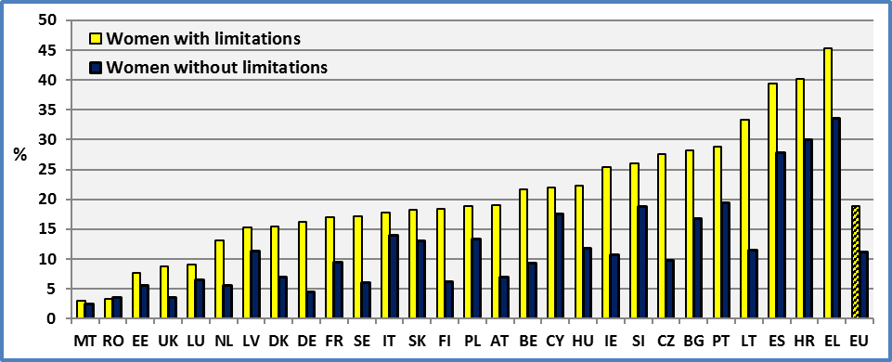

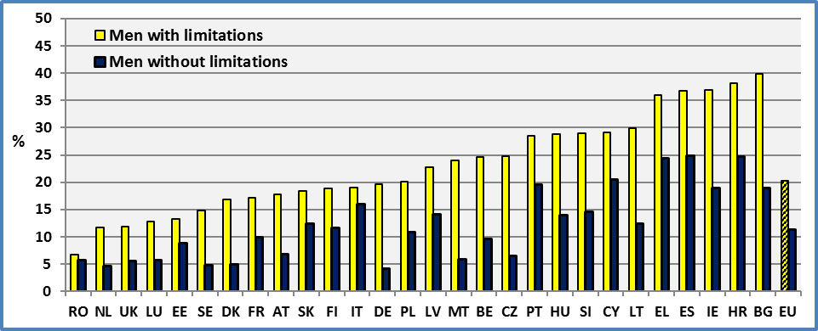

**Data source:** EU-SILC UDB 2013

2.4 Age

At the European level, when we compare the evolution of unemployment rates across the life cycle, we observe similar paths for people with and without disabilities. However, the unemployment rate of persons with disabilities is higher compared to persons without disabilities, at all stages of the life cycle. The shape of unemployment during the life cycle is very similar across Member States.

At the EU level, we may note that the unemployment rate is decreasing for both groups till the age of 45-54 and increases latter. Also, we may note that the difference (disability gap) between the unemployment rate of people with and without disabilities varies with age. In 2014, we observe an initial disadvantage of 8.6 percentage points which decreases to 7.1 for the age group 25-34 but increases latter. It reaches 11.1 percentage points for the age group 55-64. During these last years, we observe an increase of the disability gap at the end of the life cycle which might stem from the following factors:

* An initial disadvantage leads to unemployment and lack of experience which further increases the initial disadvantage of persons with disabilities;
* An initial activity limitation might deteriorate through time increasing the initial health disadvantage. This deterioration might be the result of the initial unemployment situation (poverty, risky living styles, etc.).

This indicates that priority might be given to decrease unemployment at an early stage of life.

**Figure 32: Unemployment rate by disability status and age group, 2014**

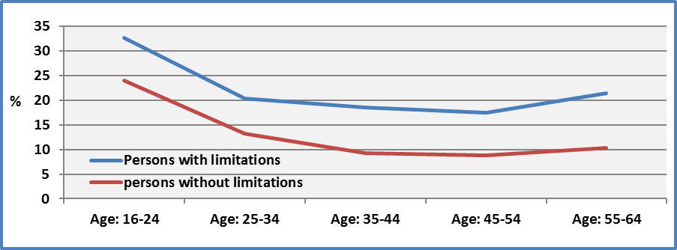

**Data source:** EU-SILC 2014

Concerning gender differences, at the EU level, the evolution is identical for men and women with disabilities. Unlike previous years, there is no difference between young disabled girls and boys.

Concerning the age group 55-64, the disincentive effect pushing them out of the labour market described above, might explain why women experience a lower unemployment rate.

**Figure 33: Unemployment rate by gender and age group of persons with disabilities, 2014**

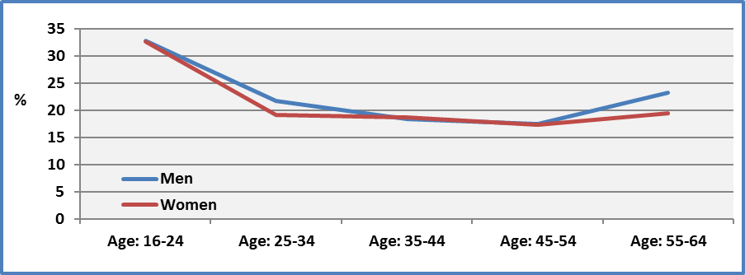

**Data source:** EU-SILC UDB 2014

2.5 Degree of disability

The degree of disability is a significant factor affecting unemployment rate. The degree of disability increases unemployment rate. Persons with a severe disability experience an unemployment rate of 29.8%, persons with a moderate disability 17.3% and persons without disabilities 11.3%. The unemployment rate of persons with severe disabilities is high notably in Lithuania, Bulgaria and Greece.

The unemployment gap between persons with severe disabilities and persons without disabilities is absent from the Netherlands and small in Estonia, Romania and Latvia. This gap is high notably in Hungary, Lithuania and Austria.

A cross-country analysis indicates that the unemployment rate of moderately disabled is closely related to the unemployment rate of non-disabled (R²=0.76; n=28). The relation between unemployment rate of severe disabled is also correlated with the unemployment rate of non-disabled but with a looser link (R²=0.36, n=28).

**Figure 34: Unemployment rate by degree of disability and Member State (age 20-64), 2014**

Unemployed persons as a percentage of the labour force (same age).

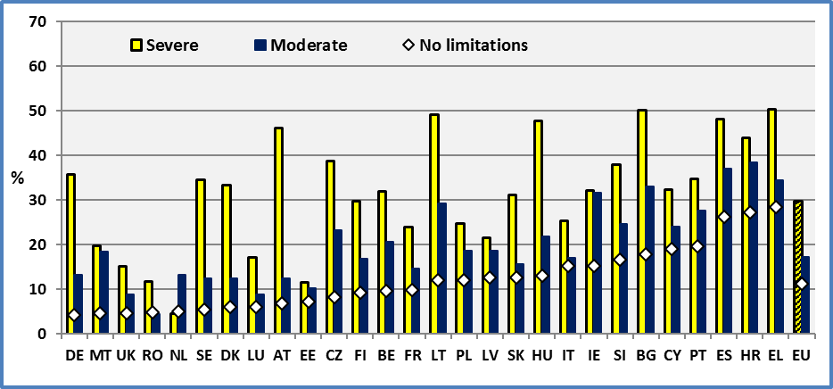

**Data source:** EU-SILC UDB 2014

2.6 Unemployment and education level

As noted in the discussion of employment, human capital enhances employment prospects and the probability to find a job. Consequently, the unemployment rate is inversely related to the educational attainment both for persons with and without disabilities. Furthermore, the educational level decreases the difference between persons with and without disabilities. At the lowest education level of persons with no education (Pre-primary), the unemployment rates are 42.5% for persons with disabilities and 28.9% for persons without disabilities. We observe a difference of 13.6 percentage points. At the highest education level of persons with a tertiary education, the respective employment rates are 10.1% and 6.4%. This represents a gap of 3.7 percentage points. Consequently, education not only increases employment opportunities but also reduces any discrimination gap.

Education will be discussed further below.

**Figure 35: Unemployment rate by disability status and education level. EU, age 20-64, 2014**

Unemployed persons as a percentage of the labour force (same age).

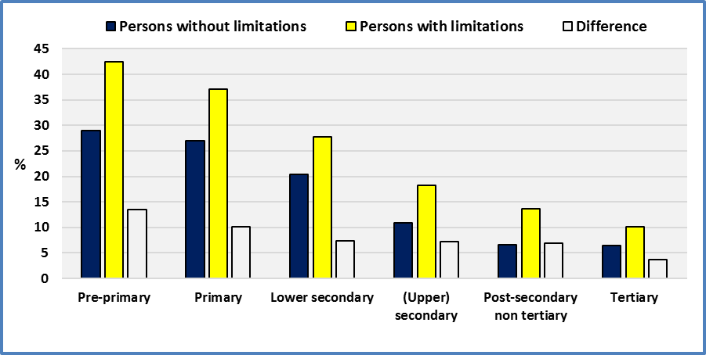

**Data source:** EU-SILC UDB 2014

2.7 Evolution at the EU level

At the EU level, we note an increase of unemployment rate for persons with disabilities and a small decrease for persons without disabilities between 2013 and 2014. More precisely, there is an increase of the unemployment rate of persons with disabilities (+1.6 percentage points) and a decrease for persons without disabilities (-0.6 pp). The total decrease is about -0.4 percentage points.

**Figure 36: Evolution of the unemployment rate of people with disabilities, EU, age: 20-64**

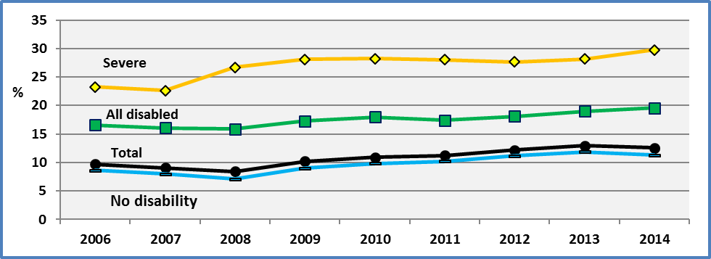

**Note:** The different years do not include all 28 Member States. However, the unemployment rates change only marginally and do not affect the conclusions.

**Data source:** EU-SILC UDB

In case of an improvement of the economic situation, we expect at an initial stage a decrease of the unemployment rate of persons without disabilities and at a later stage an improvement of the unemployment rate of persons with disabilities.

However, we ought to take into account of any age composition effects. In fact, disability prevalence increases with age and the characteristics of employed older workers might be dominant at a highly-aggregated level. Also, the presence of a group of older workers with disabilities who are protected by labour legislation and held stable jobs might dominate the sample.

First, we compare the unemployment rate by age group between 2008 and 2014. The year 2008 is the turning point of the financial crisis. The first results indicate that 2014 might be a turning point towards an improvement of the economic situation. In order to avoid any age-composition effects, we present the evolution of the unemployment rate by age group ‘and by disability status. The comparison indicates un upward movement of the unemployment curves for both groups (persons with and without disabilities). The movement is close to a parallel upward shift for all age groups except young disabled people.

**Figure 37: Comparison between 2008 and 2014 of the unemployment rate by age group, EU, age: 20-64**

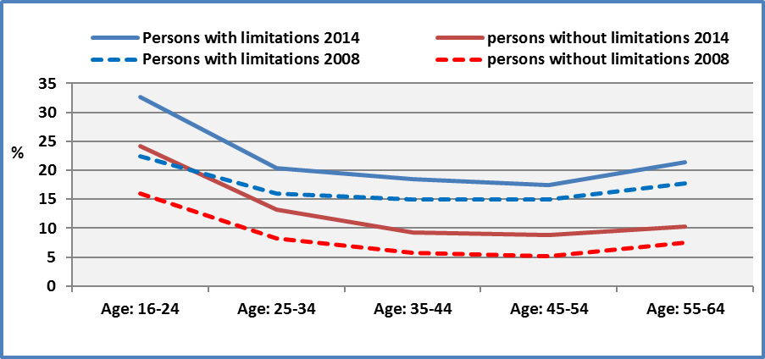

**Data source:** EU-SILC UDB

Secondly, we study the evolution of the unemployment rate of young persons with and without disabilities. In fact, younger persons with disabilities might experience much more important shocks than elderly persons with disabilities. Older workers might benefit from seniority rights, more work experience, better protection against dismissals, etc.

However, the age group 16-24 includes a limited number of observations, notably concerning persons with disabilities. For this reason, we present also for comparison the age group 25-34.

We may note that the unemployment rate of persons with disabilities aged 16-24 continued to increase in 2014 unlike the unemployment rate of persons without disabilities which experienced a decrease. On the contrary, the evolution of unemployment rate of both persons with and without disabilities aged 25-34 presented a decrease.

We may observe that for the age group 16-24, the average difference for the period 2006-2014 is about 4.4 percentage points compared to 7.8 percentage points for persons aged 25-34. We may note that at an initial stage, following the entry to the labour force, both youth with and without disabilities aged 16-24 face high unemployment rates and a relatively small gap. However, the employment search looks more successful for young persons without disabilities compared to persons without disabilities. In fact, when we pass from the age group 16-24 to 25-34, we observe an increase of the unemployment gap. This might indicate the need to take action at an early stage, notably concerning human capital (lack in education and skills), work adaptations (lack of technical aids), guidance on the labour market (lack of information concerning employment opportunities due to marginalisation and lack of social capital), etc.

**Figure 38: Evolution of the unemployment rate by disability status and age group, EU**

|  |  |
| --- | --- |
| **Persons aged 16-24** | **Persons aged 25-34** |
|  |  |
|  | |

**Note:** In 2009 a new classification of self-defined economic status was adopted.

**Data source:** EU-SILC (EU-SILC UDB Version February 2016)

2.8 Evolution at national level

The above estimations are European aggregates and national evolutions might be very different. In ten Member States, we observe a decrease of the unemployment rate of persons with disabilities. The decrease is important in Latvia (-3.2 percentage points), Ireland (-3.3 pp) and Estonia (-4.3 pp). The deterioration of unemployment is notable in Finland (+4.0 percentage points), Lithuania (+5.5 pp) and Bulgaria (+8.1 pp).

**Figure 39: Persons with disabilities; Evolution of the unemployment rate by Member State. Age 20-64**

The unemployment rate represents unemployed persons as a percentage of the labour force.

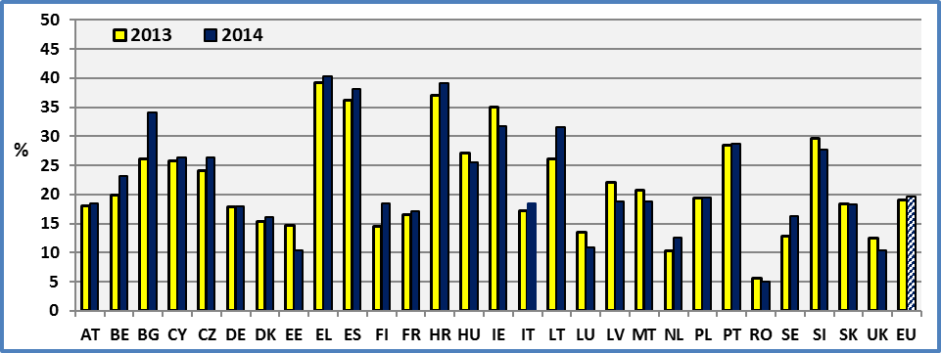

**Data source :** EU-SILC UDB 2013 & 2014

In previous reports, we have noted that cross-national changes, through time, in the unemployment rate of both groups are not correlated and when a positive correlation is present it is very weak and depends on outliers. This might indicate that disabled and not disabled are affected by different factors. Similar conclusions were reached, when we studied the evolution of employment rates.

### 3. Data

**Table 33: Unemployment rate by disability status and Member State (age 20-64)**

The unemployment rate represents unemployed persons as a percentage of the labour force.

The labour force is the total number of people employed and unemployed.

The data are not seasonally adjusted

|  |  |  |  |  |  |  |  |  |
| --- | --- | --- | --- | --- | --- | --- | --- | --- |
|  | **2008** | | | | **2009** | | | |
|  | **Men + Women** | | | | **Men + Women** | | | |
|  | **Disability** | | | **All observations** | **Disability** | | | **All observations** |
|  | **Yes** | **No** | **Total** |  | **Yes** | **No** | **Total** |  |
| **AT** | 16,4 | 4,4 | 6,6 | **6,6** | 19,2 | 6,3 | 8,5 | **8,5** |
| **BE** | 26,7 | 7,5 | 9,9 | **9,9** | 23,7 | 8,9 | 10,9 | **10,9** |
| **BG** | 27,4 | 13,8 | 14,6 | **14,6** | 22,4 | 14,4 | 14,9 | **15,0** |
| **CY** | 6,6 | 3,6 | 3,9 | **3,9** | 8,4 | 5,6 | 5,9 | **5,9** |
| **CZ** | 24,7 | 7,1 | 9,0 | **9,0** | 23,3 | 7,1 | 9,0 | **9,0** |
| **DE** | 21,3 | 6,9 | 10,5 | **10,5** | 21,1 | 7,3 | 10,3 | **10,8** |
| **DK** | 10,4 | 2,7 | 4,0 | **4,1** | 14,4 | 4,3 | 6,2 | **6,1** |
| **EE** | 9,0 | 4,5 | 5,1 | **5,1** | 15,2 | 11,8 | 12,3 | **12,3** |
| **EL** | 17,1 | 7,9 | 8,5 | **8,5** | 17,9 | 9,6 | 10,0 | **10,0** |
| **ES** | 19,3 | 10,3 | 11,3 | **11,3** | 25,8 | 17,3 | 18,4 | **18,4** |
| **FI** | 11,2 | 6,7 | 7,5 | **7,9** | 14,8 | 7,6 | 9,1 | **9,4** |
| **FR** |  |  |  |  | 16,6 | 9,3 | 10,3 | **10,3** |
| **HU** | 20,0 | 9,9 | 11,2 | **11,2** | 19,8 | 9,7 | 11,0 | **10,9** |
| **IE** | 20,2 | 9,9 | 10,9 | **10,9** | 26,4 | 15,3 | 16,3 | **16,3** |
| **IT** | 11,1 | 8,9 | 9,2 | **9,2** | 13,9 | 10,6 | 11,0 | **11,0** |
| **LT** | 13,5 | 6,4 | 7,1 | **7,1** | 17,0 | 14,5 | 14,7 | **14,9** |
| **LU** | 10,8 | 3,5 | 4,5 | **4,5** | 13,4 | 6,4 | 7,4 | **7,4** |
| **LV** | 14,0 | 7,6 | 8,9 | **8,9** | 29,4 | 20,8 | 22,3 | **22,3** |
| **MT** |  |  |  |  | 17,6 | 6,1 | 6,6 | **6,6** |
| **NL** | 4,5 | 1,1 | 1,7 | **1,7** | 5,0 | 1,9 | 2,5 | **2,5** |
| **PL** | 15,3 | 8,9 | 9,4 | **9,4** | 13,9 | 8,4 | 8,9 | **8,9** |
| **PT** | 12,3 | 8,6 | 9,2 | **9,2** | 19,4 | 12,5 | 13,6 | **13,7** |
| **RO** | 5,9 | 4,8 | 4,9 | **4,9** | 7,6 | 4,7 | 4,9 | **4,9** |
| **SE** | 9,7 | 4,4 | 5,0 | **5,1** | 11,0 | 6,2 | 6,6 | **6,7** |
| **SI** | 22,3 | 8,7 | 11,2 | **11,0** | 21,0 | 9,0 | 11,3 | **12,0** |
| **SK** | 9,5 | 6,6 | 7,2 | **7,2** | 11,4 | 8,9 | 9,4 | **9,5** |
| **UK** | 7,4 | 3,2 | 3,6 | **3,6** | 8,5 | 5,3 | 5,6 | **5,6** |
|  |  |  |  |  |  |  |  |  |
| **EU** | 15,9 | 7,1 | 8,4 | **8,4** | 17,3 | 9,0 | 10,2 | **10,2** |

**Data source:** EU-SILC UDB 2008 & 2009

**All:** It includes observations for which we do not dispose information on disability status.

**Table 34: Unemployment rate by disability status and Member State (age 20-64)**

The unemployment rate represents unemployed persons as a percentage of the labour force.

The labour force is the total number of people employed and unemployed.

The data are not seasonally adjusted

|  |  |  |  |  |  |  |  |  |
| --- | --- | --- | --- | --- | --- | --- | --- | --- |
|  | **2010** | | | | **2011** | | | |
|  | **Men + Women** | | | | **Men + Women** | | | |
|  | **Disability** | | | **All observations** | **Disability** | | | **All observations** |
|  | **Yes** | **No** | **Total** |  | **Yes** | **No** | **Total** |  |
| **AT** | 18,0 | 5,7 | 7,9 | **7,9** | 19,5 | 6,3 | 8,8 | **8,7** |
| **BE** | 22,0 | 9,7 | 11,2 | **11,2** | 26,0 | 9,1 | 11,2 | **11,2** |
| **BG** | 30,3 | 15,7 | 16,5 | **16,5** | 29,4 | 17,2 | 18,0 | **18,0** |
| **CY** |  |  |  |  | 10,8 | 8,8 | 9,1 | **9,1** |
| **CZ** | 24,5 | 9,0 | 10,7 | **10,4** | 21,4 | 8,9 | 10,3 | **9,9** |
| **DE** | 20,2 | 6,9 | 9,7 | **10,2** | 18,4 | 5,4 | 8,2 | **8,6** |
| **DK** | 20,4 | 6,3 | 9,2 | **8,6** | 14,6 | 6,9 | 8,4 | **8,2** |
| **EE** | 21,2 | 16,8 | 17,5 | **17,5** | 18,6 | 11,1 | 12,4 | **12,4** |
| **EL** | 19,0 | 12,4 | 12,7 | **12,7** | 32,6 | 24,0 | 24,6 | **24,6** |
| **ES** | 27,3 | 20,0 | 20,8 | **20,8** | 31,0 | 20,9 | 21,9 | **21,9** |
| **FI** | 16,0 | 10,9 | 12,0 | **12,1** | 16,6 | 9,1 | 10,7 | **11,0** |
| **FR** | 17,2 | 9,9 | 11,0 | **11,0** | 15,1 | 9,1 | 9,9 | **9,9** |
| **HR** |  |  |  |  | 49,0 | 26,8 | 29,7 | **27,8** |
| **HU** | 19,7 | 12,6 | 13,5 | **13,5** | 24,2 | 13,8 | 15,1 | **15,1** |
| **IE** |  |  |  |  |  |  |  |  |
| **IT** | 15,0 | 10,7 | 11,1 | **11,1** | 16,4 | 12,3 | 12,8 | **12,8** |
| **LT** | 19,5 | 19,2 | 19,3 | **19,4** | 26,1 | 16,6 | 17,3 | **17,4** |
| **LU** | 14,8 | 5,1 | 6,4 | **6,4** | 16,8 | 5,7 | 7,1 | **7,1** |
| **LV** | 33,1 | 22,3 | 24,1 | **24,0** | 29,1 | 19,6 | 21,2 | **21,2** |
| **MT** | 26,7 | 5,5 | 6,4 | **6,4** | 13,2 | 5,2 | 5,5 | **5,5** |
| **NL** | 7,7 | 2,8 | 3,6 | **3,7** | 6,6 | 2,9 | 3,5 | **3,7** |
| **PL** | 16,4 | 10,0 | 10,7 | **10,7** | 15,2 | 11,2 | 11,6 | **11,6** |
| **PT** | 25,8 | 12,8 | 14,9 | **14,9** | 23,9 | 13,1 | 14,8 | **14,8** |
| **RO** | 6,3 | 5,5 | 5,6 | **5,6** | 4,9 | 5,4 | 5,3 | **5,3** |
| **SE** | 11,3 | 5,1 | 5,7 | **6,1** | 14,2 | 5,3 | 6,2 | **6,0** |
| **SI** | 23,3 | 10,7 | 14,0 | **14,1** | 23,5 | 12,3 | 15,2 | **15,6** |
| **SK** | 17,3 | 12,9 | 13,8 | **13,8** | 17,3 | 12,8 | 13,7 | **13,8** |
| **UK** | 10,1 | 4,7 | 5,2 | **5,4** | 10,1 | 5,1 | 5,7 | **5,8** |
|  |  |  |  |  |  |  |  |  |
| **EU** | 18,0 | 9,8 | 10,9 | **10,9** | 17,4 | 10,2 | 11,2 | **11,3** |

**Data source:** EU-SILC UDB 2010 & 2011

**All:** It includes observations for which we do not dispose information on disability status.

**Table 35: Unemployment rate by disability status and Member State (age 20-64)**

The unemployment rate represents unemployed persons as a percentage of the labour force.

The labour force is the total number of people employed and unemployed.

The data are not seasonally adjusted

|  |  |  |  |  |  |  |  |  |
| --- | --- | --- | --- | --- | --- | --- | --- | --- |
|  | **2012** | | | | **2013** | | | |
|  | **Men + Women** | | | | **Men + Women** | | | |
|  | **Disability** | | | **All observations** | **Disability** | | | **All observations** |
|  | **Yes** | **No** | **Total** |  | **Yes** | **No** | **Total** |  |
| **AT** | 17,7 | 5,5 | **7,6** | 7,6 | 18,1 | 6,4 | **8,7** | 8,7 |
| **BE** | 23,8 | 9,1 | **10,7** | 10,7 | 19,9 | 9,7 | **11,1** | 11,1 |
| **BG** | 23,2 | 18,4 | **18,8** | 18,8 | 26,1 | 19,0 | **19,5** | 19,5 |
| **CY** | 18,0 | 13,6 | **14,1** | 14,0 | 25,7 | 20,7 | **21,3** | 21,2 |
| **CZ** | 23,6 | 8,0 | **9,8** | 9,5 | 24,2 | 8,4 | **10,2** | 10,3 |
| **DE** | 19,0 | 4,7 | **8,1** | 8,4 | 17,8 | 4,6 | **7,8** | 8,2 |
| **DK** | 17,1 | 7,9 | **9,8** | 9,7 | 15,4 | 7,6 | **9,2** | 9,8 |
| **EE** | 12,6 | 9,9 | **10,4** | 10,4 | 14,7 | 9,0 | **10,1** | 10,1 |
| **EL** | 34,1 | 25,0 | **25,8** | 25,8 | 39,2 | 28,7 | **29,5** | 29,5 |
| **ES** | 37,3 | 26,4 | **27,5** | 27,5 | 36,1 | 28,0 | **29,1** | 29,1 |
| **FI** | 14,1 | 8,0 | **9,5** | 10,3 | 14,5 | 7,6 | **9,9** | 10,8 |
| **FR** | 15,0 | 9,5 | **10,3** | 10,3 | 16,6 | 10,5 | **11,5** | 11,5 |
| **HR** | 40,1 | 26,5 | **27,6** | 27,7 | 37,1 | 27,5 | **28,7** | 28,8 |
| **HU** | 26,1 | 13,7 | **15,0** | 15,0 | 27,1 | 13,7 | **15,3** | 15,3 |
| **IE** | 32,0 | 19,4 | **20,4** | 20,4 | 35,1 | 18,2 | **19,5** | 19,5 |
| **IT** | 15,6 | 13,6 | **13,9** | 13,9 | 17,3 | 14,1 | **14,7** | 14,6 |
| **LT** | 25,1 | 15,1 | **15,9** | 16,0 | 26,2 | 11,9 | **13,1** | 13,0 |
| **LU** | 13,1 | 6,1 | **7,1** | 7,1 | 13,5 | 4,8 | **6,3** | 6,3 |
| **LV** | 25,2 | 17,6 | **18,8** | 18,8 | 22,1 | 13,2 | **15,1** | 15,1 |
| **MT** | 21,0 | 5,2 | **5,6** | 5,6 | 20,7 | 4,7 | **5,3** | 5,3 |
| **NL** | 7,6 | 3,4 | **4,2** | 4,1 | 10,3 | 4,6 | **5,7** | 5,7 |
| **PL** | 18,4 | 11,7 | **12,4** | 12,4 | 19,5 | 12,8 | **13,5** | 13,5 |
| **PT** | 27,0 | 19,1 | **20,1** | 20,1 | 28,4 | 21,7 | **22,6** | 22,6 |
| **RO** | 4,9 | 4,8 | **4,8** | 4,8 | 5,6 | 4,7 | **4,8** | 4,8 |
| **SE** | 11,7 | 5,1 | **5,8** | 6,2 | 12,8 | 6,2 | **7,2** | 7,2 |
| **SI** | 28,6 | 13,6 | **17,2** | 17,2 | 29,6 | 15,4 | **18,2** | 18,3 |
| **SK** | 18,1 | 12,6 | **13,7** | 13,7 | 18,4 | 13,7 | **14,6** | 14,6 |
| **UK** | 10,5 | 5,4 | **5,9** | 5,9 | 12,5 | 5,5 | **6,2** | 6,2 |
|  |  |  |  |  |  |  |  |  |
| **EU** | **18,1** | **11,2** | **12,2** | **12,2** | **19,0** | **11,8** | **12,9** | **13,0** |
|  |  |  |  |  |  |  |  |  |
| **CH** | 5,5 | 3,1 | **3,4** | 3,4 | 4,3 | 3,0 | **3,3** | 3,3 |
| **IS** | 10,0 | 6,0 | **6,4** | 6,7 | 8,0 | 5,4 | **5,6** | 5,5 |
| **NO** | 8,8 | 2,7 | **3,2** | 3,4 | 6,0 | 2,7 | **3,0** | 3,4 |
| **RS** |  |  |  |  | 47,1 | 31,3 | **32,5** | 31,2 |

**Data source:** EU-SILC UDB 2012 & 2013

**Table 36: Unemployment rate by disability status and Member State (age 20-64)**

The unemployment rate represents unemployed persons as a percentage of the labour force.

The labour force is the total number of people employed and unemployed.

The data are not seasonally adjusted

|  |  |  |  |  |
| --- | --- | --- | --- | --- |
|  | **2014** | | | |
|  | **Men + Women** | | | |
|  | **Disability** | | | **All observations** |
|  | **Yes** | **No** | **Total** |  |
| **AT** | 18,4 | 6,9 | **9,7** | 9,7 |
| **BE** | 23,1 | 9,5 | **11,3** | 11,3 |
| **BG** | 34,2 | 17,9 | **19,0** | 19,0 |
| **CY** | 26,3 | 19,1 | **19,8** | 19,8 |
| **CZ** | 26,3 | 8,2 | **10,2** | 10,1 |
| **DE** | 18,0 | 4,3 | **7,8** | 8,3 |
| **DK** | 16,2 | 6,0 | **8,1** | 8,8 |
| **EE** | 10,5 | 7,3 | **7,9** | 7,9 |
| **EL** | 40,2 | 28,4 | **29,3** | 29,3 |
| **ES** | 38,1 | 26,2 | **27,7** | 27,7 |
| **FI** | 18,6 | 9,2 | **11,4** | 11,8 |
| **FR** | 17,1 | 9,8 | **10,9** | 10,9 |
| **HR** | 39,1 | 27,2 | **28,6** | 28,7 |
| **HU** | 25,6 | 13,0 | **14,5** | 14,5 |
| **IE** | 31,7 | 15,2 | **16,6** | 16,6 |
| **IT** | 18,5 | 15,2 | **15,7** | 15,7 |
| **LT** | 31,7 | 12,0 | **14,0** | 13,9 |
| **LU** | 11,0 | 6,1 | **7,0** | 7,0 |
| **LV** | 18,9 | 12,7 | **14,1** | 14,1 |
| **MT** | 18,7 | 4,6 | **5,0** | 5,0 |
| **NL** | 12,5 | 5,0 | **6,3** | 6,8 |
| **PL** | 19,5 | 12,0 | **12,8** | 12,8 |
| **PT** | 28,8 | 19,5 | **21,5** | 21,5 |
| **RO** | 5,1 | 4,8 | **4,8** | 4,8 |
| **SE** | 16,3 | 5,4 | **6,2** | 6,4 |
| **SI** | 27,6 | 16,5 | **18,8** | 18,7 |
| **SK** | 18,3 | 12,7 | **13,7** | 13,8 |
| **UK** | 10,4 | 4,6 | **5,3** | 5,3 |
|  |  |  |  |  |
| **EU** | **19,6** | **11,3** | **12,6** | **12,7** |
|  |  |  |  |  |
| **CH** | 5,0 | 3,6 | **3,9** | 3,9 |
| **IS** | 7,1 | 4,5 | **4,8** | 4,4 |
| **NO** | 5,9 | 2,4 | **2,7** | 3,1 |
| **RS** | 48,6 | 34,8 | **35,8** | 35,8 |

**Data source:** EU-SILC UDB 2014

**Table 37: Unemployment rate by disability status, gender and Member State (age 20-64)**

The unemployment rate represents unemployed persons as a percentage of the labour force.

The labour force is the total number of people employed and unemployed.

The data are not seasonally adjusted

|  |  |  |  |  |  |  |  |  |  |  |  |  |
| --- | --- | --- | --- | --- | --- | --- | --- | --- | --- | --- | --- | --- |
|  | **2008** | | | | | | **2009** | | | | | |
|  | **Females** | | | **Males** | | | **Females** | | | **Males** | | |
|  | **Disability** | | | **Disability** | | | **Disability** | | | **Disability** | | |
|  | **Yes** | **No** | **Total** | **Yes** | **No** | **Total** | **Yes** | **No** | **Total** | **Yes** | **No** | **Total** |
| **AT** | 15,5 | 4,8 | **6,8** | 17,1 | 4,1 | **6,5** | 19,7 | 5,5 | **8,1** | 18,8 | 6,9 | **8,9** |
| **BE** | 30,0 | 9,3 | **12,1** | 23,6 | 6,0 | **8,1** | 22,8 | 10,6 | **12,4** | 24,7 | 7,5 | **9,6** |
| **BG** | 33,2 | 15,7 | **16,9** | 21,7 | 12,0 | **12,6** | 21,3 | 15,9 | **16,3** | 23,4 | 13,1 | **13,8** |
| **CY** | 8,0 | 4,5 | **4,8** | 5,7 | 2,9 | **3,2** | 6,3 | 5,2 | **5,3** | 10,0 | 5,8 | **6,3** |
| **CZ** | 28,4 | 9,0 | **11,3** | 20,9 | 5,4 | **7,3** | 28,4 | 8,7 | **11,1** | 18,3 | 5,6 | **7,0** |
| **DE** | 20,8 | 7,3 | **10,8** | 21,8 | 6,5 | **10,2** | 20,1 | 7,6 | **10,4** | 22,1 | 7,0 | **10,3** |
| **DK** | 13,7 | 3,1 | **5,1** | 6,7 | 2,3 | **3,0** | 11,3 | 3,9 | **5,4** | 18,0 | 4,6 | **7,0** |
| **EE** | 3,2 | 2,6 | **2,6** | 14,4 | 6,3 | **7,5** | 9,3 | 7,2 | **7,5** | 21,2 | 16,2 | **17,0** |
| **EL** | 18,5 | 10,9 | **11,4** | 16,0 | 5,7 | **6,4** | 21,2 | 12,2 | **12,6** | 15,1 | 7,7 | **8,0** |
| **ES** | 20,8 | 11,8 | **12,9** | 18,0 | 9,1 | **10,0** | 27,5 | 18,3 | **19,6** | 24,4 | 16,5 | **17,5** |
| **FI** | 10,0 | 6,4 | **7,1** | 12,5 | 7,0 | **7,9** | 14,7 | 6,2 | **8,1** | 14,9 | 8,8 | **10,0** |
| **FR** |  |  |  |  |  |  | 16,3 | 9,4 | **10,4** | 17,0 | 9,2 | **10,1** |
| **HU** | 20,6 | 10,0 | **11,4** | 19,5 | 9,8 | **11,0** | 19,0 | 9,8 | **11,1** | 20,7 | 9,7 | **11,0** |
| **IE** | 11,4 | 6,2 | **6,6** | 25,9 | 12,8 | **14,1** | 15,9 | 9,5 | **10,0** | 33,5 | 19,6 | **20,9** |
| **IT** | 11,2 | 10,9 | **11,0** | 11,0 | 7,6 | **8,0** | 15,6 | 12,8 | **13,1** | 12,4 | 9,1 | **9,5** |
| **LT** | 13,4 | 5,1 | **6,0** | 13,5 | 7,7 | **8,2** | 12,9 | 11,8 | **11,9** | 23,2 | 17,2 | **17,6** |
| **LU** | 8,8 | 3,8 | **4,5** | 12,6 | 3,3 | **4,5** | 14,4 | 8,6 | **9,5** | 12,6 | 4,8 | **5,8** |
| **LV** | 11,2 | 5,8 | **6,9** | 17,0 | 9,2 | **10,7** | 23,3 | 16,3 | **17,6** | 35,8 | 25,2 | **27,0** |
| **MT** |  |  |  |  |  |  | 14,1 | 6,2 | **6,5** | 19,2 | 6,0 | **6,7** |
| **NL** | 4,2 | 1,1 | **1,7** | 4,7 | 1,1 | **1,6** | 4,0 | 1,6 | **2,1** | 6,1 | 2,2 | **2,8** |
| **PL** | 16,3 | 11,3 | **11,7** | 14,6 | 6,9 | **7,5** | 15,4 | 9,0 | **9,5** | 12,6 | 7,9 | **8,4** |
| **PT** | 11,5 | 10,1 | **10,4** | 13,2 | 7,3 | **8,1** | 18,2 | 14,1 | **14,9** | 20,9 | 11,1 | **12,5** |
| **RO** | 2,9 | 3,2 | **3,2** | 8,7 | 5,9 | **6,1** | 2,9 | 3,6 | **3,5** | 12,2 | 5,5 | **5,9** |
| **SE** | 9,3 | 4,3 | **4,9** | 10,2 | 4,6 | **5,1** | 10,2 | 5,4 | **5,9** | 12,2 | 7,0 | **7,3** |
| **SI** | 22,9 | 10,5 | **12,8** | 21,9 | 7,1 | **9,8** | 24,0 | 9,5 | **12,4** | 18,1 | 8,6 | **10,3** |
| **SK** | 10,8 | 8,2 | **8,7** | 8,1 | 5,2 | **5,9** | 9,7 | 9,6 | **9,6** | 13,1 | 8,4 | **9,3** |
| **UK** | 6,2 | 2,1 | **2,6** | 8,7 | 4,2 | **4,6** | 4,8 | 3,5 | **3,7** | 12,1 | 6,7 | **7,3** |
|  |  |  |  |  |  |  |  |  |  |  |  |  |
| **EU** | 15,6 | 7,7 | **9,0** | 16,2 | 6,6 | **7,9** | 16,6 | 9,1 | **10,2** | 18,0 | 8,9 | **10,1** |

**Data source:** EU-SILC UDB 2008 & 2009

**Table 38: Unemployment rate by disability status, gender and Member State (age 20-64)**

The unemployment rate represents unemployed persons as a percentage of the labour force.

The labour force is the total number of people employed and unemployed.

The data are not seasonally adjusted

|  |  |  |  |  |  |  |  |  |  |  |  |  |
| --- | --- | --- | --- | --- | --- | --- | --- | --- | --- | --- | --- | --- |
|  | **2010** | | | | | | **2011** | | | | | |
|  | **Females** | | | **Males** | | | **Females** | | | **Males** | | |
|  | **Disability** | | | **Disability** | | | **Disability** | | | **Disability** | | |
|  | **Yes** | **No** | **Total** | **Yes** | **No** | **Total** | **Yes** | **No** | **Total** | **Yes** | **No** | **Total** |
| **AT** | 19,7 | 5,0 | **7,7** | 16,6 | 6,3 | **8,2** | 17,3 | 5,6 | **8,0** | 21,5 | 6,8 | **9,4** |
| **BE** | 21,0 | 10,3 | **11,8** | 23,1 | 9,1 | **10,6** | 26,1 | 9,7 | **12,0** | 26,0 | 8,5 | **10,4** |
| **BG** | 32,8 | 16,0 | **17,0** | 27,9 | 15,5 | **16,1** | 35,1 | 15,5 | **16,9** | 24,1 | 18,7 | **19,0** |
| **CY** |  |  |  |  |  |  | 10,0 | 8,6 | **8,8** | 11,5 | 9,0 | **9,3** |
| **CZ** | 25,7 | 10,4 | **12,1** | 23,2 | 7,6 | **9,2** | 20,9 | 10,4 | **11,7** | 22,0 | 7,3 | **8,8** |
| **DE** | 19,0 | 7,2 | **9,8** | 21,4 | 6,6 | **10,0** | 16,9 | 6,0 | **8,5** | 20,0 | 4,8 | **8,0** |
| **DK** | 23,1 | 5,8 | **8,8** | 22,8 | 8,8 | **8,9** | 14,6 | 7,1 | **8,8** | 14,6 | 6,6 | **8,0** |
| **EE** | 14,6 | 13,4 | **13,6** | 27,7 | 20,1 | **21,3** | 16,8 | 8,4 | **9,9** | 20,8 | 13,9 | **14,9** |
| **EL** | 23,9 | 12,9 | **13,5** | 14,8 | 12,0 | **12,1** | 37,5 | 26,1 | **26,8** | 29,0 | 22,5 | **22,9** |
| **ES** | 30,2 | 21,5 | **22,6** | 24,3 | 18,8 | **19,4** | 33,4 | 21,5 | **22,8** | 28,6 | 20,5 | **21,1** |
| **FI** | 15,1 | 9,7 | **10,5** | 23,4 | 13,0 | **13,7** | 14,3 | 7,7 | **9,3** | 18,9 | 10,3 | **11,9** |
| **FR** | 18,0 | 9,4 | **10,8** | 16,5 | 10,3 | **11,2** | 15,2 | 9,4 | **10,3** | 14,9 | 8,7 | **9,6** |
| **HR** |  |  |  |  |  |  | 49,6 | 29,3 | **31,8** | 48,4 | 23,5 | **27,2** |
| **HU** | 17,3 | 11,9 | **12,7** | 22,1 | 13,1 | **14,1** | 23,8 | 12,9 | **14,4** | 24,7 | 14,5 | **15,6** |
| **IE** |  |  |  |  |  |  |  |  |  |  |  |  |
| **IT** | 14,6 | 12,7 | **12,8** | 15,3 | 9,4 | **9,9** | 15,0 | 13,2 | **13,4** | 17,4 | 11,7 | **12,4** |
| **LT** | 15,4 | 15,0 | **15,0** | 24,3 | 23,6 | **23,8** | 23,5 | 14,7 | **15,5** | 29,2 | 18,4 | **19,2** |
| **LU** | 14,1 | 5,1 | **6,4** | 15,4 | 5,0 | **6,4** | 14,8 | 6,2 | **7,3** | 18,4 | 5,3 | **7,0** |
| **LV** | 27,7 | 19,1 | **20,6** | 39,1 | 25,4 | **27,5** | 23,7 | 16,3 | **17,6** | 35,1 | 22,7 | **24,7** |
| **MT** | 20,6 | 3,4 | **4,2** | 30,1 | 6,6 | **7,6** | 14,3 | 3,6 | **3,9** | 12,8 | 6,1 | **6,4** |
| **NL** | 12,0 | 2,3 | **3,7** | 7,3 | 3,4 | **3,9** | 5,8 | 2,2 | **2,9** | 7,8 | 3,4 | **4,0** |
| **PL** | 16,4 | 10,5 | **11,1** | 16,5 | 9,5 | **10,3** | 16,2 | 12,7 | **13,0** | 14,4 | 9,9 | **10,4** |
| **PT** | 25,3 | 14,5 | **16,5** | 26,5 | 11,3 | **13,4** | 25,4 | 15,1 | **16,9** | 21,9 | 11,5 | **12,8** |
| **RO** | 4,0 | 4,6 | **4,6** | 8,6 | 6,1 | **6,3** | 3,4 | 4,2 | **4,1** | 6,3 | 6,2 | **6,2** |
| **SE** | 11,7 | 5,4 | **5,5** | 12,4 | 6,1 | **6,1** | 13,5 | 4,9 | **6,1** | 15,2 | 5,5 | **6,3** |
| **SI** | 26,4 | 11,3 | **14,8** | 25,3 | 9,9 | **13,5** | 23,3 | 13,0 | **15,8** | 23,6 | 11,7 | **14,6** |
| **SK** | 15,4 | 13,4 | **13,9** | 19,2 | 12,4 | **13,8** | 17,4 | 12,8 | **13,9** | 17,1 | 12,8 | **13,6** |
| **UK** | 6,2 | 3,4 | **3,7** | 14,2 | 5,8 | **6,7** | 8,4 | 3,9 | **4,5** | 12,0 | 6,1 | **6,7** |
|  |  |  |  |  |  |  |  |  |  |  |  |  |
| **EU** | 17,8 | 10,1 | **11,2** | 18,8 | 9,8 | **10,9** | 16,7 | 10,3 | **11,3** | 18,1 | 10,0 | **11,1** |

**Data source:** EU-SILC UDB 2010 & 2011

**Table 39: Unemployment rate by disability status, gender and Member State (age 20-64)**

The unemployment rate represents unemployed persons as a percentage of the labour force.

The labour force is the total number of people employed and unemployed.

The data are not seasonally adjusted

|  |  |  |  |  |  |  |  |  |  |  |  |  |
| --- | --- | --- | --- | --- | --- | --- | --- | --- | --- | --- | --- | --- |
|  | **2012** | | | | | | **2013** | | | | | |
|  | **Females** | | | **Males** | | | **Females** | | | **Males** | | |
|  | **Disability** | | | **Disability** | | | **Disability** | | | **Disability** | | |
|  | **Yes** | **No** | **Total** | **Yes** | **No** | **Total** | **Yes** | **No** | **Total** | **Yes** | **No** | **Total** |
| **AT** | 17,1 | 5,9 | **7,9** | 18,1 | 5,1 | **7,4** | 17,1 | 6,5 | **8,7** | 19,0 | 6,3 | **8,7** |
| **BE** | 26,5 | 8,3 | **10,4** | 21,4 | 9,8 | **11,0** | 21,0 | 8,9 | **10,6** | 18,7 | 10,5 | **11,5** |
| **BG** | 24,4 | 16,5 | **17,2** | 21,9 | 20,0 | **20,2** | 25,8 | 17,4 | **18,0** | 26,3 | 20,4 | **20,8** |
| **CY** | 15,5 | 13,2 | **13,5** | 20,1 | 13,9 | **14,6** | 22,4 | 19,8 | **20,1** | 28,4 | 21,5 | **22,3** |
| **CZ** | 27,0 | 9,2 | **11,4** | 19,4 | 6,7 | **8,1** | 23,6 | 10,3 | **11,9** | 24,8 | 6,3 | **8,4** |
| **DE** | 18,6 | 4,3 | **7,8** | 19,4 | 5,1 | **8,3** | 16,6 | 4,8 | **7,9** | 19,1 | 4,5 | **7,7** |
| **DK** | 18,7 | 8,3 | **10,6** | 15,5 | 7,5 | **9,1** | 15,0 | 7,5 | **9,3** | 16,0 | 7,7 | **9,2** |
| **EE** | 10,6 | 8,9 | **9,2** | 14,8 | 11,0 | **11,6** | 11,1 | 7,8 | **8,4** | 18,7 | 10,2 | **11,7** |
| **EL** | 31,4 | 28,8 | **29,0** | 35,8 | 22,2 | **23,4** | 34,9 | 31,2 | **31,5** | 42,2 | 26,8 | **28,0** |
| **ES** | 39,0 | 27,9 | **29,0** | 35,8 | 25,3 | **26,3** | 36,2 | 29,5 | **30,4** | 36,1 | 26,9 | **28,0** |
| **FI** | 10,7 | 6,8 | **7,9** | 18,4 | 9,0 | **11,0** | 12,1 | 5,8 | **8,0** | 17,2 | 9,2 | **11,6** |
| **FR** | 15,3 | 9,9 | **10,8** | 14,6 | 9,0 | **9,8** | 16,7 | 10,4 | **11,4** | 16,4 | 10,7 | **11,5** |
| **HR** | 41,6 | 28,6 | **29,7** | 38,7 | 24,6 | **25,6** | 37,3 | 29,3 | **30,3** | 36,9 | 25,8 | **27,3** |
| **HU** | 27,0 | 13,2 | **14,8** | 25,1 | 14,2 | **15,2** | 25,4 | 13,2 | **14,7** | 28,9 | 14,2 | **15,8** |
| **IE** | 20,8 | 11,9 | **12,5** | 40,5 | 25,4 | **26,6** | 25,2 | 12,4 | **13,3** | 42,1 | 23,0 | **24,5** |
| **IT** | 15,5 | 12,3 | **12,8** | 15,8 | 14,4 | **14,6** | 15,7 | 12,2 | **12,9** | 18,5 | 15,5 | **15,9** |
| **LT** | 22,9 | 12,9 | **13,8** | 27,4 | 17,3 | **18,2** | 23,4 | 10,5 | **11,7** | 29,1 | 13,2 | **14,6** |
| **LU** | 12,6 | 5,9 | **6,9** | 13,7 | 6,2 | **7,2** | 10,4 | 4,9 | **5,9** | 16,2 | 4,7 | **6,6** |
| **LV** | 19,1 | 15,5 | **16,1** | 32,0 | 19,7 | **21,5** | 19,2 | 10,9 | **12,9** | 25,6 | 15,4 | **17,5** |
| **MT** | 19,3 | 3,3 | **3,7** | 22,0 | 6,4 | **6,8** | 13,1 | 2,9 | **3,3** | 24,4 | 5,8 | **6,5** |
| **NL** | 7,8 | 2,8 | **3,9** | 7,4 | 3,9 | **4,5** | 8,7 | 3,3 | **4,6** | 12,2 | 5,5 | **6,7** |
| **PL** | 21,1 | 13,6 | **14,3** | 16,0 | 10,1 | **10,7** | 19,3 | 14,3 | **14,8** | 19,6 | 11,5 | **12,4** |
| **PT** | 26,3 | 19,5 | **20,5** | 27,9 | 18,8 | **19,8** | 28,9 | 21,7 | **22,9** | 27,7 | 21,7 | **22,4** |
| **RO** | 3,4 | 4,0 | **3,9** | 6,3 | 5,4 | **5,4** | 2,8 | 3,7 | **3,6** | 8,4 | 5,3 | **5,6** |
| **SE** | 12,5 | 4,8 | **5,8** | 10,5 | 5,4 | **5,9** | 13,0 | 5,5 | **6,8** | 12,5 | 6,8 | **7,6** |
| **SI** | 27,8 | 15,5 | **18,7** | 29,4 | 11,9 | **15,9** | 28,5 | 15,3 | **18,0** | 30,5 | 15,5 | **18,4** |
| **SK** | 18,2 | 12,8 | **14,0** | 17,9 | 12,4 | **13,4** | 20,6 | 14,3 | **15,7** | 16,1 | 13,2 | **13,7** |
| **UK** | 8,5 | 4,4 | **4,9** | 12,6 | 6,2 | **6,8** | 9,9 | 4,0 | **4,7** | 15,2 | 6,7 | **7,5** |
|  |  |  |  |  |  |  |  |  |  |  |  |  |
| **EU** | **17,8** | **11,1** | **12,1** | **18,4** | **11,3** | **12,3** | **17,9** | **11,5** | **12,6** | **20,1** | **12,1** | **13,2** |
|  |  |  |  |  |  |  |  |  |  |  |  |  |
| **CH** |  |  |  |  |  |  | 4,4 | 2,4 | **3,0** | 4,1 | 3,4 | **3,5** |
| **IS** |  |  |  |  |  |  | 4,7 | 5,3 | **5,2** | 13,0 | 5,5 | **6,0** |
| **NO** |  |  |  |  |  |  | 4,2 | 2,8 | **3,0** | 8,2 | 2,6 | **3,0** |
| **RS** |  |  |  |  |  |  | 47,0 | 32,8 | **33,9** | 47,2 | 30,0 | **31,3** |

**Data source:** EU-SILC UDB 2012 & 2013

**Table 40: Unemployment rate by disability status, gender and Member State (age 20-64)**

The unemployment rate represents unemployed persons as a percentage of the labour force.

The labour force is the total number of people employed and unemployed.

The data are not seasonally adjusted

|  |  |  |  |  |  |  |
| --- | --- | --- | --- | --- | --- | --- |
|  | **2014** | | | | | |
|  | **Females** | | | **Males** | | |
|  | **Disability** | | | **Disability** | | |
|  | **Yes** | **No** | **Total** | **Yes** | **No** | **Total** |
| **AT** | 19,1 | 7,0 | 10,1 | 17,8 | 6,8 | 9,3 |
| **BE** | 21,7 | 9,4 | 11,1 | 24,6 | 9,7 | 11,5 |
| **BG** | 28,3 | 16,8 | 17,6 | 39,9 | 18,9 | 20,3 |
| **CY** | 22,0 | 17,6 | 17,9 | 29,2 | 20,6 | 21,6 |
| **CZ** | 27,6 | 9,8 | 12,0 | 24,7 | 6,4 | 8,4 |
| **DE** | 16,2 | 4,4 | 7,6 | 19,7 | 4,1 | 8,0 |
| **DK** | 15,5 | 7,0 | 8,8 | 16,8 | 5,0 | 7,4 |
| **EE** | 7,7 | 5,6 | 6,1 | 13,2 | 8,8 | 9,7 |
| **EL** | 45,3 | 33,6 | 34,6 | 35,9 | 24,3 | 25,2 |
| **ES** | 39,4 | 27,8 | 29,4 | 36,8 | 24,8 | 26,2 |
| **FI** | 18,3 | 6,2 | 9,4 | 18,8 | 11,7 | 13,2 |
| **FR** | 17,0 | 9,5 | 10,7 | 17,1 | 10,0 | 11,0 |
| **HR** | 40,2 | 29,9 | 31,3 | 38,1 | 24,7 | 26,3 |
| **HU** | 22,2 | 11,8 | 13,1 | 28,9 | 14,0 | 15,7 |
| **IE** | 25,5 | 10,7 | 11,9 | 37,0 | 19,0 | 20,4 |
| **IT** | 17,8 | 13,9 | 14,6 | 19,0 | 16,0 | 16,5 |
| **LT** | 33,3 | 11,5 | 13,8 | 29,9 | 12,5 | 14,2 |
| **LU** | 9,0 | 6,5 | 6,9 | 12,8 | 5,8 | 7,0 |
| **LV** | 15,3 | 11,3 | 12,2 | 22,8 | 14,1 | 16,0 |
| **MT** | 3,0 | 2,5 | 2,5 | 24,1 | 5,8 | 6,4 |
| **NL** | 13,2 | 5,5 | 7,2 | 11,7 | 4,6 | 5,6 |
| **PL** | 18,9 | 13,4 | 14,0 | 20,1 | 10,8 | 11,8 |
| **PT** | 28,9 | 19,5 | 21,8 | 28,6 | 19,6 | 21,2 |
| **RO** | 3,4 | 3,6 | 3,5 | 6,7 | 5,7 | 5,7 |
| **SE** | 17,1 | 6,1 | 7,1 | 14,9 | 4,9 | 5,4 |
| **SI** | 26,1 | 18,8 | 20,3 | 28,9 | 14,6 | 17,6 |
| **SK** | 18,2 | 13,1 | 14,1 | 18,3 | 12,4 | 13,4 |
| **UK** | 8,8 | 3,5 | 4,1 | 11,9 | 5,6 | 6,3 |
|  |  |  |  |  |  |  |
| **EU** | 18,9 | 11,2 | 12,5 | 20,3 | 11,3 | 12,6 |
|  |  |  |  |  |  |  |
| **CH** | 4,3 | 3,7 | 3,9 | 5,7 | 3,5 | 3,9 |
| **IS** | 6,6 | 3,8 | 4,2 | 7,9 | 5,0 | 5,3 |
| **NO** | 5,6 | 2,5 | 2,9 | 6,4 | 2,4 | 2,6 |
| **RS** | 46,4 | 36,1 | 36,8 | 50,3 | 33,7 | 35,0 |

**Data source:** EU-SILC UDB 2014

**Table 41: Unemployment rate by disability status, age group and Member State**

|  |  |  |  |  |  |  |  |  |  |  |  |  |
| --- | --- | --- | --- | --- | --- | --- | --- | --- | --- | --- | --- | --- |
|  | **2009** | | | | | | | | | | | |
|  | **Persons with disabilities** | | | | | | **All persons** | | | | | |
|  | **16-24\*** | **25-34** | **35-44** | **45-54** | **55-64** | **16-64** | **16-24** | **25-34** | **35-44** | **45-54** | **55-64** | **16-64** |
| **AT** | 11,1 | 32,1 | 18,4 | 15,5 | 20,3 | **19,0** | 12,1 | 10,6 | 7,6 | 7,0 | 10,3 | **8,8** |
| **BE** | 44,1 | 19,5 | 17,1 | 21,9 | 37,5 | **24,0** | 23,0 | 9,6 | 7,3 | 8,6 | 20,8 | **11,1** |
| **BG** | 32,8 | 12,6 | 17,8 | 29,5 | 22,6 | **22,7** | 32,7 | 14,2 | 11,9 | 13,9 | 16,6 | **15,7** |
| **CY** | 11,2 | 14,1 | 8,8 | 6,1 | 6,9 | **8,4** | 14,4 | 6,6 | 3,3 | 4,7 | 7,4 | **5,9** |
| **CZ** | 21,7 | 21,2 | 22,1 | 25,9 | 22,5 | **23,4** | 20,8 | 8,7 | 6,3 | 10,3 | 8,7 | **9,5** |
| **DE** | 23,7 | 27,4 | 16,0 | 18,7 | 25,9 | **21,3** | 10,9 | 11,9 | 8,5 | 9,2 | 15,7 | **10,7** |
| **DK** | 24,8 | 20,4 | 8,2 | 17,3 | 7,6 | **14,2** | 15,3 | 7,9 | 4,3 | 6,1 | 4,1 | **6,4** |
| **EE** | 21,6 | 15,6 | 17,9 | 15,8 | 11,8 | **15,3** | 28,8 | 12,4 | 10,0 | 11,5 | 8,8 | **12,7** |
| **EL** | 39,8 | 79,8 | 26,9 | 13,5 | 12,8 | **18,2** | 30,2 | 13,5 | 8,1 | 6,2 | 5,6 | **10,2** |
| **ES** | 43,2 | 28,3 | 24,0 | 21,3 | 30,9 | **26,3** | 37,2 | 19,9 | 16,5 | 14,3 | 19,2 | **19,0** |
| **FI** | 12,0 | 11,9 | 13,5 | 13,5 | 20,1 | **14,9** | 16,3 | 8,7 | 7,7 | 7,8 | 12,9 | **9,7** |
| **FR** | 28,6 | 18,9 | 14,2 | 14,3 | 19,2 | **16,7** | 24,7 | 10,8 | 8,5 | 6,7 | 12,9 | **10,7** |
| **HU** | 63,8 | 21,8 | 22,2 | 18,6 | 14,7 | **20,0** | 25,3 | 11,2 | 10,5 | 9,4 | 7,5 | **11,3** |
| **IE** | 36,0 | 25,6 | 26,8 | 28,0 | 22,0 | **26,7** | 28,9 | 17,3 | 17,0 | 12,5 | 11,9 | **17,0** |
| **IT** | 38,9 | 25,0 | 12,8 | 10,9 | 10,0 | **14,1** | 39,9 | 15,8 | 8,7 | 6,6 | 5,5 | **11,7** |
| **LT** | 39,5 | 26,1 | 15,5 | 12,2 | 17,2 | **17,1** | 30,7 | 17,0 | 13,1 | 10,3 | 13,6 | **15,1** |
| **LU** | 38,3 | 10,0 | 12,3 | 12,3 | 21,5 | **13,5** | 20,0 | 7,7 | 6,3 | 5,6 | 6,1 | **7,4** |
| **LV** | 50,2 | 34,8 | 31,7 | 25,9 | 26,0 | **29,9** | 39,3 | 23,8 | 19,9 | 19,8 | 19,7 | **23,2** |
| **MT** | 19,4 | 15,3 | 8,1 | 22,1 | 15,6 | **17,5** | 18,0 | 5,1 | 4,3 | 7,2 | 4,9 | **7,9** |
| **NL** | 7,3 | 5,3 | 3,1 | 3,4 | 8,6 | **5,0** | 7,3 | 2,3 | 1,6 | 1,7 | 3,8 | **2,6** |
| **PL** | 27,4 | 23,5 | 9,6 | 13,2 | 10,7 | **14,0** | 19,4 | 9,2 | 6,1 | 8,7 | 7,4 | **9,1** |
| **PT** | 25,8 | 21,6 | 18,7 | 21,0 | 16,4 | **19,6** | 25,2 | 13,7 | 12,3 | 12,2 | 13,2 | **13,8** |
| **RO** | 22,6 | 9,2 | 9,5 | 7,1 | 3,5 | **7,6** | 17,3 | 4,3 | 3,8 | 4,1 | 2,2 | **5,2** |
| **SE** | 48,3 | 11,4 | 15,7 | 6,6 | 6,9 | **12,3** | 25,4 | 6,2 | 4,9 | 5,2 | 6,3 | **7,5** |
| **SI** | 37,4 | 24,2 | 14,8 | 21,2 | 27,3 | **21,1** | 25,7 | 12,4 | 7,5 | 11,1 | 23,3 | **12,2** |
| **SK** | 30,0 | 9,9 | 10,6 | 12,5 | 8,4 | **11,5** | 27,3 | 8,6 | 7,4 | 9,0 | 6,3 | **9,9** |
| **UK** | 26,4 | 12,9 | 4,6 | 7,9 | 8,8 | **9,4** | 17,1 | 6,4 | 4,1 | 4,8 | 4,7 | **6,5** |
|  |  |  |  |  |  |  |  |  |  |  |  |  |
| **EU** | 28,3 | 21,9 | 14,6 | 15,3 | 19,2 | **17,6** | 21,9 | 11,5 | 8,3 | 8,1 | 10,7 | **10,6** |

**\*:** The number of persons with limitations in the Age group 16-24 is relatively small. The estimations are indicative.

**Note:** The number of observations in the Age group 16-24 is relatively small. The estimations of unemployment for persons with disabilities have only an indicative value.

**Data source:** EU-SILC UDB 2009

**Table 42: Unemployment rate by disability status, age group and Member State**

|  |  |  |  |  |  |  |  |  |  |  |  |  |
| --- | --- | --- | --- | --- | --- | --- | --- | --- | --- | --- | --- | --- |
|  | **2010** | | | | | | | | | | | |
|  | **Persons with disabilities** | | | | | | **All persons** | | | | | |
|  | **16-24\*** | **25-34** | **35-44** | **45-54** | **55-64** | **16-64** | **16-24** | **25-34** | **35-44** | **45-54** | **55-64** | **16-64** |
| **AT** | 16,6 | 21,6 | 19,0 | 14,7 | 22,0 | **18,0** | 11,4 | 6,8 | 5,5 | 5,3 | 8,7 | **8,1** |
| **BE** | 30,3 | 16,0 | 19,9 | 17,6 | 37,8 | **22,1** | 23,6 | 11,1 | 7,3 | 7,7 | 20,1 | **11,4** |
| **BG** | 40,8 | 32,0 | 29,4 | 27,2 | 33,3 | **30,5** | 41,9 | 19,9 | 14,8 | 14,6 | 17,1 | **17,4** |
| **CY** |  |  |  |  |  |  |  |  |  |  |  |  |
| **CZ** | 52,9 | 22,7 | 19,8 | 23,6 | 25,7 | **24,4** | 23,0 | 8,6 | 6,7 | 7,3 | 9,1 | **10,9** |
| **DE** | 16,5 | 19,8 | 18,2 | 18,2 | 24,5 | **20,1** | 11,5 | 8,7 | 6,8 | 7,6 | 12,9 | **10,2** |
| **DK** | 49,6 | 23,8 | 17,4 | 22,2 | 10,2 | **20,8** | 15,5 | 7,5 | 4,8 | 4,3 | 4,4 | **8,8** |
| **EE** | 37,7 | 17,0 | 17,9 | 23,6 | 20,7 | **21,4** | 38,1 | 20,5 | 15,4 | 15,5 | 15,1 | **17,8** |
| **EL** | ** | 34,5 | 31,7 | 20,4 | 8,6 | **19,0** | 40,1 | 18,3 | 10,2 | 9,3 | 8,7 | **13,0** |
| **ES** | 36,7 | 30,3 | 25,5 | 21,4 | 34,8 | **27,5** | 40,8 | 23,1 | 18,4 | 15,7 | 20,7 | **21,3** |
| **FI** | 23,5 | 12,8 | 15,3 | 20,8 | 13,2 | **16,4** | 25,2 | 9,9 | 7,3 | 7,9 | 11,1 | **12,4** |
| **FR** | 26,6 | 18,2 | 14,7 | 16,2 | 18,4 | **17,1** | 23,8 | 11,0 | 7,8 | 7,0 | 12,5 | **11,2** |
| **HU** | 44,9 | 18,3 | 19,9 | 17,7 | 20,5 | **19,7** | 33,1 | 12,8 | 11,9 | 11,5 | 11,7 | **13,8** |
| **IE** |  |  |  |  |  |  |  |  |  |  |  |  |
| **IT** | 32,4 | 22,3 | 14,7 | 14,6 | 10,8 | **15,1** | 39,9 | 18,0 | 9,9 | 6,9 | 7,6 | **11,7** |
| **LT** | 41,5 | 17,6 | 18,1 | 20,5 | 17,0 | **19,6** | 38,3 | 19,7 | 17,3 | 16,3 | 15,1 | **19,8** |
| **LU** | 59,7 | 8,6 | 15,4 | 14,9 | 9,7 | **14,9** | 23,5 | 7,2 | 5,7 | 6,0 | 4,5 | **6,7** |
| **LV** | 48,0 | 39,9 | 37,3 | 30,3 | 26,0 | **33,3** | 38,8 | 25,0 | 22,4 | 22,3 | 20,6 | **24,4** |
| **MT** | 17,6 | 41,7 | 24,9 | 29,1 | 15,7 | **26,6** | 16,4 | 5,6 | 3,7 | 5,6 | 5,9 | **7,2** |
| **NL** | 11,5 | 7,7 | 7,9 | 6,5 | 10,5 | **8,1** | 6,5 | 2,2 | 1,5 | 2,3 | 4,1 | **4,0** |
| **PL** | 33,4 | 23,8 | 9,6 | 17,0 | 14,7 | **16,4** | 24,8 | 11,1 | 8,0 | 10,1 | 11,8 | **10,8** |
| **PT** | 24,4 | 33,5 | 25,1 | 25,5 | 23,5 | **25,9** | 27,0 | 14,2 | 12,7 | 13,2 | 15,9 | **15,2** |
| **RO** | 22,6 | 6,2 | 7,0 | 5,7 | 5,1 | **6,4** | 18,9 | 5,2 | 3,3 | 4,8 | 3,8 | **5,8** |
| **SE** | 24,7 | 3,9 | 16,1 | 7,0 | 12,5 | **11,5** | 26,3 | 4,9 | 4,7 | 4,0 | 5,2 | **6,7** |
| **SI** | 41,6 | 22,1 | 17,9 | 22,3 | 32,8 | **23,4** | 30,1 | 15,0 | 9,6 | 11,5 | 22,6 | **14,4** |
| **SK** | 39,8 | 19,7 | 16,4 | 16,3 | 16,6 | **17,6** | 31,0 | 10,3 | 8,0 | 9,6 | 10,3 | **14,3** |
| **UK** | 14,8 | 11,5 | 10,4 | 9,3 | 8,5 | **10,2** | 17,0 | 5,4 | 4,2 | 4,4 | 4,1 | **6,1** |
|  |  |  |  |  |  |  |  |  |  |  |  |  |
| **EU** | 24,5 | 20,0 | 16,7 | 16,8 | 20,2 | **18,4** | 27,4 | 12,8 | 9,2 | 9,2 | 11,4 | **11,3** |

**\*:** The number of persons with limitations in the Age group 16-24 is relatively small. The estimations are indicative. The number of observations is less than 10 in Bulgaria, Greece and Malta. This number amounts to 11 in Lithuania.

**\*\*:** Less than two observations

**Data source:** EU-SILC UDB 2010

**Table 43: Unemployment rate by disability status, age group and Member State**

|  |  |  |  |  |  |  |  |  |  |  |  |  |
| --- | --- | --- | --- | --- | --- | --- | --- | --- | --- | --- | --- | --- |
|  | **2011** | | | | | | | | | | | |
|  | **Persons with disabilities** | | | | | | **All persons** | | | | | |
|  | **16-24\*** | **25-34** | **35-44** | **45-54** | **55-64** | **16-64** | **16-24** | **25-34** | **35-44** | **45-54** | **55-64** | **16-64** |
| **AT** | 6,9 | 26,7 | 17,3 | 15,7 | 29,4 | **19,2** | 11,3 | 9,3 | 8,0 | 6,8 | 13,1 | **8,9** |
| **BE** | 36,4 | 28,2 | 24,3 | 20,8 | 34,3 | **26,0** | 20,3 | 11,0 | 8,1 | 9,3 | 17,6 | **11,3** |
| **BG** | 37,4 | 34,1 | 22,9 | 29,6 | 28,9 | **29,4** | 39,7 | 19,1 | 15,0 | 15,0 | 17,9 | **18,5** |
| **CY** | 25,3 | 12,7 | 8,9 | 10,1 | 9,4 | **11,0** | 21,3 | 9,2 | 6,4 | 7,9 | 9,6 | **9,4** |
| **CZ** | 70,7 | 16,6 | 10,6 | 29,1 | 20,4 | **21,8** | 31,7 | 9,5 | 8,1 | 10,7 | 10,2 | **10,7** |
| **DE** | 19,6 | 23,8 | 15,2 | 16,2 | 21,2 | **18,4** | 8,2 | 8,9 | 6,2 | 6,9 | 12,1 | **8,2** |
| **DK** | 17,0 | 17,8 | 15,8 | 14,7 | 7,2 | **14,5** | 15,5 | 12,4 | 6,5 | 8,5 | 4,9 | **8,6** |
| **EE** | 35,8 | 22,6 | 17,7 | 16,9 | 16,1 | **18,8** | 25,2 | 11,5 | 10,7 | 12,9 | 9,7 | **12,6** |
| **EL** | 4,6 | 40,6 | 29,7 | 32,6 | 32,5 | **32,6** | 59,5 | 30,6 | 21,4 | 18,2 | 19,5 | **25,0** |
| **ES** | 59,3 | 31,4 | 32,5 | 26,4 | 32,8 | **31,0** | 45,0 | 24,2 | 19,0 | 17,7 | 22,7 | **22,2** |
| **FI** | 24,5 | 14,1 | 14,0 | 17,7 | 18,1 | **16,7** | 14,2 | 10,1 | 8,3 | 10,2 | 14,2 | **10,8** |
| **FR** | 22,0 | 17,4 | 14,7 | 13,1 | 15,9 | **15,2** | 23,7 | 10,0 | 8,1 | 7,1 | 11,3 | **10,1** |
| **HR** | 67,5 | 49,3 | 36,0 | 47,0 | 56,4 | **49,0** | 59,1 | 30,1 | 24,7 | 27,1 | 35,5 | **30,2** |
| **HU** | 60,5 | 23,2 | 26,7 | 22,4 | 22,6 | **24,4** | 37,5 | 15,0 | 12,4 | 13,1 | 13,7 | **15,5** |
| **IE** |  |  |  |  |  |  |  |  |  |  |  |  |
| **IT** | 40,5 | 16,8 | 18,4 | 13,0 | 17,6 | **16,5** | 36,3 | 17,5 | 10,5 | 8,9 | 10,3 | **13,2** |
| **LT** | 10,5 | 32,6 | 23,4 | 28,6 | 22,8 | **26,1** | 29,3 | 16,9 | 16,1 | 15,8 | 17,4 | **17,4** |
| **LU** | 9,9 | 19,0 | 17,6 | 11,4 | 26,3 | **16,8** | 18,3 | 8,1 | 5,5 | 5,4 | 9,4 | **7,4** |
| **LV** | 37,6 | 26,4 | 28,7 | 29,2 | 28,8 | **29,1** | 35,0 | 20,3 | 18,0 | 21,5 | 19,7 | **21,4** |
| **MT** | 21,5 | 19,5 | 12,5 | 13,6 | 7,2 | **13,4** | 15,2 | 5,4 | 4,0 | 4,7 | 4,4 | **6,3** |
| **NL** | 22,2 | 7,2 | 7,0 | 3,8 | 8,1 | **6,8** | 9,9 | 3,0 | 2,5 | 2,3 | 5,4 | **3,5** |
| **PL** | 27,8 | 17,4 | 11,5 | 14,0 | 17,1 | **15,3** | 25,9 | 11,6 | 8,4 | 10,3 | 13,8 | **11,9** |
| **PT** | 16,2 | 25,3 | 28,1 | 22,0 | 23,1 | **24,0** | 22,4 | 14,6 | 13,3 | 14,8 | 16,5 | **15,1** |
| **RO** | 0,0 | 6,3 | 5,9 | 4,8 | 3,8 | **4,9** | 16,4 | 6,0 | 3,7 | 4,4 | 3,0 | **5,5** |
| **SE** | 16,4 | 7,2 | 19,5 | 14,5 | 12,9 | **14,1** | 19,8 | 5,5 | 3,9 | 5,4 | 6,0 | **6,6** |
| **SI** | 40,2 | 23,8 | 17,9 | 20,3 | 39,3 | **23,5** | 37,9 | 16,2 | 9,6 | 12,2 | 30,3 | **15,3** |
| **SK** | 48,2 | 15,7 | 16,6 | 16,9 | 16,4 | **17,4** | 33,1 | 14,3 | 10,8 | 11,4 | 12,9 | **14,0** |
| **UK** | 21,9 | 7,2 | 10,0 | 12,3 | 8,3 | **10,9** | 14,9 | 5,6 | 4,7 | 4,9 | 4,4 | **6,1** |
|  |  |  |  |  |  |  |  |  |  |  |  |  |
| **EU** | 24,4 | 19,0 | 16,5 | 15,7 | 18,9 | **17,5** | 22,2 | 12,5 | 9,2 | 9,0 | 11,7 | **11,4** |

**\*:** The number of persons with limitations in the Age group 16-24 is relatively small. The estimations are indicative.

In the age group 16-24, the number of observations is 50 or less in: Czech Republic, Greece, Croatia, Lithuania, Malta and Sweden. In several others, it is between 50 and 100.

**Data source:** EU-SILC UDB 2011

**Table 44: Unemployment rate by disability status, age group and Member State**

|  |  |  |  |  |  |  |  |  |  |  |  |  |
| --- | --- | --- | --- | --- | --- | --- | --- | --- | --- | --- | --- | --- |
|  | **2012** | | | | | | | | | | | |
|  | **Persons with disabilities** | | | | | | **All persons** | | | | | |
|  | **16-24\*** | **25-34** | **35-44** | **45-54** | **55-64** | **16-64** | **16-24** | **25-34** | **35-44** | **45-54** | **55-64** | **16-64** |
| **AT** | 19,2 | 29,1 | 11,3 | 14,7 | 23,2 | **17,7** | 10,0 | 10,5 | 5,8 | 5,9 | 10,5 | **7,8** |
| **BE** | 39,8 | 22,3 | 19,3 | 21,6 | 30,4 | **23,9** | 21,1 | 11,3 | 8,6 | 7,0 | 16,9 | **10,8** |
| **BG** | 36,3 | 28,4 | 21,2 | 18,3 | 24,2 | **23,4** | 44,2 | 19,7 | 15,7 | 15,9 | 18,3 | **19,4** |
| **CY** | 55,6 | 26,5 | 15,4 | 11,8 | 18,0 | **18,1** | 32,9 | 15,0 | 9,2 | 11,5 | 12,9 | **14,3** |
| **CZ** | 31,5 | 24,9 | 16,3 | 28,8 | 22,1 | **23,6** | 26,5 | 9,9 | 6,7 | 8,9 | 10,1 | **10,0** |
| **DE** | 8,1 | 21,3 | 14,5 | 19,0 | 22,0 | **18,9** | 7,2 | 8,7 | 5,7 | 8,0 | 12,6 | **8,0** |
| **DK** | 16,1 | 10,3 | 17,6 | 20,8 | 15,9 | **17,1** | 13,2 | 12,6 | 7,0 | 10,2 | 8,7 | **9,8** |
| **EE** | 22,1 | 14,4 | 14,9 | 11,3 | 10,0 | **12,6** | 17,9 | 11,3 | 10,7 | 8,6 | 7,9 | **10,5** |
| **EL** | -- | 44,5 | 35,1 | 27,2 | 35,7 | **34,5** | 62,7 | 33,1 | 21,8 | 16,9 | 24,5 | **26,1** |
| **ES** | 55,0 | 47,8 | 34,2 | 34,6 | 37,8 | **37,5** | 51,8 | 28,1 | 26,2 | 23,6 | 27,7 | **27,7** |
| **FI** | 22,5 | 14,1 | 9,8 | 13,2 | 18,5 | **14,4** | 17,6 | 8,5 | 7,8 | 8,3 | 14,8 | **9,8** |
| **FR** | 37,8 | 16,7 | 12,9 | 12,4 | 17,2 | **15,3** | 26,0 | 10,7 | 7,8 | 7,5 | 12,0 | **10,6** |
| **HR** | (72,4) | 33,8 | 33,1 | 41,6 | 42,7 | **40,6** | 55,1 | 29,0 | 24,4 | 23,4 | 27,9 | **28,5** |
| **HU** | 61,8 | 30,3 | 25,0 | 23,6 | 24,8 | **26,2** | 34,2 | 16,5 | 11,9 | 12,2 | 14,6 | **15,4** |
| **IE** | 61,0 | 34,8 | 28,5 | 27,9 | 33,3 | **31,9** | 40,7 | 22,5 | 16,0 | 17,9 | 18,4 | **21,0** |
| **IT** | 34,4 | 23,1 | 15,3 | 13,1 | 14,6 | **15,8** | 42,9 | 20,2 | 10,3 | 9,2 | 11,4 | **14,2** |
| **LT** | 71,6 | 53,6 | 22,8 | 23,2 | 19,9 | **25,1** | 28,1 | 17,1 | 14,7 | 14,0 | 14,1 | **16,0** |
| **LU** | 16,9 | 17,3 | 13,2 | 10,5 | 15,0 | **13,4** | 20,2 | 8,7 | 5,5 | 4,1 | 9,5 | **7,4** |
| **LV** | 33,4 | 22,1 | 27,6 | 28,8 | 18,6 | **25,3** | 29,1 | 18,3 | 16,6 | 20,1 | 15,9 | **18,9** |
| **MT** | -- | 26,2 | 20,4 | 21,9 | 15,5 | **22,4** | 10,7 | 5,8 | 3,7 | 6,0 | 5,8 | **6,2** |
| **NL** | 0,0 | 6,5 | 6,6 | 7,8 | 10,7 | **7,6** | 4,5 | 4,1 | 3,6 | 4,6 | 4,9 | **4,3** |
| **PL** | 35,2 | 17,7 | 18,1 | 17,0 | 19,7 | **18,6** | 26,9 | 12,0 | 9,3 | 11,3 | 14,6 | **12,7** |
| **PT** | 52,6 | 31,6 | 21,5 | 28,9 | 24,7 | **27,4** | 43,2 | 19,4 | 17,0 | 19,0 | 20,2 | **20,6** |
| **RO** | 38,3 | 4,2 | 4,6 | 4,0 | 3,6 | **5,2** | 16,5 | 5,8 | 3,1 | 3,7 | 3,4 | **5,0** |
| **SE** | 40,3 | 1,8 | 10,8 | 11,3 | 12,1 | **11,6** | 17,4 | 4,7 | 4,1 | 4,2 | 7,1 | **6,1** |
| **SI** | 58,3 | 25,9 | 16,2 | 28,2 | 47,1 | **28,7** | 37,4 | 17,9 | 10,8 | 15,7 | 32,5 | **17,4** |
| **SK** | 46,8 | 17,7 | 18,3 | 16,4 | 16,8 | **18,1** | 36,8 | 13,5 | 10,8 | 11,5 | 12,5 | **14,1** |
| **UK** | 24,9 | 10,8 | 9,2 | 11,4 | 8,3 | **11,0** | 18,4 | 5,5 | 5,5 | 4,2 | 3,8 | **6,6** |
|  |  |  |  |  |  |  |  |  |  |  |  |  |
| **EU** | 27,4 | 20,2 | 15,7 | 17,2 | 19,7 | **18,3** | 24,4 | 13,5 | 10,3 | 9,9 | 12,6 | **12,4** |

**\* :** The data are indicative

**Data source:** EU-SILC UDB 2012

**Table 45: Unemployment rate by disability status, age group and Member State**

|  |  |  |  |  |  |  |  |  |  |  |  |  |
| --- | --- | --- | --- | --- | --- | --- | --- | --- | --- | --- | --- | --- |
|  | **2013** | | | | | | | | | | | |
|  | **Persons with disabilities** | | | | | | **All persons** | | | | | |
|  | **16-24\*** | **25-34** | **35-44** | **45-54** | **55-64** | **16-64** | **16-24** | **25-34** | **35-44** | **45-54** | **55-64** | **16-64** |
| **AT** | 17,1 | 18,2 | 14,9 | 17,4 | 22,3 | 17,1 | 12,8 | 9,2 | 6,8 | 7,6 | 10,1 | 12,8 |
| **BE** | 20,6 | 20,3 | 16,4 | 19,6 | 25,6 | 20,6 | 21,7 | 12,0 | 8,2 | 8,8 | 14,6 | 21,7 |
| **BG** | (51,8) | 21,2 | 25,2 | 22,5 | 30,4 | 51,8 | 43,3 | 23,1 | 16,1 | 15,2 | 18,9 | 43,3 |
| **CY** | 57,6 | 33,4 | 22,2 | 18,9 | 25,8 | 57,6 | 49,6 | 23,4 | 14,8 | 15,8 | 21,4 | 49,6 |
| **CZ** | (30,6) | 22,8 | 18,8 | 29,7 | 22,2 | 30,6 | 29,0 | 9,9 | 8,3 | 9,8 | 9,2 | 29,0 |
| **DE** | 17,9 | 19,3 | 14,2 | 17,3 | 20,9 | 17,9 | 8,6 | 8,0 | 5,7 | 7,9 | 12,2 | 8,6 |
| **DK** | 23,6 | 21,5 | 16,3 | 11,4 | 12,2 | 23,6 | 16,9 | 12,5 | 8,2 | 8,2 | 6,2 | 16,9 |
| **EE** | 18,3 | 13,8 | 20,9 | 11,8 | 13,5 | 18,3 | 16,9 | 9,3 | 10,1 | 9,8 | 9,1 | 16,9 |
| **EL** | (100,0) | 67,4 | 40,1 | 31,0 | 37,1 | 100,0 | 67,5 | 40,1 | 23,7 | 20,0 | 24,6 | 67,5 |
| **ES** | 61,4 | 36,9 | 33,5 | 36,4 | 36,1 | 61,4 | 56,5 | 30,2 | 27,5 | 26,4 | 27,6 | 56,5 |
| **FI** | 18,5 | 14,4 | 10,2 | 13,0 | 19,3 | 18,5 | 15,5 | 8,1 | 7,0 | 8,9 | 15,4 | 15,5 |
| **FR** | 26,6 | 16,1 | 16,6 | 13,8 | 19,3 | 26,6 | 26,9 | 13,9 | 8,1 | 8,4 | 12,8 | 26,9 |
| **HR** | 64,4 | 31,6 | 36,7 | 35,9 | 40,5 | 64,4 | 55,9 | 29,5 | 23,8 | 25,3 | 31,4 | 55,9 |
| **HU** | 68,3 | 26,7 | 24,5 | 24,4 | 28,2 | 68,3 | 37,4 | 15,9 | 12,2 | 12,8 | 14,9 | 37,4 |
| **IE** | (36,0) | 30,7 | 39,5 | 33,5 | 35,6 | 36,0 | 39,3 | 18,7 | 17,4 | 17,5 | 19,2 | 39,3 |
| **IT** | 30,6 | 24,5 | 16,7 | 14,0 | 17,7 | 30,6 | 44,2 | 20,6 | 11,2 | 10,5 | 11,5 | 44,2 |
| **LT** | (19,3) | 37,4 | 33,8 | 20,5 | 24,1 | 19,3 | 18,4 | 14,7 | 11,5 | 11,5 | 14,0 | 18,4 |
| **LU** | 20,4 | 11,7 | 9,3 | 14,3 | 20,2 | 20,4 | 18,6 | 6,0 | 4,7 | 4,8 | 9,6 | 18,6 |
| **LV** | 27,5 | 33,8 | 19,6 | 23,2 | 17,7 | 27,5 | 25,4 | 14,2 | 14,3 | 15,7 | 13,2 | 25,4 |
| **MT** | (61,6) | (16,8) | (23,5) | 22,9 | 16,2 | 61,6 | 12,0 | 4,5 | 4,4 | 4,8 | 6,2 | 12,0 |
| **NL** | 15,6 | 11,9 | 11,7 | 8,4 | 9,3 | 15,6 | 6,7 | 6,1 | 5,6 | 5,5 | 5,8 | 6,7 |
| **PL** | 33,6 | 22,9 | 20,3 | 17,2 | 18,4 | 33,6 | 31,2 | 14,8 | 9,7 | 11,7 | 14,2 | 31,2 |
| **PT** | 52,7 | 29,7 | 23,3 | 28,9 | 29,2 | 52,7 | 40,3 | 24,4 | 18,3 | 20,7 | 25,7 | 40,3 |
| **RO** | 8,2 | 9,8 | 2,9 | 7,5 | 3,4 | 8,2 | 15,9 | 6,5 | 2,1 | 4,1 | 3,9 | 15,9 |
| **SE** | 25,2 | 19,1 | 11,3 | 8,3 | 12,5 | 25,2 | 20,7 | 7,4 | 4,6 | 5,4 | 8,7 | 20,7 |
| **SI** | 45,8 | 29,9 | 18,5 | 29,2 | 44,0 | 45,8 | 41,7 | 21,4 | 11,1 | 15,0 | 31,8 | 41,7 |
| **SK** | 40,6 | 18,8 | 20,6 | 15,7 | 17,6 | 40,6 | 39,6 | 15,4 | 11,7 | 11,6 | 12,7 | 39,6 |
| **UK** | 32,9 | 12,1 | 12,3 | 12,4 | 6,9 | 32,9 | 16,5 | 5,4 | 5,2 | 4,7 | 5,7 | 16,5 |
|  |  |  |  |  |  |  |  |  |  |  |  |  |
| **EU** | **28,2** | **20,9** | **17,6** | **17,7** | **19,9** | **28,2** | **25,6** | **14,6** | **10,8** | **10,7** | **13,1** | **25,6** |
|  |  |  |  |  |  |  |  |  |  |  |  |  |
| **CH** | 9,1 | 4,3 | 4,6 | 3,2 | 3,7 | 4,4 | 6,1 | 4,8 | 2,3 | 2,2 | 2,7 | 6,1 |
| **IS** | 32,3 | 11,2 | 2,4 | 1,9 | 6,2 | 8,2 | 15,7 | 8,3 | 4,8 | 2,9 | 4,1 | 15,7 |
| **NO** | (24,7) | 5,7 | 7,6 | 5,4 | 0,9 | 5,9 | 8,1 | 3,3 | 2,9 | 2,3 | 1,7 | 8,1 |
| **RS** | (75,6) | 47,9 | 42,1 | 50,8 | 43,1 | 47,2 | 59,3 | 35,1 | 25,7 | 27,6 | 29,4 | 59,3 |

**\* :** The data are indicative

**Data source:** EU-SILC UDB 2013

**Table 46: Unemployment rate by disability status, age group and Member State**

|  |  |  |  |  |  |  |  |  |  |  |  |  |  |
| --- | --- | --- | --- | --- | --- | --- | --- | --- | --- | --- | --- | --- | --- |
|  | **2014** | | | | | | | | | | | | |
|  | **Persons with disabilities** | | | | | | **Persons without disabilities** | | | | | | **Total** |
|  | **16-24\*** | **25-34** | **35-44** | **45-54** | **55-64** | **16-64** | **16-24** | **25-34** | **35-44** | **45-54** | **55-64** | **16-64** | **16-64** |
| **AT** | 21,3 | 16,0 | 21,6 | 16,7 | 18,5 | 18,3 | 12,3 | 8,9 | 4,9 | 6,1 | 5,9 | 7,4 | 10,0 |
| **BE** | 35,1 | 24,5 | 17,8 | 22,0 | 27,1 | 23,0 | 26,8 | 10,3 | 6,2 | 7,6 | 11,2 | 9,9 | 11,6 |
| **BG** | 46,0 | 43,9 | 36,1 | 23,7 | 36,9 | 34,6 | 36,2 | 21,4 | 14,0 | 14,1 | 19,4 | 18,3 | 19,4 |
| **CY** | 54,5 | 22,6 | 21,0 | 23,9 | 33,4 | 26,5 | 42,1 | 18,9 | 13,7 | 15,1 | 21,6 | 19,5 | 20,2 |
| **CZ** | (0,0) | 27,2 | 20,1 | 31,9 | 27,4 | 26,3 | 15,1 | 9,8 | 8,3 | 5,9 | 8,2 | 8,3 | 10,3 |
| **DE** | 17,5 | 19,0 | 15,7 | 16,0 | 21,2 | 17,9 | 5,4 | 5,9 | 2,7 | 3,1 | 5,8 | 4,3 | 7,8 |
| **DK** | 38,3 | 14,9 | 18,9 | 12,0 | 15,8 | 16,2 | 13,0 | 8,7 | 4,0 | 4,7 | 4,6 | 6,0 | 8,1 |
| **EE** | 17,9 | 8,6 | 18,8 | 10,5 | 6,3 | 10,7 | 12,8 | 6,9 | 6,1 | 6,5 | 9,1 | 7,4 | 8,0 |
| **EL** | (61,4) | 67,0 | 42,3 | 36,5 | 34,7 | 40,3 | 64,9 | 36,8 | 24,0 | 19,9 | 23,8 | 28,9 | 29,8 |
| **ES** | 58,4 | 42,0 | 37,5 | 34,1 | 40,7 | 38,2 | 53,1 | 27,7 | 23,7 | 23,9 | 24,2 | 26,4 | 27,9 |
| **FI** | 31,6 | 15,3 | 13,1 | 17,0 | 23,7 | 18,6 | 17,0 | 8,4 | 6,5 | 7,1 | 13,3 | 9,2 | 11,4 |
| **FR** | 52,5 | 18,0 | 16,7 | 13,9 | 17,3 | 17,5 | 24,7 | 11,8 | 6,9 | 6,6 | 9,3 | 10,1 | 11,2 |
| **HR** | (36,8) | 42,9 | 36,4 | 34,0 | 45,8 | 39,1 | 53,1 | 28,4 | 23,8 | 22,2 | 25,8 | 27,8 | 29,2 |
| **HU** | 42,8 | 17,8 | 24,9 | 27,1 | 25,1 | 25,6 | 32,5 | 14,3 | 9,4 | 10,3 | 14,2 | 13,4 | 14,8 |
| **IE** | 57,2 | 37,3 | 23,8 | 29,6 | 33,7 | 32,3 | 33,0 | 14,8 | 12,8 | 13,6 | 14,5 | 16,0 | 17,3 |
| **IT** | 42,1 | 16,0 | 18,8 | 14,8 | 22,6 | 18,6 | 47,6 | 20,8 | 11,9 | 11,3 | 9,6 | 15,6 | 16,1 |
| **LT** | (39,8) | 28,7 | 37,6 | 27,7 | 31,4 | 31,5 | 22,0 | 14,9 | 7,8 | 10,8 | 10,6 | 12,1 | 14,0 |
| **LU** | 3,9 | 9,9 | 9,4 | 13,3 | 11,3 | 11,0 | 24,6 | 5,6 | 3,8 | 4,4 | 6,0 | 6,5 | 7,3 |
| **LV** | 30,7 | 26,5 | 18,6 | 21,2 | 13,2 | 18,8 | 21,3 | 14,0 | 11,2 | 10,8 | 10,5 | 12,8 | 14,1 |
| **MT** | (84,7) | (24,2) | (17,4) | 19,1 | 14,6 | 19,0 | 10,0 | 4,7 | 4,1 | 3,5 | 5,1 | 5,1 | 5,5 |
| **NL** | 46,1 | 13,8 | 9,5 | 10,1 | 12,0 | 12,5 | 7,8 | 4,1 | 3,8 | 5,0 | 7,0 | 5,0 | 6,3 |
| **PL** | 29,0 | 18,2 | 17,5 | 18,9 | 21,2 | 19,6 | 27,3 | 12,8 | 8,0 | 10,6 | 13,4 | 12,2 | 13,0 |
| **PT** | 69,8 | 27,2 | 21,2 | 27,6 | 34,4 | 29,0 | 42,2 | 22,7 | 14,7 | 16,4 | 19,7 | 20,0 | 21,9 |
| **RO** | (15,5) | 9,2 | 4,1 | 6,0 | 3,5 | 5,4 | 18,9 | 5,9 | 2,8 | 2,8 | 5,1 | 4,9 | 5,0 |
| **SE** | (33,2) | 11,1 | 20,7 | 15,3 | 13,5 | 16,4 | 16,0 | 5,3 | 4,3 | 3,9 | 5,2 | 5,7 | 6,5 |
| **SI** | 58,3 | 28,0 | 21,0 | 26,6 | 35,8 | 27,7 | 39,6 | 22,6 | 9,3 | 11,6 | 23,5 | 16,7 | 18,9 |
| **SK** | 63,0 | 19,5 | 15,7 | 17,2 | 18,6 | 18,3 | 32,4 | 15,0 | 9,7 | 8,7 | 11,3 | 13,1 | 14,0 |
| **UK** | 21,6 | 15,0 | 8,3 | 8,9 | 9,3 | 10,7 | 14,8 | 5,8 | 3,0 | 3,0 | 3,3 | 5,3 | 5,9 |
|  |  |  |  |  |  |  |  |  |  |  |  |  |  |
| **EU** | 32,7 | 20,4 | 18,5 | 17,4 | 21,4 | 19,7 | 24,1 | 13,2 | 9,3 | 8,8 | 10,3 | 11,6 | 12,8 |
|  |  |  |  |  |  |  |  |  |  |  |  |  |  |
| **CH** | 12,4 | 7,1 | 5,0 | 4,3 | 4,2 | 5,6 | 5,2 | 3,6 | 1,8 | 3,7 | 4,1 | 3,5 | 4,0 |
| **IS** | 12,2 | (10,2) | 4,1 | 3,8 | 10,3 | 7,3 | 10,1 | 6,9 | 3,6 | 2,7 | 3,4 | 4,7 | 5,0 |
| **NO** | 15,8 | 10,7 | 9,4 | 3,0 | 0,9 | 5,9 | 10,3 | 2,9 | 2,5 | 1,3 | 1,4 | 2,6 | 2,9 |
| **RS** | 52,4 | 36,8 | 43,5 | 50,1 | 54,7 | 48,9 | 60,7 | 38,5 | 28,9 | 31,7 | 33,1 | 35,3 | 36,3 |

**\* :** The data are indicative

**Data source:** EU-SILC UDB 2014

**Table 47: Unemployment rate by degree of disability and Member State. Age: 20-64, 2010**

The unemployment rate represents unemployed persons as a percentage of the labour force.

The labour force is the total number of people employed and unemployed.

|  |  |  |  |  |  |  |  |  |  |  |
| --- | --- | --- | --- | --- | --- | --- | --- | --- | --- | --- |
|  | **2008** | | | | | **2009** | | | | |
|  | **Disability** | | |  | **All observations** | **Disability** | | |  | **All**  **observations** |
|  | **Severe** | **Moderate** | **No** | **Total** |  | **Severe** | **Moderate** | **No** | **Total** |  |
| **AT** | 36,1 | 10,7 | 4,4 | **6,6** | 6,6 | 40,3 | 13,7 | 6,3 | **8,5** | 8,5 |
| **BE** | 36,4 | 24,3 | 7,5 | **9,9** | 9,9 | 33,4 | 21,3 | 8,9 | **10,9** | 10,9 |
| **BG** | 39,1 | 25,9 | 13,8 | **14,6** | 14,6 | 38,9 | 20,9 | 14,4 | **15,0** | 15,0 |
| **CY** | 6,0 | 6,8 | 3,6 | **3,9** | 3,9 | 16,4 | 6,7 | 5,6 | **5,9** | 5,9 |
| **CZ** | 42,5 | 21,7 | 7,1 | **9,0** | 9,0 | 29,7 | 22,0 | 7,1 | **9,0** | 9,0 |
| **DE** | 38,0 | 16,4 | 6,9 | **10,5** | 10,5 | 40,0 | 16,2 | 7,3 | **10,8** | 10,8 |
| **DK** | 16,2 | 8,7 | 2,7 | **4,0** | 4,1 | 16,2 | 13,7 | 4,3 | **6,1** | 6,1 |
| **EE** | 16,2 | 8,4 | 4,5 | **5,1** | 5,1 | 15,4 | 15,2 | 11,8 | **12,3** | 12,3 |
| **EL** | 17,6 | 17,0 | 7,9 | **8,5** | 8,5 | 47,6 | 11,2 | 9,6 | **10,0** | 10,0 |
| **ES** | 21,9 | 19,0 | 10,3 | **11,3** | 11,3 | 36,3 | 24,4 | 17,3 | **18,4** | 18,4 |
| **FI** | 16,0 | 10,4 | 6,7 | **7,5** | 7,9 | 20,6 | 13,8 | 7,6 | **9,4** | 9,4 |
| **FR** |  |  |  |  |  | 22,4 | 14,7 | 9,3 | **10,3** | 10,3 |
| **HU** | 29,0 | 17,6 | 9,9 | **11,2** | 11,2 | 31,0 | 17,7 | 9,7 | **10,9** | 10,9 |
| **IE** | 26,3 | 19,1 | 9,9 | **10,9** | 10,9 | 28,0 | 26,1 | 15,3 | **16,3** | 16,3 |
| **IT** | 19,4 | 9,4 | 8,9 | **9,2** | 9,2 | 23,0 | 12,2 | 10,6 | **11,0** | 11,0 |
| **LT** | 33,1 | 11,7 | 6,4 | **7,1** | 7,1 | 27,4 | 15,6 | 14,5 | **14,9** | 14,9 |
| **LU** | 18,8 | 8,0 | 3,5 | **4,5** | 4,5 | 29,0 | 8,8 | 6,4 | **7,4** | 7,4 |
| **LV** | 23,1 | 13,0 | 7,6 | **8,9** | 8,9 | 36,9 | 28,7 | 20,8 | **22,3** | 22,3 |
| **MT** |  |  |  |  |  | 18,9 | 17,2 | 6,1 | **6,6** | 6,6 |
| **NL** | 6,3 | 4,3 | 1,1 | **1,7** | 1,7 | 15,3 | 3,9 | 1,9 | **2,5** | 2,5 |
| **PL** | 23,7 | 14,1 | 8,9 | **9,4** | 9,4 | 18,2 | 13,1 | 8,4 | **8,9** | 8,9 |
| **PT** | 14,8 | 11,7 | 8,6 | **9,2** | 9,2 | 26,3 | 18,2 | 12,5 | **13,7** | 13,7 |
| **RO** | 10,7 | 5,1 | 4,8 | **4,9** | 4,9 | 11,4 | 7,3 | 4,7 | **4,9** | 4,9 |
| **SE** | 15,5 | 6,8 | 4,4 | **5,0** | 5,1 | 15,3 | 9,2 | 6,2 | **6,7** | 6,7 |
| **SI** | 29,2 | 19,3 | 8,7 | **11,2** | 11,0 | 28,7 | 17,2 | 9,0 | **12,0** | 12,0 |
| **SK** | 17,2 | 8,2 | 6,6 | **7,2** | 7,2 | 21,6 | 9,8 | 8,9 | **9,5** | 9,5 |
| **UK** | 9,3 | 6,8 | 3,2 | **3,6** | 3,6 | 13,0 | 7,2 | 5,3 | **5,6** | 5,6 |
|  |  |  |  |  |  |  |  |  |  |  |
| **EU** | 26,7 | 13,4 | 7,1 | **8,4** | 8,4 | 28,1 | 14,9 | 9,0 | **10,2** | 10,2 |

**Data source:** EU-SILC UDB 2008 & 2009

**All:** It includes observations for which we do not dispose information on disability status.

**Table 48: Unemployment rate by degree of disability and Member State. Age: 20-64**

The unemployment rate represents unemployed persons as a percentage of the labour force.

The labour force is the total number of people employed and unemployed.

|  |  |  |  |  |  |  |  |  |  |  |
| --- | --- | --- | --- | --- | --- | --- | --- | --- | --- | --- |
|  | **2010** | | | | | **2011** | | | | |
|  | **Disability** | | |  | **All observations** | **Disability** | | |  | **All**  **observations** |
|  | **Severe** | **Moderate** | **No** | **Total** |  | **Severe** | **Moderate** | **No** | **Total** |  |
| **AT** | 29,4 | 15,5 | 5,7 | **7,9** | 7,9 | 32,9 | 16,3 | 6,3 | **8,8** | 8,7 |
| **BE** | 28,9 | 20,4 | 9,7 | **11,2** | 11,2 | 35,3 | 23,3 | 9,1 | **11,2** | 11,2 |
| **BG** | 51,9 | 27,3 | 15,7 | **16,5** | 16,5 | 42,1 | 28,1 | 17,2 | **18,0** | 18,0 |
| **CY** |  |  |  |  |  | 12,9 | 10,0 | 8,8 | **9,1** | 9,1 |
| **CZ** | 31,4 | 23,3 | 9,0 | **10,7** | 10,4 | 31,2 | 19,7 | 8,9 | **10,3** | 9,9 |
| **DE** | 38,6 | 14,9 | 6,9 | **9,7** | 10,2 | 36,7 | 13,4 | 5,4 | **8,2** | 8,6 |
| **DK** | 27,1 | 17,6 | 6,3 | **9,2** | 8,6 | 29,8 | 9,4 | 6,9 | **8,4** | 8,2 |
| **EE** | 26,6 | 20,6 | 16,8 | **17,5** | 17,5 | 19,5 | 18,5 | 11,1 | **12,4** | 12,4 |
| **EL** | 29,5 | 15,5 | 12,4 | **12,7** | 12,7 | 40,6 | 28,1 | 24,0 | **24,6** | 24,6 |
| **ES** | 31,4 | 26,7 | 20,0 | **20,8** | 20,8 | 45,5 | 29,3 | 20,9 | **21,9** | 21,9 |
| **FI** | 29,1 | 13,5 | 10,9 | **12,0** | 12,1 | 31,2 | 14,6 | 9,1 | **10,7** | 11,0 |
| **FR** | 23,4 | 15,3 | 9,9 | **11,0** | 11,0 | 22,4 | 12,5 | 9,1 | **9,9** | 9,9 |
| **HR** |  |  |  |  |  | 67,6 | 45,6 | 26,8 | **29,7** | 27,8 |
| **HU** | 24,1 | 18,8 | 12,6 | **13,5** | 13,5 | 30,9 | 23,1 | 13,8 | **15,1** | 15,1 |
| **IE** |  |  |  |  |  |  |  |  |  |  |
| **IT** | 21,2 | 13,8 | 10,7 | **11,1** | 11,1 | 22,0 | 15,2 | 12,3 | **12,8** | 12,8 |
| **LT** | 37,8 | 18,0 | 19,2 | **19,3** | 19,4 | 53,9 | 22,1 | 16,6 | **17,3** | 17,4 |
| **LU** | 25,8 | 11,1 | 5,1 | **6,4** | 6,4 | 33,1 | 10,5 | 5,7 | **7,1** | 7,1 |
| **LV** | 40,9 | 32,2 | 22,3 | **24,1** | 24,0 | 40,2 | 28,2 | 19,6 | **21,2** | 21,2 |
| **MT** | 23,0 | 27,6 | 5,5 | **6,4** | 6,4 | 12,6 | 13,3 | 5,2 | **5,5** | 5,5 |
| **NL** | 8,2 | 7,6 | 2,8 | **3,6** | 3,7 | 13,2 | 5,9 | 2,9 | **3,5** | 3,7 |
| **PL** | 18,3 | 16,1 | 10,0 | **10,7** | 10,7 | 18,2 | 14,6 | 11,2 | **11,6** | 11,6 |
| **PT** | 37,8 | 23,9 | 12,8 | **14,9** | 14,9 | 30,0 | 22,9 | 13,1 | **14,8** | 14,8 |
| **RO** | 4,7 | 6,4 | 5,5 | **5,6** | 5,6 | 12,9 | 3,9 | 5,4 | **5,3** | 5,3 |
| **SE** | 16,9 | 8,9 | 5,1 | **5,7** | 6,1 | 23,4 | 10,0 | 5,3 | **6,2** | 6,0 |
| **SI** | 30,6 | 20,6 | 10,7 | **14,0** | 14,1 | 33,6 | 19,5 | 12,3 | **15,2** | 15,6 |
| **SK** | 32,0 | 14,9 | 12,9 | **13,8** | 13,8 | 29,3 | 15,5 | 12,8 | **13,7** | 13,8 |
| **UK** | 16,8 | 8,3 | 4,7 | **5,2** | 5,4 | 16,9 | 7,8 | 5,1 | **5,7** | 5,8 |
|  |  |  |  |  |  |  |  |  |  |  |
| **EU\*** | 28,2 | 15,6 | 9,8 | **10,9** | 10,9 | 28,0 | 14,8 | 10,2 | **11,2** | 11,3 |

**EU*:** For 2011, if we excluded Cyprus and Croatia in order to have comparable data between 2010 and 2011, we obtain the following rates: 27,9 (severe), 14,7 (moderate), 10,1 (no disability) and 11,2 (total).

**Data source:** EU-SILC UDB 2010 & 2011

**All:** It includes observations for which we do not dispose information on disability status.

**Table 49: Unemployment rate by degree of disability and Member State. Age: 20-64**

The unemployment rate represents unemployed persons as a percentage of the labour force.

The labour force is the total number of people employed and unemployed.

|  |  |  |  |  |  |  |  |  |  |  |
| --- | --- | --- | --- | --- | --- | --- | --- | --- | --- | --- |
|  | **2012** | | | | | **2013** | | | | |
|  | **Disability** | | |  | **All observations** | **Disability** | | |  | **All**  **observations** |
|  | **Severe** | **Moderate** | **No** | **Total** |  | **Severe** | **Moderate** | **No** | **Total** |  |
| **AT** | 33,4 | 13,3 | 5,5 | **7,6** | 7,6 | 36,2 | 13,6 | 6,4 | **8,7** | 8,7 |
| **BE** | 41,5 | 19,8 | 9,1 | **10,7** | 10,7 | 32,8 | 16,6 | 9,7 | **11,1** | 11,1 |
| **BG** | 28,3 | 22,9 | 18,4 | **18,8** | 18,8 | 44,5 | 24,8 | 19,0 | **19,5** | 19,5 |
| **CY** | 23,1 | 16,2 | 13,6 | **14,1** | 14,0 | 32,5 | 23,5 | 20,7 | **21,2** | 21,2 |
| **CZ** | 30,9 | 22,3 | 8,0 | **9,8** | 9,5 | 30,5 | 22,9 | 8,4 | **10,2** | 10,3 |
| **DE** | 38,4 | 13,7 | 4,7 | **8,1** | 8,4 | 35,0 | 13,4 | 4,6 | **7,8** | 8,2 |
| **DK** | 33,8 | 13,3 | 7,9 | **9,8** | 9,7 | 34,0 | 11,9 | 7,6 | **9,2** | 9,8 |
| **EE** | 14,0 | 12,4 | 9,9 | **10,4** | 10,4 | 10,6 | 15,4 | 9,0 | **10,1** | 10,1 |
| **EL** | 36,5 | 32,7 | 25,0 | **25,8** | 25,8 | 41,9 | 37,8 | 28,7 | **29,5** | 29,5 |
| **ES** | 40,7 | 36,9 | 26,4 | **27,5** | 27,5 | 45,3 | 35,0 | 28,0 | **29,1** | 29,1 |
| **FI** | 27,6 | 12,6 | 8,0 | **9,5** | 10,3 | 28,0 | 12,9 | 7,6 | **9,9** | 10,8 |
| **FR** | 20,6 | 13,5 | 9,5 | **10,3** | 10,3 | 20,6 | 15,2 | 10,5 | **11,4** | 11,5 |
| **HR** | 45,0 | 39,5 | 26,5 | **27,6** | 27,7 | 45,6 | 35,8 | 27,5 | **28,7** | 28,8 |
| **HU** | 28,0 | 25,7 | 13,7 | **15,0** | 15,0 | 35,2 | 25,7 | 13,7 | **15,3** | 15,3 |
| **IE** | 38,3 | 30,9 | 19,4 | **20,4** | 20,4 | 32,9 | 35,5 | 18,2 | **19,5** | 19,5 |
| **IT** | 21,6 | 14,1 | 13,6 | **13,9** | 13,9 | 23,6 | 15,9 | 14,1 | **14,7** | 14,6 |
| **LT** | 42,7 | 22,4 | 15,1 | **15,9** | 16,0 | 35,6 | 25,2 | 11,9 | **13,1** | 13,0 |
| **LU** | 22,7 | 10,5 | 6,1 | **7,1** | 7,1 | 20,7 | 11,1 | 4,8 | **6,3** | 6,3 |
| **LV** | 34,9 | 24,2 | 17,6 | **18,8** | 18,8 | 27,1 | 21,4 | 13,2 | **15,1** | 15,1 |
| **MT** | 13,1 | 23,1 | 5,2 | **5,6** | 5,6 | 19,2 | 21,2 | 4,7 | **5,3** | 5,3 |
| **NL** | 6,0 | 7,8 | 3,4 | **4,2** | 4,1 | 12,6 | 10,2 | 4,6 | **5,7** | 5,7 |
| **PL** | 25,2 | 17,0 | 11,7 | **12,4** | 12,4 | 25,0 | 18,2 | 12,8 | **13,5** | 13,5 |
| **PT** | 33,5 | 25,0 | 19,1 | **20,1** | 20,1 | 37,8 | 25,6 | 21,6 | **22,6** | 22,6 |
| **RO** | 15,6 | 3,8 | 4,8 | **4,8** | 4,8 | 11,8 | 4,8 | 4,7 | **4,8** | 4,8 |
| **SE** | 16,9 | 9,1 | 5,1 | **5,8** | 6,2 | 17,4 | 11,0 | 6,2 | **7,2** | 7,2 |
| **SI** | 39,4 | 24,4 | 13,6 | **17,2** | 17,2 | 41,2 | 25,4 | 15,4 | **18,2** | 18,3 |
| **SK** | 28,1 | 16,2 | 12,6 | **13,7** | 13,7 | 22,5 | 17,8 | 13,7 | **14,6** | 14,6 |
| **UK** | 12,4 | 9,9 | 5,4 | **5,9** | 5,9 | 18,4 | 10,7 | 5,5 | **6,2** | 6,2 |
|  |  |  |  |  |  |  |  |  |  |  |
| **EU** | **27,6** | **15,9** | **11,2** | **12,2** | **12,2** | 28,1 | 16,9 | 11,8 | **12,9** | 13,0 |
|  |  |  |  |  |  |  |  |  |  |  |
| **CH** |  |  |  |  |  | 6,4 | 4,0 | 3,0 | **3,3** | 3,3 |
| **IS** |  |  |  |  |  | 11,3 | 5,2 | 5,4 | **5,6** | 5,5 |
| **NO** |  |  |  |  |  | 4,6 | 6,3 | 2,7 | **3,0** | 3,4 |
| **RS** |  |  |  |  |  | 68,6 | 42,6 | 31,3 | **32,5** | 31,2 |

**Data source:** EU-SILC UDB 2012 & 2013

**All:** It includes observations for which we do not dispose information on disability status.

**Table 50: Unemployment rate by degree of disability and Member State. Age: 20-64**

The unemployment rate represents unemployed persons as a percentage of the labour force.

The labour force is the total number of people employed and unemployed.

|  |  |  |  |  |  |
| --- | --- | --- | --- | --- | --- |
|  | **2014** | | | | |
|  | **Disability** | | |  | **All observations** |
|  | **Severe** | **Moderate** | **No** | **Total** |  |
| **AT** | 46,1 | 12,5 | 6,9 | **9,7** | 9,7 |
| **BE** | 32,0 | 20,7 | 9,5 | **11,3** | 11,3 |
| **BG** | 50,1 | 33,0 | 17,9 | **19,0** | 19,0 |
| **CY** | 32,4 | 24,0 | 19,1 | **19,8** | 19,8 |
| **CZ** | 38,8 | 23,3 | 8,2 | **10,2** | 10,1 |
| **DE** | 35,7 | 13,2 | 4,3 | **7,8** | 8,3 |
| **DK** | 33,3 | 12,4 | 6,0 | **8,1** | 8,8 |
| **EE** | 11,5 | 10,3 | 7,3 | **7,9** | 7,9 |
| **EL** | 50,4 | 34,5 | 28,4 | **29,3** | 29,3 |
| **ES** | 48,1 | 37,1 | 26,2 | **27,7** | 27,7 |
| **FI** | 29,6 | 16,9 | 9,2 | **11,4** | 11,8 |
| **FR** | 23,9 | 14,7 | 9,8 | **10,9** | 10,9 |
| **HR** | 44,0 | 38,4 | 27,2 | **28,6** | 28,7 |
| **HU** | 47,7 | 21,8 | 13,0 | **14,5** | 14,5 |
| **IE** | 32,1 | 31,6 | 15,2 | **16,6** | 16,6 |
| **IT** | 25,2 | 17,1 | 15,2 | **15,7** | 15,7 |
| **LT** | 49,2 | 29,2 | 12,0 | **14,0** | 13,9 |
| **LU** | 17,0 | 8,9 | 6,1 | **7,0** | 7,0 |
| **LV** | 21,6 | 18,6 | 12,7 | **14,1** | 14,1 |
| **MT** | 19,8 | 18,4 | 4,6 | **5,0** | 5,0 |
| **NL** | 4,6 | 13,3 | 5,0 | **6,3** | 6,8 |
| **PL** | 24,7 | 18,6 | 12,0 | **12,8** | 12,8 |
| **PT** | 34,8 | 27,6 | 19,5 | **21,5** | 21,5 |
| **RO** | 11,7 | 4,4 | 4,8 | **4,8** | 4,8 |
| **SE** | 34,5 | 12,4 | 5,4 | **6,2** | 6,4 |
| **SI** | 37,8 | 24,6 | 16,5 | **18,8** | 18,7 |
| **SK** | 31,1 | 15,6 | 12,7 | **13,7** | 13,8 |
| **UK** | 15,1 | 8,9 | 4,6 | **5,3** | 5,3 |
|  |  |  |  |  |  |
| **EU** | **29,8** | **17,3** | **11,3** | **12,6** | **12,7** |
|  |  |  |  |  |  |
| **CH** | 10,1 | 4,4 | 3,6 | **3,9** | 3,9 |
| **IS** | 11,3 | 4,0 | 4,5 | **4,8** | 4,4 |
| **NO** | 13,2 | 4,4 | 2,4 | **2,7** | 3,1 |
| **RS** | 53,9 | 47,3 | 34,8 | **35,8** | 35,8 |

**Data source:** EU-SILC UDB 2014

**All:** It includes observations for which we do not dispose information on disability status.

**Table 51: Unemployment rate of persons with disabilities by gender and age group, EU, 2014**

The unemployment rate represents unemployed persons as a percentage of the labour force.

The labour force is the total number of people employed and unemployed.

|  |  |  |  |  |  |  |
| --- | --- | --- | --- | --- | --- | --- |
|  | **16-24** | **25-34** | **35-44** | **45-54** | **55-64** | **16-64** |
| **Men with limitations** | 32,7 | 21,6 | 18,3 | 17,5 | 23,2 | 20,4 |
| **Women with limitations** | 32,6 | 19,2 | 18,7 | 17,4 | 19,4 | 19,0 |
|  |  |  |  |  |  |  |
| **Total** | 32,7 | 20,4 | 18,5 | 17,4 | 21,4 | 19,7 |

**Data source:** EU-SILC UDB 2014

**Table 52: Unemployment rate by disability status and education level. EU, age 20-64, 2014**

|  |  |  |
| --- | --- | --- |
|  | **Persons with limitations** | **Persons without limitations** |
| **Pre-primary** | 42,5 | 13,6 |
| **Primary** | 37,1 | 10,1 |
| **Lower secondary** | 27,7 | 7,3 |
| **(Upper) secondary** | 18,2 | 7,3 |
| **Post-secondary non tertiary** | 13,6 | 7,0 |
| **Tertiary** | 10,1 | 3,7 |
|  |  |  |
| **Total** | 19,6 | 8,4 |

**Data source:** EU-SILC UDB 2014

### 4. Data source

1. EUSILC UDB 2009 – version 1 of March 2011
2. EU-SILC UDB 2010 - version 1 of March 2012
3. EU-SILC UDB 2011 – version 2 of August 2013
4. EUSILC UDB 2012 – version 2 of August 2014
5. EUSILC UDB 2013 – version 2 of August 2015
6. EUSILC UDB 2014 – version 2 of August 2016
7. Eurostat: <http://ec.europa.eu/eurostat/data/database>

### 5. Methodology

The unemployment rate represents unemployed persons as a percentage of the labour force. The labour force is the total number of people employed and unemployed.

EU-SILC 2009 onwards includes a question (PL031) on ‘Self-defined current economic status’. The possible answers are:

1. Employee working full-time
2. Employee working part-time
3. Self-employed working full-time (including family worker)
4. Self-employed working part-time (including family worker)
5. Unemployed
6. Pupil, student, further training, unpaid work experience
7. In retirement or in early retirement or has given up business
8. Permanently disabled or/and unfit to work
9. In compulsory military community or service
10. Fulfilling domestic tasks and care responsibilities
11. Other inactive person

For estimations distinguishing limited and not limited people in Denmark, Finland, Netherland, Sweden and Slovenia we have used personal cross sectional weights for selected persons (pb060). This holds for Iceland and Norway too. Otherwise, we have used personal cross sectional weights (pb040).

### 6. Notes

The data here may be slightly different from those presented by Eurostat on his web page[23]. In fact, Eurostat presents estimations using the results of the Labour Force Surveys (LFS). The two surveys use different definitions of unemployment but they yield estimations which are almost perfectly correlated. However, the EU-SILC presents a systematically higher estimation as explained in the text.

EU-SILC data are based on self-declarations. The resulting unemployment rate might be different from the unemployment rate that is based on administrative registers.

The estimations of unemployment rate for the age group 16-24 are indicative. In fact, the number of persons with limitations aged 16 to 24 is relatively small.

## II.3 Activity rate

### 1. Relevance to EU policy / Strategy

The European Employment Strategy, under the Lisbon Strategy, focused on economic growth and jobs. Within this framework, the most relevant EU policy priorities were to attract more people into employment, and retain them; to increase labour supply; and to improve the adaptability of workers and enterprises. Bring more people into the labour market and reduce exits from the labour force was an important dimension for the Lisbon strategy. Participation in the labour force was a central issue.

Europe 2020 is the successor of the Lisbon strategy and is expected to turn the EU into a smart, sustainable and inclusive economy delivering high levels of employment, productivity and social cohesion. Employment rate is one of the headline indicators in this new strategy.

The European Disability Strategy 2010-2020[24] was adopted on 15 November 2010. It is a comprehensive framework committing the Commission to empowerment of people with disabilities to enjoy their full rights, and to removing everyday barriers in life. The Strategy builds on the UNCRPD and takes into account the experience of the Disability Action Plan (2004-2010). Its objectives are pursued by actions in eight priority areas. One area covers employment. The aim is to raise significantly the share of persons with disabilities working in the open labour market.

Participating in the labour market is a prerequisite for a job that ensures economic independence, foster personal achievement, and offers the best protection against poverty.

### 2. Headline findings

**2.1 General comments**

At the EU level, 60.6% (59.8% in 2013) of persons with disabilities participate on the labour market (employed or unemployed) compared to 81.7% (81.0% in 2013) of persons without disabilities. The total rate is 77.5% (76.8% in 2013). For comparison, the LFS report an activity rate of 76.8% for the same age group[25].

The activity rate is particularly low in Malta (indicative rate: 34.7%), Ireland (41.5%) and Romania (44.1%) but with an improvement in comparison to 2013. On the contrary, it is relatively high in Sweden (67.6%), in Finland (67.8%) and in Germany (72.8%). A similar ranking was reported in 2013.

The data indicates that countries with similar activity rates for non-disabled people present big differences in the activity rate of people with disabilities. This means that there is a potential for increasing the activity rate of people with disabilities by the transfer of experience from one country to another.

At the EU level, there is a big difference between persons with and without disabilities. The activity gap amounts to 21.1 percentage points (similar in 2013). There is a significant difference in the activity rates in all Member States. This activity gap is high notably in Croatia (35.0 percentage points), Malta (35.4 pp) and Ireland (37.8 pp). On the contrary it is relatively low in Germany (12.5 percentage points), Luxembourg (12.4 pp) and Austria (12.3 pp).

**Figure 40: Activity rate by disability status and Member State (age 20-64), 2014**

Percent of the population (same age group) which is employed or unemployed.

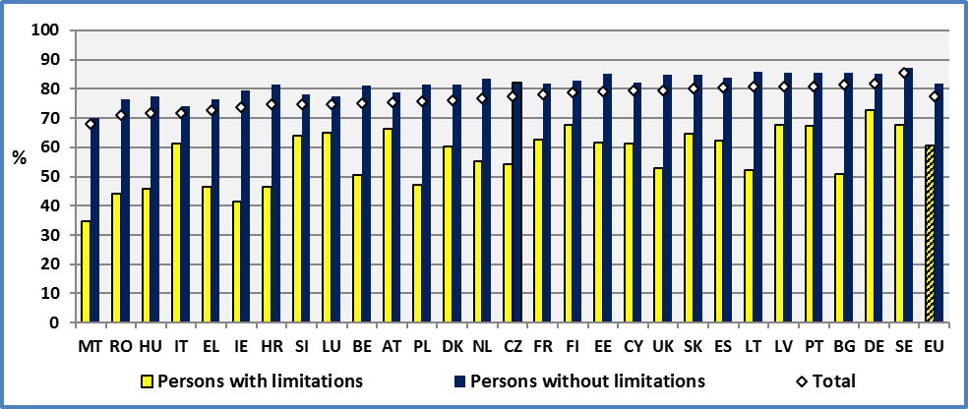

**Data source :** EU-SILC UDB 2014

**Figure 41: Activity gap. Age: 20-64, 2014**

Gap = (Activity rate of people without disabilities %) – (Activity rate of people with disabilities %)

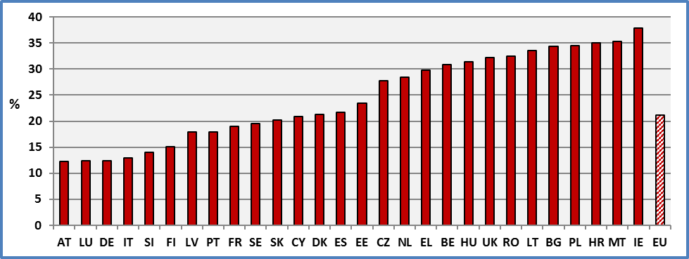

**Data source:** EU-SILC UDB 2014

**2.2 Gender**

At the EU level, the activity rate of women with disabilities is 56.3% (55.3% in 2013) and of women without disabilities it is 75.1% (73.8% in 2013). This represents a gap of 18.5 percentage points. The respective rates for men are 65.2% (63.9% in 2012) and 88% (87.7% in 2012). This represents a gap of 18.8 percentage points.

The lowest activity rate of women with disabilities can be found in Malta (indicative rate: 18.4%), Ireland (35.1%) and Romania (36.4%). A similar situation was reported in 2013. The countries with the highest activity rates of disabled women are Sweden (66.9%), Germany (68.6%) and Finland (69.3%).

These three countries had the highest scores in the last years.

The smallest difference between women with and without disabilities can be found in Austria, Luxembourg and Finland. The highest difference can be found in Lithuania, Malta and Ireland.

**Figure 42: Female activity rate by disability status and Member State (Age 20-64), 2014**

Percent of the population (same sex and age group) which is employed or unemployed

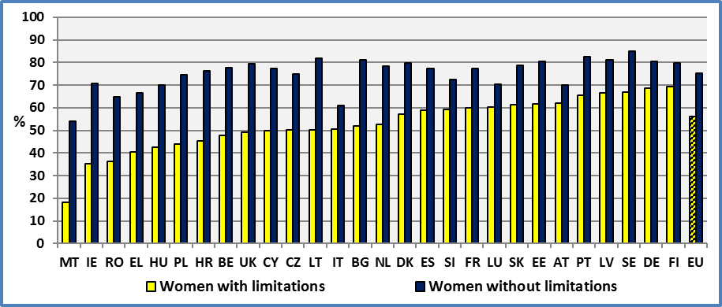

**Data source:** EU-SILC UDB 2014

**Figure 43: Male activity rate by disability status and Member State (Age 20-64), 2014**

Percent of the population (same sex and age group) which is employed or unemployed

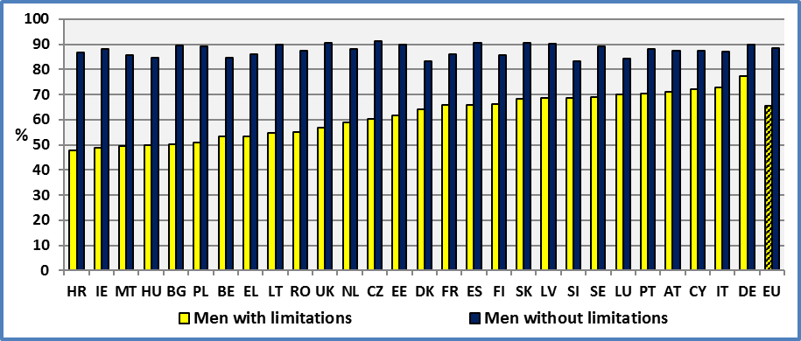

**Data source:** EU-SILC UDB 3014

The following concerns gender differences among persons with disabilities. At the EU level, the activity rate of women with disabilities is 9.9 percentage points lower compared to men with disabilities. However, in Denmark, Estonia and Sweden the activity rate of women with disabilities is similar to the one for men without disabilities. On the contrary, the gender gap among disabled people is high in Romania, Greece and Italy.

The activity rate of all women (71.1%) is lower compared to all men (84.1%). The gender gap is 13.0 percentage points.

Concerning persons with disabilities, the activity rate of women with disabilities (56.3%) is lower compared to men with disabilities (65.7%). The gender gap among persons with disabilities is 9.4 percentage points. Concerning women, the activity rate of women with disabilities (56.3%) is lower compared to the one of women without disabilities (75.1%). The disability gap among women is 18.8 percentage points. Consequently, women with disabilities face a double disadvantage related to gender and disability.

**2.3 Age**

From a life cycle perspective, the activity rate of people with disabilities is lower at all ages compared to people without disabilities. The absolute difference increases continuously with age till the retirement age.

As we noted earlier for the evolution of unemployment rate, this shape during the life cycle might stem from the following factors:

* An initial disadvantage leads to unemployment and lack of experience which further increases the initial disadvantage of persons with disabilities. This might push them to exit from the labour market.
* An initial activity limitation might deteriorate through time increasing the initial health disadvantage. This deterioration might be the result of the initial unemployment (poverty, living styles, etc.). This deterioration might push people with disabilities out of the labour market.

Recent policies aiming to increase the activity rate of elderly workers had a certain success among persons without disabilities. The activity rate of persons without disabilities aged 55-64 increased by 13.9 percentage points between 2011 and 2014. The corresponding increase for persons with disabilities was about 6.5 percentage points. This reveals a relative rigidity of the activity rate of persons with disabilities. It might arise from health reasons but also from the absence of flexible work arrangements and the necessary supporting services, including work adaptations.

On the contrary, the activity rate of both young with and without disabilities decreased respectively by -1.2 and -4.4 percentage points. This might be due to lower expectations concerning job opportunities (due to the financial crisis) and an ensuing incentive to increase human capital (education).

**Figure 44: Life cycle and activity rate by disability status. EU, age 16-64, 2014**

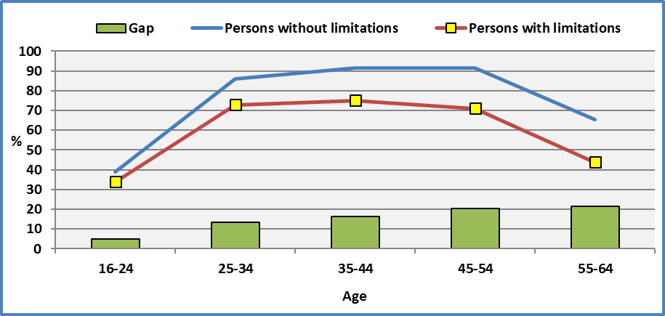

**Data source :** EU-SILC UDB 2014

2.4 Degree

The disability degree decreases significantly the activity rate. The labour force participation rate is 40.3% (39.8% in 2013) for persons with a severe disability, 68.6% (67.7% in 2013) for persons with a moderate disability and 81.7% (81.0% in 2013) for persons without disabilities.

The lowest activity rates for persons with severe disabilities can be found in Romania (16.2%), Bulgaria (19.1%) and Poland (25.7%). Luxembourg (53.2%), Portugal (54.3%) and Slovenia (54.7%) report the highest rates.

The difference of participation rates between severely disabled and non-disabled is small in Slovenia (24 percentage points), Luxembourg (24 pp) and Italy (27 pp). On the contrary, this difference is high in Lithuania (60 pp), Romania (60 pp) and Bulgaria (66 pp).

**Figure 45: Activity rate by disability status and Member State (Age 20-64), 2014**

Percent of the population (same sex and age group) which is employed or unemployed

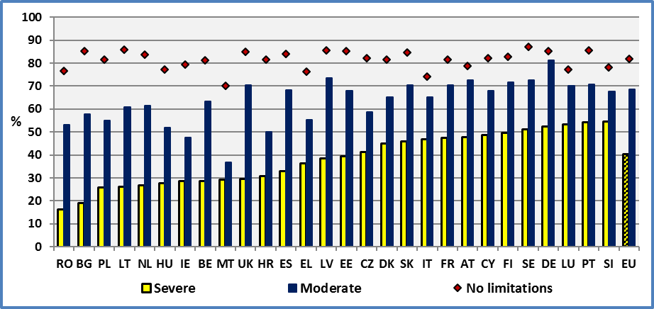

**Data source:** EU-SILC UDB 2014

It is interesting to study the interrelations between the activity rates of the three groups: persons with severe disabilities, persons with moderate disabilities and persons without disabilities.

At this end, we compare the national activity rates. The goal is to identify the presence of any correlation between two groups of persons.

The activity rates of persons with a moderate disability and of persons without disabilities are correlated (R²=0.35). On the contrary there is no correlation between the activity rates of persons with a severe disability and persons without disabilities. The analysis of previous years provided similar results.

This is important for policy elaboration. It means that persons with a moderate disability and persons without disabilities share similar behaviours and react in a similar way to exogenous factors in the labour market. A policy targeting persons without disabilities can with the relevant adaptation reach persons with a moderate disability. Mainstreaming can be a useful tool.

On the contrary, persons with a severe disability and persons without disabilities do not share similar behaviours concerning participation in the labour force. They react differently to the same (national) environment and policies. This means that general policies might not reach persons with severe disabilities even after some kind of adaptation.

We may question the efficacy of mainstreaming for persons with severe disabilities. If they don’t share some characteristics with persons without disabilities, then it means that we have to elaborate specific policies for this group.

2.5 Evolution

At the EU level, we note a continuous increase of the activity rate of all groups, notably of persons with disabilities, since 2010. Since this year, the activity rate of persons with severe disabilities gained 3.3 percentage points, persons with moderate disabilities 5.2 pp and persons without disabilities 2.1 pp. The total increase was 2.2 pp.

**Figure 46: Evolution of the activity rate of people with and without disabilities, EU, age: 20-64**

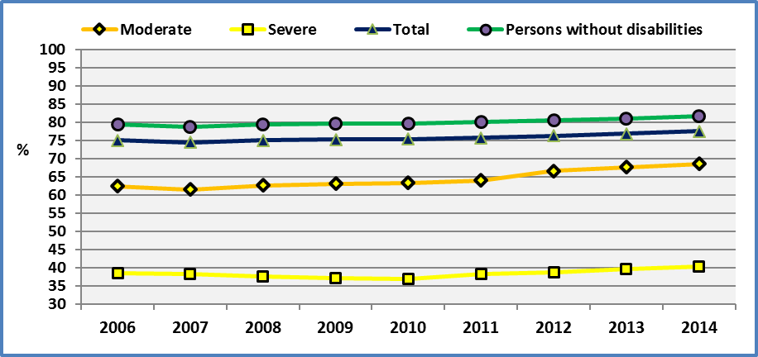

**Note:** The different years do not include all Member States. But this changes the activity rates only marginally and does not affect the conclusions. See the tables.

**Data source:** EU-SILC UDB Version August 2016

Between 2013 and 2014, national evolutions are very different across Member States. We observe an increase of the activity rate of persons with disabilities in eighteen Member States and a decrease in ten Member States.

A further analysis of changes between 2013 and 2014 indicates that the activity rate changes of persons with and without disabilities are not correlated. The graph below presenting the changes in the activity rates between 2013 and 2014 help us to visualise this result.

This might indicate that each activity rate (of persons with and without disabilities) is affected by specific factors. In fact, this might be true as persons with disabilities might not benefit from a generalised growth if they do not have the necessary work adaptations and technical aids.

**Figure 47: Persons with disabilities; Evolution of the activity rate by Member State. Age 20-64**

Percent of the population (same age group) which is employed or unemployed

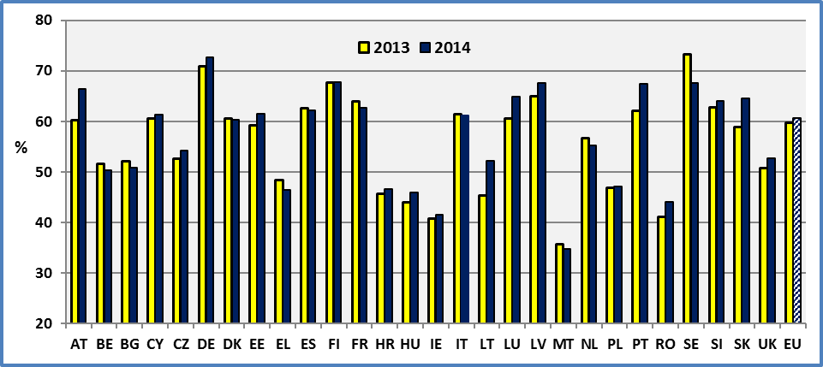

**Dta source :** EU-SILC UDB 2013 & EU-SILC UDB 2014

**Figure 48: Change in the activity rate between 2013 and 2014, age: 20-64**

Change = Activity rate of 2014-Activity rate of 2013.

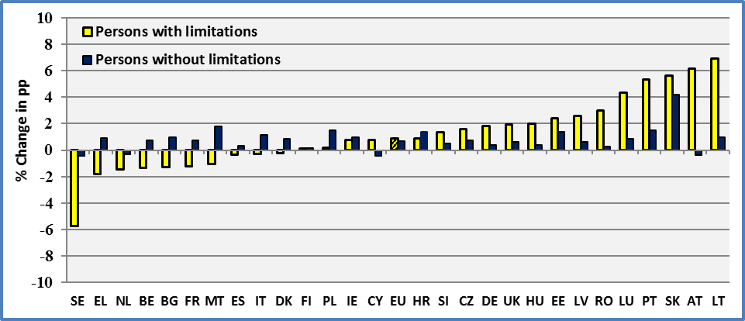

**Data source:** EU-SILC UDB 2013 & EU-SILC UDB 2014

### 3. Data

**Table 53: Activity rate by disability status and Member State (age 20-64)**

Percent of the population (same age group) which is employed or unemployed.

The data are not seasonally adjusted

|  |  |  |  |  |  |  |  |  |
| --- | --- | --- | --- | --- | --- | --- | --- | --- |
|  | **2008** | | | | **2009** | | | |
|  | **Females + Males** | | | | **Females + Males** | | | |
|  | **Disability** | | |  | **Disability** | | |  |
|  | **Yes** | **No** | **Total** | **All observations** | **Yes** | **No** | **Total** | **All observations** |
| **AT** | 59,7 | 77,5 | 73,4 | **73,4** | 59,7 | 78,2 | 74,2 | **74,2** |
| **BE** | 52,9 | 79,3 | 74,6 | **74,6** | 55,8 | 79,4 | 75,1 | **75,1** |
| **BG** | 52,6 | 85,0 | 81,7 | **81,7** | 50,2 | 84,3 | 80,7 | **80,8** |
| **CY** | 59,1 | 77,5 | 75,3 | **75,3** | 58,2 | 77,4 | 75,0 | **75,0** |
| **CZ** | 49,8 | 80,3 | 76,0 | **76,0** | 50,4 | 79,9 | 74,8 | **75,7** |
| **DE** | 68,9 | 82,4 | 78,9 | **78,9** | 68,4 | 82,4 | 78,9 | **79,0** |
| **DK** | 59,1 | 83,5 | 77,8 | **77,1** | 65,7 | 84,7 | 80,2 | **79,8** |
| **EE** | 58,0 | 85,5 | 79,8 | **79,8** | 59,8 | 84,8 | 79,9 | **79,9** |
| **EL** | 41,8 | 75,8 | 72,0 | **72,0** | 38,2 | 75,3 | 72,4 | **72,4** |
| **ES** | 54,2 | 81,2 | 76,9 | **76,9** | 57,9 | 82,1 | 77,8 | **77,8** |
| **FI** | 62,8 | 84,1 | 78,8 | **78,1** | 65,1 | 83,5 | 78,8 | **78,1** |
| **FR** |  |  |  |  | 59,7 | 79,4 | 76,1 | **76,1** |
| **HU** | 39,1 | 76,0 | 67,6 | **67,6** | 40,1 | 76,2 | 68,2 | **68,5** |
| **IE** | 41,5 | 78,7 | 72,5 | **72,5** | 39,5 | 76,8 | 70,7 | **70,7** |
| **IT** | 51,4 | 72,4 | 68,9 | **68,9** | 51,9 | 71,6 | 68,5 | **68,4** |
| **LT** | 52,1 | 85,4 | 79,2 | **79,2** | 46,1 | 85,7 | 79,9 | **79,9** |
| **LU** | 60,6 | 75,3 | 72,8 | **72,8** | 64,5 | 74,5 | 72,8 | **72,9** |
| **LV** | 64,4 | 85,4 | 80,2 | **80,2** | 63,9 | 88,3 | 82,7 | **82,7** |
| **MT** |  |  |  |  | 38,8 | 65,5 | 63,4 | **63,4** |
| **NL** | 55,6 | 80,2 | 74,5 | **75,2** | 56,8 | 81,1 | 75,4 | **76,0** |
| **PL** | 37,6 | 76,0 | 70,0 | **70,0** | 38,7 | 76,7 | 70,3 | **70,3** |
| **PT** | 57,4 | 85,1 | 79,3 | **79,3** | 57,6 | 85,8 | 79,3 | **79,3** |
| **RO** | 30,7 | 72,8 | 67,3 | **67,3** | 31,8 | 73,1 | 67,2 | **67,2** |
| **SE** | 63,7 | 88,4 | 85,1 | **84,6** | 59,3 | 88,1 | 84,5 | **84,8** |
| **SI** | 64,9 | 77,5 | 74,8 | **74,0** | 64,8 | 77,5 | 74,7 | **74,2** |
| **SK** | 58,6 | 83,7 | 77,2 | **77,2** | 58,9 | 82,1 | 76,1 | **76,1** |
| **UK** | 51,1 | 84,0 | 78,8 | **78,8** | 48,4 | 83,9 | 78,1 | **78,1** |
|  |  |  |  |  |  |  |  |  |
| **EU** | 55,1 | 79,5 | 75,0 | **75,0** | 55,8 | 79,6 | 75,2 | **75,3** |

**Data source:** EU-SILC UDB 2008 & 2009

**All:** It includes observations for which we do not dispose information on disability status.

**Table 54: Activity rate by disability status and Member State (age 20-64)**

Percent of the population (same age group) which is employed or unemployed.

|  |  |  |  |  |  |  |  |  |
| --- | --- | --- | --- | --- | --- | --- | --- | --- |
|  | **2010** | | | | **2011** | | | |
|  | **Females + Males** | | | | **Females + Males** | | | |
|  | **Disability** | | |  | **Disability** | | |  |
|  | **Yes** | **No** | **Total** | **All observations** | **Yes** | **No** | **Total** | **All observations** |
| **AT** | 59,5 | 77,6 | 73,6 | **73,6** | 62,5 | 78,3 | 74,8 | **74,8** |
| **BE** | 52,2 | 79,6 | 74,7 | **74,7** | 51,8 | 79,6 | 74,6 | **74,6** |
| **BG** | 46,6 | 84,0 | 80,5 | **80,5** | 48,0 | 83,9 | 79,9 | **79,9** |
| **CY** |  |  |  |  | 62,0 | 81,6 | 78,4 | **78,5** |
| **CZ** | 49,5 | 79,4 | 74,5 | **75,2** | 49,2 | 78,8 | 73,8 | **75,0** |
| **DE** | 68,2 | 83,1 | 79,5 | **79,4** | 69,7 | 83,8 | 80,3 | **80,2** |
| **DK** | 70,3 | 84,2 | 81,0 | **80,2** | 62,4 | 84,2 | 78,7 | **78,6** |
| **EE** | 58,9 | 84,5 | 79,0 | **79,0** | 58,4 | 84,2 | 78,4 | **78,4** |
| **EL** | 47,1 | 75,9 | 73,5 | **73,5** | 44,9 | 75,0 | 72,2 | **72,2** |
| **ES** | 56,5 | 83,1 | 78,9 | **78,9** | 51,5 | 80,6 | 76,6 | **76,6** |
| **FI** | 64,0 | 81,4 | 76,9 | **76,6** | 61,9 | 81,7 | 76,5 | **76,4** |
| **FR** | 60,3 | 79,0 | 75,6 | **75,6** | 60,7 | 79,7 | 76,2 | **76,2** |
| **HR** |  |  |  |  | 38,6 | 72,3 | 64,7 | **69,3** |
| **HU** | 41,7 | 76,3 | 68,9 | **68,9** | 42,3 | 76,8 | 69,7 | **69,8** |
| **IE** |  |  |  |  |  |  |  |  |
| **IT** | 50,8 | 70,9 | 68,6 | **68,4** | 54,9 | 73,1 | 70,0 | **70,0** |
| **LT** | 43,9 | 86,1 | 80,5 | **80,2** | 43,6 | 85,0 | 79,0 | **78,8** |
| **LU** | 61,3 | 76,4 | 73,9 | **73,9** | 62,6 | 77,0 | 74,8 | **74,9** |
| **LV** | 60,6 | 85,2 | 79,8 | **79,8** | 60,9 | 84,3 | 79,2 | **79,2** |
| **MT** | 34,9 | 65,3 | 63,0 | **62,9** | 36,5 | 65,7 | 63,6 | **63,6** |
| **NL** | 55,9 | 81,8 | 76,0 | **76,4** | 54,8 | 82,7 | 76,3 | **76,2** |
| **PL** | 42,9 | 77,5 | 71,5 | **71,5** | 43,2 | 78,7 | 72,6 | **72,6** |
| **PT** | 57,0 | 85,3 | 78,9 | **78,9** | 59,5 | 85,1 | 79,9 | **79,9** |
| **RO** | 40,1 | 75,2 | 68,9 | **68,9** | 40,3 | 75,8 | 69,2 | **69,2** |
| **SE** | 67,7 | 87,2 | 84,8 | **85,0** | 68,4 | 87,8 | 85,2 | **85,0** |
| **SI** | 64,2 | 78,7 | 74,3 | **73,6** | 62,1 | 78,3 | 73,4 | **73,4** |
| **SK** | 60,9 | 82,0 | 76,4 | **76,4** | 60,4 | 81,6 | 75,9 | **75,9** |
| **UK** | 46,6 | 83,4 | 77,3 | **77,2** | 51,6 | 84,0 | 78,4 | **78,3** |
|  |  |  |  |  |  |  |  |  |
| **EU\*** | 56,1 | 79,7 | 75,5 | **75,4** | 56,7 | 80,2 | 75,8 | **75,8** |

**EU*:** For 2011, if we exclude Cyprus and Croatia, we obtain: 56,8 for persons with disabilities and the remaining unchanged.

**Data source:** EU-SILC UDB 2010 & 2011

**All:** It includes observations for which we do not dispose information on disability status.

**Table 55: Activity rate by disability status and Member State (age 20-64)**

Percent of the population (same age group) which is employed or unemployed.

|  |  |  |  |  |  |  |  |  |
| --- | --- | --- | --- | --- | --- | --- | --- | --- |
|  | **2012** | | | | **2013** | | | |
|  | **Females + Males** | | | | **Females + Males** | | | |
|  | **Disability** | | |  | **Disability** | | |  |
|  | **Yes** | **No** | **Total** | **All observations** | **Yes** | **No** | **Total** | **All observations** |
| **AT** | 60,2 | 78,7 | **74,7** | 74,7 | 60,3 | 79,2 | **74,6** | 74,6 |
| **BE** | 47,4 | 80,6 | **75,0** | 75,0 | 51,7 | 80,5 | **75,0** | 75,0 |
| **BG** | 53,3 | 83,5 | **79,9** | 79,9 | 52,2 | 84,4 | **80,9** | 80,9 |
| **CY** | 61,1 | 82,5 | **79,4** | 79,4 | 60,5 | 82,5 | **79,3** | 79,3 |
| **CZ** | 50,3 | 79,4 | **74,5** | 75,7 | 52,7 | 81,3 | **76,4** | 77,4 |
| **DE** | 71,5 | 83,6 | **80,4** | 80,2 | 71,0 | 84,8 | **81,0** | 80,9 |
| **DK** | 59,9 | 81,7 | **76,0** | 76,0 | 58,8 | 80,2 | **74,5** | 74,0 |
| **EE** | 56,4 | 83,9 | **77,4** | 77,4 | 59,2 | 83,6 | **77,7** | 77,7 |
| **EL** | 50,0 | 75,9 | **72,7** | 72,7 | 48,3 | 75,4 | **72,3** | 72,3 |
| **ES** | 56,1 | 81,6 | **78,2** | 78,2 | 62,6 | 83,6 | **80,1** | 80,1 |
| **FI** | 65,5 | 81,4 | **76,7** | 76,5 | 67,6 | 82,7 | **77,1** | 76,5 |
| **FR** | 63,1 | 80,2 | **77,1** | 77,1 | 64,7 | 80,2 | **77,4** | 77,4 |
| **HR** | 40,7 | 79,0 | **73,6** | 73,8 | 45,7 | 80,2 | **73,2** | 73,4 |
| **HU** | 38,3 | 76,7 | **69,8** | 69,8 | 43,9 | 77,0 | **70,8** | 70,8 |
| **IE** | 41,1 | 78,2 | **73,2** | 73,2 | 40,7 | 78,3 | **73,1** | 73,1 |
| **IT** | 59,4 | 72,8 | **70,4** | 70,3 | 61,7 | 72,9 | **70,7** | 70,7 |
| **LT** | 44,3 | 85,1 | **78,8** | 78,9 | 45,4 | 84,8 | **78,7** | 78,6 |
| **LU** | 61,8 | 77,6 | **75,0** | 75,0 | 60,6 | 76,5 | **73,2** | 73,2 |
| **LV** | 61,1 | 84,8 | **80,1** | 80,1 | 65,0 | 84,9 | **79,6** | 79,6 |
| **MT** | 27,1 | 67,9 | **65,5** | 65,5 | 35,8 | 68,2 | **66,1** | 66,1 |
| **NL** | 57,7 | 82,6 | **76,6** | 76,6 | 56,7 | 83,9 | **76,5** | 76,2 |
| **PL** | 45,1 | 79,6 | **73,7** | 73,7 | 46,9 | 80,1 | **74,4** | 74,4 |
| **PT** | 57,7 | 84,7 | **80,0** | 80,0 | 62,2 | 84,0 | **80,0** | 80,0 |
| **RO** | 41,6 | 75,3 | **69,3** | 69,3 | 41,2 | 76,3 | **70,1** | 70,1 |
| **SE** | 69,4 | 88,0 | **85,5** | 85,5 | 73,4 | 87,6 | **85,1** | 84,9 |
| **SI** | 64,9 | 78,0 | **74,4** | 74,4 | 62,8 | 77,6 | **74,2** | 74,6 |
| **SK** | 58,6 | 81,3 | **75,5** | 75,5 | 58,9 | 80,5 | **75,1** | 75,2 |
| **UK** | 51,3 | 84,6 | **79,1** | 79,1 | 50,8 | 84,4 | **79,0** | 79,0 |
|  |  |  |  |  |  |  |  |  |
| **EU** | **58,5** | **80,5** | **76,3** | **76,3** | **59,8** | **81,0** | **76,8** | **76,7** |
|  |  |  |  |  |  |  |  |  |
| **CH** | 70,0 | 84,3 | **81,9** | 81,9 | 73,3 | 83,6 | **81,0** | 81,0 |
| **IS** | 52,8 | 83,3 | **78,8** | 78,6 | 53,7 | 85,1 | **80,3** | 79,3 |
| **NO** | 52,9 | 88,3 | **83,9** | 83,8 | 57,8 | 89,1 | **84,4** | 83,5 |
| **RS** |  |  |  |  | 46,7 | 76,7 | **73,1** | 73,7 |

**Data source:** EU-SILC UDB 2012 & 2013

**All:** It includes observations for which we do not dispose information on disability status.

**Table 56: Activity rate by disability status and Member State (age 20-64)**

Percent of the population (same age group) which is employed or unemployed.

|  |  |  |  |  |
| --- | --- | --- | --- | --- |
|  | **2014** | | | |
|  | **Females + Males** | | | |
|  | **Disability** | | |  |
|  | **Yes** | **No** | **Total** | **All observations** |
| **AT** | 66,5 | 78,8 | **75,4** | 75,4 |
| **BE** | 50,4 | 81,2 | **75,2** | 75,2 |
| **BG** | 50,9 | 85,3 | **81,6** | 81,6 |
| **CY** | 61,3 | 82,1 | **79,4** | 79,4 |
| **CZ** | 54,3 | 82,0 | **77,5** | 78,1 |
| **DE** | 72,8 | 85,2 | **81,6** | 81,4 |
| **DK** | 60,4 | 81,6 | **76,1** | 75,1 |
| **EE** | 61,6 | 85,0 | **79,2** | 79,2 |
| **EL** | 46,5 | 76,3 | **72,7** | 72,7 |
| **ES** | 62,3 | 83,9 | **80,4** | 80,4 |
| **FI** | 67,8 | 82,9 | **78,8** | 77,8 |
| **FR** | 62,7 | 81,7 | **78,1** | 78,1 |
| **HR** | 46,5 | 81,6 | **74,7** | 74,9 |
| **HU** | 45,9 | 77,4 | **71,6** | 71,6 |
| **IE** | 41,5 | 79,3 | **73,8** | 73,8 |
| **IT** | 61,1 | 74,1 | **71,7** | 71,7 |
| **LT** | 52,3 | 85,8 | **80,6** | 80,6 |
| **LU** | 64,9 | 77,4 | **74,8** | 74,8 |
| **LV** | 67,6 | 85,5 | **80,7** | 80,7 |
| **MT** | 34,7 | 70,0 | **68,0** | 68,0 |
| **NL** | 55,2 | 83,6 | **76,6** | 76,9 |
| **PL** | 47,1 | 81,6 | **75,6** | 75,6 |
| **PT** | 67,5 | 85,5 | **80,8** | 80,8 |
| **RO** | 44,1 | 76,6 | **71,1** | 71,1 |
| **SE** | 67,6 | 87,2 | **85,4** | 85,2 |
| **SI** | 64,1 | 78,1 | **74,8** | 75,4 |
| **SK** | 64,6 | 84,8 | **80,0** | 80,1 |
| **UK** | 52,8 | 85,0 | **79,5** | 79,5 |
|  |  |  |  |  |
| **EU** | **60,6** | **81,7** | **77,5** | **77,5** |
|  |  |  |  |  |
| **CH** | 74,1 | 84,5 | **81,7** | 81,8 |
| **IS** | 55,1 | 82,9 | **78,3** | 79,1 |
| **NO** | 55,6 | 88,6 | **83,7** | 81,8 |
| **RS** | 50,3 | 78,0 | **75,0** | 75,0 |

**Data source:** EU-SILC UDB 2014

**All:** It includes observations for which we do not dispose information on disability status.

**Table 57: Activity rate by year, gender, disability status and Member State (age 20-64)**

Percent of the population (same sex and age group) which is employed or unemployed.

|  |  |  |  |  |  |  |  |  |  |  |  |  |
| --- | --- | --- | --- | --- | --- | --- | --- | --- | --- | --- | --- | --- |
|  | **2008** | | | | | | **2009** | | | | | |
|  | **Females** | | | **Males** | | | **Females** | | | **Males** | | |
|  | **Disability** | | | **Disability** | | | **Disability** | | | **Disability** | | |
|  | **Yes** | **No** | **Total** | **Yes** | **No** | **Total** | **Yes** | **No** | **Total** | **Yes** | **No** | **Total** |
| **AT** | 52,0 | 67,3 | **63,8** | 67,3 | 87,7 | **83,0** | 53,6 | 69,3 | **65,9** | 65,9 | 87,1 | **82,5** |
| **BE** | 48,3 | 73,6 | **68,8** | 58,0 | 84,9 | **80,3** | 53,1 | 73,4 | **69,4** | 58,9 | 85,3 | **80,8** |
| **BG** | 51,2 | 79,0 | **76,2** | 54,2 | 91,1 | **87,4** | 46,5 | 79,0 | **75,4** | 54,5 | 89,6 | **86,2** |
| **CY** | 48,4 | 70,7 | **68,0** | 69,2 | 84,7 | **82,7** | 49,6 | 70,2 | **67,7** | 66,5 | 84,8 | **82,5** |
| **CZ** | 45,4 | 70,7 | **66,6** | 55,4 | 91,1 | **85,7** | 44,5 | 71,2 | **66,4** | 58,1 | 90,3 | **85,0** |
| **DE** | 63,1 | 76,4 | **72,8** | 74,7 | 88,5 | **85,0** | 63,5 | 76,8 | **73,4** | 73,5 | 88,2 | **84,6** |
| **DK** | 54,5 | 80,4 | **73,6** | 65,1 | 86,5 | **82,1** | 62,7 | 83,2 | **77,8** | 69,6 | 86,2 | **82,7** |
| **EE** | 54,9 | 79,5 | **74,6** | 61,2 | 92,2 | **85,6** | 59,3 | 79,7 | **75,8** | 60,2 | 90,6 | **84,4** |
| **EL** | 33,3 | 64,3 | **60,5** | 52,1 | 87,0 | **83,5** | 31,4 | 64,8 | **61,9** | 46,7 | 85,7 | **83,0** |
| **ES** | 48,4 | 71,3 | **67,3** | 60,8 | 90,6 | **86,2** | 51,0 | 72,7 | **68,5** | 65,9 | 91,0 | **87,0** |
| **FI** | 62,9 | 79,8 | **75,3** | 62,7 | 88,2 | **82,2** | 63,9 | 79,7 | **75,5** | 66,4 | 87,2 | **82,2** |
| **FR** |  |  |  |  |  |  | 57,8 | 75,3 | **72,1** | 62,0 | 83,6 | **80,3** |
| **HU** | 36,1 | 68,0 | **60,6** | 42,4 | 84,4 | **74,9** | 37,0 | 68,2 | **61,1** | 43,6 | 84,4 | **75,8** |
| **IE** | 32,3 | 68,4 | **62,3** | 51,0 | 89,1 | **82,8** | 31,8 | 64,5 | **59,2** | 47,2 | 89,4 | **82,4** |
| **IT** | 42,0 | 59,2 | **56,0** | 62,9 | 85,0 | **81,7** | 43,5 | 58,6 | **56,0** | 62,2 | 84,1 | **80,9** |
| **LT** | 51,0 | 80,9 | **74,8** | 53,5 | 90,5 | **84,2** | 48,0 | 81,9 | **76,6** | 43,5 | 89,8 | **83,6** |
| **LU** | 51,7 | 64,9 | **62,4** | 71,3 | 85,2 | **83,1** | 58,5 | 63,3 | **62,5** | 71,0 | 85,2 | **83,0** |
| **LV** | 61,1 | 78,7 | **74,1** | 68,4 | 92,5 | **86,8** | 61,1 | 84,1 | **78,7** | 67,2 | 92,9 | **87,2** |
| **MT** |  |  |  |  |  |  | 24,9 | 44,8 | **43,2** | 52,1 | 85,8 | **83,1** |
| **NL** | 51,4 | 71,9 | **66,5** | 61,7 | 88,2 | **83,0** | 51,3 | 73,8 | **67,8** | 64,5 | 88,2 | **83,4** |
| **PL** | 33,0 | 67,5 | **62,3** | 42,1 | 84,7 | **77,9** | 34,0 | 68,8 | **63,0** | 43,6 | 85,4 | **78,3** |
| **PT** | 53,4 | 79,5 | **73,5** | 62,5 | 90,4 | **85,2** | 54,0 | 81,1 | **74,0** | 62,5 | 90,2 | **84,7** |
| **RO** | 27,3 | 60,6 | **55,9** | 34,8 | 84,8 | **78,9** | 28,0 | 60,7 | **55,5** | 36,7 | 85,3 | **79,2** |
| **SE** | 61,2 | 85,8 | **81,8** | 67,3 | 90,7 | **88,1** | 58,1 | 85,4 | **81,2** | 61,3 | 90,5 | **87,8** |
| **SI** | 60,3 | 72,4 | **69,8** | 69,5 | 82,6 | **79,8** | 60,6 | 72,7 | **69,9** | 69,3 | 81,9 | **79,4** |
| **SK** | 53,6 | 78,3 | **71,2** | 65,3 | 89,3 | **83,7** | 51,8 | 76,0 | **69,2** | 67,8 | 88,1 | **83,3** |
| **UK** | 49,1 | 77,5 | **72,8** | 53,4 | 91,3 | **85,6** | 44,7 | 76,8 | **71,4** | 52,5 | 91,1 | **85,1** |
|  |  |  |  |  |  |  |  |  |  |  |  |  |
| **EU** | 49,8 | 71,1 | **66,9** | 61,1 | 87,9 | **83,2** | 51,0 | 72,0 | **67,9** | 61,4 | 87,3 | **82,8** |

**Data source:** EU-SILC UDB 2008 & 2009

**Table 58: Activity rate by year, gender, disability status and Member State (age 20-64)**

Percent of the population (same sex and age group) which is employed or unemployed.

|  |  |  |  |  |  |  |  |  |  |  |  |  |
| --- | --- | --- | --- | --- | --- | --- | --- | --- | --- | --- | --- | --- |
|  | **2010** | | | | | | **2011** | | | | | |
|  | **Females** | | | **Males** | | | **Females** | | | **Males** | | |
|  | **Disability** | | | **Disability** | | | **Disability** | | | **Disability** | | |
|  | **Yes** | **No** | **Total** | **Yes** | **No** | **Total** | **Yes** | **No** | **Total** | **Yes** | **No** | **Total** |
| **AT** | 52,1 | 68,4 | **64,8** | 66,9 | 86,9 | **82,4** | 56,6 | 69,0 | **66,1** | 69,1 | 87,6 | **83,7** |
| **BE** | 49,7 | 73,5 | **68,9** | 55,1 | 85,5 | **80,6** | 50,1 | 75,2 | **70,3** | 53,9 | 83,9 | **78,9** |
| **BG** | 45,8 | 78,2 | **75,1** | 47,4 | 89,8 | **85,9** | 44,7 | 78,2 | **74,5** | 51,5 | 89,5 | **85,5** |
| **CY** |  |  |  |  |  |  | 54,0 | 76,1 | **72,5** | 70,6 | 87,4 | **84,7** |
| **CZ** | 45,0 | 70,7 | **66,5** | 55,2 | 90,2 | **84,5** | 46,4 | 70,1 | **66,0** | 53,1 | 89,5 | **83,7** |
| **DE** | 63,4 | 77,6 | **74,0** | 73,6 | 88,6 | **85,0** | 65,2 | 77,7 | **74,4** | 74,9 | 89,9 | **86,3** |
| **DK** | 68,1 | 82,0 | **78,4** | 73,1 | 86,4 | **83,6** | 57,2 | 82,2 | **74,8** | 69,7 | 86,0 | **82,6** |
| **EE** | 57,9 | 80,2 | **75,6** | 59,9 | 89,2 | **82,7** | 60,0 | 79,8 | **75,3** | 56,6 | 89,2 | **81,8** |
| **EL** | 42,4 | 65,5 | **63,5** | 52,0 | 86,4 | **83,6** | 37,5 | 64,6 | **62,0** | 52,6 | 85,3 | **82,3** |
| **ES** | 51,9 | 74,6 | **70,7** | 62,1 | 91,0 | **87,0** | 48,0 | 71,2 | **67,9** | 55,4 | 89,6 | **85,2** |
| **FI** | 64,9 | 75,6 | **72,6** | 62,8 | 86,8 | **81,2** | 61,4 | 76,4 | **72,2** | 62,5 | 86,6 | **80,6** |
| **FR** | 57,6 | 74,7 | **71,4** | 63,4 | 83,4 | **79,9** | 58,1 | 76,1 | **72,7** | 63,6 | 83,3 | **79,9** |
| **HR** |  |  |  |  |  |  | 35,8 | 68,6 | **61,7** | 41,7 | 77,5 | **68,7** |
| **HU** | 39,8 | 68,6 | **62,2** | 43,8 | 84,2 | **75,9** | 40,2 | 69,5 | **63,2** | 44,7 | 84,1 | **76,6** |
| **IE** |  |  |  |  |  |  |  |  |  |  |  |  |
| **IT** | 42,9 | 57,8 | **55,9** | 60,2 | 83,7 | **81,2** | 45,2 | 60,0 | **57,3** | 65,9 | 86,0 | **82,7** |
| **LT** | 43,6 | 83,1 | **77,7** | 44,3 | 89,4 | **83,6** | 45,0 | 81,6 | **76,1** | 42,1 | 88,8 | **82,2** |
| **LU** | 55,3 | 67,1 | **65,1** | 67,5 | 85,7 | **82,7** | 55,2 | 68,7 | **66,6** | 70,0 | 85,2 | **82,8** |
| **LV** | 58,8 | 80,2 | **75,3** | 62,7 | 90,6 | **84,8** | 59,2 | 79,2 | **74,7** | 63,1 | 89,9 | **84,3** |
| **MT** | 24,6 | 45,8 | **44,1** | 45,5 | 84,4 | **81,4** | 18,9 | 47,2 | **45,2** | 53,2 | 83,8 | **81,6** |
| **NL** | 48,8 | 74,9 | **68,5** | 64,9 | 88,7 | **83,9** | 50,6 | 76,1 | **69,2** | 61,3 | 88,9 | **83,8** |
| **PL** | 38,6 | 69,5 | **64,2** | 47,5 | 86,2 | **79,5** | 38,5 | 71,0 | **65,6** | 48,0 | 87,4 | **80,4** |
| **PT** | 54,1 | 81,0 | **74,0** | 61,1 | 89,3 | **84,0** | 59,3 | 81,0 | **75,9** | 59,9 | 89,0 | **83,9** |
| **RO** | 34,5 | 63,1 | **57,2** | 47,8 | 86,6 | **80,8** | 33,7 | 63,7 | **57,2** | 49,7 | 87,0 | **81,3** |
| **SE** | 66,6 | 84,3 | **81,6** | 69,4 | 89,9 | **88,0** | 67,7 | 85,0 | **82,3** | 69,4 | 90,2 | **88,1** |
| **SI** | 60,5 | 74,7 | **70,2** | 68,2 | 82,5 | **78,4** | 59,6 | 74,0 | **69,4** | 64,9 | 82,4 | **77,3** |
| **SK** | 55,1 | 76,1 | **70,0** | 68,1 | 87,9 | **83,1** | 55,1 | 75,7 | **69,7** | 66,8 | 87,3 | **82,2** |
| **UK** | 44,1 | 76,6 | **71,0** | 49,5 | 90,3 | **83,9** | 49,1 | 77,3 | **71,9** | 54,7 | 90,7 | **85,1** |
|  |  |  |  |  |  |  |  |  |  |  |  |  |
| **EU** | 51,5 | 71,9 | **68,0** | 60,7 | 87,2 | **82,7** | 52,4 | 72,7 | **68,6** | 61,8 | 87,7 | **83,2** |

**Data source:** EU-SILC UDB 2010 & 2011

**Table 59: Activity rate by year, gender, disability status and Member State (age 20-64)**

Percent of the population (same sex and age group) which is employed or unemployed.

|  |  |  |  |  |  |  |  |  |  |  |  |  |
| --- | --- | --- | --- | --- | --- | --- | --- | --- | --- | --- | --- | --- |
|  | **2012** | | | | | | **2013** | | | | | |
|  | **Females** | | | **Males** | | | **Females** | | | **Males** | | |
|  | **Disability** | | | **Disability** | | | **Disability** | | | **Disability** | | |
|  | **Yes** | **No** | **Total** | **Yes** | **No** | **Total** | **Yes** | **No** | **Total** | **Yes** | **No** | **Total** |
| **AT** | 54,2 | 69,8 | **66,4** | 66,1 | 87,9 | **83,1** | 55,1 | 70,4 | **66,6** | 65,8 | 87,7 | **82,6** |
| **BE** | 43,4 | 75,5 | **69,7** | 51,7 | 85,6 | **80,1** | 50,7 | 76,0 | **70,9** | 52,8 | 84,9 | **79,1** |
| **BG** | 50,1 | 77,9 | **74,4** | 56,8 | 89,0 | **85,3** | 52,7 | 79,3 | **76,4** | 51,7 | 89,3 | **85,3** |
| **CY** | 54,9 | 77,5 | **74,3** | 67,5 | 87,8 | **84,8** | 52,4 | 77,5 | **73,8** | 69,1 | 87,9 | **85,1** |
| **CZ** | 48,2 | 72,1 | **67,9** | 53,2 | 88,8 | **83,0** | 48,1 | 74,2 | **69,6** | 59,2 | 90,8 | **85,5** |
| **DE** | 67,1 | 77,9 | **74,9** | 76,4 | 89,4 | **86,1** | 66,8 | 79,5 | **75,8** | 76,0 | 90,1 | **86,5** |
| **DK** | 55,2 | 77,7 | **71,3** | 65,6 | 85,5 | **80,8** | 58,7 | 76,9 | **71,6** | 58,8 | 83,3 | **77,5** |
| **EE** | 56,2 | 79,1 | **73,8** | 56,6 | 89,2 | **81,3** | 59,0 | 78,9 | **74,0** | 59,3 | 88,8 | **81,8** |
| **EL** | 37,9 | 66,1 | **62,5** | 62,5 | 85,7 | **82,9** | 39,5 | 64,6 | **61,6** | 57,8 | 86,2 | **83,0** |
| **ES** | 51,2 | 73,6 | **70,5** | 61,0 | 89,6 | **85,7** | 57,9 | 76,9 | **73,5** | 68,1 | 90,0 | **86,7** |
| **FI** | 65,9 | 76,0 | **72,7** | 65,0 | 86,3 | **80,7** | 66,0 | 78,4 | **73,5** | 69,5 | 86,7 | **80,7** |
| **FR** | 60,6 | 76,6 | **73,5** | 65,8 | 83,8 | **80,7** | 61,0 | 76,3 | **73,3** | 69,1 | 84,2 | **81,6** |
| **HR** | 39,9 | 73,6 | **68,7** | 41,6 | 84,5 | **78,5** | 42,3 | 74,4 | **68,0** | 48,9 | 86,1 | **78,5** |
| **HU** | 36,6 | 68,9 | **62,6** | 40,3 | 84,6 | **77,3** | 41,0 | 69,6 | **63,9** | 47,4 | 84,5 | **78,1** |
| **IE** | 35,5 | 67,7 | **63,4** | 46,6 | 89,3 | **83,3** | 33,0 | 69,5 | **64,4** | 48,8 | 87,4 | **82,1** |
| **IT** | 49,1 | 59,3 | **57,3** | 70,8 | 86,2 | **83,5** | 51,7 | 59,6 | **58,0** | 73,0 | 86,0 | **83,7** |
| **LT** | 43,8 | 81,7 | **75,8** | 44,8 | 89,1 | **82,1** | 43,5 | 80,6 | **74,7** | 47,5 | 89,4 | **83,0** |
| **LU** | 57,7 | 69,7 | **67,6** | 66,3 | 85,3 | **82,3** | 53,7 | 68,8 | **65,5** | 68,1 | 83,8 | **80,7** |
| **LV** | 60,1 | 80,9 | **76,6** | 62,3 | 89,0 | **83,8** | 63,4 | 81,0 | **76,0** | 67,1 | 89,1 | **83,7** |
| **MT** | 19,1 | 49,6 | **47,8** | 35,0 | 85,9 | **82,8** | 23,8 | 50,7 | **48,9** | 47,4 | 85,4 | **82,9** |
| **NL** | 52,8 | 76,0 | **69,4** | 65,0 | 88,5 | **84,0** | 51,1 | 78,5 | **69,6** | 64,8 | 88,6 | **83,3** |
| **PL** | 40,9 | 72,2 | **66,9** | 49,5 | 87,5 | **81,0** | 43,5 | 72,7 | **67,7** | 50,6 | 88,2 | **81,7** |
| **PT** | 54,6 | 81,6 | **76,2** | 62,5 | 87,8 | **84,1** | 60,1 | 80,7 | **76,3** | 65,2 | 87,3 | **83,8** |
| **RO** | 34,5 | 63,0 | **57,1** | 51,7 | 87,2 | **81,9** | 34,3 | 64,6 | **58,2** | 51,3 | 87,2 | **82,0** |
| **SE** | 68,6 | 85,9 | **83,1** | 70,6 | 89,8 | **87,7** | 72,8 | 85,3 | **82,8** | 74,0 | 89,7 | **87,3** |
| **SI** | 61,5 | 74,3 | **70,5** | 68,7 | 81,5 | **78,1** | 59,9 | 72,6 | **69,6** | 65,6 | 82,3 | **78,5** |
| **SK** | 54,2 | 75,6 | **69,5** | 64,2 | 86,7 | **81,6** | 54,9 | 73,8 | **68,6** | 64,0 | 87,1 | **81,9** |
| **UK** | 48,7 | 78,8 | **73,5** | 54,2 | 90,5 | **84,9** | 48,3 | 77,2 | **72,2** | 53,8 | 91,6 | **85,9** |
|  |  |  |  |  |  |  |  |  |  |  |  |  |
| **EU** | **53,8** | **73,3** | **69,4** | **63,9** | **87,7** | **83,4** | **55,3** | **73,8** | **69,9** | **65,2** | **88,0** | **83,9** |
|  |  |  |  |  |  |  |  |  |  |  |  |  |
| **CH** |  |  |  |  |  |  | 66,3 | 75,0 | **72,5** | 82,4 | 91,4 | **89,4** |
| **IS** |  |  |  |  |  |  | 51,0 | 80,9 | **75,0** | 58,5 | 88,9 | **85,5** |
| **NO** |  |  |  |  |  |  | 55,8 | 87,3 | **81,4** | 60,5 | 90,6 | **87,0** |
| **RS** |  |  |  |  |  |  | 39,0 | 68,4 | **64,7** | 56,4 | 86,0 | **82,6** |

**Data source:** EU-SILC UDB 2012 & 2013

**Table 60: Activity rate by year, gender, disability status and Member State (age 20-64)**

Percent of the population (same sex and age group) which is employed or unemployed.

|  |  |  |  |  |  |  |
| --- | --- | --- | --- | --- | --- | --- |
|  | **2014** | | | | | |
|  | **Females** | | | **Males** | | |
|  | **Disability** | | | **Disability** | | |
|  | **Yes** | **No** | **Total** | **Yes** | **No** | **Total** |
| **AT** | 62,1 | 69,9 | 67,7 | 71,2 | 87,5 | 83,1 |
| **BE** | 47,9 | 77,6 | 71,3 | 53,3 | 84,6 | 79,0 |
| **BG** | 51,8 | 81,2 | 78,1 | 50,1 | 89,4 | 85,1 |
| **CY** | 49,9 | 77,4 | 74,0 | 72,1 | 87,3 | 85,2 |
| **CZ** | 50,2 | 74,9 | 70,6 | 60,4 | 91,3 | 86,7 |
| **DE** | 68,6 | 80,6 | 77,0 | 77,5 | 89,9 | 86,4 |
| **DK** | 57,1 | 79,9 | 73,6 | 64,0 | 83,3 | 78,5 |
| **EE** | 61,6 | 80,4 | 75,8 | 61,5 | 89,8 | 82,7 |
| **EL** | 40,4 | 66,7 | 63,3 | 53,4 | 85,9 | 82,1 |
| **ES** | 59,0 | 77,2 | 74,1 | 65,8 | 90,5 | 86,7 |
| **FI** | 69,3 | 79,8 | 76,7 | 66,1 | 85,7 | 80,8 |
| **FR** | 60,1 | 77,4 | 74,0 | 65,7 | 85,9 | 82,4 |
| **HR** | 45,3 | 76,3 | 70,2 | 47,8 | 86,9 | 79,3 |
| **HU** | 42,4 | 70,0 | 64,7 | 49,9 | 84,8 | 78,8 |
| **IE** | 35,1 | 70,7 | 65,4 | 48,9 | 88,1 | 82,7 |
| **IT** | 50,5 | 61,1 | 59,1 | 72,9 | 87,0 | 84,6 |
| **LT** | 50,3 | 82,0 | 76,9 | 54,6 | 89,8 | 84,6 |
| **LU** | 60,2 | 70,3 | 68,1 | 69,9 | 84,2 | 81,4 |
| **LV** | 66,7 | 81,3 | 77,3 | 68,6 | 90,2 | 84,4 |
| **MT** | 18,4 | 53,9 | 51,9 | 49,6 | 85,6 | 83,5 |
| **NL** | 52,6 | 78,4 | 70,8 | 59,1 | 88,1 | 82,3 |
| **PL** | 43,8 | 74,5 | 69,1 | 50,8 | 89,2 | 82,7 |
| **PT** | 65,5 | 82,6 | 77,5 | 70,3 | 88,3 | 84,3 |
| **RO** | 36,4 | 65,0 | 59,3 | 55,0 | 87,4 | 82,9 |
| **SE** | 66,9 | 85,1 | 82,9 | 69,0 | 89,1 | 87,7 |
| **SI** | 59,3 | 72,6 | 69,4 | 68,8 | 83,4 | 79,9 |
| **SK** | 61,2 | 78,6 | 74,3 | 68,3 | 90,7 | 85,7 |
| **UK** | 49,3 | 79,5 | 74,0 | 56,9 | 90,4 | 85,2 |
|  |  |  |  |  |  |  |
| **EU** | **56,3** | **75,1** | **71,1** | **65,7** | **88,4** | **84,1** |
|  |  |  |  |  |  |  |
| **CH** | 67,6 | 76,7 | 73,9 | 82,4 | 91,6 | 89,4 |
| **IS** | 52,4 | 79,6 | 73,8 | 59,9 | 85,8 | 82,7 |
| **NO** | 55,1 | 86,0 | 80,1 | 56,4 | 90,7 | 87,1 |
| **RS** | 41,7 | 69,9 | 66,9 | 59,3 | 86,1 | 83,3 |

**Data source:** EU-SILC UDB 2014

**Table 61: Activity rate by age group and Member State**

Percent of the population (same age group) which is employed or unemployed.

|  |  |  |  |  |  |  |  |  |  |  |  |  |
| --- | --- | --- | --- | --- | --- | --- | --- | --- | --- | --- | --- | --- |
|  | **2009** | | | | | | | | | | | |
|  | **Persons with disabilities** | | | | | | **All persons** | | | | | |
|  | **16-24\*** | **25-34** | **35-44** | **45-54** | **55-64** | **16-64** | **16-24** | **25-34** | **35-44** | **45-54** | **55-64** | **16-64** |
| **AT** | 52,5 | 79,7 | 80,9 | 73,9 | 27,7 | **59,3** | 52,5 | 79,5 | 89,5 | 86,8 | 38,0 | **71,7** |
| **BE** | 39,8 | 78,4 | 74,4 | 59,0 | 32,4 | **54,9** | 32,6 | 90,7 | 90,0 | 81,8 | 44,7 | **70,5** |
| **BG** | 53,4 | 71,1 | 67,0 | 65,5 | 32,1 | **50,0** | 46,0 | 89,0 | 94,2 | 92,0 | 56,0 | **77,0** |
| **CY** | 33,7 | 70,1 | 71,0 | 63,9 | 46,2 | **57,2** | 24,8 | 86,5 | 90,2 | 83,2 | 56,0 | **69,7** |
| **CZ** | 33,4 | 66,4 | 72,2 | 66,5 | 27,8 | **49,3** | 35,6 | 81,5 | 91,1 | 91,2 | 47,3 | **70,9** |
| **DE** | 48,9 | 74,5 | 77,5 | 77,0 | 54,2 | **67,4** | 45,3 | 77,2 | 88,8 | 89,0 | 64,5 | **75,4** |
| **DK** | 39,7 | 80,8 | 77,9 | 76,0 | 39,6 | **63,1** | 39,8 | 83,2 | 93,5 | 90,4 | 60,8 | **75,7** |
| **EE** | 34,7 | 80,6 | 76,1 | 62,5 | 45,6 | **58,8** | 39,0 | 85,7 | 91,2 | 87,7 | 66,8 | **74,7** |
| **EL** | 29,3 | 26,2 | 46,2 | 57,7 | 27,5 | **38,0** | 30,3 | 85,5 | 85,5 | 78,9 | 45,8 | **68,9** |
| **ES** | 39,3 | 77,1 | 72,5 | 60,8 | 37,1 | **57,0** | 42,8 | 89,5 | 88,5 | 80,5 | 51,2 | **74,7** |
| **FI** | 43,6 | 80,5 | 79,6 | 74,7 | 47,8 | **64,0** | 37,9 | 82,8 | 89,0 | 89,4 | 62,1 | **73,5** |
| **FR** | 39,6 | 82,2 | 84,0 | 74,4 | 33,2 | **58,4** | 40,6 | 90,4 | 92,3 | 89,3 | 41,1 | **71,9** |
| **HU** | 20,8 | 62,3 | 64,1 | 57,3 | 17,0 | **39,4** | 30,0 | 80,3 | 86,3 | 82,2 | 34,3 | **63,5** |
| **IE** | 32,1 | 55,6 | 49,4 | 43,6 | 24,5 | **38,2** | 42,4 | 78,9 | 78,4 | 73,2 | 53,8 | **65,1** |
| **IT** | 33,9 | 72,9 | 70,1 | 66,8 | 26,6 | **51,3** | 36,2 | 77,7 | 81,3 | 77,5 | 39,4 | **65,8** |
| **LT** | 22,6 | 63,9 | 56,2 | 54,5 | 33,2 | **44,9** | 35,8 | 90,6 | 91,1 | 87,7 | 59,8 | **74,2** |
| **LU** | 20,7 | 88,7 | 82,6 | 71,5 | 31,3 | **63,2** | 33,2 | 89,5 | 86,1 | 77,8 | 39,4 | **69,5** |
| **LV** | 44,8 | 78,1 | 76,5 | 74,7 | 44,5 | **62,6** | 47,3 | 89,4 | 92,3 | 89,9 | 62,8 | **77,4** |
| **MT** | 54,2 | 67,6 | 56,7 | 48,9 | 15,5 | **38,5** | 61,3 | 84,3 | 71,2 | 63,1 | 26,0 | **61,3** |
| **NL** | 29,2 | 70,3 | 61,9 | 71,7 | 39,2 | **55,7** | 37,1 | 88,8 | 85,5 | 84,4 | 54,1 | **72,1** |
| **PL** | 21,9 | 57,5 | 62,6 | 52,1 | 19,2 | **38,0** | 36,1 | 85,0 | 88,6 | 78,8 | 32,9 | **65,9** |
| **PT** | 41,1 | 67,5 | 72,5 | 68,4 | 39,3 | **56,6** | 42,0 | 91,1 | 90,3 | 85,6 | 52,2 | **75,4** |
| **RO** | 36,1 | 50,7 | 56,5 | 39,3 | 15,8 | **31,7** | 35,2 | 81,8 | 84,6 | 73,5 | 31,3 | **63,6** |
| **SE** | 38,8 | 69,3 | 69,0 | 70,4 | 45,9 | **57,9** | 46,0 | 86,3 | 93,4 | 92,6 | 77,0 | **80,5** |
| **SI** | 17,6 | 90,1 | 91,6 | 79,7 | 28,6 | **63,3** | 22,8 | 90,2 | 95,9 | 89,5 | 33,3 | **69,7** |
| **SK** | 26,7 | 77,2 | 83,5 | 79,4 | 31,0 | **57,1** | 31,5 | 88,1 | 94,0 | 91,7 | 42,7 | **70,2** |
| **UK** | 49,2 | 56,2 | 56,7 | 55,5 | 34,4 | **48,1** | 53,1 | 82,8 | 84,7 | 85,6 | 60,9 | **74,4** |
|  |  |  |  |  |  |  |  |  |  |  |  |  |
| **EU** | 39,9 | 71,1 | 71,5 | 66,5 | 35,5 | **54,9** | 41,7 | 84,0 | 87,6 | 84,2 | 49,6 | **71,6** |

**\*:** The number of persons with limitations in the Age group 16-24 is relatively small. The estimations are indicative.

**Note:** The total in this table is lower compared to previous tables because it includes young people aged less than 20 years. This group has a very low activity rate due to school enrolment.

**Data source:** EU-SILC UDB 2009

**Table 62: Activity rate by age group and Member State**

Percent of the population (same age group) which is employed or unemployed.

|  |  |  |  |  |  |  |  |  |  |  |  |  |
| --- | --- | --- | --- | --- | --- | --- | --- | --- | --- | --- | --- | --- |
|  | **2010** | | | | | | | | | | | |
|  | **Persons with disabilities** | | | | | | **All persons** | | | | | |
|  | **16-24\*** | **25-34** | **35-44** | **45-54** | **55-64** | **16-64** | **16-24** | **25-34** | **35-44** | **45-54** | **55-64** | **16-64** |
| **AT** | 63,8 | 75,7 | 81,3 | 74,0 | 30,7 | **59,3** | 55,3 | 76,6 | 88,6 | 87,0 | 38,6 | **71,6** |
| **BE** | 23,9 | 73,6 | 70,4 | 56,2 | 29,7 | **50,5** | 31,0 | 89,9 | 89,4 | 81,9 | 46,2 | **70,0** |
| **BG** | 23,8 | 71,6 | 65,5 | 64,8 | 27,3 | **46,2** | 44,0 | 88,7 | 94,3 | 92,0 | 57,0 | **76,9** |
| **CY** |  |  |  |  |  |  |  |  |  |  |  |  |
| **CZ** | 50,4 | 67,7 | 74,6 | 65,8 | 26,2 | **49,2** | 33,4 | 80,7 | 91,4 | 91,1 | 47,6 | **70,4** |
| **DE** | 44,1 | 76,4 | 77,6 | 77,3 | 54,1 | **67,1** | 45,0 | 78,5 | 89,0 | 89,4 | 65,3 | **75,9** |
| **DK** | 40,2 | 82,7 | 81,2 | 81,1 | 48,8 | **66,1** | 36,9 | 83,0 | 92,9 | 91,6 | 64,4 | **76,0** |
| **EE** | 37,9 | 73,2 | 78,9 | 65,2 | 39,7 | **57,3** | 37,5 | 85,1 | 92,2 | 87,6 | 63,5 | **74,1** |
| **EL** | 2,6 | 62,6 | 52,3 | 66,7 | 33,6 | **46,7** | 33,0 | 85,9 | 86,1 | 78,9 | 49,7 | **70,4** |
| **ES** | 38,8 | 74,2 | 71,3 | 61,7 | 36,6 | **55,8** | 40,7 | 89,5 | 89,4 | 82,6 | 54,1 | **75,5** |
| **FI** | 42,7 | 73,0 | 79,2 | 73,0 | 48,7 | **61,1** | 33,7 | 79,9 | 89,6 | 89,1 | 61,2 | **71,9** |
| **FR** | 41,2 | 87,4 | 81,0 | 72,7 | 31,4 | **58,9** | 39,3 | 90,2 | 91,3 | 88,3 | 42,1 | **71,4** |
| **HU** | 25,8 | 58,4 | 65,1 | 54,7 | 23,1 | **41,0** | 30,5 | 78,6 | 87,1 | 82,4 | 40,0 | **64,2** |
| **IE** |  |  |  |  |  |  |  |  |  |  |  |  |
| **IT** | 29,5 | 69,1 | 67,3 | 65,2 | 26,8 | **50,3** | 33,8 | 77,1 | 81,3 | 78,4 | 39,3 | **65,4** |
| **LT** | 33,2 | 58,4 | 55,3 | 57,3 | 25,7 | **43,1** | 36,6 | 90,9 | 91,8 | 89,7 | 57,2 | **74,5** |
| **LU** | 35,8 | 90,4 | 85,8 | 65,7 | 30,7 | **60,3** | 33,3 | 90,3 | 88,6 | 79,4 | 36,8 | **70,1** |
| **LV** | 38,7 | 70,2 | 78,7 | 74,5 | 36,6 | **58,9** | 40,3 | 87,6 | 91,5 | 89,1 | 55,8 | **74,4** |
| **MT** | 55,4 | 60,2 | 61,3 | 43,8 | 15,2 | **35,0** | 55,5 | 82,2 | 73,9 | 63,7 | 31,4 | **61,3** |
| **NL** | 30,4 | 75,2 | 70,5 | 64,0 | 35,6 | **54,5** | 36,4 | 89,0 | 88,1 | 84,3 | 55,2 | **72,6** |
| **PL** | 30,8 | 66,0 | 69,8 | 52,9 | 22,6 | **42,2** | 36,8 | 86,1 | 89,6 | 80,8 | 36,4 | **67,4** |
| **PT** | 38,2 | 68,4 | 73,8 | 67,3 | 38,9 | **56,1** | 40,3 | 90,8 | 91,2 | 85,6 | 51,4 | **75,4** |
| **RO** | 26,5 | 63,7 | 64,7 | 48,8 | 22,8 | **39,7** | 35,8 | 83,3 | 84,7 | 74,9 | 36,7 | **65,4** |
| **SE** | 54,1 | 77,2 | 80,2 | 72,0 | 52,8 | **64,6** | 44,2 | 85,7 | 94,3 | 94,0 | 77,8 | **80,4** |
| **SI** | 20,3 | 83,2 | 91,9 | 79,9 | 32,3 | **61,1** | 21,4 | 89,4 | 96,1 | 88,8 | 33,2 | **69,3** |
| **SK** | 28,6 | 75,5 | 83,5 | 78,0 | 37,5 | **59,4** | 32,1 | 87,2 | 93,8 | 91,5 | 46,9 | **70,8** |
| **UK** | 38,4 | 59,2 | 53,3 | 51,2 | 31,9 | **45,3** | 51,1 | 83,5 | 83,5 | 84,2 | 59,2 | **73,3** |
|  |  |  |  |  |  |  |  |  |  |  |  |  |
| **EU** | 38,5 | 72,7 | 71,3 | 65,8 | 35,7 | **54,8** | 40,5 | 84,2 | 87,7 | 84,7 | 50,5 | **71,7** |

**\*:** The number of persons with limitations in the Age group 16-24 is relatively small. The number of persons with activity limitations is lower than 50 persons in Bulgaria, Greece, Lithuania, Malta and Sweden. The estimations are indicative. The number of observations is 21 in Greece and 11 in Malta.

**Note:** The total in this table is lower compared to previous tables because it includes young people aged less than 20 years. This group has a very low activity rate due to school enrolment.

**Data source:** EU-SILC UDB 2010

**Table 63: Activity rate by age group and Member State**

Percent of the population (same age group) which is employed or unemployed.

|  |  |  |  |  |  |  |  |  |  |  |  |  |
| --- | --- | --- | --- | --- | --- | --- | --- | --- | --- | --- | --- | --- |
|  | **2011** | | | | | | | | | | | |
|  | **Persons with disabilities** | | | | | | **All persons** | | | | | |
|  | **16-24\*** | **25-34** | **35-44** | **45-54** | **55-64** | **16-64** | **16-24** | **25-34** | **35-44** | **45-54** | **55-64** | **16-64** |
| **AT** | 55,7 | 78,3 | 82,0 | 78,1 | 31,2 | 62,0 | 56,2 | 75,8 | 89,5 | 88,9 | 41,6 | 72,6 |
| **BE** | 27,2 | 68,7 | 67,5 | 56,5 | 32,8 | 50,7 | 33,3 | 87,2 | 89,7 | 82,6 | 47,3 | 70,5 |
| **BG** | 39,4 | 65,6 | 61,9 | 68,0 | 29,8 | 47,0 | 42,3 | 86,6 | 93,8 | 91,3 | 56,5 | 76,2 |
| **CY** | 50,9 | 85,3 | 75,5 | 69,3 | 43,8 | 60,8 | 33,5 | 89,6 | 92,0 | 84,7 | 58,2 | 72,7 |
| **CZ** | 40,3 | 67,9 | 70,2 | 68,0 | 27,2 | 48,7 | 38,2 | 77,3 | 89,4 | 92,2 | 43,8 | 71,4 |
| **DE** | 47,8 | 77,6 | 78,5 | 78,7 | 56,4 | 68,8 | 44,3 | 78,2 | 89,1 | 89,9 | 68,1 | 76,3 |
| **DK** | 29,1 | 74,9 | 75,9 | 72,8 | 36,9 | 59,0 | 33,9 | 82,6 | 91,2 | 90,8 | 63,5 | 73,9 |
| **EE** | 49,2 | 68,6 | 75,5 | 62,7 | 45,1 | 57,4 | 38,7 | 82,8 | 90,7 | 87,3 | 65,0 | 74,0 |
| **EL** | 34,9 | 57,3 | 59,3 | 57,1 | 30,5 | 44,7 | 30,0 | 85,3 | 86,9 | 78,2 | 43,6 | 69,1 |
| **ES** | 24,4 | 69,2 | 64,8 | 58,3 | 34,9 | 50,9 | 34,9 | 87,1 | 87,6 | 81,0 | 53,1 | 73,2 |
| **FI** | 24,7 | 78,5 | 76,5 | 75,9 | 43,5 | 60,4 | 35,4 | 80,7 | 87,3 | 88,9 | 60,9 | 72,8 |
| **FR** | 37,1 | 81,7 | 80,0 | 75,5 | 34,7 | 59,0 | 40,8 | 90,3 | 91,8 | 89,9 | 42,6 | 72,1 |
| **HR** | 57,3 | 78,4 | 57,2 | 49,2 | 24,8 | 38,4 | 52,6 | 88,3 | 86,5 | 73,6 | 36,1 | 64,1 |
| **HU** | 22,8 | 67,9 | 66,1 | 54,8 | 24,7 | 41,6 | 31,0 | 80,9 | 86,6 | 83,8 | 43,3 | 65,4 |
| **IE** |  |  |  |  |  |  |  |  |  |  |  |  |
| **IT** | 41,9 | 72,0 | 73,1 | 69,3 | 32,4 | 54,6 | 33,7 | 78,7 | 83,1 | 79,5 | 42,4 | 67,1 |
| **LT** | 13,1 | 50,0 | 53,7 | 61,2 | 29,2 | 43,0 | 31,7 | 90,4 | 91,4 | 89,7 | 55,4 | 73,5 |
| **LU** | 40,6 | 87,6 | 80,3 | 67,1 | 35,7 | 61,6 | 32,2 | 89,5 | 89,4 | 81,4 | 38,6 | 70,5 |
| **LV** | 44,9 | 67,7 | 76,4 | 73,1 | 42,6 | 59,9 | 39,5 | 87,4 | 90,6 | 89,2 | 57,1 | 74,1 |
| **MT** | 50,7 | 54,8 | 64,8 | 47,6 | 18,8 | 37,0 | 52,5 | 83,0 | 76,4 | 63,1 | 30,9 | 61,2 |
| **NL** | 33,6 | 65,4 | 64,9 | 65,2 | 37,3 | 53,8 | 38,5 | 86,4 | 87,3 | 84,6 | 56,6 | 73,8 |
| **PL** | 29,2 | 68,8 | 65,6 | 55,9 | 23,5 | 42,5 | 35,7 | 87,7 | 90,4 | 81,8 | 38,9 | 68,5 |
| **PT** | 28,1 | 74,5 | 73,0 | 72,2 | 39,3 | 58,4 | 39,9 | 91,7 | 92,4 | 86,7 | 51,4 | 76,0 |
| **RO** | 29,3 | 53,2 | 68,1 | 49,0 | 23,2 | 39,8 | 31,0 | 82,8 | 84,8 | 77,5 | 36,8 | 65,3 |
| **SE** | 47,8 | 76,4 | 75,6 | 75,4 | 58,2 | 67,0 | 45,2 | 85,6 | 94,3 | 94,1 | 79,6 | 80,8 |
| **SI** | 20,1 | 83,6 | 89,8 | 80,7 | 26,4 | 60,4 | 24,6 | 90,0 | 95,9 | 89,3 | 30,4 | 70,1 |
| **SK** | 21,4 | 73,7 | 85,7 | 79,0 | 35,8 | 58,6 | 29,7 | 86,8 | 93,4 | 91,9 | 46,1 | 70,0 |
| **UK** | 45,9 | 61,8 | 58,4 | 58,7 | 35,8 | 50,7 | 52,5 | 84,0 | 84,6 | 86,0 | 60,2 | 74,8 |
|  |  |  |  |  |  |  |  |  |  |  |  |  |
| **EU** | 38,3 | 71,9 | 71,6 | 68,0 | 37,4 | 55,8 | 40,1 | 84,1 | 88,0 | 85,4 | 51,5 | 72,1 |

**\*:** The number of persons with limitations in the Age group 16-24 is relatively small. The estimations are indicative.

**Note:** The total in this table is lower compared to previous tables because it includes young people aged less than 20 years. This group has a very low activity rate due to school enrolment.

**Data source:** EU-SILC UDB 2011

**Table 64: Activity rate by age group and Member State**

Percent of the population (same age group) which is employed or unemployed.

|  |  |  |  |  |  |  |  |  |  |  |  |  |
| --- | --- | --- | --- | --- | --- | --- | --- | --- | --- | --- | --- | --- |
|  | **2012** | | | | | | | | | | | |
|  | **Persons with disabilities** | | | | | | **All persons** | | | | | |
|  | **16-24\*** | **25-34** | **35-44** | **45-54** | **55-64** | **16-64** | **16-24** | **25-34** | **35-44** | **45-54** | **55-64** | **16-64** |
| **AT** | 51,2 | 80,0 | 72,4 | 72,9 | 35,5 | **59,6** | 54,7 | 78,6 | 87,9 | 87,4 | 43,6 | **72,1** |
| **BE** | 27,0 | 63,3 | 61,9 | 49,5 | 32,5 | **46,4** | 29,7 | 87,5 | 88,3 | 82,9 | 49,5 | **70,0** |
| **BG** | 49,7 | 62,5 | 77,1 | 68,0 | 33,8 | **52,5** | 42,0 | 85,4 | 93,4 | 91,9 | 59,4 | **76,5** |
| **CY** | 27,8 | 79,2 | 75,5 | 66,1 | 48,1 | **59,7** | 36,7 | 90,9 | 91,3 | 84,3 | 59,2 | **74,1** |
| **CZ** | 36,1 | 71,2 | 70,6 | 68,7 | 29,1 | **49,9** | 34,0 | 80,8 | 91,1 | 93,2 | 47,4 | **71,4** |
| **DE** | 42,9 | 76,5 | 83,4 | 79,3 | 59,2 | **70,6** | 42,6 | 78,1 | 90,2 | 89,5 | 69,1 | **76,4** |
| **DK** | 33,8 | 68,1 | 77,0 | 67,7 | 39,6 | **57,7** | 31,4 | 78,7 | 89,7 | 87,8 | 61,6 | **71,4** |
| **EE** | 33,9 | 68,3 | 73,8 | 66,7 | 42,0 | **55,0** | 37,2 | 82,1 | 90,1 | 88,8 | 61,5 | **73,5** |
| **EL** | -- | 74,4 | 76,3 | 59,5 | 32,5 | **49,9** | 29,9 | 86,2 | 88,2 | 78,7 | 42,7 | **69,2** |
| **ES** | 34,7 | 67,2 | 69,5 | 64,3 | 39,8 | **55,5** | 33,6 | 87,4 | 90,1 | 82,7 | 55,9 | **74,7** |
| **FI** | 38,8 | 72,2 | 78,7 | 78,3 | 47,9 | **64,4** | 35,6 | 78,9 | 87,0 | 88,5 | 63,7 | **72,7** |
| **FR** | 34,6 | 81,5 | 83,3 | 80,3 | 36,1 | **61,3** | 39,8 | 89,5 | 92,3 | 91,4 | 45,1 | **72,8** |
| **HR** | (49,0) | 66,9 | 56,4 | 47,5 | 22,8 | **40,4** | 40,7 | 90,9 | 88,3 | 78,8 | 41,3 | **70,4** |
| **HU** | 28,6 | 62,0 | 62,1 | 49,8 | 24,4 | **37,7** | 32,3 | 80,5 | 86,7 | 85,6 | 44,4 | **65,7** |
| **IE** | 21,8 | 50,5 | 44,9 | 45,8 | 31,2 | **39,6** | 37,4 | 81,1 | 81,8 | 76,5 | 54,5 | **67,6** |
| **IT** | 31,3 | 77,2 | 78,1 | 72,0 | 36,0 | **58,4** | 31,6 | 76,9 | 83,1 | 79,7 | 46,4 | **67,4** |
| **LT** | 8,0 | 54,8 | 56,9 | 61,3 | 31,1 | **43,5** | 31,2 | 90,7 | 91,3 | 88,7 | 57,7 | **73,3** |
| **LU** | 35,4 | 90,6 | 82,0 | 71,4 | 26,8 | **60,5** | 35,1 | 90,7 | 90,0 | 82,8 | 36,5 | **70,6** |
| **LV** | 34,9 | 76,5 | 76,1 | 73,2 | 41,2 | **59,5** | 38,7 | 88,9 | 91,9 | 89,6 | 59,5 | **75,4** |
| **MT** | -- | 24,6 | 39,9 | 41,9 | 15,3 | **27,5** | 64,1 | 84,4 | 76,3 | 63,9 | 33,4 | **64,0** |
| **NL** | 35,1 | 73,4 | 69,8 | 68,4 | 36,7 | **56,9** | 39,3 | 85,4 | 87,4 | 84,7 | 59,8 | **74,3** |
| **PL** | 27,1 | 71,6 | 65,4 | 59,1 | 24,4 | **44,4** | 38,1 | 87,6 | 90,6 | 83,0 | 41,9 | **69,8** |
| **PT** | 39,4 | 76,0 | 77,3 | 68,9 | 35,9 | **57,1** | 42,3 | 91,4 | 93,6 | 87,0 | 51,5 | **76,1** |
| **RO** | 22,9 | 64,1 | 67,8 | 51,2 | 23,5 | **40,9** | 28,1 | 82,6 | 85,4 | 78,1 | 39,7 | **64,9** |
| **SE** | 41,4 | 68,0 | 82,2 | 73,7 | 61,8 | **67,6** | 41,0 | 83,8 | 94,1 | 93,5 | 81,7 | **79,9** |
| **SI** | 23,4 | 83,2 | 90,8 | 86,4 | 30,3 | **63,3** | 22,1 | 90,7 | 96,9 | 92,1 | 34,0 | **70,9** |
| **SK** | 29,0 | 71,1 | 80,8 | 79,7 | 34,3 | **57,1** | 30,0 | 86,1 | 92,8 | 92,0 | 47,2 | **70,0** |
| **UK** | 39,2 | 56,0 | 58,5 | 57,7 | 40,1 | **50,1** | 54,2 | 84,6 | 84,8 | 86,5 | 62,9 | **75,5** |
|  |  |  |  |  |  |  |  |  |  |  |  |  |
| **EU** | 35,9 | 71,5 | 74,4 | 69,6 | 39,8 | **57,4** | 39,6 | 83,8 | 88,5 | 85,8 | 53,9 | **72,5** |

**\*:** The number of persons with limitations in the Age group 16-24 is relatively small, notably for Greece and Malta. The estimations are indicative.

**Data source:** EU-SILC UDB 2012

**Table 65: Activity rate by age group and Member State**

Percent of the population (same age group) which is employed or unemployed.

|  |  |  |  |  |  |  |  |  |  |  |  |  |
| --- | --- | --- | --- | --- | --- | --- | --- | --- | --- | --- | --- | --- |
|  | **2013** | | | | | | | | | | | |
|  | **Persons with disabilities** | | | | | | **All persons** | | | | | |
|  | **16-24\*** | **25-34** | **35-44** | **45-54** | **55-64** | **16-64** | **16-24** | **25-34** | **35-44** | **45-54** | **55-64** | **16-64** |
| **AT** | 51,0 | 70,1 | 78,7 | 72,5 | 34,0 | **59,3** | 54,4 | 79,1 | 88,1 | 87,2 | 45,3 | **72,1** |
| **BE** | 26,5 | 75,1 | 61,1 | 60,0 | 31,0 | **50,4** | 29,1 | 88,6 | 87,0 | 84,4 | 51,8 | **70,3** |
| **BG** | (22,0) | 62,3 | 73,0 | 61,2 | 37,1 | **50,9** | 42,6 | 86,4 | 93,6 | 91,3 | 62,8 | **77,7** |
| **CY** | 42,7 | 78,3 | 74,4 | 66,7 | 43,7 | **59,3** | 36,6 | 92,4 | 90,9 | 84,5 | 58,2 | **74,4** |
| **CZ** | (46,6) | 67,8 | 71,9 | 70,3 | 32,7 | **52,4** | 33,5 | 82,8 | 91,7 | 93,2 | 52,2 | **73,3** |
| **DE** | 42,5 | 74,4 | 82,6 | 79,5 | 58,4 | **69,8** | 40,6 | 80,5 | 90,8 | 89,7 | 69,3 | **76,8** |
| **DK** | 27,2 | 73,3 | 79,9 | 62,3 | 39,6 | **55,7** | 26,6 | 78,2 | 92,5 | 85,9 | 61,3 | **70,1** |
| **EE** | 40,4 | 70,7 | 71,5 | 72,3 | 42,1 | **57,9** | 38,2 | 82,2 | 88,9 | 88,6 | 62,1 | **73,6** |
| **EL** | (14,3) | 76,1 | 69,0 | 60,6 | 32,0 | **48,0** | 32,2 | 88,4 | 87,7 | 77,2 | 41,6 | **68,9** |
| **ES** | 36,4 | 77,1 | 77,3 | 69,5 | 43,9 | **61,8** | 31,8 | 89,5 | 91,4 | 85,4 | 59,6 | **76,5** |
| **FI** | 37,4 | 73,7 | 80,1 | 81,7 | 51,6 | **66,5** | 38,5 | 78,4 | 86,9 | 89,9 | 62,8 | **73,1** |
| **FR** | 35,8 | 85,7 | 85,6 | 80,3 | 37,4 | **63,1** | 37,5 | 89,9 | 93,1 | 91,4 | 47,0 | **73,1** |
| **HR** | 44,0 | 71,4 | 61,5 | 60,4 | 27,3 | **45,4** | 40,8 | 90,4 | 89,0 | 80,4 | 41,9 | **69,9** |
| **HU** | 24,8 | 59,2 | 67,1 | 62,5 | 28,5 | **43,2** | 31,4 | 79,9 | 87,5 | 88,5 | 48,7 | **67,2** |
| **IE** | (26,1) | 57,8 | 57,1 | 43,3 | 24,3 | **39,1** | 35,5 | 82,7 | 82,8 | 77,0 | 54,0 | **67,5** |
| **IT** | 35,7 | 78,2 | 77,2 | 71,3 | 40,0 | **60,7** | 29,4 | 76,3 | 82,9 | 80,0 | 49,8 | **67,5** |
| **LT** | (10,3) | 68,3 | 59,6 | 57,9 | 30,8 | **44,5** | 29,6 | 90,7 | 90,9 | 88,6 | 59,7 | **73,3** |
| **LU** | 40,8 | 85,2 | 76,9 | 69,7 | 29,6 | **59,7** | 31,1 | 89,1 | 89,2 | 81,5 | 37,7 | **68,7** |
| **LV** | 43,3 | 72,3 | 79,5 | 78,0 | 46,9 | **63,9** | 40,2 | 87,5 | 90,9 | 88,9 | 60,9 | **75,5** |
| **MT** | (32,3) | (57,2) | (64,9) | 41,8 | 24,3 | **35,3** | 52,8 | 84,9 | 77,3 | 67,0 | 35,2 | **63,6** |
| **NL** | 35,4 | 67,0 | 68,6 | 61,4 | 43,0 | **56,1** | 37,8 | 87,1 | 87,4 | 83,0 | 62,9 | **74,4** |
| **PL** | 31,0 | 69,9 | 64,3 | 61,6 | 28,3 | **46,2** | 37,9 | 88,1 | 89,9 | 83,3 | 45,8 | **70,8** |
| **PT** | 32,4 | 83,2 | 82,9 | 70,7 | 40,0 | **60,9** | 41,1 | 91,4 | 94,2 | 86,9 | 52,2 | **76,0** |
| **RO** | 30,4 | 59,3 | 61,0 | 56,7 | 23,7 | **40,5** | 25,2 | 81,8 | 85,2 | 81,8 | 40,9 | **66,0** |
| **SE** | 43,2 | 79,4 | 84,1 | 80,8 | 59,8 | **70,2** | 42,3 | 84,7 | 94,5 | 94,3 | 79,8 | **80,4** |
| **SI** | 28,1 | 81,6 | 90,1 | 86,3 | 28,0 | **61,3** | 24,5 | 89,8 | 96,9 | 92,9 | 31,3 | **70,5** |
| **SK** | 29,5 | 69,7 | 80,4 | 77,8 | 36,8 | **57,7** | 29,6 | 84,8 | 91,3 | 91,4 | 49,3 | **70,0** |
| **UK** | 37,3 | 56,8 | 56,5 | 55,9 | 40,3 | **49,2** | 51,7 | 84,6 | 84,9 | 85,0 | 63,1 | **75,0** |
|  |  |  |  |  |  |  |  |  |  |  |  |  |
| **EU** | **36,5** | **72,9** | **74,8** | **70,3** | **41,4** | **58,6** | **38,0** | **84,5** | **88,8** | **86,1** | **55,6** | **73,0** |
|  |  |  |  |  |  |  |  |  |  |  |  |  |
| **CH** | 63,2 | 81,7 | 78,8 | 78,1 | 61,0 | **72,5** | 57,8 | 85,3 | 84,7 | 88,3 | 71,7 | **79,0** |
| **IS** | 32,5 | 55,3 | 58,2 | 53,9 | 54,1 | **51,2** | 40,4 | 73,9 | 86,0 | 89,5 | 86,3 | **75,3** |
| **NO** | (39,2) | 67,9 | 68,0 | 62,0 | 44,0 | **56,8** | 39,8 | 87,2 | 93,1 | 90,7 | 76,7 | **80,1** |
| **RS** | (51,1) | 73,5 | 71,0 | 63,9 | 27,2 | **46,7** | 37,3 | 86,0 | 91,6 | 86,8 | 44,3 | **70,2** |

**\*:** The number of persons with limitations in the Age group 16-24 is relatively small. The estimations are indicative.

**Data source:** EU-SILC UDB 2013

**Table 66: Activity rate by age group and Member State**

Percent of the population (same age group) which is employed or unemployed.

|  |  |  |  |  |  |  |  |  |  |  |  |  |  |
| --- | --- | --- | --- | --- | --- | --- | --- | --- | --- | --- | --- | --- | --- |
|  | **2014** | | | | | | | | | | | | |
|  | **Persons with disabilities** | | | | | | **Persons without disabilities** | | | | | | **Total** |
|  | **16-24\*** | **25-34** | **35-44** | **45-54** | **55-64** | **16-64** | **16-24** | **25-34** | **35-44** | **45-54** | **55-64** | **16-64** | **16-64** |
| **AT** | 60,2 | 74,4 | 85,3 | 79,0 | 38,7 | **65,8** | 52,5 | 80,4 | 90,1 | 93,1 | 53,6 | **75,2** | **72,7** |
| **BE** | 27,0 | 59,5 | 63,1 | 55,1 | 37,7 | **49,4** | 29,9 | 91,2 | 93,0 | 91,4 | 63,5 | **75,8** | **70,9** |
| **BG** | 27,9 | 63,5 | 67,5 | 55,2 | 41,7 | **49,9** | 40,6 | 90,3 | 95,7 | 95,1 | 71,4 | **81,8** | **78,4** |
| **CY** | 20,0 | 83,0 | 73,1 | 67,2 | 47,5 | **60,0** | 36,7 | 92,4 | 93,9 | 87,4 | 64,1 | **75,9** | **73,9** |
| **CZ** | (42,1) | 72,9 | 75,4 | 66,2 | 35,6 | **54,1** | 39,2 | 80,6 | 93,2 | 98,2 | 58,5 | **79,7** | **75,7** |
| **DE** | 40,7 | 77,0 | 82,9 | 80,7 | 62,0 | **71,6** | 37,9 | 82,0 | 92,1 | 95,2 | 80,5 | **79,2** | **77,1** |
| **DK** | 25,8 | 60,2 | 76,9 | 66,9 | 49,2 | **58,1** | 27,7 | 80,2 | 95,3 | 97,3 | 75,9 | **75,9** | **71,4** |
| **EE** | 33,3 | 74,5 | 71,7 | 71,1 | 48,5 | **60,4** | 39,3 | 84,6 | 92,8 | 96,5 | 81,5 | **80,3** | **75,5** |
| **EL** | (22,4) | 58,5 | 66,2 | 59,9 | 31,7 | **46,0** | 33,2 | 90,9 | 89,9 | 80,1 | 47,9 | **72,7** | **69,5** |
| **ES** | 31,5 | 74,7 | 77,1 | 69,6 | 44,5 | **61,6** | 31,2 | 90,0 | 94,4 | 90,1 | 68,8 | **79,6** | **76,8** |
| **FI** | 44,4 | 71,8 | 82,5 | 80,3 | 51,3 | **66,3** | 42,1 | 80,4 | 90,6 | 95,2 | 75,8 | **78,4** | **75,2** |
| **FR** | 33,4 | 79,8 | 81,4 | 78,9 | 36,8 | **61,1** | 39,2 | 91,1 | 94,0 | 94,9 | 54,8 | **76,1** | **73,4** |
| **HR** | (27,8) | 76,7 | 66,7 | 55,9 | 30,8 | **45,9** | 41,1 | 92,2 | 94,1 | 88,7 | 54,2 | **76,8** | **71,0** |
| **HU** | 24,8 | 62,0 | 72,7 | 63,1 | 30,3 | **45,2** | 32,1 | 80,9 | 90,3 | 95,5 | 60,8 | **72,9** | **68,1** |
| **IE** | 23,9 | 60,3 | 56,2 | 39,8 | 28,0 | **39,8** | 40,5 | 84,8 | 86,3 | 83,3 | 69,0 | **73,4** | **68,8** |
| **IT** | 26,2 | 69,2 | 75,2 | 73,4 | 44,0 | **60,1** | 29,0 | 77,3 | 84,8 | 83,1 | 57,3 | **70,0** | **68,3** |
| **LT** | (28,5) | 70,4 | 65,0 | 66,0 | 37,4 | **52,1** | 37,6 | 91,1 | 95,5 | 94,9 | 75,5 | **79,5** | **75,6** |
| **LU** | 38,3 | 84,3 | 83,1 | 74,0 | 35,7 | **63,7** | 35,9 | 86,9 | 93,5 | 88,0 | 43,4 | **72,8** | **71,0** |
| **LV** | 40,9 | 78,6 | 79,0 | 77,0 | 54,5 | **66,8** | 41,0 | 87,1 | 94,2 | 95,0 | 76,9 | **80,2** | **76,7** |
| **MT** | (19,6) | (48,0) | (58,2) | 41,0 | 25,4 | **34,3** | 52,5 | 85,1 | 81,1 | 70,3 | 42,1 | **67,2** | **65,4** |
| **NL** | 27,3 | 68,9 | 67,0 | 56,5 | 46,7 | **54,5** | 42,0 | 86,9 | 94,0 | 92,0 | 76,0 | **80,8** | **74,5** |
| **PL** | 28,7 | 69,1 | 67,5 | 59,0 | 30,6 | **46,3** | 39,8 | 90,9 | 93,5 | 90,0 | 57,3 | **77,2** | **72,0** |
| **PT** | 39,5 | 86,0 | 86,6 | 77,2 | 45,9 | **66,3** | 38,4 | 93,5 | 96,9 | 91,6 | 63,8 | **80,0** | **76,6** |
| **RO** | (36,5) | 57,5 | 69,0 | 62,0 | 25,6 | **43,7** | 26,1 | 82,6 | 88,5 | 88,5 | 55,6 | **71,9** | **67,4** |
| **SE** | (50,5) | 79,0 | 74,6 | 69,8 | 56,6 | **66,4** | 40,7 | 84,7 | 95,8 | 97,0 | 87,2 | **82,1** | **80,7** |
| **SI** | 19,9 | 86,4 | 91,0 | 86,9 | 28,8 | **62,4** | 27,3 | 90,6 | 97,9 | 95,0 | 38,4 | **74,3** | **71,6** |
| **SK** | 26,7 | 80,0 | 84,0 | 86,3 | 41,2 | **63,6** | 36,7 | 88,4 | 93,0 | 98,1 | 71,9 | **80,2** | **76,4** |
| **UK** | 31,1 | 69,0 | 57,5 | 58,0 | 40,8 | **50,9** | 55,5 | 87,3 | 89,9 | 92,9 | 73,1 | **80,6** | **75,7** |
|  |  |  |  |  |  |  |  |  |  |  |  |  |  |
| **EU** | **33,9** | **72,9** | **75,1** | **71,0** | **43,9** | **59,5** | **38,9** | **86,1** | **91,6** | **91,4** | **65,4** | **77,0** | **73,7** |
|  |  |  |  |  |  |  |  |  |  |  |  |  |  |
| **CH** | 60,0 | 88,1 | 83,1 | 79,5 | 57,2 | **73,1** | 57,3 | 87,3 | 86,7 | 92,7 | 78,1 | **81,8** | **79,5** |
| **IS** | 38,4 | (47,6) | 66,5 | 56,5 | 53,3 | **53,5** | 35,8 | 76,9 | 90,1 | 94,1 | 93,9 | **77,5** | **73,6** |
| **NO** | 28,3 | 61,8 | 69,2 | 61,0 | 42,0 | **54,2** | 34,1 | 90,5 | 96,9 | 96,3 | 86,5 | **82,6** | **78,7** |
| **RS** | 40,9 | 64,6 | 75,8 | 66,5 | 31,3 | **49,6** | 38,3 | 88,8 | 94,1 | 90,8 | 48,8 | **73,9** | **71,4** |

**\*:** The number of persons with limitations in the Age group 16-24 is relatively small. The estimations are indicative.

**Data source:** EU-SILC UDB 2014

**Table 67: Activity rate by degree of disability and Member State. Age: 20-64**

Percent of the population (same age group) which is employed or unemployed.

|  |  |  |  |  |  |  |  |  |
| --- | --- | --- | --- | --- | --- | --- | --- | --- |
|  | **2008** | | | | **2009** | | | |
|  | **Disability** | | |  | **Disability** | | |  |
|  | **Severe** | **Moderate** | **No** | **Total** | **Severe** | **Moderate** | **No** | **Total** |
| **AT** | 42,5 | 67,6 | 77,5 | **73,4** | 40,7 | 68,0 | 78,2 | **74,2** |
| **BE** | 35,9 | 59,7 | 79,3 | **74,6** | 35,3 | 65,4 | 79,4 | **75,1** |
| **BG** | 25,1 | 61,7 | 85,0 | **81,7** | 19,7 | 58,2 | 84,3 | **80,8** |
| **CY** | 36,7 | 69,5 | 77,5 | **75,3** | 33,8 | 69,1 | 77,4 | **75,0** |
| **CZ** | 32,7 | 54,5 | 80,3 | **76,0** | 37,9 | 54,3 | 79,9 | **75,7** |
| **DE** | 51,5 | 76,6 | 82,4 | **78,9** | 47,4 | 77,3 | 82,4 | **79,0** |
| **DK** | 42,9 | 66,4 | 83,5 | **77,8** | 58,8 | 68,6 | 84,7 | **80,2** |
| **EE** | 22,2 | 68,5 | 85,5 | **79,8** | 35,2 | 65,9 | 84,8 | **79,9** |
| **EL** | 29,1 | 49,0 | 75,8 | **72,0** | 20,5 | 47,4 | 75,3 | **72,4** |
| **ES** | 35,6 | 58,7 | 81,2 | **76,9** | 37,4 | 62,6 | 82,1 | **77,8** |
| **FI** | 37,6 | 69,9 | 84,1 | **78,8** | 45,7 | 70,3 | 83,5 | **78,7** |
| **FR** |  |  |  |  | 48,0 | 65,1 | 79,4 | **76,1** |
| **HU** | 26,7 | 44,7 | 76,0 | **67,6** | 26,1 | 44,6 | 76,2 | **68,5** |
| **IE** | 23,4 | 48,4 | 78,7 | **72,5** | 22,0 | 46,3 | 76,8 | **70,7** |
| **IT** | 35,3 | 56,6 | 72,4 | **68,9** | 34,3 | 57,3 | 71,6 | **68,4** |
| **LT** | 19,1 | 61,7 | 85,4 | **79,2** | 19,2 | 57,1 | 85,7 | **79,9** |
| **LU** | 52,8 | 64,0 | 75,3 | **72,8** | 51,0 | 69,9 | 74,5 | **72,9** |
| **LV** | 34,0 | 71,8 | 85,4 | **80,2** | 32,8 | 69,7 | 88,3 | **82,7** |
| **MT** |  |  |  |  | 35,1 | 40,2 | 65,5 | **63,4** |
| **NL** | 23,4 | 63,1 | 80,2 | **74,5** | 29,3 | 62,9 | 81,1 | **75,3** |
| **PL** | 18,8 | 43,8 | 76,0 | **70,0** | 24,1 | 44,0 | 76,7 | **70,3** |
| **PT** | 31,1 | 69,9 | 85,1 | **79,3** | 31,3 | 67,8 | 85,8 | **79,3** |
| **RO** | 13,3 | 38,5 | 72,8 | **67,3** | 8,9 | 40,6 | 73,1 | **67,2** |
| **SE** | 50,9 | 73,1 | 88,4 | **85,1** | 43,4 | 69,7 | 88,1 | **84,5** |
| **SI** | 58,3 | 68,3 | 77,5 | **74,8** | 59,7 | 67,6 | 77,5 | **74,7** |
| **SK** | 34,6 | 66,4 | 83,7 | **77,2** | 33,5 | 67,3 | 82,1 | **76,1** |
| **UK** | 30,4 | 65,3 | 84,0 | **78,8** | 28,3 | 61,8 | 83,9 | **78,1** |
|  |  |  |  |  |  |  |  |  |
| **EU** | 36,7 | 62,5 | 79,5 | **75,0** | 37,0 | 63,1 | 79,6 | **75,3** |

**Data source:** EU-SILC UDB 2008 & 2009

**Table 68: Activity rate by degree of disability and Member State. Age: 20-64**

Percent of the population (same age group) which is employed or unemployed.

|  |  |  |  |  |  |  |  |  |
| --- | --- | --- | --- | --- | --- | --- | --- | --- |
|  | **2010** | | | | **2011** | | | |
|  | **Disability** | | |  | **Disability** | | |  |
|  | **Severe** | **Moderate** | **No** | **Total** | **Severe** | **Moderate** | **No** | **Total** |
| **AT** | 38,8 | 67,4 | 77,6 | **73,6** | 45,4 | 68,8 | 78,3 | **74,8** |
| **BE** | 32,4 | 61,0 | 79,6 | **74,7** | 34,7 | 60,7 | 79,6 | **74,6** |
| **BG** | 26,4 | 52,2 | 84,0 | **80,5** | 22,1 | 54,2 | 83,9 | **79,9** |
| **CY** |  |  |  |  | 49,8 | 68,9 | 81,6 | **78,4** |
| **CZ** | 30,9 | 55,3 | 79,4 | **74,5** | 30,7 | 54,8 | 78,8 | **73,8** |
| **DE** | 49,9 | 76,4 | 83,1 | **79,5** | 49,4 | 78,7 | 83,8 | **80,3** |
| **DK** | 64,5 | 73,1 | 84,2 | **81,0** | 52,3 | 66,7 | 84,2 | **78,7** |
| **EE** | 33,5 | 64,7 | 84,5 | **79,0** | 28,2 | 66,3 | 84,2 | **78,4** |
| **EL** | 32,9 | 55,0 | 75,9 | **73,5** | 41,0 | 47,4 | 75,0 | **72,2** |
| **ES** | 35,0 | 61,9 | 83,1 | **78,9** | 27,8 | 56,9 | 80,6 | **76,6** |
| **FI** | 46,2 | 68,9 | 81,4 | **76,9** | 38,8 | 67,3 | 81,7 | **76,5** |
| **FR** | 44,1 | 68,2 | 79,0 | **75,6** | 46,1 | 68,1 | 79,7 | **76,2** |
| **HR** |  |  |  |  | 31,3 | 40,3 | 72,3 | **64,7** |
| **HU** | 26,6 | 47,0 | 76,3 | **68,9** | 24,8 | 48,2 | 76,8 | **69,7** |
| **IE** |  |  |  |  |  |  |  |  |
| **IT** | 34,1 | 56,0 | 70,9 | **68,6** | 38,6 | 60,2 | 73,1 | **70,0** |
| **LT** | 13,3 | 54,4 | 86,1 | **80,5** | 17,7 | 55,0 | 85,0 | **79,0** |
| **LU** | 54,7 | 63,9 | 76,4 | **73,9** | 58,4 | 64,4 | 77,0 | **74,8** |
| **LV** | 36,6 | 65,7 | 85,2 | **79,8** | 30,8 | 66,3 | 84,3 | **79,2** |
| **MT** | 26,1 | 37,8 | 65,3 | **63,0** | 27,2 | 39,9 | 65,7 | **63,6** |
| **NL** | 27,0 | 62,8 | 81,8 | **76,0** | 24,9 | 63,8 | 82,7 | **76,3** |
| **PL** | 26,8 | 48,7 | 77,5 | **71,5** | 26,4 | 49,3 | 78,7 | **72,6** |
| **PT** | 30,9 | 65,9 | 85,3 | **78,9** | 33,7 | 68,1 | 85,1 | **79,9** |
| **RO** | 11,7 | 47,3 | 75,2 | **68,9** | 17,0 | 47,8 | 75,8 | **69,2** |
| **SE** | 51,1 | 78,6 | 87,2 | **84,8** | 54,4 | 77,4 | 87,8 | **85,2** |
| **SI** | 57,5 | 67,1 | 78,7 | **74,3** | 55,0 | 65,4 | 78,3 | **73,4** |
| **SK** | 35,3 | 69,1 | 82,0 | **76,4** | 32,6 | 68,9 | 81,6 | **75,9** |
| **UK** | 25,0 | 61,4 | 83,4 | **77,3** | 32,3 | 64,2 | 84,0 | **78,4** |
|  |  |  |  |  |  |  |  |  |
| **EU** | 37,2 | 63,6 | 79,7 | **75,5** | 38,4 | 64,1 | 80,2 | **75,8** |

**Data source:** EU-SILC UDB 2010 & 2011

**Table 69: Activity rate by degree of disability and Member State. Age: 20-64**

Percent of the population (same age group) which is employed or unemployed.

|  |  |  |  |  |  |  |  |  |
| --- | --- | --- | --- | --- | --- | --- | --- | --- |
|  | **2012** | | | | **2013** | | | |
|  | **Disability** | | |  | **Disability** | | |  |
|  | **Severe** | **Moderate** | **No** | **Total** | **Severe** | **Moderate** | **No** | **Total** |
| **AT** | 42,1 | 68,5 | 78,7 | **74,7** | 43,2 | 66,9 | 79,2 | **74,6** |
| **BE** | 24,9 | 59,6 | 80,6 | **75,0** | 31,9 | 61,3 | 80,5 | **75,0** |
| **BG** | 17,3 | 59,9 | 83,5 | **79,9** | 19,4 | 58,9 | 84,4 | **80,9** |
| **CY** | 46,4 | 68,7 | 82,5 | **79,4** | 43,9 | 69,1 | 82,5 | **79,3** |
| **CZ** | 30,8 | 56,5 | 79,4 | **74,5** | 36,4 | 57,7 | 81,3 | **76,4** |
| **DE** | 51,2 | 80,1 | 83,6 | **80,4** | 49,8 | 79,7 | 84,8 | **81,0** |
| **DK** | 41,6 | 66,6 | 81,7 | **76,0** | 37,4 | 65,9 | 80,2 | **74,5** |
| **EE** | 32,5 | 64,0 | 83,9 | **77,4** | 38,1 | 65,4 | 83,6 | **77,7** |
| **EL** | 45,3 | 53,3 | 75,9 | **72,7** | 39,8 | 54,1 | 75,4 | **72,3** |
| **ES** | 26,9 | 62,8 | 81,6 | **78,2** | 38,9 | 67,5 | 83,6 | **80,1** |
| **FI** | 38,2 | 71,4 | 81,4 | **76,7** | 47,5 | 71,4 | 82,7 | **77,1** |
| **FR** | 46,7 | 69,9 | 80,2 | **77,1** | 50,0 | 71,7 | 80,2 | **77,4** |
| **HR** | 25,6 | 44,2 | 79,0 | **73,6** | 28,7 | 50,3 | 80,2 | **73,2** |
| **HU** | 23,4 | 44,2 | 76,7 | **69,8** | 26,0 | 49,9 | 77,0 | **70,8** |
| **IE** | 21,3 | 48,5 | 78,2 | **73,2** | 24,1 | 47,3 | 78,3 | **73,1** |
| **IT** | 48,6 | 63,0 | 72,8 | **70,4** | 47,1 | 66,2 | 72,9 | **70,7** |
| **LT** | 21,3 | 53,2 | 85,1 | **78,8** | 16,4 | 55,9 | 84,8 | **78,7** |
| **LU** | 51,4 | 65,5 | 77,6 | **75,0** | 48,8 | 65,9 | 76,5 | **73,2** |
| **LV** | 34,1 | 66,7 | 84,8 | **80,1** | 41,9 | 70,3 | 84,9 | **79,6** |
| **MT** | 20,6 | 29,6 | 67,9 | **65,5** | 30,7 | 37,9 | 68,2 | **66,1** |
| **NL** | 28,7 | 64,7 | 82,6 | **76,6** | 21,3 | 63,7 | 83,9 | **76,5** |
| **PL** | 27,5 | 51,9 | 79,6 | **73,7** | 29,4 | 54,0 | 80,1 | **74,4** |
| **PT** | 46,8 | 62,1 | 84,7 | **80,0** | 47,7 | 68,3 | 84,0 | **80,0** |
| **RO** | 15,3 | 50,0 | 75,3 | **69,3** | 17,9 | 49,5 | 76,3 | **70,1** |
| **SE** | 56,3 | 78,3 | 88,0 | **85,5** | 61,5 | 79,5 | 87,6 | **85,1** |
| **SI** | 59,8 | 67,2 | 78,0 | **74,4** | 56,4 | 65,4 | 77,6 | **74,2** |
| **SK** | 36,9 | 65,9 | 81,3 | **75,5** | 34,0 | 66,8 | 80,5 | **75,1** |
| **UK** | 27,0 | 72,3 | 84,6 | **79,1** | 26,8 | 69,6 | 84,4 | **79,0** |
|  |  |  |  |  |  |  |  |  |
| **EU** | **38,7** | **66,6** | **80,5** | **76,3** | **39,8** | **67,7** | **81,0** | **76,8** |
|  |  |  |  |  |  |  |  |  |
| **CH** |  |  |  |  | 53,9 | 77,3 | 83,6 | **81,0** |
| **IS** |  |  |  |  | 42,1 | 69,3 | 85,1 | **80,3** |
| **NO** |  |  |  |  | 37,1 | 66,7 | 89,1 | **84,4** |
| **RS** |  |  |  |  | 30,9 | 52,3 | 76,7 | **73,1** |

**Data source:** EU-SILC UDB 2012 & 2013

**Table 70: Activity rate by degree of disability and Member State. Age: 20-64**

Percent of the population (same age group) which is employed or unemployed.

|  |  |  |  |  |
| --- | --- | --- | --- | --- |
|  | **2014** | | | |
|  | **Disability** | | |  |
|  | **Severe** | **Moderate** | **No** | **Total** |
| **AT** | 47,7 | 72,6 | 78,8 | **75,4** |
| **BE** | 28,8 | 63,4 | 81,2 | **75,2** |
| **BG** | 19,1 | 57,8 | 85,3 | **81,6** |
| **CY** | 48,7 | 67,9 | 82,1 | **79,4** |
| **CZ** | 41,3 | 58,8 | 82,0 | **77,5** |
| **DE** | 52,3 | 81,3 | 85,2 | **81,6** |
| **DK** | 45,0 | 65,3 | 81,6 | **76,1** |
| **EE** | 39,5 | 68,1 | 85,0 | **79,2** |
| **EL** | 36,4 | 55,2 | 76,3 | **72,7** |
| **ES** | 32,9 | 68,4 | 83,9 | **80,4** |
| **FI** | 49,5 | 71,7 | 82,9 | **78,8** |
| **FR** | 47,3 | 70,6 | 81,7 | **78,1** |
| **HR** | 30,9 | 50,2 | 81,6 | **74,7** |
| **HU** | 27,6 | 51,8 | 77,4 | **71,6** |
| **IE** | 28,6 | 47,5 | 79,3 | **73,8** |
| **IT** | 47,0 | 65,2 | 74,1 | **71,7** |
| **LT** | 26,2 | 60,9 | 85,8 | **80,6** |
| **LU** | 53,2 | 70,3 | 77,4 | **74,8** |
| **LV** | 38,7 | 73,5 | 85,5 | **80,7** |
| **MT** | 29,4 | 36,9 | 70,0 | **68,0** |
| **NL** | 26,7 | 61,4 | 83,6 | **76,6** |
| **PL** | 25,7 | 55,0 | 81,6 | **75,6** |
| **PT** | 54,3 | 70,9 | 85,5 | **80,8** |
| **RO** | 16,2 | 53,0 | 76,6 | **71,1** |
| **SE** | 51,2 | 72,6 | 87,2 | **85,4** |
| **SI** | 54,7 | 67,6 | 78,1 | **74,8** |
| **SK** | 46,0 | 70,4 | 84,8 | **80,0** |
| **UK** | 29,4 | 70,5 | 85,0 | **79,5** |
|  |  |  |  |  |
| **EU** | **40,3** | **68,6** | **81,7** | **77,5** |
|  |  |  |  |  |
| **CH** | 49,4 | 79,0 | 84,5 | **81,7** |
| **IS** | 42,2 | 71,3 | 82,9 | **78,3** |
| **NO** | 33,9 | 64,0 | 88,6 | **83,7** |
| **RS** | 37,6 | 55,0 | 78,0 | **75,0** |

**Data source:** EU-SILC UDB 2014

### 4. Data source

1. EUSILC UDB 2009 – version 3 of March 2011
2. EUSILC UDB 2010 – version 1 of March 2012
3. EUSILC UDB 2011 – version 2 of August 2013
4. EUSILC UDB 2012 – version 2 of August 2014
5. EUSILC UDB 2013 – version 2 of August 2015
6. EUSILC UDB 2014 – version 2 of August 2016
7. Eurostat: <http://ec.europa.eu/eurostat/data/database>

### 5. Methodology

Total population is divided into economically active and inactive population. The economically active population includes those who are employed, and those who are unemployed. An active person is a person who is economically active on the labour market.

The activity rate is the ratio of economically active people on the labour market (employed or unemployed) to the total population of the same age group.

The EU-SILC survey introduced in 2009 a new classification of ‘Self-defined current economic status’ (question PL031). The possible answers are:

1. Employee working full-time
2. Employee working part-time
3. Self-employed working full-time (including family worker)
4. Self-employed working part-time (including family worker)
5. Unemployed
6. Pupil, student, further training, unpaid work experience
7. In retirement or in early retirement or has given up business
8. Permanently disabled or/and unfit to work
9. In compulsory military community or service
10. Fulfilling domestic tasks and care responsibilities
11. Other inactive person

We have included in the group of inactive people categories from ‘6’ to ‘11’.

A question asks whether non-employed persons are actively looking for a job in previous 4 weeks. This variable only applies to persons not currently working, where "working" refers to the self-defined status as recorded in PL031. However, people aged more than the standard retirement age are not concerned by this variable.

If the person answers positively in the previous question, he is asked whether he is currently available for work, i.e. were available for paid employment or self-employment before the end of the two weeks following the reference week.

For estimations distinguishing limited and not limited people in Denmark, Finland, Netherland, Sweden and Slovenia we have used personal cross sectional weights for selected persons (pb060). This holds for Iceland and Norway too. Otherwise, we have used personal cross sectional weights (pb040).

### 6. Notes

In order to make this indicator comparable to Europe 2020 indicators, we focus on people aged 20-64. However, estimations by age group follow the standard Eurostat age groups.

The number of persons with limitations in the age group 16-24 is relatively small. The estimations for this age group have only an indicative value.

EU-SILC estimators might overestimate the percentage of people with disabilities who participate in the labour force. In fact, persons living in collective households and in institutions are generally excluded from the sample.

## II.4 Early leavers from education and training

### 1. Relevance to EU policy / Strategy

The EU strategy for the period 2010-2020 is a comprehensive framework committing the Commission to empowerment of people with disabilities to enjoy their full rights, and to removing everyday barriers in life. The Strategy builds on the UNCRPD and takes into account the experience of the Disability Action Plan (2004-2010). Its objectives are pursued by actions in eight priority areas. One area covers ‘Education and training’. The aim is to promote inclusive education and lifelong learning for students and pupils with disabilities.

The EU strategy set a target of 10 percent or less of early school leavers by 2020. It considers that it is essential that all people have a set of basic knowledge and skills in order to fully participate in society. This is crucial in social and political life but also for smoothly entering the labour market, and will enable young people to understand and adapt to quick-evolving societies.

The strategy considers that reducing the number of early school-leavers is crucial because better educational levels help employability and progress in increasing the employment rate helps to reduce poverty.

According to the Europe 2020 objectives, the share of early school leavers should be under 10%. This indicator covers population aged 18-24 with at most lower secondary education and not in further education or training.

The European Commission[26] considers that access to mainstream education for children with severe disabilities is difficult and sometimes segregated. People with disabilities, in particular children, need to be integrated appropriately into the general education system and provided with individual support in the best interest of the child. The reduction of early school leavers constitutes a good indicator of success of such policies.

The European Disability Strategy will support national efforts to remove legal and organisational barriers for people with disabilities to general education and lifelong learning systems; provide timely support for inclusive education and personalised learning, and early identification of special needs.

Article 24 of the UN Convention treats “Education”. It notes that, “States Parties recognize the right of persons with disabilities to education. With a view to realizing this right without discrimination and on the basis of equal opportunity, States Parties shall ensure an inclusive education system at all levels and lifelong learning”.

### 2. Headline findings

2.1 Comparison between EU-SILC and LFS estimations

The indicator presents the percentage of the population aged 18-24 with at most lower secondary education and not in further education or training. Eurostat[27] and the Member States use the LFS survey in order to monitor the percentage of early school leavers. But the LFS survey (except in certain Member States) does not provide information on disability status.

Before 2014

Eurostat estimations concerning early leavers from education and training refer to persons aged 18 to 24 fulfilling the following two conditions: 1) the highest level of education or training attained is ISCED 0, 1, 2 or 3c short, and 2) respondents declared not having received any education or training in the four weeks preceding the survey.

However, in the present study, we use the EU-SILC survey as it provides information on disability status. But the two estimators might be different due to sampling characteristics and the structure of the relevant question in the two surveys.

In fact, in the available EU-SILC UDB version of the micro-data, we cannot distinguish educational level “3c short”. Consequently, we include only ISCED 0, 1, and 2 levels in our indicator. This might tend to underestimate the true percentage of early school leavers. This might explain why the EU-SILC estimations report a rate which is generally 1.5 percentage points lower compared to the LFS estimator, for the EU level. However, the two estimators (EU-SILC and LFS) are quasi-perfectly correlated (R²=0.99).

To conclude, we have to note that when we use the EU-SILC estimations in order to assess the distance from Europe 2020 target, we have to keep in mind the difference of about 1.5 percentage points. This difference might represent the educational level “3c short” which is not included in the EU-SILC estimator and sampling errors. However, since both reveal exactly the same evolution through time, we can use both in order to assess whether followed policies have a positive or negative impact.

**Figure 49: Share of early school leavers by survey. Persons aged 18-24, EU**

Percentage of the population aged 18-24 with at most lower secondary education and not in further education or training. Europe 2020 target: the EU average should be under 10%.

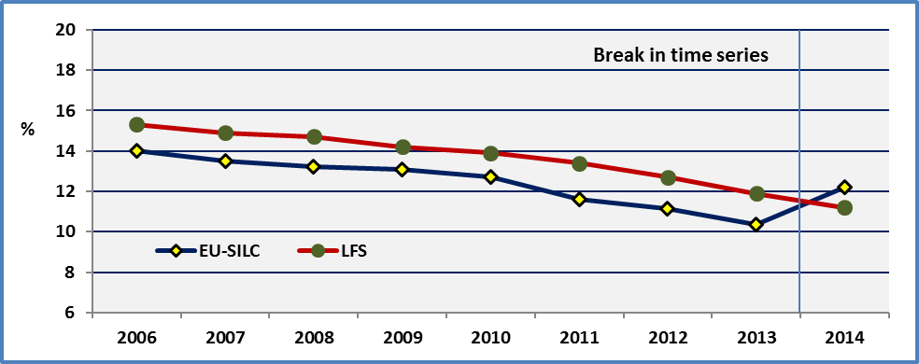

**Data source:** EU-SILC UDB and Eurostat.

2014 and after

As noted the indicator is defined as the percentage of the population aged 18-24 with at most lower secondary education and who were not in further education or training during the last four weeks preceding the survey. Educational attainment is defined according to the International Standard Classification of Education (ISCED).

Eurostat notes that from 2014, the educational attainment level is to be coded according to the ISCED 2011 in the LFS survey. Lower secondary education refers to ISCED 2011 level 0, 1 and 2 (for data as from 2014) for the LFS survey.

Similarly, for the EU-SILC survey, the classification to be used for Highest ISCED level attained is ISCED 2011.

For 2014, although both surveys use the same ISCED 2011 classification, there is a significant difference between the two surveys. The LFS survey presents an estimation of 11.2% and the EU-SILC of 12.2%. The corresponding 95% confidence interval for the EU-SILC estimation is 11.6% and 12.8%.[28]

Sampling size issues

The indicator for persons with disabilities presents another specific problem. The number of observations in the EU-SILC survey, notably persons with activity limitations aged 18-24, is relatively small. Consequently, the estimations ought to be taken with care. In order to avoid these statistical problems, we enlarge the age group to cover persons aged 18-29. But this indicator does not correspond anymore to Europe 2020 target population.

Comparison by Member State and survey

In order to assess further the strength of this indicator, we compare the national results of both surveys below. Generally, there is a good correlation of national estimators (R²=0.78) but the difference is higher than 3 percentage points (in absolute values) in seven Member States (Finland, Romania, Latvia, UK, Bulgaria, Portugal and Luxembourg). This requires further analysis in the future.

**Figure 50: Share of early school leavers by survey. Persons aged 18-24, 2014**

Percentage of the population aged 18-24 with at most lower secondary education and not in further education or training. Europe 2020 target: the EU average should be under 10%.

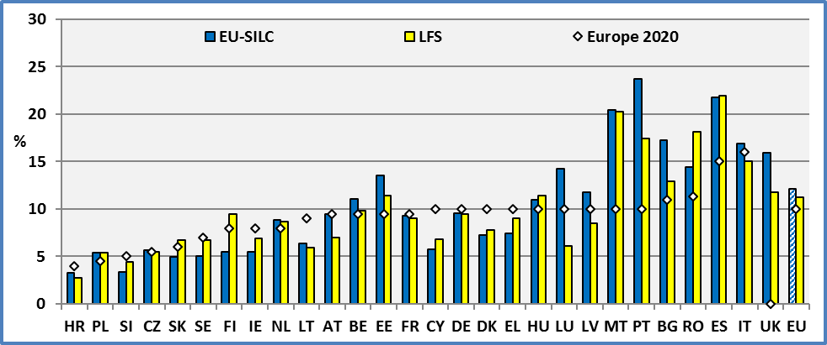

**UK**: The UK did not set any national targets for employment, R&D, tertiary education and early-school leaving.

**Note:** A higher national percentage compared to the national target means that the share of early school leavers ought to be reduced.

**Surveys:** The two surveys do not use the same sample.

**Data source:** EU-SILC 2014 and Eurostat.

The LFS survey does not distinguish between disabled and non-disabled. Consequently, in the following, we use the EU-SILC data.

2.2 General comments

Several Member States have reached or are close to the national or the European target of 10%. This is notably true for persons without disabilities. On the contrary, the situation of people with disabilities appears extremely disadvantaged.

However, due to sampling limitations, the annual estimations concerning persons with disabilities ought to be interpreted with caution. In fact, the number of observations concerning persons with limitations aged 18 to 24 in the sample and for which we have the relevant information is less than 50 in several countries. As shown in previous ANED reports, the confidence intervals are large and any conclusion based on the mean for persons with disabilities aged 18-24 might lead to erroneous conclusions. For this reason, we present also the averages for 2013 and 2014.

**Figure 51: Share of early school leavers by disability status, Age 18-24, 2014**

The EU-SILC indicators tend to under-estimate the rate of early school leavers.

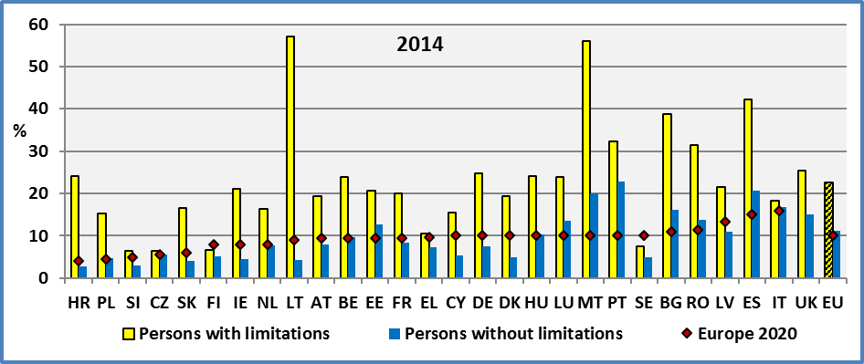

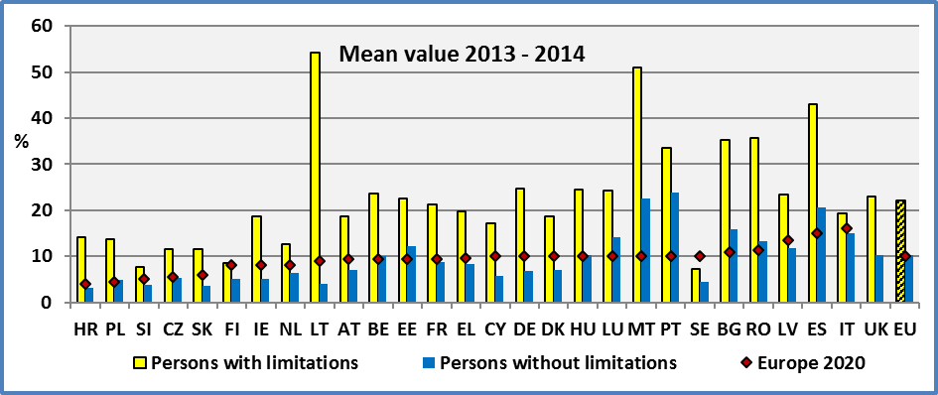

**UK**: The UK did not set any national targets for employment, R&D, tertiary education and early-school leaving.

**Note:** Due to sampling limitations, the estimations for persons with disabilities are indicative, notably 2014 annual estimations for BG, CZ, EL, HR, LT, MT, RO, & SE.

**Data source:** EU-SILC UDB 2014

Despite sampling limitations, the EU indicator is quite robust. The values of two consecutive years are close despite certain changes noted above in the methodology.

In 2014, at the EU level, 22.5% of young disabled aged 18-24 are early school leavers compared to 11.2% for non-disabled young persons. The EU average rate is 12.2%.

At the EU level, there is a gap between persons with and without disabilities of about 11.3 percentage points. We can say that this gap between young persons with and without disabilities is small in Italy, Slovenia, Finland and Sweden. On the other hand, this gap is relatively high in Spain, Romania, Malta and Lithuania.

In 2014, this represents about 705,000 young persons with limitations aged 18-24, living in private households, who are early school leavers, out of approximately 3,131,000 young disabled aged 18-24 living in private households.

The high rates of early school leavers among young disabled might indicate problems related to accessibility and absence of adapted programmes. Physical and architectural barriers might be important obstacles but also methods and instruments which do not meet the abilities of young disabled.

2.3 Extension of the target group to persons aged 18-29

Despite the reservations noted above, the discussion below indicates that the estimators for young disabled persons can be used as a basis for discussion and monitoring in most countries.

As noted above, the number of observations concerning people with disabilities aged 18-24 is relatively small. For this reason, we present for comparison the estimations for the age group 18-29. These estimations are more robust.

In the following graph, we present the rate of early school leavers for persons with disabilities. We may note that the two series (age 18-24 and 18-29) are very close (R²=0.84). Despite the statistical limitations of the national indicators for persons with disabilities aged 18-24, the general picture seems correct, except in a limited number of countries. For example, a big difference can be observed in Greece between the age groups 18-24 and 18-29, but this might be due to the impact of the economic recession; younger persons tend to stay more at school given the low job opportunities.

For the big majority of Member States, the two estimators are very close. At the EU level, the share of early school leavers among young disabled aged 18-29 is close to the share of young disabled aged 18-24. The percentages are respectively 23.9% (age 18-29) and 22.5% (age 18-24). Recent policies have decreased the number of early school leavers among younger generations.

**Figure 52: Share of young disabled early school leavers by age group, 2014**

The estimations for 18-24 are indicative.

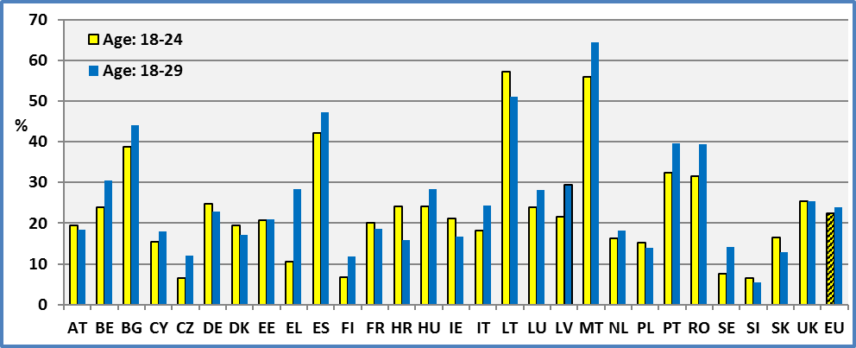

**Note:** Data for the age group 18-24 are indicative for BG, CZ, EL, HR, LT, MT, RO, & SE. Data for the age group 18-29 are indicative for MT and SE.

**Data source:** EU-SILC UDB 2014

The next graph presents the share of early school leavers for the enlarged age group 18-29 for youth with and without disabilities. Again, we find important differences between young persons with and without disabilities aged 18-29.

At the EU level, about 23.9% of persons with disabilities aged 18-29 are early school leavers compared to 12.4% for the equivalent group of persons without disabilities. The total rate for persons aged 18-29 is 13.4%. As noted above, a new classification was used in 2014.

Generally, if we compare the results for persons with and without disabilities, we find a correlation (R²=0.57) between the two rates. Countries with low rates of early school leavers among young persons without disabilities present low rates for young persons with disabilities too. However, countries with similar rates for young non-disabled present very different rates for young disabled. This means, that there is a possibility for improving the situation in a certain number of Member States.

**Figure 53: Share of early school leavers by disability status, Age 18-29, 2014**

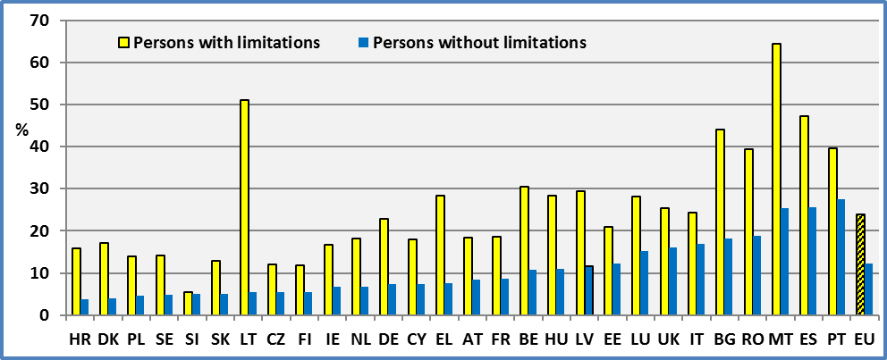

**Data source:** EU-SILC UDB 2014

The disadvantage of young persons with disabilities compared to young persons without disabilities can be measured by the difference of the respective shares of early school leavers. The estimations for the age group 18-24 are sensible due to a relatively small sample size in several Member States. In order to minimise these problems, we present also, the gap for the age group 18-29. The estimations for this later age group are relatively more robust are they are based on a larger sample.

At the EU level and for the age group 18-29, the disability gap between persons with and without disabilities is about 11.6 percentage points (11.5 pp in 2013). This is close to the gap noted above for the age group 18-24 (11.3%) but lower as expected. This difference seems to be small in Slovenia, Finland and the Czech Republic. Finland had a small gap in previous years too. On the other hand, this gap is relatively important in Bulgaria, Malta and Lithuania. This gap was high in Lithuania in previous years too.

From a policy perspective, this gap measures the efforts Member States ought to develop in order to achieve equality of opportunities among young persons with and without disabilities.

**Figure 54: The disadvantage of young persons with disabilities, 2014**

Disability gap in early school leavers = Percent of persons with disabilities – Percent of persons without disabilities

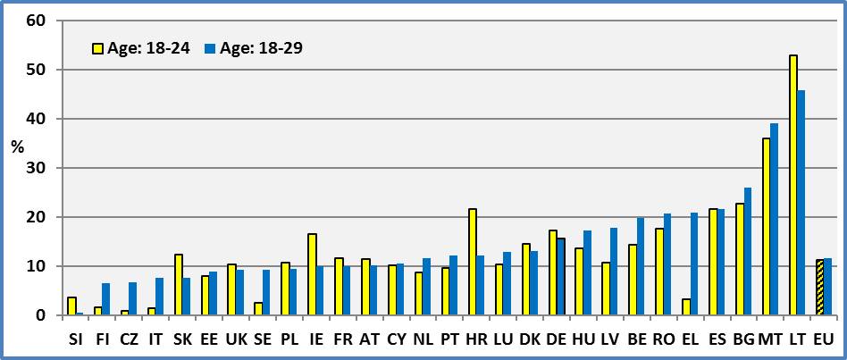

**Note:** Data for the age group 18-24 are indicative for BG, CZ, EL, HR, LT, MT, RO, & SE. Data for the age group 18-29 are indicative for MT and SE.

**Data source:** EU-SILC 2014

2.4 Early school leavers by gender

Due to sampling limitations, we do not present estimations by gender for the age group 18-24. The data in the tables have only an indicative value. As noted above, the number of observations concerning young persons with disabilities aged 18-24 is relatively small. This makes the indicators very unstable. The standard errors are very high and the confidence intervals become very large. Consequently, we discuss here only the EU indicators as they are not affected by these problems.

At the EU level, young women aged 18-24 have better achievements (lower share of early school levers) compared to young boys aged 18-24. Early school leavers among young girls represent 9.8% compared to 14.4% among young boys. The grand total is 12.2% with the new classification.

This applies also for young women with disabilities in comparison to young boys with disabilities. At the EU level, among girls with disabilities aged 18-24, 17.5% are early school leavers compared to 27.5% for young disabled boys. Among disabled youth, the gender gap is -9.9 percentage points.

The disability gap between boys with and without disabilities is about 14.2 percentage points. The difference for girls with and without disabilities is about 8.5 percentage points.

**Figure 55: Persons with disabilities - Share of early school leavers by gender, EU, Age 18-24, 2014**

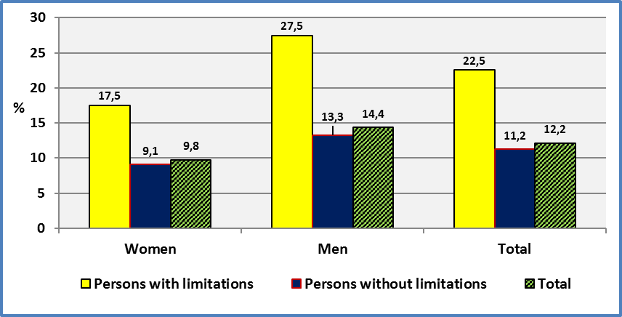

**Data source:** EU-SILC UDB 2014

In order to discuss national situations, we enlarge the age group to cover young persons aged 18-29. This reduces sampling problems as the number of observations concerning young disabled increases.

The following graph indicates that in the big majority of Member States, young women with disabilities aged 18-29 have better achievements (lower share of early school levers) compared to young boys with disabilities of the same age group.

At the EU level, among girls with disabilities aged 18-29, 20.7% are early school leavers compared to 27.3% for young disabled boys. There is a difference of 6.6 percentage points.

**Figure 56: Persons with disabilities - Share of early school leavers by gender, Age 18-29, 2014**

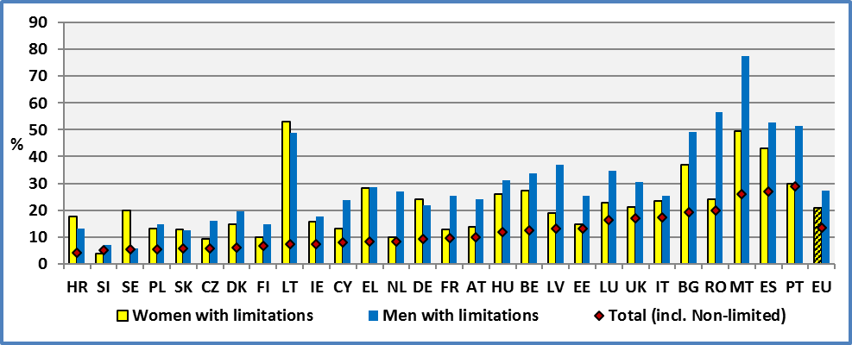

**Note:** The estimations are indicative for BG, CZ, DK, EL, HR, LT, MT, RO & SE.

**Data source:** EU-SILC UDB 2014

2.5 Early school leavers by degree of disability

The limited number of observations concerning persons with disabilities aged 18-24 does not enable us to present estimations by degree of disability and by Member State. Consequently, we present the percentage of early school leavers for the EU.

The rate of early school leavers among young with a severe limitation is 41.1%. The equivalent rate for persons with a moderate disability is 17.0%. This rate is 11.2% for persons without disabilities. The total is 12.2%.

The following chart reveals the particularly disadvantaged position of young persons with a severe limitation aged 18-24.

**Figure 57: Early school leavers by degree of disability. Age 18-24, EU 2014**

Percent of the population aged 18-24. Europe 2020 is 10%.

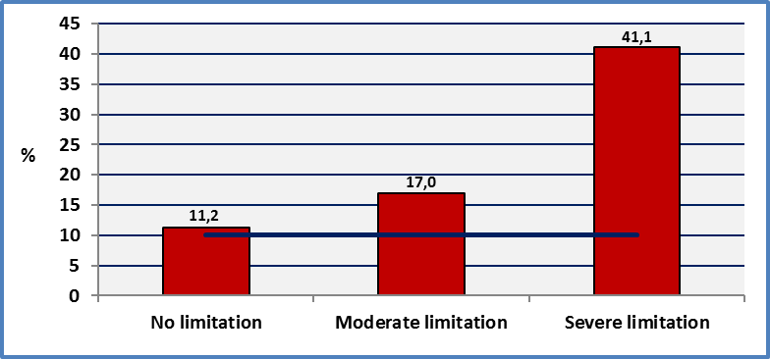

**Data source:** EU-SILC UDB 2014

2.6 Evolution at the EU level

A persistent high level of early school leavers means that these persons enter the labour market without a skill. This constitutes an important barrier for their integration into the labour market and their adaptability to technological change. This disadvantage is notably high for young disabled persons.

For young persons without disabilities, the decrease was continuous since 2006, except a small increase in 2009. The evolution for persons with disabilities is more erratic. We may observe a declining trend concerning the share of early school leavers among persons with disabilities but with several fluctuations around the trend. However, the analysis of the evolution of early school leavers aged 18-29 indicates that this fluctuation for persons aged 18-24 might be due to sampling errors and thus overstated.

For both groups (disabled and non-disabled), we may observe a change after 2010. This is more apparent for the age group 18-29. After this date, the line has shifted downwards. Probably, the economic crisis of 2008/2009 has reduced job opportunities for young persons. This has pushed several young to stay at school or prolong their studies.

The change of classification in 2014 does not enable us to present a comparison by Member State.

**Figure 58: Evolution of the shares of early school leavers. EU, Age: 18-24 and 18-29**

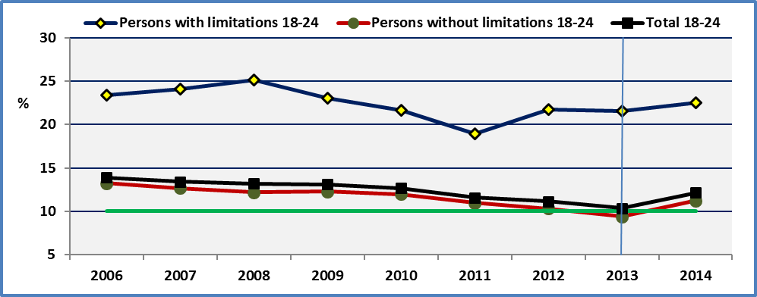

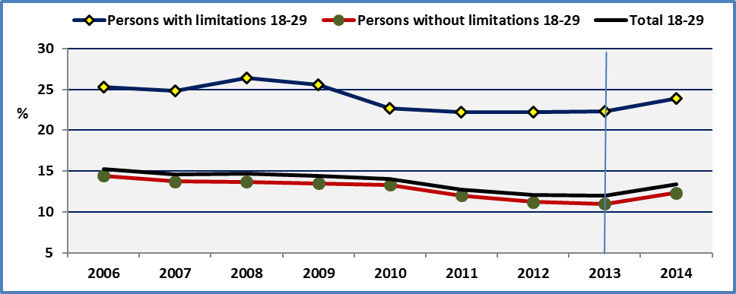

**Note:** Break in time series due to a new classification since 2014.

**Data source:** EU-SILC UDB

A further analysis by degree of disability indicates that the gap between persons with and without disabilities aged 18-24 was higher in 2014 compared to 2010. But this might have been affected by the change of classification in 2014.

**Figure 59: Evolution of the shares of early school leavers by degree of disability. EU, Age: 18-24.**

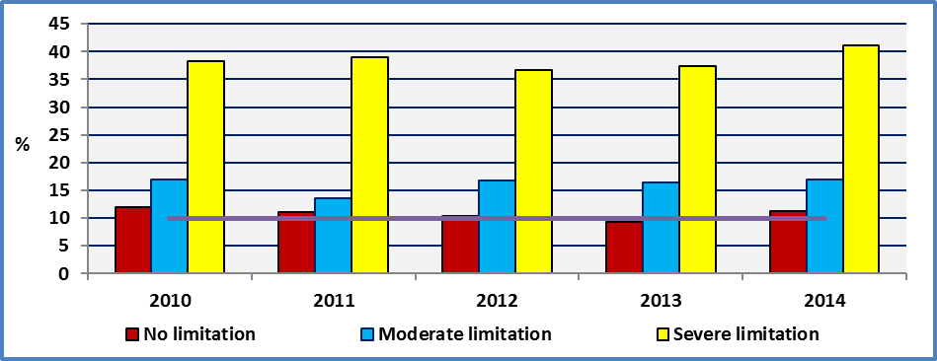

**Data source:** EU-SILC UDB

2.7 Early school leavers and households with and without computers

The EU-SILC survey includes a question asking if the household has a computer (Question HS090: Do you have a computer)? This question is used to construct a non-monetary household deprivation indicator. The possible answers are 1. Yes, 2. No – cannot afford and 3. No – other reason. It is accepted that the second answer (No – cannot afford) can be used as an indicator of household wealth. The third option (No – other reason) might be due to a lack of skills in using a computer. But any significant difference between persons with and without disabilities might reveal a lack of technical aids and accessible instruments.

We may note that poverty and the associated lack of a computer in the household increases sharply the percentage of early school leavers for all groups. Furthermore, the difference between persons with and without disabilities is decreased.

The third option “no – other reason” presents some interesting aspects. We may advance that the lack of relevant skills might be one of the “other reasons”. Lack of computer skills might explain the absence of a computer in the household or less probably because they don’t need it. However, for persons with a severe disability a lack of adequate/accessible equipment might be another reason. In any case, the unreasonable high rate (71.0%) of early school leavers among this group requires further analysis.

**Figure 60: Percent of early school leavers by disability status living in households with and without computer. EU 2014**

How to read the graph;9.1: Percentage of early school leavers among persons without limitations living in a household with a computer. 71.0: Percentage of early school leavers among persons with a severe limitation living in a household which does not have a computer (for other reason).

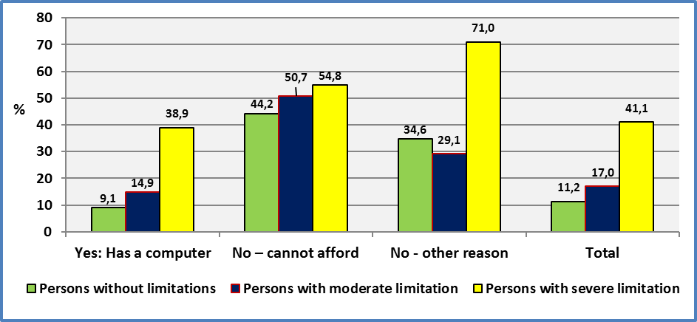

**Data source :** EU-SILC UDB 2014

2.8 Unemployment of early school leavers

As noted above, early school leavers enter the labour market without the necessary educational/training capital required by labour market needs. Furthermore, they might miss the necessary minimal human capital enabling them to acquire on the job training and hence a low initial human capital may push early school leavers into low qualified unstable jobs.

The following graph indicates that there is an important difference between early school leavers and non-early school leavers. The unemployment rate among early school leavers is much higher compared to non-early school leavers. This holds both for persons with and without disabilities.

**Figure 61: Unemployment rate of early school leavers, EU 2014**

|  |  |
| --- | --- |
| **Age: 20-29** | **Age: 20-64** |

**Data source:** EU-SILC 2014

For all young persons aged 20-29, the difference between early school leavers and non-early school leavers is about 21 percentage points. The equivalent gap for persons with disabilities is 24 percentage points. For persons aged 20-64, this gap amounts to 14 percentage points. The equivalent gap for persons with disabilities is 15 percentage points.

Furthermore, we may note a qualitative difference concerning the unemployment rate of early school leavers and non-early school leavers. The unemployment duration of early school leavers is higher compared to non-early school leavers.

To summarise, investing in education leads to higher employment possibilities and probably to better jobs (better qualified and stable). Furthermore, the labour force has the necessary human capital in order to participate in continuous training and learning able to accompany technological change and innovation.

2.9 Percent of early school leavers and confidence interval at 95%

As noted above, the number of persons with disabilities aged 18-24 is relatively small in several Member States (less than 50 disabled persons in the sample aged 18-24). This creates a certain number of problems, notably concerning the robustness of the indicator covering the number of persons aged 18-24 who are early school leavers.

In fact, the standard error for this indicator covering persons without disabilities varies from 0.5 percentage point (in several countries) to 1.3 (in Bulgaria). The average of national standard errors for this group is 0.9 percentage point. But the standard error for the same indicator covering persons with disabilities varies from 2.0 percentage points (in Finland) to 12.0 (in Malta). The average of national standard errors for this group is 4.9 percentage points. Consequently, this indicator conveys little information and the comparison between persons with and without disabilities is not possible in several Member States.

However, if we focus on indicators at the EU level, the standard errors are reduced sharply and the confidence intervals are not overlapping. The difference between persons with and without disabilities is statistically significant. When we extend the age group to 18-29, the robustness of the indicators are improved as shown in the following graph.

**Figure 62: Percent of early school leavers by disability status and confidence intervals at 95%. EU 2014**

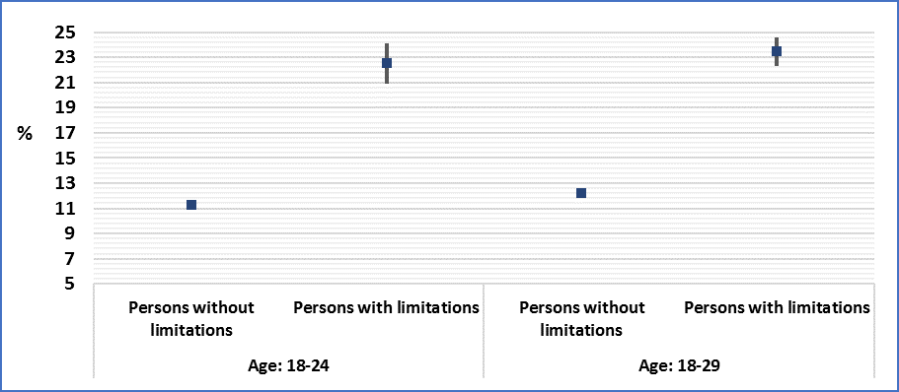

**Data source:** EU-SILC UDB 2014

### 3. Data

**Table 71: Share of early school leavers (Age 18-24).**

The EU-SILC estimators for disabled young are indicative.

Percentage of the population aged 18-24 with at most lower secondary education and not in further education or training. The EU-SILC data are not comparable with LFS data.

|  |  |  |  |  |  |  |  |  |  |  |  |
| --- | --- | --- | --- | --- | --- | --- | --- | --- | --- | --- | --- |
|  | **2008** | | | | | **2009** | | | | | **EU 2020** |
|  | **Men + Women** | | | | | **Men + Women** | | | | |  |
|  | **Disability** | | | **All** | **LFS** | **Disability** | | | **All** | **LFS** |  |
|  | **Yes** | **No** | **Total** |  |  | **Yes** | **No** | **Total** |  |  |  |
| **AT** | 24,7 | 12,6 | 13,6 | **13,6** | 10,1 | 27,3 | 9,5 | 11,2 | **11,2** | 8,7 | 9,5 |
| **BE** | 27,1 | 9,9 | 12,7 | **12,7** | 12,0 | 25,7 | 11,5 | 12,4 | **12,4** | 11,1 | 9,5 |
| **BG** | 54,7 | 21,9 | 23,1 | **23,1** | 14,8 | 23,9 | 18,2 | 18,4 | **18,4** | 14,7 | 11,0 |
| **CY** | 22,8 | 8,4 | 8,9 | **8,9** | 13,7 | 25,7 | 5,2 | 6,1 | **6,1** | 11,7 | 10,0 |
| **CZ** | 9,7 | 5,7 | 6,5 | **6,5** | 5,6 | 15,3 | 5,8 | 6,5 | **6,6** | 5,4 | 5,5 |
| **DE** | 19,9 | 8,1 | 9,5 | **9,5** | 11,8 | 24,3 | 8,6 | 10,0 | **10,4** | 11,1 | 9,9 |
| **DK** | 27,2 | 16,8 | 18,7 | **17,1** | 12,5 | 16,2 | 19,6 | 19,1 | **21,3** | 10,6 | 9,9 |
| **EE** | 28,3 | 13,7 | 14,6 | **14,6** | 14,0 | 17,6 | 15,7 | 15,8 | **15,8** | 13,9 | 9,5 |
| **EL** | 36,0 | 10,1 | 10,5 | **10,5** | 14,8 | 23,5 | 5,9 | 6,0 | **6,0** | 14,5 | 9,7 |
| **ES** | 40,5 | 27,7 | 28,4 | **28,4** | 31,9 | 42,3 | 26,5 | 27,6 | **27,6** | 31,2 | 15,0 |
| **FI** | 26,8 | 8,7 | 11,2 | **10,9** | 9,8 | 14,5 | 8,4 | 9,3 | **10,0** | 9,9 | 8,0 |
| **FR** |  |  |  |  | 11,5 | 17,7 | 12,6 | 13,0 | **13,0** | 12,4 | 9,5 |
| **HU** | 20,3 | 12,3 | 12,7 | **12,7** | 11,7 | 22,5 | 10,8 | 11,3 | **11,5** | 11,2 | 10,0 |
| **IE** | 31,3 | 10,1 | 11,9 | **11,9** | 11,3 | 26,5 | 8,1 | 9,8 | **9,8** | 11,3 | 8,0 |
| **IT** | 32,5 | 17,0 | 18,0 | **18,0** | 19,7 | 19,5 | 18,3 | 18,4 | **18,4** | 19,2 | 15,0 |
| **LT** | 11,8 | 5,8 | 5,7 | **5,7** | 7,4 | 28,7 | 7,6 | 8,6 | **9,2** | 8,7 | 8,9 |
| **LU** | 24,1 | 12,1 | 13,1 | **13,1** | 13,4 | 17,6 | 13,6 | 13,8 | **14,0** | 7,7 | 9,9 |
| **LV** | 29,1 | 15,1 | 16,3 | **16,3** | 15,5 | 32,5 | 16,5 | 17,9 | **17,9** | 13,9 | 13,4 |
| **MT** |  |  |  |  | 38,1 | 48,9 | 30,1 | 30,6 | **30,5** | 36,8 | 29,0 |
| **NL** | 21,0 | 8,1 | 9,5 | **13,1** | 11,4 | 22,5 | 7,8 | 9,6 | **13,4** | 10,9 | 7,9 |
| **PL** | 17,2 | 3,7 | 4,4 | **4,4** | 5,0 | 15,5 | 4,4 | 5,0 | **5,0** | 5,3 | 4,5 |
| **PT** | 58,5 | 33,1 | 34,8 | **34,8** | 35,4 | 40,4 | 28,3 | 29,4 | **29,4** | 31,2 | 10,0 |
| **RO** | 65,9 | 14,6 | 16,1 | **16,1** | 15,9 | 64,6 | 14,7 | 15,8 | **15,8** | 16,6 | 11,3 |
| **SE** | 12,4 | 6,1 | 6,6 | **7,2** | 7,9 | 13,0 | 5,2 | 5,7 | **8,0** | 10,7 | 9,9 |
| **SI** | 8,3 | 4,2 | 4,7 | **4,9** | 5,1 | 4,9 | 4,6 | 4,6 | **4,9** | 5,3 | 5,0 |
| **SK** | 4,5 | 2,4 | 2,6 | **2,6** | 6,0 | 4,5 | 3,0 | 3,1 | **3,1** | 4,9 | 6,0 |
| **UK** | 16,1 | 6,8 | 7,6 | **7,6** | 17,0 | 16,6 | 7,9 | 8,5 | **8,6** | 15,7 |  |
|  |  |  |  |  |  |  |  |  |  |  |  |
| **EU** | 25,1 | 12,2 | 13,2 | **13,3** | 14,8 | 23,0 | 12,3 | 13,1 | **13,3** | 14,4 | 10,0 |

**Data source:** EU-SILC UDB 2008, 2009 and Eurostat

**LFS data:** <http://epp.eurostat.ec.europa.eu/portal/page/portal/europe_2020_indicators/headline_indicators>

**Note:** The number of observations concerning persons with disabilities aged 18-24 is very small in several Member States. For example, in 2008, this number is less than 100 observations in 16 Member States.

**All:** It includes observations for which we do not dispose information on disability status.

**Table 72: Share of early school leavers (Age 18-24).**

The EU-SILC estimators for disabled young are indicative.

Percentage of the population aged 18-24 with at most lower secondary education and not in further education or training. The EU-SILC data are not comparable with LFS data.

|  |  |  |  |  |  |  |  |  |  |  |  |
| --- | --- | --- | --- | --- | --- | --- | --- | --- | --- | --- | --- |
|  | **2010** | | | | | **2011** | | | | | **EU 2020** |
|  | **Men + Women** | | | | | **Men + Women** | | | | |  |
|  | **Disability** | | | **All** | **LFS** | **Disability** | | | **All** | **LFS** |  |
|  | **Yes** | **No** | **Total** |  |  | **Yes** | **No** | **Total** |  |  |  |
| **AT** | 17,6 | 10,1 | 10,7 | **10,7** | 8,3 | 10,8 | 13,4 | 13,2 | **13,2** | 8,3 | 9,5 |
| **BE** | 17,5 | 12,8 | 13,1 | **13,6** | 11,9 | 18,8 | 9,2 | 9,7 | **9,8** | 12,3 | 9,5 |
| **BG** | 44,1 | 18,1 | 18,6 | **18,6** | 13,9 | 16,9 | 18,0 | 18,0 | **18,0** | 11,8 | 11,0 |
| **CY** |  |  |  |  | 12,6 | 15,3 | 6,7 | 7,1 | **7,1** | 11,3 | 10,0 |
| **CZ** | 23,0 | 6,2 | 7,2 | **6,4** | 4,9 | 25,6 | 6,2 | 7,2 | **6,6** | 4,9 | 5,5 |
| **DE** | 23,5 | 7,5 | 8,9 | **9,1** | 11,9 | 20,6 | 6,9 | 8,1 | **8,5** | 11,7 | 9,9 |
| **DK** | 38,2 | 18,6 | 22,1 | **22,8** | 11,0 | 31,9 | 14,0 | 17,2 | **17,9** | 9,6 | 9,9 |
| **EE** | 15,7 | 13,0 | 13,2 | **13,2** | 11,6 | 24,2 | 11,3 | 12,5 | **12,5** | 10,9 | 9,5 |
| **EL** | 5,0 | 5,4 | 5,4 | **5,4** | 13,7 | 33,6 | 4,6 | 4,9 | **4,9** | 13,1 | 9,7 |
| **ES** | 38,1 | 28,6 | 29,2 | **29,2** | 28,4 | 37,7 | 23,2 | 23,9 | **23,9** | 26,5 | 15,0 |
| **FI** | 10,9 | 4,5 | 5,5 | **8,0** | 10,3 | 8,4 | 6,2 | 6,6 | **8,1** | 9,8 | 8,0 |
| **FR** | 16,9 | 10,4 | 10,9 | **10,9** | 12,6 | 18,6 | 9,7 | 10,4 | **10,4** | 12,0 | 9,5 |
| **HR** |  |  |  |  |  | 17,6 | 2,3 | 2,8 | **3,4** | 4,1 |  |
| **HU** | 18,1 | 11,1 | 11,4 | **11,4** | 10,5 | 20,9 | 10,3 | 10,8 | **10,8** | 11,2 | 10,0 |
| **IE** |  |  |  |  | 11,4 |  |  |  |  | 10,8 | 8,0 |
| **IT** | 22,7 | 18,0 | 18,2 | **18,2** | 18,8 | 30,3 | 18,0 | 18,4 | **18,1** | 18,2 | 15,0 |
| **LT** | 34,8 | 9,3 | 10,2 | **10,2** | 8,1 | 47,6 | 7,8 | 9,8 | **10,0** | 7,2 | 8,9 |
| **LU** | 12,9 | 15,4 | 15,2 | **15,5** | 7,1 | 26,4 | 13,4 | 14,2 | **14,1** | 6,2 | 9,9 |
| **LV** | 27,8 | 16,8 | 17,7 | **17,7** | 13,3 | 31,3 | 15,5 | 16,7 | **16,7** | 11,6 | 13,4 |
| **MT** | 41,1 | 29,3 | 29,4 | **29,4** | 36,9 | 44,4 | 30,1 | 30,4 | **30,3** | 23,6 | 29,0 |
| **NL** | 15,3 | 9,2 | 9,9 | **13,1** | 10,0 | 12,8 | 13,4 | 13,4 | **13,7** | 9,1 | 7,9 |
| **PL** | 18,1 | 4,8 | 5,6 | **5,6** | 5,4 | 7,3 | 4,6 | 4,8 | **4,8** | 5,6 | 4,5 |
| **PT** | 39,5 | 24,5 | 25,9 | **25,8** | 28,7 | 34,0 | 24,4 | 25,0 | **25,0** | 23,2 | 10,0 |
| **RO** | 31,8 | 15,7 | 16,3 | **16,3** | 18,4 | 50,5 | 15,7 | 17,0 | **17,0** | 17,5 | 11,3 |
| **SE** | 9,9 | 5,6 | 5,8 | **8,0** | 9,7 | 4,9 | 4,7 | 4,7 | **7,5** | 6,6 | 9,9 |
| **SI** | 5,2 | 2,9 | 3,3 | **4,1** | 5,0 | 5,9 | 4,3 | 4,6 | **5,0** | 4,2 | 5,0 |
| **SK** | 5,4 | 3,6 | 3,7 | **3,8** | 4,7 | 6,1 | 3,2 | 3,4 | **3,5** | 5 | 6,0 |
| **UK** | 18,0 | 7,7 | 8,6 | **8,5** | 14,9 | 9,2 | 5,0 | 5,4 | **5,6** | 15 |  |
|  |  |  |  |  |  |  |  |  |  |  |  |
| **EU** | 21,6 | 12,0 | 12,7 | **12,8** | 14,1 | 18,9 | 11,0 | 11,6 | **11,6** | 13,4 | 10,0 |

**Data source:** EU-SILC UDB 2010 & 2011

**LFS data:** <http://epp.eurostat.ec.europa.eu/portal/page/portal/europe_2020_indicators/headline_indicators>

**Note:** **In 2010**, the number of limited persons aged 18 to 24 are less than 50 observations in the following countries: Bulgaria, Greece, Lithuania, Malta and Sweden. Also, Poland and the UK have a relatively high number of observations with missing information on education. **In 2011**, the number of limited persons aged 18 to 24 are less than 50 observations in the following countries: Czech Republic, Greece, Croatia, Lithuania, Malta, Romania and Sweden. Also, Poland and the UK have a relatively high number of observations with missing information on education.

**All:** It includes observations for which we do not dispose information on disability status.

**Table 73: Share of early school leavers (Age 18-24).**

The EU-SILC estimators for disabled young are indicative.

Percentage of the population aged 18-24 with at most lower secondary education and not in further education or training. The EU-SILC data are not comparable with LFS data.

|  |  |  |  |  |  |  |  |  |  |  |  |
| --- | --- | --- | --- | --- | --- | --- | --- | --- | --- | --- | --- |
|  | **2012** | | | | | **2013** | | | | | **EU 2020** |
|  | **Men + Women** | | | | | **Men + Women** | | | | |  |
|  | **Disability** | | | **All** | **LFS** | **Disability** | | | **All** | **LFS** | **Target** |
|  | **Yes** | **No** | **Total** |  |  | **Yes** | **No** | **Total** |  |  |  |
| **AT** | 27,4 | 9,7 | 11,2 | **11,2** | 7,6 | 18,0 | 6,0 | 7,2 | **7,2** | 7,5 | 9,5 |
| **BE** | 32,5 | 9,2 | 10,8 | **10,8** | 12,0 | 23,4 | 10,4 | 11,5 | **11,8** | 11,0 | 9,5 |
| **BG** | 30,6 | 14,7 | 15,6 | **15,6** | 12,5 | (31,6) | 15,6 | 16,3 | **16,3** | 12,5 | 11 |
| **CY** | 20,5 | 8,3 | 8,9 | **8,9** | 11,4 | 19,0 | 6,2 | 6,9 | **6,9** | 9,1 | 10 |
| **CZ** | (11,2) | 4,4 | 4,8 | **6,1** | 5,5 | 16,6 | 5,0 | 5,5 | **6,0** | 5,4 | 5,5 |
| **DE** | 19,0 | 7,5 | 8,5 | **9,1** | 10,6 | 24,6 | 6,2 | 8,0 | **8,8** | 9,8 | <10 |
| **DK** | 15,3 | 9,9 | 10,8 | **10,8** | 9,1 | 17,7 | 9,0 | 10,5 | **11,6** | 8,0 | <10 |
| **EE** | 27,0 | 11,4 | 13,2 | **13,3** | 10,3 | 24,3 | 11,6 | 13,1 | **13,1** | 9,7 | 9,5 |
| **EL** | 37,2 | 6,0 | 6,3 | **6,3** | 11,4 | 29,0 | 9,2 | 9,4 | **9,4** | 10,1 | 9,7 |
| **ES** | 37,4 | 23,1 | 23,7 | **23,7** | 24,7 | 43,9 | 20,7 | 22,0 | **22,0** | 23,6 | * 15 |
| **FI** | 11,1 | 3,9 | 5,1 | **6,3** | 8,9 | 10,5 | 5,0 | 6,3 | **7,3** | 9,3 | 8 |
| **FR** | 20,5 | 10,0 | 10,8 | **10,8** | 11,5 | 22,7 | 9,2 | 10,2 | **10,2** | 9,7 | 9,5 |
| **HR** | (22,3) | 2,4 | 3,1 | **3,1** | 4,2 | (3,9) | 3,7 | 3,7 | **3,7** | 4,5 | 4 |
| **HU** | 28,0 | 10,9 | 11,6 | **11,6** | 11,5 | 25,0 | 10,1 | 10,9 | **10,9** | 11,9 | 10 |
| **IE** | (16,5) | 6,6 | 7,1 | **7,1** | 9,7 | (16,2) | 5,6 | 6,1 | **6,1** | 8,4 | 8 |
| **IT** | 23,8 | 14,5 | 15,2 | **15,0** | 17,6 | 20,5 | 13,1 | 13,6 | **13,7** | 16,8 | (15-16) 16 |
| **LT** | (51,1) | 6,7 | 9,2 | **9,1** | 6,5 | (51,4) | 3,8 | 5,8 | **6,0** | 6,3 | <9 |
| **LU** | 15,3 | 13,2 | 13,3 | **13,5** | 8,1 | 24,6 | 14,9 | 15,7 | **15,6** | 6,1 | <10 |
| **LV** | 18,4 | 11,6 | 12,2 | **12,2** | 10,6 | 25,4 | 12,5 | 13,8 | **13,8** | 9,8 | 13,4 |
| **MT** | 69,3 | 27,1 | 27,5 | **27,5** | 21,1 | 46,1 | 25,2 | 25,5 | **25,5** | 20,5 | 10 |
| **NL** | 18,4 | 9,9 | 11,0 | **11,0** | 8,8 | 9,0 | 4,9 | 5,5 | **11,4** | 9,2 | <8 |
| **PL** | 12,2 | 4,3 | 4,8 | **4,8** | 5,7 | 12,0 | 4,9 | 5,3 | **5,3** | 5,6 | 4,5 |
| **PT** | 35,1 | 21,4 | 22,1 | **22,1** | 20,8 | 34,5 | 24,8 | 25,4 | **25,4** | 18,9 | 10 |
| **RO** | 42,6 | 17,0 | 18,4 | **18,4** | 17,4 | 40,1 | 12,7 | 14,0 | **14,0** | 17,3 | 11,3 |
| **SE** | (14,8) | 4,1 | 4,9 | **4,9** | 7,5 | 7,2 | 3,9 | 4,3 | **4,8** | 7,1 | <10 |
| **SI** | 11,2 | 4,6 | 5,5 | **5,5** | 4,4 | 9,1 | 4,6 | 5,1 | **4,9** | 3,9 | 5 |
| **SK** | 5,1 | 3,5 | 3,6 | **3,6** | 5,3 | 6,5 | 3,0 | 3,2 | **3,2** | 6,4 | <6 |
| **UK** | 20,6 | 6,0 | 7,2 | **7,2** | 13,6 | 20,5 | 5,6 | 7,0 | **7,0** | 12,3 |  |
|  |  |  |  |  |  |  |  |  |  |  |  |
| **EU** | **21,8** | **10,3** | **11,2** | **11,2** | **12,7** | **21,5** | **9,4** | **10,4** | **10,7** | 11,9 | **<10** |
|  |  |  |  |  |  |  |  |  |  |  |  |
| **CH** | 8,0 | 5,3 | 5,6 | **5,6** | 5,5 | 5,9 | 9,3 | 6,5 | **6,5** |  |  |
| **IS** | (22,1) | 17,8 | 18,3 | **18,7** | 20,1 | (17,8) | 32,5 | 19,7 | **20,2** |  |  |
| **NO** | (45,3) | 16,0 | 18,3 | **18,3** | 14,8 | (14,8) | 33,9 | 16,2 | **18,3** |  |  |
| **RS** |  |  |  |  |  | (9,5) | 9,1 | 9,5 | **8,9** |  |  |

**All:** It includes observations for which we do not dispose information on disability status.

**\* :** Target defined for school drop-out rate

**Notes:** **( )** : Between 20 and 49 observation. **In shadow**: Less than 20 observations.

**Data source:** EU-SILC UDB 2012, 2013 & Eurostat

**Table 74: Share of early school leavers (Age 18-24).**

The EU-SILC estimators for disabled young are indicative.

Percentage of the population aged 18-24 with at most lower secondary education and not in further education or training. The EU-SILC data are not comparable with LFS data.

|  |  |  |  |  |  |  |
| --- | --- | --- | --- | --- | --- | --- |
|  | **2014** | | | | | **EU 2020** |
|  | **Men + Women** | | | | |  |
|  | **Disability** | | | **All** | **LFS** | **Target** |
|  | **Yes** | **No** | **Total** |  |  |  |
| **AT** | 19,4 | 8,0 | 9,5 | **9,5** | 7 | 9,5 |
| **BE** | 24,0 | 9,7 | 11,1 | **11,1** | 9,8 | 9,5 |
| **BG** | (38,7) | 16,1 | 17,2 | **17,2** | 12,9 | 11 |
| **CY** | 15,4 | 5,3 | 5,8 | **5,8** | 6,8 | 10 |
| **CZ** | (6,5) | 5,6 | 5,7 | **4,9** | 5,5 | 5,5 |
| **DE** | 24,9 | 7,6 | 9,5 | **9,7** | 9,5 | <10 |
| **DK** | 19,5 | 5,0 | 7,3 | **7,6** | 7,8 | <10 |
| **EE** | 20,8 | 12,7 | 13,6 | **13,6** | 11,4 | 9,5 |
| **EL** | (10,5) | 7,4 | 7,4 | **7,4** | 9 | 9,7 |
| **ES** | 42,2 | 20,6 | 21,8 | **21,8** | 21,9 | * 15 |
| **FI** | 6,7 | 5,2 | 5,5 | **6,3** | 9,5 | 8 |
| **FR** | 20,0 | 8,4 | 9,3 | **9,3** | 9 | 9,5 |
| **HR** | (24,2) | 2,7 | 3,3 | **3,2** | 2,7 | 4 |
| **HU** | 24,0 | 10,4 | 10,9 | **10,9** | 11,4 | 10 |
| **IE** | 21,1 | 4,5 | 5,5 | **5,5** | 6,9 | 8 |
| **IT** | 18,2 | 16,8 | 16,9 | **17,0** | 15 | (15-16) 16 |
| **LT** | (57,1) | 4,4 | 6,4 | **6,6** | 5,9 | <9 |
| **LU** | 23,8 | 13,5 | 14,2 | **14,2** | 6,1 | <10 |
| **LV** | 21,5 | 10,9 | 11,8 | **11,8** | 8,5 | 13,4 |
| **MT** | 55,9 | 20,0 | 20,5 | **20,5** | 20,3 | 10 |
| **NL** | 16,3 | 7,7 | 8,9 | **10,9** | 8,7 | <8 |
| **PL** | 15,3 | 4,7 | 5,4 | **5,4** | 5,4 | 4,5 |
| **PT** | 32,4 | 22,9 | 23,8 | **23,8** | 17,4 | 10 |
| **RO** | (31,5) | 13,8 | 14,4 | **14,4** | 18,1 | 11,3 |
| **SE** | (7,5) | 5,0 | 5,1 | **5,7** | 6,7 | <10 |
| **SI** | 6,5 | 2,9 | 3,4 | **3,8** | 4,4 | 5 |
| **SK** | 16,5 | 4,1 | 5,0 | **5,0** | 6,7 | <6 |
| **UK** | 25,3 | 15,0 | 15,9 | **15,9** | 11,8 |  |
|  |  |  |  |  |  |  |
| **EU** | **22,5** | **11,2** | **12,2** | **12,2** | **11,2** | **<10** |
|  |  |  |  |  |  |  |
| **CH** | 11,0 | 5,8 | 6,8 | **6,7** | 5,4 |  |
| **IS** | 40,6 | 15,5 | 19,2 | **20,2** | 19,1 |  |
| **NO** | 25,3 | 12,5 | 13,6 | **15,4** | 11,7 |  |
| **RS** | (24,3) | 8,5 | 8,9 | **8,9** |  |  |

**All:** It includes observations for which we do not dispose information on disability status.

**\* :** Target defined for school drop-out rate

**Notes:** **( )** : Between 20 and 49 observation. **In shadow**: Less than 20 observations.

**Data source:** EU-SILC UDB 2012, 2013 & Eurostat

**Table 75: Share of early school leavers (Age 18-29)**

Percentage of the population aged 18-29 with at most lower secondary education and not in further education or training.

|  |  |  |  |  |  |  |  |  |  |  |  |  |
| --- | --- | --- | --- | --- | --- | --- | --- | --- | --- | --- | --- | --- |
|  | **2008** | | | **2009** | | | **2010** | | | **2011** | | |
|  | **Men + Women** | | | **Men + Women** | | | **Men + Women** | | | **Men + Women** | | |
|  | **Disability** | | | **Disability** | | | **Disability** | | | **Disability** | | |
|  | **Yes** | **No** | **Total** | **Yes** | **No** | **Total** | **Yes** | **No** | **Total** | **Yes** | **No** | **Total** |
| **AT** | 21,7 | 11,1 | **12,2** | 28,7 | 10,2 | **12,0** | 23,3 | 9,9 | **11,1** | 15,5 | 12,5 | **12,7** |
| **BE** | 24,4 | 11,7 | **14,3** | 30,9 | 13,3 | **14,6** | 19,4 | 13,9 | **14,4** | 22,0 | 10,9 | **11,6** |
| **BG** | 42,2 | 24,3 | **25,0** | 30,2 | 20,6 | **21,1** | 42,5 | 18,9 | **19,5** | 30,5 | 19,6 | **20,1** |
| **CY** | 19,6 | 10,7 | **11,1** | 21,1 | 9,8 | **10,4** |  |  |  | 18,6 | 10,0 | **10,4** |
| **CZ** | 11,4 | 5,4 | **6,1** | 13,0 | 5,9 | **6,4** | 16,0 | 6,3 | **7,0** | 17,5 | 4,8 | **5,6** |
| **DE** | 23,8 | 8,6 | **10,7** | 26,7 | 7,9 | **9,7** | 23,3 | 8,0 | **9,4** | 23,2 | 7,0 | **8,6** |
| **DK** | 21,5 | 14,3 | **15,7** | 17,6 | 16,0 | **16,3** | 29,0 | 14,0 | **16,5** | 25,4 | 11,7 | **14,2** |
| **EE** | 35,2 | 14,4 | **16,0** | 24,8 | 14,0 | **14,9** | 20,7 | 12,9 | **13,6** | 23,8 | 12,4 | **13,5** |
| **EL** | 37,9 | 12,1 | **12,7** | 24,7 | 10,4 | **10,5** | 10,9 | 9,3 | **9,3** | 33,3 | 7,2 | **7,6** |
| **ES** | 46,2 | 28,9 | **29,9** | 41,4 | 29,0 | **30,0** | 43,2 | 29,0 | **29,9** | 43,7 | 26,5 | **27,3** |
| **FI** | 22,0 | 8,2 | **10,0** | 15,3 | 9,2 | **10,2** | 8,8 | 5,2 | **5,8** | 9,5 | 6,9 | **7,3** |
| **FR** |  |  |  | 20,1 | 11,7 | **12,3** | 20,0 | 11,0 | **11,8** | 19,7 | 8,9 | **9,8** |
| **HR** |  |  |  |  |  |  |  |  |  | 15,0 | 4,2 | **4,6** |
| **HU** | 16,7 | 11,4 | **11,8** | 23,3 | 10,9 | **11,5** | 20,7 | 11,2 | **11,7** | 22,5 | 10,9 | **11,5** |
| **IE** | 32,8 | 11,7 | **13,4** | 29,7 | 8,6 | **10,4** |  |  |  |  |  |  |
| **IT** | 36,0 | 21,1 | **22,1** | 31,5 | 21,6 | **22,2** | 27,8 | 22,2 | **22,3** | 36,8 | 19,7 | **20,6** |
| **LT** | 28,7 | 8,9 | **10,0** | 29,1 | 10,4 | **11,3** | 34,7 | 10,1 | **11,0** | 58,9 | 9,1 | **11,7** |
| **LU** | 26,3 | 19,2 | **19,8** | 29,9 | 19,7 | **20,4** | 31,3 | 18,2 | **19,2** | 29,3 | 16,0 | **16,9** |
| **LV** | 35,2 | 17,1 | **19,0** | 37,7 | 17,4 | **19,4** | 31,3 | 17,8 | **19,0** | 34,4 | 16,0 | **17,4** |
| **MT** |  |  |  | 52,1 | 35,6 | **36,1** | 53,5 | 34,4 | **34,7** | 52,9 | 34,6 | **35,0** |
| **NL** | 18,9 | 8,8 | **10,0** | 22,4 | 9,1 | **10,9** | 16,7 | 10,1 | **10,9** | 14,3 | 11,4 | **11,7** |
| **PL** | 21,0 | 4,4 | **5,3** | 15,8 | 5,2 | **5,8** | 19,7 | 4,9 | **5,8** | 10,9 | 4,9 | **5,2** |
| **PT** | 57,0 | 35,9 | **37,4** | 47,1 | 32,7 | **34,1** | 44,6 | 31,5 | **32,7** | 38,0 | 31,0 | **31,5** |
| **RO** | 51,8 | 17,4 | **18,5** | 52,3 | 16,9 | **18,2** | 37,3 | 17,3 | **18,1** | 46,0 | 16,5 | **17,8** |
| **SE** | 17,1 | 7,0 | **7,7** | 10,8 | 5,8 | **6,1** | 11,2 | 6,2 | **6,5** | 6,8 | 5,4 | **5,5** |
| **SI** | 7,8 | 4,9 | **5,2** | 9,4 | 5,2 | **5,7** | 7,4 | 4,2 | **4,8** | 8,7 | 4,3 | **5,1** |
| **SK** | 6,1 | 2,5 | **2,8** | 5,8 | 3,0 | **3,3** | 6,4 | 3,9 | **4,1** | 5,8 | 3,5 | **3,8** |
| **UK** | 13,2 | 7,0 | **7,6** | 13,9 | 8,4 | **8,8** | 12,5 | 7,4 | **7,9** | 10,1 | 5,7 | **6,1** |
|  |  |  |  |  |  |  |  |  |  |  |  |  |
| **EU** | 26,4 | 13,7 | **14,7** | 25,6 | 13,5 | **14,4** | 22,7 | 13,3 | **14,0** | 22,2 | 12,0 | **12,7** |

**Data source:** EU-SILC UDB

**Table 76: Share of early school leavers (Age 18-29)**

Percentage of the population aged 18-29 with at most lower secondary education and not in further education or training.

|  |  |  |  |  |  |  |  |  |  |
| --- | --- | --- | --- | --- | --- | --- | --- | --- | --- |
|  | **2012** | | | **2013** | | | **2014** | | |
|  | **Men + Women** | | | **Men + Women** | | | **Men + Women** | | |
|  | **Disability** | | | **Disability** | | | **Disability** | | |
|  | **Yes** | **No** | **Total** | **Yes** | **No** | **Total** | **Yes** | **No** | **Total** |
| **AT** | 22,0 | 9,9 | **11,0** | 13,6 | 7,7 | **8,3** | 18,5 | 8,4 | **9,8** |
| **BE** | 35,4 | 10,5 | **12,5** | 23,1 | 10,8 | **11,9** | 30,5 | 10,7 | **12,6** |
| **BG** | 32,8 | 16,4 | **17,4** | 32,5 | 16,9 | **17,6** | 44,0 | 18,1 | **19,4** |
| **CY** | 15,7 | 10,6 | **10,9** | 23,7 | 8,3 | **9,2** | 18,0 | 7,5 | **8,1** |
| **CZ** | 10,1 | 4,1 | **4,6** | 10,8 | 4,9 | **5,2** | 12,1 | 5,4 | **5,8** |
| **DE** | 19,1 | 6,8 | **8,1** | 23,8 | 7,0 | **8,9** | 22,9 | 7,4 | **9,4** |
| **DK** | 13,8 | 7,9 | **8,8** | 19,1 | 7,6 | **9,6** | 17,1 | 4,0 | **6,1** |
| **EE** | 24,0 | 12,4 | **13,6** | 21,0 | 11,3 | **12,4** | 21,0 | 12,2 | **13,2** |
| **EL** | (14,1) | 7,4 | **7,6** | (12,6) | 8,9 | **9,0** | 28,5 | 7,7 | **8,3** |
| **ES** | 45,4 | 27,4 | **28,3** | 41,3 | 26,5 | **27,4** | 47,3 | 25,7 | **27,0** |
| **FI** | 11,1 | 4,5 | **5,7** | 10,1 | 5,5 | **6,7** | 11,9 | 5,4 | **6,7** |
| **FR** | 19,2 | 9,1 | **10,0** | 22,0 | 8,9 | **10,0** | 18,7 | 8,6 | **9,5** |
| **HR** | 20,8 | 4,1 | **4,7** | 10,6 | 5,2 | **5,4** | 15,9 | 3,8 | **4,2** |
| **HU** | 28,1 | 11,3 | **12,1** | 24,8 | 10,7 | **11,5** | 28,4 | 11,1 | **11,8** |
| **IE** | 18,6 | 7,3 | **8,0** | 19,9 | 7,9 | **8,6** | 16,7 | 6,7 | **7,4** |
| **IT** | 27,0 | 17,3 | **18,0** | 26,8 | 14,7 | **15,7** | 24,4 | 16,9 | **17,4** |
| **LT** | 61,4 | 8,6 | **11,6** | 58,8 | 6,0 | **8,4** | 51,1 | 5,4 | **7,3** |
| **LU** | 23,5 | 15,7 | **16,3** | 24,0 | 16,5 | **17,2** | 28,2 | 15,3 | **16,4** |
| **LV** | 20,6 | 13,7 | **14,3** | 28,5 | 13,8 | **15,2** | 29,4 | 11,5 | **13,1** |
| **MT** | (78,2) | 30,8 | **31,3** | (43,3) | 30,0 | **30,2** | (64,5) | 25,4 | **26,1** |
| **NL** | 16,6 | 9,3 | **10,2** | 11,4 | 6,7 | **7,4** | 18,2 | 6,7 | **8,4** |
| **PL** | 12,3 | 4,5 | **5,1** | 11,5 | 4,5 | **5,0** | 14,0 | 4,7 | **5,3** |
| **PT** | 40,6 | 28,2 | **29,1** | 37,1 | 28,2 | **28,9** | 39,6 | 27,5 | **28,8** |
| **RO** | 35,3 | 17,9 | **18,8** | 40,3 | 17,5 | **18,6** | 39,4 | 18,7 | **19,8** |
| **SE** | 13,5 | 5,6 | **6,2** | 7,0 | 4,4 | **4,8** | (14,1) | 4,8 | **5,3** |
| **SI** | 11,3 | 5,0 | **5,9** | 11,1 | 5,5 | **6,0** | 5,4 | 5,0 | **5,0** |
| **SK** | 6,4 | 4,0 | **4,2** | 6,3 | 3,3 | **3,5** | 12,8 | 5,2 | **5,7** |
| **UK** | 21,6 | 5,8 | **7,2** | 21,7 | 7,2 | **8,5** | 25,3 | 16,1 | **16,9** |
|  |  |  |  |  |  |  |  |  |  |
| **EU** | **22,2** | **11,2** | **12,1** | **22,4** | **10,9** | **11,9** | **23,9** | **12,4** | **13,4** |
|  |  |  |  |  |  |  |  |  |  |
| **CH** |  |  |  | 10,6 | 6,3 | **7,1** | 10,6 | 6,5 | **7,2** |
| **IS** |  |  |  | 31,6 | 17,7 | **19,3** | 37,2 | 15,7 | **18,7** |
| **NO** |  |  |  | 27,9 | 17,7 | **18,5** | 22,4 | 13,3 | **14,0** |
| **RS** |  |  |  | (21,9) | 9,6 | **10,0** | 28,6 | 8,4 | **8,9** |

**Notes:** **( )** : Between 20 and 49 observation.

**Data source:** EU-SILC UDB 2012, 2013

**Table 77: Share of early school leavers by gender (Age 18-24)**

***The data for disabled persons have an indicative value.***

Percentage of the population aged 18-24 with at most lower secondary education and not in further education or training.

|  |  |  |  |  |  |  |  |  |  |  |  |  |  |
| --- | --- | --- | --- | --- | --- | --- | --- | --- | --- | --- | --- | --- | --- |
|  | **2008** | | | | | | | **2009** | | | | | |
|  | **Females** | | | | **Males** | | | **Females** | | | **Males** | | |
|  | **Disability** | | | | **Disability** | | | **Disability** | | | **Disability** | | |
|  | **Yes** | **No** | **Total** | | **Yes** | **No** | **Total** | **Yes** | **No** | **Total** | **Yes** | **No** | **Total** |
| **AT** | 19,4 | 12,9 | | **13,4** | 29,1 | 12,3 | **13,8** | 23,5 | 10,7 | **11,5** | 29,2 | 8,4 | **10,8** |
| **BE** | 29,5 | 7,5 | | **10,4** | 24,3 | 12,3 | **15,0** | 22,0 | 9,0 | **10,1** | 31,1 | 13,9 | **14,8** |
| **BG** | 58,9 | 21,4 | | **23,0** | 48,7 | 22,4 | **23,2** | 27,5 | 18,3 | **18,6** | 20,9 | 18,1 | **18,3** |
| **CY** | 23,4 | 6,7 | | **7,1** | 22,4 | 10,4 | **10,8** | 22,7 | 4,0 | **4,6** | 27,7 | 6,5 | **7,6** |
| **CZ** | 10,9 | 5,0 | | **5,4** | 8,3 | 6,4 | **7,5** | 17,1 | 4,6 | **5,6** | 13,0 | 6,9 | **7,3** |
| **DE** | 14,6 | 8,0 | | **8,9** | 24,7 | 8,1 | **10,0** | 12,7 | 8,6 | **8,9** | 32,5 | 8,6 | **10,9** |
| **DK** | 17,9 | 18,7 | | **18,5** | 41,6 | 14,9 | **18,9** | 18,2 | 15,9 | **16,4** | 11,6 | 22,7 | **21,6** |
| **EE** | 27,8 | 9,0 | | **10,1** | 28,7 | 18,4 | **19,1** | 10,0 | 11,5 | **11,4** | 24,7 | 19,7 | **20,1** |
| **EL** | 41,4 | 9,0 | | **9,4** | 32,9 | 11,2 | **11,6** | 13,6 | 5,1 | **5,2** | 29,6 | 6,6 | **6,8** |
| **ES** | 36,3 | 20,0 | | **20,9** | 45,7 | 35,2 | **35,7** | 32,7 | 20,3 | **21,2** | 52,8 | 32,4 | **33,7** |
| **FI** | 28,8 | 6,2 | | **9,6** | 23,7 | 11,1 | **12,7** | 14,4 | 6,1 | **7,7** | 14,7 | 10,5 | **10,9** |
| **FR** |  |  | |  |  |  |  | 17,8 | 11,5 | **12,1** | 17,6 | 13,6 | **13,9** |
| **HU** | 10,8 | 11,8 | | **11,8** | 29,2 | 12,9 | **13,7** | 23,0 | 8,8 | **9,4** | 22,1 | 12,7 | **13,1** |
| **IE** | 24,7 | 7,9 | | **9,3** | 36,1 | 11,9 | **14,0** | 23,3 | 6,7 | **8,5** | 30,1 | 9,2 | **10,9** |
| **IT** | 28,1 | 13,4 | | **14,3** | 37,6 | 20,4 | **21,5** | 8,4 | 17,0 | **16,5** | 29,5 | 19,6 | **20,2** |
| **LT** | 10,5 | 3,3 | | **3,4** | 13,5 | 8,4 | **8,1** | 29,2 | 3,7 | **5,1** | 27,8 | 12,4 | **13,0** |
| **LU** | 36,3 | 9,8 | | **12,1** | 9,0 | 14,5 | **14,1** | 8,1 | 14,8 | **14,4** | 28,1 | 12,5 | **13,3** |
| **LV** | 14,7 | 10,5 | | **10,9** | 47,9 | 19,4 | **21,6** | 27,5 | 12,0 | **13,8** | 40,0 | 20,6 | **21,9** |
| **MT** |  |  | |  |  |  |  | 39,7 | 25,3 | **25,7** | 55,9 | 34,6 | **35,2** |
| **NL** | 18,1 | 7,8 | | **9,2** | 26,0 | 8,4 | **9,7** | 24,6 | 5,3 | **8,1** | 19,0 | 10,4 | **11,2** |
| **PL** | 10,4 | 2,0 | | **2,3** | 21,2 | 5,4 | **6,4** | 11,2 | 2,3 | **2,6** | 17,8 | 6,6 | **7,4** |
| **PT** | 57,1 | 22,1 | | **24,5** | 59,9 | 43,7 | **44,8** | 39,9 | 20,1 | **22,4** | 41,1 | 35,7 | **36,1** |
| **RO** | 51,1 | 14,7 | | **15,7** | 77,0 | 14,5 | **16,6** | 67,5 | 14,0 | **15,0** | 62,4 | 15,4 | **16,5** |
| **SE** | 11,0 | 5,6 | | **6,1** | 14,7 | 6,6 | **7,0** | 14,5 | 3,9 | **4,8** | 10,6 | 6,3 | **6,5** |
| **SI** | 3,3 | 2,1 | | **2,3** | 14,5 | 6,0 | **7,0** | 5,6 | 3,1 | **3,4** | 3,9 | 6,0 | **5,8** |
| **SK** | 3,4 | 2,3 | | **2,5** | 5,6 | 2,4 | **2,6** | 2,9 | 2,6 | **2,6** | 5,8 | 3,3 | **3,6** |
| **UK** | 16,0 | 5,8 | | **7,0** | 16,5 | 7,9 | **8,4** | 17,4 | 7,8 | **8,6** | 15,4 | 8,0 | **8,5** |
|  |  |  | |  |  |  |  |  |  |  |  |  |  |
| **EU** | 21,2 | 10,1 | | **11,0** | 29,4 | 14,2 | **15,2** | 19,2 | 10,6 | **11,2** | 27,0 | 13,9 | **14,8** |

**Note:** Due to the small number of observations concerning young people with disabilities, the estimations have only an indicative value. See note under previous tables.

**Data source:** EU-SILC UDB 2008 & 2009

**Table 78: Share of early school leavers by gender (Age 18-24).**

***The data for disabled persons have an indicative value.***

Percentage of the population aged 18-24 with at most lower secondary education and not in further education or training.

|  |  |  |  |  |  |  |  |  |  |  |  |  |  |
| --- | --- | --- | --- | --- | --- | --- | --- | --- | --- | --- | --- | --- | --- |
|  | **2010** | | | | | | | **2011** | | | | | |
|  | **Females** | | | | **Males** | | | **Females** | | | **Males** | | |
|  | **Disability** | | | | **Disability** | | | **Disability** | | | **Disability** | | |
|  | **Yes** | **No** | **Total** | | **Yes** | **No** | **Total** | **Yes** | **No** | **Total** | **Yes** | **No** | **Total** |
| **AT** | 15,9 | 9,9 | | **10,4** | 18,9 | 10,3 | **11,1** | 10,2 | 11,9 | **11,7** | 11,7 | 14,8 | **14,6** |
| **BE** | 17,8 | 9,4 | | **10,2** | 17,1 | 16,0 | **16,1** | 10,1 | 7,6 | **7,8** | 32,6 | 10,7 | **11,7** |
| **BG** | 49,1 | 19,4 | | **20,2** | 35,4 | 16,8 | **17,1** | 11,1 | 19,7 | **19,3** | 22,9 | 16,4 | **16,7** |
| **CY** |  |  | |  |  |  |  | 13,1 | 4,4 | **4,8** | 17,0 | 8,8 | **9,3** |
| **CZ** | 16,4 | 5,1 | | **5,7** | 27,6 | 7,2 | **8,6** | 10,9 | 4,8 | **5,1** | 37,1 | 7,5 | **9,1** |
| **DE** | 17,4 | 7,3 | | **8,1** | 28,0 | 7,7 | **9,6** | 18,2 | 5,6 | **6,8** | 23,0 | 8,1 | **9,3** |
| **DK** | 36,1 | 15,4 | | **19,4** | 40,3 | 21,2 | **24,5** | 23,1 | 14,4 | **16,7** | 47,2 | 13,7 | **17,6** |
| **EE** | 14,6 | 8,5 | | **9,0** | 16,8 | 17,3 | **17,2** | 25,6 | 5,5 | **7,4** | 22,8 | 16,9 | **17,4** |
| **EL** | 0,0 | 4,6 | | **4,6** | 6,9 | 6,2 | **6,2** | 23,9 | 3,7 | **3,9** | 37,4 | 5,5 | **6,0** |
| **ES** | 31,5 | 23,2 | | **23,7** | 45,2 | 33,8 | **34,4** | 44,3 | 21,4 | **22,3** | 32,5 | 25,0 | **25,4** |
| **FI** | 3,2 | 3,3 | | **3,3** | 19,4 | 5,6 | **7,8** | 3,4 | 3,9 | **3,8** | 15,4 | 8,4 | **9,4** |
| **FR** | 16,8 | 8,9 | | **9,6** | 17,1 | 11,9 | **12,3** | 19,5 | 8,2 | **9,2** | 17,5 | 11,1 | **11,6** |
| **HR** |  |  | |  |  |  |  | 23,7 | 2,0 | **2,9** | 0,0 | 2,7 | **2,7** |
| **HU** | 11,7 | 10,7 | | **10,8** | 23,5 | 11,4 | **12,1** | 22,5 | 9,1 | **9,8** | 19,1 | 11,4 | **11,8** |
| **IE** |  |  | |  |  |  |  |  |  |  |  |  |  |
| **IT** | 18,0 | 15,5 | | **15,5** | 27,4 | 20,5 | **20,7** | 19,9 | 13,7 | **13,9** | 36,6 | 22,3 | **23,0** |
| **LT** | 31,1 | 3,4 | | **4,5** | 39,8 | 16,0 | **16,7** | 34,7 | 3,4 | **4,9** | 60,3 | 12,3 | **14,7** |
| **LU** | 10,3 | 12,2 | | **12,0** | 18,6 | 18,0 | **18,0** | 9,7 | 13,7 | **13,5** | 41,2 | 13,1 | **14,7** |
| **LV** | 23,4 | 13,0 | | **13,9** | 32,3 | 20,3 | **21,2** | 22,4 | 10,9 | **11,7** | 38,6 | 20,0 | **21,5** |
| **MT** | 42,9 | 23,7 | | **23,8** | 40,3 | 34,4 | **34,5** | 51,1 | 28,1 | **28,5** | 38,8 | 31,8 | **32,0** |
| **NL** | 13,7 | 6,7 | | **7,6** | 17,7 | 11,7 | **12,3** | 19,8 | 6,3 | **8,3** | 1,6 | 20,7 | **18,8** |
| **PL** | 15,6 | 3,1 | | **3,8** | 20,0 | 6,4 | **7,4** | 8,2 | 3,2 | **3,5** | 6,5 | 6,1 | **6,1** |
| **PT** | 39,4 | 17,7 | | **19,9** | 39,6 | 31,0 | **31,8** | 22,0 | 19,2 | **19,4** | 46,0 | 29,3 | **30,3** |
| **RO** | 24,2 | 15,8 | | **16,1** | 40,9 | 15,6 | **16,5** | 39,3 | 15,0 | **15,9** | 60,3 | 16,4 | **18,1** |
| **SE** | 14,9 | 3,5 | | **4,4** | 0,0 | 7,5 | **7,2** | 3,7 | 3,4 | **3,4** | 7,1 | 5,9 | **6,0** |
| **SI** | 2,1 | 0,9 | | **1,1** | 8,2 | 4,7 | **5,3** | 0,0 | 2,4 | **2,1** | 10,7 | 6,0 | **6,8** |
| **SK** | 4,6 | 2,8 | | **2,9** | 6,3 | 4,2 | **4,4** | 5,6 | 1,9 | **2,3** | 6,5 | 4,2 | **4,4** |
| **UK** | 11,6 | 6,6 | | **7,1** | 29,1 | 8,8 | **10,3** | 6,9 | 4,7 | **5,0** | 14,7 | 5,3 | **5,9** |
|  |  |  | |  |  |  |  |  |  |  |  |  |  |
| **EU** | 17,6 | 10,3 | | **10,8** | 25,8 | 13,8 | **14,6** | 16,0 | 9,2 | **9,8** | 22,4 | 12,7 | **13,3** |

**Note:** Due to the small number of observations concerning young people with disabilities, the estimations have only an indicative value. See note under previous tables.

**Data source:** EU-SILC UDB 2010 & 2011

**Table 79: Share of early school leavers by gender (Age 18-24).**

***The data for disabled persons have an indicative value.***

Percentage of the population aged 18-24 with at most lower secondary education and not in further education or training.

|  |  |  |  |  |  |  |  |  |  |  |  |  |  |
| --- | --- | --- | --- | --- | --- | --- | --- | --- | --- | --- | --- | --- | --- |
|  | **2012** | | | | | | | **2013** | | | | | |
|  | **Females** | | | | **Males** | | | **Females** | | | **Males** | | |
|  | **Disability** | | | | **Disability** | | | **Disability** | | | **Disability** | | |
|  | **Yes** | **No** | **Total** | | **Yes** | **No** | **Total** | **Yes** | **No** | **Total** | **Yes** | **No** | **Total** |
| **AT** | 25,1 | 10,4 | | **11,7** | 29,4 | 9,0 | **10,7** | 7,1 | 6,2 | **6,3** | 26,2 | 5,9 | **8,1** |
| **BE** | 29,7 | 7,7 | | **9,6** | 36,6 | 10,6 | **11,9** | 22,4 | 8,6 | **10,0** | 24,9 | 12,1 | **13,0** |
| **BG** | 35,6 | 15,7 | | **16,9** | 25,6 | 13,7 | **14,4** | 34,8 | 17,3 | **18,0** | 29,2 | 14,0 | **14,7** |
| **CY** | 8,0 | 5,8 | | **5,9** | 24,9 | 10,7 | **11,7** | 12,0 | 2,7 | **3,1** | 23,4 | 9,7 | **10,7** |
| **CZ** | 11,1 | 5,6 | | **6,0** | 11,2 | 3,2 | **3,5** | 12,3 | 4,5 | **5,0** | 23,1 | 5,5 | **6,2** |
| **DE** | 19,0 | 5,8 | | **7,1** | 19,0 | 8,9 | **9,7** | 23,6 | 6,1 | **8,1** | 25,8 | 6,2 | **7,9** |
| **DK** | 12,5 | 5,3 | | **6,6** | 18,1 | 14,3 | **15,0** | 7,5 | 8,1 | **8,0** | 29,9 | 9,9 | **13,1** |
| **EE** | 17,8 | 7,2 | | **8,3** | 34,3 | 15,5 | **17,9** | 27,7 | 6,5 | **9,1** | 20,6 | 16,4 | **16,9** |
| **EL** | 48,3 | 4,7 | | **5,1** | 24,5 | 7,4 | **7,5** | 20,6 | 7,9 | **8,0** | 39,2 | 10,4 | **10,7** |
| **ES** | 29,6 | 18,2 | | **18,6** | 43,8 | 27,9 | **28,6** | 33,6 | 15,7 | **16,8** | 55,4 | 25,4 | **26,9** |
| **FI** | 3,3 | 2,7 | | **2,8** | 25,8 | 5,1 | **7,7** | 11,7 | 3,6 | **5,7** | 8,8 | 6,4 | **6,9** |
| **FR** | 14,0 | 6,7 | | **7,3** | 30,2 | 13,1 | **14,1** | 16,1 | 7,2 | **8,0** | 32,7 | 11,1 | **12,4** |
| **HR** | 8,1 | 2,7 | | **2,9** | 40,0 | 2,2 | **3,3** | 8,1 | 5,4 | **5,4** | 0,0 | 2,1 | **2,1** |
| **HU** | 32,0 | 10,7 | | **11,5** | 24,7 | 11,1 | **11,7** | 26,4 | 11,1 | **11,8** | 24,0 | 9,1 | **10,0** |
| **IE** | 13,0 | 4,7 | | **5,1** | 19,2 | 8,3 | **8,8** | 10,6 | 3,9 | **4,2** | 21,6 | 7,1 | **7,8** |
| **IT** | 20,6 | 10,2 | | **11,0** | 27,2 | 18,6 | **19,2** | 18,3 | 9,7 | **10,2** | 22,2 | 16,5 | **17,0** |
| **LT** | 45,5 | 2,5 | | **5,0** | 57,4 | 10,9 | **13,3** | 55,0 | 1,4 | **3,0** | 49,7 | 6,0 | **8,4** |
| **LU** | 10,2 | 11,5 | | **11,4** | 21,2 | 14,8 | **15,1** | 23,3 | 12,4 | **13,6** | 26,8 | 17,1 | **17,7** |
| **LV** | 16,2 | 7,5 | | **8,1** | 20,2 | 15,7 | **16,1** | 13,1 | 10,5 | **10,7** | 36,3 | 14,4 | **16,7** |
| **MT** | 87,3 | 22,2 | | **22,9** | 51,1 | 31,9 | **32,1** | 23,7 | 19,7 | **19,8** | 70,2 | 31,0 | **31,6** |
| **NL** | 16,7 | 7,9 | | **9,4** | 22,6 | 11,9 | **12,7** | 6,4 | 2,2 | **2,9** | 13,0 | 7,4 | **8,1** |
| **PL** | 12,2 | 2,7 | | **3,2** | 12,2 | 5,9 | **6,4** | 9,8 | 3,2 | **3,5** | 13,7 | 6,7 | **7,2** |
| **PT** | 23,9 | 16,7 | | **17,2** | 53,7 | 25,9 | **27,1** | 28,2 | 18,9 | **19,6** | 44,0 | 30,3 | **31,0** |
| **RO** | 28,8 | 17,2 | | **17,7** | 56,3 | 16,8 | **19,4** | 14,5 | 13,2 | **13,3** | 64,1 | 12,1 | **14,7** |
| **SE** | 10,3 | 4,8 | | **5,3** | 22,2 | 3,5 | **4,5** | 2,7 | 2,7 | **2,7** | 11,5 | 5,0 | **5,9** |
| **SI** | 9,5 | 3,2 | | **4,1** | 12,8 | 5,8 | **6,7** | 8,4 | 2,7 | **3,2** | 9,6 | 6,4 | **6,7** |
| **SK** | 5,5 | 3,5 | | **3,7** | 4,8 | 3,4 | **3,5** | 8,9 | 2,6 | **3,1** | 4,0 | 3,3 | **3,3** |
| **UK** | 17,7 | 5,4 | | **6,5** | 24,2 | 6,6 | **7,8** | 13,3 | 4,5 | **5,3** | 26,6 | 6,7 | **8,7** |
|  |  |  | |  |  |  |  |  |  |  |  |  |  |
| **EU** | **18,3** | **8,4** | | **9,2** | **25,8** | **12,1** | **13,0** | **16,7** | **7,7** | **8,5** | **26,6** | **11,0** | **12,2** |
|  |  |  | |  |  |  |  |  |  |  |  |  |  |
| **CH** |  |  | |  |  |  |  | 5,6 | 4,2 | **4,5** | 15,5 | 7,2 | **8,2** |
| **IS** |  |  | |  |  |  |  | 29,3 | 18,0 | **20,2** | 38,8 | 17,5 | **19,3** |
| **NO** |  |  | |  |  |  |  | 35,2 | 15,1 | **16,8** | 32,0 | 14,6 | **15,5** |
| **RS** |  |  | |  |  |  |  | 0,0 | 9,8 | **9,5** | 20,1 | 9,3 | **9,5** |

**Note:** Due to the small number of observations concerning young people with disabilities, the estimations have only an indicative value. See note under previous tables.

**Data source:** EU-SILC UDB 2012 & 2013

**Table 80: Share of early school leavers by gender (Age 18-24).**

***The data for disabled persons have an indicative value.***

Percentage of the population aged 18-24 with at most lower secondary education and not in further education or training.

|  |  |  |  |  |  |  |  |
| --- | --- | --- | --- | --- | --- | --- | --- |
|  | **2014** | | | | | | |
|  | **Females** | | | | **Males** | | |
|  | **Disability** | | | | **Disability** | | |
|  | **Yes** | **No** | **Total** | | **Yes** | **No** | **Total** |
| **AT** | 10,2 | 5,8 | | **6,4** | 27,5 | 9,8 | **12,0** |
| **BE** | 20,9 | 6,4 | | **7,9** | 27,4 | 12,8 | **14,1** |
| **BG** | 35,8 | 17,5 | | **18,5** | 41,5 | 14,7 | **16,1** |
| **CY** | 16,0 | 2,5 | | **3,1** | 15,0 | 8,1 | **8,5** |
| **CZ** | 10,1 | 6,2 | | **6,4** | 0,0 | 5,1 | **4,8** |
| **DE** | 21,2 | 7,5 | | **9,0** | 27,6 | 7,7 | **10,0** |
| **DK** | 18,4 | 2,4 | | **5,2** | 20,7 | 7,4 | **9,4** |
| **EE** | 16,5 | 9,6 | | **10,2** | 24,0 | 15,7 | **16,7** |
| **EL** | 7,4 | 6,4 | | **6,5** | 12,8 | 8,3 | **8,4** |
| **ES** | 35,3 | 15,5 | | **16,6** | 49,6 | 25,6 | **26,8** |
| **FI** | 5,2 | 4,7 | | **4,8** | 9,4 | 5,6 | **6,1** |
| **FR** | 11,9 | 5,4 | | **5,9** | 29,0 | 11,3 | **12,6** |
| **HR** | 34,7 | 3,4 | | **4,6** | 4,5 | 2,0 | **2,0** |
| **HU** | 19,0 | 12,7 | | **13,0** | 28,4 | 8,3 | **9,1** |
| **IE** | 20,7 | 3,7 | | **4,4** | 21,3 | 5,4 | **6,5** |
| **IT** | 15,5 | 12,9 | | **13,1** | 20,7 | 20,3 | **20,4** |
| **LT** | 58,0 | 1,9 | | **4,9** | 55,2 | 6,6 | **7,8** |
| **LU** | 22,4 | 13,6 | | **14,2** | 25,2 | 13,5 | **14,3** |
| **LV** | 21,8 | 8,0 | | **9,0** | 21,3 | 13,5 | **14,2** |
| **MT** | 36,9 | 15,7 | | **15,9** | 66,9 | 23,9 | **24,6** |
| **NL** | 0,0 | 3,8 | | **3,3** | 30,8 | 11,2 | **13,9** |
| **PL** | 17,3 | 3,0 | | **3,8** | 13,8 | 6,4 | **6,9** |
| **PT** | 21,0 | 17,2 | | **17,6** | 45,2 | 28,2 | **29,6** |
| **RO** | 1,9 | 14,9 | | **14,4** | 60,5 | 12,8 | **14,4** |
| **SE** | 11,0 | 3,8 | | **4,3** | 0,0 | 6,0 | **5,8** |
| **SI** | 4,4 | 2,6 | | **2,8** | 8,7 | 3,3 | **3,9** |
| **SK** | 16,2 | 3,1 | | **4,2** | 17,0 | 5,1 | **5,7** |
| **UK** | 23,2 | 12,4 | | **13,4** | 27,8 | 17,5 | **18,3** |
|  |  |  | |  |  |  |  |
| **EU** | **17,5** | **9,1** | | **9,8** | **27,5** | **13,3** | **14,4** |
|  |  |  | |  |  |  |  |
| **CH** | 5,0 | 5,8 | | **5,6** | 20,8 | 5,7 | **7,8** |
| **IS** | 35,0 | 12,9 | | **16,9** | 48,5 | 17,6 | **21,2** |
| **NO** | 15,0 | 9,2 | | **9,9** | 47,4 | 15,4 | **17,0** |
| **RS** | 25,7 | 8,5 | | **8,8** | 23,6 | 8,4 | **8,9** |

**Note:** Due to the small number of observations concerning young people with disabilities, the estimations have only an indicative value. See note under previous tables.

**Data source:** EU-SILC UDB 2012 & 2013

**Table 81: Early school leavers by degree of disability. Age 18-24, EU**

Percent of the population aged 18-24. Early school leavers are young persons with at most lower secondary education and not in further education or training.

|  |  |  |  |  |  |  |  |  |  |
| --- | --- | --- | --- | --- | --- | --- | --- | --- | --- |
|  | **2008** | | | **2009** | | | **2010** | | |
|  | **Early**  **school leavers** | |  | **Early**  **school leavers** | |  | **Early**  **school leavers** | |  |
|  | **No** | **Yes** | **Total** | **No** | **Yes** | **Total** | **No** | **Yes** | **Total** |
| **Disability** |  |  |  |  |  |  |  |  |  |
| No limitation | 88 | **12** | 100 | 88 | **12** | 100 | 88 | **12** | 100 |
| Moderate limitation | 80 | **20** | 100 | 80 | **20** | 100 | 83 | **17** | 100 |
| Severe limitation | 58 | **42** | 100 | 64 | **36** | 100 | 62 | **38** | 100 |

|  |  |  |  |  |  |  |  |  |  |  |  |  |
| --- | --- | --- | --- | --- | --- | --- | --- | --- | --- | --- | --- | --- |
|  | **2011** | | | **2012** | | | **2013** | | | **2014** | | |
|  | **Early**  **school leavers** | |  | **Early**  **school leavers** | |  | **Early**  **school leavers** | |  | **Early**  **school leavers** | |  |
|  | **No** | **Yes** | **Total** | **No** | **Yes** | **Total** | **No** | **Yes** | **Total** | **No** | **Yes** | **Total** |
| **Disability** |  |  |  |  |  |  |  |  |  |  |  |  |
| No limitation | 89 | **11** | 100 | 90 | **10** | 100 | 91 | **9** | 100 | 89 | **11** | 89 |
| Moderate limitation | 86 | **14** | 100 | 83 | **17** | 100 | 84 | **16** | 100 | 83 | **17** | 83 |
| Severe limitation | 61 | **39** | 100 | 63 | **37** | 100 | 63 | **37** | 100 | 59 | **41** | 59 |

**Data source:** EU-SILC UDB

**Note:** Due to the small number of observations concerning young people with disabilities, several national estimates are not reliable. Consequently, we present the EU averages. Change of classification in 2014.

### 4. Data source

1. EUSILC UDB 2009 – version 3 of March 2011
2. EUSILC UDB 2010 – version 1 of March 2012
3. EUSILC UDB 2011 – version 2 of August 2013
4. EUSILC UDB 2012 – version 2 of August 2014
5. EUSILC UDB 2013 – version 2 of August 2015
6. EUSILC UDB 2014 – version 2 of August 2016
7. Eurostat: <http://ec.europa.eu/eurostat/data/database>

### 5. Methodology

The indicator is defined as the percentage of the population aged 18-24 with at most lower secondary education and who were not in further education or training during the last four weeks preceding the survey. Eurostat publishes on his webpage the percentage of early leavers from education and training. Eurostat uses the results of the LFS (Labour Force Survey). From 20 November 2009, this indicator is based on annual averages of quarterly data instead of one unique reference quarter in spring.

Lower secondary education refers to ISCED 2011 level 0, 1 and 2 (for data as from 2014) and to ISCED 1997 level 0, 1, 2 and 3C short (for data up to 2013).

EU-SILC before 2014

The EU-SILC survey reports the ‘Highest ISCED level attained’ (Question: PE040). It distinguishes:

0 pre-primary education,

1 primary education,

2 lower secondary education,

3 (upper) secondary education,

4 post-secondary non tertiary education,

5 first stage of tertiary education (not leading directly to an advanced research qualification) and second stage of tertiary education (leading to an advanced research qualification)

The level is recorded according to the International Standard Classification of Education 1997. Value "5" correspond to usual ISCED values ‘5’ and ‘6’.

If the person has never been in education, we include him in the category ‘pre-primary education’.

We define early leavers from education as those who have attained level ‘0’, ‘1’ or ‘2’ and are not currently participating in an educational activity. The EU-SILC survey collects information on “Current education activity” (whether the person is “In education” or “Not in education”).

When we compare LFS and EU-SILC results, we have to keep in mind that LFS presents a category “3c short” while the EU-SILC survey presents only a category “3: (upper) secondary education”.

EU-SILC 2014

The classification to be used for this variable is the International Standard Classification of Education (ISCED 2011) which includes 9 categories for educational attainment "

0 Less than primary education

1 Primary education

2 Lower secondary education

3 Upper secondary education (not further specified)

4 post-secondary non tertiary education

5 first stage of tertiary education (not leading directly to an advanced research qualification)

6 second stage of tertiary education (leading to an advanced research qualification)

5 Short cycle tertiary

6 Bachelor or equivalent

7 Master or equivalent

8 Doctorate or equivalent

We define early leavers from education as those who have attained level ‘0’, ‘1’ or ‘2’ and are not currently participating in an educational activity. The EU-SILC survey collects information on “Current education activity” (whether the person is “In education” or “Not in education”).

ISCED 2011 levels 2 and 3, lower secondary and upper secondary education, correspond mainly to levels 2 and 3 in ISCED 1997. However, due to the clarification of criteria and subsidiary criteria, ISCED 2011 may be implemented differently than ISCED 1997 (i.e. with some programmes being classified at different levels than before). Such differences may affect time series data for some countries".

The methodology is described in “METHODOLOGICAL GUIDELINES AND DESCRIPTION OF EU-SILC TARGET VARIABLES 2014 operation (Version October 2014), DocSILC065 (2014 operation); Directorate F: Social Statistics Unit F-4: Quality of life; EUROPEAN COMMISSION, EUROSTAT”.

For estimations distinguishing limited and not limited people in Denmark, Finland, Netherland, Sweden and Slovenia we have used personal cross sectional weights for selected persons (pb060). This holds for Iceland and Norway too. Otherwise, we have used personal cross sectional weights (pb040).

Due to the small number of observations, notably for data concerning people with disabilities by sex, we provide for comparison, estimations for the age group from 18 to 29 years.

### 6. Notes

Analysis by Member State may be considered to be robust for most countries. However, analysis by gender presents a certain number of statistical problems due to the low number of observations. Consequently, estimations for the age group 18-24 ought to be treated with caution. The reader may compare the results of the age group 18-24 with estimations concerning the age group 18-29 which are more robust.

Concerning estimations by gender, in order to increase the robustness of estimations, the reader ought to use the average of several years.

As noted EU-SILC survey indicators cannot be compared with administrative data. For information, we report here two indicators. Young persons with disabilities aged 16-18 represent 8.0% of all young persons aged 16-18 in education (EU-SILC 2013). Young persons with a severe disability represent 2% and young persons with a moderate disability 6%. For information, we may note that administrative data report that pupils with special education needs represent 4.0% to 4,5% of all pupils of compulsory school age (2% in ordinary schools and 2.5% in special education)[29]. Generally compulsory education varies from 5/6 to 15/16 years.

## II.5 Persons who have completed a tertiary or equivalent edcuation

### 1. Relevance to EU policy / Strategy

The Europe 2020 strategy for jobs and smart, sustainable and inclusive growth aims at helping Europe to recover from the crisis by boosting competitiveness, productivity, growth potential, social cohesion and economic convergence.

The EU considers that education has a central role in this important strategy in terms of fostering both societal and economic progress across the EU. It notes that education is crucial for young people's transitions from education into the labour market and for their successful integration in the society. Higher educational attainment levels increase employability and reduce poverty in the context of a knowledge-based economy.

European Council gave its political endorsement on 17 June 2010 to increase the participation in tertiary education: the share of the 30-34 years old having completed tertiary or equivalent education should be at least 40% in 2020. Consequently, we present below the share of the population aged 30-34 years who have successfully completed university or university-like (tertiary-level) education.

Also, the EU strategy for the period 2010-2020 is a comprehensive framework committing the Commission to empowerment of people with disabilities to enjoy their full rights, and to removing everyday barriers in life. The Strategy builds on the UNCRPD and takes into account the experience of the Disability Action Plan (2004-2010). Its objectives are pursued by actions in eight priority areas. One area covers ‘Education and training’. The aim is to promote inclusive education and lifelong learning for students and pupils with disabilities.

Article 24 of the UN Convention treats “Education”. It notes that, “States Parties recognize the right of persons with disabilities to education. With a view to realizing this right without discrimination and on the basis of equal opportunity, States Parties shall ensure an inclusive education system at all levels and lifelong learning”.

### 2. Headline findings

2.1 Comparison between EU-SILC and LFS estimations

In the present study, we use the EU-SILC survey. However, Eurostat and the Member States use the LFS survey in order to monitor the percentage of persons who have completed a tertiary or equivalent education. The two estimators might be different due to sampling characteristics, the structure of the relevant questions and implementation practices (even if classifications are similar).

In order to assess the strength of this indicator, we present the results of both surveys below. We highlight below some elements for the assessment of the results of both surveys.

First, when we compare the results of the two surveys at the EU level, we find that both surveys present similar results (R²=0,99) but the EU-SILC tends to provide an estimator higher compared to LFS. The average difference for 2013 was 1.8 percentage points and it increased to 2.9 pp in 2014, despite efforts to harmonise classifications. Also, the EU-SILC estimator presents a higher variability.

**Figure 63: Percent of persons who have completed a tertiary or equivalent education by Member State and survey (age: 30-34).**

Share of the population of the same age group

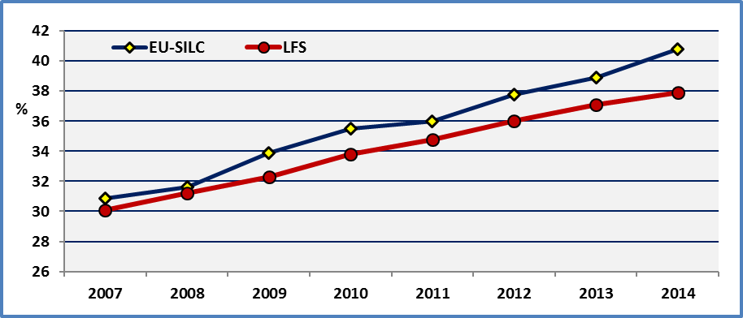

**Note:** LFS are averages of quarterly data

**Data source :** EU-SILC & Eurostat

Secondly, when we compare the national estimations, we find that the two surveys provide similar results. In fact, there is a high correlation (R²=0.78) between EU-SILC and LFS national estimators. But, we observe big differences for certain Member States. This difference is higher than 5 percentage points in Luxembourg, Croatia, Hungary, Sweden, UK, Slovakia, Denmark, Belgium and Ireland. This requires further analysis and comparison of the methodologies used by the two surveys.

**Figure 64: Percent of persons who have completed a tertiary or equivalent education by Member State and survey (age: 30-34), 2014**

Share of the population of the same age group

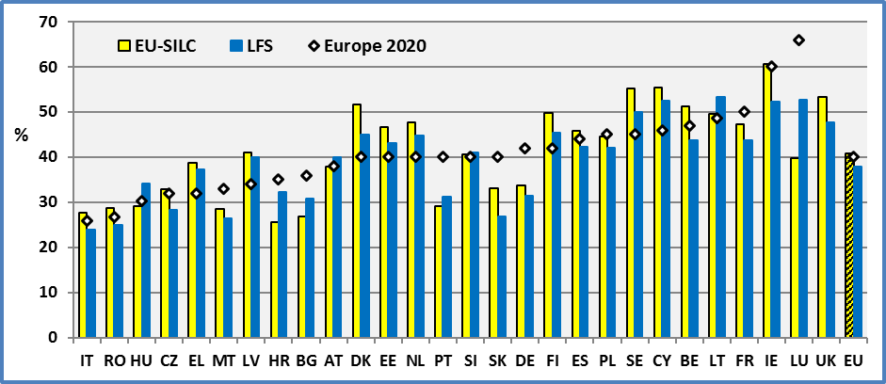

**Note:** LFS are averages of quarterly data

**AT & DE**: See tables

**Data source:** EU-SILC UDB 2014 & Eurostat

Thirdly, the LFS estimators are annual averages while the EU-SILC are based on a specific period, generally the first two quarters of the year.

As indicated below (see Methodology) the two surveys were using different classifications of education curricula before 2014. Furthermore, the LFS was using a much more detailed one compared to EU-SILC.

From 2014 on, the two surveys use the same methodology. In fact, from this date, the educational attainment level is to be coded according to the International Standard Classification of Education (ISCED 2011). However, differences might appear in the implementation process. At this end, Eurostat notes that all questions about implementation of ISCED in the LFS may be addressed to the national ISCED coordinator who is nominated in each country to ensure coherence of the variable “Educational attainment” in different sources (in particular with EU-SILC)[30]. This ought to improve comparability and reduce any differences between the LFS and the EU-SILC in the future.

In the following, we will use the EU-SILC data as this survey enables us to distinguish between persons with and without disabilities.

This indicator presents a specific problem for persons with disabilities. The number of observations in the EU-SILC survey, concerning persons with activity limitations aged 30-34, is relatively small. Consequently, the estimations for persons with disabilities aged 30-34 ought to be treated with caution. Estimations concerning persons without disabilities aged 30-34 do not present this problem. The sample for this group is big enough.

In order to avoid these statistical problems, we present for comparison estimations for the enlarged age group 30-39. But this indicator does not correspond to Europe 2020 target.

2.2 General comments

At the European level, 41.2% (not comparable with 2013) of persons aged 30-34 have completed a tertiary or equivalent education. But we have to keep in mind that the EU-SILC presents a higher estimation compared to LFS which is the reference for monitoring. As noted above, the LFS provides a percentage of 37.9%. The target for Europe 2020 is 40%. Consequently, it is more interesting to focus on the difference between persons with and without disabilities.

The number of persons with disabilities who have completed a tertiary or equivalent education is 29.7% (not comparable with 2013). This rate is 42.6% for persons without disabilities.

If we focus only on people with disabilities, only two Member States have attained their national target for the group of persons with disabilities (Denmark and Finland). For the remaining countries (e.g. Sweden, Cyprus, Lithuania) are volatile and may not be considered robust.

At the EU level, about 1,017,000 persons with disabilities (aged 30-34 living in private households) have acquired a tertiary or equivalent education, out of 3,639,000 disabled persons with the same age and housing conditions.

**Figure 65: Percent of persons who have completed a tertiary or equivalent education by Member State and disability status (age: 30-34), 2014.** Share of the population of the same age group

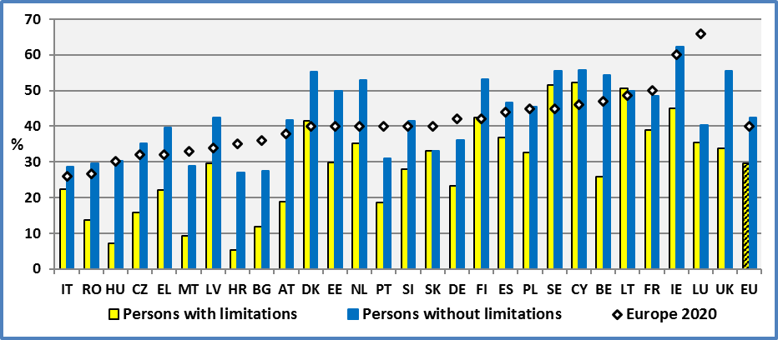

**Data source :** EU-SILC UDB 2014

**AT & DE:** If we add persons with a post-secondary non-tertiary education (level 4), the rates are: **AT**: Total: 40.6%; Disabled: 21.4%; Non-disabled: 44.3%. **DE**: Total: 52.6% (All: 51.5%); Disabled: 44.5%; Non-disabled: 54.0%. The Austrian target includes only part of level ‘4’. Consequently, the reported estimation overstates the achievements. Concerning Germany, the estimation for persons with disabilities is very different from the one presented in 2013 but this difference might be due to the new classification applied in 2014. The EU average for level 4 is 4.7% and Germany has the highest rate: 17.7%.

**Note:** The data for young disabled are indicative (see Tables below). Due to the limited number of observations, the estimations ought to be interpreted with caution. The number of persons with disabilities in the sample aged 30-34 is between 20 and 49 in Bulgaria, Denmark, Croatia, Lithuania, Malta and Sweden.

The disadvantage of people with disabilities may be measured in different ways. One way consists in measuring the difference between the percent of people with and without disabilities that have completed a tertiary education. At the EU level the disadvantage of people with disabilities amounts to 12.9 percentage points (12.8 pp in 2013 but with a different classification). In fact, the percent of persons who have completed a tertiary or equivalent education aged 30-34 in 2014 is 29.7% for people with disabilities and 42.6% for people without disabilities.

The analysis by Member States presents a certain number of limitations due to the limited number of observations in the age group 30-34 for persons with disabilities and the introduction of the new classification in 2014.

We may observe that certain countries with good achievements for persons without disabilities present very low performances for persons with disabilities.

At the EU level, the distance between the EU 2020 target and the rate of persons with disabilities is 10 percentage points (12 pp in 2013 but with a different classification). This distance for persons without disabilities is close to zero and even reversed in 2014. However, we have to keep in mind that the EU-SILC survey presents a higher rate compared to LFS.

2.3 Extension of the target group to persons aged 30-39

As noted above, the number of observations concerning people with disabilities aged 30-34 is relatively small. For this reason, we present for comparison the estimations for the age group 30-39. These estimations are more robust. Generally, the results are similar. The correlation of national estimations is high (R²=0.97 for all persons and R²=0.79 for persons with disabilities) but the national rates might be lower for the age group 30-39 compared to 30-34.

At the European level, 26.9% of persons with disabilities aged 30-39 have completed a tertiary or equivalent education, compared to 40.8% for persons without disabilities. The gap between persons with and without disabilities is 13.9 percentage points.

In terms of absolute performances, they confirm the good achievements for persons with disabilities in Finland and Denmark as in previous years. On the other side, Croatia, Malta, Hungary and Romania present the lowest rates. The rates for Hungary and Romania were among the lowest in 2013 too.

**Figure 66: Percent of persons who have completed a tertiary or equivalent education by disability status, Age 30-39, 2014**

Europe 2020 is indicative as it concerns persons aged 30-34

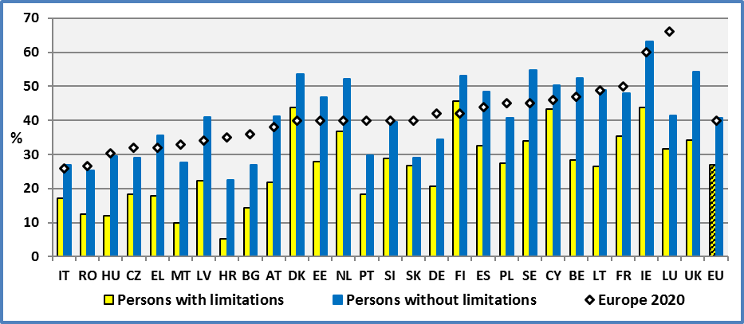

**Note:** Estimations for Austria and Germany do not include persons with a post-secondary non-tertiary education. Data for Malta are indicative.

**Data source :** EU-SILC UDB 2014

We may observe that certain countries with good achievements for persons without disabilities present very low results for persons with disabilities.

As noted above, the disadvantage of persons with disabilities compared to persons without disabilities can be measured by the difference of the respective shares of persons who have completed a tertiary or equivalent education. The gap is relatively important in the UK, Sweden, Lithuania and Belgium. A similar situation was found in 2013. This gap measures the efforts Member States ought to develop in order to achieve equality of opportunities among persons with and without disabilities.

2.4 Gender

Concerning gender, women face an advantage in comparison to men. This is also true for women with disabilities in comparison to men with disabilities.

At the European level, the percentage of women with disabilities aged 30-34 who completed tertiary or equivalent education is 34%. This rate for women without disabilities is 45%. The equivalent rates for men are 21 (disabled) and 36% (non-disabled).

The gap between men with and without disabilities is about 15 percentage points while the equivalent for women with and without disabilities is 11 percentage points.

As the number of observations concerning persons with disabilities (males or females) aged 30-34 is relatively small, we present below the rates by gender for the enlarged age group 30-39.

At the European level, the percentage of women with disabilities aged 30-39 who completed tertiary or equivalent education is 30.8%. This rate for women without disabilities is 45.0%. The equivalent rates for men are 22.3% (disabled) and 36.7% (non-disabled). Similar rates were reported in 2013 although the classification was slightly different.

The gap between men with and without disabilities is about 14.3 percentage points while the equivalent for women with and without disabilities is 14.2 percentage points. The respective rates for the age group 30-34 are 12.9 pp (men) and 13.4 pp (women).

**Figure 67: Percent of persons with disabilities who have completed a tertiary or equivalent education by disability status. Age 30-39, 2014**

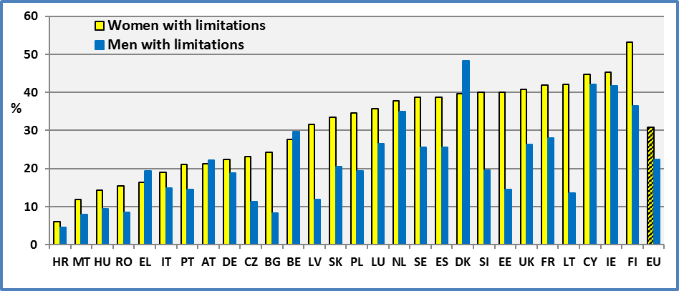

**Note:** The estimations for BG, HR, LT, MT and SE are indicative.

**Data source :** EU-SILC UDB 2014

2.5 Degree of disability

The limited number of observations concerning persons with disabilities aged 30-34 does not permit us to present estimations by degree of disability and by Member State. Consequently, we present the percentage of persons who completed tertiary or equivalent education at the EU level.

About 23.5% of persons with a severe disability aged 30-34 have completed a tertiary or equivalent education programme. This rate is 31.5% for persons with a moderate disability and 42.6% for persons without disability. The following chart reveals the particularly disadvantaged position of persons with a severe limitation.

**Figure 68: Percent of persons who have completed a tertiary or equivalent education by degree of disability. Age: 30-34, EU 2014.**

Share of the population of the same age group and disability status

**Source of data**: EU-SILC UDB 2014

2.6 Evolution

We may observe a continuous improvement of the situation of persons with disabilities. However, after a decrease of the gap between persons with and without disabilities in 2011, the gap has increased again since 2012. In 2011, 2012 and 2013 the gap was respectively 9.8 percentage points, 11.5 pp and 12.5 pp. In 2014, the gap was 12.9 percentage points with the new classification.

**Figure 69: Evolution of the share of persons who have completed a tertiary or equivalent education by disability status. EU.**

Share of the population of the same age group and disability status

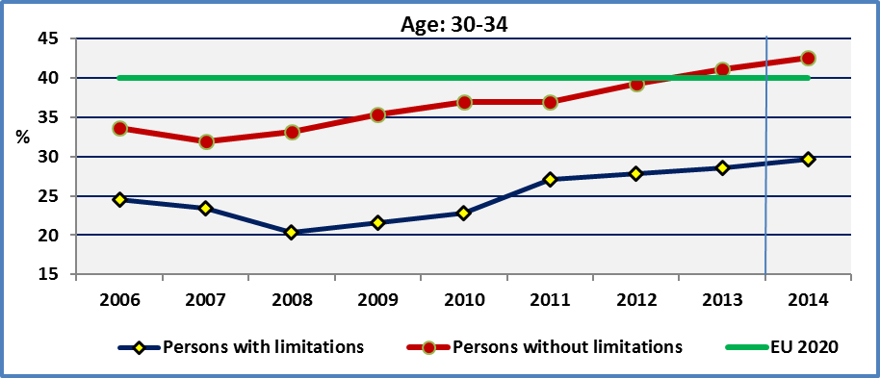

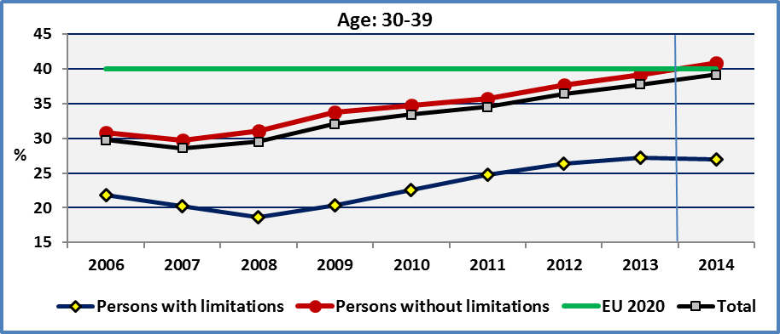

**Note:** Change of classification in 2014

**Source of data**: EU-SILC UDB

The evolution of the rates covering persons aged 30-39 are similar but present smaller fluctuations around the trend.

Given the adoption of a new classification in 2014, the rates between 2013 and 2014 are not comparable. Consequently, we do not present the change between 2013 and 2014 for the Member States.

2.6 Employment and education

According to human capital theory, employment prospects and wages depend on educational attainment. An investment in human capital increases employability (the probability of being in employment over the course of lifetime) and the wages individuals earn in employment. Concerning employment prospects, additional years of education increase employment and career opportunities.

In the following graph, we compare the employment rate of individuals with different educational levels. The employment rate is positively correlated with the educational level. In a causative interpretation, education increases the employment prospects. The employment rate of persons with disabilities having completed a primary education is 27% (46% for persons without disabilities). This rate is 68% for persons with disabilities who have completed a tertiary education level (82% for persons without disabilities). The situation was similar in 2012. This means that the relation is stable.

We may observe that additional years of education increase the employment rate of each group. The employment rate for persons with disabilities increases from 27% (persons who have completed a primary education level), to 38% (lower secondary), to 52% (upper secondary), to 62% (post-secondary non-tertiary) and finally to 68% (tertiary education). The respective rates for persons without disabilities are 49%, 62%, 71%, 79 and 82%. A similar order of magnitude was reported for 2013 although the classification was different.

Furthermore, the graph indicates that more education provides generally a bigger change in the employment rate of persons with disabilities compared to persons without disabilities. In fact, when we pass from primary to tertiary education, persons with disabilities improve their employment rate by 41 percentage points compared to 33 percentage points of persons without disabilities. This means that investing in education for persons with disabilities yields a higher profit compared to persons without disabilities.

**Figure 70: Relation between employment and education. EU 2014, age 20-64.**

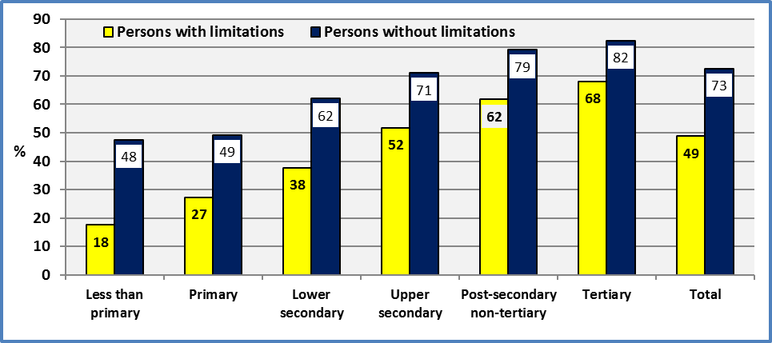

**Note:** The employment rate is calculated by dividing the number of persons aged 20 to 64 in employment by the total population of the same disability status and age group. The education level refers to persons who have completed the specified education or equivalent education level.

**Source of data**: EU-SILC UDB 2014

The graph indicates that a policy pushing persons with disabilities to complete post-secondary non-tertiary education doubles their employment rate in comparison to those with a primary education level. In other words, education increases significantly their chances to get a job.

Furthermore, education decreases the employment gap between persons with and without disabilities. As could be seen in the previous graph, the absolute difference of employment rates decreases significantly as educational level increases.

2.7 Youth employment and education

When we focus on persons aged 20-29, we find certain similarities and differences with previous results covering all persons aged 20-64. In fact, we find relatively smaller differences in employment rates between educational levels among persons without disabilities but these differences remain important for persons with disabilities when we pass from a lower to a higher educational level.

Also, for lower educational levels, the employment gap for persons with and without disabilities is very important. This difference is relatively small for higher educational levels. Education seems to exert a much more important impact on the employment of persons with disabilities. The employment rates of young disabled with at most a lower secondary education i.e. early school leavers are very low. This reveals the importance of upper secondary or higher education.

**Figure 71: Relation between employment and education. EU 2014, age 20-29.**

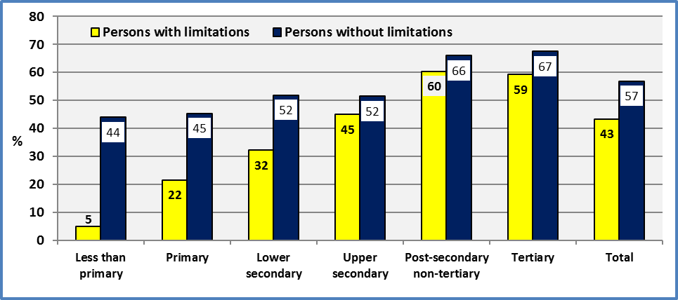

**Note:** The employment rate is calculated by dividing the number of persons aged 20 to 29 in employment by the total population of the same disability status and age group. The education level refers to persons who have completed the specified education or equivalent education level.

**Source of data**: EU-SILC UDB 2014

Differences in employment rates might arise from a lower hiring rate of persons with low educational achievements. However, certain have argued that job finding rates are similar but more educated workers experience lower employment separation rates. This lower rate is due to the initial better education which provides more opportunities for on the job training and thus more stable jobs or jobs with better careers. This means that an initial difference in educational capital creates a dynamic process increasing further the initial employment gap.

As I. Cairo and T. Cajner note, different educational groups face roughly the same job finding rate. What creates the divergent patterns in employment by education is the job separation rate. More educated people get more on the job training opportunities. Since on-the-job training is strongly and positively related to education, higher amounts of specific training should reduce incentives of firms and workers to separate. This implies that more educated workers lose their jobs less frequently and experience lower turnover rates. Consequently, the volatility of employment decreases with education.

The following graph indicates that persons with a lower secondary education have been affected by the financial crisis much more than the more educated persons. Following the financial crisis in 2008, the employment rate of less educated people (lower secondary) decreased by about 9.8 percentage points compared to 5.5 pp of persons with a tertiary education.

To summarise, one important way to increase the employability of less educated young persons is to improve their educational level. Factors which might influence this process are personal characteristics, parental education level, school support, poverty, family networks and social environment. For persons with special educational needs, this requires additional measures in order to eradicate barriers and provide the necessary technical support.

**Figure 72: Employment rates by educational attainment level. EU, age 25-29**

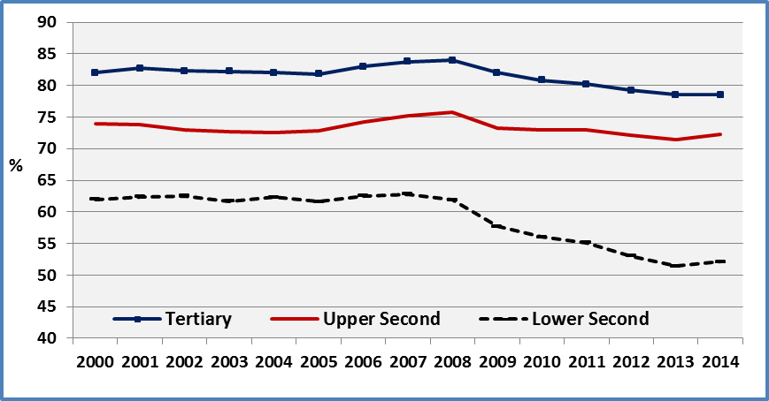

**Source of the data**: Eurostat (LFS), Extracted on 02.11.15

2.8 Youth employment, gender and education

The comparison by gender (men-women) reveals a gender gap. This gender gap decreases sharply as educational level increases. If we focus on persons with disabilities, the results are mixed. At the extremes (less than primary and tertiary) educational levels, disabled women experience a higher employment rate compared to disabled men.

A further analysis of youth employment (age 20-29) reveals that young males with a low educational level benefit from a significant advantage in comparison to males with disabilities and women.

Generally, higher education decreases the different gaps (disability and gender).

**Figure 73: Employment rates by educational attainment and disability status. EU, age 20-29**

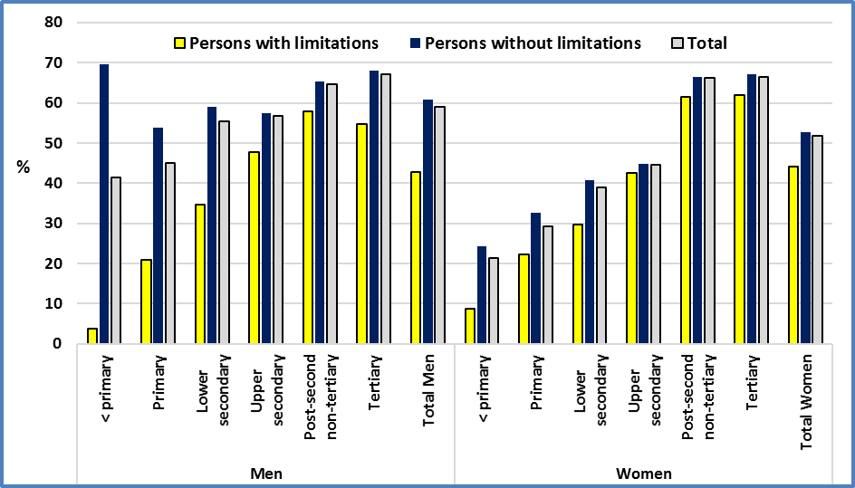

**Source of data**: EU-SILC UDB 2014

### 3. Data

**Table 82: Percent of persons who have completed a tertiary or equivalent education by Member State and disability status** (Share of the population of the same age group); Age 30-34.

|  |  |  |  |  |  |  |  |  |  |  |  |  |
| --- | --- | --- | --- | --- | --- | --- | --- | --- | --- | --- | --- | --- |
|  | **2008** | | | | | | | **2009** | | | | |
|  | **Men + Women** | | | | | | | **Men + Women** | | | | |
|  | **Disability** | | | **All** | | **LFS** | | **Disability** | | | **All** | **LFS** |
|  | **Yes** | **No** | **Total** | |  | |  | **Yes** | **No** | **Total** |  |  |
| **AT** | 15,7 | 28,5 | 26,8 | | **26,8** | | 22,2 | 25,0 | 25,7 | 25,6 | **25,6** | 23,5 |
| **BE** | 28,6 | 53,8 | 50,5 | | **50,5** | | 42,9 | 23,6 | 50,0 | 46,7 | **46,6** | 42,0 |
| **BG** | (24,1) | 23,7 | 23,7 | | **23,7** | | 27,1 | 19,5 | 24,0 | 23,8 | **23,8** | 27,9 |
| **CY** | (26,4) | 43,6 | 42,7 | | **42,7** | | 47,1 | (21,0) | 42,5 | 41,1 | **41,1** | 44,7 |
| **CZ** | 16,8 | 15,8 | 15,8 | | **15,8** | | 15,4 | 15,1 | 17,9 | 17,7 | **17,3** | 17,5 |
| **DE** | 16,3 | 32,6 | 29,5 | | **29,5** | | 27,7 | 13,7 | 34,0 | 30,9 | **30,3** | 29,4 |
| **DK** | 39,8 | 43,3 | 42,7 | | **43,3** | | 39,2 | 33,3 | 44,1 | 42,4 | **42,4** | 48,1 |
| **EE** | 23,8 | 35,5 | 34,2 | | **34,2** | | 34,1 | 18,9 | 36,8 | 34,9 | **34,9** | 35,9 |
| **EL** | 4,4 | 30,8 | 29,4 | | **29,4** | | 25,6 | (0,0) | 32,3 | 31,4 | **31,4** | 26,5 |
| **ES** | 32,9 | 45,0 | 44,0 | | **44,0** | | 39,8 | 31,6 | 45,5 | 44,0 | **44,0** | 39,4 |
| **FI** | 36,2 | 46,7 | 44,9 | | **46,8** | | 45,7 | 35,4 | 48,0 | 46,0 | **46,4** | 45,9 |
| **FR** |  |  |  | |  | | 41,2 | 31,7 | 46,0 | 44,6 | **44,6** | 43,2 |
| **HU** | 12,7 | 24,2 | 22,9 | | **22,9** | | 22,4 | 13,1 | 25,0 | 24,1 | **24,1** | 23,9 |
| **IE** | 27,8 | 47,6 | 45,6 | | **45,6** | | 46,1 | 39,4 | 52,2 | 50,6 | **50,6** | 49,0 |
| **IT** | 13,9 | 20,2 | 19,5 | | **19,5** | | 19,2 | 11,7 | 21,0 | 20,2 | **20,2** | 19,0 |
| **LT** | 26,4 | 44,9 | 42,2 | | **42,2** | | 39,9 | (12,6) | 41,4 | 39,4 | **39,0** | 40,6 |
| **LU** | 31,4 | 39,8 | 38,8 | | **38,8** | | 39,8 | 29,7 | 42,5 | 41,1 | **41,2** | 46,6 |
| **LV** | 24,7 | 28,6 | 28,1 | | **28,1** | | 27,0 | 22,3 | 30,5 | 29,4 | **29,4** | 30,1 |
| **MT** |  |  |  | |  | | 20,9 | 0,0 | 24,1 | 23,1 | **23,1** | 21,0 |
| **NL** | 36,6 | 44,3 | 43,3 | | **43,0** | | 40,2 | 24,5 | 44,4 | 41,5 | **40,8** | 40,5 |
| **PL** | 15,4 | 31,6 | 30,4 | | **30,4** | | 29,7 | 18,0 | 33,9 | 32,6 | **32,6** | 32,8 |
| **PT** | 6,3 | 19,2 | 17,7 | | **17,7** | | 21,6 | 6,7 | 22,4 | 19,9 | **19,9** | 21,1 |
| **RO** | 5,5 | 16,6 | 16,1 | | **16,1** | | 16,0 | 10,7 | 20,0 | 19,7 | **19,7** | 16,8 |
| **SE** | (31,2) | 48,7 | 47,7 | | **45,0** | | 42,0 | (33,8) | 46,2 | 45,3 | **43,6** | 43,9 |
| **SI** | 20,8 | 29,4 | 28,1 | | **27,3** | | 30,9 | 22,5 | 29,4 | 28,4 | **28,7** | 31,6 |
| **SK** | 16,8 | 22,0 | 21,5 | | **21,5** | | 15,8 | 22,4 | 29,2 | 28,4 | **28,0** | 17,6 |
| **UK** | 26,1 | 45,4 | 43,9 | | **43,9** | | 39,7 | 29,0 | 44,6 | 42,9 | **42,8** | 41,5 |
|  |  |  |  | |  | |  |  |  |  |  |  |
| **EU** | **20,4** | **33,1** | **31,6** | | **31,6** | | **31,0** | **21,6** | **35,4** | **33,9** | **33,6** | **32,3** |

**Note:** Due to the limited number of observations, estimations for persons with disabilities ought to be interpreted with caution.

**All:** It includes observations for which we do not dispose information on disability status.

**Data source:** EU-SILC UDB 2008 & 2009

**Table 83: Percent of persons who have completed a tertiary or equivalent education by Member State and disability status** (Share of the population of the same age group); Age 30-34.

|  |  |  |  |  |  |  |  |  |  |  |  |
| --- | --- | --- | --- | --- | --- | --- | --- | --- | --- | --- | --- |
|  | **2010** | | | | | **2011** | | | | |  |
|  | **Men + Women** | | | | | **Men + Women** | | | | |  |
|  | **Disability** | | | **All** | **LFS** | **Disability** | | | **All** | **LFS** | **Target 2020** |
|  | **Yes** | **No** | **Total** |  |  | **Yes** | **No** | **Total** | **(a)** |  | **(b)** |
| **AT** | 16,0 | 27,6 | 26,3 | **26,3** | 23,5 | 22,8 | 27,0 | 26,4 | **(37,5) 26,4** | 23,8 | 38,0 |
| **BE** | 27,1 | 49,5 | 47,2 | **47,3** | 44,4 | 38,8 | 47,7 | 47,0 | **46,9** | 42,6 | 47,0 |
| **BG** | 15,4 | 26,8 | 26,2 | **26,2** | 27,7 | (15,3) | 26,4 | 25,8 | **25,8** | 27,3 | 36,0 |
| **CY** |  |  |  |  |  | 38,4 | 52,7 | 51,3 | **51,3** | 46,2 | 46,0 |
| **CZ** | 9,2 | 20,8 | 20,0 | **18,6** | 20,4 | 16,4 | 25,3 | 24,5 | **22,4** | 23,8 | 32,0 |
| **DE** | 13,1 | 35,2 | 32,1 | **31,9** | 29,8 | 18,6 | 32,7 | 30,8 | **(44,6) 30,4** | 30,7 | 42,0 |
| **DK** | 43,2 | 46,8 | 46,1 | **45,0** | 41,2 | 41,5 | 47,8 | 46,4 | **45,2** | 41,2 | 40,0 |
| **EE** | 37,6 | 39,3 | 39,1 | **39,1** | 40,0 | 23,1 | 45,3 | 42,5 | **42,4** | 40,3 | 40,0 |
| **EL** | (8,7) | 35,5 | 34,9 | **34,9** | 28,4 | (33,5) | 34,4 | 34,3 | **34,3** | 28,9 | 32,0 |
| **ES** | 27,9 | 46,2 | 44,5 | **44,5** | 40,6 | 33,4 | 43,2 | 42,5 | **42,5** | 40,6 | 44,0 |
| **FI** | 43,6 | 47,0 | 46,3 | **47,7** | 45,7 | 38,5 | 49,8 | 47,7 | **48,1** | 46,0 | 42,0 |
| **FR** | 37,5 | 46,6 | 45,6 | **45,6** | 43,5 | 35,6 | 46,5 | 45,3 | **45,3** | 43,3 | 50,0 |
| **HR** |  |  |  |  |  | (4,8) | 23,3 | 21,3 | **20,2** | 24,5 | : |
| **HU** | 14,5 | 25,5 | 24,5 | **24,5** | 25,7 | 14,6 | 24,8 | 24,0 | **24,0** | 28,1 | 30,3 |
| **IE** |  |  |  |  |  |  |  |  |  | 49,7 | 60,0 |
| **IT** | 19,6 | 20,8 | 20,7 | **20,8** | 19,8 | 17,5 | 20,4 | 20,2 | **20,2** | 20,3 | 26,0 |
| **LT** | (34,3) | 47,8 | 46,9 | **46,9** | 43,8 | (21,9) | 50,0 | 48,1 | **47,9** | 45,8 | 40,0 |
| **LU** | 19,3 | 40,5 | 38,4 | **38,1** | 46,1 | 29,6 | 37,4 | 36,7 | **36,7** | 48,2 | 40,0 |
| **LV** | 24,1 | 32,9 | 31,8 | **32,1** | 32,3 | 22,4 | 34,7 | 33,4 | **33,4** | 35,9 | 34,0 |
| **MT** | 21,3 | 23,0 | 22,9 | **22,9** | 21,5 | (13,5) | 24,6 | 24,3 | **24,3** | 21,4 | 33,0 |
| **NL** | 21,9 | 48,8 | 44,6 | **45,3** | 41,4 | 32,8 | 49,8 | 47,0 | **48,1** | 41,1 | 40,0 |
| **PL** | 28,2 | 37,4 | 36,6 | **36,6** | 35,3 | 26,9 | 37,7 | 36,9 | **36,9** | 36,9 | 45,0 |
| **PT** | 8,9 | 22,5 | 20,8 | **20,7** | 23,5 | 13,2 | 24,1 | 22,9 | **22,9** | 26,1 | 40,0 |
| **RO** | 10,9 | 21,1 | 20,5 | **20,5** | 18,1 | 7,5 | 24,3 | 23,4 | **23,4** | 20,4 | 26,7 |
| **SE** | (33,3) | 47,9 | 46,9 | **46,2** | 45,8 | (30,8) | 47,5 | 46,0 | **46,9** | 46,8 | 40,0 |
| **SI** | 20,9 | 34,4 | 31,6 | **31,6** | 34,8 | 33,9 | 34,3 | 34,2 | **32,4** | 37,9 | 40,0 |
| **SK** | 21,3 | 29,2 | 28,3 | **28,3** | 22,1 | 28,5 | 31,8 | 31,3 | **31,2** | 23,4 | 40,0 |
| **UK** | 20,5 | 51,2 | 47,8 | **47,7** | 43,0 | 39,5 | 51,2 | 49,9 | **49,7** | 45,8 | : |
|  |  |  |  |  |  |  |  |  |  |  |  |
| **EU** | 22,8 | 37,0 | 35,5 | **35,4** | 33,5 | 27,1 | 36,9 | 36,0 | **35,6** | (c)34,5 | (c)40,0 |

**Note:** Due to the limited number of observations, estimations for persons with disabilities ought to be interpreted with caution.

**All:** It includes observations for which we do not dispose information on disability status.

**(a)** Estimations in parenthesis for Austria and Germany include level 4 (post-secondary non tertiary education).

**(b):**  EU target - at least 40 %. For comparability, we have to note: DK - National target - at least 40 %; DE - National target - 42%, including ISCED4 which represented 11.4% of the population aged 30-34 in 2011 (LFS estimations); IT - National target 26 - 27 %; LV – National target 34 – 36 %; NL – National target – more than 40%, 45% expected in 2020; AT - National target - 38%, including ISCED 4a, which represented 12% of the population aged 30-34, in 2011 (LFS estimations); FI – Narrow national definition; SE – National target 40 – 45 %; UK – No national target.

**(c):** The estimation for EU 27 is 34,6. The target 2020 for EU refers to EU 27.

**Data source:** EU-SILC UDB 2010 & 2011

**Table 84: Percent of persons who have completed a tertiary or equivalent education by Member State and disability status** (Share of the population of the same age group); Age 30-34.

|  |  |  |  |  |  |  |  |  |  |  |  |  |
| --- | --- | --- | --- | --- | --- | --- | --- | --- | --- | --- | --- | --- |
|  | **2012** | | | | | **2013** | | | | | **EU 2020** | |
|  | **Men + Women** | | | |  | **Men + Women** | | | |  |  | |
|  | **Disability** | | | **All** | **LFS** | **Disability** | | | **All** | **LFS** | **Target** |  |
|  | **Yes** | **No** | **Total** |  |  | **Yes** | **No** | **Total** |  |  |  |  |
| **AT\*** | 19,3 | 29,4 | (42) 28,1 | **28,1** | 26,3 | 14,7 | 29,6 | (43) 27,4 | **27,4** | 27,1 | 38 | (a) |
| **BE** | 40,9 | 46,6 | 45,9 | **45,9** | 43,9 | 37,0 | 47,9 | 46,8 | **46,8** | 42,7 | 47 |  |
| **BG** | 27,6 | 26,9 | 26,9 | **26,9** | 26,9 | 18,6 | 24,5 | 24,1 | **24,1** | 29,4 | 36 |  |
| **CY** | 29,8 | 51,7 | 50,0 | **50,0** | 49,9 | 31,6 | 53,2 | 51,5 | **51,6** | 47,8 | 46 |  |
| **CZ** | 16,0 | 27,4 | 26,4 | **25,5** | 25,6 | 14,1 | 30,4 | 29,0 | **27,1** | 26,7 | 32 |  |
| **DE\*** | 19,3 | 36,5 | (47) 33,9 | **33,1** | 32,0 | 16,9 | 37,7 | (49) 34,6 | **33,8** | 32,9 | 42 | (a) |
| **DK** | 37,0 | 57,2 | 52,8 | **51,3** | 43,0 | 41,6 | 53,0 | 50,1 | **48,0** | 43,4 | 40 |  |
| **EE** | 33,9 | 43,4 | 42,2 | **42,1** | 39,5 | 33,6 | 42,9 | 41,5 | **41,5** | 43,7 | 40 |  |
| **EL** | (30,6) | 35,4 | 35,2 | **35,2** | 30,9 | (16,8) | 37,7 | 36,9 | **36,9** | 34,9 | 32 |  |
| **ES** | 26,0 | 43,0 | 42,0 | **42,0** | 41,5 | 26,3 | 44,2 | 42,6 | **42,6** | 42,3 | 44 |  |
| **FI** | 52,2 | 50,2 | 50,6 | **49,5** | 45,8 | 49,4 | 52,2 | 51,4 | **50,3** | 45,1 | 42 | (a) |
| **FR\*\*** | 34,2 | 48,2 | (47) 46,7 | **46,7** | 43,5 | 47,7 | 47,9 | (47) 47,9 | **47,9** | 44,1 | 50 | (a) |
| **HR** | (4,6) | 24,0 | 22,8 | **22,6** | 23,7 | (24,8) | 28,9 | 28,6 | **28,1** | 25,6 | 35 |  |
| **HU** | 19,6 | 29,5 | 28,9 | **28,9** | 29,9 | 13,7 | 29,3 | 28,4 | **28,4** | 32,3 | 30,3 |  |
| **IE** | 29,8 | 61,7 | 59,3 | **59,3** | 51,1 | 40,6 | 63,0 | 60,9 | **60,9** | 52,6 | 60 |  |
| **IT** | 18,5 | 22,0 | 21,7 | **21,9** | 21,7 | 16,6 | 24,9 | 24,0 | **24,0** | 22,5 | 26 | (a) |
| **LT** | (26,4) | 54,4 | 53,5 | **53,1** | 48,6 | (31,1) | 53,6 | 52,0 | **51,8** | 51,3 | 48,7 |  |
| **LU** | 30,7 | 40,5 | 39,6 | **39,2** | 49,6 | 24,6 | 42,8 | 40,7 | **40,7** | 52,5 | 66 |  |
| **LV** | 28,3 | 38,2 | 37,2 | **37,2** | 37,2 | 28,9 | 41,7 | 40,2 | **40,2** | 40,7 | 34 | (a) |
| **MT** | 11,7 | 26,4 | 26,1 | **26,1** | 24,9 | (8,9) | 28,0 | 27,4 | **27,4** | 26,0 | 33 |  |
| **NL** | 46,9 | 50,5 | 49,8 | **49,8** | 42,2 | 48,5 | 47,5 | 47,6 | **47,3** | 43,1 | 40 | (a) |
| **PL** | 27,8 | 41,1 | 40,0 | **40,0** | 39,1 | 30,7 | 42,7 | 41,7 | **41,7** | 40,5 | 45 |  |
| **PT** | 20,9 | 23,9 | 23,6 | **23,6** | 27,2 | 20,7 | 28,6 | 27,6 | **27,6** | 30,0 | 40 |  |
| **RO** | 15,6 | 24,9 | 24,2 | **24,2** | 21,8 | 24,5 | 26,2 | 26,1 | **26,1** | 22,9 | 26,7 |  |
| **SE** | (48,9) | 52,0 | 51,7 | **51,0** | 47,9 | 38,0 | 56,2 | 53,4 | **52,8** | 48,3 | 40 | (a) |
| **SI** | 28,5 | 36,5 | 35,0 | **33,8** | 39,2 | 29,1 | 38,9 | 37,5 | **37,5** | 40,1 | 40 |  |
| **SK** | 20,8 | 32,2 | 30,9 | **30,7** | 23,7 | 25,1 | 32,3 | 31,4 | **31,5** | 26,9 | 40 |  |
| **UK** | 36,0 | 53,1 | 51,4 | **51,4** | 47,1 | 24,9 | 56,0 | 53,0 | **53,0** | 47,4 | : | (a) |
|  |  |  |  |  |  |  |  |  |  |  |  |  |
| **EU** | **27,8** | **39,3** | **38,1** | **37,8** | **35,8** | 28,0 | 40,7 | 39,3 | **38,9** | 37,1 | **40** | **(a)** |
|  |  |  |  |  |  |  |  |  |  |  |  |  |
| **CH** |  |  |  |  |  | 37,5 | 44,2 | 43,0 | **42,9** |  |  |  |
| **IS** |  |  |  |  |  | (30,9) | 46,6 | 44,4 | **44,1** |  |  |  |
| **NO** |  |  |  |  |  | (26,6) | 42,5 | 41,0 | **44,6** |  |  |  |
| **RS** |  |  |  |  |  | (28,4) | 26,1 | 26,2 | **26,1** |  |  |  |

**\*:** Totals in parenthesis include ISCED level 4.

**2012**: **AT:** Total: 42%;. Disabled: 28%; Non-disabled: 44%. **DE**: Total: 47%; Disabled: 29%; Non-disabled:52%. **2013**: **AT**: Total: 43%; Disabled: 24%; Non-disabled: 46%. **DE**: Total: 49%; Disabled: 31%; Non-disabled: 53%.

**\*\*:**  Data in parenthesis are for the age group 27-33. **2013**: Disabled: 43%, Non-disabled: 47%, Total: 47%.

**(a):** Definition differs. AT: including ISCED 4/4a; DE: including ISCED 4; FI: narrower national definition (excludes former tertiary Vocational Education and Training (VET)); FR: 27-33 years-old; IT: 26%-27%; LV: 34%-36%; NL: >40%; Sweden: 40%-45%; UK: No national target. EU: at least 40 %.

**Data source:** EU-SILC UDB 2012 & 2013

**Table 85: Percent of persons who have completed a tertiary or equivalent education by Member State and disability status** (Share of the population of the same age group); Age 30-34.

|  |  |  |  |  |  |  |  |
| --- | --- | --- | --- | --- | --- | --- | --- |
|  | **2014** (New classification) | | | | | **EU 2020** | |
|  | **Men + Women** | | | |  |  | |
|  | **Disability** | | | **All** | **LFS** | **Target** |  |
|  | **Yes** | **No** | **Total** |  |  |  |  |
| **AT\*** | 18,9 | 41,7 | (40.6) 37,9 | 37,9 | 40,0 | 38 | (a) |
| **BE** | 26,0 | 54,4 | 51,4 | 51,3 | 43,8 | 47 |  |
| **BG** | (11,8) | 27,6 | 26,7 | 26,7 | 30,9 | 36 |  |
| **CY** | 52,2 | 55,7 | 55,4 | 55,4 | 52,5 | 46 |  |
| **CZ** | 15,8 | 35,3 | 33,7 | 32,9 | 28,2 | 32 |  |
| **DE\*** | 23,2 | 36,1 | (52.6) 34,2 | 33,8 | 31,4 | 42 | (a) |
| **DK** | (41,5) | 55,3 | 52,8 | 51,6 | 44,9 | 40 |  |
| **EE** | 29,8 | 50,0 | 46,7 | 46,6 | 43,2 | 40 |  |
| **EL** | 22,0 | 39,6 | 38,7 | 38,7 | 37,2 | 32 |  |
| **ES** | 36,9 | 46,7 | 45,9 | 45,9 | 42,3 | 44 |  |
| **FI** | 42,6 | 53,3 | 51,1 | 49,8 | 45,3 | 42 | (a) |
| **FR\*\*** | 38,9 | 48,5 | (45.9) 47,2 | 47,3 | 43,7 | 50 | (a) |
| **HR** | (5,4) | 27,0 | 25,7 | 25,6 | 32,2 | 35 |  |
| **HU** | 7,1 | 30,4 | 29,1 | 29,1 | 34,1 | 30,3 |  |
| **IE** | 45,0 | 62,3 | 60,7 | 60,7 | 52,2 | 60 |  |
| **IT** | 22,3 | 28,6 | 28,0 | 27,8 | 23,9 | 26 | (a) |
| **LT** | (50,6) | 49,9 | 50,0 | 49,6 | 53,3 | 48,7 |  |
| **LU** | 35,5 | 40,4 | 39,7 | 39,7 | 52,7 | 66 |  |
| **LV** | 29,5 | 42,5 | 41,0 | 41,0 | 39,9 | 34 | (a) |
| **MT** | (9,3) | 29,0 | 28,6 | 28,6 | 26,5 | 33 |  |
| **NL** | 35,1 | 52,9 | 49,9 | 47,7 | 44,8 | 40 | (a) |
| **PL** | 32,6 | 45,4 | 44,5 | 44,5 | 42,1 | 45 |  |
| **PT** | 18,7 | 31,0 | 29,1 | 29,1 | 31,3 | 40 |  |
| **RO** | 13,8 | 29,6 | 28,7 | 28,7 | 25,0 | 26,7 |  |
| **SE** | (51,6) | 55,6 | 55,3 | 55,1 | 49,9 | 40 | (a) |
| **SI** | 27,9 | 41,4 | 39,5 | 40,7 | 41,0 | 40 |  |
| **SK** | 33,2 | 33,2 | 33,2 | 33,1 | 26,9 | 40 |  |
| **UK** | 33,9 | 55,6 | 53,3 | 53,3 | 47,7 | : | (a) |
|  |  |  |  |  |  |  |  |
| **EU** | 29,7 | 42,6 | 41,2 | 40,8 | 37,9 | **40** | **(a)** |
|  |  |  |  |  |  |  |  |
| **CH** | 42,6 | 44,9 | 44,5 | 44,8 | 49,2 |  |  |
| **IS** | (31,4) | 45,9 | 44,8 | 46,4 | 46,4 |  |  |
| **NO** | (41,4) | 58,4 | 56,8 | 55,2 | 52,1 |  |  |
| **RS** | 21,9 | 27,5 | 27,2 | 27,2 |  |  |  |

**\*:** Totals in parenthesis include ISCED level 4.

**2014**: **AT**: Tot: 40.6%; Disabled: 21.4%; Non-disabled: 44.3%. **DE:** Tot: 52.6%; Disabled: 44.5%; Non-disabled: 54.0%

**\*\*:** Total in parenthesis is for the age group 27-33. **2014**: Disabled: 32.8%, Non-disabled: 47.5%, Total: 45.9%.

**(a):** Definition differs. AT: EU 2020 includes ISCED 4/4a; DE: EU 2020 includes ISCED 4; FI: narrower national definition (excludes former tertiary Vocational Education and Training (VET)); DK: >40; FR: 27-33 years-old; IT: 26%-27%; LV: 34%-36%; NL: >40%; Sweden: 40%-45%; UK: No national target. EU: at least 40 %.

**Data source:** EU-SILC UDB 2014

**Table 86: Percent of persons who have completed a tertiary or equivalent education by Member State, gender and disability status.** The estimations for persons with disabilities are indicative.

Share of the population of the same age group; Age 30-34

|  |  |  |  |  |  |  |  |  |  |  |  |  |  |
| --- | --- | --- | --- | --- | --- | --- | --- | --- | --- | --- | --- | --- | --- |
|  | **2008** | | | | | | | **2009** | | | | | |
|  | **Females** | | | | **Males** | | | **Females** | | | **Males** | | |
|  | **Disability** | | | | **Disability** | | | **Disability** | | | **Disability** | | |
|  | **Yes\*** | **No** | **Total** | | **Yes\*** | **No** | **Total** | **Yes\*** | **No** | **Total** | **Yes\*** | **No** | **Total** |
| **AT** | 24,0 | 27,8 | | **27,4** | 9,2 | 29,3 | **26,2** | 20,1 | 26,4 | **25,6** | 29,6 | 25,0 | **25,6** |
| **BE** | 27,2 | 61,7 | | **57,7** | 30,1 | 46,3 | **43,7** | 27,2 | 59,4 | **55,7** | 20,7 | 41,0 | **38,2** |
| **BG** | 19,5 | 30,9 | | **30,3** | 27,5 | 17,1 | **17,7** | 31,5 | 32,4 | **32,3** | 12,9 | 15,3 | **15,2** |
| **CY** | 39,4 | 50,4 | | **49,8** | 10,5 | 36,9 | **35,7** | 26,0 | 47,4 | **46,4** | 18,1 | 37,4 | **35,8** |
| **CZ** | 13,7 | 15,8 | | **15,6** | 20,4 | 15,9 | **16,1** | 16,7 | 19,0 | **18,8** | 13,1 | 16,8 | **16,5** |
| **DE** | 16,7 | 31,8 | | **28,7** | 16,0 | 33,5 | **30,2** | 13,7 | 31,3 | **28,7** | 13,6 | 36,8 | **33,1** |
| **DK** | 42,3 | 47,3 | | **46,3** | 36,4 | 39,1 | **38,7** | 45,6 | 46,7 | **46,5** | 20,2 | 41,2 | **37,9** |
| **EE** | 38,6 | 47,4 | | **46,5** | 10,6 | 23,2 | **21,7** | 23,4 | 49,6 | **47,8** | 16,8 | 23,7 | **22,8** |
| **EL** | 0,0 | 35,3 | | **34,1** | 6,1 | 26,5 | **25,0** | 0,0 | 38,5 | **37,8** | 0,0 | 25,8 | **24,8** |
| **ES** | 37,4 | 48,2 | | **47,4** | 28,4 | 42,0 | **40,9** | 43,3 | 50,6 | **49,8** | 19,5 | 40,7 | **38,5** |
| **FI** | 40,4 | 56,3 | | **53,2** | 31,5 | 38,3 | **37,1** | 41,7 | 56,6 | **54,5** | 29,9 | 39,1 | **37,5** |
| **FR** |  |  | |  |  |  |  | 30,6 | 51,8 | **49,4** | 33,4 | 40,2 | **39,6** |
| **HU** | 15,5 | 29,4 | | **27,9** | 10,2 | 19,6 | **18,5** | 17,1 | 30,3 | **29,5** | 10,3 | 19,9 | **19,0** |
| **IE** | 39,5 | 55,4 | | **53,8** | 14,6 | 38,0 | **35,6** | 39,1 | 55,9 | **53,7** | 39,8 | 47,6 | **46,6** |
| **IT** | 17,1 | 24,2 | | **23,2** | 10,9 | 16,5 | **15,9** | 11,5 | 25,5 | **24,3** | 11,8 | 16,5 | **16,1** |
| **LT** | 37,0 | 56,7 | | **54,3** | 18,5 | 30,8 | **29,0** | 17,2 | 53,6 | **51,6** | 9,6 | 28,3 | **26,7** |
| **LU** | 30,6 | 40,7 | | **39,1** | 32,6 | 39,0 | **38,5** | 35,3 | 46,2 | **45,0** | 23,4 | 38,6 | **37,0** |
| **LV** | 44,9 | 39,5 | | **40,2** | 6,0 | 18,4 | **16,7** | 28,0 | 36,8 | **35,5** | 16,4 | 24,2 | **23,1** |
| **MT** |  |  | |  |  |  |  | 0,0 | 22,9 | **22,3** | 0,0 | 25,1 | **23,8** |
| **NL** | 27,5 | 43,6 | | **41,4** | 47,0 | 45,0 | **45,3** | 29,8 | 44,9 | **42,6** | 18,3 | 43,8 | **40,2** |
| **PL** | 22,2 | 37,8 | | **36,9** | 10,8 | 25,3 | **24,1** | 24,6 | 40,1 | **39,0** | 12,2 | 27,1 | **25,9** |
| **PT** | 3,3 | 24,4 | | **22,5** | 8,3 | 13,7 | **12,9** | 5,9 | 28,9 | **25,5** | 7,4 | 15,6 | **14,3** |
| **RO** | 10,1 | 18,2 | | **17,7** | 0,0 | 15,1 | **14,5** | 11,6 | 23,3 | **22,9** | 9,9 | 16,8 | **16,6** |
| **SE** | 24,5 | 55,4 | | **52,9** | 45,3 | 42,9 | **43,0** | 34,8 | 53,1 | **51,6** | 32,7 | 40,0 | **39,5** |
| **SI** | 25,9 | 38,9 | | **37,2** | 16,9 | 20,1 | **19,6** | 30,1 | 39,1 | **37,6** | 13,2 | 21,3 | **20,4** |
| **SK** | 16,1 | 23,0 | | **22,3** | 17,5 | 21,0 | **20,8** | 25,7 | 29,5 | **29,1** | 19,6 | 28,9 | **27,9** |
| **UK** | 25,7 | 47,7 | | **46,1** | 26,5 | 42,8 | **41,4** | 33,8 | 47,3 | **45,5** | 21,3 | 41,9 | **40,0** |
|  |  |  | |  |  |  |  |  |  |  |  |  |  |
| **EU** | 22,4 | 36,4 | | **34,8** | 18,4 | 29,9 | **28,5** | 25,4 | 39,1 | **37,6** | 17,6 | 31,6 | **30,2** |

**\*:** The estimations by gender presented in the tables have only an indicative value. In fact, the number of observations for persons with disabilities is relatively small (less than 50) in several countries. Due to the limited number of observations for persons with disabilities, estimations ought to be interpreted with caution.

**Data source:** EU-SILC UDB 2008 & 2009

**Table 87: Percent of persons who have completed a tertiary or equivalent education by Member State, gender and disability status.** The estimations for persons with disabilities are indicative.

Share of the population of the same age group; Age 30-34

|  |  |  |  |  |  |  |  |  |  |  |  |  |  |
| --- | --- | --- | --- | --- | --- | --- | --- | --- | --- | --- | --- | --- | --- |
|  | **2010** | | | | | | | **2011** | | | | | |
|  | **Females** | | | | **Males** | | | **Females** | | | **Males** | | |
|  | **Disability** | | | | **Disability** | | | **Disability** | | | **Disability** | | |
|  | **Yes\*** | **No** | **Total** | | **Yes\*** | **No** | **Total** | **Yes\*** | **No** | **Total** | **Yes\*** | **No** | **Total** |
| **AT** | 11,9 | 30,1 | | **28,0** | 20,9 | 24,8 | **24,4** | 23,1 | 28,7 | **27,9** | 22,4 | 25,3 | **24,9** |
| **BE** | 40,0 | 59,4 | | **57,4** | 15,9 | 40,0 | **37,4** | 51,1 | 57,5 | **56,9** | 22,1 | 37,6 | **36,5** |
| **BG** | 19,2 | 36,4 | | **35,5** | 12,4 | 17,8 | **17,4** | 19,7 | 35,2 | **34,3** | 10,6 | 18,6 | **18,2** |
| **CY** |  |  | |  |  |  |  | 37,8 | 55,0 | **53,5** | 38,9 | 50,1 | **48,9** |
| **CZ** | 11,7 | 22,8 | | **21,9** | 6,1 | 18,7 | **17,8** | 23,1 | 28,3 | **27,8** | 7,0 | 21,8 | **20,6** |
| **DE** | 13,3 | 34,6 | | **31,0** | 12,9 | 35,8 | **33,2** | 20,2 | 31,9 | **30,1** | 16,3 | 33,6 | **31,6** |
| **DK** | 46,8 | 57,5 | | **55,1** | 38,7 | 36,8 | **37,2** | 52,2 | 52,4 | **52,4** | 24,6 | 43,9 | **40,7** |
| **EE** | 41,0 | 52,7 | | **51,6** | 35,1 | 25,1 | **26,4** | 37,2 | 55,8 | **53,9** | 13,5 | 33,6 | **30,6** |
| **EL** | 14,2 | 41,1 | | **40,6** | 5,4 | 30,1 | **29,4** | 49,5 | 37,2 | **37,7** | 20,4 | 31,9 | **31,3** |
| **ES** | 28,2 | 52,5 | | **49,9** | 27,6 | 40,6 | **39,5** | 36,7 | 48,0 | **47,2** | 29,9 | 38,3 | **37,8** |
| **FI** | 52,0 | 61,0 | | **59,0** | 32,9 | 34,4 | **34,1** | 50,1 | 64,3 | **61,8** | 29,0 | 37,3 | **35,8** |
| **FR** | 44,7 | 52,1 | | **51,3** | 31,0 | 41,0 | **39,8** | 38,5 | 52,4 | **50,8** | 32,3 | 40,6 | **39,7** |
| **HR** |  |  | |  |  |  |  | 4,3 | 24,6 | **22,9** | 5,3 | 20,9 | **18,6** |
| **HU** | 17,4 | 31,5 | | **30,1** | 10,8 | 20,0 | **19,3** | 21,7 | 28,2 | **27,6** | 7,1 | 21,3 | **20,2** |
| **IE** |  |  | |  |  |  |  |  |  |  |  |  |  |
| **IT** | 25,0 | 24,3 | | **24,4** | 14,4 | 17,5 | **17,3** | 20,7 | 25,5 | **25,1** | 14,5 | 15,6 | **15,5** |
| **LT** | 38,5 | 61,3 | | **59,7** | 30,3 | 34,8 | **34,5** | 29,1 | 58,5 | **56,1** | 11,5 | 42,0 | **40,4** |
| **LU** | 19,6 | 43,1 | | **40,8** | 19,0 | 38,0 | **36,1** | 11,7 | 41,1 | **38,3** | 47,9 | 33,7 | **35,0** |
| **LV** | 30,3 | 40,4 | | **39,3** | 19,0 | 25,5 | **24,7** | 27,6 | 43,1 | **41,6** | 17,8 | 26,1 | **25,1** |
| **MT** | 38,7 | 26,6 | | **26,8** | 6,8 | 19,3 | **19,0** | 48,6 | 28,2 | **28,4** | 4,6 | 21,0 | **20,2** |
| **NL** | 26,0 | 54,0 | | **50,0** | 18,2 | 42,8 | **38,6** | 30,5 | 53,6 | **48,5** | 37,4 | 46,3 | **45,3** |
| **PL** | 32,5 | 46,1 | | **45,1** | 24,5 | 27,8 | **27,5** | 41,0 | 43,9 | **43,7** | 17,6 | 31,1 | **29,8** |
| **PT** | 14,9 | 28,4 | | **26,7** | 2,9 | 16,5 | **14,8** | 21,0 | 31,3 | **30,1** | 4,1 | 16,9 | **15,6** |
| **RO** | 13,8 | 25,2 | | **24,4** | 7,4 | 17,3 | **16,8** | 6,2 | 25,9 | **25,1** | 8,3 | 22,5 | **21,5** |
| **SE** | 50,3 | 55,0 | | **54,6** | 6,9 | 42,4 | **40,7** | 30,6 | 59,1 | **56,2** | 31,0 | 36,9 | **36,4** |
| **SI** | 31,3 | 45,1 | | **42,7** | 13,7 | 23,5 | **21,2** | 48,9 | 42,8 | **43,8** | 21,7 | 25,8 | **25,0** |
| **SK** | 29,9 | 29,8 | | **29,8** | 13,5 | 28,7 | **26,9** | 34,6 | 35,8 | **35,6** | 22,9 | 27,9 | **27,2** |
| **UK** | 22,5 | 48,9 | | **45,8** | 17,6 | 53,8 | **50,2** | 38,1 | 55,9 | **53,7** | 41,6 | 46,1 | **45,7** |
|  |  |  | |  |  |  |  |  |  |  |  |  |  |
| **EU** | **25,6** | **41,2** | | **39,5** | **19,6** | **32,8** | **31,6** | **30,7** | **41,3** | **40,2** | **23,0** | **32,5** | **31,7** |

**\*:** The estimations by gender presented in the tables have only an indicative value. In fact, the number of observations for persons with disabilities is relatively small (less than 50) in several countries. Due to the limited number of observations for persons with disabilities, estimations ought to be interpreted with caution.

In 2010, the number of persons with disabilities (males and females) was less than 100 persons in the following countries: AT, BE, BG, CZ, DK, EE, EL, LT, MT, NL, PT, RO & SE.

In 2011, the number of observations concerning persons with disabilities (males and females) aged 30-34 was less than 50 persons in the following countries: Bulgaria, Greece, Croatia, Lithuania, Malta and Sweden. The number was between 50 and 100 in Belgium, Cyprus, Czech Republic, Denmark, Estonia, Luxembourg, Latvia, Netherlands, Portugal and Romania.

**Data source:** EU-SILC UDB 2010 & 2011

**Table 88: Percent of persons who have completed a tertiary or equivalent education by Member State, gender and disability status.** The estimations for persons with disabilities are indicative.

Share of the population of the same age group; Age 30-34

|  |  |  |  |  |  |  |  |  |  |  |  |  |  |
| --- | --- | --- | --- | --- | --- | --- | --- | --- | --- | --- | --- | --- | --- |
|  | **2012** | | | | | | | **2013** | | | | | |
|  | **Females** | | | | **Males** | | | **Females** | | | **Males** | | |
|  | **Disability** | | | | **Disability** | | | **Disability** | | | **Disability** | | |
|  | **Yes\*** | **No** | **Total** | | **Yes\*** | **No** | **Total** | **Yes\*** | **No** | **Total** | **Yes\*** | **No** | **Total** |
| **AT** | 22,7 | 29,2 | | **28,4** | 16,0 | 29,6 | **27,7** | 11,0 | 29,4 | **28,1** | 18,8 | 29,7 | **26,9** |
| **BE** | 38,7 | 57,2 | | **55,5** | 42,4 | 36,1 | **37,0** | 43,8 | 56,0 | **38,7** | 28,8 | 39,7 | **54,7** |
| **BG** | 40,5 | 33,6 | | **34,1** | 15,3 | 20,7 | **20,3** | 28,1 | 29,8 | **19,3** | 13,1 | 19,9 | **29,7** |
| **CY** | 38,5 | 54,5 | | **53,5** | 23,7 | 48,4 | **46,0** | 42,1 | 58,6 | **45,1** | 19,0 | 47,2 | **57,2** |
| **CZ** | 21,6 | 30,8 | | **30,1** | 9,5 | 23,1 | **21,9** | 16,4 | 33,4 | **25,2** | 11,5 | 26,5 | **32,0** |
| **DE** | 20,3 | 35,5 | | **33,1** | 18,0 | 37,6 | **34,8** | 19,9 | 36,9 | **35,1** | 13,2 | 38,4 | **34,2** |
| **DK** | 44,4 | 62,2 | | **58,1** | 29,4 | 52,7 | **47,8** | 34,7 | 60,5 | **44,6** | 47,1 | 43,6 | **54,9** |
| **EE** | 40,6 | 53,6 | | **52,2** | 29,5 | 32,8 | **32,3** | 35,6 | 54,3 | **31,6** | 31,5 | 31,7 | **51,5** |
| **EL** | 61,8 | 37,7 | | **38,8** | 0,0 | 33,1 | **31,5** | 10,9 | 39,8 | **34,9** | 20,3 | 35,5 | **39,1** |
| **ES** | 34,0 | 48,8 | | **48,0** | 18,2 | 37,1 | **36,0** | 35,8 | 52,8 | **34,3** | 17,4 | 36,0 | **51,3** |
| **FI** | 65,5 | 60,3 | | **61,6** | 33,9 | 42,1 | **40,8** | 56,9 | 60,5 | **43,6** | 40,4 | 44,8 | **59,3** |
| **FR** | 34,7 | 53,2 | | **51,2** | 33,6 | 42,9 | **41,9** | 54,2 | 51,4 | **43,6** | 38,5 | 44,2 | **51,7** |
| **HR** | 0,0 | 28,5 | | **27,2** | 7,3 | 19,5 | **18,6** | 31,2 | 38,9 | **19,0** | 19,4 | 18,9 | **38,3** |
| **HU** | 24,9 | 33,8 | | **33,3** | 12,0 | 24,8 | **24,2** | 19,4 | 31,9 | **25,5** | 5,3 | 26,5 | **31,1** |
| **IE** | 22,1 | 63,7 | | **60,4** | 40,7 | 59,3 | **58,0** | 41,9 | 65,2 | **58,4** | 39,3 | 60,6 | **63,0** |
| **IT** | 21,7 | 27,5 | | **27,0** | 15,6 | 16,5 | **16,4** | 18,8 | 31,0 | **18,5** | 14,6 | 19,0 | **29,6** |
| **LT** | 55,6 | 62,9 | | **62,7** | 0,0 | 45,3 | **43,7** | 40,8 | 63,7 | **42,3** | 25,1 | 43,9 | **62,4** |
| **LU** | 28,2 | 43,4 | | **42,0** | 32,6 | 37,7 | **37,1** | 28,6 | 46,9 | **37,1** | 19,2 | 38,9 | **44,5** |
| **LV** | 33,7 | 51,5 | | **50,0** | 24,1 | 24,1 | **24,1** | 41,2 | 49,8 | **31,2** | 12,7 | 33,4 | **48,7** |
| **MT** | 19,4 | 30,1 | | **29,9** | 5,2 | 23,0 | **22,7** | 21,0 | 28,9 | **26,3** | 0,0 | 27,2 | **28,7** |
| **NL** | 35,9 | 51,7 | | **48,5** | 59,3 | 49,3 | **51,0** | 53,6 | 53,9 | **41,6** | 39,7 | 41,8 | **53,8** |
| **PL** | 38,7 | 47,1 | | **46,5** | 18,7 | 34,8 | **33,3** | 38,8 | 49,1 | **34,7** | 22,6 | 35,7 | **48,4** |
| **PT** | 35,7 | 30,0 | | **30,6** | 4,1 | 18,0 | **16,7** | 25,2 | 35,5 | **21,2** | 14,1 | 21,9 | **34,1** |
| **RO** | 17,2 | 25,7 | | **25,0** | 14,1 | 24,1 | **23,4** | 29,1 | 27,8 | **24,4** | 20,2 | 24,7 | **27,9** |
| **SE** | 45,0 | 63,9 | | **61,6** | 54,8 | 41,1 | **42,2** | 45,6 | 66,7 | **44,0** | 28,2 | 46,4 | **62,9** |
| **SI** | 34,2 | 44,8 | | **42,6** | 21,6 | 28,8 | **27,7** | 42,2 | 47,3 | **29,1** | 16,3 | 31,2 | **46,5** |
| **SK** | 24,1 | 38,4 | | **36,7** | 17,6 | 26,9 | **25,9** | 37,4 | 40,6 | **24,2** | 15,1 | 25,4 | **40,2** |
| **UK** | 36,4 | 56,5 | | **54,3** | 35,5 | 49,6 | **48,4** | 33,9 | 58,4 | **50,1** | 13,4 | 53,6 | **55,8** |
|  |  |  | |  |  |  |  |  |  |  |  |  |  |
| **EU** | **30,6** | **43,3** | | **42,0** | **24,8** | **35,2** | **34,1** | **33,7** | **45,0** | **34,8** | **21,4** | **36,4** | **43,7** |
|  |  |  | |  |  |  |  |  |  |  |  |  |  |
| **CH** |  |  | |  |  |  |  | 37,9 | 41,6 | **45,0** | 36,9 | 46,3 | **40,8** |
| **IS** |  |  | |  |  |  |  | 32,7 | 54,9 | **38,1** | 27,5 | 39,2 | **50,8** |
| **NO** |  |  | |  |  |  |  | 33,3 | 55,3 | **30,4** | 7,6 | 31,5 | **52,2** |
| **RS** |  |  | |  |  |  |  | 37,1 | 28,5 | **23,3** | 17,7 | 23,6 | **28,9** |

**\*:** The estimations by gender for persons with disabilities presented in the tables have only an indicative value. In fact, the number of observations is relatively small (less than 50) in several countries. Due to the limited number of observations, estimations ought to be interpreted with caution.

**Data source:** EU-SILC UDB 2012 & 2013

**Table 89: Percent of persons who have completed a tertiary or equivalent education by Member State, gender and disability status.** The estimations for persons with disabilities are indicative.

Share of the population of the same age group; Age 30-34

|  |  |  |  |  |  |  |
| --- | --- | --- | --- | --- | --- | --- |
|  | **2014** | | | | | |
|  | **Females** | | | **Males** | | |
|  | **Disability** | | | **Disability** | | |
|  | **Yes\*** | **No** | **Total** | **Yes\*** | **No** | **Total** |
| **AT** | 17,6 | 44,5 | 40,0 | 20,3 | 38,6 | 35,7 |
| **BE** | 28,9 | 60,5 | 56,5 | (21,5) | 48,4 | 46,2 |
| **BG** | 18,0 | 33,2 | 32,6 | (8,9) | 22,5 | 21,5 |
| **CY** | (51,9) | 63,0 | 62,4 | (52,4) | 47,4 | 47,9 |
| **CZ** | (21,8) | 37,3 | 36,1 | (9,1) | 33,0 | 31,1 |
| **DE** | 24,1 | 35,8 | 34,0 | 22,2 | 36,4 | 34,3 |
| **DK** | (39,4) | 62,5 | 57,6 | 44,5 | 48,6 | 48,0 |
| **EE** | 47,9 | 61,1 | 58,8 | 9,1 | 39,5 | 34,9 |
| **EL** | (18,8) | 44,5 | 43,1 | (26,0) | 34,9 | 34,5 |
| **ES** | 45,8 | 53,4 | 52,8 | 29,1 | 40,0 | 38,9 |
| **FI** | 53,7 | 65,5 | 62,8 | 28,9 | 42,2 | 39,8 |
| **FR** | 47,0 | 53,6 | 52,8 | 30,0 | 42,6 | 40,9 |
| **HR** | (5,2) | 33,4 | 31,4 | (5,8) | 20,9 | 20,2 |
| **HU** | 8,0 | 34,4 | 32,6 | (5,8) | 26,3 | 25,4 |
| **IE** | 45,8 | 64,7 | 62,8 | (43,8) | 59,3 | 57,9 |
| **IT** | 21,8 | 34,1 | 32,7 | 22,9 | 23,2 | 23,2 |
| **LT** | 82,1 | 57,4 | 58,8 | 22,5 | 42,2 | 40,9 |
| **LU** | 43,5 | 46,9 | 46,4 | (23,8) | 34,1 | 32,8 |
| **LV** | (39,1) | 52,0 | 50,6 | (20,1) | 32,9 | 31,4 |
| **MT** | 20,9 | 32,2 | 32,0 | 0,0 | 26,1 | 25,6 |
| **NL** | 43,0 | 59,1 | 55,6 | (23,7) | 47,8 | 44,6 |
| **PL** | 41,1 | 54,1 | 53,2 | 23,8 | 35,9 | 35,0 |
| **PT** | 23,4 | 36,3 | 33,7 | 10,9 | 26,2 | 24,4 |
| **RO** | (15,7) | 31,8 | 30,7 | (11,4) | 27,6 | 26,8 |
| **SE** | 62,8 | 60,2 | 60,5 | 30,6 | 51,3 | 50,2 |
| **SI** | 42,4 | 53,1 | 51,6 | (15,7) | 31,1 | 28,9 |
| **SK** | 40,8 | 45,4 | 44,9 | 23,6 | 23,0 | 23,1 |
| **UK** | 38,3 | 60,0 | 57,7 | 29,5 | 51,2 | 48,9 |
|  |  |  |  |  |  |  |
| **EU** | 33,9 | 47,3 | 45,8 | 24,8 | 37,7 | 36,4 |
|  |  |  |  |  |  |  |
| **CH** | 40,8 | 36,3 | 37,2 | 44,4 | 52,2 | 50,9 |
| **IS** | 39,7 | 53,0 | 51,7 | 17,3 | 39,5 | 38,3 |
| **NO** | (53,9) | 66,5 | 64,9 | 20,0 | 51,0 | 48,9 |
| **RS** | 37,6 | 30,9 | 31,1 | (14,6) | 24,1 | 23,5 |

**\*:** The estimations by gender for persons with disabilities presented in the tables have only an indicative value. In fact, the number of observations is relatively small (less than 50) in several countries. Due to the limited number of observations, estimations ought to be interpreted with caution.

**Data source:** EU-SILC UDB 2014

**Table 90: Percent of persons who have completed a tertiary or equivalent education by Member State and disability status** (Share of the population of the same age group); Age 30-39.

|  |  |  |  |  |  |  |  |  |  |
| --- | --- | --- | --- | --- | --- | --- | --- | --- | --- |
|  | **2008** | | | **2009** | | | **2010** | | |
|  | **Men + Women** | | | **Men + Women** | | | **Men + Women** | | |
|  | **Disability** | | | **Disability** | | | **Disability** | | |
|  | **Yes** | **No** | **Total** | **Yes** | **No** | **Total** | **Yes** | **No** | **Total** |
| **AT** | 15,9 | 26,6 | **24,9** | 19,1 | 24,8 | **24,0** | 14,4 | 26,5 | **24,8** |
| **BE** | 21,7 | 50,4 | **46,6** | 24,3 | 48,3 | **45,0** | 28,4 | 49,3 | **46,7** |
| **BG** | 23,7 | 21,4 | **21,5** | 14,8 | 23,4 | **22,9** | 15,9 | 26,3 | **25,7** |
| **CY** | 26,3 | 41,4 | **40,3** | 29,0 | 43,2 | **42,1** |  |  |  |
| **CZ** | 10,7 | 15,5 | **15,1** | 12,2 | 16,0 | **15,7** | 8,9 | 18,1 | **17,4** |
| **DE** | 16,1 | 31,9 | **28,7** | 13,2 | 33,9 | **30,3** | 16,4 | 33,9 | **31,3** |
| **DK** | 35,0 | 42,8 | **41,3** | 30,4 | 41,4 | **39,4** | 38,3 | 44,6 | **43,2** |
| **EE** | 18,2 | 34,7 | **32,8** | 18,1 | 36,7 | **34,8** | 27,3 | 38,2 | **36,8** |
| **EL** | 7,8 | 29,2 | **28,0** | 9,7 | 29,9 | **29,3** | 4,0 | 31,2 | **30,3** |
| **ES** | 26,9 | 42,4 | **40,7** | 30,9 | 42,7 | **41,3** | 27,3 | 43,3 | **41,6** |
| **FI** | 35,3 | 47,7 | **45,3** | 40,4 | 49,2 | **47,6** | 45,1 | 48,5 | **47,9** |
| **FR** |  |  |  | 26,8 | 43,1 | **41,3** | 32,0 | 44,0 | **42,4** |
| **HR** |  |  |  |  |  |  |  |  |  |
| **HU** | 13,5 | 22,7 | **21,7** | 13,5 | 23,3 | **22,4** | 13,8 | 24,2 | **23,1** |
| **IE** | 22,1 | 44,8 | **42,2** | 29,7 | 48,6 | **46,1** |  |  |  |
| **IT** | 12,4 | 19,0 | **18,2** | 9,3 | 20,1 | **19,1** | 16,3 | 19,4 | **19,2** |
| **LT** | 18,0 | 36,0 | **33,5** | 13,4 | 38,0 | **35,9** | 20,2 | 40,9 | **39,2** |
| **LU** | 24,4 | 34,8 | **33,4** | 23,5 | 41,1 | **39,1** | 30,9 | 38,8 | **37,9** |
| **LV** | 16,3 | 29,5 | **27,5** | 21,2 | 32,0 | **30,4** | 20,2 | 31,4 | **29,9** |
| **MT** |  |  |  | 4,2 | 21,5 | **20,8** | 7,1 | 21,6 | **21,1** |
| **NL** | 33,7 | 42,8 | **41,4** | 31,7 | 43,6 | **41,6** | 30,0 | 45,7 | **43,5** |
| **PL** | 14,1 | 27,6 | **26,6** | 19,3 | 29,9 | **29,0** | 25,4 | 32,8 | **32,1** |
| **PT** | 5,9 | 16,4 | **14,9** | 8,0 | 19,0 | **17,2** | 12,2 | 18,6 | **17,7** |
| **RO** | 8,4 | 14,3 | **14,0** | 6,1 | 17,5 | **16,8** | 11,1 | 19,4 | **18,8** |
| **SE** | 19,9 | 44,7 | **42,9** | 21,8 | 46,2 | **44,1** | 26,4 | 46,3 | **44,7** |
| **SI** | 16,3 | 29,8 | **27,8** | 19,7 | 29,1 | **27,7** | 19,2 | 31,8 | **29,3** |
| **SK** | 16,7 | 19,9 | **19,5** | 18,3 | 24,4 | **23,5** | 20,2 | 25,0 | **24,3** |
| **UK** | 24,1 | 42,3 | **40,5** | 28,4 | 42,8 | **41,2** | 22,3 | 48,1 | **45,1** |
|  |  |  |  |  |  |  |  |  |  |
| **EU** | **18,7** | **31,1** | **29,5** | **20,4** | **33,7** | **32,1** | **22,6** | **34,7** | **33,4** |

**Data source:** EU-SILC UDB

**Table 91: Percent of persons who have completed a tertiary or equivalent education by Member State and disability status** (Share of the population of the same age group); Age 30-39.

|  |  |  |  |  |  |  |  |  |  |
| --- | --- | --- | --- | --- | --- | --- | --- | --- | --- |
|  | **2011** | | | **2012** | | | **2013** | | |
|  | **Men + Women** | | | **Men + Women** | | | **Men + Women** | | |
|  | **Disability** | | | **Disability** | | | **Disability** | | |
|  | **Yes** | **No** | **Total** | **Yes** | **No** | **Total** | **Yes** | **No** | **Total** |
| **AT** | 16,4 | 25,8 | **24,3** | 16,4 | 27,6 | **26,0** | 13,2 | 28,9 | **26,5** |
| **BE** | 31,9 | 48,8 | **46,9** | 33,0 | 48,5 | **46,7** | 41,3 | 50,2 | **49,0** |
| **BG** | 12,6 | 26,9 | **26,1** | 21,8 | 26,8 | **26,3** | 20,6 | 26,0 | **25,6** |
| **CY** | 36,6 | 47,5 | **46,5** | 31,8 | 48,4 | **47,0** | 43,3 | 50,0 | **49,4** |
| **CZ** | 12,1 | 21,9 | **21,0** | 18,1 | 23,3 | **22,8** | 16,1 | 24,9 | **24,1** |
| **DE** | 21,8 | 33,2 | **31,5** | 19,8 | 36,0 | **33,3** | 18,5 | 36,3 | **33,3** |
| **DK** | 37,9 | 45,4 | **43,6** | 42,7 | 53,2 | **50,8** | 44,1 | 52,9 | **50,9** |
| **EE** | 24,2 | 42,0 | **39,7** | 28,0 | 42,4 | **40,4** | 29,5 | 41,7 | **39,9** |
| **EL** | 26,4 | 33,3 | **33,0** | 22,8 | 31,9 | **31,4** | 17,2 | 34,5 | **33,8** |
| **ES** | 30,1 | 41,9 | **40,9** | 25,2 | 42,6 | **41,2** | 29,9 | 44,7 | **43,1** |
| **FI** | 41,5 | 51,0 | **49,2** | 48,7 | 52,6 | **51,8** | 47,8 | 53,1 | **51,4** |
| **FR** | 30,3 | 45,1 | **43,2** | 36,0 | 46,8 | **45,4** | 39,3 | 46,3 | **45,3** |
| **HR** | 4,4 | 19,0 | **17,8** | 6,8 | 21,4 | **20,5** | 18,8 | 23,5 | **23,1** |
| **HU** | 11,8 | 24,6 | **23,4** | 13,5 | 27,6 | **26,7** | 13,6 | 28,7 | **27,6** |
| **IE** |  |  |  | 29,9 | 60,3 | **57,9** | 42,8 | 61,2 | **59,6** |
| **IT** | 11,6 | 20,0 | **19,2** | 16,6 | 21,1 | **20,7** | 14,0 | 24,1 | **22,9** |
| **LT** | 14,4 | 44,6 | **42,2** | 26,0 | 47,4 | **46,0** | 22,1 | 49,0 | **46,9** |
| **LU** | 26,4 | 38,5 | **37,2** | 28,5 | 40,8 | **39,3** | 26,8 | 39,7 | **38,1** |
| **LV** | 21,1 | 33,8 | **32,0** | 27,2 | 35,2 | **34,2** | 23,3 | 39,2 | **36,8** |
| **MT** | (9,2) | 21,0 | **20,6** | (8,4) | 25,9 | **25,5** | (17,7) | 25,6 | **25,4** |
| **NL** | 33,9 | 45,0 | **43,1** | 42,6 | 47,2 | **46,3** | 38,8 | 46,6 | **45,0** |
| **PL** | 24,9 | 34,0 | **33,2** | 22,9 | 35,8 | **34,6** | 27,8 | 37,8 | **36,9** |
| **PT** | 10,4 | 22,1 | **20,7** | 18,2 | 23,2 | **22,7** | 20,1 | 26,8 | **26,0** |
| **RO** | 12,1 | 21,9 | **21,2** | 14,1 | 21,9 | **21,2** | 16,0 | 23,1 | **22,5** |
| **SE** | 30,2 | 50,1 | **48,3** | 41,9 | 50,9 | **50,1** | 33,9 | 55,0 | **52,0** |
| **SI** | 26,7 | 32,7 | **31,6** | 28,0 | 34,7 | **33,5** | 30,6 | 38,2 | **37,1** |
| **SK** | 21,5 | 27,3 | **26,3** | 19,5 | 28,2 | **26,9** | 23,3 | 28,2 | **27,5** |
| **UK** | 33,6 | 49,7 | **47,8** | 34,4 | 53,8 | **51,8** | 29,7 | 53,9 | **51,3** |
|  |  |  |  |  |  |  |  |  |  |
| **EU** | **24,7** | **35,7** | **34,5** | **26,3** | **37,7** | **36,4** | **26,8** | **38,9** | **37,4** |
|  |  |  |  |  |  |  |  |  |  |
| **CH** |  |  |  |  |  |  | 35,8 | 44,5 | **42,7** |
| **IS** |  |  |  |  |  |  | 33,7 | 46,0 | **44,3** |
| **NO** |  |  |  |  |  |  | 23,8 | 47,6 | **44,9** |
| **RS** |  |  |  |  |  |  | 24,3 | 23,0 | **23,1** |

**Data source:** EU-SILC UDB

**Table 92: Percent of persons who have completed a tertiary or equivalent education by Member State and disability status** (Share of the population of the same age group); Age 30-39.

|  |  |  |  |
| --- | --- | --- | --- |
|  | **2014** | | |
|  | **Men + Women** | | |
|  | **Disability** | | |
|  | **Yes** | **No** | **Total** |
| **AT** | 21,8 | 41,3 | **37,6** |
| **BE** | 28,5 | 52,4 | **49,5** |
| **BG** | 14,4 | 27,0 | **26,3** |
| **CY** | 43,3 | 50,3 | **49,7** |
| **CZ** | 18,4 | 29,0 | **28,0** |
| **DE** | 20,7 | 34,4 | **31,9** |
| **DK** | 43,7 | 53,5 | **51,6** |
| **EE** | 28,0 | 46,8 | **43,9** |
| **EL** | 17,8 | 35,7 | **34,8** |
| **ES** | 32,6 | 48,4 | **46,8** |
| **FI** | 45,6 | 53,1 | **51,5** |
| **FR** | 35,4 | 48,1 | **46,4** |
| **HR** | 5,3 | 22,6 | **21,2** |
| **HU** | 12,0 | 29,5 | **28,2** |
| **IE** | 43,8 | 63,2 | **61,4** |
| **IT** | 17,3 | 26,9 | **25,9** |
| **LT** | 26,6 | 48,9 | **47,0** |
| **LU** | 31,6 | 41,3 | **40,0** |
| **LV** | 22,2 | 40,9 | **38,3** |
| **MT** | (9,9) | 27,6 | **27,2** |
| **NL** | 36,7 | 52,2 | **49,4** |
| **PL** | 27,5 | 40,9 | **39,7** |
| **PT** | 18,3 | 29,8 | **27,9** |
| **RO** | 12,4 | 25,2 | **24,2** |
| **SE** | 33,9 | 54,7 | **53,0** |
| **SI** | 28,9 | 39,6 | **38,0** |
| **SK** | 26,8 | 29,2 | **28,9** |
| **UK** | 34,2 | 54,3 | **52,0** |
|  |  |  |  |
| **EU** | **26,9** | **40,8** | **39,2** |
|  |  |  |  |
| **CH** | 38,0 | 43,0 | **41,9** |
| **IS** | 47,0 | 48,0 | **47,9** |
| **NO** | 40,0 | 61,2 | **58,7** |
| **RS** | 17,2 | 24,1 | **23,7** |

**Data source:** EU-SILC UDB 2014

**Table 93: Percent of persons who have completed a tertiary or equivalent education by degree of disability. Age 30-34, EU.**

Share of the population of the same age group and disability status.

|  |  |  |  |  |  |  |  |  |  |
| --- | --- | --- | --- | --- | --- | --- | --- | --- | --- |
|  | **2008** | | | **2009** | | | **2010** | | |
|  | **Tertiary or**  **Equivalent education** | | **Total** | **Tertiary or**  **Equivalent education** | | **Total** | **Tertiary or**  **Equivalent**  **education** | | **Total** |
|  | **NO** | **YES** |  | **NO** | **YES** |  | **NO** | **YES** |  |
| **No limitation** | 67 | 33 | **100** | 65 | 35 | **100** | 63 | 37 | **100** |
| **Moderate**  **limitation** | 78 | 22 | **100** | 76 | 24 | **100** | 74 | 26 | **100** |
| **Severe**  **limitation** | 85 | 15 | **100** | 85 | 15 | **100** | 86 | 14 | **100** |

|  |  |  |  |  |  |  |  |  |  |
| --- | --- | --- | --- | --- | --- | --- | --- | --- | --- |
|  | **2011** | | | **2012** | | | **2013** | | |
|  | **Tertiary or**  **equivalent education** | | **Total** | **Tertiary or**  **equivalent education** | | **Total** | **Tertiary or**  **equivalent education** | | **Total** |
|  | **NO** | **YES** |  | **NO** | **YES** |  | **NO** | **YES** |  |
| **No limitation** | 63 | 37 | **100** | 61 | 39 | **100** | 59 | 41 | **100** |
| **Moderate**  **limitation** | 68 | 32 | **100** | 69 | 31 | **100** | 69 | 31 | **100** |
| **Severe**  **limitation** | 85 | 15 | **100** | 82 | 18 | **100** | 82 | 18 | **100** |

|  |  |  |  |
| --- | --- | --- | --- |
|  | **2014** | | |
|  | **Tertiary or**  **equivalent education** | | **Total** |
|  | **NO** | **YES** |  |
| **No limitation** | 57.4 | 42.6 | **100** |
| **Moderate**  **limitation** | 68.6 | 31.5 | **100** |
| **Severe**  **limitation** | 76.6 | 23.5 | **100** |

**Data source:** EU-SILC UDB

**Note:** Due to the small number of observations concerning people with disabilities aged 30-34, several national estimates are not reliable. Consequently, we present the EU averages.

**Table 94: Percent of persons who are employed by educational level, sex and disability. EU, Age 20-29.**

|  |  |  |  |  |  |  |
| --- | --- | --- | --- | --- | --- | --- |
|  | **Men** | | | **Women** | | |
|  | **Persons**  **with**  **limitations** | **Persons**  **without**  **limitations** | **Total** | **Persons**  **with**  **limitations** | **Persons**  **without**  **limitations** | **Total** |
| **Less than**  **primary** | 3.7 | 69.5 | **41.5** | 8.7 | 24.3 | **21.3** |
| **Primary** | 21.0 | 53.9 | **45.0** | 22.3 | 32.7 | **29.2** |
| **Lower secondary** | 34.6 | 59.0 | **55.5** | 29.6 | 40.8 | **39.0** |
| **Upper secondary** | 47.7 | 57.5 | **56.8** | 42.6 | 44.8 | **44.6** |
| **Post-secondary**  **non-tertiary** | 57.8 | 65.4 | **64.6** | 61.4 | 66.5 | **66.3** |
| **Tertiary** | 54.8 | 68.0 | **67.1** | 62.0 | 67.1 | **66.5** |
| **Total** | 42.7 | 60.8 | **59.1** | 44.1 | 52.7 | **51.8** |

**Data source:** EU-SILC UDB 2014

### 4. Data source

1. EUSILC UDB 2009 – version 3 of March 2012
2. EUSILC UDB 2010 – version 1 of March 2012
3. EUSILC UDB 2011 – version 2 of August 2013
4. EUSILC UDB 2012 – version 2 of August 2014
5. EUSILC UDB 2013 – version 2 of August 2015
6. EUSILC UDB 2014 – version 2 of August 2016
7. Eurostat: <http://ec.europa.eu/eurostat/data/database>

### 5. Methodology

Europe 2020 indicator refers to the age group 30-34.

Eurostat presents an indicator based on the LFS survey. Tertiary education covers ISCED 2011 levels 5, 6, 7 and 8 (short-cycle tertiary education, bachelor's or equivalent level, master's or equivalent level, doctoral or equivalent level, online code ED5-8 ‘tertiary education’). Data up to 2013 refer to ISCED 1997 levels 5 and 6. The data are calculated as annual averages of quarterly EU Labour Force Survey data (EU-LFS).

The educational attainment level of an individual is the highest ISCED (International Standard Classification of Education) level successfully completed, the successful completion of an education programme being validated by a recognised qualification.

EU-SILC UDB before 2014

The EU-SILC survey reports the ‘Highest ISCED level attained’ (Question: PE040). It distinguishes:

0 pre-primary education,

1 primary education,

2 lower secondary education,

3 (upper) secondary education,

4 post-secondary non-tertiary education,

5 first stage of tertiary education (not leading directly to an advanced research qualification) and second stage of tertiary education (leading to an advanced research qualification)

The level is recorded according to the International Standard Classification of Education 1997. Value "5" correspond to usual ISCED values ‘5’ and ‘6’.

If the person has never been in education, we include him in the category ‘pre-primary education’. In fact, the EU-SILC survey codes persons who have never been at school (illiterate) separately (-2). They are not included in ‘0’. In order to ensure comparability with the results of the LFS survey, we include illiterate people into category ‘0’. The percentage of illiterate people at the EU level is less than 1% of persons aged 30-34, except in certain countries (e.g. Bulgaria, Spain, Italy, Portugal, Romania and the United Kingdom).

EU-SILC UDB 2014

The classification to be used for this variable is the International Standard Classification of Education (ISCED 2011) which includes 9 categories for educational attainment "

0 Less than primary education

1 Primary education

2 Lower secondary education

3 Upper secondary education (not further specified)

4 Post-secondary non-tertiary education

5 Short cycle tertiary

6 Bachelor or equivalent

7 Master or equivalent

8 Doctorate or equivalent

The methodology is described in “METHODOLOGICAL GUIDELINES AND DESCRIPTION OF EU-SILC TARGET VARIABLES 2014 operation (Version October 2014), DocSILC065 (2014 operation); Directorate F: Social Statistics Unit F-4: Quality of life; EUROPEAN COMMISSION, EUROSTAT”.

For estimations distinguishing limited and not limited people in Denmark, Finland, Netherland, Sweden and Slovenia we have used personal cross sectional weights for selected persons (pb060). This holds for Iceland and Norway too.

### 6. Notes

There is a very high variability of the percentage of persons with a ‘post-secondary non-tertiary education’ (level 4). This category plays a role in the definition of Austrian and German Targets. At the EU level, the average for persons aged 30-34 is 4.7%. It ranges from 0.0% in Bulgaria to 17.7% in Germany. It is 2.6% for Austria.

EU-SILC estimators may overestimate the percentage of people who have completed a tertiary education. In fact, persons living in collective households and in institutions are generally excluded from the sample.

## II.6 People living in households with very low work intensity

### 1. Relevance to EU policy / Strategy

At the European Council held on 17 June 2010, the Member states’ Heads of State and Government endorsed a new EU strategy for jobs and smart, sustainable and inclusive growth, known as the Europe 2020 strategy. The strategy will help Europe to recover from the crisis and come out stronger, both internally and at the international level, by boosting competitiveness, productivity, growth potential, social cohesion and economic convergence.

Work intensity is a component of the Europe 2020 headline indicator "population at risk of poverty or social exclusion" which is attached to the EU-wide agreed objectives to reduce by at least 20 million the number of Europeans exposed to poverty and social exclusion by 2020.

Europe 2020 indicator refers to very low work intensity: people living in households with very low work intensity are people living in households where the adults work less than 20% of their total work potential during the past year.

The work intensity of the household is defined as the ratio between on the one hand, the number of months that all working age household members have been working during the income reference year and on the other hand, the total number of months that could theoretically have been worked by the same household members in the same period[31].

People living in households with very low work intensity are more likely exposed to social exclusion and risk of poverty, due to their dependency on social transfers and their difficulty to access to common goods and services.

### 2. Headline findings

2.1 General comments

People living in households with very low work intensity are people living in households where the adults work less than 20% of their total work potential during the past year. Consequently, work intensity measures the employment rate of the household but it does not take into account the distribution of employment inside a household (including several adults).

At the EU level, 25.1% of persons with disabilities live in households with a low work intensity (<20%) compared to 8.7% of persons without disabilities. This represents a difference of about 16.4 percentage points. Similar differences were observed in previous years.

The percentage of persons with disabilities living in households with a low work intensity (<20%) varies from 13.8% Slovakia) to 49.2% (Ireland) in the Member States. The highest rates are found in the poorest Member States but also in countries like Belgium.

This indicator has to be treated with care. In fact, work intensity is estimated at the household level. The same value is then attributed to all household members.

**Figure 74: Percent of persons living in households with low work intensity (Work Intensity < 20%)**

Age 16-59, 2014

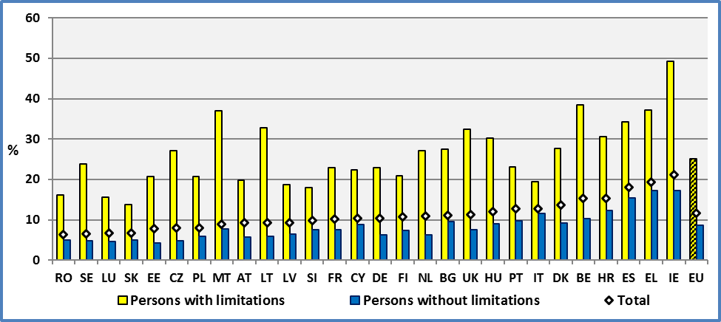

**Data source: E**U-SILC UDB 2014

In certain countries, the difference between persons with and without disabilities is relatively small (e.g. Italy, Slovakia and Slovenia). Italy presented a low gap in previous years too. However, in other Member States the difference is relatively important (Belgium, Malta and Ireland). Belgium and Ireland presented high gaps in previous years too.

**Figure 75: The work intensity gap between persons with and without disabilities, 2014**

Gap = % of persons with disabilities - % of persons without disabilities

Persons living in households with low work intensity (Work Intensity < 20%); Age 16-59.

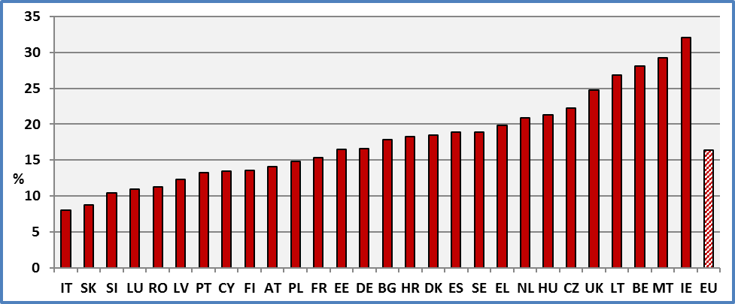

**Data source: E**U-SILC UDB 2014

2.2 Gender

Gender differences provide mixed results. Women have higher rates compared to men in 20 countries but the opposite is true in the remaining 8 Member States covered here. Among persons with disabilities, women have higher rates compared to men in 6 Member States.

Apparently, there is no gender disadvantage among persons with disabilities at the EU level. But this might be the result of the nature of the indicator. The unit of the indicator is the household and the indicator does not take into account the distribution of work inside the household among adult members. The same work intensity status is assigned to each household member. For comparison, if we retain only one member-households, then the total of women is higher compared to men in 17 countries. Furthermore, if we focus only on persons with disabilities inside this group, this number is nine (9).

In the discussion of unemployment rates, we noticed that contrary to our expectations, the unemployment rate of women with disabilities was lower compared to men with disabilities. The results concerning low work intensity are partly related to the unemployment situation. Partly, because low work intensity is established at the household level, while the unemployment rate is established at the individual level. Also, the distribution of part-time work is not equally distributed among men and women. Low work intensity requires a threshold of 20% for the household. Women with disabilities are overrepresented among part-time work compared both to men with disabilities (less than 35 hours per week in all jobs) and women without disabilities (less than 30 hours per week in all jobs).

**Figure 76: Percent of persons with disabilities living in households with low work intensity (WI < 20%). Age 16-59, 2014**

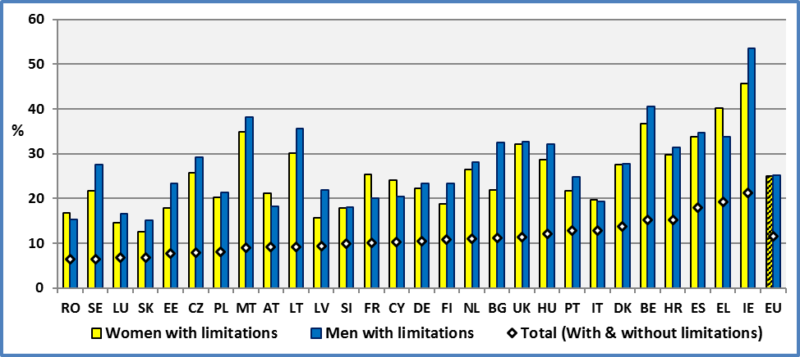

**Data source: E**U-SILC UDB 2014

About 25.0% of women with disabilities live in households with low work intensity compared to 9.4% of women without disabilities. The respective percentages for men are 25.3% and 8.1%.

Both women and men with disabilities are disadvantaged compared to respective women and men without disabilities. The disability related gap is 15.7 percentage points among women and 17.2 pp among men. At the EU level, the gender gap inside each group is apparently very small or inexistent.

The differences between disabled and non-disabled are substantial for both genders in all Member States.

**Figure 77: Percent of persons living in households with low work intensity (WI < 20%) by gender and disability status. Age 16-59, 2014 (Disability related gap)**

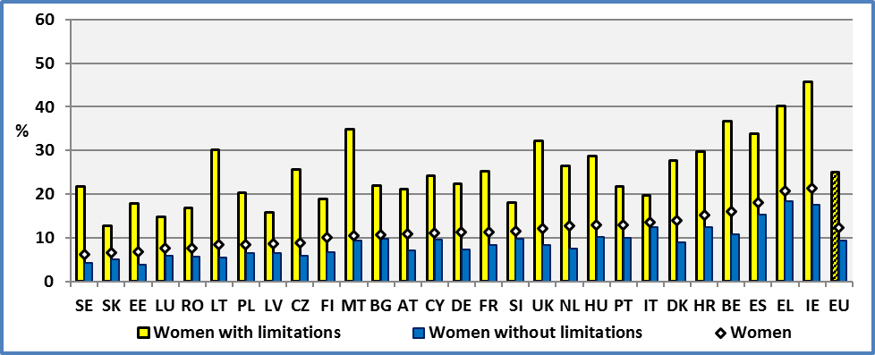

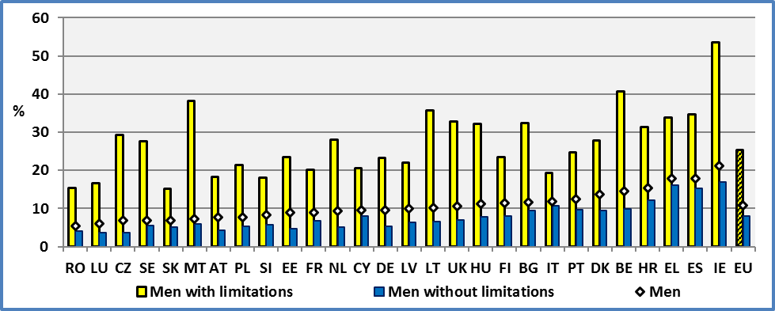

**Data source: E**U-SILC UDB 2014

2.3 Characteristics by age

We may observe that the percentage of persons living in households with low work intensity (WI < 20%) does not evolves in a similar way for persons with and without disabilities. Furthermore, the difference between the two groups is increasing with age.

**Figure 78: Percent of persons living in households with low work intensity (WI < 20%) by age-group and disability status. Age 16-59, EU 2014**

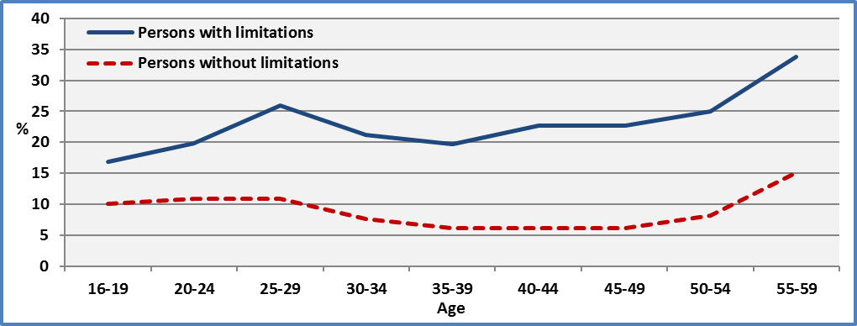

**Data source: E**U-SILC UDB 2014

2.4 Degree of disability

The degree of disability is an important factor. At the EU level, the percentage of severely disabled people living in households with a low work intensity (WI<20%) amounts to 41.6% compared to 8.7% of people without disabilities. The rate among persons with a moderate disability is 18.9%. We observed a similar ordering in previous years.

When we compare the percentage of persons living in households with low work intensity across Member States, we observe a big variability of this percentage. It ranges from 21.0% (Slovakia) to 57.8% (Ireland). This percentage for persons without disabilities ranges from 4.3% (Estonia) to 17.3% (Greece).

Countries with similar rates for persons without disabilities experience different rates for persons with a severe disability. These rates reveal the diversity of national policies concerning people with disabilities and the different impact of such policies.

**Figure 79: Percent of persons living in households with low work intensity (WI < 20%) by degree of disability.** Age 16-59, 2014

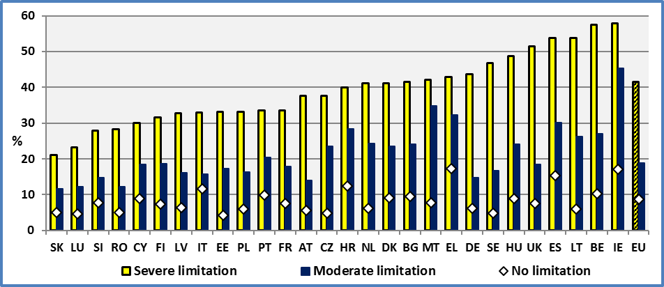

**Data source: E**U-SILC UDB 2014

The countries with the highest rates among persons with severe disabilities are Denmark (50%), Netherlands (50%), the UK (53%), Ireland (57%) and Belgium (57%). Netherlands, Denmark, the UK and Belgium had high rates in 2012 too.

On the contrary, the lowest rates for persons with severe disabilities can be found in Slovenia (23%), Romania (24%) and Luxembourg (25%). Slovenia and Luxembourg experienced similar rates in 2012.

As expected, national work intensities at the household level are correlated with national unemployment rates. The same holds for national work intensities at the household level and change of GDP. However, this relation is looser for households comprising persons with severe disabilities. This means that barriers and health issues might drive work intensity of households comprising persons with severe disabilities and that a generalised growth might not benefit to persons with severe disabilities in the same extent as for other groups.

2.5 Evolution

At the EU level, we observe that since 2008/2009 and the financial crisis, the rate of persons living in households with very low work intensity has increased. The evolution is similar for persons with and without disabilities.

We may observe a small decrease of the gap between persons with and without disabilities in 2013, but an increase in 2014.

At the EU level, about 25.1% of persons with disabilities aged 16-59 live in households with low work intensity. This rate for persons without disabilities is 8.7%. The total for the same age group is 11.6%.

**Figure 80: Evolution of the number of persons living in households with low work intensity (WI < 20%).** Age 16-59

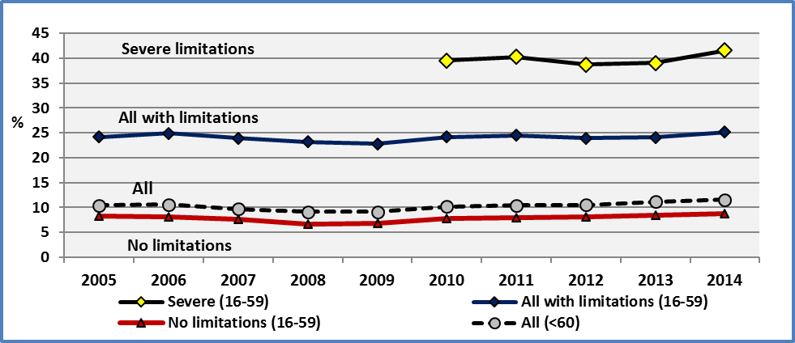

**Data source: E**U-SILC UDB

Although the change was small at the EU level, we observe significant differences across Member States.

In twenty (20) Member States, we observe a deterioration of the situation of persons with disabilities. The percentage of persons with disabilities living in households with low work intensity increased. This deterioration was notable in Malta. The situation improved in the remaining eight (8) Member States.

**Figure 81: Evolution of the number of persons with disabilities living in households with low work intensity (WI < 20%). Age 16-59.**

**Data source: E**U-SILC UDB 2013 & 2014

At the EU level, the percentage of persons with disabilities living in households with low work intensity increased from 24.1% to 25.1% between 2013 and 2014.

The following graph indicates that there is no correlation (R²=0.1) in the evolution of the percentages of persons with and without disabilities across the Member States.

**Figure 82: Difference between 2013 and 2014 in the percentage of persons with and without disabilities living in households with low work intensity (WI < 20%).** Age 16-59

Difference = % of persons in 2014 - % of persons in 2013

A negative value means an improvement (reduction of the percentage of persons with low work intensity)

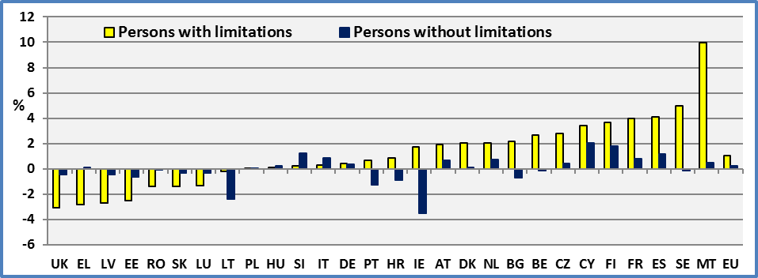

**Data source: E**U-SILC UDB 2013 & 2014

### 3. Data

**Table 95: Percent of persons living in households with very low work intensity (age 16-59)**

People living in households with very low work intensity are people living in households where the adults work less than 20% of their total work potential during the past year

|  |  |  |  |  |  |  |  |  |
| --- | --- | --- | --- | --- | --- | --- | --- | --- |
|  | **Persons with limitations (16-59)** | | | | | | | |
|  | **2005** | **2006** | **2007** | **2008** | **2009** | **2010** | **2011** | **2012** |
| **AT** | 16,1 | 18,6 | 21,4 | 20,0 | 18,9 | 17,9 | 20,7 | 19,2 |
| **BE** | 33,4 | 35,3 | 34,3 | 33,6 | 31,7 | 33,4 | 33,6 | 38,2 |
| **BG** | : | 25,9 | 37,6 | 17,7 | 15,8 | 21,5 | 25,1 | 25,0 |
| **CY** | 11,8 | 10,9 | 10,9 | 14,9 | 11,9 | 12,8 | 14,4 | 16,0 |
| **CZ** | 19,6 | 22,1 | 22,2 | 23,2 | 21,0 | 21,2 | 22,8 | 25,3 |
| **DE** | 22,8 | 25,0 | 23,9 | 23,6 | 23,3 | 24,2 | 24,5 | 22,2 |
| **DK** | 23,5 | 30,0 | 30,8 | 22,5 | 21,6 | 24,0 | 23,1 | 25,1 |
| **EE** | 18,7 | 18,2 | 18,4 | 20,4 | 20,0 | 22,3 | 26,5 | 24,8 |
| **EL** | 19,3 | 23,6 | 24,5 | 25,8 | 25,7 | 25,5 | 32,4 | 35,9 |
| **ES** | 16,5 | 15,9 | 16,0 | 20,2 | 18,9 | 23,3 | 30,3 | 31,3 |
| **FI** | 18,5 | 18,2 | 22,0 | 17,9 | 18,6 | 20,2 | 21,7 | 18,3 |
| **FR** | 22,7 | 22,5 | 22,5 | 21,7 | 19,3 | 21,0 | 20,6 | 19,2 |
| **HR** | : | : | : | : | : | 31,6 | : | 35,5 |
| **HU** | 22,9 | 30,6 | 29,4 | 29,7 | 29,2 | 27,4 | 28,9 | 31,1 |
| **IE** | 35,3 | 30,5 | 36,4 | 36,1 | 39,4 | 44,4 | 47,5 | 49,9 |
| **IT** | 24,3 | 24,3 | 21,1 | 21,9 | 19,8 | 22,4 | 21,3 | 17,8 |
| **LT** | 25,2 | 23,2 | 18,1 | 20,9 | 24,9 | 30,7 | 33,9 | 33,6 |
| **LU** | 16,6 | 15,3 | 12,4 | 14,6 | 18,0 | 17,5 | 19,2 | 18,1 |
| **LV** | 14,8 | 14,7 | 15,4 | 14,7 | 18,0 | 26,6 | 26,5 | 26,5 |
| **MT** | 30,3 | 29,4 | 29,5 | 37,2 | 32,1 | 28,7 | 25,3 | 35,2 |
| **NL** | 27,3 | 29,1 | 29,9 | 23,6 | 23,3 | 23,6 | 25,4 | 23,1 |
| **PO** | 40,9 | 32,5 | 28,0 | 25,5 | 22,4 | 22,3 | 21,8 | 21,9 |
| **PT** | 18,1 | 19,9 | 20,6 | 16,2 | 16,8 | 19,9 | 18,9 | 19,7 |
| **RO** | : | : | 24,7 | 24,8 | 24,6 | 19,4 | 19,0 | 19,8 |
| **SE** | 22,8 | 19,9 | 17,3 | 20,8 | 24,1 | 21,2 | 20,3 | 17,8 |
| **SI** | 18,7 | 16,1 | 14,0 | 15,1 | 12,9 | 16,2 | 15,7 | 15,5 |
| **SK** | 15,3 | 14,8 | 16,3 | 12,6 | 12,4 | 15,2 | 16,0 | 15,6 |
| **UK** | 32,3 | 32,6 | 30,4 | 27,0 | 33,1 | 34,8 | 30,8 | 34,0 |
|  |  |  |  |  |  |  |  |  |
| **EU** | 24,2 | 24,9 | 23,9 | 23,2 | 22,8 | 24,2 | 24,5 | 23,9 |
|  |  |  |  |  |  |  |  |  |
| **CH** | : | : | 10,7 | 9,2 | 9,1 | 10,6 | 12,9 | 11,2 |
| **IS** | 13,1 | 10,3 | 12,7 | 16,1 | 12,0 | 18,6 | 18,9 | 20,1 |
| **NO** | 19,3 | 25,0 | 23,3 | 24,4 | 24,6 | 26,5 | 22,1 | 30,8 |
| **RS** | : | : | : | : | : | : | : | : |

**Data source: 2005-2012:** Eurostat:Extracted on 05.11.15

**Table 96: Percent of persons living in households with very low work intensity (age 16-59)**

People living in households with very low work intensity are people living in households where the adults work less than 20% of their total work potential during the past year

|  |  |  |  |  |  |  |  |  |
| --- | --- | --- | --- | --- | --- | --- | --- | --- |
|  | **Persons without limitations (16-59)** | | | | | | | |
|  | **2005** | **2006** | **2007** | **2008** | **2009** | **2010** | **2011** | **2012** |
| **AT** | 5,1 | 6,1 | 5,8 | 5,3 | 4,8 | 5,9 | 5,4 | 5,3 |
| **BE** | 12,0 | 10,9 | 10,5 | 8,7 | 9,1 | 8,8 | 9,9 | 10,3 |
| **BG** | : | 12,7 | 14,8 | 6,6 | 5,9 | 6,2 | 8,8 | 9,8 |
| **CY** | 3,4 | 3,2 | 3,0 | 3,7 | 3,3 | 4,3 | 3,9 | 5,6 |
| **CZ** | 6,7 | 6,1 | 6,1 | 4,9 | 3,8 | 4,4 | 4,9 | 4,7 |
| **DE** | 9,1 | 10,1 | 9,4 | 7,7 | 7,1 | 7,7 | 6,7 | 5,9 |
| **DK** | 8,9 | 7,1 | 7,6 | 5,7 | 6,1 | 7,1 | 8,7 | 8,4 |
| **EE** | 6,1 | 4,0 | 3,4 | 2,6 | 3,0 | 6,1 | 6,2 | 5,9 |
| **EL** | 7,4 | 7,8 | 7,5 | 6,7 | 6,6 | 7,4 | 11,6 | 13,8 |
| **ES** | 5,8 | 5,4 | 5,6 | 5,1 | 6,1 | 9,6 | 11,8 | 12,8 |
| **FI** | 7,7 | 5,9 | 6,0 | 5,1 | 6,1 | 7,1 | 7,0 | 6,6 |
| **FR** | 7,0 | 7,6 | 8,3 | 7,0 | 7,0 | 8,0 | 7,4 | 6,8 |
| **HR** | : | : | : | : | : | 13,9 | : | 14,2 |
| **HU** | 5,5 | 8,5 | 7,6 | 7,9 | 7,2 | 8,0 | 8,1 | 8,8 |
| **IE** | 9,4 | 8,9 | 10,0 | 9,2 | 14,8 | 18,5 | 20,4 | 20,4 |
| **IT** | 10,0 | 10,3 | 9,2 | 8,7 | 8,0 | 9,6 | 9,4 | 9,9 |
| **LT** | 7,3 | 6,3 | 4,3 | 2,8 | 5,2 | 8,0 | 10,2 | 9,0 |
| **LU** | 4,7 | 3,8 | 4,2 | 3,6 | 5,0 | 4,3 | 4,8 | 4,8 |
| **LV** | 6,2 | 4,9 | 4,1 | 3,1 | 4,7 | 9,1 | 9,4 | 9,1 |
| **MT** | 8,1 | 8,0 | 8,2 | 6,7 | 7,3 | 7,7 | 7,4 | 7,1 |
| **NL** | 7,5 | 8,2 | 6,8 | 5,1 | 5,3 | 5,1 | 5,5 | 5,8 |
| **PO** | 12,9 | 10,7 | 8,4 | 6,5 | 5,6 | 6,1 | 5,6 | 5,5 |
| **PT** | 4,2 | 4,6 | 4,9 | 4,3 | 4,9 | 6,2 | 6,3 | 9,1 |
| **RO** | : | : | 7,1 | 6,9 | 6,2 | 5,4 | 5,1 | 5,3 |
| **SE** | 5,0 | 4,6 | 3,8 | 4,0 | 4,7 | 4,5 | 5,3 | 4,3 |
| **SI** | 7,5 | 5,5 | 6,6 | 5,7 | 4,8 | 4,5 | 5,7 | 6,0 |
| **SK** | 5,3 | 4,7 | 4,6 | 3,2 | 3,6 | 5,6 | 5,1 | 4,9 |
| **UK** | 7,7 | 7,3 | 6,0 | 6,6 | 8,1 | 8,1 | 7,1 | 8,1 |
|  |  |  |  |  |  |  |  |  |
| **EU** | **8,3** | **8,2** | **7,7** | **6,7** | **6,8** | **7,8** | **7,9** | **8,1** |
|  |  |  |  |  |  |  |  |  |
| **CH** | : | : | 3,2 | 2,3 | 3,1 | 2,9 | 3,0 | 2,9 |
| **IS** | 1,4 | 1,4 | 1,1 | 0,9 | 1,0 | 3,2 | 3,3 | 3,5 |
| **NO** | 6,0 | 5,1 | 5,8 | 4,2 | 4,7 | 5,0 | 4,7 | 4,4 |
| **RS** | : | : | : | : | : | : | : | : |

**Data source: 2005-2012:** Eurostat:Extracted on 05.11.15

**Table 97: Percent of persons living in households with very low work intensity (age <60)\***

People living in households with very low work intensity are people living in households where the adults work less than 20% of their total work potential during the past year

|  |  |  |  |  |  |  |  |  |  |
| --- | --- | --- | --- | --- | --- | --- | --- | --- | --- |
|  | **ALL (<60)** | | | | | | | | |
|  | **2005** | **2006** | **2007** | **2008** | **2009** | **2010** | **2011** | **2012** | **2013** |
| **AT** | 7,3 | 8,1 | 8,2 | 7,4 | 7,1 | 7,8 | 8,6 | 7,7 | 7,8 |
| **BE** | 15,1 | 14,3 | 13,8 | 11,7 | 12,3 | 12,7 | 13,8 | 13,9 | 14 |
| **BG** | : | 14,7 | 16 | 8,1 | 6,9 | 8 | 11 | 12,5 | 13 |
| **CY** | 4,4 | 3,8 | 3,7 | 4,5 | 4 | 4,9 | 4,9 | 6,5 | 7,9 |
| **CZ** | 8,9 | 8,9 | 8,6 | 7,2 | 6 | 6,4 | 6,6 | 6,8 | 6,9 |
| **DE** | 12 | 13,6 | 11,5 | 11,7 | 10,9 | 11,2 | 11,2 | 9,9 | 9,9 |
| **DK** | 10,1 | 9,6 | 10,1 | 8,5 | 8,8 | 10,6 | 11,7 | 11,3 | 12,9 |
| **EE** | 9,5 | 7,1 | 6,2 | 5,3 | 5,6 | 9 | 10 | 9,1 | 8,4 |
| **EL** | 7,6 | 8,1 | 8,1 | 7,5 | 6,6 | 7,6 | 12 | 14,2 | 18,2 |
| **ES** | 6,9 | 6,4 | 6,8 | 6,6 | 7,6 | 10,8 | 13,4 | 14,3 | 15,7 |
| **FI** | 10 | 9,1 | 8,8 | 7,5 | 8,4 | 9,3 | 10 | 9,3 | 9 |
| **FR** | 8,7 | 9,1 | 9,6 | 8,8 | 8,4 | 9,9 | 9,4 | 8,4 | 8,1 |
| **HR** | : | : | : | : | : | 13,9 | 15,9 | 16,8 | 14,8 |
| **HU** | 9,5 | 13,1 | 11,3 | 12 | 11,3 | 11,9 | 12,2 | 12,8 | 12,6 |
| **IE** | 14,7 | 12,9 | 14,3 | 13,7 | 20 | 22,9 | 24,2 | 23,4 | 23,9 |
| **IT** | 10,4 | 10,9 | 10 | 9,8 | 8,8 | 10,2 | 10,4 | 10,3 | 11 |
| **LT** | 9,6 | 8,3 | 6,4 | 6,1 | 7,2 | 9,5 | 12,7 | 11,4 | 11 |
| **LU** | 5,7 | 5,2 | 5 | 4,7 | 6,3 | 5,5 | 5,8 | 6,1 | 6,6 |
| **LV** | 8,3 | 7,1 | 6,2 | 5,4 | 7,4 | 12,6 | 12,6 | 11,7 | 10 |
| **MT** | 9,6 | 9,7 | 9,6 | 8,6 | 9,2 | 9,2 | 8,9 | 9 | 9 |
| **NL** | 9,8 | 10,9 | 9,7 | 8,2 | 8,5 | 8,4 | 8,9 | 8,9 | 9,3 |
| **PO** | 14,3 | 12,4 | 10,1 | 8 | 6,9 | 7,3 | 6,9 | 6,9 | 7,2 |
| **PT** | 6 | 6,6 | 7,2 | 6,3 | 7 | 8,6 | 8,3 | 10,1 | 12,2 |
| **RO** | : | : | 8,4 | 8,3 | 7,7 | 6,9 | 6,7 | 7,4 | 6,4 |
| **SE** | 7,6 | 6,8 | 6 | 5,5 | 6,4 | 6 | 6,9 | 5,7 | 7,1 |
| **SI** | 8,6 | 6,9 | 7,3 | 6,7 | 5,6 | 7 | 7,6 | 7,5 | 8 |
| **SK** | 6,6 | 6,2 | 6,4 | 5,2 | 5,6 | 7,9 | 7,7 | 7,2 | 7,6 |
| **UK** | 12,9 | 12 | 10,4 | 10,4 | 12,7 | 13,2 | 11,5 | 13 | 13,2 |
|  |  |  |  |  |  |  |  |  |  |
| **EU** | **10,4** | **10,6** | **9,7** | **9,1** | **9,1** | **10,2** | **10,4** | **10,5** | **10,8** |
|  |  |  |  |  |  |  |  |  |  |
| **CH** | : | : | 4,5 | 3,3 | 4 | 4,1 | 4,7 | 3,5 | 4,1 |
| **IS** | 3,2 | 2,8 | 2,4 | 2,6 | 2,1 | 5,7 | 6,2 | 6,1 | 6,2 |
| **NO** | 8,3 | 7,7 | 8,7 | 6,5 | 6,9 | 7,5 | 7,1 | 7,1 | 6,4 |
| **RS** | : | : | : | : | : | : | : | : | 18,1 |

**\*:** For persons aged 16-59 see next table and below in tables by degree.

**Data source:** Eurostat:Extracted on 05.11.15

**Table 98: Percent of persons living in households with very low work intensity (age 16-59)**

People living in households with very low work intensity are people living in households where the adults work less than 20% of their total work potential during the past year

|  |  |  |  |  |  |  |
| --- | --- | --- | --- | --- | --- | --- |
|  | **Persons with limitations** | | **Persons without limitations** | | **TOTAL** | |
|  | **2013** | **2014** | **2013** | **2014** | **2013** | **2014** |
| **AT** | 17,8 | 19,8 | 5,0 | 5,7 | 7,8 | 9,2 |
| **BE** | 35,7 | 38,4 | 10,5 | 10,3 | 14,8 | 15,3 |
| **BG** | 25,3 | 27,4 | 10,3 | 9,6 | 11,6 | 11,2 |
| **CY** | 18,8 | 22,3 | 6,8 | 8,8 | 8,3 | 10,3 |
| **CZ** | 24,3 | 27,1 | 4,5 | 4,9 | 7,4 | 8,0 |
| **DE** | 22,4 | 22,8 | 5,9 | 6,2 | 9,8 | 10,5 |
| **DK** | 25,7 | 27,7 | 9,0 | 9,2 | 13,2 | 13,8 |
| **EE** | 23,2 | 20,7 | 4,9 | 4,3 | 8,8 | 7,8 |
| **EL** | 40,0 | 37,1 | 17,2 | 17,3 | 19,3 | 19,3 |
| **ES** | 30,1 | 34,2 | 14,2 | 15,4 | 16,5 | 18,1 |
| **FI** | 17,3 | 20,9 | 5,6 | 7,4 | 9,6 | 10,8 |
| **FR** | 19,0 | 23,0 | 6,8 | 7,6 | 8,8 | 10,2 |
| **HR** | 29,8 | 30,6 | 13,2 | 12,3 | 16,0 | 15,3 |
| **HU** | 30,2 | 30,3 | 8,8 | 9,0 | 12,0 | 12,1 |
| **IE** | 47,5 | 49,2 | 20,7 | 17,2 | 23,9 | 21,2 |
| **IT** | 19,2 | 19,5 | 10,7 | 11,5 | 12,1 | 12,8 |
| **LT** | 33,0 | 32,8 | 8,3 | 5,9 | 11,4 | 9,3 |
| **LU** | 16,9 | 15,6 | 5,0 | 4,7 | 7,2 | 6,7 |
| **LV** | 21,4 | 18,7 | 6,9 | 6,4 | 10,3 | 9,3 |
| **MT** | 27,0 | 37,0 | 7,3 | 7,8 | 8,3 | 9,0 |
| **NL** | 25,1 | 27,1 | 5,5 | 6,2 | 10,5 | 11,0 |
| **PO** | 20,7 | 20,8 | 5,9 | 5,9 | 8,0 | 8,1 |
| **PT** | 22,4 | 23,1 | 11,1 | 9,8 | 12,9 | 12,8 |
| **RO** | 17,6 | 16,2 | 5,0 | 4,9 | 6,8 | 6,5 |
| **SE** | 18,8 | 23,8 | 5,0 | 4,9 | 7,4 | 6,5 |
| **SI** | 17,8 | 18,1 | 6,4 | 7,6 | 8,8 | 9,9 |
| **SK** | 15,2 | 13,8 | 5,4 | 5,1 | 7,4 | 6,8 |
| **UK** | 35,5 | 32,4 | 8,1 | 7,6 | 12,0 | 11,4 |
|  |  |  |  |  |  |  |
| **EU** | **24,1** | **25,1** | **8,5** | **8,7** | **11,2** | **11,6** |
|  |  |  |  |  |  |  |
| **CH** | 9,0 | 10,8 | 2,9 | 3,3 | 4,3 | 5,2 |
| **IS** | 20,0 | 16,9 | 3,5 | 2,6 | 5,8 | 4,8 |
| **NO** | 21,5 | 23,1 | 4,6 | 4,0 | 7,0 | 6,5 |
| **RS** | 37,8 | 38,3 | 17,6 | 19,8 | 19,6 | 21,4 |

**Data source:** EU-SILC UDB

**Table 99: Percent of persons living in households with very low work intensity by sex (age 16-59)**

People living in households with very low work intensity are people living in households where the adults work less than 20% of their total work potential during the past year

|  |  |  |  |  |  |  |  |  |  |
| --- | --- | --- | --- | --- | --- | --- | --- | --- | --- |
|  | **Men with limitations (16-59)** | | | | | | | | |
|  | **2005** | **2006** | **2007** | **2008** | **2009** | **2010** | **2011** | **2012** | **2013** |
| **AT** | 14,9 | 16,9 | 18,6 | 17,7 | 16,8 | 15,4 | 19,9 | 18,4 | 17,0 |
| **BE** | 31,5 | 33,3 | 36,2 | 34,0 | 34,0 | 37,0 | 36,6 | 38,5 | 38,4 |
| **BG** | : | 27,6 | 43,7 | 16,5 | 17,2 | 22,9 | 25,5 | 26,6 | 30,0 |
| **CY** | 8,2 | 7,1 | 7,8 | 13,1 | 9,0 | 11,1 | 13,3 | 15,6 | 17,4 |
| **CZ** | 19,3 | 22,0 | 22,5 | 22,5 | 19,2 | 19,2 | 23,3 | 27,3 | 28,3 |
| **DE** | 18,4 | 21,7 | 20,5 | 21,9 | 22,8 | 24,5 | 24,4 | 21,1 | 22,5 |
| **DK** | 25,8 | 29,0 | 34,0 | 23,1 | 20,3 | 21,4 | 21,8 | 26,9 | 30,3 |
| **EE** | 20,5 | 20,7 | 20,0 | 23,1 | 22,6 | 26,4 | 29,8 | 27,5 | 26,6 |
| **EL** | 19,0 | 21,3 | 23,5 | 27,5 | 25,4 | 27,6 | 31,5 | 33,6 | 38,8 |
| **ES** | 17,6 | 17,8 | 17,2 | 23,7 | 21,7 | 27,9 | 34,9 | 34,4 | 31,6 |
| **FI** | 19,6 | 17,9 | 23,5 | 19,2 | 20,7 | 24,3 | 24,3 | 21,6 | 19,8 |
| **FR** | 24,4 | 23,7 | 22,5 | 21,4 | 18,6 | 19,9 | 19,5 | 19,5 | 14,7 |
| **HR** | : | : | : | : | : | 34,8 | : | 37,5 | 29,8 |
| **HU** | 20,5 | 29,5 | 27,7 | 28,6 | 29,9 | 28,1 | 29,5 | 31,8 | 31,5 |
| **IE** | 40,5 | 33,5 | 38,6 | 40,8 | 41,3 | 47,2 | 49,5 | 53,9 | 52,2 |
| **IT** | 23,2 | 23,5 | 19,3 | 20,1 | 18,6 | 22,6 | 20,0 | 16,7 | 19,7 |
| **LT** | 26,0 | 22,7 | 17,6 | 22,2 | 30,3 | 33,1 | 37,4 | 33,0 | 36,4 |
| **LU** | 17,2 | 13,5 | 11,0 | 14,6 | 15,8 | 15,8 | 18,6 | 18,0 | 17,2 |
| **LV** | 16,5 | 16,2 | 15,7 | 16,4 | 21,5 | 27,9 | 29,6 | 30,6 | 24,0 |
| **MT** | 29,7 | 29,5 | 27,0 | 34,8 | 29,9 | 28,1 | 24,2 | 35,7 | 30,9 |
| **NL** | 25,9 | 28,3 | 31,9 | 23,9 | 22,1 | 21,6 | 24,8 | 24,6 | 26,1 |
| **PO** | 41,1 | 32,6 | 28,5 | 26,6 | 22,4 | 23,4 | 22,2 | 23,1 | 21,6 |
| **PT** | 18,8 | 20,1 | 20,8 | 16,2 | 17,9 | 22,7 | 22,2 | 21,4 | 24,5 |
| **RO** | : | : | 23,3 | 24,8 | 25,7 | 19,0 | 16,7 | 19,9 | 16,3 |
| **SE** | 25,5 | 17,6 | 14,8 | 20,4 | 24,7 | 24,9 | 23,1 | 19,7 | 18,3 |
| **SI** | 18,1 | 16,5 | 12,8 | 16,4 | 12,2 | 16,3 | 15,6 | 15,1 | 17,8 |
| **SK** | 12,7 | 15,4 | 15,7 | 11,1 | 11,4 | 14,5 | 15,5 | 14,6 | 15,2 |
| **UK** | 33,1 | 33,6 | 30,7 | 27,9 | 33,6 | 37,2 | 33,7 | 34,4 | 38,3 |
|  |  |  |  |  |  |  |  |  |  |
| **EU** | 23,2 | 24,3 | 23,1 | 23,1 | 22,9 | 25,0 | 24,9 | 24,3 | 24,6 |
|  |  |  |  |  |  |  |  |  |  |
| **CH** | : | : | 9,5 | 9,2 | 9,6 | 11,6 | 13,0 | 11,1 | 9,5 |
| **IS** | 12,4 | 6,2 | 7,9 | 14,7 | 12,3 | 17,9 | 17,1 | 20,3 | 22,8 |
| **NO** | 23,8 | 26,0 | 25,6 | 25,5 | 27,2 | 33,5 | 25,5 | 33,4 | 24,9 |
| **RS** | : | : | : | : | : | : | : | : | 38,5 |

**Data source: 2005-2012:** Eurostat:Extracted on 05.11.15

**2013**: EU-SILC UDB 2013

**Table 100: Percent of persons living in households with very low work intensity by sex (age 16-59)**

People living in households with very low work intensity are people living in households where the adults work less than 20% of their total work potential during the past year

|  |  |  |  |  |  |  |  |  |  |
| --- | --- | --- | --- | --- | --- | --- | --- | --- | --- |
|  | **Men without limitations (16-59)** | | | | | | | | |
|  | **2005** | **2006** | **2007** | **2008** | **2009** | **2010** | **2011** | **2012** | **2013** |
| **AT** | 3,2 | 4,7 | 3,9 | 4,3 | 3,2 | 4,8 | 4,6 | 4,0 | 4,2 |
| **BE** | 10,5 | 9,1 | 8,9 | 7,2 | 7,2 | 7,7 | 9,1 | 9,4 | 10,1 |
| **BG** | : | 12,5 | 13,9 | 6,4 | 5,7 | 5,8 | 8,7 | 9,7 | 10,2 |
| **CY** | 2,2 | 1,9 | 2,1 | 2,2 | 2,3 | 3,7 | 3,0 | 4,8 | 6,8 |
| **CZ** | 4,9 | 5,2 | 4,5 | 3,6 | 2,4 | 3,3 | 3,5 | 3,6 | 3,1 |
| **DE** | 7,9 | 8,7 | 8,3 | 6,6 | 6,2 | 6,5 | 5,9 | 5,2 | 4,9 |
| **DK** | 8,4 | 5,7 | 6,1 | 6,1 | 5,5 | 6,6 | 9,0 | 8,2 | 10,2 |
| **EE** | 5,7 | 3,9 | 3,6 | 2,9 | 3,7 | 6,3 | 7,2 | 6,1 | 5,7 |
| **EL** | 5,5 | 6,0 | 5,6 | 4,9 | 5,2 | 5,9 | 10,2 | 11,9 | 16,1 |
| **ES** | 4,6 | 4,6 | 4,9 | 4,0 | 5,2 | 9,3 | 11,0 | 12,0 | 14,5 |
| **FI** | 8,1 | 6,6 | 6,4 | 5,2 | 6,3 | 7,2 | 6,9 | 7,4 | 5,9 |
| **FR** | 5,8 | 6,5 | 7,0 | 6,0 | 6,1 | 7,1 | 6,8 | 6,4 | 6,3 |
| **HR** | : | : | : | : | : | 14,3 | : | 14,4 | 13,6 |
| **HU** | 4,5 | 8,0 | 7,2 | 6,8 | 6,0 | 6,9 | 7,7 | 8,5 | 8,6 |
| **IE** | 7,6 | 7,4 | 8,5 | 7,7 | 12,6 | 16,0 | 18,9 | 20,0 | 20,1 |
| **IT** | 8,2 | 8,6 | 7,4 | 7,2 | 6,4 | 7,8 | 7,9 | 8,4 | 9,1 |
| **LT** | 6,7 | 6,5 | 4,4 | 2,9 | 5,6 | 9,4 | 10,7 | 10,2 | 8,8 |
| **LU** | 3,3 | 2,9 | 3,4 | 2,5 | 3,5 | 3,4 | 3,6 | 3,3 | 4,2 |
| **LV** | 5,7 | 4,2 | 4,0 | 3,1 | 4,8 | 10,2 | 9,6 | 9,5 | 7,1 |
| **MT** | 5,5 | 5,6 | 6,0 | 4,3 | 4,9 | 5,1 | 4,9 | 5,3 | 5,1 |
| **NL** | 5,4 | 6,3 | 6,0 | 3,9 | 5,0 | 4,1 | 5,7 | 5,3 | 4,8 |
| **PO** | 12,2 | 9,7 | 7,6 | 5,5 | 4,6 | 4,8 | 4,7 | 4,6 | 5,1 |
| **PT** | 4,0 | 4,3 | 4,6 | 3,8 | 4,5 | 6,0 | 5,7 | 8,8 | 11,3 |
| **RO** | : | : | 6,2 | 5,8 | 4,8 | 4,8 | 4,5 | 4,1 | 3,9 |
| **SE** | 4,7 | 4,7 | 3,9 | 3,9 | 5,0 | 4,5 | 4,8 | 4,0 | 5,4 |
| **SI** | 7,1 | 4,6 | 6,1 | 5,1 | 4,1 | 3,5 | 4,2 | 5,0 | 5,7 |
| **SK** | 4,5 | 4,2 | 3,9 | 2,7 | 3,4 | 5,2 | 5,1 | 4,9 | 5,2 |
| **UK** | 5,7 | 5,6 | 4,9 | 5,5 | 7,8 | 6,8 | 6,0 | 7,3 | 6,7 |
|  |  |  |  |  |  |  |  |  |  |
| **EU** | **7,0** | **7,1** | **6,6** | **5,6** | **5,9** | **6,8** | **7,0** | **7,3** | **7,8** |
|  |  |  |  |  |  |  |  |  |  |
| **CH** | : | : | 1,8 | 1,2 | 2,0 | 2,1 | 2,1 | 2,4 | 2,0 |
| **IS** | 0,7 | 1,2 | 0,9 | 0,8 | 1,1 | 3,0 | 3,1 | 3,7 | 2,4 |
| **NO** | 5,9 | 5,1 | 5,3 | 3,5 | 4,4 | 4,2 | 4,6 | 4,6 | 4,2 |
| **RS** | : | : | : | : | : | : | : | : | 16,7 |

**Data source: 2005-2012:** Eurostat:Extracted on 05.11.15

**2013**: EU-SILC UDB 2013

**Table 101: Percent of persons living in households with very low work intensity by sex (age 16-59)**

People living in households with very low work intensity are people living in households where the adults work less than 20% of their total work potential during the past year

|  |  |  |  |  |  |  |  |  |  |
| --- | --- | --- | --- | --- | --- | --- | --- | --- | --- |
|  | **Women with limitations (16-59)** | | | | | | | | |
|  | **2005** | **2006** | **2007** | **2008** | **2009** | **2010** | **2011** | **2012** | **2013** |
| **AT** | 17,3 | 20,3 | 24,4 | 22,3 | 21,0 | 20,4 | 21,4 | 19,9 | 18,6 |
| **BE** | 35,0 | 36,8 | 32,7 | 33,2 | 29,7 | 30,6 | 31,1 | 38,0 | 33,4 |
| **BG** | : | 24,4 | 28,3 | 18,9 | 14,6 | 20,1 | 24,8 | 23,4 | 20,4 |
| **CY** | 15,0 | 14,5 | 13,9 | 16,6 | 14,9 | 14,4 | 15,5 | 16,3 | 20,3 |
| **CZ** | 19,8 | 22,2 | 21,9 | 23,7 | 22,4 | 22,9 | 22,4 | 23,9 | 21,5 |
| **DE** | 27,0 | 27,9 | 26,8 | 25,3 | 23,7 | 23,9 | 24,6 | 23,2 | 22,3 |
| **DK** | 22,1 | 30,6 | 28,5 | 22,0 | 22,5 | 26,2 | 23,9 | 23,6 | 27,9 |
| **EE** | 16,9 | 15,7 | 16,8 | 17,6 | 17,2 | 18,2 | 23,3 | 22,1 | 20,1 |
| **EL** | 19,6 | 25,7 | 25,4 | 24,3 | 26,0 | 23,4 | 33,2 | 38,2 | 41,1 |
| **ES** | 15,4 | 14,4 | 14,9 | 17,0 | 16,4 | 19,6 | 26,2 | 28,3 | 28,9 |
| **FI** | 17,4 | 18,4 | 20,6 | 16,7 | 16,6 | 17,0 | 19,2 | 15,6 | 15,1 |
| **FR** | 21,2 | 21,6 | 22,4 | 22,0 | 20,0 | 22,0 | 21,6 | 19,0 | 19,3 |
| **HR** | : | : | : | : | : | 28,8 | : | 33,4 | 29,7 |
| **HU** | 25,1 | 31,6 | 30,9 | 30,8 | 28,5 | 26,8 | 28,3 | 30,4 | 29,1 |
| **IE** | 31,0 | 27,8 | 34,1 | 31,6 | 37,5 | 41,9 | 45,6 | 45,9 | 43,1 |
| **IT** | 25,2 | 24,8 | 22,6 | 23,4 | 20,8 | 22,2 | 22,4 | 18,7 | 18,3 |
| **LT** | 24,4 | 23,7 | 18,5 | 19,8 | 20,9 | 28,7 | 30,7 | 34,1 | 29,8 |
| **LU** | 16,0 | 17,1 | 13,9 | 14,5 | 20,1 | 19,3 | 19,7 | 18,2 | 16,7 |
| **LV** | 13,3 | 13,5 | 15,1 | 13,3 | 14,9 | 25,4 | 23,6 | 22,8 | 19,2 |
| **MT** | 31,0 | 29,3 | 32,0 | 40,2 | 34,6 | 29,2 | 26,7 | 34,8 | 23,8 |
| **NL** | 28,3 | 29,6 | 28,7 | 23,4 | 24,2 | 25,1 | 25,8 | 22,1 | 24,4 |
| **PO** | 40,6 | 32,4 | 27,5 | 24,4 | 22,4 | 21,3 | 21,3 | 20,7 | 20,0 |
| **PT** | 17,5 | 19,8 | 20,5 | 16,1 | 15,9 | 18,0 | 16,6 | 18,6 | 21,0 |
| **RO** | : | : | 25,7 | 24,9 | 23,8 | 19,8 | 20,7 | 19,8 | 18,5 |
| **SE** | 20,7 | 21,6 | 19,1 | 21,1 | 23,7 | 18,9 | 18,5 | 16,4 | 19,2 |
| **SI** | 19,4 | 15,7 | 15,4 | 13,8 | 13,5 | 16,1 | 15,8 | 15,9 | 17,8 |
| **SK** | 17,5 | 14,5 | 16,8 | 13,7 | 13,2 | 15,9 | 16,5 | 16,4 | 15,2 |
| **UK** | 31,6 | 31,9 | 30,2 | 26,3 | 32,6 | 32,9 | 28,6 | 33,6 | 33,2 |
|  |  |  |  |  |  |  |  |  |  |
| **EU** | **25,2** | **25,5** | **24,5** | **23,3** | **22,7** | **23,6** | **24,1** | **23,7** | **23,4** |
|  |  |  |  |  |  |  |  |  |  |
| **CH** | : | : | 11,6 | 9,3 | 8,7 | 9,8 | 12,8 | 11,2 | 8,6 |
| **IS** | 13,6 | 13,5 | 15,6 | 17,1 | 11,8 | 19,1 | 20,4 | 19,9 | 18,5 |
| **NO** | 15,7 | 24,1 | 21,4 | 23,7 | 22,6 | 21,0 | 19,3 | 29,0 | 18,9 |
| **RS** | : | : | : | : | : | : | : | : | 37,3 |

**Data source: 2005-2012:** Eurostat:Extracted on 05.11.15

**2013**: EU-SILC UDB 2013

**Table 102: Percent of persons living in households with very low work intensity by sex (age 16-59)**

People living in households with very low work intensity are people living in households where the adults work less than 20% of their total work potential during the past year

|  |  |  |  |  |  |  |  |  |  |
| --- | --- | --- | --- | --- | --- | --- | --- | --- | --- |
|  | **Women without limitations (16-59)** | | | | | | | | |
|  | **2005** | **2006** | **2007** | **2008** | **2009** | **2010** | **2011** | **2012** | **2013** |
| **AT** | 7,0 | 7,5 | 7,5 | 6,4 | 6,3 | 6,9 | 6,2 | 6,6 | 5,9 |
| **BE** | 13,6 | 12,8 | 12,2 | 10,2 | 10,9 | 9,9 | 10,6 | 11,2 | 10,9 |
| **BG** | : | 12,9 | 15,7 | 6,9 | 6,1 | 6,6 | 8,8 | 9,8 | 10,4 |
| **CY** | 4,5 | 4,4 | 3,9 | 5,2 | 4,3 | 4,8 | 4,7 | 6,4 | 6,8 |
| **CZ** | 8,3 | 6,9 | 7,7 | 6,1 | 5,0 | 5,4 | 6,1 | 5,6 | 5,6 |
| **DE** | 10,5 | 11,5 | 10,7 | 8,9 | 8,1 | 8,9 | 7,6 | 6,7 | 6,9 |
| **DK** | 9,4 | 8,6 | 9,3 | 5,3 | 6,7 | 7,5 | 8,3 | 8,6 | 8,0 |
| **EE** | 6,5 | 4,0 | 3,2 | 2,3 | 2,4 | 5,8 | 5,3 | 5,6 | 4,2 |
| **EL** | 9,3 | 9,5 | 9,3 | 8,6 | 8,0 | 8,8 | 12,9 | 15,8 | 18,3 |
| **ES** | 7,0 | 6,3 | 6,4 | 6,3 | 7,1 | 9,9 | 12,6 | 13,6 | 14,0 |
| **FI** | 7,3 | 5,1 | 5,6 | 5,1 | 5,9 | 7,0 | 7,1 | 5,8 | 5,2 |
| **FR** | 8,2 | 8,8 | 9,5 | 8,1 | 8,0 | 8,8 | 8,1 | 7,2 | 7,5 |
| **HR** | : | : | : | : | : | 13,6 | : | 14,1 | 12,8 |
| **HU** | 6,4 | 9,0 | 8,1 | 8,9 | 8,4 | 9,0 | 8,5 | 9,0 | 9,0 |
| **IE** | 11,4 | 10,4 | 11,5 | 10,8 | 17,0 | 20,9 | 21,8 | 20,9 | 21,3 |
| **IT** | 11,7 | 12,0 | 11,1 | 10,3 | 9,6 | 11,4 | 10,9 | 11,4 | 11,7 |
| **LT** | 8,0 | 6,1 | 4,3 | 2,8 | 4,8 | 6,8 | 9,7 | 7,9 | 8,0 |
| **LU** | 6,2 | 4,6 | 5,1 | 4,7 | 6,7 | 5,3 | 6,1 | 6,3 | 6,0 |
| **LV** | 6,7 | 5,6 | 4,2 | 3,1 | 4,7 | 8,1 | 9,2 | 8,7 | 6,7 |
| **MT** | 10,7 | 10,4 | 10,4 | 9,1 | 9,8 | 10,3 | 9,9 | 9,0 | 9,4 |
| **NL** | 9,8 | 10,4 | 7,7 | 6,3 | 5,7 | 6,1 | 5,4 | 6,5 | 6,4 |
| **PO** | 13,6 | 11,7 | 9,2 | 7,5 | 6,4 | 7,4 | 6,5 | 6,3 | 6,6 |
| **PT** | 4,4 | 4,8 | 5,2 | 4,7 | 5,3 | 6,5 | 6,9 | 9,4 | 10,8 |
| **RO** | : | : | 8,0 | 8,0 | 7,6 | 6,1 | 5,8 | 6,5 | 6,1 |
| **SE** | 5,2 | 4,5 | 3,8 | 4,0 | 4,3 | 4,6 | 6,0 | 4,6 | 4,6 |
| **SI** | 7,9 | 6,5 | 7,1 | 6,4 | 5,6 | 5,6 | 7,3 | 7,2 | 7,2 |
| **SK** | 5,9 | 5,3 | 5,4 | 3,7 | 3,8 | 5,9 | 5,1 | 4,9 | 5,7 |
| **UK** | 9,6 | 8,9 | 7,1 | 7,6 | 8,4 | 9,3 | 8,3 | 9,0 | 9,4 |
|  |  |  |  |  |  |  |  |  |  |
| **EU** | **9,6** | **9,5** | **8,8** | **7,8** | **7,7** | **8,8** | **8,7** | **8,9** | **9,2** |
|  |  |  |  |  |  |  |  |  |  |
| **CH** | : | : | 4,6 | 3,4 | 4,2 | 3,7 | 3,9 | 3,5 | 3,9 |
| **IS** | 2,2 | 1,7 | 1,2 | 1,1 | 0,9 | 3,5 | 3,5 | 3,3 | 4,7 |
| **NO** | 6,0 | 5,1 | 6,4 | 5,1 | 5,0 | 5,8 | 4,7 | 4,3 | 5,1 |
| **RS** | : | : | : | : | : | : | : | : | 18,4 |

**Data source: 2005-2012:** Eurostat:Extracted on 05.11.15

**2013**: EU-SILC UDB 2013

**Table 103: Percent of persons living in households with very low work intensity by sex (age 16-59)**

People living in households with very low work intensity are people living in households where the adults work less than 20% of their total work potential during the past year

|  |  |  |  |  |  |  |
| --- | --- | --- | --- | --- | --- | --- |
|  | **Women (16-59)** | | | **Men (16-59)** | | |
|  | **Limitation** | | **Total** | **Limitation** | | **Total** |
|  | **Yes** | **No** |  | **Yes** | **No** |  |
| **AT** | 21,2 | 7,2 | **10,8** | 18,2 | 4,2 | **7,6** |
| **BE** | 36,7 | 10,9 | **15,9** | 40,6 | 9,8 | **14,6** |
| **BG** | 22,0 | 9,7 | **10,8** | 32,4 | 9,5 | **11,7** |
| **CY** | 24,2 | 9,5 | **11,0** | 20,5 | 8,1 | **9,6** |
| **CZ** | 25,7 | 5,9 | **8,9** | 29,3 | 3,6 | **6,8** |
| **DE** | 22,4 | 7,3 | **11,3** | 23,4 | 5,2 | **9,6** |
| **DK** | 27,6 | 8,9 | **13,9** | 27,8 | 9,4 | **13,7** |
| **EE** | 17,9 | 3,8 | **6,7** | 23,4 | 4,8 | **8,9** |
| **EL** | 40,2 | 18,4 | **20,7** | 33,8 | 16,2 | **17,9** |
| **ES** | 33,8 | 15,4 | **18,1** | 34,7 | 15,4 | **18,0** |
| **FI** | 18,8 | 6,7 | **10,1** | 23,4 | 8,0 | **11,5** |
| **FR** | 25,3 | 8,3 | **11,3** | 20,2 | 6,9 | **8,9** |
| **HR** | 29,7 | 12,4 | **15,2** | 31,5 | 12,2 | **15,4** |
| **HU** | 28,7 | 10,1 | **12,9** | 32,1 | 7,9 | **11,3** |
| **IE** | 45,7 | 17,5 | **21,3** | 53,5 | 16,9 | **21,1** |
| **IT** | 19,8 | 12,4 | **13,6** | 19,3 | 10,7 | **11,9** |
| **LT** | 30,2 | 5,3 | **8,4** | 35,6 | 6,6 | **10,1** |
| **LU** | 14,7 | 5,8 | **7,5** | 16,6 | 3,7 | **6,0** |
| **LV** | 15,7 | 6,5 | **8,7** | 21,9 | 6,3 | **10,0** |
| **MT** | 34,9 | 9,4 | **10,4** | 38,1 | 6,0 | **7,4** |
| **NL** | 26,5 | 7,4 | **12,7** | 28,1 | 5,2 | **9,4** |
| **PO** | 20,3 | 6,4 | **8,5** | 21,3 | 5,4 | **7,6** |
| **PT** | 21,8 | 10,0 | **13,0** | 24,8 | 9,6 | **12,5** |
| **RO** | 16,8 | 5,7 | **7,5** | 15,4 | 4,2 | **5,4** |
| **SE** | 21,7 | 4,2 | **6,2** | 27,6 | 5,5 | **6,9** |
| **SI** | 18,0 | 9,7 | **11,5** | 18,2 | 5,7 | **8,4** |
| **SK** | 12,6 | 5,0 | **6,6** | 15,1 | 5,1 | **7,0** |
| **UK** | 32,2 | 8,3 | **12,2** | 32,7 | 7,0 | **10,6** |
|  |  |  |  |  |  |  |
| **EU** | 25,0 | 9,4 | **12,3** | 25,3 | 8,1 | **10,9** |
|  |  |  |  |  |  |  |
| **CH** | 12,1 | 4,4 | **6,6** | 9,2 | 2,5 | **3,9** |
| **IS** | 17,0 | 2,8 | **5,6** | 16,6 | 2,4 | **4,1** |
| **NO** | 21,2 | 4,0 | **7,1** | 26,4 | 3,9 | **6,0** |
| **RS** | 37,0 | 20,0 | **21,5** | 39,6 | 19,5 | **21,3** |

**Data source:** EU-SILC UDB 2014

**Table 104: Percent of persons living in households with very low work intensity (age 16-59)**

% in jobless households (WI=0). The data are not comparable with 2010 and later years.

|  |  |  |  |  |  |  |  |  |  |  |
| --- | --- | --- | --- | --- | --- | --- | --- | --- | --- | --- |
|  | **2008** | | | | | **2009** | | | | |
|  | **Disability** | | |  |  | **Disability** | | |  |  |
|  | **Severe** | **Moderate** | **No** | **Total** | **All** | **Severe** | **Moderate** | **No** | **Total** | **All** |
| **AT** | 33,1 | 11,3 | 4,5 | **7,3** | 7,3 | 32,5 | 10,1 | 3,8 | **6,2** | 6,2 |
| **BE** | 41,9 | 25,8 | 7,0 | **10,8** | 10,8 | 42,2 | 22,9 | 7,7 | **11,2** | 11,2 |
| **BG** | 20,2 | 9,5 | 4,5 | **5,2** | 5,2 | 25,5 | 8,7 | 4,1 | **4,8** | 4,8 |
| **CY** | 18,0 | 4,7 | 2,4 | **3,0** | 3,0 | 15,4 | 5,8 | 2,1 | **2,8** | 2,8 |
| **CZ** | 26,0 | 18,2 | 4,3 | **6,0** | 6,0 | 23,6 | 16,2 | 3,4 | **5,6** | 5,2 |
| **DE** | 37,4 | 14,2 | 6,6 | **10,0** | 10,0 | 37,1 | 14,5 | 5,6 | **9,0** | 9,3 |
| **DK** | 35,7 | 15,5 | 5,6 | **9,0** | 9,3 | 29,3 | 17,5 | 6,0 | **9,3** | 9,4 |
| **EE** | 33,4 | 13,3 | 2,0 | **4,7** | 4,7 | 30,5 | 14,2 | 2,3 | **4,9** | 4,9 |
| **EL** | 23,4 | 19,7 | 5,1 | **6,5** | 6,5 | 39,3 | 13,8 | 5,0 | **5,9** | 5,9 |
| **ES** | 25,6 | 12,7 | 3,1 | **4,8** | 4,8 | 26,5 | 11,5 | 3,8 | **5,4** | 5,4 |
| **FI** | 28,2 | 11,6 | 3,5 | **6,0** | 6,2 | 29,1 | 12,4 | 3,7 | **6,6** | 6,5 |
| **FR** |  |  |  |  |  | 24,8 | 12,1 | 5,3 | **6,9** | 6,9 |
| **HU** | 31,9 | 22,4 | 5,9 | **9,8** | 9,8 | 33,9 | 22,4 | 5,6 | **9,1** | 9,0 |
| **IE** | 36,4 | 25,5 | 6,9 | **9,9** | 9,9 | 45,0 | 36,0 | 15,1 | **18,4** | 18,4 |
| **IT** | 32,3 | 14,4 | 7,0 | **8,7** | 8,7 | 29,9 | 12,6 | 6,6 | **7,9** | 8,0 |
| **LT** | 45,9 | 13,5 | 2,5 | **5,3** | 5,3 | 36,4 | 15,1 | 3,6 | **5,7** | 5,7 |
| **LU** | 17,2 | 8,5 | 2,7 | **4,0** | 4,0 | 21,7 | 11,4 | 3,6 | **5,2** | 5,2 |
| **LV** | 25,6 | 9,0 | 2,1 | **4,3** | 4,3 | 30,4 | 11,5 | 3,7 | **5,8** | 6,0 |
| **MT** |  |  |  |  |  | 31,0 | 25,9 | 5,5 | **6,9** | 7,0 |
| **NL** | 36,5 | 14,9 | 4,3 | **7,4** | 7,7 | 36,4 | 16,0 | 4,1 | **7,4** | 7,8 |
| **PL** | 31,4 | 21,0 | 6,0 | **8,3** | 8,3 | 28,8 | 18,4 | 5,4 | **7,7** | 7,7 |
| **PT** | 27,2 | 8,2 | 3,0 | **5,0** | 5,0 | 25,5 | 9,3 | 3,6 | **5,6** | 5,6 |
| **RO** | 28,9 | 19,7 | 6,0 | **7,7** | 7,7 | 30,1 | 17,5 | 5,5 | **7,3** | 7,3 |
| **SE** | 26,5 | 9,6 | 2,8 | **4,5** | 4,4 | 31,5 | 15,2 | 3,0 | **5,0** | 5,0 |
| **SI** | 19,4 | 10,1 | 5,2 | **6,8** | 6,7 | 16,5 | 9,7 | 4,3 | **5,8** | 5,9 |
| **SK** | 19,7 | 9,0 | 2,8 | **4,8** | 4,8 | 21,0 | 7,3 | 2,8 | **4,5** | 4,5 |
| **UK** | 41,1 | 18,6 | 7,4 | **10,1** | 10,1 | *53,3* | *30,7* | *14,0* | ***17,5*** | *17,6* |
|  |  |  |  |  |  |  |  |  |  |  |
| **EU** | 33,9 | 15,5 | 5,7 | **8,1** | 8,1 | 34,5 | 15,6 | 6,3 | **8,6** | 8,7 |

**Data source:** EU-SILC UDB 2008 & 2009

**All:** It includes observations for which we do not dispose information on disability status.

**Table 105: Percent of persons living in households with very low work intensity (age 16-59)**

% in households with low work intensity (WI<20)

|  |  |  |  |  |  |  |  |
| --- | --- | --- | --- | --- | --- | --- | --- |
|  | **2010** | | | | | **Recipients of disability benefits** | |
|  | **Disability** | | |  |  | **Yes** | **No** |
|  | **Severe** | **Moderate** | **No** | **Total** | **All** |  |  |
| **AT** | 31,3 | 13,1 | 5,9 | **8,3** | 8,3 | 50,3 | 7,0 |
| **BE** | 48,6 | 26,6 | 8,8 | **12,8** | 12,9 | 55,4 | 10,9 |
| **BG** | 33,6 | 18,3 | 6,3 | **7,4** | 7,4 | 20,3 | 6,5 |
| **CY** |  |  |  |  |  |  |  |
| **CZ** | 32,3 | 17,9 | 4,5 | **6,8** | 6,3 | 32,6 | 4,3 |
| **DE** | 42,3 | 16,4 | 7,7 | **11,3** | 11,7 | 50,1 | 10,3 |
| **DK** | 34,3 | 20,2 | 7,4 | **11,3** | 11,5 | 56,8 | 8,2 |
| **EE** | 36,6 | 19,2 | 6,1 | **9,1** | 9,0 | 40,4 | 6,3 |
| **EL** | 30,7 | 22,8 | 7,5 | **8,6** | 8,6 | 45,1 | 8,0 |
| **ES** | 34,9 | 19,2 | 8,7 | **10,6** | 10,6 | 49,3 | 9,5 |
| **FI** | 37,4 | 17,2 | 7,2 | **10,6** | 10,4 | 42,3 | 7,4 |
| **FR** | 31,3 | 16,4 | 8,1 | **10,2** | 10,2 | 44,8 | 8,7 |
| **HU** | 36,7 | 24,2 | 8,0 | **11,4** | 11,4 | 45,5 | 8,7 |
| **IE** |  |  |  |  |  |  |  |
| **IT** | 36,8 | 18,2 | 9,6 | **10,9** | 11,0 | 38,9 | 9,9 |
| **LT** | 52,0 | 22,8 | 7,8 | **10,3** | 10,3 | 35,6 | 8,2 |
| **LU** | 24,7 | 14,8 | 4,3 | **6,3** | 6,3 | 39,4 | 5,3 |
| **LV** | 38,8 | 22,7 | 9,0 | **12,1** | 12,1 | 36,9 | 10,4 |
| **MT** | 30,7 | 27,0 | 7,2 | **8,4** | 8,5 | 44,9 | 7,5 |
| **NL** | 43,0 | 19,6 | 5,2 | **9,2** | 9,4 | 42,5 | 7,9 |
| **PL** | 31,3 | 19,1 | 6,1 | **8,5** | 8,5 | 35,3 | 6,6 |
| **PT** | 36,6 | 14,5 | 6,3 | **8,9** | 8,9 | 44,8 | 7,9 |
| **RO** | 32,5 | 15,9 | 5,4 | **7,5** | 7,5 | 33,2 | 6,2 |
| **SE** | 37,1 | 11,8 | 4,6 | **6,5** | 6,5 | 40,0 | 4,6 |
| **SI** | 21,7 | 14,0 | 4,5 | **7,9** | 7,9 | 30,3 | 6,5 |
| **SK** | 27,6 | 11,5 | 5,6 | **7,8** | 7,8 | 34,2 | 6,2 |
| **UK** | 51,2 | 24,5 | 8,1 | **11,9** | 11,8 | 53,2 | 9,5 |
|  |  |  |  |  |  |  |  |
| **EU** | 38,9 | 18,3 | 7,6 | **10,2** | 10,3 | 43,5 | 8,7 |

**Data source:** EU-SILC UDB 2010

**All:** It includes observations for which we do not dispose information on disability status.

**Table 106: Percent of persons living in households with very low work intensity (age 16-59)**

% in households with low work intensity (WI<20)

|  |  |  |  |  |  |  |  |  |  |  |
| --- | --- | --- | --- | --- | --- | --- | --- | --- | --- | --- |
|  | **2011** | | | | | **2012** | | | | |
|  | **Disability** | | |  |  | **Disability** | | |  |  |
|  | **Severe** | **Moderate** | **No** | **Total** | **All** | **Severe** | **Moderate** | **No** | **Total** | **All** |
| **AT** | 38,5 | 14,4 | 5,5 | 8,5 | **8,5** | 32,9 | 13,0 | 5,3 | 8,0 | **8,0** |
| **BE** | 51,7 | 24,8 | 9,9 | 13,8 | **13,8** | 54,3 | 30,0 | 10,3 | 14,6 | **14,5** |
| **BG** | 42,5 | 21,3 | 8,8 | 10,2 | **10,2** | 45,8 | 21,3 | 9,8 | 11,3 | **11,3** |
| **CY** | 20,2 | 10,1 | 3,8 | 5,1 | **5,1** | 20,5 | 13,6 | 5,6 | 6,9 | **6,9** |
| **CZ** | 34,8 | 19,2 | 5,0 | 7,5 | **6,6** | 38,6 | 21,3 | 4,8 | 7,7 | **6,8** |
| **DE** | 44,0 | 16,4 | 6,8 | 10,7 | **11,2** | 40,1 | 15,0 | 6,0 | 9,7 | **10,1** |
| **DK** | 35,3 | 19,0 | 9,0 | 12,6 | **12,6** | 47,6 | 18,2 | 8,8 | 13,1 | **13,3** |
| **EE** | 41,8 | 22,4 | 6,3 | 10,2 | **10,2** | 38,0 | 20,8 | 5,9 | 9,8 | **9,7** |
| **EL** | 46,3 | 22,6 | 11,8 | 13,4 | **13,4** | 41,7 | 31,7 | 14,0 | 16,2 | **16,2** |
| **ES** | 48,3 | 25,1 | 10,8 | 13,0 | **13,0** | 49,5 | 27,3 | 12,9 | 15,0 | **15,0** |
| **FI** | 41,5 | 18,0 | 7,1 | 10,8 | **10,6** | 36,4 | 15,3 | 6,8 | 10,1 | **10,3** |
| **FR** | 32,6 | 14,7 | 7,5 | 9,7 | **9,7** | 30,4 | 14,9 | 6,9 | 8,9 | **8,9** |
| **HR** | 41,8 | 40,3 | 15,7 | 20,6 | **17,6** | 43,8 | 33,3 | 13,9 | 16,5 | **16,5** |
| **HU** | 37,2 | 26,1 | 8,2 | 11,7 | **11,7** | 42,2 | 26,6 | 8,9 | 12,1 | **12,0** |
| **IE** |  |  |  |  |  | 55,4 | 48,0 | 20,6 | 23,9 | **23,9** |
| **IT** | 35,2 | 16,7 | 9,5 | 11,2 | **11,2** | 26,5 | 15,0 | 9,9 | 11,2 | **11,3** |
| **LT** | 50,2 | 25,8 | 10,1 | 12,9 | **12,8** | 46,7 | 28,8 | 9,1 | 12,2 | **12,1** |
| **LU** | 26,2 | 16,2 | 4,9 | 6,9 | **6,8** | 26,2 | 15,2 | 4,8 | 6,8 | **6,7** |
| **LV** | 49,8 | 22,4 | 9,5 | 12,6 | **12,5** | 46,5 | 22,7 | 9,2 | 12,2 | **12,1** |
| **MT** | 30,3 | 21,1 | 7,2 | 8,2 | **8,2** | 31,2 | 36,2 | 7,0 | 8,3 | **8,3** |
| **NL** | 49,6 | 18,4 | 5,7 | 7,2 | **9,7** | 41,8 | 19,1 | 6,0 | 9,9 | **9,7** |
| **PL** | 30,5 | 18,7 | 5,7 | 8,6 | **7,7** | 31,3 | 18,4 | 5,5 | 7,8 | **7,5** |
| **PT** | 33,3 | 14,4 | 6,3 | 8,5 | **8,5** | 31,5 | 15,1 | 9,1 | 10,7 | **10,7** |
| **RO** | 31,1 | 15,0 | 5,2 | 7,3 | **7,3** | 31,4 | 16,1 | 5,3 | 7,5 | **7,5** |
| **SE** | 33,9 | 12,2 | 5,5 | 9,7 | **7,4** | 29,2 | 10,4 | 4,4 | 6,0 | **6,0** |
| **SI** | 21,0 | 13,4 | 5,7 | 11,7 | **8,5** | 21,3 | 13,1 | 6,1 | 8,4 | **8,7** |
| **SK** | 28,5 | 12,5 | 5,1 | 7,6 | **7,6** | 27,8 | 11,6 | 4,9 | 7,2 | **7,2** |
| **UK** | 45,7 | 21,4 | 7,2 | 10,8 | **10,7** | 49,7 | 20,5 | 8,2 | 11,9 | **11,9** |
|  |  |  |  |  |  |  |  |  |  |  |
| **EU** | 39,8 | 18,2 | 7,7 | 10,4 | **10,4** | 38,7 | 18,1 | 8,2 | 10,8 | **10,8** |

**Data source:** EU-SILC UDB

**All:** It includes observations for which we do not dispose information on disability status.

**Table 107: Percent of persons living in households with very low work intensity (age 16-59)**

% in households with low work intensity (WI<20)

|  |  |  |  |  |  |  |  |  |  |  |
| --- | --- | --- | --- | --- | --- | --- | --- | --- | --- | --- |
|  | **2013** | | | | | **2014** | | | | |
|  | **Disability** | | |  |  | **Disability** | | |  |  |
|  | **Severe** | **Moderate** | **No** | **Total** | **All** | **Severe** | **Moderate** | **No** | **Total** | **All** |
| **AT** | 29,2 | 13,6 | 5,0 | 7,8 | **7,8** | 37,6 | 14,0 | 5,7 | 9,2 | **9,2** |
| **BE** | 57,0 | 25,6 | 10,5 | 14,8 | **14,8** | 57,6 | 27,0 | 10,3 | 15,3 | **15,3** |
| **BG** | 45,3 | 20,8 | 10,3 | 11,6 | **11,6** | 41,5 | 24,2 | 9,6 | 11,2 | **11,2** |
| **CY** | 26,3 | 15,1 | 6,8 | 8,3 | **8,3** | 29,9 | 18,5 | 8,8 | 10,3 | **10,3** |
| **CZ** | 34,6 | 21,1 | 4,5 | 7,4 | **7,1** | 37,7 | 23,5 | 4,9 | 8,0 | **7,1** |
| **DE** | 41,5 | 15,1 | 5,9 | 9,8 | **10,1** | 43,7 | 14,8 | 6,2 | 10,5 | **10,8** |
| **DK** | 49,7 | 22,0 | 9,2 | 13,2 | **13,3** | 41,1 | 23,4 | 9,2 | 13,8 | **13,8** |
| **EE** | 35,4 | 19,5 | 4,9 | 8,8 | **8,8** | 33,1 | 17,2 | 4,3 | 7,8 | **7,9** |
| **EL** | 42,9 | 37,9 | 17,2 | 19,3 | **19,3** | 42,9 | 32,3 | 17,3 | 19,3 | **19,3** |
| **ES** | 47,1 | 26,8 | 14,2 | 16,5 | **16,5** | 53,7 | 30,1 | 15,4 | 18,1 | **18,1** |
| **FI** | 29,7 | 15,1 | 5,6 | 9,6 | **9,9** | 31,5 | 18,7 | 7,4 | 10,8 | **11,0** |
| **FR** | 27,4 | 12,5 | 6,9 | 8,8 | **8,8** | 33,4 | 17,9 | 7,6 | 10,2 | **10,2** |
| **HR** | 37,7 | 27,6 | 13,2 | 16,0 | **15,8** | 39,9 | 28,4 | 12,3 | 15,3 | **15,2** |
| **HU** | 41,9 | 26,2 | 8,8 | 12,0 | **12,0** | 48,7 | 24,1 | 9,0 | 12,1 | **12,1** |
| **IE** | 57,0 | 43,5 | 20,7 | 23,9 | **23,9** | 57,8 | 45,2 | 17,2 | 21,2 | **21,2** |
| **IT** | 30,1 | 15,6 | 10,4 | 12,1 | **12,2** | 32,9 | 15,7 | 11,5 | 12,8 | **12,9** |
| **LT** | 49,6 | 26,6 | 8,3 | 11,4 | **11,3** | 53,8 | 26,2 | 5,9 | 9,3 | **9,2** |
| **LU** | 24,5 | 13,6 | 5,0 | 7,2 | **7,2** | 23,2 | 12,1 | 4,7 | 6,7 | **6,7** |
| **LV** | 36,0 | 18,2 | 6,9 | 10,3 | **10,2** | 32,7 | 16,0 | 6,4 | 9,3 | **9,5** |
| **MT** | 27,4 | 27,4 | 7,2 | 8,3 | **8,3** | 42,1 | 34,7 | 7,8 | 9,0 | **9,0** |
| **NL** | 50,4 | 20,2 | 5,5 | 10,5 | **10,5** | 41,1 | 24,3 | 6,2 | 11,0 | **11,3** |
| **PL** | 32,9 | 15,9 | 5,9 | 8,0 | **7,8** | 33,2 | 16,2 | 5,9 | 8,1 | **7,9** |
| **PT** | 34,8 | 17,5 | 11,1 | 12,9 | **12,9** | 33,4 | 20,4 | 9,8 | 12,8 | **12,8** |
| **RO** | 24,4 | 15,1 | 5,0 | 6,8 | **6,8** | 28,3 | 12,3 | 4,9 | 6,5 | **6,5** |
| **SE** | 25,9 | 15,4 | 5,0 | 7,4 | **7,5** | 46,7 | 16,8 | 4,9 | 6,5 | **6,7** |
| **SI** | 23,0 | 15,7 | 6,4 | 8,8 | **9,1** | 27,8 | 14,7 | 7,6 | 9,9 | **10,0** |
| **SK** | 24,8 | 12,2 | 5,4 | 7,4 | **7,4** | 21,0 | 11,6 | 5,1 | 6,8 | **6,8** |
| **UK** | 52,6 | 22,5 | 8,1 | 12,0 | **12,0** | 51,5 | 18,5 | 7,6 | 11,4 | **11,4** |
|  |  |  |  |  |  |  |  |  |  |  |
| **EU** | **39,1** | **18,2** | **8,5** | **11,2** | **11,2** | **41,6** | **18,9** | **8,7** | **11,6** | **11,6** |
|  |  |  |  |  |  |  |  |  |  |  |
| **CH** | 24,0 | 6,0 | 2,9 | **4,3** | **4,3** | 25,1 | 8,1 | 3,3 | 5,2 | **5,2** |
| **IS** | 26,1 | 12,0 | 3,5 | **5,8** | **6,0** | 24,8 | 6,7 | 2,6 | 4,8 | **4,9** |
| **NO** | 35,0 | 15,5 | 4,6 | **7,0** | **6,9** | 43,2 | 16,3 | 4,0 | 6,5 | **6,6** |
| **RS** | 51,4 | 33,4 | 17,6 | **19,6** | **18,9** | 45,6 | 35,8 | 19,8 | 21,4 | **21,4** |

**Data source:** EU-SILC UDB

**All:** It includes observations for which we do not dispose information on disability status.

### 4. Data source

1. EU SILC UDB 2009 – version 3 of March 2011
2. EU SILC UDB 2010 – version 1 of March 2012
3. EU SILC UDB 2011 – version 2 of August 2013
4. EUSILC UDB 2012 – version 2 of August 2014
5. EUSILC UDB 2013 – version 2 of August 2015
6. EUSILC UDB 2014 – version 2 of August 2016
7. Eurostat: <http://ec.europa.eu/eurostat/data/database>

### 5. Methodology

We summarise below the methodology adopted in EU-SILC.

A working age person is defined as a person aged 18-64. For each working age person (Wage/person) two figures are computed[32]:

* • The number of months during the income reference period for which information on his/her activity status is available (the ‘workable’ months: NWAm)
* • The number of months during the income reference period for which the person has been classified as worker (Number of ‘worked’ months: NWm )

A derived ‘AGE’ variable is constructed. This is the age at the end of income reference period.

In each household, EU-SILC UDB (User Data Base) calculates the derived variables:

TNWm = 

TNWAm = 

WI =  (WI : Work Intensity)

Work intensity (RX040) is a continuous variable from 0 to 1 (People older than 59 has WORK_INT = 99). It is based on persons aged 18-59 (students excluded).

For 2011 and afterwards, the EU-SILC UDB data present a continuous variable varying from ‘0’ to ‘1’. For 2010, the EU-SILC UDB data presented a binary indicator (0/1). For 2008 and 2009, the data presented four categories: 1) WI = 0; 2) 0 < WI < 0.5; 3) 0.5 ≤ W < 1and 4) W = 1. However, recent Eurostat updates present complete data since 2005.

The same work intensity status is assigned to each household member (including those younger than 18 years old).

WI=0 means that no adult is working in the household (a jobless household).

WI=1 means that all the adults in the household are employed during the whole year.

People living in households with very low work intensity are people living in households where the adults work less than 20% of their total work potential during the past year.

For estimations distinguishing limited and not limited people in Denmark, Finland, Netherland, Sweden and Slovenia we have used personal cross sectional weights for selected persons (pb060). This holds for Iceland and Norway too. Otherwise, we have used personal cross sectional weights (pb040).

We have used the age at the end of the income reference period (px020).

### 6. Notes

Concerning Europe 2020, Eurostat presents an indicator covering people aged 0-59 living in households where the adults work less than 20% of their total work potential during the past year. As the EU-SILC survey presents information on disability only for people aged 16 or more, we present the percentage of people with and without disabilities aged 16 to 59.

Work intensity in the household can be seen as an indicator of the employment rate of the household. However, other factors than unemployment may affect it.

## II.7 People at-risk-of-poverty after social transfers

### 1. Relevance to EU policy / Strategy

The Lisbon European Council (2000) established a social inclusion process in order to aid in combating poverty. Barcelona European Council (2002) stressed again the importance of the fight against poverty and social exclusion and invited Member States to set targets, in their National Action Plans, for significantly reducing the number of people at risk of poverty and social exclusion by 2010.

At the European Council held on 17 June 2010, the Member states’ Heads of State and Government endorsed a new EU strategy for jobs and smart, sustainable and inclusive growth, known as the Europe 2020 strategy. The strategy will help Europe to recover from the crisis by boosting competitiveness, productivity, growth potential, social cohesion and economic convergence.

Article 28 of the UN Convention treats “Adequate standard of living and social protection”. It provides notably for measures “To ensure access by persons with disabilities, in particular women and girls with disabilities and older persons with disabilities, to social protection programmes and poverty reduction programmes”.

In the Europe 2020 strategy, the Commission proposed among others the following EU headline target: lifting over 20 million people out of poverty. One of the seven flagships of the Europe 2020 strategy is the "European platform against poverty". This platform should ensure social and territorial cohesion such that the benefits of growth and jobs are widely shared and people experiencing poverty and social exclusion are enabled to live in dignity and take an active part in society.

One of the three indicators proposed is the number of People at-risk-of-poverty after social transfers. Persons at risk-of-poverty are persons with an equivalised disposable income below the risk-of-poverty threshold, which is set at 60 % of the national median equivalised household disposable income (after social transfers).

### 2. Headline findings

2.1 general comments

The data reveal that people with a disability face a higher risk of poverty after social transfers compared to people without disabilities. At the EU level, in 2014, 19.7% of persons with disabilities aged 16 and over face a risk of poverty compared to 15.3% of persons without disabilities of the same age group. The percentage for all persons aged 16 and over is 16.5%.

The risk of poverty means that a person lives in a household with a household equivalised disposable income less than 60% of the median national household equivalised disposable income (after social transfers).

At the EU level, there are about 67,148,541 persons aged 16 and over living in private households at risk of financial poverty. This number includes about 21,712,231 persons with disabilities and 45,436,310 persons without disabilities[33].

The percentage of persons with disabilities living in households at risk of poverty is high in Croatia (25.3%), Latvia (27.3%) and Estonia (31.1%). On the other hand, this rate is relatively low in Denmark (14.1%), Netherlands (14.0%) and Slovakia (11.2%).

**Figure 83:** **People living in households at risk of poverty after social transfers; Age: 16+, 2014**

Percent of people living in households with a household equivalised disposable income less than 60% of the median national household equivalised disposable income (after social transfers)

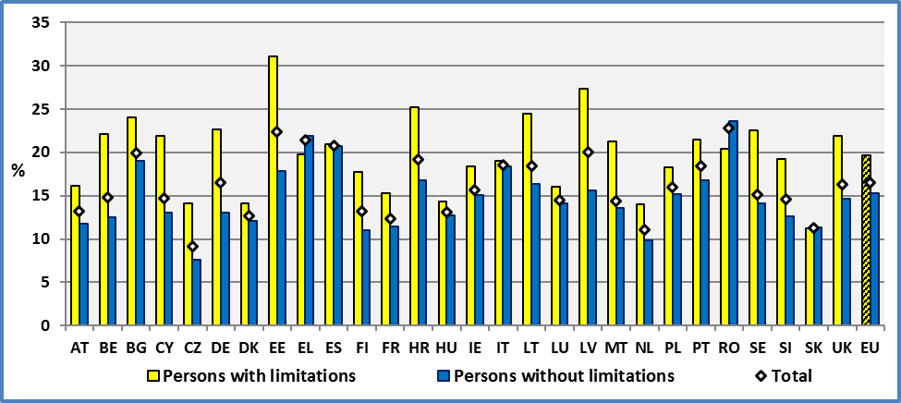

**Data source:** EU-SILC UDB 2014

Absolute numbers measure poverty but high numbers for one group do not imply discrimination necessarily if all groups share the same disadvantage. In order to measure any comparative disadvantage, we measure the difference between the two groups.

**Figure 84: Disadvantage of people with disabilities in comparison to people without disabilities. Age 16+, 2014**

Disadvantage = (% of disabled people at risk of poverty) – (% of non-disabled people at risk of poverty)

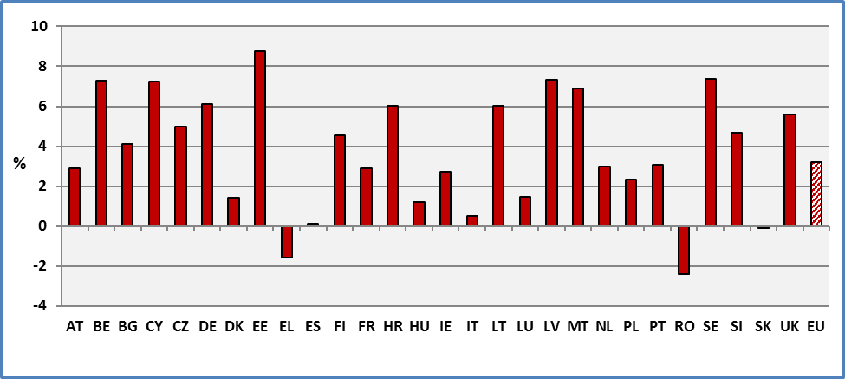

**Data source:** EU-SILC UDB 2014

In certain countries, the difference between people with and without disabilities is relatively low and in certain Member States, this gap is reversed, notably in Romania, Greece and Slovakia. A general pauperization in Greece and the role of disability allowances might explain the results in this Member State and generally in countries that experience sharp economic slowdowns. This point will be discussed below. But in other Member States the difference is relatively high notably in Belgium, Latvia, Sweden and Estonia.

The data indicate that the difference between people with and without disabilities is significantly lower compared to work related measures. We can conclude that the welfare state is correcting the labour market inequalities.

However, it is important to note that these results might underestimate poverty rates among persons with disabilities. The Irish National Disability Authority analyses[34] the cost of disability in terms of additional spending needs of people with disabilities. The Commission singled out five areas where the cost of living for people with a disability could be higher than for people without a disability: Equipment, Mobility and communication, Living costs, Medical and Care and assistance. Reported research by Indecon indicates that the additional costs involved can vary with the nature and the degree of the disability. It notes that at high levels of disability the cost is unlikely to be less than €40-50 a week. This means that the poverty thresholds for persons with and without disabilities are not the same. If we increase the threshold for persons with severe disabilities in order to take into account additional costs related to disability, then the number of persons at risk of poverty is increasing significantly.

Certain disability related expenditures favour independent living. Hurstfield et al.[35] note that expenditure on independent living ought to be seen as a form of social and economic investment. As they put it, traditionally, disability benefits have been viewed as a transfer or redistributive payment – i.e. not intended to effect any sort of economic gain. They add that expenditure on independent living is likely to result in long-term savings at service delivery level, due to reduced pressure on health services and improved tax revenues.

This issue will be developed further in the next chapter when new will analyse severe material deprivation.

2.2 Gender

At the EU level, about 20.3% of women with disabilities aged 16 and over live in households at risk of financial poverty compared to 15.9% of women without disabilities. This rate for all women is 17.2%. The respective percentages for men are 18.8% (men with disabilities), 14.7% (men without disabilities) and 15.7% (men). But there are significant differences across countries.

We distinguish below the gender gap (difference between women and men) and the disability gap (difference between persons with and without disabilities). The gender gap (disadvantage) among persons with disabilities is 1.5 percentage points. The gender gap among persons without disabilities is 1.2 percentage points. The disability related gap among women is 4.4 percentage points and among men 4.1 percentage points. Differences stemming from disability are much bigger than pure gender differences inside the group of persons with disabilities.

However, the method of estimating poverty might underestimate gender differences. In fact, the income level is computed at the household level. The same value is then attributed to all members of a household. Consequently, it does not take into account of any intra-family differences.

Generally, poverty rates of disabled women and men are strongly correlated. If the percentage of men with disabilities is high, in a country, the corresponding rate for women is high too.

**Figure 85: Percent of people living in households at risk of poverty after social transfers by gender and disability. Age 16+, 2014**

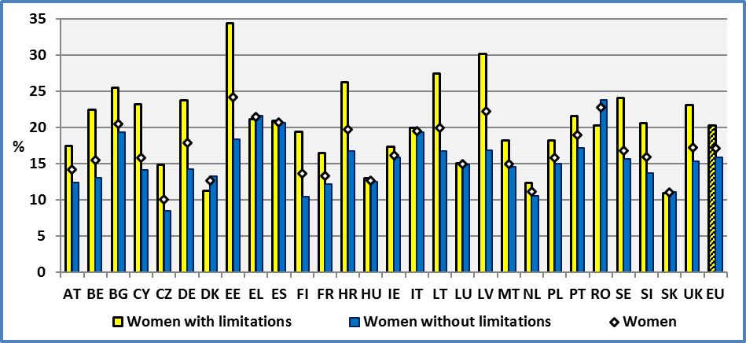

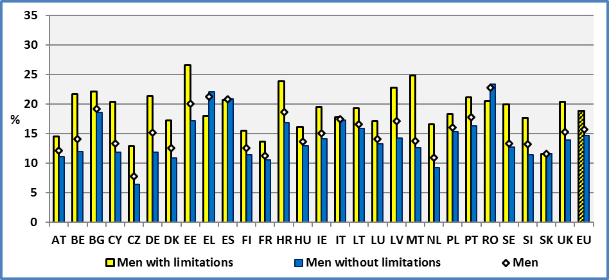

**Note:** The risk of poverty means that a person lives in a household with a household equivalised disposable income less than 60% of the median national household equivalised disposable income (after social transfers).

**Data source:** EU-SILC UDB 2014

2.3 Age

At the EU level, in the age group 16 to 64, about 23.2% of persons with disabilities are at risk of financial poverty compared to 15.9% for persons without disabilities. The respective percentages for elderly people aged 65 and over are 15.3% and 11.7%.

As noted above, the number of persons with disabilities aged 16 and over at risk of financial poverty can be estimated at about 21,712,231 persons. This includes 13,858,373 persons aged 16-64 and 7,853,858 aged 65 and over.

Pension schemes in the EU decrease the risk of relative poverty. The percentage of elderly at risk of poverty (13.7%) is less compared to persons aged 16-64 (17.3%). This is notably true for persons with disabilities (15.3% and 23.2% respectively). A disability related gap of 7.3 percentage points among persons aged 16-64 is reduced to 3.7 percentage points among elderly people.

However, we have to keep in mind the comments developed above concerning special expenses related to disabilities and differential poverty thresholds for persons with and without disabilities. In fact, we have to note that special allowances aiming to ensure autonomy or pay extra medical expenses might artificially increase disposable income and reduce the number of people with disabilities under the poverty threshold. In fact, these allowances do not constitute a ‘disposable’ income as they are aimed to meet specific expenses.

As noted, at the EU level, the disability related gap among persons aged 16-64 is about 7.3 percentage points. This gap is inexistent in Romania and low in Greece (2.7 percentage points) and Italy (2.8 pp). On the contrary, it is relatively high in Estonia (11.6 percentage points), Germany (13.8 pp) and Malta (14.4 pp). A similar situation was found in Estonia and Germany in 2013.

Concerning the age group 65 and over, at the EU level, the disability related gap is about 3.7 percentage points. It is inexistent (and even reversed in certain countries) in Luxembourg, Denmark and Malta. It is relatively high in Slovenia, Sweden and Croatia. High rates were found for Croatia, Sweden and Slovenia in 2013.

A small difference between persons with and without disabilities in the age group 16-64 does not imply necessarily a small difference for elderly persons. The correlation between these two indicators is inexistent. We reached the same conclusion in previous years.

**Figure 86: Percent of people living in households at risk of poverty after social transfers by age group and disability, 2014**

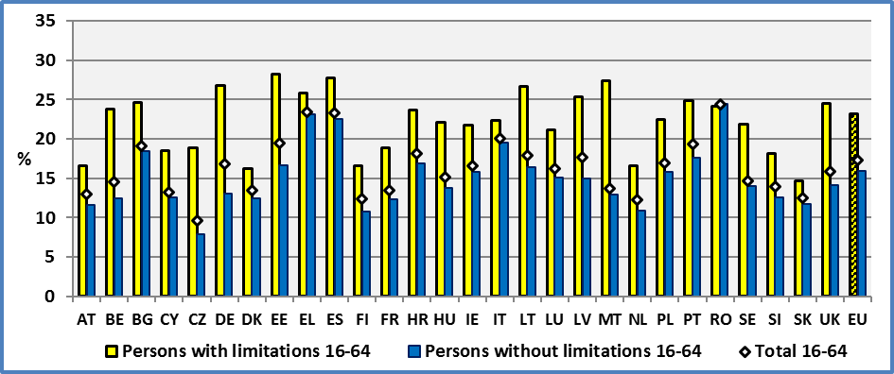

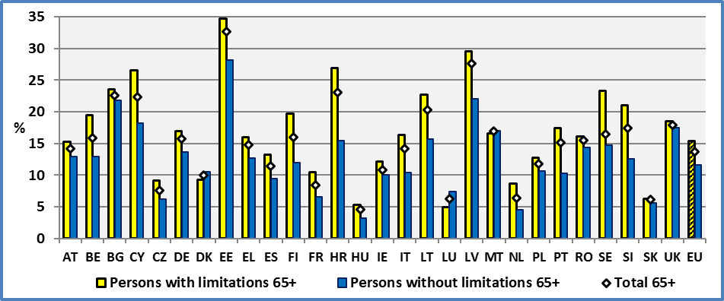

**Note:** The risk of poverty means that a person lives in a household with a household equivalised disposable income less than 60% of the median national household equivalised disposable income (after social transfers).

**Data source:** EU-SILC UDB 2014

2.4 Degree of disability

At the EU level, 22.5% of persons with severe disabilities aged 16 and over live in households at risk of financial poverty, compared to 18.4% of persons with moderate disabilities and 15.3% among persons without disabilities.

As noted above, the number of persons with disabilities aged 16 and over at risk of financial poverty can be estimated at about 21,712,000 persons. This includes 13,858,000 persons with moderate disabilities and 7,854,000 with a severe limitation.

As indicated above, poverty rate is not the same through the life cycle. Consequently, we distinguish below the situation of persons aged 16-64 and 65 and over.

In the age group 16 to 64, the respective rates of persons at risk of poverty are 29.2% (severe), 20.8% (moderate) and 15.9% (no disability). Concerning persons with severe disabilities, the highest rates can be found in Estonia (33.1%), Sweden (34.0%) and Germany (39.1%). Germany experienced the highest rate in 2013 too. The lowest financial poverty rates can be found in Netherlands (14.1%), Slovakia (16.6%) and Ireland (17.6%),

The respective percentages for elderly people aged 65 and over are 16.1% for severely disabled, 14.9% for moderately disabled and 11.7% for persons without disabilities. Similar rates were reported in 2013. Concerning people with severe disabilities, the highest rates can be found in Latvia (32.4%), Croatia (33.4%) and Estonia (36.2%). The lowest rates can be found in Hungary (4.5%), Luxembourg (4.5%) and Denmark (4.7%).

Overall, retirement pensions reduce poverty among retired persons and reduce the gap between persons with and without disabilities. Again, as noted above, this does not take into account health related expenditure both for elderly disabled and non-disabled.

The number of persons with disabilities aged 16-64 at risk of financial poverty can be estimated at approximately 14,142,000 persons. This includes 9,153,000 persons with a moderate disability and 4,989,000 persons with a severe disability. This later number ought to constitute the core target group for policy makers.

**Figure 87: People with disabilities living in households at risk of poverty after social transfers by degree and age group, 2014**

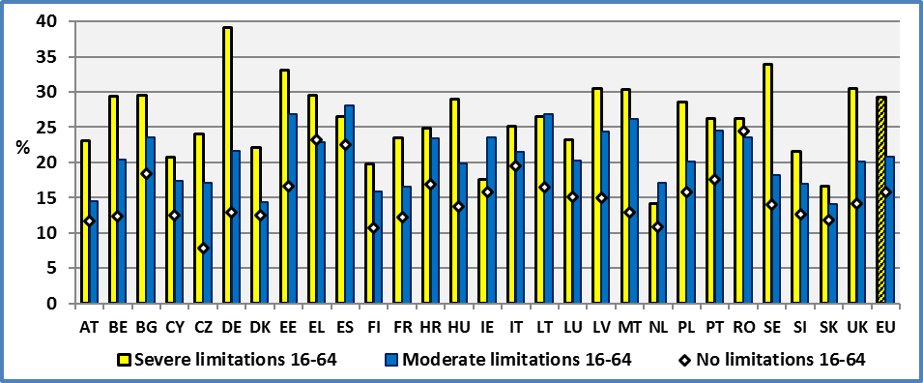

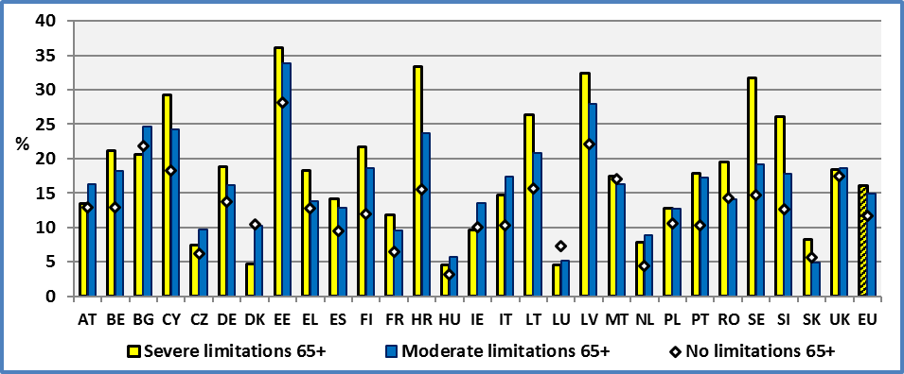

**Note:** The risk of poverty means that a person lives in a household with a household equivalised disposable income less than 60% of the median national household equivalised disposable income (after social transfers).

**Data source:** EU-SILC UDB 2014

2.4 Evolution through time at the EU level

Comparing the situation between 2013 and 2014, we may observe a deterioration of the situation of persons with disabilities at the EU level of 0.9 percentage points (increase of the percentage at risk of poverty after transfers). This deterioration was of 1.4 percentage points for persons with severe disabilities (increase of poverty risk). Persons without disabilities experienced a deterioration of 0.5 percentage points. Globally, there was a deterioration of 0.7 percentage points.

**Figure 88: Persons living in households at risk of poverty after social transfers by disability and year.**

**EU, Age 16+**

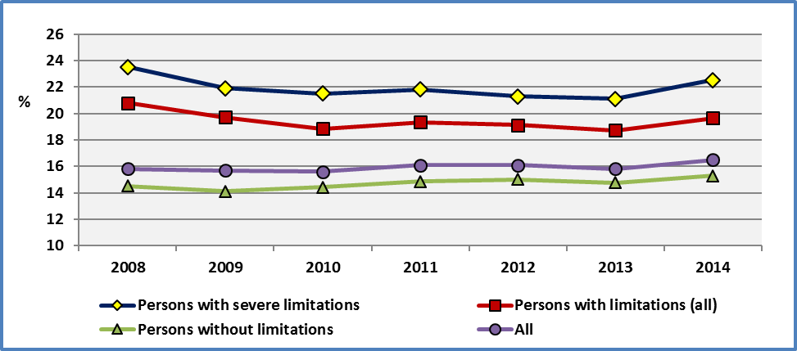

**Note:** The risk of poverty means that a person lives in a household with a household equivalised disposable income less than 60% of the median national household equivalised disposable income (after social transfers).

**Data source: 2008-20012:** Eurostat. Extracted on 10.11.15

**2013 & 2014:** EU-SILC UDB

However, these data on financial poverty might underestimate the real evolution of poverty. In fact, during a recession, the median and median income is decreasing. Consequently, the denominator of the ratio measuring the risk of poverty decreases and this dampens any measure of deterioration.

In fact, during a recession, the median income will decrease but the poverty rate might not fall, if all incomes decrease in the same proportion. Despite a general recession, poverty rates might even decrease if the distribution of incomes changes.

In order to capture better the situation of persons with disabilities, we present below the evolution of persons by age group.

First, we focus on persons aged 16-64. This age group relies mainly on work income.

The risk of financial poverty increases in a similar way for both persons with and without disabilities since 2008. Since this date, persons with disabilities experienced an increase of poverty rates of 3.4 percentage points. This rate is 2.2 percentage points for persons without disabilities. We observe an approximately constant gap (difference in levels of poverty risk) between the two groups of about 6 percentage points at the disadvantage of persons with disabilities but an increase of this gap between 2013 and 2014.

Secondly, concerning persons aged 65 and over the evolution is very different. We may note that this age group relies mainly on retirement pensions.

Generally, retirement pensions and social transfers dampen any negative impact of the economic crisis and the ensuing reduction of income. In fact, retirement pensions and social allowances might not decrease in the same proportion as nominal wages. Consequently, for elderly people, household income might not decrease in case of a recession, at least at the initial stage. On the contrary, for persons active in the labour market, the loss of employment and probably the evolution of wages might mean a lower median income. This might explain why we observe an increase of poverty levels for persons aged 16-64 and a decrease for elderly persons aged 65 and over.

We have to stress that this indicator does not take into account health expenses which might be important for elderly people.

**Figure 89: Persons living in households at risk of poverty after social transfers by disability and year. EU**

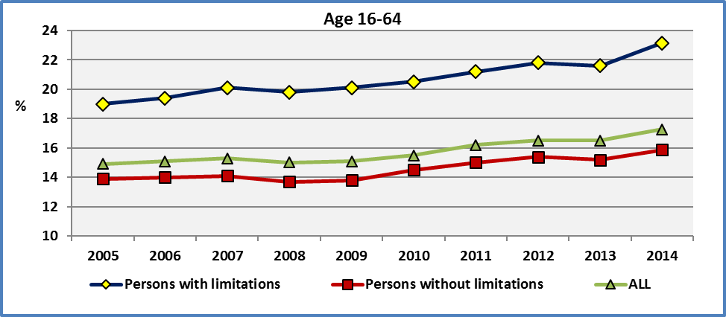

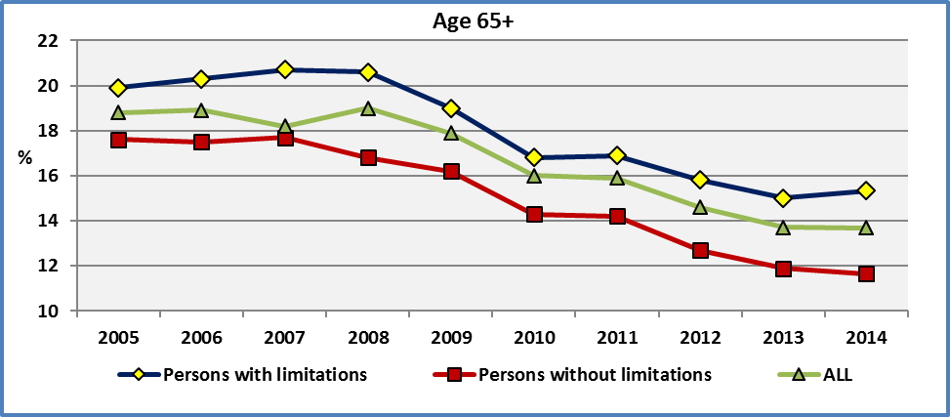

**Data source: 2008-20012:** Eurostat. Extracted on 10.11.15

**2013 & 2014:** EU-SILC UDB

These graphs reveal the weakness of a relative measure of financial poverty indicator based on a threshold which might not correspond to real needs (food, housing, education, health, etc.). Despite these weaknesses, the indicator provides interesting information concerning the disadvantage of persons with disabilities compared to persons without disabilities after social transfers.

For persons aged 16-64 the disadvantage fluctuates around 6 percentage points (but 7 in 2014) and for persons aged 65 and over around 3 percentage points (3.7 in 2014). In both cases, there is a small increase of this disadvantage during the years.

2.5 Evolution through time at the national level

The evolution of financial poverty risk of persons with disabilities varies across Member States. A deterioration of the situation of persons with disabilities has taken place notably in Denmark (+3.2 percentage points), Estonia (+5.1 pp) and Latvia (+5.5 pp).

**Figure 90: People with disabilities living in households at risk of poverty after social transfers by year and change between 2013 and 2014; Age 16+.**

Change = % 2014 - % 2013. A positive value implies a deterioration (increase of financial poverty)

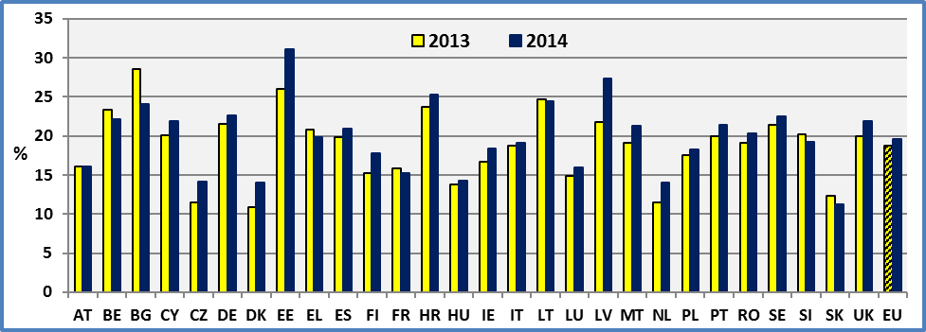

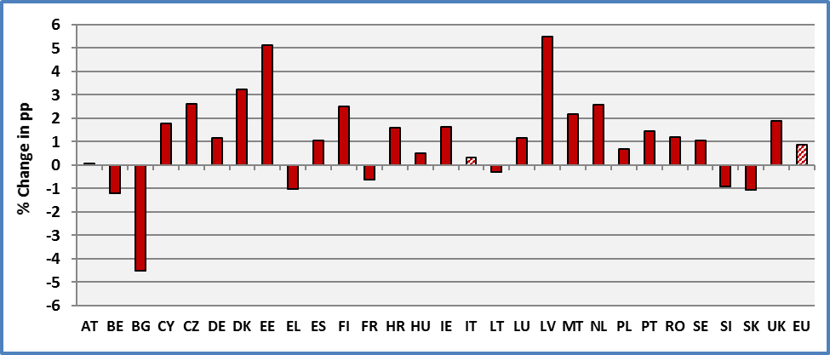

**Data source:** EU-SILC UDB 2013 & 2014

The graph indicates an improvement of the situation of persons with disabilities in seven (7) Member States. This improvement is around one percentage point in absolute terms except in Bulgaria (decrease of 4.5 percentage points).

2.6 Comments concerning the indicator of financial poverty

The indicator of financial poverty risk measures persons living in a household with a household equivalised disposable income less than 60% of the median national household equivalised disposable income (after social transfers). This indicator is a relative measure. The thresholds are defined at the national level. Consequently, they are low in certain countries and high in other countries.

The thresholds are arbitrary (household equivalised disposable income less than 60% of the median national household equivalised disposable income) but Eurostat provides different thresholds for comparison.

In this approach, the threshold in Luxembourg is sixteen (15.6) times the Romanian threshold for all persons. In a unified market, free movement of goods, services and capital tend to equalize prices. However, since this is not the case, we have to compare incomes in purchasing power parities. In this case, the ratio is decreased from sixteen (16) to seven (7). The thresholds are low in certain countries and it is questionable whether they correspond to a socially acceptable minimal.

A first critic of this measure notes that Europe 2020 indicator does not take into account real needs. It does not define a minimum standard of living (for example expenses covering a basket of goods for food, clothing, housing, health, education, etc.). The Europe 2020 indicator defines a threshold (standard of living) which is the same for all persons in a country. Consequently, it does not take into account specific needs of certain groups, for example additional health care costs for elderly and disabled people[36].

D. S. Johnson and T. M. Smeeding argue that most elderly spend 12.5 percent on average of their net income on healthcare. As these healthcare costs cannot be used for food, clothing, etc. they should be subtracted from income like work-related expenses[37]. But the opponents consider that many healthcare expenses are voluntary and may even improve the quality of life and chances for longevity among the elderly. Proponents of this view argue that healthcare expenses should not be subtracted from income. This might be particularly true for preventive health care which is correlated with income (rich and educated people spend relatively more on preventive health care).

We have to note that health care expenses are different from disability related expenses, although in certain cases they might be intermingled. We could argue that expenses related to disability ought always to be subtracted from income as these expenses aim to re-establish equality of rights. In fact, often they finance technical aids and adaptations which are necessary to overcome social and architectural barriers. These might cover expenses for housing adaptations, educational aids, work adaptations or elimination of architectural barriers.

Another critic notes that in a growing economy where all nominal wages and rents increase proportionately, the percentage of persons at risk of poverty might not change (it depends notably upon the progressivity of taxation). The median income will increase and the poverty rate may not fall. In this case, the indicator will overstate poverty[38].

Similarly, in a recession where all wages and rents decrease proportionately, the percentage of persons at risk of poverty might remain stable if the distribution of incomes remains the same. In this case, the median income will decrease and the poverty rate might not fall. In this case, the indicator will underestimate poverty.

An important question is how the recent recession of 2008/2009 has affected poverty levels as defined in Europe 2020. The following graph presents the change between 2008 and 2014 for all persons aged 16 and over. Except Latvia, the change varies from -1.9 percentage points (Cyprus) to +3.2 percentage points (Sweden). Also, despite the sharp economic recession in certain Member States, the percentage of persons aged 16 and over at-risk-of poverty has changed relatively little. This is true notably in Greece (+1.7 percentage points), Ireland (+0.9 pp), and Portugal (+0.7 pp).

Following the European debt crisis, countries participating in an Economic Adjustment Programme (notably, Greece, Ireland and Portugal) experience a decrease of the percentage of disabled persons at risk of poverty. The standard Europe 2020 method presents a significant decrease of the percentage of persons with disabilities at risk of financial poverty in the last years. In fact, the economic recession decreased sharply incomes (notably for unemployed) and consequently the at-risk-of poverty threshold in these countries. But apparently, disability benefits did not decrease in the same proportion. Consequently, beneficiaries of disability benefits found themselves over the poverty threshold and this decreased the relative poverty level of this group.

The increase of the number of unemployed persons with low or inexistent unemployment benefits tends to increase the ratio of disability benefits over income of the unemployed. The relative position of disability recipients will tend to improve relative to unemployed, even if all groups experience a sharp reduction of living standards. Also, if budgetary efforts are based on progressive taxation, (low) disability benefits and generally retirement pensions will improve their position relative to higher incomes, even if they don’t change. This again will tend to improve the situation of pensioners and hence decrease the percentage of persons at risk of financial poverty.

**Figure 91: Persons at-risk-of-poverty in 2008 and 2014. Age: 16+**

The poverty threshold changes every year (EU 2020 methodology).

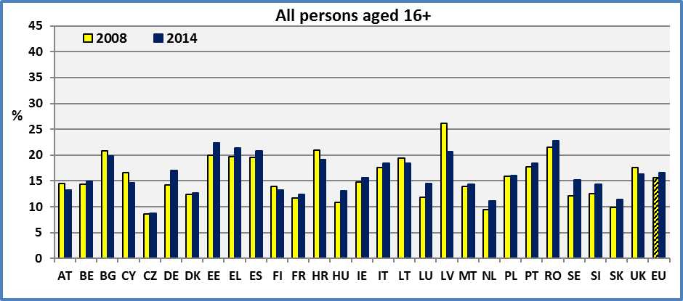

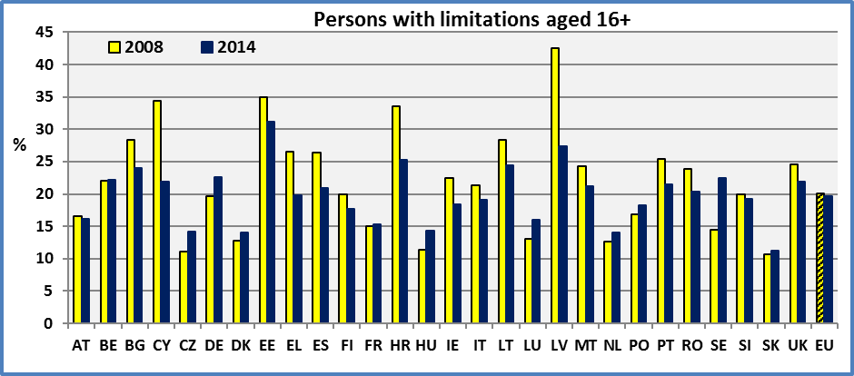

**Note:** Data for Croatia refer to 2010 and 2014

**Source:** EU-SILC UDB

This has led several social movements to criticise the Europe 2020 indicator and to stress the fact that the indicator makes it difficult to highlight the social consequences of the crisis and of the austerity cuts[39].

In the following, we will study alternative measures of poverty[40] and analyse their impact on persons with and without disabilities. In this approach, we take the 2008 poverty threshold as base for comparison. We will focus on 2008 and 2014. However, in order to take into account price changes between 2008 and 2014, we adjust 2014 disposable income by the Harmonised index of consumer prices (HICP)[41]. The HICP gives comparable measures of inflation for the participating countries. It is calculated according to a harmonised approach and a single set of definitions.

While the EU 2020 methodology has provided relatively small changes between 2008 and 2014, the new approach provides quite different results. The following graph indicates that significant changes have taken place between 2008 and 2014 in several Member States, notably Cyprus, Greece, Croatia, Spain and Ireland. These changes are often in an opposite direction compared to the previous methodology.

**Figure 92: Persons at-risk-of-poverty in 2008 and 2014. Age: 16+**

2014: Income is expressed in 2008 prices and compared to the 2008 threshold.

2008: All are expressed in current prices

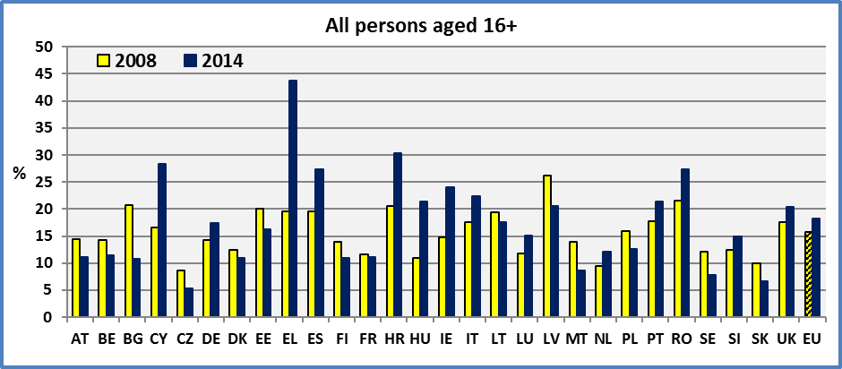

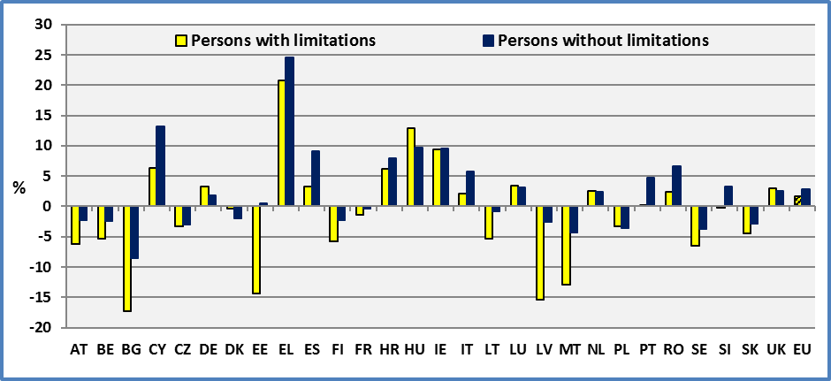

**Note:** Data for Croatia refer to 2010 and 2014

**Source:** EU-SILC UDB

Concerning persons with disabilities, the new methodology indicates a significant deterioration between 2008 and 2014 in Greece, Hungary, Ireland and Croatia. The EU 2020 methodology provided an improvement (reduction of poverty) for these countries except in Hungary.

Concerning persons with and without disabilities, we may note a significant positive correlation of respective changes. In fact, there is a positive correlation in the medium term (R²=0.75) but significant differences remain in certain countries between persons with and without disabilities (e.g. Estonia, Latvia, Malta and Bulgaria).

Globally, once we leave enough time for adjustment, persons with and without disabilities evolve in the same direction. But short term rigidities and adjustment lags may provide uncorrelated changes in the short term.

Generally cyclical factors might affect the relative position of disability pensioners relative to other groups (e.g. wage earners). In countries where wages are highly flexible and adapt more rapidly than pensions to a slowdown, pensioners will improve their relative position at least at the beginning of the recession. Budgetary efforts might reduce pensions at a later stage and reverse the situation. The inverse is taking place in growing economies.

Financial poverty indicators are popular because they are easy to understand by a wide public. But Europe 2020 poverty indicators add two additional ones which complete the picture and hence correct at least partly the financial poverty indicators: low work intensity (presented above) and severe material deprivation (see next chapter). These indicators complement the income-related measures of poverty in order to have a wider understanding of the various facets of social exclusion.

Low work intensity measures a family’s potential and the share which is used or under-utilised. It is close to the concept of a “family’s net earnings capacity (NEC), which reflects a family’s ability to achieve economic independence (i.e., to attain a minimum level of living) through the use of its own capabilities”.[42] This measure might provide more information to policy makers concerning future policies compared to at-the-risk of poverty measure.

Severe material deprivation is an absolute measure. It expresses the person’s inability to afford for certain goods or services which are considered as of common use. The collection "material deprivation" covers indicators relating to economic strain, durables, housing and environment of the dwelling. It is common to all Member States and does not depend on national specificities. Also, it is a fixed indicator as it does not change from year to year. But this does not exclude periodic adaptations in order to meet changing social norms and technological change. Critics will argue that it contains a set of goods and services which are chosen arbitrarily. This indicator will be discussed in the next chapter.

2.7 Percent of persons at risk of poverty and confidence intervals

In the following, we present standard error estimates and the resulting confidence intervals for the at-risk-of-poverty rate indicator.

The standard error and hence the confidence intervals for persons with disabilities are larger compared to persons without disabilities as the number of sample units concerning persons with limitations is lower compared to persons without limitations.

We may note that for the big majority of Member States, there is a significant difference between persons with and without limitations.

**Figure 93: Percent of persons at-risk-of-poverty and confidence interval of the estimate at 95%; 2014**

L: persons with limitations and N: Persons without limitations; Age: 16+

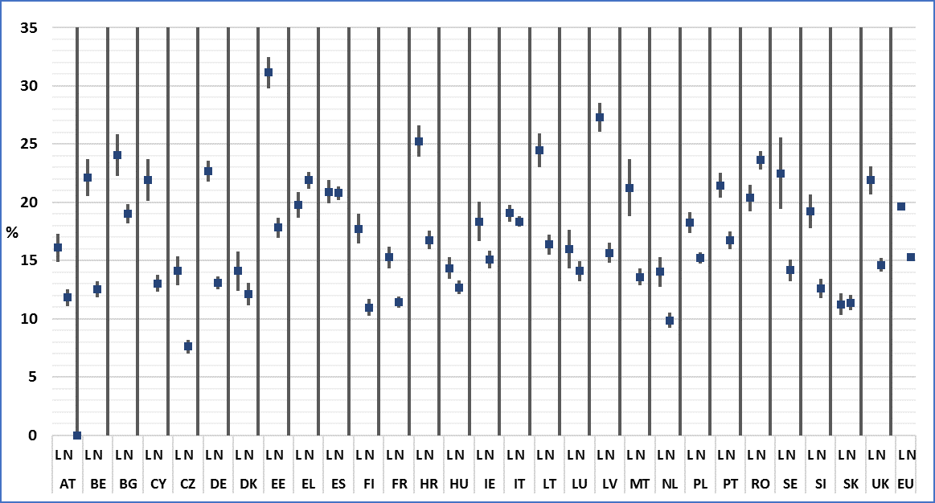

**Source:** EU-SILC UDB 2014

### 3. Data

**Table 108: People at risk of poverty by disability status and Member State; Age 16+**

Percent of people living in households with a household equivalised disposable income less than 60% of the median national household equivalised disposable income

|  |  |  |  |  |  |  |  |  |  |  |  |
| --- | --- | --- | --- | --- | --- | --- | --- | --- | --- | --- | --- |
| **All persons aged 16+** | | | | | | | | | | | |
|  | **2005** | **2006** | **2007** | **2008** | **2009** | **2010** | **2011** | **2012** | **2013** | **2013\*** | **2014\*** |
| **AT** | 12,0 | 12,1 | 11,4 | 14,4 | 13,9 | 13,7 | 13,7 | 13,7 | 13,4 | 13,4 | 13,2 |
| **BE** | 14,1 | 14,6 | 14,8 | 14,3 | 14,2 | 13,7 | 14,6 | 14,8 | 14,7 | 14,7 | 14,8 |
| **BG** | 14 | 17,1 | 20,7 | 20,6 | 21,3 | 19,7 | 21,2 | 20,0 | 19,8 | 19,8 | 19,9 |
| **CY** | 17,0 | 16,8 | 16,3 | 16,5 | 16,6 | 16,2 | 15,3 | 14,8 | 15,3 | 15,3 | 14,7 |
| **CZ** | 8,9 | 8,5 | 8,4 | 8,4 | 7,8 | 8,2 | 9,0 | 8,9 | 8,2 | 8,2 | 9,2 |
| **DE** | 12,3 | 12,6 | 15,4 | 15,3 | 15,7 | 15,4 | 15,9 | 16,3 | 15,7 | 15,1 | 16,6 |
| **DK** | 12,3 | 12,2 | 12,2 | 12,5 | 13,7 | 13,9 | 13,6 | 13,9 | 13,1 | 13,1 | 12,7 |
| **EE** | 17,7 | 18,0 | 19,8 | 19,9 | 19,6 | 15,8 | 17,1 | 17,8 | 18,9 | 18,7 | 22,4 |
| **EL** | 19,7 | 20,3 | 19,8 | 19,7 | 19,0 | 19,7 | 21,0 | 22,5 | 21,7 | 21,7 | 21,4 |
| **ES** | 19,1 | 19,1 | 18,6 | 19,4 | 18,8 | 19,2 | 19,4 | 19,7 | 19,3 | 19,3 | 20,8 |
| **FI** | 12,2 | 13,4 | 13,6 | 13,9 | 14,2 | 13,5 | 14,0 | 13,7 | 12,4 | 12,5 | 13,2 |
| **FR** | 12,7 | 13,1 | 12,6 | 11,8 | 12,1 | 12,2 | 12,9 | 13,0 | 12,7 | 12,7 | 12,4 |
| **HR** | : | : | : | : | : | 20,9 | 20,9 | 19,8 | 19,1 | 19,3 | 19,2 |
| **HU** | 12,2 | 13,8 | 10,9 | 10,9 | 10,8 | 10,8 | 12,2 | 12,5 | 12,6 | 12,6 | 13,1 |
| **IE** | 19,1 | 17,7 | 16,7 | 14,8 | 14,2 | 14,0 | 14,8 | 15,4 | 13,7 | 13,7 | 15,6 |
| **IT** | 18,0 | 18,7 | 18,8 | 17,6 | 17,4 | 17,1 | 18,4 | 18,2 | 18,0 | 18,1 | 18,6 |
| **LT** | 19,0 | 19,1 | 18,6 | 20,5 | 19,7 | 19,9 | 18,2 | 18,4 | 19,5 | 19,5 | 18,5 |
| **LU** | 11,9 | 12,8 | 12,0 | 11,8 | 13,2 | 12,9 | 12,1 | 13,5 | 14,0 | 14,1 | 14,5 |
| **LV** | 19,2 | 23,2 | 21,7 | 26,3 | 26,5 | 19,9 | 18,0 | 18,4 | 18,9 | 18,6 | 20,0 |
| **MT** | 13,5 | 13,4 | 14,1 | 14,1 | 13,6 | 14,3 | 14,2 | 13,6 | 14,1 | 14,1 | 14,4 |
| **NL** | 9,4 | 8,7 | 9,1 | 9,8 | 10,0 | 9,5 | 9,9 | 9,2 | 9,9 | 10,1 | 11,1 |
| **PO** | 18,7 | 17,6 | 16,0 | 15,8 | 16,0 | 16,7 | 17,0 | 16,3 | 16,3 | 16,2 | 16,0 |
| **PT** | 18,7 | 18,2 | 17,6 | 17,7 | 17,1 | 17,3 | 17,4 | 17,3 | 17,8 | 17,8 | 18,4 |
| **RO** | : | : | 23,1 | 21,6 | 20,4 | 19,1 | 20,2 | 20,4 | 20,6 | 20,6 | 22,8 |
| **SE** | 9,6 | 11,7 | 10,3 | 12,2 | 13,4 | 13,0 | 14,1 | 14,2 | 14,8 | 14,8 | 15,1 |
| **SI** | 12,2 | 11,6 | 11,5 | 12,5 | 11,3 | 12,7 | 13,4 | 13,5 | 14,4 | 14,4 | 14,6 |
| **SK** | 12,3 | 10,7 | 9,8 | 9,9 | 10,0 | 11,0 | 11,7 | 11,9 | 11,5 | 11,5 | 11,3 |
| **UK** | 18,0 | 17,7 | 17,6 | 17,4 | 16,5 | 16,5 | 15,9 | 15,7 | 15,4 | 15,4 | 16,3 |
|  |  |  |  |  |  |  |  |  |  |  |  |
| **EU** | **15,7** | **15,8** | **15,9** | **15,8** | **15,7** | **15,6** | **16,1** | **16,1** | **15,9** | **15,8** | **16,5** |
|  |  |  |  |  |  |  |  |  |  |  |  |
| **CH** | : | : | 14,2 | 14,8 | 14,9 | 14,5 | 14,6 | 15,5 | 14,4 | 14,4 | 12,4 |
| **IS** | 9,5 | 8,8 | 9,3 | 9,5 | 10,2 | 8,9 | 8,5 | 7,1 | 8,3 | 8,4 | 7,3 |
| **NO** | 12,0 | 12,8 | 12,2 | 12,0 | 11,9 | 11,2 | 10,9 | 10,5 | 11,1 | 10,8 | 11,0 |
| **RS** | : | : | : | : | : | : | : | : | 23,6 | 24,3 | 24,6 |

**\*:** It covers only persons for which we possess information on disability status

**Data source: 2005-2012:** Eurostat:Extracted on 10.11.15

**2013 & 2014**: EU-SILC UDB

**Table 109: People at risk of poverty by disability status and Member State; Age 16+**

Percent of people living in households with a household equivalised disposable income less than 60% of the median national household equivalised disposable income

|  |  |  |  |  |  |  |  |  |  |  |
| --- | --- | --- | --- | --- | --- | --- | --- | --- | --- | --- |
| **Persons with limitations aged 16+** | | | | | | | | | | |
|  | **2005** | **2006** | **2007** | **2008** | **2009** | **2010** | **2011** | **2012** | **2013** | **2014** |
| **AT** | 15,3 | 16,7 | 15,5 | 16,6 | 16,7 | 16,7 | 17,3 | 17,3 | 16,1 | 16,1 |
| **BE** | 20,1 | 23,4 | 23,5 | 22,0 | 21,6 | 19,5 | 22,0 | 22,5 | 23,3 | 22,1 |
| **BG** | : | 21,4 | 31,3 | 28,3 | 32,4 | 30,0 | 29,8 | 28,0 | 28,6 | 24,0 |
| **CY** | 33,8 | 35,6 | 34,1 | 34,4 | 32,1 | 30,7 | 25,7 | 24,5 | 20,1 | 21,9 |
| **CZ** | 9,6 | 10,5 | 10,7 | 11,1 | 11,8 | 10,2 | 11,6 | 11,6 | 11,5 | 14,1 |
| **DE** | 15,4 | 15,1 | 19,5 | 19,6 | 19,9 | 19,5 | 20,3 | 20,9 | 21,5 | 22,7 |
| **DK** | 16,5 | 16,2 | 14,6 | 12,8 | 15,3 | 16,3 | 14,2 | 13,5 | 12,7 | 14,1 |
| **EE** | 22,8 | 25,6 | 29,9 | 34,9 | 31,4 | 20,8 | 21,9 | 24,5 | 26,0 | 31,1 |
| **EL** | 26,8 | 27,6 | 27,5 | 26,5 | 24,9 | 25,3 | 26,7 | 24,3 | 20,8 | 19,8 |
| **ES** | 26,1 | 26,0 | 24,5 | 26,4 | 23,8 | 23,2 | 23,5 | 21,1 | 19,8 | 20,9 |
| **FI** | 15,6 | 16,6 | 19,3 | 20,0 | 20,1 | 17,4 | 18,3 | 18,2 | 15,2 | 17,7 |
| **FR** | 18,0 | 18,1 | 16,1 | 15,0 | 14,8 | 14,0 | 15,6 | 15,5 | 15,0 | 15,3 |
| **HR** | : | : | : | : | : | 33,5 | 35,5 | 28,6 | 23,7 | 25,3 |
| **HU** | 13,4 | 15,3 | 11,0 | 11,4 | 11,2 | 10,5 | 12,8 | 14,3 | 13,8 | 14,3 |
| **IE** | 32,4 | 29,1 | 30,0 | 22,4 | 19,8 | 17,8 | 16,7 | 19,2 | 16,7 | 18,4 |
| **IT** | 23,4 | 23,8 | 22,7 | 21,4 | 20,7 | 18,9 | 19,9 | 19,2 | 18,7 | 19,1 |
| **LT** | 22,6 | 24,7 | 27,5 | 28,4 | 27,6 | 19,2 | 16,0 | 21,7 | 24,8 | 24,5 |
| **LU** | 14,5 | 15,1 | 15,9 | 13,0 | 15,0 | 15,2 | 13,7 | 16,7 | 14,9 | 16,0 |
| **LV** | 22,9 | 30,8 | 32,7 | 42,6 | 42,3 | 24,0 | 18,5 | 21,0 | 21,8 | 27,3 |
| **MT** | 23,0 | 21,0 | 22,8 | 24,3 | 21,5 | 18,7 | 16,9 | 18,0 | 19,1 | 21,2 |
| **NL** | 10,9 | 8,4 | 11,8 | 12,6 | 12,2 | 10,7 | 10,0 | 10,1 | 11,5 | 14,0 |
| **PO** | 16,7 | 16,0 | 15,7 | 16,8 | 19,5 | 20,0 | 20,1 | 19,4 | 17,6 | 18,3 |
| **PT** | 26,5 | 26,2 | 26,5 | 25,4 | 23,0 | 24,4 | 23,7 | 21,4 | 20,0 | 21,5 |
| **RO** | : | : | 28,5 | 23,9 | 21,2 | 17,9 | 18,6 | 18,4 | 19,2 | 20,4 |
| **SE** | 10,8 | 12,1 | 9,5 | 14,5 | 18,4 | 16,8 | 18,0 | 20,4 | 21,4 | 22,5 |
| **SI** | 18,4 | 18,0 | 17,6 | 20,0 | 18,3 | 18,5 | 17,5 | 19,0 | 20,2 | 19,2 |
| **SK** | 10,4 | 9,8 | 10,3 | 10,7 | 10,9 | 11,1 | 11,4 | 12,2 | 12,3 | 11,2 |
| **UK** | 25,1 | 26,0 | 24,9 | 24,5 | 21,2 | 22,7 | 20,5 | 20,8 | 20,0 | 21,9 |
|  |  |  |  |  |  |  |  |  |  |  |
| **EU** | **19,4** | **19,8** | **20,3** | **20,1** | **19,6** | **18,9** | **19,3** | **19,1** | **18,7** | **19,7** |
|  |  |  |  |  |  |  |  |  |  |  |
| **CH** | : | : | 17,4 | 19,8 | 21,3 | 19,9 | 21,1 | 22,6 | 19,6 | 18,6 |
| **IS** | 9,5 | 11,2 | 11,6 | 16,2 | 13,6 | 9,2 | 8,2 | 7,5 | 10,1 | 9,0 |
| **NO** | 13,7 | 15,0 | 13,2 | 13,4 | 16,0 | 13,5 | 12,8 | 13,5 | 14,9 | 14,7 |
| **RS** | : | : | : | : | : | : | : | : | 29,7 | 28,9 |

**Data source: 2005-2012:** Eurostat:Extracted on 10.11.15

**2013 & 2014**: EU-SILC UDB

**Table 110: People at risk of poverty by disability status and Member State; Age 16+**

Percent of people living in households with a household equivalised disposable income less than 60% of the median national household equivalised disposable income

|  |  |  |  |  |  |  |  |  |  |  |
| --- | --- | --- | --- | --- | --- | --- | --- | --- | --- | --- |
| **Persons without limitations aged 16+** | | | | | | | | | | |
|  | **2005** | **2006** | **2007** | **2008** | **2009** | **2010** | **2011** | **2012** | **2013** | **2014** |
| **AT** | 10,3 | 10,3 | 9,8 | 9,8 | 9,7 | 9,6 | 9,8 | 12,3 | 12,2 | 11,8 |
| **BE** | 12,1 | 11,9 | 12,3 | 12,0 | 11,9 | 11,6 | 12,2 | 12,4 | 12,0 | 12,5 |
| **BG** | : | 16,7 | 20,4 | 19,4 | 19,1 | 17,9 | 19,4 | 18,2 | 17,9 | 19,0 |
| **CY** | 11,6 | 12,3 | 11,9 | 12,4 | 13,1 | 12,8 | 12,1 | 12,3 | 14,1 | 13,1 |
| **CZ** | 8,5 | 8,2 | 8,0 | 7,8 | 6,8 | 8,0 | 8,7 | 8,0 | 7,2 | 7,6 |
| **DE** | 9,6 | 10,6 | 13,6 | 11,6 | 11,9 | 12,1 | 11,8 | 11,4 | 11,7 | 13,1 |
| **DK** | 11,5 | 11,4 | 11,7 | 12,3 | 13,2 | 13,0 | 13,4 | 13,9 | 13,2 | 12,1 |
| **EE** | 14,7 | 13,9 | 14,7 | 13,4 | 15,0 | 13,7 | 14,9 | 14,7 | 15,2 | 17,8 |
| **EL** | 18,2 | 18,8 | 18,1 | 17,9 | 17,8 | 18,4 | 19,5 | 22,2 | 21,9 | 21,9 |
| **ES** | 17,2 | 17,2 | 16,9 | 17,5 | 17,7 | 19,6 | 20,4 | 20,9 | 19,2 | 20,8 |
| **FI** | 11,7 | 11,9 | 11,9 | 11,4 | 11,8 | 11,9 | 12,0 | 11,6 | 10,6 | 11,0 |
| **FR** | 11,2 | 11,1 | 11,4 | 10,7 | 11,0 | 11,3 | 11,5 | 12,0 | 11,9 | 11,4 |
| **HR** | : | : | : | : | : | 18,8 | 18,8 | 17,4 | 17,4 | 16,8 |
| **HU** | 11,7 | 13,3 | 10,8 | 10,7 | 10,8 | 10,9 | 11,9 | 11,9 | 12,2 | 12,7 |
| **IE** | 15,7 | 15,0 | 14,0 | 12,9 | 12,9 | 13,2 | 14,3 | 14,7 | 13,0 | 15,1 |
| **IT** | 16,8 | 17,2 | 17,2 | 16,1 | 16,0 | 16,6 | 18,0 | 18,1 | 17,9 | 18,4 |
| **LT** | 18,0 | 17,8 | 15,5 | 16,4 | 17,2 | 20,0 | 19,1 | 17,4 | 17,7 | 16,4 |
| **LU** | 11,2 | 12,0 | 10,8 | 11,5 | 12,8 | 12,2 | 11,8 | 12,6 | 13,8 | 14,1 |
| **LV** | 17,4 | 19,1 | 16,6 | 18,1 | 18,9 | 18,0 | 17,8 | 17,1 | 16,6 | 15,6 |
| **MT** | 12,2 | 11,4 | 13,0 | 12,6 | 12,5 | 13,5 | 13,8 | 13,1 | 13,4 | 13,6 |
| **NL** | 9,0 | 8,9 | 8,4 | 8,4 | 9,0 | 9,1 | 10,0 | 9,3 | 9,6 | 9,9 |
| **PO** | 19,3 | 18,3 | 16,0 | 15,7 | 15,5 | 16,1 | 16,1 | 15,5 | 15,8 | 15,2 |
| **PT** | 15,3 | 14,8 | 13,7 | 14,4 | 14,4 | 14,1 | 14,6 | 15,9 | 17,0 | 16,7 |
| **RO** | : | : | 21,8 | 21,0 | 20,1 | 19,5 | 20,8 | 22,1 | 21,1 | 23,6 |
| **SE** | 9,3 | 11,7 | 10,3 | 11,6 | 12,5 | 12,3 | 13,3 | 13,2 | 13,0 | 14,2 |
| **SI** | 9,9 | 9,3 | 9,5 | 9,9 | 8,9 | 9,5 | 11,0 | 10,7 | 12,0 | 12,6 |
| **SK** | 13,0 | 11,1 | 9,3 | 9,5 | 9,4 | 10,9 | 11,7 | 11,8 | 11,2 | 11,4 |
| **UK** | 15,8 | 15,5 | 15,6 | 15,8 | 15,3 | 14,8 | 14,6 | 14,4 | 14,1 | 14,6 |
|  |  |  |  |  |  |  |  |  |  |  |
| **EU** | **14,4** | **14,4** | **14,6** | **14,1** | **14,1** | **14,5** | **14,9** | **15,0** | **14,8** | **15,3** |
|  |  |  |  |  |  |  |  |  |  |  |
| **CH** | : | : | 12,2 | 14,0 | 12,8 | 12,2 | 12,2 | 13,9 | 12,3 | 9,6 |
| **IS** | 9,6 | 8,5 | 9,2 | 8,8 | 9,7 | 9,1 | 8,6 | 7,0 | 8,0 | 6,9 |
| **NO** | 11,6 | 12,2 | 12,2 | 11,7 | 11,0 | 10,7 | 10,4 | 9,8 | 10,0 | 10,3 |
| **RS** | : | : | : | : | : | : | : | : | 23,1 | 23,8 |

**Data source: 2005-2012:** Eurostat:Extracted on 10.11.15

**2013**: EU-SILC UDB 2013

**Table 111: People at risk of poverty by disability status, gender and Member State; Age 16+**

Percent of people living in households with a household equivalised disposable income less than 60% of the median national household equivalised disposable income

|  |  |  |  |  |  |  |  |  |  |  |
| --- | --- | --- | --- | --- | --- | --- | --- | --- | --- | --- |
| **Men with limitations aged 16+** | | | | | | | | | | |
|  | **2005** | **2006** | **2007** | **2008** | **2009** | **2010** | **2011** | **2012** | **2013** | **2014** |
| **AT** | 14,3 | 13,5 | 13,2 | 14,7 | 14,6 | 14,2 | 16,4 | 15,9 | 14,6 | 14,5 |
| **BE** | 19,1 | 21,3 | 23,1 | 21,3 | 21,8 | 20,3 | 22,6 | 23,0 | 24,2 | 21,7 |
| **BG** | : | 17,8 | 30,1 | 24,6 | 25,9 | 25,8 | 25,5 | 24,0 | 23,7 | 22,1 |
| **CY** | 31,0 | 32,1 | 30,1 | 28,9 | 26,6 | 27,7 | 23,7 | 20,4 | 18,9 | 20,4 |
| **CZ** | 8,9 | 8,7 | 9,0 | 9,4 | 9,4 | 7,4 | 10,0 | 9,1 | 10,4 | 12,9 |
| **DE** | 14,0 | 14,3 | 17,6 | 19,1 | 19,9 | 20,0 | 20,5 | 20,3 | 20,6 | 21,4 |
| **DK** | 19,7 | 18,8 | 17,1 | 11,9 | 14,6 | 16,6 | 14,7 | 15,2 | 14,5 | 17,3 |
| **EE** | 19,8 | 22,0 | 24,6 | 28,8 | 25,8 | 21,2 | 22,5 | 24,0 | 23,2 | 26,6 |
| **EL** | 26,0 | 26,4 | 26,5 | 26,3 | 25,8 | 24,2 | 24,8 | 23,6 | 20,2 | 18,0 |
| **ES** | 25,2 | 24,9 | 24,2 | 25,3 | 22,7 | 22,4 | 23,1 | 21,4 | 20,0 | 20,8 |
| **FI** | 12,8 | 15,6 | 18,0 | 18,3 | 16,5 | 17,1 | 15,5 | 17,2 | 14,9 | 15,5 |
| **FR** | 17,5 | 18,1 | 15,5 | 12,5 | 13,5 | 12,8 | 14,3 | 14,3 | 14,1 | 13,7 |
| **HR** | : | : | : | : | : | 30,6 | 32,5 | 26,4 | 21,5 | 23,9 |
| **HU** | 13,8 | 15,7 | 11,0 | 12,0 | 11,9 | 10,9 | 13,8 | 14,8 | 14,2 | 16,2 |
| **IE** | 33,0 | 28,8 | 30,0 | 21,6 | 19,8 | 18,5 | 19,6 | 21,1 | 18,1 | 19,6 |
| **IT** | 21,2 | 22,5 | 19,9 | 19,3 | 18,5 | 16,8 | 18,7 | 17,5 | 17,4 | 17,8 |
| **LT** | 21,5 | 20,4 | 21,7 | 25,1 | 24,7 | 20,7 | 16,4 | 19,4 | 21,1 | 19,4 |
| **LU** | 15,7 | 14,7 | 16,1 | 16,3 | 12,2 | 15,0 | 13,6 | 16,1 | 14,6 | 17,2 |
| **LV** | 21,0 | 25,0 | 27,3 | 38,6 | 38,9 | 23,0 | 20,5 | 22,0 | 20,7 | 22,8 |
| **MT** | 24,4 | 24,1 | 25,4 | 22,1 | 23,1 | 20,1 | 18,7 | 19,8 | 22,5 | 24,9 |
| **NL** | 12,0 | 9,0 | 13,5 | 12,1 | 12,1 | 10,8 | 9,4 | 9,7 | 9,6 | 16,6 |
| **PO** | 18,7 | 17,9 | 16,5 | 17,8 | 19,5 | 19,7 | 20,5 | 19,5 | 17,2 | 18,3 |
| **PT** | 27,1 | 25,9 | 26,3 | 24,5 | 23,5 | 24,6 | 24,2 | 20,0 | 20,7 | 21,2 |
| **RO** | : | : | 28,1 | 22,5 | 18,1 | 15,3 | 16,5 | 17,3 | 18,4 | 20,5 |
| **SE** | 9,6 | 11,2 | 9,6 | 10,6 | 14,5 | 15,1 | 15,0 | 16,1 | 19,4 | 20,0 |
| **SI** | 15,3 | 15,9 | 15,2 | 19,2 | 16,0 | 15,7 | 13,6 | 16,3 | 17,4 | 17,6 |
| **SK** | 9,1 | 8,9 | 8,2 | 8,7 | 8,6 | 10,6 | 11,5 | 11,5 | 12,3 | 11,6 |
| **UK** | 26,0 | 25,2 | 24,5 | 24,4 | 21,3 | 23,3 | 19,3 | 20,5 | 20,9 | 20,4 |
|  |  |  |  |  |  |  |  |  |  |  |
| **EU** | **18,6** | **19,0** | **19,3** | **19,0** | **18,7** | **18,3** | **18,7** | **18,4** | **18,1** | **18,8** |
|  |  |  |  |  |  |  |  |  |  |  |
| **CH** | : | : | 14,0 | 18,1 | 17,0 | 18,5 | 19,4 | 21,6 | 18,8 | 17,4 |
| **IS** | 11,8 | 12,8 | 12,0 | 16,6 | 13,5 | 11,4 | 9,6 | 10,4 | 14,3 | 11,9 |
| **NO** | 9,1 | 9,4 | 9,5 | 13,2 | 13,2 | 12,2 | 15,8 | 15,1 | 12,5 | 13,5 |
| **RS** | : | : | : | : | : | : | : | : | 31,1 | 31,3 |

**Data source: 2005-2012:** Eurostat:Extracted on 10.11.15

**2013 & 2014**: EU-SILC UDB

**Table 112: People at risk of poverty by disability status, gender and Member State; Age 16+**

Percent of people living in households with a household equivalised disposable income less than 60% of the median national household equivalised disposable income

|  |  |  |  |  |  |  |  |  |  |  |
| --- | --- | --- | --- | --- | --- | --- | --- | --- | --- | --- |
| **Men without limitations aged 16+** | | | | | | | | | | |
|  | **2005** | **2006** | **2007** | **2008** | **2009** | **2010** | **2011** | **2012** | **2013** | **2014** |
| **AT** | 9,1 | 9,1 | 8,3 | 9,0 | 8,6 | 8,4 | 9,0 | 11,1 | 11,3 | 11,2 |
| **BE** | 11,4 | 11,2 | 11,2 | 11,0 | 10,7 | 10,8 | 11,3 | 11,4 | 11,6 | 12,0 |
| **BG** | : | 15,8 | 18,7 | 17,8 | 17,5 | 16,6 | 18,3 | 16,9 | 17,3 | 18,6 |
| **CY** | 10,3 | 10,7 | 10,0 | 10,7 | 11,3 | 11,1 | 9,8 | 10,6 | 12,9 | 11,9 |
| **CZ** | 7,4 | 7,5 | 7,1 | 6,6 | 5,4 | 6,5 | 7,1 | 7,0 | 5,8 | 6,5 |
| **DE** | 8,3 | 9,9 | 12,2 | 10,8 | 10,8 | 10,4 | 10,9 | 10,2 | 10,6 | 11,9 |
| **DK** | 10,7 | 10,8 | 10,3 | 11,9 | 13,0 | 13,1 | 13,9 | 12,5 | 13,4 | 10,9 |
| **EE** | 13,9 | 12,1 | 13,0 | 11,5 | 13,5 | 13,1 | 15,3 | 14,1 | 13,8 | 17,2 |
| **EL** | 16,6 | 17,8 | 17,6 | 17,2 | 17,1 | 17,9 | 19,3 | 21,4 | 20,9 | 22,1 |
| **ES** | 15,8 | 15,5 | 15,6 | 16,4 | 17,0 | 19,3 | 19,8 | 21,0 | 19,4 | 20,9 |
| **FI** | 10,9 | 11,7 | 12,3 | 10,5 | 10,9 | 11,1 | 12,1 | 11,6 | 10,9 | 11,4 |
| **FR** | 10,4 | 10,0 | 10,9 | 10,3 | 10,1 | 10,7 | 10,8 | 11,4 | 11,1 | 10,6 |
| **HR** | : | : | : | : | : | 19,1 | 18,0 | 17,1 | 17,3 | 16,8 |
| **HU** | 12,2 | 13,4 | 10,6 | 10,5 | 10,7 | 10,7 | 11,7 | 11,9 | 12,4 | 12,9 |
| **IE** | 14,2 | 13,9 | 12,3 | 11,5 | 12,5 | 12,9 | 14,6 | 14,6 | 13,1 | 14,2 |
| **IT** | 15,0 | 15,4 | 15,8 | 14,5 | 14,7 | 15,2 | 16,3 | 16,7 | 16,7 | 17,3 |
| **LT** | 17,5 | 17,5 | 13,9 | 13,5 | 15,6 | 20,4 | 19,1 | 17,8 | 17,3 | 15,9 |
| **LU** | 10,3 | 11,4 | 10,1 | 9,8 | 12,0 | 11,8 | 10,7 | 12,3 | 13,4 | 13,3 |
| **LV** | 16,3 | 17,7 | 15,1 | 16,3 | 18,0 | 18,9 | 17,7 | 16,3 | 15,8 | 14,3 |
| **MT** | 11,2 | 10,1 | 11,7 | 11,1 | 11,3 | 12,3 | 12,9 | 12,2 | 12,3 | 12,7 |
| **NL** | 9,0 | 8,7 | 6,8 | 8,1 | 9,4 | 7,6 | 9,5 | 8,1 | 9,6 | 9,2 |
| **PO** | 19,9 | 18,9 | 16,5 | 15,7 | 15,2 | 16,0 | 15,9 | 15,4 | 15,9 | 15,4 |
| **PT** | 14,8 | 14,3 | 12,6 | 13,5 | 13,5 | 13,4 | 13,9 | 15,8 | 17,2 | 16,3 |
| **RO** | : | : | 21,5 | 20,0 | 19,6 | 19,6 | 20,9 | 21,8 | 21,0 | 23,4 |
| **SE** | 9,6 | 11,4 | 10,5 | 10,9 | 11,6 | 11,1 | 10,5 | 10,9 | 10,9 | 12,7 |
| **SI** | 9,1 | 8,7 | 8,5 | 8,6 | 8,1 | 8,4 | 10,0 | 9,8 | 12,2 | 11,4 |
| **SK** | 12,7 | 11,1 | 8,8 | 9,1 | 9,0 | 10,6 | 11,5 | 11,9 | 11,0 | 11,6 |
| **UK** | 14,4 | 14,1 | 14,2 | 14,0 | 14,7 | 13,4 | 12,7 | 14,4 | 13,2 | 13,9 |
|  |  |  |  |  |  |  |  |  |  |  |
| **EU** | **13,4** | **13,5** | **13,6** | **13,2** | **13,3** | **13,6** | **14,0** | **14,4** | **14,2** | **14,7** |
|  |  |  |  |  |  |  |  |  |  |  |
| **CH** | : | : | 10,7 | 11,9 | 10,9 | 10,3 | 10,6 | 12,0 | 10,7 | 8,2 |
| **IS** | 9,6 | 7,8 | 8,4 | 8,4 | 8,9 | 8,4 | 8,1 | 6,9 | 7,5 | 6,5 |
| **NO** | 10,7 | 11,7 | 10,3 | 9,8 | 9,4 | 9,5 | 8,8 | 8,8 | 8,8 | 9,2 |
| **RS** | : | : | : | : | : | : | : | : | 23,5 | 24,3 |

**Data source: 2005-2012:** Eurostat:Extracted on 10.11.15

**2013**: EU-SILC UDB 2013

**Table 113: People at risk of poverty by disability status, gender and Member State; Age 16+**

Percent of people living in households with a household equivalised disposable income less than 60% of the median national household equivalised disposable income

|  |  |  |  |  |  |  |  |  |  |  |
| --- | --- | --- | --- | --- | --- | --- | --- | --- | --- | --- |
| **Men aged 16+** | | | | | | | | | | |
|  | **2005** | **2006** | **2007** | **2008** | **2009** | **2010** | **2011** | **2012** | **2013** | **2014** |
| **AT** | 10,8 | 10,3 | 9,6 | 13,2 | 13,0 | 12,3 | 12,9 | 12,4 | 12,2 | 12,2 |
| **BE** | 13,0 | 13,3 | 13,6 | 13,1 | 13,0 | 13,0 | 13,7 | 13,9 | 14,2 | 14,1 |
| **BG** | 12 | 15,8 | 18,8 | 18,4 | 18,7 | 17,7 | 19,4 | 18,0 | 18,3 | 19,2 |
| **CY** | 14,9 | 14,4 | 13,7 | 13,8 | 13,9 | 13,9 | 12,8 | 12,5 | 14,0 | 13,4 |
| **CZ** | 8,2 | 7,5 | 7,3 | 7,1 | 6,4 | 6,9 | 7,7 | 7,8 | 6,8 | 7,9 |
| **DE** | 11,4 | 12,1 | 14,0 | 14,1 | 14,5 | 14,3 | 15,0 | 15,0 | 13,9 | 15,2 |
| **DK** | 11,9 | 11,8 | 11,8 | 12,2 | 13,4 | 13,8 | 13,6 | 14,1 | 13,7 | 12,6 |
| **EE** | 16,2 | 15,3 | 16,6 | 16,2 | 16,5 | 15,2 | 17,3 | 16,9 | 16,6 | 20,1 |
| **EL** | 18,1 | 19,2 | 19,0 | 18,9 | 18,4 | 19,0 | 20,4 | 21,9 | 20,8 | 21,2 |
| **ES** | 17,5 | 17,3 | 17,2 | 18,1 | 17,4 | 18,5 | 18,6 | 19,7 | 19,6 | 20,9 |
| **FI** | 10,8 | 12,7 | 12,6 | 12,9 | 13,1 | 12,9 | 13,4 | 13,2 | 12,4 | 12,6 |
| **FR** | 11,9 | 12,1 | 12,0 | 10,9 | 11,0 | 11,4 | 12,1 | 12,3 | 11,8 | 11,3 |
| **HR** | : | : | : | : | : | 19,9 | 19,7 | 18,9 | 18,5 | 18,7 |
| **HU** | 12,6 | 14,0 | 10,7 | 10,9 | 10,9 | 10,8 | 12,3 | 12,6 | 12,8 | 13,7 |
| **IE** | 17,7 | 16,6 | 15,2 | 13,4 | 13,8 | 13,8 | 15,5 | 15,7 | 13,9 | 15,1 |
| **IT** | 16,0 | 16,8 | 16,9 | 15,7 | 15,6 | 15,5 | 16,8 | 16,7 | 16,9 | 17,5 |
| **LT** | 18,2 | 17,5 | 15,6 | 17,3 | 17,7 | 20,7 | 18,4 | 17,9 | 18,1 | 16,7 |
| **LU** | 11,5 | 12,1 | 11,4 | 11,0 | 12,0 | 12,4 | 11,2 | 13,0 | 13,6 | 14,1 |
| **LV** | 17,7 | 20,0 | 18,6 | 23,0 | 24,2 | 20,1 | 18,4 | 18,0 | 17,4 | 17,1 |
| **MT** | 12,6 | 12,4 | 13,1 | 12,5 | 12,6 | 13,3 | 13,5 | 12,8 | 13,3 | 13,8 |
| **NL** | 9,4 | 8,7 | 8,3 | 9,7 | 9,8 | 8,7 | 9,6 | 8,6 | 9,6 | 10,9 |
| **PO** | 19,6 | 18,5 | 16,6 | 16,1 | 15,6 | 16,4 | 16,9 | 16,4 | 16,2 | 16,1 |
| **PT** | 18,0 | 17,2 | 16,2 | 16,3 | 16,1 | 16,1 | 16,5 | 16,7 | 17,9 | 17,8 |
| **RO** | : | : | 22,5 | 20,5 | 19,5 | 18,8 | 20,0 | 19,6 | 20,4 | 22,8 |
| **SE** | 9,1 | 11,4 | 10,2 | 11,0 | 11,8 | 11,2 | 11,8 | 12,4 | 12,5 | 13,4 |
| **SI** | 10,4 | 10,1 | 9,8 | 11,1 | 9,5 | 10,8 | 11,7 | 12,2 | 13,6 | 13,2 |
| **SK** | 11,8 | 10,5 | 9,2 | 9,0 | 9,0 | 10,7 | 11,6 | 11,8 | 11,4 | 11,6 |
| **UK** | 17,1 | 16,2 | 16,3 | 15,9 | 15,9 | 15,4 | 14,2 | 15,6 | 14,8 | 15,3 |
|  |  |  |  |  |  |  |  |  |  |  |
| **EU** | **14,8** | **14,8** | **14,8** | **14,7** | **14,6** | **14,7** | **15,2** | **15,4** | **15,1** | **15,7** |
|  |  |  |  |  |  |  |  |  |  |  |
| **CH** | : | : | 12,8 | 12,7 | 12,9 | 12,9 | 13,0 | 14,0 | 12,7 | 10,7 |
| **IS** | 9,5 | 8,1 | 8,3 | 9,0 | 9,2 | 9,0 | 8,5 | 7,8 | 8,3 | 7,2 |
| **NO** | 10,7 | 11,9 | 10,1 | 10,1 | 10,0 | 9,8 | 10,0 | 9,9 | 9,3 | 9,7 |
| **RS** | : | : | : | : | : | : | : | : | 24,7 | 25,3 |

**Data source: 2005-2012:** Eurostat:Extracted on 10.11.15

**2013:& 2014** EU-SILC UDB

**Table 114: People at risk of poverty by disability status, gender and Member State; Age 16+**

Percent of people living in households with a household equivalised disposable income less than 60% of the median national household equivalised disposable income

|  |  |  |  |  |  |  |  |  |  |  |
| --- | --- | --- | --- | --- | --- | --- | --- | --- | --- | --- |
| **Women with limitations aged 16+** | | | | | | | | | | |
|  | **2005** | **2006** | **2007** | **2008** | **2009** | **2010** | **2011** | **2012** | **2013** | **2014** |
| **AT** | 16,1 | 19,4 | 17,4 | 18,2 | 18,5 | 18,8 | 18,1 | 18,5 | 17,3 | 17,5 |
| **BE** | 20,8 | 24,9 | 23,8 | 22,4 | 21,5 | 18,9 | 21,6 | 22,1 | 22,7 | 22,4 |
| **BG** | : | 23,9 | 32,4 | 31,0 | 37,1 | 33,2 | 33,1 | 30,8 | 32,2 | 25,5 |
| **CY** | 36,0 | 38,4 | 37,3 | 38,9 | 36,4 | 33,0 | 27,4 | 27,9 | 21,2 | 23,2 |
| **CZ** | 10,2 | 11,9 | 12,0 | 12,3 | 13,6 | 12,3 | 12,6 | 13,2 | 12,2 | 14,9 |
| **DE** | 16,6 | 15,8 | 21,0 | 20,1 | 19,9 | 19,1 | 20,1 | 21,5 | 22,3 | 23,8 |
| **DK** | 14,7 | 14,6 | 13,0 | 13,5 | 15,7 | 16,0 | 13,8 | 12,1 | 11,3 | 11,3 |
| **EE** | 25,0 | 28,1 | 33,7 | 39,0 | 35,1 | 20,6 | 21,6 | 24,8 | 27,9 | 34,4 |
| **EL** | 27,5 | 28,6 | 28,2 | 26,7 | 24,3 | 26,1 | 28,1 | 24,9 | 21,3 | 21,2 |
| **ES** | 26,8 | 26,7 | 24,8 | 27,2 | 24,6 | 23,8 | 23,8 | 20,8 | 19,7 | 21,0 |
| **FI** | 17,9 | 17,3 | 20,3 | 21,3 | 23,0 | 17,7 | 20,6 | 18,9 | 15,5 | 19,5 |
| **FR** | 18,3 | 18,2 | 16,5 | 17,0 | 15,8 | 14,9 | 16,7 | 16,4 | 15,7 | 16,5 |
| **HR** | : | : | : | : | : | 35,5 | 37,6 | 30,2 | 25,5 | 26,3 |
| **HU** | 13,0 | 14,9 | 11,1 | 11,1 | 10,6 | 10,2 | 12,1 | 13,9 | 13,6 | 13,1 |
| **IE** | 31,9 | 29,4 | 30,1 | 23,1 | 19,8 | 17,2 | 14,0 | 17,3 | 15,5 | 17,3 |
| **IT** | 25,0 | 24,6 | 24,7 | 22,8 | 22,1 | 20,3 | 20,9 | 20,5 | 19,7 | 20,0 |
| **LT** | 23,3 | 27,4 | 31,1 | 30,4 | 29,4 | 18,3 | 15,8 | 23,2 | 27,0 | 27,5 |
| **LU** | 13,5 | 15,5 | 15,8 | 10,5 | 17,3 | 15,4 | 13,8 | 17,2 | 15,1 | 15,1 |
| **LV** | 24,1 | 34,2 | 36,0 | 45,0 | 44,5 | 24,6 | 17,3 | 20,3 | 22,5 | 30,2 |
| **MT** | 21,8 | 18,5 | 20,6 | 26,3 | 20,1 | 17,6 | 15,5 | 16,7 | 16,5 | 18,3 |
| **NL** | 10,2 | 8,0 | 10,8 | 12,9 | 12,3 | 10,7 | 10,3 | 10,5 | 12,7 | 12,3 |
| **PO** | 15,0 | 14,6 | 15,0 | 16,1 | 19,4 | 20,1 | 19,8 | 19,4 | 17,9 | 18,2 |
| **PT** | 26,0 | 26,4 | 26,7 | 26,1 | 22,7 | 24,4 | 23,4 | 22,2 | 19,6 | 21,6 |
| **RO** | : | : | 28,8 | 24,8 | 23,3 | 19,5 | 20,0 | 19,1 | 19,7 | 20,3 |
| **SE** | 11,7 | 12,8 | 9,5 | 17,3 | 21,0 | 17,9 | 19,9 | 23,4 | 23,0 | 24,1 |
| **SI** | 20,9 | 19,7 | 19,6 | 20,7 | 20,1 | 20,7 | 20,7 | 21,2 | 22,5 | 20,6 |
| **SK** | 11,4 | 10,4 | 11,7 | 12,1 | 12,6 | 11,4 | 11,4 | 12,7 | 12,3 | 11,0 |
| **UK** | 24,4 | 26,5 | 25,2 | 24,6 | 21,1 | 22,2 | 21,3 | 21,0 | 19,3 | 23,2 |
|  |  |  |  |  |  |  |  |  |  |  |
| **EU** | **19,9** | **20,3** | **21,1** | **21,0** | **20,3** | **19,3** | **19,7** | **19,7** | **19,1** | **20,3** |
|  |  |  |  |  |  |  |  |  |  |  |
| **CH** | : | : | 19,9 | 21,1 | 24,3 | 21,0 | 22,4 | 23,4 | 20,1 | 19,5 |
| **IS** | 7,9 | 10,2 | 11,3 | 16,0 | 13,8 | 7,7 | 7,1 | 5,6 | 7,8 | 7,4 |
| **NO** | 16,8 | 18,9 | 15,9 | 13,5 | 18,0 | 14,4 | 10,7 | 12,4 | 16,6 | 15,5 |
| **RS** | : | : | : | : | : | : | : | : | 28,8 | 27,1 |

**Data source: 2005-2012:** Eurostat:Extracted on 10.11.15

**2013**: EU-SILC UDB 2013

**Table 115: People at risk of poverty by disability status, gender and Member State; Age 16+**

Percent of people living in households with a household equivalised disposable income less than 60% of the median national household equivalised disposable income

|  |  |  |  |  |  |  |  |  |  |  |
| --- | --- | --- | --- | --- | --- | --- | --- | --- | --- | --- |
| **Women without limitations aged 16+** | | | | | | | | | | |
|  | **2005** | **2006** | **2007** | **2008** | **2009** | **2010** | **2011** | **2012** | **2013** | **2014** |
| **AT** | 11,5 | 11,4 | 11,4 | 10,6 | 10,9 | 10,7 | 10,6 | 13,5 | 13,1 | 12,5 |
| **BE** | 13,0 | 12,7 | 13,3 | 13,1 | 13,1 | 12,5 | 13,1 | 13,4 | 12,5 | 13,0 |
| **BG** | : | 17,6 | 22,0 | 20,9 | 20,6 | 19,2 | 20,4 | 19,5 | 18,5 | 19,3 |
| **CY** | 12,9 | 14,0 | 13,7 | 14,0 | 14,8 | 14,5 | 14,4 | 13,9 | 15,3 | 14,2 |
| **CZ** | 9,6 | 8,8 | 8,9 | 8,9 | 8,0 | 9,2 | 10,0 | 8,7 | 8,2 | 8,5 |
| **DE** | 10,8 | 11,5 | 15,0 | 12,3 | 13,0 | 13,7 | 12,7 | 12,6 | 12,9 | 14,3 |
| **DK** | 12,4 | 11,9 | 13,2 | 12,8 | 13,4 | 13,0 | 12,9 | 15,2 | 12,9 | 13,3 |
| **EE** | 15,4 | 15,6 | 16,1 | 15,1 | 16,3 | 14,2 | 14,6 | 15,2 | 16,4 | 18,4 |
| **EL** | 19,8 | 19,8 | 18,7 | 18,7 | 18,5 | 19,0 | 19,7 | 23,1 | 22,9 | 21,6 |
| **ES** | 18,7 | 18,9 | 18,3 | 18,6 | 18,4 | 19,8 | 20,9 | 20,9 | 18,9 | 20,7 |
| **FI** | 12,4 | 12,1 | 11,5 | 12,4 | 12,6 | 12,8 | 11,9 | 11,5 | 10,2 | 10,5 |
| **FR** | 12,0 | 12,1 | 12,0 | 11,1 | 11,9 | 12,0 | 12,2 | 12,5 | 12,7 | 12,2 |
| **HR** | : | : | : | : | : | 18,7 | 19,3 | 17,6 | 17,5 | 16,7 |
| **HU** | 11,2 | 13,1 | 11,1 | 10,9 | 10,9 | 11,0 | 12,1 | 11,9 | 11,9 | 12,5 |
| **IE** | 17,2 | 16,1 | 15,7 | 14,3 | 13,2 | 13,6 | 14,0 | 14,8 | 13,0 | 15,9 |
| **IT** | 18,5 | 19,0 | 18,6 | 17,8 | 17,5 | 18,0 | 19,8 | 19,5 | 19,1 | 19,4 |
| **LT** | 18,4 | 18,1 | 17,0 | 18,8 | 18,5 | 19,7 | 19,0 | 17,1 | 18,1 | 16,8 |
| **LU** | 12,0 | 12,6 | 11,5 | 13,3 | 13,5 | 12,7 | 12,9 | 13,0 | 14,2 | 14,9 |
| **LV** | 18,5 | 20,4 | 17,9 | 19,7 | 19,8 | 17,3 | 17,8 | 17,8 | 17,4 | 16,9 |
| **MT** | 13,2 | 12,6 | 14,3 | 14,1 | 13,7 | 14,8 | 14,8 | 14,0 | 14,5 | 14,6 |
| **NL** | 9,0 | 9,2 | 10,0 | 8,6 | 8,6 | 10,5 | 10,5 | 10,7 | 9,5 | 10,6 |
| **PO** | 18,7 | 17,7 | 15,5 | 15,7 | 15,7 | 16,2 | 16,2 | 15,5 | 15,6 | 15,0 |
| **PT** | 15,9 | 15,4 | 14,8 | 15,3 | 15,4 | 14,9 | 15,4 | 16,0 | 16,9 | 17,2 |
| **RO** | : | : | 22,2 | 22,0 | 20,6 | 19,4 | 20,7 | 22,4 | 21,3 | 23,9 |
| **SE** | 8,9 | 12,0 | 10,1 | 12,3 | 13,5 | 13,6 | 16,3 | 15,5 | 15,1 | 15,7 |
| **SI** | 10,7 | 9,9 | 10,4 | 11,0 | 9,6 | 10,6 | 12,1 | 11,6 | 11,9 | 13,8 |
| **SK** | 13,2 | 11,1 | 9,9 | 9,8 | 9,8 | 11,1 | 12,0 | 11,6 | 11,3 | 11,1 |
| **UK** | 17,1 | 16,9 | 17,0 | 17,6 | 15,9 | 16,2 | 16,5 | 14,3 | 14,9 | 15,3 |
|  |  |  |  |  |  |  |  |  |  |  |
| **EU** | **15,3** | **15,4** | **15,6** | **15,1** | **14,9** | **15,4** | **15,8** | **15,6** | **15,3** | **15,9** |
|  |  |  |  |  |  |  |  |  |  |  |
| **CH** | : | : | 13,8 | 16,2 | 14,9 | 14,2 | 13,9 | 15,9 | 14,1 | 11,0 |
| **IS** | 9,7 | 9,3 | 10,1 | 9,1 | 10,6 | 9,8 | 9,2 | 7,2 | 8,6 | 7,2 |
| **NO** | 12,5 | 12,8 | 14,3 | 13,7 | 12,7 | 12,0 | 12,3 | 10,9 | 11,6 | 11,6 |
| **RS** | : | : | : | : | : | : | : | : | 22,7 | 23,4 |

**Data source: 2005-2012:** Eurostat:Extracted on 10.11.15

**2013**: EU-SILC UDB 2013

**Table 116: People at risk of poverty by disability status, gender and Member State; Age 16+**

Percent of people living in households with a household equivalised disposable income less than 60% of the median national household equivalised disposable income

|  |  |  |  |  |  |  |  |  |  |  |
| --- | --- | --- | --- | --- | --- | --- | --- | --- | --- | --- |
| **Women aged 16+** | | | | | | | | | | |
|  | **2005** | **2006** | **2007** | **2008** | **2009** | **2010** | **2011** | **2012** | **2013** | **2014** |
| **AT** | 13,0 | 13,8 | 13,1 | 15,5 | 14,7 | 15,0 | 14,5 | 14,9 | 14,4 | 14,2 |
| **BE** | 15,1 | 15,9 | 15,9 | 15,4 | 15,3 | 14,3 | 15,4 | 15,7 | 15,2 | 15,5 |
| **BG** | 15 | 18,3 | 22,3 | 22,7 | 23,8 | 21,5 | 22,8 | 21,8 | 21,1 | 20,6 |
| **CY** | 19,0 | 19,1 | 18,8 | 19,1 | 19,0 | 18,4 | 17,5 | 16,9 | 16,5 | 15,9 |
| **CZ** | 9,7 | 9,5 | 9,4 | 9,7 | 9,1 | 9,4 | 10,1 | 9,9 | 9,2 | 10,1 |
| **DE** | 13,1 | 13,2 | 16,7 | 16,5 | 16,7 | 16,4 | 16,8 | 17,5 | 16,3 | 17,9 |
| **DK** | 12,6 | 12,5 | 12,6 | 12,7 | 14,0 | 14,0 | 13,6 | 13,6 | 12,4 | 12,7 |
| **EE** | 18,9 | 20,1 | 22,4 | 23,0 | 22,1 | 16,2 | 16,9 | 18,5 | 20,5 | 24,2 |
| **EL** | 21,2 | 21,4 | 20,6 | 20,4 | 19,6 | 20,4 | 21,6 | 23,0 | 22,5 | 21,5 |
| **ES** | 20,6 | 20,9 | 20,0 | 20,8 | 20,0 | 19,8 | 20,2 | 19,7 | 19,1 | 20,8 |
| **FI** | 13,4 | 14,0 | 14,5 | 14,9 | 15,4 | 14,2 | 14,7 | 14,1 | 12,6 | 13,7 |
| **FR** | 13,5 | 14,0 | 13,2 | 12,7 | 13,1 | 12,9 | 13,7 | 13,7 | 13,5 | 13,4 |
| **HR** | : | : | : | : | : | 21,8 | 22,1 | 20,7 | 20,0 | 19,7 |
| **HU** | 11,9 | 13,7 | 11,1 | 10,9 | 10,7 | 10,8 | 12,1 | 12,4 | 12,4 | 12,7 |
| **IE** | 20,4 | 18,9 | 18,1 | 16,1 | 14,5 | 14,2 | 14,0 | 15,2 | 13,4 | 16,2 |
| **IT** | 19,9 | 20,5 | 20,6 | 19,3 | 19,0 | 18,5 | 19,9 | 19,6 | 19,3 | 19,6 |
| **LT** | 19,7 | 20,4 | 21,1 | 23,1 | 21,3 | 19,2 | 18,0 | 18,8 | 20,7 | 19,9 |
| **LU** | 12,4 | 13,5 | 12,5 | 12,7 | 14,4 | 13,2 | 12,9 | 13,9 | 14,5 | 15,0 |
| **LV** | 20,4 | 25,7 | 24,2 | 29,0 | 28,4 | 19,8 | 17,7 | 18,7 | 19,5 | 22,3 |
| **MT** | 14,4 | 14,3 | 15,1 | 15,6 | 14,6 | 15,2 | 14,9 | 14,3 | 14,8 | 15,0 |
| **NL** | 9,5 | 8,8 | 9,9 | 9,9 | 10,3 | 10,3 | 10,2 | 9,9 | 10,7 | 11,2 |
| **PO** | 17,9 | 16,8 | 15,4 | 15,6 | 16,4 | 16,9 | 17,0 | 16,3 | 16,2 | 15,9 |
| **PT** | 19,4 | 19,1 | 18,8 | 19,0 | 18,0 | 18,4 | 18,2 | 17,9 | 17,7 | 19,0 |
| **RO** | : | : | 23,6 | 22,6 | 21,3 | 19,4 | 20,4 | 21,1 | 20,8 | 22,8 |
| **SE** | 10,1 | 11,9 | 10,5 | 13,3 | 14,9 | 14,6 | 16,2 | 16,0 | 17,0 | 16,9 |
| **SI** | 13,9 | 13,0 | 13,1 | 13,8 | 13,0 | 14,5 | 15,0 | 14,8 | 15,2 | 15,9 |
| **SK** | 12,7 | 10,8 | 10,3 | 10,7 | 10,9 | 11,2 | 11,8 | 12,1 | 11,7 | 11,1 |
| **UK** | 18,8 | 19,1 | 18,8 | 18,9 | 17,1 | 17,5 | 17,6 | 15,8 | 15,9 | 17,3 |
|  |  |  |  |  |  |  |  |  |  |  |
| **EU** | **16,5** | **16,7** | **16,9** | **16,9** | **16,7** | **16,5** | **17,0** | **16,8** | **16,5** | **17,2** |
|  |  |  |  |  |  |  |  |  |  |  |
| **CH** | : | : | 15,6 | 16,8 | 16,8 | 16,0 | 16,2 | 17,0 | 16,1 | 14,0 |
| **IS** | 9,6 | 9,6 | 10,3 | 10,1 | 11,2 | 8,8 | 8,6 | 6,4 | 8,4 | 7,3 |
| **NO** | 13,3 | 13,7 | 14,3 | 13,8 | 13,7 | 12,6 | 11,8 | 11,1 | 12,6 | 12,4 |
| **RS** | : | : | : | : | : | : | : | : | 23,9 | 24,0 |

**Data source: 2005-2012:** Eurostat:Extracted on 10.11.15

**2013 1 2014**: EU-SILC UDB

**Table 117: People at risk of poverty by age, year, disability status and Member State**

Percent of people living in households with a household equivalised disposable income less than 60% of the median national household equivalised disposable income

|  |  |  |  |  |  |  |  |  |  |  |
| --- | --- | --- | --- | --- | --- | --- | --- | --- | --- | --- |
| **Persons with limitations aged 16-64** | | | | | | | | | | |
|  | **2005** | **2006** | **2007** | **2008** | **2009** | **2010** | **2011** | **2012** | **2013** | **2014** |
| **AT** | 15,6 | 16,1 | 15,2 | 16,3 | 16,5 | 15,6 | 16,7 | 17,6 | 16,1 | 16,6 |
| **BE** | 16,9 | 21,1 | 21,6 | 20,4 | 19,4 | 17,7 | 20,5 | 23,5 | 24,3 | 23,8 |
| **BG** | : | 21,7 | 40,0 | 25,5 | 24,2 | 24,6 | 26,6 | 24,7 | 26,3 | 24,6 |
| **CY** | 19,2 | 19,2 | 17,6 | 18,4 | 16,4 | 18,5 | 15,2 | 16,2 | 17,0 | 18,5 |
| **CZ** | 12,1 | 12,8 | 13,0 | 13,1 | 13,4 | 11,5 | 13,7 | 14,8 | 14,9 | 18,9 |
| **DE** | 16,3 | 16,1 | 20,3 | 22,0 | 22,8 | 23,5 | 24,8 | 24,7 | 25,7 | 26,8 |
| **DK** | 15,2 | 14,8 | 13,1 | 11,7 | 14,1 | 16,5 | 12,8 | 13,2 | 12,7 | 16,2 |
| **EE** | 23,7 | 23,9 | 26,7 | 28,1 | 25,8 | 24,6 | 27,3 | 28,8 | 26,3 | 28,3 |
| **EL** | 21,3 | 26,9 | 26,8 | 26,6 | 28,0 | 25,5 | 28,7 | 30,3 | 28,3 | 25,9 |
| **ES** | 21,9 | 21,3 | 22,2 | 22,4 | 22,7 | 24,7 | 25,2 | 26,5 | 24,3 | 27,8 |
| **FI** | 12,8 | 12,3 | 15,9 | 16,1 | 16,7 | 14,7 | 15,9 | 15,3 | 13,2 | 16,6 |
| **FR** | 17,5 | 18,1 | 16,7 | 15,5 | 15,1 | 16,2 | 19,0 | 18,9 | 18,6 | 18,9 |
| **HR** | : | : | : | : | : | 26,9 | 29,8 | 25,6 | 21,6 | 23,7 |
| **HU** | 17,1 | 18,6 | 13,9 | 15,3 | 15,3 | 14,8 | 18,6 | 20,0 | 20,8 | 22,1 |
| **IE** | 29,5 | 28,5 | 28,4 | 21,6 | 20,6 | 22,0 | 19,5 | 21,0 | 20,2 | 21,7 |
| **IT** | 21,2 | 23,8 | 21,7 | 19,1 | 19,4 | 19,7 | 21,4 | 20,8 | 20,8 | 22,3 |
| **LT** | 25,0 | 25,0 | 23,7 | 24,8 | 28,5 | 30,3 | 23,9 | 24,6 | 29,0 | 26,7 |
| **LU** | 16,3 | 18,0 | 18,1 | 17,3 | 18,8 | 19,4 | 18,0 | 21,4 | 19,3 | 21,2 |
| **LV** | 23,6 | 29,5 | 27,9 | 31,8 | 34,2 | 28,6 | 26,9 | 27,1 | 24,7 | 25,4 |
| **MT** | 21,3 | 20,2 | 22,0 | 21,8 | 22,1 | 19,0 | 17,1 | 19,2 | 22,9 | 27,4 |
| **NL** | 13,6 | 10,1 | 12,6 | 12,3 | 14,9 | 12,7 | 12,0 | 12,7 | 14,4 | 16,6 |
| **PO** | 23,5 | 21,6 | 20,9 | 20,2 | 22,4 | 23,2 | 22,9 | 22,3 | 21,0 | 22,4 |
| **PT** | 23,5 | 23,9 | 25,6 | 25,4 | 23,2 | 24,2 | 23,5 | 22,8 | 23,4 | 24,8 |
| **RO** | : | : | 24,3 | 21,1 | 20,1 | 17,4 | 21,5 | 20,6 | 21,8 | 24,2 |
| **SE** | 9,3 | 10,2 | 9,3 | 12,2 | 15,9 | 15,2 | 16,3 | 18,9 | 21,5 | 21,9 |
| **SI** | 15,4 | 15,3 | 14,6 | 17,2 | 14,9 | 15,4 | 14,5 | 17,1 | 18,0 | 18,2 |
| **SK** | 12,0 | 10,2 | 11,5 | 10,6 | 10,5 | 12,6 | 14,2 | 14,8 | 15,5 | 14,7 |
| **UK** | 25,9 | 25,5 | 23,5 | 23,5 | 22,3 | 24,2 | 20,2 | 24,4 | 22,8 | 24,6 |
|  |  |  |  |  |  |  |  |  |  |  |
| **EU** | **19,0** | **19,4** | **20,1** | **19,8** | **20,1** | **20,5** | **21,2** | **21,8** | **21,6** | **23,2** |
|  |  |  |  |  |  |  |  |  |  |  |
| **CH** | : | : | 13,7 | 14,9 | 15,5 | 15,3 | 17,3 | 17,1 | 13,3 | 13,2 |
| **IS** | 8,4 | 11,5 | 9,5 | 16,6 | 12,6 | 10,7 | 9,9 | 7,5 | 11,7 | 8,9 |
| **NO** | 10,7 | 12,4 | 11,0 | 10,8 | 15,9 | 14,2 | 12,9 | 13,7 | 14,4 | 13,5 |
| **RS** | : | : | : | : | : | : | : | : | 33,9 | 32,2 |

**Data source: 2005-2012:** Eurostat:Extracted on 10.11.15

**2013 & 2014**: EU-SILC UDB

**Table 118: People at risk of poverty by age, year, disability status and Member State**

Percent of people living in households with a household equivalised disposable income less than 60% of the median national household equivalised disposable income

|  |  |  |  |  |  |  |  |  |  |  |
| --- | --- | --- | --- | --- | --- | --- | --- | --- | --- | --- |
| **Persons without limitations aged 16-64** | | | | | | | | | | |
|  | **2005** | **2006** | **2007** | **2008** | **2009** | **2010** | **2011** | **2012** | **2013** | **2004** |
| **AT** | 10,0 | 9,8 | 9,6 | 9,5 | 9,3 | 9,4 | 9,4 | 12,2 | 11,8 | 11,7 |
| **BE** | 11,2 | 10,6 | 11,0 | 11,0 | 10,8 | 10,8 | 11,5 | 11,8 | 11,4 | 12,4 |
| **BG** | : | 16,5 | 19,6 | 16,8 | 15,9 | 15,8 | 17,6 | 16,7 | 16,3 | 18,5 |
| **CY** | 9,6 | 9,5 | 9,1 | 10,1 | 10,4 | 10,9 | 10,9 | 11,5 | 14,0 | 12,5 |
| **CZ** | 9,0 | 8,5 | 8,6 | 8,0 | 7,0 | 8,3 | 9,2 | 8,5 | 7,6 | 7,9 |
| **DE** | 9,3 | 10,5 | 13,3 | 11,7 | 11,8 | 12,3 | 12,0 | 11,4 | 11,8 | 13,0 |
| **DK** | 10,5 | 10,3 | 10,5 | 10,9 | 11,5 | 11,6 | 13,1 | 13,8 | 14,1 | 12,5 |
| **EE** | 14,6 | 13,6 | 13,3 | 12,0 | 13,7 | 13,8 | 15,5 | 14,8 | 14,5 | 16,7 |
| **EL** | 17,0 | 17,9 | 18,1 | 18,0 | 17,7 | 18,7 | 19,3 | 23,5 | 23,2 | 23,2 |
| **ES** | 16,0 | 15,8 | 15,8 | 16,9 | 17,2 | 19,6 | 20,8 | 21,9 | 20,4 | 22,5 |
| **FI** | 11,2 | 11,0 | 10,8 | 10,5 | 10,8 | 11,6 | 11,6 | 11,2 | 10,2 | 10,8 |
| **FR** | 10,8 | 10,7 | 11,5 | 10,9 | 11,4 | 12,0 | 12,1 | 12,8 | 12,8 | 12,3 |
| **HR** | : | : | : | : | : | 18,0 | 17,9 | 17,2 | 17,3 | 16,9 |
| **HU** | 12,3 | 13,8 | 11,4 | 11,5 | 11,5 | 11,6 | 12,9 | 12,7 | 13,2 | 13,7 |
| **IE** | 14,4 | 14,0 | 12,9 | 12,3 | 12,7 | 13,6 | 14,8 | 15,3 | 13,4 | 15,8 |
| **IT** | 16,2 | 16,9 | 17,0 | 16,1 | 16,1 | 16,9 | 18,5 | 18,6 | 18,6 | 19,5 |
| **LT** | 18,5 | 17,7 | 14,5 | 15,4 | 16,9 | 21,2 | 20,2 | 17,4 | 17,8 | 16,5 |
| **LU** | 12,0 | 12,7 | 11,8 | 12,3 | 13,8 | 13,2 | 12,8 | 13,6 | 14,7 | 15,1 |
| **LV** | 17,1 | 18,4 | 15,2 | 15,5 | 16,8 | 18,5 | 18,7 | 17,7 | 16,8 | 15,0 |
| **MT** | 10,9 | 10,4 | 12,3 | 11,3 | 11,6 | 12,9 | 13,2 | 12,3 | 13,3 | 12,9 |
| **NL** | 9,4 | 9,2 | 8,1 | 8,6 | 9,0 | 9,6 | 10,5 | 9,9 | 10,2 | 10,9 |
| **PO** | 20,8 | 19,4 | 16,9 | 16,1 | 15,6 | 16,4 | 16,3 | 15,8 | 16,3 | 15,8 |
| **PT** | 14,5 | 14,1 | 12,9 | 14,3 | 14,4 | 14,2 | 14,9 | 16,1 | 17,7 | 17,6 |
| **RO** | : | : | 21,1 | 20,5 | 20,2 | 20,1 | 21,5 | 22,9 | 21,9 | 24,5 |
| **SE** | 9,5 | 12,2 | 10,4 | 11,3 | 11,8 | 12,0 | 12,4 | 12,5 | 12,8 | 14,0 |
| **SI** | 9,0 | 8,3 | 8,7 | 8,7 | 7,8 | 9,1 | 10,5 | 10,3 | 11,6 | 12,6 |
| **SK** | 13,5 | 11,3 | 9,5 | 9,6 | 9,5 | 11,2 | 12,1 | 12,0 | 11,6 | 11,8 |
| **UK** | 14,1 | 13,8 | 13,8 | 13,6 | 13,7 | 13,5 | 13,2 | 14,0 | 13,6 | 14,1 |
|  |  |  |  |  |  |  |  |  |  |  |
| **EU** | **13,9** | **14,0** | **14,1** | **13,7** | **13,8** | **14,5** | **15,0** | **15,4** | **15,2** | **15,9** |
|  |  |  |  |  |  |  |  |  |  |  |
| **CH** | : | : | 10,4 | 11,7 | 10,3 | 9,9 | 9,6 | 11,1 | 10,1 | 7,6 |
| **IS** | 10,0 | 8,1 | 8,5 | 7,8 | 9,5 | 9,8 | 9,3 | 7,6 | 8,8 | 6,9 |
| **NO** | 10,8 | 12,0 | 12,3 | 11,4 | 11,1 | 10,5 | 10,5 | 10,3 | 10,7 | 11,1 |
| **RS** | : | : | : | : | : | : | : | : | 24,5 | 25,0 |

**Data source: 2005-2012:** Eurostat:Extracted on 10.11.15

**2013 & 2014**: EU-SILC UDB

**Table 119: People at risk of poverty by age, year, disability status and Member State**

Percent of people living in households with a household equivalised disposable income less than 60% of the median national household equivalised disposable income

|  |  |  |  |  |  |  |  |  |  |  |
| --- | --- | --- | --- | --- | --- | --- | --- | --- | --- | --- |
| **Persons aged 16-64** | | | | | | | | | | |
|  | **2005** | **2006** | **2007** | **2008** | **2009** | **2010** | **2011** | **2012** | **2013** | **2014** |
| **AT** | 11,5 | 11,1 | 10,8 | 13,3 | 13,0 | 12,9 | 13,1 | 13,3 | 12,8 | 13,0 |
| **BE** | 12,3 | 12,5 | 12,8 | 12,6 | 12,3 | 12,3 | 13,2 | 13,7 | 13,7 | 14,6 |
| **BG** | 12 | 16,4 | 19,8 | 17,3 | 16,7 | 16,5 | 18,5 | 17,6 | 17,4 | 19,1 |
| **CY** | 11,3 | 10,8 | 10,3 | 11,1 | 11,1 | 11,9 | 11,5 | 12,1 | 14,4 | 13,3 |
| **CZ** | 9,7 | 9,1 | 9,0 | 8,7 | 7,9 | 8,5 | 9,5 | 9,6 | 8,8 | 9,7 |
| **DE** | 12,0 | 12,7 | 15,2 | 15,5 | 15,9 | 15,8 | 16,4 | 16,7 | 16,0 | 16,8 |
| **DK** | 11,0 | 10,9 | 10,9 | 11,1 | 12,1 | 12,9 | 13,0 | 13,8 | 13,7 | 13,4 |
| **EE** | 17,1 | 16,2 | 16,5 | 15,1 | 16,0 | 15,9 | 18,1 | 17,9 | 17,4 | 19,5 |
| **EL** | 17,4 | 18,8 | 19,0 | 19,0 | 18,3 | 19,3 | 20,3 | 24,0 | 23,8 | 23,5 |
| **ES** | 16,8 | 16,7 | 16,9 | 17,7 | 17,5 | 18,6 | 19,3 | 20,9 | 21,0 | 23,3 |
| **FI** | 10,6 | 11,3 | 11,6 | 11,8 | 12,3 | 12,3 | 12,7 | 12,3 | 11,4 | 12,3 |
| **FR** | 11,8 | 12,3 | 12,5 | 11,8 | 12,1 | 12,9 | 13,8 | 14,0 | 13,8 | 13,5 |
| **HR** | : | : | : | : | : | 18,4 | 18,7 | 18,3 | 18,0 | 18,2 |
| **HU** | 13,5 | 14,8 | 11,9 | 12,3 | 12,2 | 12,3 | 14,0 | 14,0 | 14,5 | 15,2 |
| **IE** | 16,7 | 16,2 | 14,8 | 13,7 | 13,9 | 14,8 | 15,5 | 16,0 | 14,3 | 16,6 |
| **IT** | 16,7 | 17,8 | 17,8 | 16,6 | 16,7 | 17,2 | 18,9 | 18,9 | 19,0 | 20,0 |
| **LT** | 19,5 | 18,4 | 16,0 | 17,8 | 18,6 | 22,5 | 20,5 | 18,4 | 19,5 | 18,0 |
| **LU** | 12,8 | 13,8 | 12,9 | 13,2 | 14,6 | 14,2 | 13,5 | 14,9 | 15,5 | 16,3 |
| **LV** | 18,7 | 21,3 | 18,1 | 19,6 | 21,0 | 20,7 | 20,5 | 19,6 | 19,3 | 17,7 |
| **MT** | 11,7 | 11,4 | 12,9 | 12,2 | 12,5 | 13,5 | 13,5 | 12,7 | 13,9 | 13,7 |
| **NL** | 10,3 | 9,4 | 9,0 | 9,9 | 10,5 | 10,3 | 10,6 | 10,1 | 11,0 | 12,3 |
| **PO** | 20,9 | 19,5 | 17,5 | 16,6 | 16,4 | 17,2 | 17,4 | 16,8 | 17,1 | 16,9 |
| **PT** | 16,4 | 16,1 | 15,5 | 16,5 | 16,3 | 16,3 | 16,7 | 17,3 | 18,8 | 19,4 |
| **RO** | : | : | 21,5 | 20,7 | 20,3 | 19,6 | 21,5 | 21,7 | 21,9 | 24,4 |
| **SE** | 9,5 | 11,8 | 10,4 | 11,5 | 12,2 | 12,2 | 12,8 | 13,2 | 14,2 | 14,7 |
| **SI** | 10,4 | 9,7 | 9,8 | 10,5 | 9,3 | 11,0 | 11,7 | 12,1 | 13,0 | 13,9 |
| **SK** | 13,2 | 11,1 | 9,8 | 10,0 | 9,8 | 11,5 | 12,7 | 12,7 | 12,5 | 12,5 |
| **UK** | 16,3 | 15,7 | 15,4 | 15,0 | 15,1 | 15,3 | 14,4 | 15,5 | 15,0 | 15,8 |
|  |  |  |  |  |  |  |  |  |  |  |
| **EU** | **14,9** | **15,1** | **15,3** | **15,0** | **15,1** | **15,5** | **16,2** | **16,5** | **16,5** | **17,3** |
|  |  |  |  |  |  |  |  |  |  |  |
| **CH** | : | : | 11,8 | 11,9 | 11,4 | 11,4 | 11,4 | 12,0 | 10,9 | 9,1 |
| **IS** | 9,6 | 8,3 | 8,3 | 8,6 | 9,8 | 9,6 | 9,3 | 7,6 | 9,1 | 7,3 |
| **NO** | 10,7 | 11,3 | 11,8 | 11,3 | 11,8 | 11,0 | 10,9 | 10,8 | 11,4 | 11,4 |
| **RS** | : | : | : | : | : | : | : | : | 24,7 | 25,8 |

**Data source: 2005-2012:** Eurostat:Extracted on 10.11.15

**2013**: EU-SILC UDB 2013

**Table 120: People at risk of poverty by age, year, disability status and Member State**

Percent of people living in households with a household equivalised disposable income less than 60% of the median national household equivalised disposable income

|  |  |  |  |  |  |  |  |  |  |  |
| --- | --- | --- | --- | --- | --- | --- | --- | --- | --- | --- |
| **Persons with limitations aged 65+** | | | | | | | | | | |
|  | **2005** | **2006** | **2007** | **2008** | **2009** | **2010** | **2011** | **2012** | **2013** | **2014** |
| **AT** | 14,9 | 17,5 | 15,9 | 17,1 | 17,1 | 18,4 | 18,2 | 16,7 | 15,9 | 15,3 |
| **BE** | 25,3 | 26,9 | 26,4 | 24,3 | 25,1 | 22,0 | 24,2 | 21,0 | 21,8 | 19,5 |
| **BG** | : | 21,0 | 25,9 | 30,9 | 40,2 | 34,8 | 33,0 | 31,2 | 30,5 | 23,6 |
| **CY** | 55,9 | 59,3 | 59,2 | 54,6 | 52,9 | 46,9 | 40,6 | 35,6 | 24,8 | 26,6 |
| **CZ** | 5,7 | 6,8 | 7,5 | 8,5 | 9,7 | 8,6 | 8,9 | 7,7 | 7,7 | 9,1 |
| **DE** | 13,9 | 13,6 | 18,3 | 16,3 | 16,0 | 14,3 | 14,4 | 15,9 | 15,7 | 16,9 |
| **DK** | 19,8 | 19,7 | 18,7 | 16,3 | 18,3 | 15,5 | 18,5 | 14,3 | 12,7 | 9,2 |
| **EE** | 21,7 | 27,9 | 34,0 | 41,8 | 37,5 | 16,4 | 15,1 | 18,8 | 25,6 | 34,7 |
| **EL** | 31,5 | 28,3 | 28,0 | 26,5 | 23,6 | 25,2 | 25,5 | 20,2 | 16,3 | 16,0 |
| **ES** | 31,8 | 32,3 | 28,1 | 31,5 | 25,2 | 21,4 | 21,7 | 15,9 | 14,8 | 13,2 |
| **FI** | 21,4 | 25,4 | 25,8 | 26,7 | 26,3 | 22,3 | 22,5 | 23,7 | 19,5 | 19,7 |
| **FR** | 18,5 | 18,2 | 15,3 | 14,5 | 14,5 | 11,1 | 11,4 | 11,2 | 10,5 | 10,4 |
| **HR** | : | : | : | : | : | 40,6 | 41,1 | 31,5 | 25,9 | 27,0 |
| **HU** | 7,1 | 10,5 | 6,7 | 5,0 | 5,2 | 4,5 | 5,1 | 7,0 | 5,3 | 5,3 |
| **IE** | 38,0 | 30,3 | 33,3 | 24,0 | 18,2 | 9,8 | 12,1 | 15,7 | 10,5 | 12,2 |
| **IT** | 25,1 | 23,7 | 23,6 | 23,3 | 21,7 | 18,3 | 18,8 | 17,8 | 16,7 | 16,4 |
| **LT** | 19,1 | 24,2 | 31,8 | 32,3 | 26,9 | 9,8 | 9,3 | 19,3 | 21,3 | 22,7 |
| **LU** | 11,1 | 9,8 | 11,9 | 4,2 | 7,5 | 6,3 | 4,8 | 6,4 | 4,9 | 5,0 |
| **LV** | 21,9 | 32,5 | 38,7 | 56,7 | 52,6 | 18,6 | 9,3 | 14,5 | 18,5 | 29,6 |
| **MT** | 24,8 | 21,7 | 23,5 | 26,4 | 20,8 | 18,5 | 16,7 | 17,2 | 15,8 | 16,6 |
| **NL** | 5,1 | 4,3 | 10,1 | 13,2 | 6,4 | 6,7 | 5,6 | 4,7 | 5,2 | 8,6 |
| **PO** | 7,5 | 8,0 | 8,3 | 12,3 | 15,4 | 15,5 | 15,9 | 15,4 | 13,1 | 12,7 |
| **PT** | 29,8 | 28,8 | 27,6 | 25,5 | 22,8 | 24,7 | 24,1 | 19,9 | 16,0 | 17,4 |
| **RO** | : | : | 33,3 | 26,9 | 22,4 | 18,4 | 15,1 | 15,7 | 16,2 | 16,1 |
| **SE** | 13,4 | 16,5 | 10,1 | 18,5 | 22,6 | 19,4 | 20,7 | 22,8 | 21,4 | 23,4 |
| **SI** | 24,0 | 23,1 | 24,0 | 25,7 | 25,3 | 25,1 | 24,2 | 23,0 | 23,7 | 21,1 |
| **SK** | 7,7 | 9,2 | 8,7 | 10,9 | 11,6 | 8,5 | 6,5 | 7,7 | 6,8 | 6,2 |
| **UK** | 23,9 | 26,7 | 27,0 | 26,0 | 19,6 | 20,5 | 20,9 | 16,0 | 16,3 | 18,5 |
|  |  |  |  |  |  |  |  |  |  |  |
| **EU** | **19,9** | **20,3** | **20,7** | **20,6** | **19,0** | **16,8** | **16,9** | **15,8** | **15,0** | **15,3** |
|  |  |  |  |  |  |  |  |  |  |  |
| **CH** | : | : | 26,6 | 30,6 | 33,7 | 29,6 | 29,4 | 34,5 | 33,0 | 29,7 |
| **IS** | 12,5 | 10,5 | 18,8 | 15,2 | 15,8 | 5,3 | 3,5 | 7,4 | 5,1 | 9,4 |
| **NO** | 20,7 | 20,9 | 18,4 | 19,8 | 16,3 | 11,6 | 12,7 | 13,0 | 16,0 | 17,6 |
| **RS** | : | : | : | : | : | : | : | : | 25,7 | 25,5 |

**Data source: 2005-2012:** Eurostat:Extracted on 10.11.15

**2013**: EU-SILC UDB 2013

**Table 121: People at risk of poverty by age, year, disability status and Member State**

Percent of people living in households with a household equivalised disposable income less than 60% of the median national household equivalised disposable income

|  |  |  |  |  |  |  |  |  |  |  |
| --- | --- | --- | --- | --- | --- | --- | --- | --- | --- | --- |
| **Persons without limitations aged 65+** | | | | | | | | | | |
|  | **2005** | **2006** | **2007** | **2008** | **2009** | **2010** | **2011** | **2012** | **2013** | **2014** |
| **AT** | 13,4 | 14,4 | 11,4 | 11,9 | 12,6 | 11,1 | 13,1 | 13,4 | 14,9 | 12,9 |
| **BE** | 18,1 | 20,1 | 20,2 | 18,6 | 18,8 | 17,2 | 16,5 | 15,4 | 15,9 | 12,9 |
| **BG** | : | 17,6 | 23,9 | 33,4 | 38,4 | 30,4 | 29,8 | 26,1 | 26,4 | 21,8 |
| **CY** | 39,6 | 43,4 | 40,8 | 36,4 | 39,5 | 31,9 | 27,3 | 21,4 | 15,0 | 18,2 |
| **CZ** | 4,7 | 5,2 | 3,9 | 6,4 | 5,8 | 6,0 | 5,7 | 5,0 | 4,8 | 6,2 |
| **DE** | 11,7 | 11,6 | 14,9 | 10,7 | 12,3 | 10,6 | 10,3 | 11,3 | 11,3 | 13,7 |
| **DK** | 16,8 | 16,4 | 17,3 | 19,0 | 20,8 | 19,5 | 14,9 | 14,1 | 9,4 | 10,5 |
| **EE** | 16,1 | 17,9 | 31,1 | 31,3 | 26,7 | 12,5 | 8,9 | 13,8 | 22,2 | 28,2 |
| **EL** | 25,0 | 23,7 | 18,7 | 17,6 | 18,4 | 16,6 | 21,3 | 13,5 | 12,3 | 12,7 |
| **ES** | 25,9 | 26,5 | 24,3 | 21,8 | 21,0 | 19,6 | 17,1 | 13,5 | 10,3 | 9,5 |
| **FI** | 15,4 | 19,4 | 19,3 | 17,8 | 17,8 | 14,2 | 14,6 | 13,5 | 12,5 | 11,9 |
| **FR** | 14,0 | 13,4 | 10,7 | 9,0 | 8,6 | 6,8 | 7,1 | 7,1 | 6,6 | 6,5 |
| **HR** | : | : | : | : | : | 23,3 | 22,7 | 18,5 | 18,8 | 15,5 |
| **HU** | 5,4 | 7,2 | 4,9 | 3,1 | 3,7 | 3,3 | 3,3 | 4,6 | 2,8 | 3,2 |
| **IE** | 28,3 | 24,2 | 24,3 | 18,7 | 14,6 | 9,9 | 10,3 | 10,2 | 9,9 | 10,1 |
| **IT** | 20,3 | 19,2 | 18,8 | 16,7 | 15,6 | 14,9 | 14,5 | 14,5 | 12,9 | 10,4 |
| **LT** | 12,4 | 19,3 | 26,0 | 24,8 | 19,7 | 9,7 | 10,1 | 17,7 | 16,6 | 15,7 |
| **LU** | 5,1 | 6,2 | 3,3 | 6,1 | 5,0 | 5,7 | 4,5 | 5,8 | 7,3 | 7,4 |
| **LV** | 19,7 | 25,9 | 29,2 | 42,2 | 37,7 | 14,3 | 8,5 | 12,7 | 14,4 | 22,1 |
| **MT** | 22,4 | 20,3 | 18,3 | 22,9 | 19,1 | 18,0 | 18,1 | 17,4 | 14,4 | 17,1 |
| **NL** | 6,3 | 7,2 | 10,0 | 7,0 | 8,8 | 5,5 | 6,9 | 5,9 | 5,7 | 4,5 |
| **PO** | 7,1 | 7,4 | 7,1 | 10,8 | 13,9 | 13,2 | 14,0 | 12,6 | 11,3 | 10,6 |
| **PT** | 23,1 | 21,4 | 21,2 | 15,6 | 14,6 | 14,0 | 12,8 | 14,7 | 13,0 | 10,3 |
| **RO** | : | : | 28,0 | 25,2 | 19,3 | 13,5 | 11,7 | 13,0 | 12,7 | 14,3 |
| **SE** | 7,9 | 9,2 | 9,6 | 13,2 | 15,8 | 13,6 | 17,0 | 15,8 | 13,8 | 14,7 |
| **SI** | 16,4 | 16,1 | 15,0 | 18,0 | 15,7 | 13,3 | 15,9 | 14,3 | 15,9 | 12,6 |
| **SK** | 5,8 | 6,5 | 6,9 | 6,2 | 6,9 | 4,3 | 5,0 | 8,0 | 3,6 | 5,7 |
| **UK** | 25,4 | 25,7 | 26,4 | 28,3 | 24,3 | 21,8 | 22,3 | 16,1 | 16,8 | 17,5 |
|  |  |  |  |  |  |  |  |  |  |  |
| **EU** | **17,6** | **17,5** | **17,7** | **16,8** | **16,2** | **14,3** | **14,2** | **12,7** | **11,9** | **11,7** |
|  |  |  |  |  |  |  |  |  |  |  |
| **CH** | : | : | 23,6 | 27,3 | 27,4 | 25,3 | 26,4 | 27,6 | 25,4 | 21,1 |
| **IS** | 6,8 | 11,3 | 14,2 | 15,6 | 11,5 | 4,3 | 4,2 | 3,4 | 3,5 | 6,4 |
| **NO** | 16,3 | 13,7 | 12,0 | 12,9 | 10,1 | 11,6 | 10,0 | 7,5 | 7,0 | 7,2 |
| **RS** | : | : | : | : | : | : | : | : | 16,2 | 17,3 |

**Data source: 2005-2012:** Eurostat:Extracted on 10.11.15

**2013**: EU-SILC UDB 2013

**Table 122: People at risk of poverty by age, year, disability status and Member State**

Percent of people living in households with a household equivalised disposable income less than 60% of the median national household equivalised disposable income

|  |  |  |  |  |  |  |  |  |  |  |
| --- | --- | --- | --- | --- | --- | --- | --- | --- | --- | --- |
| **Persons aged 65+** | | | | | | | | | | |
|  | **2005** | **2006** | **2007** | **2008** | **2009** | **2010** | **2011** | **2012** | **2013** | **2014** |
| **AT** | 13,9 | 16,2 | 14,0 | 18,9 | 17,4 | 16,8 | 16,2 | 15,1 | 15,4 | 14,2 |
| **BE** | 21,4 | 23,2 | 23,0 | 21,2 | 21,6 | 19,4 | 20,2 | 19,4 | 18,4 | 15,8 |
| **BG** | 18 | 19,9 | 23,9 | 33,8 | 39,3 | 32,2 | 31,2 | 28,2 | 28,1 | 22,6 |
| **CY** | 50,3 | 51,9 | 50,6 | 46,3 | 46,4 | 39,9 | 35,5 | 29,3 | 20,1 | 22,4 |
| **CZ** | 5,3 | 5,9 | 5,5 | 7,4 | 7,2 | 6,8 | 6,6 | 6,0 | 5,8 | 7,6 |
| **DE** | 13,4 | 12,5 | 16,2 | 14,9 | 15,0 | 14,1 | 14,2 | 15,0 | 14,5 | 15,7 |
| **DK** | 17,6 | 17,4 | 17,7 | 18,1 | 20,1 | 17,7 | 16,0 | 14,1 | 10,7 | 10,0 |
| **EE** | 20,3 | 25,1 | 33,2 | 39,0 | 33,9 | 15,1 | 13,1 | 17,2 | 24,4 | 32,7 |
| **EL** | 27,9 | 25,6 | 22,9 | 22,3 | 21,4 | 21,3 | 23,6 | 17,2 | 14,8 | 14,7 |
| **ES** | 28,8 | 29,3 | 26,1 | 26,9 | 23,8 | 21,8 | 19,8 | 14,8 | 12,8 | 11,4 |
| **FI** | 18,7 | 21,8 | 21,6 | 22,5 | 22,1 | 18,3 | 18,9 | 18,4 | 16,1 | 16,0 |
| **FR** | 16,4 | 16,1 | 13,1 | 11,9 | 11,9 | 9,4 | 9,7 | 9,4 | 8,6 | 8,4 |
| **HR** | 29 | 31 | 30 | 31,2 | 31,3 | 30,5 | 29,4 | 25,6 | 23,5 | 23,1 |
| **HU** | 6,5 | 9,4 | 6,1 | 4,3 | 4,6 | 4,1 | 4,5 | 6,0 | 4,4 | 4,5 |
| **IE** | 32,8 | 26,9 | 28,3 | 21,1 | 16,2 | 9,9 | 11,0 | 12,2 | 10,1 | 10,9 |
| **IT** | 22,6 | 21,7 | 21,9 | 20,9 | 19,6 | 16,6 | 17,0 | 16,3 | 15,1 | 14,1 |
| **LT** | 17,0 | 22,0 | 29,8 | 31,0 | 23,9 | 9,6 | 9,7 | 18,7 | 19,5 | 20,3 |
| **LU** | 7,8 | 7,9 | 7,2 | 5,4 | 6,0 | 5,9 | 4,7 | 6,1 | 6,2 | 6,3 |
| **LV** | 21,1 | 30,4 | 35,6 | 52,0 | 47,6 | 17,2 | 9,1 | 13,9 | 17,6 | 27,7 |
| **MT** | 23,3 | 23,5 | 20,3 | 24,3 | 19,7 | 18,2 | 17,6 | 17,3 | 14,9 | 16,9 |
| **NL** | 5,4 | 5,8 | 9,5 | 9,4 | 7,7 | 5,9 | 6,5 | 5,5 | 5,5 | 6,3 |
| **PO** | 7,3 | 7,8 | 7,8 | 11,7 | 14,4 | 14,2 | 14,7 | 14,0 | 12,3 | 11,8 |
| **PT** | 27,6 | 26,1 | 25,5 | 22,3 | 20,1 | 21,0 | 20,0 | 17,4 | 14,6 | 15,1 |
| **RO** | : | : | 30,6 | 26,0 | 21,0 | 16,7 | 14,1 | 15,4 | 15,0 | 15,5 |
| **SE** | 10,1 | 11,3 | 9,9 | 15,0 | 17,7 | 15,5 | 18,2 | 17,7 | 16,4 | 16,4 |
| **SI** | 20,3 | 19,9 | 19,4 | 21,3 | 20,0 | 20,2 | 20,9 | 19,6 | 20,5 | 17,4 |
| **SK** | 7,1 | 8,5 | 9,6 | 9,9 | 10,8 | 7,7 | 6,3 | 7,8 | 6,0 | 6,1 |
| **UK** | 24,8 | 26,1 | 26,5 | 27,3 | 22,3 | 21,3 | 21,8 | 16,4 | 16,6 | 17,9 |
|  |  |  |  |  |  |  |  |  |  |  |
| **EU** | **18,8** | **18,9** | **18,2** | **19,0** | **17,9** | **16,0** | **15,9** | **14,6** | **13,7** | **13,7** |
|  |  |  |  |  |  |  |  |  |  |  |
| **CH** | : | : | 26,1 | 27,2 | 30,2 | 27,6 | 28,1 | 29,9 | 29,0 | 25,5 |
| **IS** | 9,2 | 11,8 | 15,1 | 15,0 | 12,4 | 4,9 | 4,3 | 4,5 | 4,0 | 7,2 |
| **NO** | 17,9 | 18,9 | 14,1 | 14,7 | 12,2 | 12,0 | 11,1 | 9,2 | 9,7 | 9,6 |
| **RS** | : | : | : | : | : | : | : | : | 19,4 | 20,4 |

**Data source: 2005-2012:** Eurostat:Extracted on 10.11.15

**2013 & 2014**: EU-SILC UDB

**Table 123: Percent of persons at risk of poverty by degree of disability. Age: 16+.**

|  |  |  |  |  |  |  |  |  |
| --- | --- | --- | --- | --- | --- | --- | --- | --- |
|  | **2008** | | | | **2009** | | | |
|  | **Degree of disability** | | |  | **Degree of disability** | | |  |
|  | **Severe** | **Moderate** | **No** | **Total** | **Severe** | **Moderate** | **No** | **Total** |
| **AT** | 18,9 | 15,4 | 9,8 | **11,8** | 18,5 | 15,8 | 9,7 | **11,7** |
| **BE** | 22,5 | 21,7 | 12,0 | **14,3** | 22,0 | 21,5 | 11,9 | **14,2** |
| **BG** | 31,8 | 26,9 | 19,4 | **20,8** | 33,1 | 32,2 | 19,1 | **21,3** |
| **CY** | 42,1 | 32,1 | 12,8 | **16,9** | 43,2 | 31,0 | 13,3 | **17,2** |
| **CZ** | 11,4 | 11,0 | 7,8 | **8,4** | 13,3 | 11,3 | 6,8 | **8,0** |
| **DE** | 24,9 | 17,2 | 11,6 | **14,6** | 26,3 | 17,0 | 11,9 | **14,5** |
| **DK** | 13,1 | 12,7 | 12,3 | **12,5** | 15,8 | 15,1 | 13,1 | **13,6** |
| **EE** | 42,2 | 31,4 | 13,4 | **19,9** | 35,6 | 29,8 | 15,0 | **19,6** |
| **EL** | 29,9 | 24,2 | 18,0 | **19,6** | 27,6 | 23,0 | 17,8 | **19,1** |
| **ES** | 28,5 | 25,8 | 16,6 | **18,9** | 27,5 | 23,7 | 17,2 | **19,0** |
| **FI** | 23,3 | 18,7 | 11,5 | **14,0** | 25,4 | 18,3 | 11,8 | **14,3** |
| **FR** |  |  |  |  | 15,6 | 13,6 | 11,0 | **11,8** |
| **HU** | 12,6 | 10,8 | 10,7 | **10,9** | 10,2 | 11,6 | 10,8 | **10,9** |
| **IE** | 23,9 | 21,8 | 12,9 | **14,7** | 22,8 | 18,7 | 12,9 | **14,2** |
| **IT** | 22,8 | 20,8 | 16,1 | **17,6** | 21,3 | 20,4 | 16,0 | **17,3** |
| **LT** | 36,2 | 25,1 | 16,4 | **19,5** | 34,0 | 26,8 | 17,3 | **20,0** |
| **LU** | 13,2 | 12,9 | 11,5 | **11,8** | 19,7 | 12,9 | 12,8 | **13,2** |
| **LV** | 54,8 | 36,9 | 18,3 | **25,7** | 52,9 | 38,4 | 18,8 | **25,7** |
| **MT** |  |  |  |  | 16,2 | 21,1 | 13,2 | **14,0** |
| **NL** | 16,0 | 11,7 | 8,4 | **9,5** | 13,6 | 11,9 | 9,0 | **9,9** |
| **PL** | 16,3 | 17,1 | 15,7 | **15,9** | 19,9 | 19,2 | 15,5 | **16,4** |
| **PT** | 27,4 | 24,2 | 14,4 | **17,7** | 24,3 | 22,4 | 14,4 | **17,2** |
| **RO** | 27,0 | 22,2 | 21,0 | **21,6** | 26,1 | 18,9 | 20,1 | **20,3** |
| **SE** | 16,6 | 13,0 | 11,6 | **12,1** | 20,2 | 17,2 | 12,5 | **13,4** |
| **SI** | 22,7 | 18,4 | 9,9 | **12,5** | 22,8 | 15,3 | 8,9 | **11,3** |
| **SK** | 12,0 | 10,1 | 9,5 | **10,0** | 13,0 | 9,9 | 9,4 | **9,9** |
| **UK** | 26,1 | 23,2 | 15,8 | **17,4** | 21,1 | 21,5 | 15,4 | **16,6** |
|  |  |  |  |  |  |  |  |  |
| **EU** | 23,5 | 19,5 | 14,5 | **16,1** | 21,9 | 18,6 | 14,1 | **15,5** |

**Data source:** EU-SILC UDB 2008 & 2009

**Table 124: Percent of persons at risk of poverty by degree of disability. Age: 16+.**

|  |  |  |  |  |  |  |  |  |
| --- | --- | --- | --- | --- | --- | --- | --- | --- |
|  | **2010** | | | | **2011** | | | |
|  | **Degree of disability** | | |  | **Degree of disability** | | |  |
|  | **Severe** | **Moderate** | **No** | **Total** | **Severe** | **Moderate** | **No** | **Total** |
| **AT** | 17,6 | 16,3 | 9,6 | **11,6** | 19,5 | 16,3 | 9,8 | **11,9** |
| **BE** | 22,0 | 18,2 | 11,6 | **13,5** | 24,6 | 20,6 | 12,2 | **14,5** |
| **BG** | 31,6 | 29,5 | 17,9 | **19,8** | 29,3 | 29,8 | 19,3 | **21,1** |
| **CY** |  |  |  |  | 32,2 | 22,8 | 11,8 | **15,1** |
| **CZ** | 11,3 | 9,8 | 8,0 | **8,5** | 13,6 | 10,9 | 8,7 | **9,4** |
| **DE** | 26,2 | 16,3 | 12,1 | **14,4** | 27,6 | 17,0 | 11,8 | **14,5** |
| **DK** | 16,6 | 16,2 | 13,0 | **13,8** | 14,8 | 13,9 | 13,4 | **13,6** |
| **EE** | 22,6 | 20,2 | 13,7 | **15,9** | 22,5 | 21,7 | 14,9 | **17,1** |
| **EL** | 25,7 | 24,9 | 18,5 | **19,7** | 28,2 | 25,6 | 19,5 | **21,0** |
| **ES** | 28,8 | 22,2 | 19,0 | **20,1** | 23,4 | 24,6 | 20,0 | **20,9** |
| **FI** | 22,9 | 16,2 | 12,3 | **14,0** | 23,3 | 16,8 | 12,0 | **14,0** |
| **FR** | 16,6 | 12,6 | 11,4 | **12,1** | 18,3 | 14,1 | 11,5 | **12,5** |
| **HR** |  |  |  |  | 43,7 | 31,8 | 19,0 | **24,1** |
| **HU** | 11,3 | 10,1 | 10,9 | **10,8** | 12,6 | 12,9 | 11,9 | **12,2** |
| **IE** |  |  |  |  |  |  |  |  |
| **IT** | 17,4 | 19,5 | 16,6 | **17,1** | 20,3 | 19,8 | 18,0 | **18,6** |
| **LT** | 21,9 | 18,8 | 19,9 | **19,9** | 16,1 | 16,9 | 20,3 | **19,4** |
| **LU** | 16,4 | 14,7 | 12,3 | **12,8** | 15,0 | 13,1 | 11,8 | **12,2** |
| **LV** | 27,4 | 24,4 | 18,3 | **20,3** | 19,3 | 18,3 | 17,9 | **18,1** |
| **MT** | 18,1 | 20,6 | 13,8 | **14,5** | 19,5 | 16,1 | 14,0 | **14,4** |
| **NL** | 10,6 | 10,8 | 9,1 | **9,5** | 10,2 | 9,9 | 10,0 | **10,0** |
| **PL** | 19,7 | 20,1 | 16,1 | **17,0** | 21,0 | 19,7 | 16,1 | **17,0** |
| **PT** | 27,7 | 23,1 | 14,1 | **17,4** | 27,2 | 22,2 | 14,7 | **17,3** |
| **RO** | 21,4 | 16,6 | 19,5 | **19,1** | 20,5 | 17,8 | 20,8 | **20,2** |
| **SE** | 22,6 | 12,6 | 12,3 | **13,0** | 22,3 | 15,0 | 13,3 | **14,0** |
| **SI** | 23,9 | 15,7 | 9,5 | **12,7** | 22,0 | 15,0 | 11,0 | **13,4** |
| **SK** | 12,3 | 10,5 | 10,9 | **10,9** | 11,9 | 11,2 | 11,7 | **11,6** |
| **UK** | 23,3 | 22,3 | 14,8 | **16,5** | 20,9 | 20,1 | 14,6 | **15,9** |
|  |  |  |  |  |  |  |  |  |
| **EU** | 21,5 | 17,6 | 14,4 | **15,5** | 21,8 | 18,2 | 14,9 | **16,0** |

**Data source:** EU-SILC UDB 2010 & 2011

**Table 125: Percent of persons at risk of poverty by degree of disability. Age: 16+.**

|  |  |  |  |  |  |  |  |  |
| --- | --- | --- | --- | --- | --- | --- | --- | --- |
|  | **2012** | | | | **2013** | | | |
|  | **Degree of disability** | | |  | **Degree of disability** | | |  |
|  | **Severe** | **Moderate** | **No** | **Total** | **Severe** | **Moderate** | **No** | **Total** |
| **AT** | 18,7 | 16,4 | 12,3 | **13,7** | 16,2 | 16,0 | 12,2 | **13,4** |
| **BE** | 26,5 | 20,4 | 12,4 | **14,6** | 26,5 | 21,7 | 12,0 | **14,7** |
| **BG** | 30,1 | 27,4 | 18,2 | **20,0** | 29,1 | 28,4 | 17,9 | **19,8** |
| **CY** | 27,5 | 22,6 | 12,3 | **14,8** | 24,1 | 17,6 | 14,1 | **15,3** |
| **CZ** | 13,0 | 11,1 | 8,0 | **8,8** | 13,9 | 10,7 | 7,2 | **8,2** |
| **DE** | 27,0 | 18,1 | 11,4 | **14,6** | 28,7 | 18,4 | 11,7 | **15,1** |
| **DK** | 19,4 | 11,6 | 13,9 | **13,8** | 12,9 | 12,7 | 13,2 | **13,1** |
| **EE** | 24,6 | 24,5 | 14,7 | **17,9** | 27,0 | 25,6 | 15,2 | **18,7** |
| **EL** | 24,7 | 24,1 | 22,2 | **22,7** | 22,3 | 19,6 | 21,9 | **21,7** |
| **ES** | 19,0 | 21,7 | 20,9 | **21,0** | 20,1 | 19,8 | 19,2 | **19,3** |
| **FI** | 24,9 | 16,4 | 11,6 | **13,8** | 19,7 | 14,1 | 10,6 | **12,5** |
| **FR** | 17,5 | 14,5 | 12,0 | **12,9** | 15,7 | 14,7 | 11,9 | **12,7** |
| **HR** | 35,7 | 28,3 | 17,4 | **20,3** | 30,7 | 21,1 | 17,4 | **19,3** |
| **HU** | 16,4 | 13,3 | 11,9 | **12,5** | 14,9 | 13,4 | 12,2 | **12,6** |
| **IE** | 19,4 | 19,1 | 14,7 | **15,4** | 14,5 | 17,8 | 13,0 | **13,7** |
| **IT** | 18,5 | 19,6 | 18,1 | **18,4** | 18,6 | 18,7 | 17,9 | **18,1** |
| **LT** | 21,1 | 22,0 | 17,4 | **18,5** | 24,2 | 25,0 | 17,7 | **19,5** |
| **LU** | 15,3 | 17,3 | 12,6 | **13,4** | 14,0 | 15,2 | 13,8 | **14,1** |
| **LV** | 21,8 | 20,7 | 17,2 | **18,3** | 24,1 | 21,0 | 16,6 | **18,6** |
| **MT** | 15,3 | 19,2 | 13,1 | **13,6** | 16,8 | 20,0 | 13,4 | **14,1** |
| **NL** | 10,8 | 10,0 | 9,4 | **9,6** | 12,7 | 11,2 | 9,6 | **10,1** |
| **PL** | 19,4 | 19,5 | 15,5 | **16,4** | 18,8 | 17,0 | 15,8 | **16,2** |
| **PT** | 21,9 | 21,1 | 15,9 | **17,2** | 22,1 | 18,8 | 17,0 | **17,8** |
| **RO** | 21,9 | 16,8 | 22,1 | **21,1** | 22,0 | 17,9 | 21,1 | **20,6** |
| **SE** | 23,1 | 18,6 | 13,2 | **14,3** | 24,0 | 20,1 | 13,0 | **14,8** |
| **SI** | 23,8 | 16,6 | 10,7 | **13,5** | 23,5 | 18,6 | 12,0 | **14,4** |
| **SK** | 14,4 | 11,2 | 11,8 | **11,9** | 13,2 | 11,9 | 11,2 | **11,5** |
| **UK** | 21,8 | 19,8 | 14,3 | **15,7** | 21,3 | 18,8 | 14,1 | **15,4** |
|  |  |  |  |  |  |  |  |  |
| **EU** | 21,3 | 18,1 | 15,0 | **16,1** | 21,1 | 17,6 | 14,8 | **15,8** |
|  |  |  |  |  |  |  |  |  |
| **CH** |  |  |  |  | 27,6 | 17,8 | 12,3 | **14,4** |
| **IS** |  |  |  |  | 8,3 | 12,6 | 8,0 | **8,4** |
| **NO** |  |  |  |  | 18,8 | 12,9 | 10,0 | **10,8** |
| **RS** |  |  |  |  | 30,1 | 29,6 | 23,1 | **24,3** |

**Data source:** EU-SILC UDB 2012 & 2013

**Table 126: Percent of persons at risk of poverty by degree of disability. Age: 16+.**

|  |  |  |  |  |
| --- | --- | --- | --- | --- |
|  | **2014** | | | |
|  | **Degree of disability** | | |  |
|  | **Severe** | **Moderate** | **No** | **Total** |
| AT | 18,5 | 15,1 | 11,8 | **13,2** |
| **BE** | 26,0 | 19,7 | 12,5 | **14,8** |
| **BG** | 23,9 | 24,1 | 19,0 | **19,9** |
| **CY** | 25,0 | 19,9 | 13,1 | **14,7** |
| **CZ** | 15,7 | 13,6 | 7,6 | **9,2** |
| **DE** | 30,4 | 19,4 | 13,1 | **16,6** |
| **DK** | 17,7 | 13,1 | 12,1 | **12,7** |
| **EE** | 34,8 | 29,7 | 17,8 | **22,4** |
| **EL** | 22,4 | 17,4 | 21,9 | **21,4** |
| **ES** | 19,2 | 21,4 | 20,8 | **20,8** |
| **FI** | 20,8 | 16,8 | 11,0 | **13,2** |
| **FR** | 17,9 | 13,7 | 11,4 | **12,4** |
| **HR** | 30,1 | 23,5 | 16,8 | **19,2** |
| **HU** | 15,9 | 13,7 | 12,7 | **13,1** |
| **IE** | 14,6 | 20,2 | 15,1 | **15,6** |
| **IT** | 18,2 | 19,5 | 18,4 | **18,6** |
| **LT** | 26,5 | 23,7 | 16,4 | **18,5** |
| **LU** | 16,7 | 15,7 | 14,1 | **14,5** |
| **LV** | 31,8 | 25,8 | 15,6 | **20,0** |
| **MT** | 23,5 | 20,4 | 13,6 | **14,4** |
| **NL** | 11,7 | 14,6 | 9,9 | **11,1** |
| **PL** | 20,5 | 17,2 | 15,2 | **16,0** |
| **PT** | 21,5 | 21,5 | 16,7 | **18,4** |
| **RO** | 22,4 | 19,5 | 23,6 | **22,8** |
| **SE** | 32,9 | 18,6 | 14,2 | **15,1** |
| **SI** | 23,6 | 17,3 | 12,6 | **14,6** |
| **SK** | 12,1 | 10,9 | 11,4 | **11,3** |
| **UK** | 24,8 | 19,5 | 14,6 | **16,3** |
|  |  |  |  |  |
| **EU** | **22,5** | **18,4** | **15,3** | **16,5** |
|  |  |  |  |  |
| **CH** | 23,7 | 17,6 | 9,6 | **12,4** |
| **IS** | 10,8 | 6,8 | 6,9 | **7,3** |
| **NO** | 18,7 | 13,0 | 10,3 | **11,0** |
| **RS** | 26,3 | 30,1 | 23,8 | **24,6** |

**Data source:** EU-SILC UDB 2014

### 4. Data source

1. EU-SILC UDB 2009 – version 3 of March 2011
2. EU-SILC UDB 2010 – version 1 of March 2012
3. EU-SILC UDB 2011 – version 2 of August 2013
4. EUSILC UDB 2012 – version 2 of August 2014
5. EUSILC UDB 2013 – version 2 of August 2015
6. EUSILC UDB 2014 – version 2 of August 2016
7. Eurostat: <http://ec.europa.eu/eurostat/data/database>

### 5. Methodology

We use the poverty indicator (HX080) constructed in the framework of the EU-SILC UDB database. A household is at risk of poverty (HX080=1) if equivalised household disposable income (HX090) is lower than 60% of the median national household equivalised disposable income. The indicator refers to the household.

The EU-SILC personal file provides information on disability while the EU-SILC household file provides the poverty indicator. By combining both files, we estimate the percentage of persons (disabled and non-disabled) who live in households with a household equivalised disposable income lower than 60% of the median national household equivalised disposable income.

The EU-SILC UDB database[43] computes first gross household income. This includes all sources of revenue (work, allowances, benefits, rents, profits, etc.) for a given household. Then it subtracts regular taxes on wealth and tax on income and social insurance contributions in order to arrive at the total disposable household income. Then it takes into account the household size in order to arrive at the equivalised disposable income. Then it calculates median national household equivalised disposable income. A household is below poverty if his household equivalised disposable income is less than 60% of the median national household equivalised disposable income.

The EU-SILC survey provides also information on disability. Consequently, we may estimate the percentage of disabled persons who live in poor households.

For estimations distinguishing limited and not limited people in Denmark, Finland, Netherland, Sweden and Slovenia we have used personal cross sectional weights for selected persons (pb060). This holds for Iceland and Norway too. Otherwise, we have used personal cross sectional weights (pb040).

We have used the age at the end of the income reference period (px020).

### 6. Notes

The poverty rate of disabled people aged 65 or more seems smaller compared to non-disabled persons of the same age group in certain Member States. As noted above, special allowances aimed to compensate for disability related barriers might reduce artificially poverty rates among elderly disabled people. Also, the indicator does not take into account extra health costs of elderly people.

## II.8 Severely materially deprived people

### 1. Relevance to EU policy / Strategy

At the European Council held on 17 June 2010, the Member states’ Heads of State and Government endorsed a new EU strategy for jobs and smart, sustainable and inclusive growth, known as the Europe 2020 strategy. The strategy will help Europe to recover from the crisis and come out stronger, both internally and at the international level, by boosting competitiveness, productivity, growth potential, social cohesion and economic convergence.

Article 28 of the UN Convention treats “Adequate standard of living and social protection”. It recognizes the “the right of persons with disabilities to an adequate standard of living for themselves and their families, including adequate food, clothing and housing, and to the continuous improvement of living conditions, and shall take appropriate steps to safeguard and promote the realization of this right without discrimination on the basis of disability”.

"Severely materially deprived persons" is an indicator of social exclusion which expresses the person’s inability to afford for certain goods or services which are considered as of common use. This indicator complements the income-related measures of poverty in order to have wider understanding of the various facets of social exclusion. The collection "material deprivation" covers indicators relating to economic strain, durables, housing and environment of the dwelling.

It is a component of the Europe 2020 headline indicator "population at risk of poverty or social exclusion" which is attached to the EU-wide agreed objectives to reduce by at least 20 million the number of Europeans exposed to poverty and social exclusion by 2020.

The indicator concerning severely materially deprived persons presents the share of population with an enforced lack of at least four out of nine material deprivation items in the 'economic strain and durables' dimension.

### 2. Headline findings

2.1 General comments

Deprivation here refers to an enforced lack and not to a deliberate choice. For example, if a household cannot afford a colour TV, then it is counted among deprived persons. However, if it is a deliberate choice, then there is no deprivation.

The nine items are:

1. Arrears on mortgage or rent payments, utility bills, hire purchase instalments, etc;

2. Capacity to afford paying for one week's annual holiday away from home;

3. Capacity to afford a meal with meat, chicken, fish (or vegetarian equivalent) every second day;

4. Capacity to face unexpected financial expenses;

5. Household cannot afford a telephone (including mobile phone);

6. Household cannot afford a colour TV;

7. Household cannot afford a washing machine;

8. Household cannot afford a car and

9. Ability of the household to pay for keeping its home adequately warm.

Severely materially deprived persons are persons with an enforced lack of at least four out of nine material deprivation items. Critics argue that certain items are subjective measures and all persons do not share the same thresholds.

In 2014, about 12.1% (12.6% in 2013) of people with disabilities aged 16 and over are living in households which are severely materially deprived compared to 7.3% (8.0% in 2013) of people without disabilities. The total is 8.6% (9.2%).

For comparison, if we define the criterion to be lack for ‘at least 3 dimensions’, then the percentage of people with disabilities increases sharply. The cut point has a big importance for the number of materially deprived people.

At the EU level, there are about 34,886,000 persons (aged 16 and over living in private households) living in households at risk of severe material deprivation. There are about 13,329,000 persons with limitations and 21,557,000 persons without limitations.

There is a wide diversity of situations in the Member States. The share of severely materially deprived persons is about 1% in Sweden but reaches 32% in Bulgaria. Concerning people with disabilities, the percentage of severely materially deprived persons ranges from 2% in Sweden to 46% in Bulgaria. The countries with the highest rates are notably Greece, Hungary, Romania and Bulgaria.

We may note that Member States with high income have low poverty rates and countries with low income have high rates of severe material deprivations.

**Figure 94: Percent of persons living in households which are severely materially deprived by disability status and Member State, 2014**

Percent of population with an enforced lack of at least four out of nine material deprivation items in the 'economic strain and durables' dimension (Age 16+)

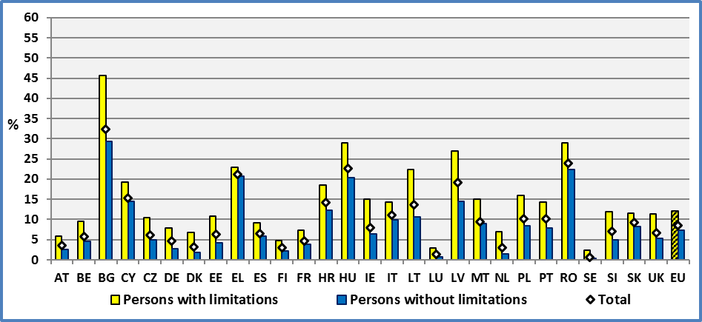

**Data source:** EU-SILC UDB 2014

The range of variation is much bigger compared to other poverty indicators. In fact, the characteristic of a group of persons in one country is not compared to a national average or indicator. Here, the reference is the same for all Member States: deprivation in at least four items out of nine.

If we define disadvantage as the difference of respective rates between persons with and without disabilities, we find that this disadvantage is high notably in most of the new Member States. This disadvantage ranges from a low two (2) percentage point to seventeen (16) percentage points.

**Figure 95: Disadvantage of persons with disabilities concerning severe material deprivation, 2014, 16+**

Disadvantage = (Percent of persons with disabilities) – (Percent of persons without disabilities)

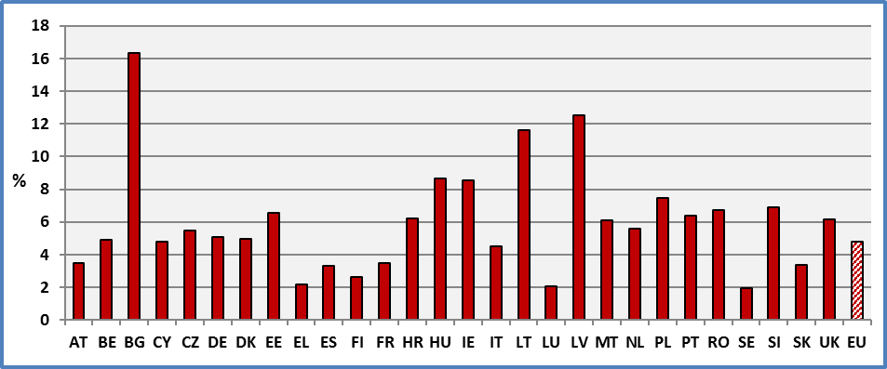

**Data source:** EU-SILC UDB 2014

2.2 Gender

In the EU, 12.6% of women with disabilities aged 16 and over live in households who are severely materially deprived compared to 7.3% of women without disabilities. The total for women aged 16 and over is 8.9%. The respective percentages for men are 11.5% and 7.2%. The total for men is 8.2%.

The gender gap among persons with disabilities is about 1.1 percentage points, at the EU level. This gap is very low in the majority of Member States. The highest difference between women and men with disabilities is 7.3 percentage points (Bulgaria). However, the method used for the construction of the indicator might underestimate gender issues.

The disability related differences are much higher. The difference between women with and without disabilities amounts to 5.2 percentage points. The respective difference for men is 4.3 percentage points.

The difference between women with and without disability ranges from 1.9 percentage points in Greece to 19.1 pp in Bulgaria. For men, these percentages range from 1 percentage point in Luxembourg to 13.8 in Lithuania.

**Figure 96: Percent of persons living in households which are severely materially deprived by gender, disability status and Member State**

Percent of population with an enforced lack of at least four out of nine items (Age 16+), 2014

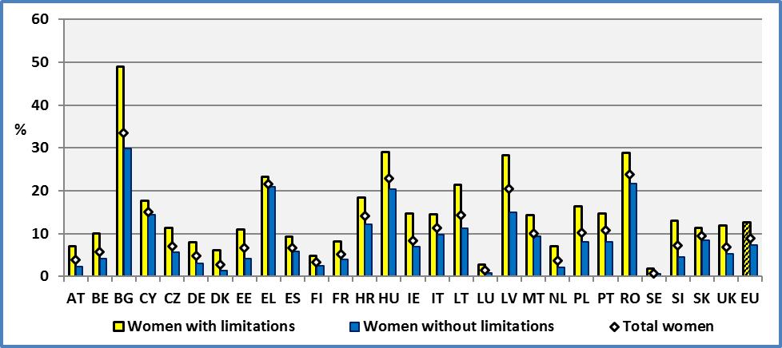

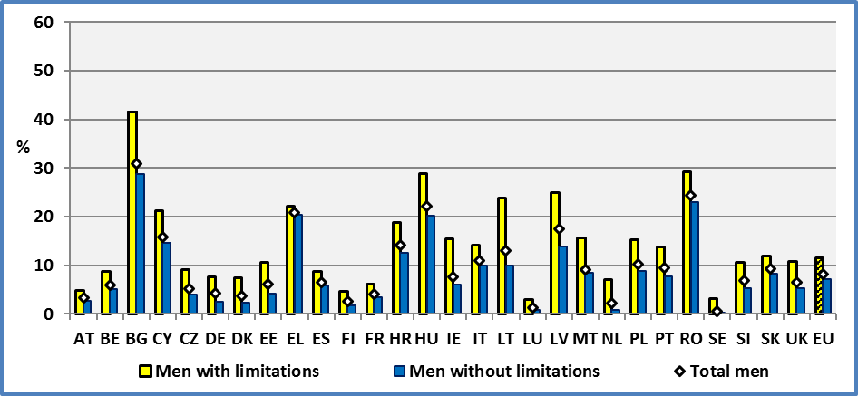

**Data source:** EU-SILC UDB 2014

2.3 Age

At the EU level and for the age group 16 to 64, about 15.5% of persons with disabilities are severely materially deprived compared to 7.8% of persons without disability. The total rate for this age group is 9.2%. The respective percentages for persons aged 65 and over are 7.9% and 4.1%. The total for this age group is 6.2%.

The disability related gap among persons aged 16-64 is 7.7 percentage points. This gap among elderly people aged 65 and over is 3.8 percentage points.

Age decreases the percentage of persons living in households which are severely materially deprived. In fact, severe material deprivation seems to be less important among elderly people (aged 65 and over) compared to younger persons (aged 16-64). However, elderly people might have lower expectations than persons aged 16-64 and underestimate certain situations and needs.

The retirement schemes reduce the number of materially deprived persons for all categories: persons with moderate disabilities and persons without disabilities.

From a life cycle perspective, disabled persons experience a higher percentage of severe material deprivation compared to non-disabled, at all ages. But the gap is reduced after retirement age. This reveals the importance of employment during the active economic life and the fact that pension schemes reduce inequalities.

Globally, material deprivation reflects the different living standards in the Member States. Countries with very high incomes (GDP per capita in PPS) present the lowest rates of material deprivation while countries with very low incomes present extremely high rates of material deprivation. This stands for all age groups and groups by disability status.

**Figure 97: Percent of persons living in households which are severely materially deprived by age, disability status and Member State**

Percent of population with an enforced lack of at least four out of nine items (Age 16+), 2014

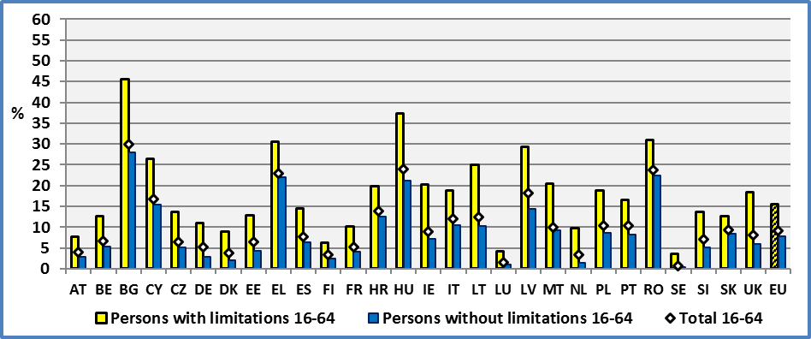

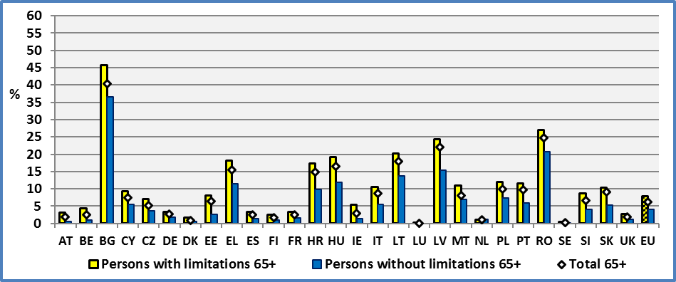

**Data source:** EU-SILC UDB 2014

2.4 Degree of disability

The degree of disability increases significantly the percentage of persons living in households which are in severe material deprivation. About 15.6% of persons with a severe disability aged 16 and over face severe material deprivation. This percentage is 10.4% for persons with a moderate disability and 7.3% for persons without disabilities.

There are about 13.329.000 persons with disabilities aged 16 and over (living in private households) at risk of severe material deprivation. This group includes about 7,871,000 persons with a moderate disability and about 5, 458,000 persons with a severe disability. The total number of persons aged 16 and over who are severely materially deprived are 34,886,000 persons.

**Figure 98: Percent of persons living in households which are severely materially deprived by degree of disability, age 16+, 2014**

Percent of population with an enforced lack of at least four out of nine items

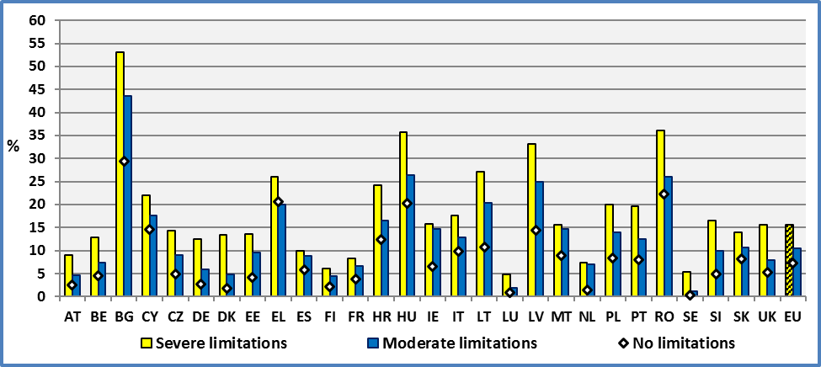

**Data source:** EU-SILC UDB 2014

2.5 Evolution through time at the EU level

In the following graph, we present the evolution of severe material deprivation for persons with and without disabilities. Furthermore, we distinguish by age group as these groups follow specific paths.

In the medium term, we may observe that all groups are affected by the recent 2008/2009 recession and that the rate presents a cyclical fluctuation. Since 2008/2009, the rates of severely material deprivation have increased for all groups except for persons aged 65 and over. However, for persons with disabilities aged 65 and over this change is relatively smaller compared to persons without disabilities. The situation of persons aged 16-64 has significantly deteriorated reflecting the difficult situation on the labour market, notably for persons with disabilities.

Concerning the relative position of persons with disabilities, we may observe a significant deterioration of their relative position since the financial crisis of 2008/2009. In fact, the difference between the rates of severe material deprivation between persons with and without disabilities has increased, notably for persons with disabilities aged 16-64.

**Figure 99: Percent of persons living in households which are severely materially deprived. EU, age 16+**

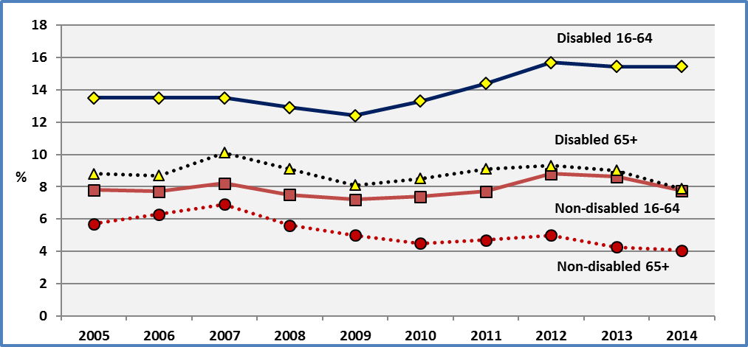

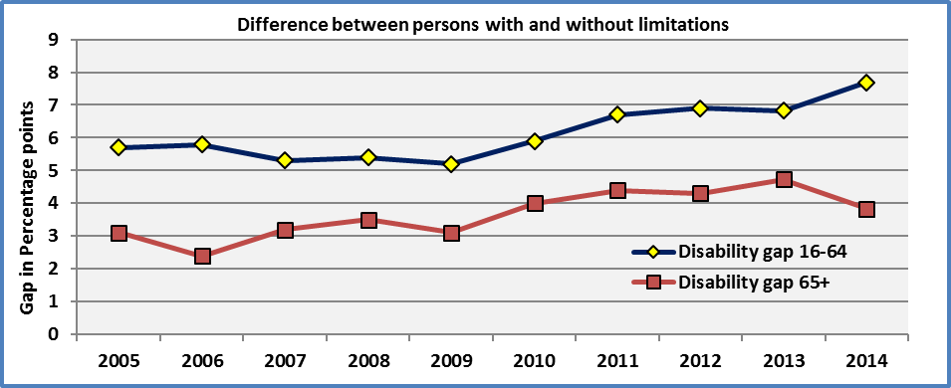

**Data source:** Eurostat (Extracted on 18.11.15) & EU-SILC UDB 2013 & 2014

2.6 Evolution through time at national level

Concerning the situation of persons with disabilities aged 16 and over, an improvement took place in the majority of Member States. This improvement was notable in Bulgaria, Latvia and Romania. On the contrary, there was a small deterioration notably in Belgium, Spain and the Netherlands. Since, these changes are relatively small, they ought to be treated with caution. Only the average of several years may yield robust conclusions.

The following graph depicts this improvement (decrease of severe material deprivation) in the majority of Member States. In the big majority of Member States, the absolute change is less than two (2) percentage points.

**Figure 100: Percent of persons with disabilities living in households which are severely materially deprived in 2013 and 2014 and Change between 2013 and 2014. Age: 16+**

A negative value means a decrease of the percentage (decrease of severe material deprivation)

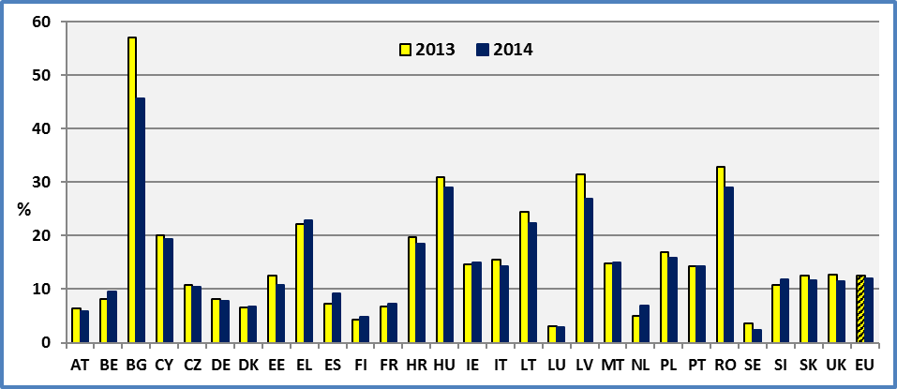

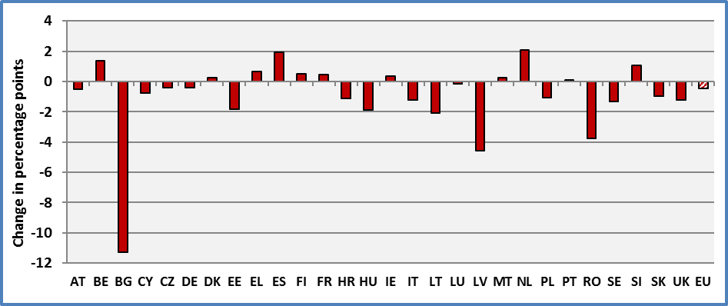

**Data source:** EU-SILC UDB 2013 & 2014

2.7 Relation between material deprivation and income

The previous annual report analysed the relation between material deprivation and income. We present below the main conclusions.

At the macro-level, the graphs presenting the rate of severe material deprivation by Member State reveal that the ranking of countries iss closely related to income levels. Poor Member States are associated with very high rates of severe material deprivation. The inverse is true for rich Member States. A further analysis focussed on the relation between the rate of severe material deprivation per Member State and Gross Domestic Product (GDP) expressed in Purchasing Power Standards (PPS). The results indicated that the rate of severe material deprivation was strongly correlated with Gross Domestic Product (GDP in PPS). We may note that values in PPS correct for different price levels between countries as a Euro does not buy the same basket good of goods in every country. As expected, severe material deprivation is negatively correlated with income.

In a second step, the analysis distinguished persons at risk of financial poverty (as defined in Europe 2020) and persons not being at risk of poverty. Despite the fact that the analysis took into account similar income groups, the rate of severe material deprivation was higher among persons with disabilities compared to persons without disabilities. This supports the hypothesis that disability generates additional costs which reduce the standard of living of persons with disabilities. The lower standard of living due to disability related expenditure might explain the higher rate of severe material deprivation of persons with disabilities compared to persons without disabilities, for a given level of financial income.

2.8 Discussion of the material deprivation components

It the context of the mid-term review of Europe 2020 strategy, the Council asked for an improvement of the SILC based indicator of at risk of poverty or social exclusion (AROPE), and in particular of the basket of items (goods, amenities and activities) that are the basis for the material deprivation component indicator. This effort has already been implemented through voluntary data collection and inclusion of the new items in annual ad hoc modules, until the 2015 data collection[44].

We analyse below a certain number of questions included in the EU-SILC 2014 module on material deprivation from a disability perspective. The module includes, notably, the following personal level variables:

* 1. Replace worn-out clothes by some new (not second-hand) ones (PD020),
  2. Two pairs of properly fitting shoes (PD030),
  3. Get-together with friends/family (relatives) for a drink/meal at least once a month (PD050),
  4. Regularly participate in a leisure activity (PD060),
  5. Spend a small amount of money each week on yourself (PD070),
  6. Internet connection for personal use at home (PD080),
  7. Regular use of public transport - Optional (PD090).

Possible answers (except for Transport) are: 1. ‘Yes’, 2. ‘No - Cannot afford it’ and 3. ‘No - Other reason’. We present below the results for the first six questions. As noted in previous chapters, persons with disabilities have a lower disposable income compared to persons without disabilities. Consequently, the proportion of persons with disabilities answering “2. No - Cannot afford it” ought to be higher compared to persons without disabilities. In fact, for all six items, the percentage of “No - Cannot afford it” is higher for persons with disabilities compared to persons without disabilities.

The answer “No - Other reason” presents a special interest for persons with disabilities as it might include problems related to barriers and accessibility issues. The analysis of the percentages of persons answering “No - Other reason” indicates a high difference between persons with and without disabilities, notably for leisure activities, getting together with friends/family and internet connection for personal use at home.

However, apart barriers, age and education might be important factors explaining the difference between persons with and without disabilities. Education plays an important role for social capital, notably the extent of social networks. In order to isolate any specific impact of barriers, we control for age and educational level. Again, we focus on differences concerning “No – Other reason”. In this case, when we compare persons with a tertiary education, with and without disabilities aged 16-64, we find that the difference between persons with and without disabilities persist for leisure activities and getting together with friends/family. On the contrary, the difference concerning ‘internet connection for personal use at home’ disappears. In this later case, technological illiteracy and age structure (importance of elderly people) explains the big difference between persons with and without disabilities for the total population.

We may conclude that the items “Get-together with friends/family (relatives) for a drink/meal at least once a month” and “Regularly participate in a leisure activity” have a special importance for persons with disabilities. In fact, they might capture part of the disadvantage related to barriers. Consequently, the inclusion of these two items could add a new material deprivation dimension, which might be at least partly related to barriers, and ought to be included in the new definition.

**Figure 101: Percent of persons who answer whether they have or not the specified material (deprivation) item by disability status. Age: 16+, EU 2014.**

Possible answers: 1. ‘Yes’, 2. ‘No - Cannot afford it’ and 3. ‘No - Other reason’

Difference in percentage points = % of persons with limitations - % of persons without limitations

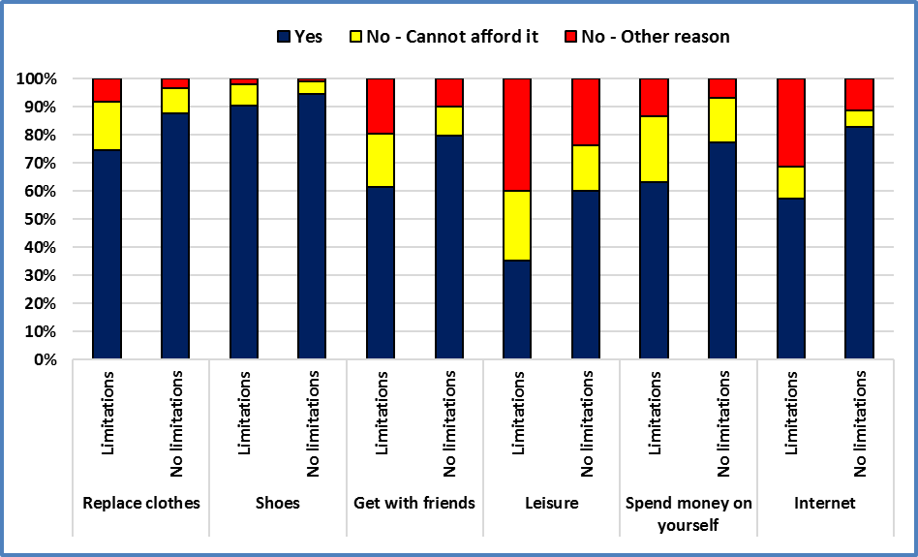

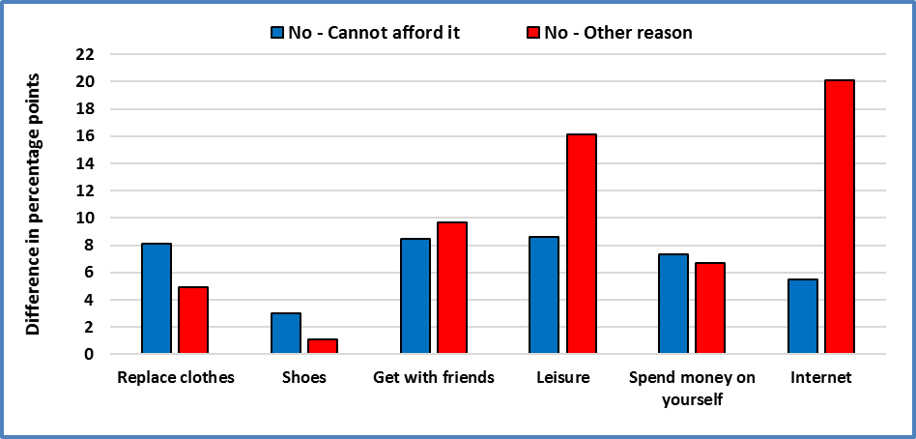

**Data source** : EU-SILC UDB 2014

The question concerning regular use of public transport is treated separately because the options for the answer to this question are different (see graph below). The different options are: 1. ‘Yes’, 2. ‘No - Ticket too expensive’, 3. ‘No - Station too far’, 4. ‘No - Access too difficult’, 5. ‘No - Private transport’, and 6. ‘No - Other reason’. The EU-SILC methodology refers explicitly to the “difficulty of getting to the station in particular for persons with disabilities”[45]. However, accessibility is just one dimension among different factors. Consequently, this option may not be considered as proxy to mobility barriers.

As expected, persons with disabilities use less regularly public transport. The respective rates for persons with and without disabilities are 29.0% and 33.7%. The difference remains even when we control for demographics (e.g. age) and other socio-economic factors (e.g. education and poverty). The proportion of “No – other reason” is always higher among persons with disabilities compared to persons without disabilities. The above remarks hold even when we exclude proxies (another person is answering for the respondent) from our estimations. The question concerns the respondent and not the household.

**Figure 102: Percent of persons who use regularly public transport by disability status. Age: 16+, EU 2014.**

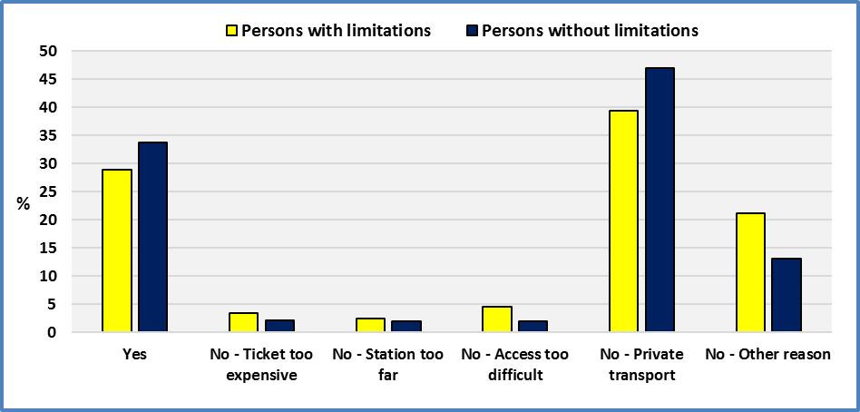

**Data source** : EU-SILC UDB 2014

### 3. Data

**Table 127: Percent of persons living in households which are severely materially deprived by disability status and Member State**

Percent of population with an enforced lack of at least four out of nine material deprivation items in the 'economic strain and durables' dimension, age 16 +

|  |  |  |  |  |  |  |  |  |  |
| --- | --- | --- | --- | --- | --- | --- | --- | --- | --- |
|  | **Persons with limitations** | | | | | | | | |
|  | **2005** | **2006** | **2007** | **2008** | **2009** | **2010** | **2011** | **2012** | **2013** |
| **AT** | 4,3 | 5,0 | 5,4 | 10,8 | 8,5 | 6,4 | 6,7 | 6,6 | 6,5 |
| **BE** | 10,7 | 10,5 | 10,5 | 8,5 | 7,8 | 8,7 | 9,1 | 11,2 | 8,1 |
| **BG** | : | 79,0 | 74,1 | 60,1 | 59,7 | 62,9 | 58,6 | 55,2 | 57,0 |
| **CY** | 19,3 | 19,1 | 23,2 | 16,1 | 14,4 | 15,1 | 14,8 | 18,9 | 20,0 |
| **CZ** | 15,0 | 13,8 | 11,3 | 11,0 | 10,2 | 8,4 | 9,3 | 10,7 | 10,9 |
| **DE** | 6,7 | 6,8 | 7,3 | 7,1 | 6,3 | 5,9 | 7,9 | 7,8 | 8,2 |
| **DK** | 5,5 | 7,2 | 7,6 | 4,8 | 4,1 | 6,0 | 5,6 | 5,1 | 6,8 |
| **EE** | 16,6 | 10,5 | 10,1 | 8,6 | 9,7 | 11,8 | 13,2 | 14,6 | 12,6 |
| **EL** | 24,5 | 22,4 | 22,8 | 21,0 | 15,7 | 17,3 | 17,5 | 22,9 | 22,2 |
| **ES** | 5,8 | 6,4 | 6,0 | 4,5 | 5,4 | 5,5 | 5,8 | 7,1 | 7,2 |
| **FI** | 5,3 | 4,9 | 6,7 | 5,7 | 5,0 | 5,1 | 5,6 | 5,0 | 4,3 |
| **FR** | 8,3 | 7,3 | 7,7 | 7,5 | 7,8 | 8,6 | 7,2 | 6,9 | 6,9 |
| **HR** | : | : | : | : | : | 22,3 | 22,9 | 22,0 | 19,7 |
| **HU** | 29,2 | 26,6 | 23,7 | 23,4 | 24,3 | 25,3 | 28,4 | 31,2 | 30,9 |
| **IE** | 7,7 | 7,7 | 6,9 | 10,8 | 8,6 | 8,0 | 12,7 | 14,5 | 14,7 |
| **IT** | 9,7 | 10,0 | 10,2 | 10,2 | 8,9 | 9,6 | 14,7 | 16,5 | 15,9 |
| **LT** | 42,3 | 33,6 | 23,1 | 18,9 | 21,4 | 26,0 | 29,0 | 29,4 | 24,4 |
| **LU** | 2,5 | 1,1 | 1,8 | 1,6 | 1,9 | 1,4 | 2,0 | 2,9 | 3,0 |
| **LV** | 51,2 | 41,9 | 36,2 | 30,7 | 31,3 | 35,4 | 37,6 | 34,2 | 31,5 |
| **MT** | 10,3 | 6,2 | 6,2 | 6,3 | 8,7 | 8,7 | 10,4 | 13,6 | 14,7 |
| **NL** | 4,3 | 5,1 | 4,5 | 3,1 | 2,9 | 4,0 | 4,3 | 3,5 | 4,9 |
| **PO** | 45,0 | 35,7 | 29,3 | 25,5 | 21,4 | 20,5 | 18,9 | 19,2 | 17,0 |
| **PT** | 15,4 | 15,5 | 14,1 | 13,9 | 13,9 | 13,4 | 11,1 | 12,0 | 14,2 |
| **RO** | : | : | 48,4 | 38,5 | 37,9 | 36,6 | 34,2 | 34,1 | 32,8 |
| **SE** | 4,0 | 4,5 | 4,2 | 3,6 | 3,8 | 3,8 | 2,8 | 3,8 | 3,7 |
| **SI** | 9,3 | 9,6 | 10,0 | 12,3 | 10,7 | 9,9 | 9,4 | 11,6 | 10,8 |
| **SK** | 25,6 | 21,6 | 18,0 | 16,2 | 13,8 | 14,1 | 14,0 | 13,7 | 12,6 |
| **UK** | 7,8 | 6,3 | 6,5 | 5,8 | 5,7 | 7,8 | 8,0 | 11,5 | 12,6 |
|  |  |  |  |  |  |  |  |  |  |
| **EU** | **11,6** | **11,4** | **12,0** | **11,2** | **10,5** | **11,2** | **12,1** | **12,8** | **12,6** |
|  |  |  |  |  |  |  |  |  |  |
| **CH** | : | : | 3,8 | 3,6 | 2,8 | 2,3 | 2,0 | 1,6 | 1,1 |
| **IS** | 4,1 | 4,8 | 5,4 | 2,1 | 2,8 | 4,4 | 5,0 | 4,1 | 3,8 |
| **NO** | 7,0 | 6,3 | 4,8 | 5,0 | 4,8 | 6,4 | 6,4 | 6,0 | 4,0 |
| **RS** | : | : | : | : | : | : | : | : | 41,0 |

**Data source: 2005-2012:** Eurostat:Extracted on 18.11.15

**2013**: EU-SILC UDB 2013

**Table 128: Percent of persons living in households which are severely materially deprived by disability status and Member State**

Percent of population with an enforced lack of at least four out of nine material deprivation items in the 'economic strain and durables' dimension, age 16 +

|  |  |  |  |  |  |  |  |  |  |
| --- | --- | --- | --- | --- | --- | --- | --- | --- | --- |
|  | **Persons without limitations** | | | | | | | | |
|  | **2005** | **2006** | **2007** | **2008** | **2009** | **2010** | **2011** | **2012** | **2013** |
| **AT** | 2,4 | 2,9 | 2,3 | 4,4 | 3,1 | 2,9 | 2,4 | 2,5 | 2,6 |
| **BE** | 4,5 | 4,3 | 4,0 | 4,3 | 4,1 | 4,4 | 3,8 | 4,6 | 4,1 |
| **BG** | : | 57,1 | 57,1 | 37,5 | 38,0 | 42,6 | 40,1 | 41,1 | 39,6 |
| **CY** | 10,0 | 11,3 | 11,4 | 7,4 | 8,3 | 10,0 | 10,0 | 13,4 | 14,6 |
| **CZ** | 9,9 | 7,9 | 5,8 | 5,4 | 4,9 | 5,4 | 5,0 | 5,4 | 5,3 |
| **DE** | 3,3 | 3,7 | 3,9 | 3,7 | 3,7 | 3,3 | 3,1 | 2,6 | 3,1 |
| **DK** | 2,6 | 2,0 | 2,0 | 0,9 | 1,7 | 1,4 | 1,4 | 1,8 | 2,7 |
| **EE** | 9,8 | 5,2 | 3,7 | 3,1 | 4,7 | 7,4 | 6,6 | 7,0 | 5,2 |
| **EL** | 11,0 | 9,7 | 9,3 | 9,1 | 9,7 | 10,2 | 14,2 | 18,6 | 19,2 |
| **ES** | 3,0 | 3,1 | 2,6 | 2,8 | 3,7 | 4,2 | 4,0 | 5,1 | 5,2 |
| **FI** | 3,3 | 2,8 | 2,7 | 2,7 | 2,0 | 2,2 | 2,1 | 1,9 | 1,5 |
| **FR** | 4,2 | 4,0 | 3,7 | 4,4 | 4,6 | 4,5 | 4,0 | 4,2 | 4,2 |
| **HR** | : | : | : | : | : | 12,2 | 13,2 | 13,8 | 12,9 |
| **HU** | 18,4 | 17,4 | 17,1 | 14,7 | 17,1 | 18,1 | 19,5 | 22,0 | 23,1 |
| **IE** | 3,1 | 3,3 | 2,9 | 3,7 | 4,4 | 4,3 | 6,1 | 7,8 | 7,5 |
| **IT** | 5,5 | 5,1 | 5,3 | 6,0 | 6,0 | 6,0 | 9,3 | 12,8 | 10,6 |
| **LT** | 29,5 | 23,1 | 14,4 | 9,5 | 13,6 | 18,0 | 16,5 | 17,3 | 12,7 |
| **LU** | 1,2 | 0,9 | 0,6 | 0,4 | 0,9 | 0,4 | 1,1 | 0,8 | 1,2 |
| **LV** | 34,6 | 26,5 | 18,9 | 13,8 | 16,9 | 23,3 | 27,7 | 21,9 | 19,3 |
| **MT** | 4,6 | 3,1 | 3,6 | 3,6 | 4,0 | 5,8 | 5,9 | 7,8 | 8,4 |
| **NL** | 1,7 | 1,2 | 0,9 | 0,7 | 0,8 | 1,4 | 1,5 | 1,4 | 1,3 |
| **PO** | 31,9 | 25,7 | 20,1 | 15,5 | 13,2 | 12,1 | 11,3 | 11,5 | 10,1 |
| **PT** | 6,5 | 6,2 | 7,0 | 7,4 | 6,3 | 6,4 | 6,3 | 7,1 | 9,1 |
| **RO** | : | : | 33,0 | 30,1 | 28,8 | 27,4 | 25,8 | 26,4 | 25,3 |
| **SE** | 1,5 | 1,2 | 1,3 | 0,9 | 1,1 | 0,9 | 0,8 | 0,8 | 0,7 |
| **SI** | 3,9 | 3,8 | 3,8 | 5,2 | 4,7 | 4,0 | 4,6 | 4,4 | 5,2 |
| **SK** | 20,5 | 16,2 | 11,6 | 9,3 | 9,2 | 9,6 | 8,2 | 8,5 | 8,5 |
| **UK** | 3,6 | 3,3 | 3,0 | 3,8 | 2,4 | 3,4 | 3,7 | 5,4 | 5,9 |
|  |  |  |  |  |  |  |  |  |  |
| **EU** | **7,5** | **7,5** | **8,0** | **7,2** | **6,9** | **7,0** | **7,3** | **8,3** | **8,0** |
|  |  |  |  |  |  |  |  |  |  |
| **CH** | : | : | 1,6 | 1,4 | 1,6 | 1,0 | 0,7 | 0,6 | 0,5 |
| **IS** | 2,2 | 1,2 | 1,4 | 0,6 | 0,5 | 1,1 | 1,5 | 1,8 | 1,2 |
| **NO** | 2,4 | 2,0 | 1,6 | 1,3 | 1,5 | 1,1 | 1,1 | 0,9 | 1,3 |
| **RS** | : | : | : | : | : | : | : | : | 25,3 |

**Data source: 2005-2012:** Eurostat:Extracted on 18.11.15

**2013**: EU-SILC UDB 2013

**Table 129: Percent of persons living in households which are severely materially deprived by disability status and Member State**

Percent of population with an enforced lack of at least four out of nine material deprivation items in the 'economic strain and durables' dimension, age 16 +

|  |  |  |  |
| --- | --- | --- | --- |
|  | **2014** | | |
|  | **Persons**  **with limitations** | **Persons**  **without limitations** | **Total** |
| **AT** | 6,0 | 2,5 | **3,6** |
| **BE** | 9,5 | 4,6 | **5,8** |
| **BG** | 45,7 | 29,4 | **32,3** |
| **CY** | 19,3 | 14,5 | **15,4** |
| **CZ** | 10,4 | 4,9 | **6,2** |
| **DE** | 7,8 | 2,8 | **4,6** |
| **DK** | 6,8 | 1,8 | **3,2** |
| **EE** | 10,7 | 4,2 | **6,4** |
| **EL** | 22,8 | 20,7 | **21,2** |
| **ES** | 9,1 | 5,8 | **6,6** |
| **FI** | 4,8 | 2,2 | **3,0** |
| **FR** | 7,3 | 3,8 | **4,7** |
| **HR** | 18,6 | 12,4 | **14,2** |
| **HU** | 29,0 | 20,3 | **22,6** |
| **IE** | 15,0 | 6,5 | **8,0** |
| **IT** | 14,4 | 9,9 | **11,2** |
| **LT** | 22,3 | 10,7 | **13,7** |
| **LU** | 2,9 | 0,8 | **1,3** |
| **LV** | 27,0 | 14,5 | **19,2** |
| **MT** | 15,0 | 8,9 | **9,5** |
| **NL** | 7,0 | 1,4 | **3,0** |
| **PO** | 15,9 | 8,4 | **10,2** |
| **PT** | 14,3 | 7,9 | **10,2** |
| **RO** | 29,0 | 22,3 | **24,0** |
| **SE** | 2,3 | 0,4 | **0,6** |
| **SI** | 11,9 | 5,0 | **7,0** |
| **SK** | 11,6 | 8,3 | **9,4** |
| **UK** | 11,4 | 5,3 | **6,7** |
|  |  |  |  |
| **EU** | **12,1** | **7,3** | **8,6** |
|  |  |  |  |
| **CH** | 2,1 | 0,8 | **1,2** |
| **IS** | 4,9 | 0,6 | **1,3** |
| **NO** | 3,0 | 0,8 | **1,1** |
| **RS** | 39,7 | 24,3 | **26,8** |

**Data source:** EU-SILC UDB 2014

**Table 130: Percent of persons living in households which are severely materially deprived by disability status, gender and Member State**

Percent of population with an enforced lack of at least four out of nine material deprivation items in the 'economic strain and durables' dimension, age 16 +

|  |  |  |  |  |  |  |  |  |  |
| --- | --- | --- | --- | --- | --- | --- | --- | --- | --- |
|  | **Males with limitations** | | | | | | | | |
|  | **2005** | **2006** | **2007** | **2008** | **2009** | **2010** | **2011** | **2012** | **2013** |
| **AT** | 4,3 | 4,6 | 5,2 | 10,3 | 8,0 | 5,2 | 6,0 | 6,0 | 6,6 |
| **BE** | 10,3 | 9,9 | 10,0 | 7,8 | 8,0 | 9,9 | 9,3 | 12,1 | 8,7 |
| **BG** | : | 78,8 | 77,6 | 59,3 | 56,6 | 61,0 | 57,2 | 54,4 | 53,3 |
| **CY** | 19,8 | 19,1 | 20,6 | 17,7 | 11,9 | 15,8 | 14,9 | 18,6 | 20,0 |
| **CZ** | 14,2 | 13,8 | 9,7 | 9,5 | 9,2 | 7,0 | 8,0 | 8,8 | 9,4 |
| **DE** | 5,9 | 6,5 | 7,0 | 7,2 | 6,4 | 5,9 | 7,4 | 7,8 | 8,4 |
| **DK** | 6,6 | 6,7 | 8,2 | 4,4 | 4,1 | 6,8 | 4,1 | 5,9 | 5,9 |
| **EE** | 15,2 | 10,9 | 9,6 | 9,4 | 9,9 | 12,2 | 14,0 | 15,7 | 12,9 |
| **EL** | 21,8 | 20,2 | 20,3 | 19,1 | 14,0 | 15,0 | 15,9 | 22,7 | 23,1 |
| **ES** | 5,7 | 7,3 | 6,5 | 5,1 | 5,4 | 5,3 | 6,0 | 7,6 | 6,9 |
| **FI** | 5,3 | 3,9 | 5,1 | 5,1 | 4,5 | 5,4 | 5,8 | 5,0 | 4,0 |
| **FR** | 8,3 | 6,6 | 6,9 | 5,8 | 6,9 | 7,5 | 6,6 | 5,8 | 5,7 |
| **HR** | : | : | : | : | : | 22,0 | 22,2 | 21,2 | 20,0 |
| **HU** | 28,3 | 25,8 | 21,7 | 21,9 | 24,7 | 23,3 | 26,7 | 30,0 | 29,8 |
| **IE** | 8,0 | 8,4 | 5,9 | 11,7 | 9,2 | 7,1 | 11,3 | 14,9 | 14,8 |
| **IT** | 9,3 | 9,6 | 9,7 | 9,7 | 8,9 | 9,3 | 13,9 | 16,4 | 16,4 |
| **LT** | 39,7 | 31,8 | 21,1 | 16,7 | 21,2 | 23,8 | 26,2 | 27,0 | 22,7 |
| **LU** | 3,6 | 0,9 | 1,5 | 1,5 | 0,8 | 0,7 | 2,7 | 2,9 | 2,2 |
| **LV** | 47,3 | 39,6 | 31,8 | 28,4 | 30,4 | 33,5 | 36,3 | 33,5 | 30,7 |
| **MT** | 9,4 | 5,9 | 5,0 | 5,1 | 7,0 | 7,5 | 10,9 | 12,3 | 14,3 |
| **NL** | 3,7 | 2,1 | 6,5 | 4,0 | 2,7 | 3,9 | 3,9 | 2,7 | 5,3 |
| **PO** | 44,2 | 35,2 | 28,0 | 25,4 | 20,4 | 19,4 | 18,4 | 18,2 | 15,7 |
| **PT** | 15,0 | 15,3 | 14,7 | 14,1 | 13,7 | 14,1 | 11,9 | 12,6 | 13,5 |
| **RO** | : | : | 48,5 | 36,7 | 36,5 | 36,2 | 32,2 | 33,4 | 32,6 |
| **SE** | 3,0 | 4,0 | 4,2 | 3,4 | 4,0 | 3,0 | 3,1 | 4,8 | 4,0 |
| **SI** | 8,9 | 9,9 | 9,0 | 12,8 | 9,3 | 9,9 | 8,1 | 11,2 | 9,8 |
| **SK** | 24,7 | 20,1 | 16,7 | 15,1 | 12,9 | 13,8 | 13,5 | 12,8 | 12,5 |
| **UK** | 7,7 | 6,3 | 6,1 | 5,7 | 6,3 | 7,6 | 7,5 | 11,9 | 13,2 |
|  |  |  |  |  |  |  |  |  |  |
| **EU** | **11,0** | **11,0** | **11,5** | **10,7** | **10,1** | **10,6** | **11,3** | **12,3** | **12,3** |
|  |  |  |  |  |  |  |  |  |  |
| **CH** | : | : | 3,0 | 3,8 | 3,1 | 2,5 | 2,0 | 1,7 | 0,6 |
| **IS** | 3,6 | 1,9 | 2,8 | 1,3 | 3,1 | 4,4 | 5,6 | 3,8 | 0,9 |
| **NO** | 7,2 | 5,9 | 5,2 | 7,1 | 6,5 | 9,2 | 7,0 | 5,7 | 2,2 |
| **RS** | : | : | : | : | : | : | : | : | 41,1 |

**Data source: 2005-2012:** Eurostat:Extracted on 18.11.15

**2013**: EU-SILC UDB 2013

**Table 131: Percent of persons living in households which are severely materially deprived by disability status, gender and Member State**

Percent of population with an enforced lack of at least four out of nine material deprivation items in the 'economic strain and durables' dimension, age 16 +

|  |  |  |  |  |  |  |  |  |  |
| --- | --- | --- | --- | --- | --- | --- | --- | --- | --- |
|  | **Females with limitations** | | | | | | | | |
|  | **2005** | **2006** | **2007** | **2008** | **2009** | **2010** | **2011** | **2012** | **2013** |
| **AT** | 4,3 | 5,4 | 5,6 | 11,2 | 8,9 | 7,4 | 7,2 | 7,2 | 6,4 |
| **BE** | 10,9 | 11,0 | 10,8 | 9,1 | 7,6 | 8,0 | 8,9 | 10,5 | 7,7 |
| **BG** | : | 79,1 | 71,0 | 60,6 | 61,9 | 64,3 | 59,6 | 55,8 | 59,8 |
| **CY** | 18,9 | 19,1 | 25,2 | 14,8 | 16,4 | 14,6 | 14,7 | 19,2 | 20,1 |
| **CZ** | 15,7 | 13,7 | 12,3 | 12,0 | 10,9 | 9,5 | 10,2 | 11,9 | 11,8 |
| **DE** | 7,3 | 7,1 | 7,5 | 6,9 | 6,3 | 5,8 | 8,3 | 7,8 | 8,1 |
| **DK** | 4,9 | 7,4 | 7,2 | 5,1 | 4,1 | 5,4 | 6,5 | 4,4 | 7,6 |
| **EE** | 17,6 | 10,3 | 10,4 | 8,0 | 9,6 | 11,5 | 12,6 | 13,8 | 12,3 |
| **EL** | 26,7 | 24,2 | 24,8 | 22,4 | 16,9 | 19,1 | 18,6 | 23,0 | 21,5 |
| **ES** | 5,9 | 5,8 | 5,7 | 4,1 | 5,4 | 5,6 | 5,7 | 6,8 | 7,5 |
| **FI** | 5,3 | 5,6 | 7,9 | 6,2 | 5,3 | 4,8 | 5,5 | 4,9 | 4,4 |
| **FR** | 8,3 | 7,8 | 8,3 | 8,8 | 8,4 | 9,4 | 7,7 | 7,8 | 7,8 |
| **HR** | : | : | : | : | : | 22,5 | 23,4 | 22,6 | 19,5 |
| **HU** | 29,8 | 27,2 | 25,1 | 24,5 | 24,0 | 26,7 | 29,6 | 32,0 | 31,6 |
| **IE** | 7,4 | 7,0 | 7,9 | 10,0 | 8,1 | 8,7 | 14,1 | 14,2 | 14,6 |
| **IT** | 10,0 | 10,3 | 10,5 | 10,6 | 8,9 | 9,8 | 15,3 | 16,6 | 15,5 |
| **LT** | 43,9 | 34,8 | 24,4 | 20,2 | 21,5 | 27,3 | 30,7 | 30,9 | 25,5 |
| **LU** | 1,5 | 1,2 | 2,1 | 1,6 | 2,8 | 2,1 | 1,3 | 2,8 | 3,7 |
| **LV** | 53,6 | 43,2 | 38,8 | 32,1 | 31,8 | 36,5 | 38,4 | 34,6 | 32,0 |
| **MT** | 11,1 | 6,3 | 7,2 | 7,4 | 10,1 | 9,7 | 10,1 | 14,6 | 15,1 |
| **NL** | 4,6 | 6,9 | 3,3 | 2,5 | 3,1 | 4,1 | 4,5 | 4,0 | 4,7 |
| **PO** | 45,6 | 36,1 | 30,4 | 25,7 | 22,1 | 21,2 | 19,3 | 19,9 | 17,9 |
| **PT** | 15,7 | 15,6 | 13,6 | 13,7 | 14,0 | 12,9 | 10,6 | 11,6 | 14,7 |
| **RO** | : | : | 48,4 | 39,8 | 38,8 | 36,9 | 35,5 | 34,5 | 33,0 |
| **SE** | 4,8 | 5,0 | 4,3 | 3,7 | 3,7 | 4,2 | 2,6 | 3,2 | 3,5 |
| **SI** | 9,6 | 9,4 | 10,8 | 11,9 | 11,8 | 9,9 | 10,5 | 11,9 | 11,6 |
| **SK** | 26,1 | 22,6 | 18,8 | 16,9 | 14,5 | 14,3 | 14,4 | 14,3 | 12,7 |
| **UK** | 7,8 | 6,2 | 6,7 | 5,9 | 5,3 | 7,9 | 8,5 | 11,2 | 12,2 |
|  |  |  |  |  |  |  |  |  |  |
| **EU** | 12,0 | 11,7 | 12,4 | 11,6 | 10,8 | 11,7 | 12,7 | 13,2 | 12,9 |
|  |  |  |  |  |  |  |  |  |  |
| **CH** | : | : | 4,3 | 3,4 | 2,6 | 2,1 | 1,9 | 1,6 | 1,5 |
| **IS** | 4,5 | 6,9 | 7,0 | 2,7 | 2,6 | 4,3 | 4,5 | 4,3 | 5,4 |
| **NO** | 6,9 | 6,5 | 4,5 | 3,7 | 3,6 | 4,2 | 6,0 | 6,2 | 5,3 |
| **RS** | : | : | : | : | : | : | : | : | 41,0 |

**Data source: 2005-2012:** Eurostat:Extracted on 18.11.15

**2013**: EU-SILC UDB 2013

**Table 132: Percent of persons living in households which are severely materially deprived by disability status, gender and Member State**

Percent of population with an enforced lack of at least four out of nine material deprivation items in the 'economic strain and durables' dimension, age 16 +

|  |  |  |  |  |  |  |  |  |  |
| --- | --- | --- | --- | --- | --- | --- | --- | --- | --- |
|  | **Males without limitations** | | | | | | | | |
|  | **2005** | **2006** | **2007** | **2008** | **2009** | **2010** | **2011** | **2012** | **2013** |
| **AT** | 2,1 | 3,5 | 2,1 | 4,1 | 2,9 | 2,7 | 2,3 | 2,5 | 2,7 |
| **BE** | 4,5 | 4,0 | 3,7 | 3,9 | 3,8 | 4,4 | 4,1 | 4,6 | 4,7 |
| **BG** | : | 57,0 | 55,6 | 35,9 | 36,4 | 41,3 | 39,2 | 39,6 | 39,2 |
| **CY** | 10,1 | 11,2 | 11,2 | 6,8 | 8,4 | 10,0 | 9,9 | 13,6 | 15,0 |
| **CZ** | 9,4 | 7,9 | 5,7 | 5,0 | 4,3 | 5,0 | 4,5 | 4,8 | 4,4 |
| **DE** | 3,2 | 3,6 | 3,7 | 3,7 | 3,4 | 3,1 | 2,8 | 2,5 | 2,8 |
| **DK** | 2,7 | 1,6 | 1,4 | 0,7 | 1,4 | 1,3 | 1,2 | 1,9 | 2,9 |
| **EE** | 10,2 | 4,9 | 3,9 | 3,1 | 4,7 | 7,4 | 6,7 | 7,0 | 5,7 |
| **EL** | 10,4 | 9,4 | 8,9 | 8,3 | 9,1 | 10,0 | 14,1 | 18,6 | 18,9 |
| **ES** | 3,1 | 3,1 | 2,6 | 2,9 | 3,6 | 4,1 | 3,9 | 5,4 | 5,4 |
| **FI** | 3,2 | 2,6 | 2,0 | 2,1 | 1,7 | 1,7 | 1,6 | 1,7 | 1,4 |
| **FR** | 3,9 | 3,7 | 3,4 | 4,2 | 4,2 | 4,7 | 3,8 | 3,9 | 4,0 |
| **HR** | : | : | : | : | : | 12,6 | 13,0 | 13,6 | 13,5 |
| **HU** | 18,4 | 17,6 | 17,5 | 14,8 | 16,9 | 18,6 | 19,5 | 21,9 | 23,2 |
| **IE** | 2,5 | 3,0 | 2,7 | 3,4 | 3,7 | 4,1 | 5,9 | 7,5 | 6,6 |
| **IT** | 5,6 | 4,9 | 5,1 | 6,0 | 5,8 | 6,0 | 9,3 | 12,5 | 10,6 |
| **LT** | 28,2 | 21,9 | 13,8 | 8,9 | 13,0 | 19,0 | 17,6 | 17,6 | 11,2 |
| **LU** | 1,2 | 0,8 | 0,7 | 0,3 | 1,0 | 0,4 | 1,2 | 0,8 | 1,1 |
| **LV** | 32,1 | 24,7 | 18,3 | 13,0 | 16,2 | 23,3 | 27,8 | 20,7 | 18,7 |
| **MT** | 4,2 | 2,6 | 3,2 | 3,3 | 3,8 | 5,6 | 5,5 | 7,4 | 8,2 |
| **NL** | 1,4 | 1,4 | 1,0 | 0,5 | 0,8 | 1,4 | 1,6 | 1,6 | 1,2 |
| **PO** | 31,5 | 25,4 | 19,7 | 15,2 | 12,8 | 11,9 | 11,3 | 11,4 | 10,2 |
| **PT** | 6,8 | 6,3 | 6,6 | 7,3 | 6,4 | 6,4 | 5,8 | 6,9 | 9,4 |
| **RO** | : | : | 32,9 | 30,2 | 29,3 | 28,1 | 26,7 | 26,8 | 25,4 |
| **SE** | 1,0 | 1,0 | 1,5 | 0,8 | 1,2 | 1,0 | 0,8 | 0,7 | 0,5 |
| **SI** | 3,5 | 3,6 | 3,7 | 4,7 | 4,8 | 4,5 | 4,8 | 4,7 | 5,6 |
| **SK** | 20,5 | 16,3 | 11,1 | 9,2 | 9,3 | 9,4 | 8,2 | 8,6 | 8,4 |
| **UK** | 3,2 | 3,0 | 2,8 | 3,4 | 2,5 | 3,2 | 3,7 | 5,1 | 5,5 |
|  |  |  |  |  |  |  |  |  |  |
| **EU** | **7,2** | **7,2** | **7,7** | **7,0** | **6,6** | **7,0** | **7,2** | **8,1** | **7,9** |
|  |  |  |  |  |  |  |  |  |  |
| **CH** | : | : | 1,5 | 1,4 | 1,5 | 1,0 | 0,6 | 0,6 | 0,6 |
| **IS** | 1,7 | 1,0 | 0,9 | 0,6 | 0,6 | 0,8 | 1,3 | 1,4 | 1,4 |
| **NO** | 2,5 | 1,6 | 1,4 | 1,4 | 1,4 | 1,1 | 1,1 | 0,8 | 1,0 |
| **RS** | : | : | : | : | : | : | : | : | 25,0 |

**Data source: 2005-2012:** Eurostat:Extracted on 18.11.15

**2013**: EU-SILC UDB 2013

**Table 133: Percent of persons living in households which are severely materially deprived by disability status, gender and Member State**

Percent of population with an enforced lack of at least four out of nine material deprivation items in the 'economic strain and durables' dimension, age 16 +

|  |  |  |  |  |  |  |  |  |  |
| --- | --- | --- | --- | --- | --- | --- | --- | --- | --- |
|  | **Females without limitations** | | | | | | | | |
|  | **2005** | **2006** | **2007** | **2008** | **2009** | **2010** | **2011** | **2012** | **2013** |
| **AT** | 2,7 | 2,4 | 2,4 | 4,6 | 3,2 | 3,2 | 2,5 | 2,6 | 2,5 |
| **BE** | 4,6 | 4,5 | 4,3 | 4,6 | 4,4 | 4,5 | 3,5 | 4,7 | 3,6 |
| **BG** | : | 57,1 | 58,4 | 39,0 | 39,6 | 43,8 | 41,0 | 42,6 | 40,0 |
| **CY** | 9,8 | 11,4 | 11,7 | 7,9 | 8,1 | 10,0 | 10,0 | 13,2 | 14,2 |
| **CZ** | 10,4 | 7,9 | 5,9 | 5,7 | 5,3 | 5,7 | 5,5 | 5,8 | 6,0 |
| **DE** | 3,5 | 3,7 | 4,1 | 3,8 | 4,1 | 3,4 | 3,3 | 2,7 | 3,4 |
| **DK** | 2,5 | 2,4 | 2,5 | 1,1 | 2,0 | 1,4 | 1,7 | 1,6 | 2,4 |
| **EE** | 9,4 | 5,5 | 3,6 | 3,0 | 4,6 | 7,5 | 6,5 | 7,1 | 4,7 |
| **EL** | 11,7 | 10,1 | 9,7 | 9,8 | 10,2 | 10,4 | 14,4 | 18,7 | 19,6 |
| **ES** | 3,0 | 3,1 | 2,6 | 2,7 | 3,7 | 4,3 | 4,1 | 4,8 | 5,0 |
| **FI** | 3,3 | 3,0 | 3,5 | 3,3 | 2,3 | 2,6 | 2,6 | 2,1 | 1,6 |
| **FR** | 4,5 | 4,3 | 4,0 | 4,6 | 4,9 | 4,3 | 4,3 | 4,4 | 4,4 |
| **HR** | : | : | : | : | : | 11,9 | 13,3 | 13,9 | 12,4 |
| **HU** | 18,4 | 17,2 | 16,7 | 14,6 | 17,4 | 17,7 | 19,4 | 22,0 | 23,0 |
| **IE** | 3,7 | 3,5 | 3,1 | 4,1 | 5,1 | 4,5 | 6,2 | 8,2 | 8,4 |
| **IT** | 5,3 | 5,2 | 5,5 | 6,0 | 6,1 | 6,0 | 9,4 | 13,2 | 10,6 |
| **LT** | 30,8 | 24,3 | 14,9 | 10,0 | 14,1 | 17,1 | 15,5 | 17,0 | 13,9 |
| **LU** | 1,2 | 0,9 | 0,5 | 0,4 | 0,9 | 0,4 | 1,0 | 0,9 | 1,2 |
| **LV** | 36,9 | 28,2 | 19,4 | 14,6 | 17,6 | 23,4 | 27,5 | 22,9 | 19,8 |
| **MT** | 5,0 | 3,5 | 4,1 | 3,9 | 4,3 | 6,0 | 6,3 | 8,3 | 8,6 |
| **NL** | 2,0 | 1,0 | 0,8 | 0,9 | 0,9 | 1,5 | 1,4 | 1,2 | 1,4 |
| **PO** | 32,3 | 26,0 | 20,5 | 15,9 | 13,5 | 12,2 | 11,2 | 11,7 | 10,0 |
| **PT** | 6,3 | 6,2 | 7,4 | 7,4 | 6,3 | 6,5 | 6,9 | 7,4 | 8,9 |
| **RO** | : | : | 33,0 | 29,9 | 28,3 | 26,7 | 24,9 | 26,0 | 25,0 |
| **SE** | 2,1 | 1,4 | 1,1 | 1,0 | 1,1 | 0,8 | 0,9 | 0,9 | 0,8 |
| **SI** | 4,2 | 4,0 | 3,8 | 5,6 | 4,5 | 3,6 | 4,3 | 4,1 | 4,7 |
| **SK** | 20,4 | 16,0 | 12,1 | 9,5 | 9,1 | 9,8 | 8,2 | 8,4 | 8,5 |
| **UK** | 4,0 | 3,5 | 3,2 | 4,2 | 2,3 | 3,5 | 3,6 | 5,8 | 6,4 |
|  |  |  |  |  |  |  |  |  |  |
| **EU** | **7,8** | **7,8** | **8,3** | **7,5** | **7,1** | **7,1** | **7,4** | **8,5** | **8,2** |
|  |  |  |  |  |  |  |  |  |  |
| **CH** | : | : | 1,6 | 1,4 | 1,7 | 0,9 | 0,7 | 0,6 | 0,5 |
| **IS** | 2,7 | 1,5 | 1,9 | 0,6 | 0,4 | 1,3 | 1,8 | 2,1 | 1,1 |
| **NO** | 2,3 | 2,4 | 1,8 | 1,3 | 1,7 | 1,0 | 1,2 | 1,1 | 1,7 |
| **RS** | : | : | : | : | : | : | : | : | 25,6 |

**Data source: 2005-2012:** Eurostat:Extracted on 18.11.15

**2013**: EU-SILC UDB 2013

**Table 134: Percent of persons living in households which are severely materially deprived by disability status, gender and Member State**

Percent of population with an enforced lack of at least four out of nine material deprivation items in the 'economic strain and durables' dimension, age 16 +

|  |  |  |  |  |  |  |  |  |  |  |  |  |
| --- | --- | --- | --- | --- | --- | --- | --- | --- | --- | --- | --- | --- |
|  | **Females** | | | | | | **Males** | | | | | |
|  | **2008** | **2009** | **2010** | **2011** | **2012** | **2013** | **2008** | **2009** | **2010** | **2011** | **2012** | **2013** |
| **AT** | 6,7 | 4,9 | 4,5 | 3,9 | 3,9 | 3,7 | 5,9 | 4,2 | 3,4 | 3,2 | 3,4 | 3,8 |
| **BE** | 5,8 | 5,2 | 5,4 | 4,9 | 6,1 | 4,6 | 4,7 | 4,6 | 5,5 | 5,2 | 6,1 | 5,5 |
| **BG** | 43,0 | 43,7 | 35,7 | 44,5 | 45,3 | 43,8 | 39,4 | 39,2 | 33,2 | 42,0 | 42,0 | 41,4 |
| **CY** | 8,5 | 8,3 |  | 10,6 | 14,5 | 15,4 | 8,0 | 7,8 |  | 9,7 | 14,6 | 16,0 |
| **CZ** | 7,2 | 6,7 | 6,6 | 6,7 | 7,4 | 7,5 | 5,9 | 5,4 | 5,4 | 5,2 | 5,7 | 5,5 |
| **DE** | 5,0 | 4,9 | 4,2 | 5,0 | 4,5 | 5,1 | 4,9 | 4,3 | 3,9 | 4,2 | 4,2 | 4,6 |
| **DK** | 2,2 | 2,6 | 2,5 | 3,2 | 2,4 | 4,0 | 1,5 | 2,1 | 2,5 | 1,8 | 2,9 | 3,7 |
| **EE** | 4,6 | 6,2 | 8,8 | 8,6 | 9,4 | 7,4 | 4,8 | 6,0 | 8,7 | 8,8 | 9,6 | 7,9 |
| **EL** | 12,6 | 11,6 | 12,2 | 15,3 | 19,7 | 20,1 | 10,2 | 9,9 | 10,8 | 14,4 | 19,4 | 19,7 |
| **ES** | 2,4 | 3,3 | 3,9 | 3,9 | 5,3 | 5,7 | 2,5 | 3,2 | 3,6 | 3,7 | 5,8 | 5,7 |
| **FI** | 4,3 | 3,4 | 3,3 | 3,6 | 3,2 | 2,9 | 2,9 | 2,5 | 2,7 | 2,8 | 2,7 | 2,4 |
| **FR** |  | 5,9 | 5,7 | 5,2 | 5,3 | 5,3 |  | 4,8 | 5,3 | 4,4 | 4,3 | 4,4 |
| **HR** |  |  |  | 16,6 | 15,6 | 14,7 |  |  |  | 15,0 | 14,6 | 15,3 |
| **HU** | 17,6 | 20,0 | 20,5 | 22 ,5 | 24,9 | 25,5 | 16,7 | 19,3 | 19,8 | 21,2 | 23,7 | 24,7 |
| **IE** | 5,3 | 10,1 |  |  | 9,2 | 9,5 | 4,9 | 9,2 |  |  | 8,7 | 8,0 |
| **IT** | 7,5 | 7,0 | 6,9 | 11,3 | 14,3 | 12,2 | 6,9 | 6,5 | 6,5 | 10,4 | 13,5 | 12,2 |
| **LT** | 13,2 | 15,6 | 19,4 | 19,2 | 20,9 | 17,2 | 11,0 | 14,1 | 19,5 | 19,0 | 19,7 | 13,7 |
| **LU** | 0,7 | 1,3 | 0,8 | 1,1 | 1,3 | 1,8 | 0,5 | 1,0 | 0,5 | 1,4 | 1,2 | 1,4 |
| **LV** | 20,8 | 22,3 | 27,7 | 31,7 | 26,7 | 24,8 | 16,8 | 20,1 | 25,7 | 30,3 | 24,0 | 22,6 |
| **MT** |  | 4,9 | 5,9 | 6,4 | 9,1 | 9,4 |  | 3,9 | 5,2 | 5,9 | 7,8 | 8,8 |
| **NL** | 1,4 | 1,6 | 2,3 | 2,4 | 2,1 | 2,6 | 1,3 | 1,2 | 2,0 | 2,1 | 1,9 | 2,3 |
| **PL** | 18,1 | 15,7 | 14,5 | 13,2 | 13,8 | 12,0 | 17,2 | 14,4 | 13,6 | 12,8 | 12,8 | 11,5 |
| **PT** | 9,6 | 9,1 | 8,8 | 8,2 | 8,6 | 10,6 | 9,1 | 8,4 | 8,4 | 7,3 | 8,0 | 10,3 |
| **RO** | 32,2 | 31,0 | 29,8 | 28,2 | 28,5 | 27,5 | 31,5 | 30,7 | 29,8 | 28,0 | 28,2 | 26,9 |
| **SE** | 1,5 | 1,6 | 1,4 | 1,2 | 1,3 | 1,5 | 1,2 | 1,5 | 1,3 | 1,1 | 1,2 | 1,1 |
| **SI** | 7,3 | 6,6 | 6,0 | 6,7 | 6,9 | 6,9 | 6,7 | 5,9 | 6,3 | 5,9 | 6,6 | 6,8 |
| **SK** | 12,3 | 11,1 | 11,5 | 10,6 | 10,6 | 10,0 | 11,1 | 10,3 | 10,7 | 9,8 | 9,8 | 9,5 |
| **UK** | 4,5 | 2,9 | 4,5 | 4,8 | 7,1 | 7,7 | 3,7 | 3,2 | 4,1 | 4,5 | 6,4 | 7,0 |
|  |  |  |  |  |  |  |  |  |  |  |  |  |
| **EU** | **9,0** | **8,2** | **8,1** | **8,8** | **9,8** | **9,5** | **8,2** | **7,4** | **7,5** | **8,1** | **9,1** | **9,0** |
|  |  |  |  |  |  |  |  |  |  |  |  |  |
| **CH** |  |  |  |  |  | 0,8 |  |  |  |  |  | 0,6 |
| **IS** |  |  |  |  |  | 2,0 |  |  |  |  |  | 1,3 |
| **NO** |  |  |  |  |  | 2,4 |  |  |  |  |  | 1,2 |
| **RS** |  |  |  |  |  | 28,7 |  |  |  |  |  | 27,6 |

**Note :** These data come from a different version of EU-SILC micro-data compared to previous data by gender.

**Data source:**  EU-SILC UDB

**Table 135: Percent of persons living in households which are severely materially deprived by disability status, gender and Member State**

Percent of population with an enforced lack of at least four out of nine material deprivation items in the 'economic strain and durables' dimension, age 16 +

|  |  |  |  |  |  |  |
| --- | --- | --- | --- | --- | --- | --- |
|  | **2014** | | | | | |
|  | **Women** | | | **Men** | | |
|  | **With**  **limitations** | **Without**  **limitations** | **Total** | **With**  **limitations** | **Without**  **limitations** | **Total** |
| **AT** | 7,0 | 2,4 | **4,0** | 4,8 | 2,6 | **3,3** |
| **BE** | 10,0 | 4,1 | **5,7** | 8,8 | 5,1 | **5,9** |
| **BG** | 48,9 | 29,8 | **33,6** | 41,6 | 28,9 | **30,9** |
| **CY** | 17,6 | 14,4 | **15,0** | 21,2 | 14,7 | **15,8** |
| **CZ** | 11,3 | 5,6 | **7,0** | 9,1 | 4,1 | **5,2** |
| **DE** | 8,1 | 3,0 | **4,9** | 7,6 | 2,6 | **4,3** |
| **DK** | 6,2 | 1,4 | **2,8** | 7,5 | 2,3 | **3,7** |
| **EE** | 10,9 | 4,1 | **6,6** | 10,6 | 4,2 | **6,2** |
| **EL** | 23,3 | 21,0 | **21,6** | 22,3 | 20,4 | **20,8** |
| **ES** | 9,4 | 5,8 | **6,7** | 8,8 | 5,9 | **6,5** |
| **FI** | 4,8 | 2,5 | **3,3** | 4,7 | 1,8 | **2,7** |
| **FR** | 8,2 | 4,1 | **5,2** | 6,1 | 3,5 | **4,1** |
| **HR** | 18,4 | 12,2 | **14,1** | 18,8 | 12,6 | **14,2** |
| **HU** | 29,0 | 20,4 | **22,9** | 28,9 | 20,2 | **22,2** |
| **IE** | 14,7 | 6,9 | **8,3** | 15,4 | 6,1 | **7,6** |
| **IT** | 14,5 | 9,8 | **11,3** | 14,1 | 10,0 | **11,0** |
| **LT** | 21,5 | 11,3 | **14,3** | 23,8 | 10,1 | **13,0** |
| **LU** | 2,8 | 0,9 | **1,4** | 3,0 | 0,8 | **1,3** |
| **LV** | 28,3 | 15,0 | **20,4** | 24,9 | 13,9 | **17,6** |
| **MT** | 14,4 | 9,4 | **10,0** | 15,7 | 8,4 | **9,1** |
| **NL** | 7,0 | 2,1 | **3,7** | 7,1 | 0,8 | **2,3** |
| **PO** | 16,4 | 8,1 | **10,3** | 15,3 | 8,8 | **10,2** |
| **PT** | 14,7 | 8,1 | **10,8** | 13,9 | 7,8 | **9,6** |
| **RO** | 28,9 | 21,6 | **23,8** | 29,2 | 23,1 | **24,3** |
| **SE** | 1,9 | 0,5 | **0,7** | 3,1 | 0,2 | **0,5** |
| **SI** | 13,1 | 4,6 | **7,3** | 10,5 | 5,4 | **6,8** |
| **SK** | 11,4 | 8,4 | **9,4** | 12,0 | 8,2 | **9,3** |
| **UK** | 11,9 | 5,3 | **6,9** | 10,9 | 5,2 | **6,4** |
|  |  |  |  |  |  |  |
| **EU** | **12,6** | **7,3** | **8,9** | **11,5** | **7,2** | **8,2** |
|  |  |  |  |  |  |  |
| **CH** | 1,8 | 0,6 | **1,0** | 2,6 | 1,0 | **1,4** |
| **IS** | 5,2 | 0,6 | **1,6** | 4,3 | 0,5 | **1,0** |
| **NO** | 2,4 | 0,8 | **1,1** | 4,0 | 0,8 | **1,2** |
| **RS** | 38,8 | 24,0 | **26,6** | 40,9 | 24,5 | **26,9** |

**Data source:** EU SILC UDB 2014

**Table 136: Percent of persons living in households which are severely materially deprived by disability status, age group and Member State**

Percent of population with an enforced lack of at least four out of nine material deprivation items in the 'economic strain and durables' dimension, age 16 +

|  |  |  |  |  |  |  |  |  |  |
| --- | --- | --- | --- | --- | --- | --- | --- | --- | --- |
|  | **Persons with limitations aged 16-64** | | | | | | | | |
|  | **2005** | **2006** | **2007** | **2008** | **2009** | **2010** | **2011** | **2012** | **2013** |
| **AT** | 5,5 | 6,9 | 7,3 | 14,1 | 11,8 | 8,8 | 8,9 | 8,9 | 9,0 |
| **BE** | 14,0 | 14,5 | 13,9 | 11,0 | 9,8 | 11,9 | 12,6 | 16,2 | 11,3 |
| **BG** | : | 79,0 | 81,1 | 53,2 | 54,3 | 59,2 | 56,8 | 52,1 | 56,8 |
| **CY** | 21,1 | 20,5 | 23,1 | 18,8 | 16,1 | 19,3 | 18,8 | 25,6 | 25,1 |
| **CZ** | 16,2 | 16,2 | 13,1 | 12,9 | 11,8 | 11,1 | 10,5 | 12,0 | 14,0 |
| **DE** | 8,8 | 9,5 | 10,3 | 10,0 | 9,0 | 8,6 | 11,4 | 10,9 | 11,4 |
| **DK** | 7,4 | 9,5 | 9,9 | 5,9 | 5,3 | 7,6 | 6,7 | 6,5 | 8,7 |
| **EE** | 17,0 | 12,0 | 10,9 | 10,2 | 12,2 | 15,2 | 17,7 | 18,9 | 16,5 |
| **EL** | 20,8 | 20,7 | 20,6 | 21,4 | 20,5 | 20,7 | 20,4 | 29,0 | 30,8 |
| **ES** | 6,9 | 7,0 | 6,4 | 5,9 | 7,2 | 7,8 | 8,2 | 10,2 | 10,4 |
| **FI** | 6,2 | 6,0 | 7,9 | 6,3 | 6,2 | 6,5 | 7,3 | 6,3 | 5,6 |
| **FR** | 12,0 | 10,4 | 9,7 | 9,8 | 10,8 | 11,7 | 10,0 | 10,0 | 9,5 |
| **HR** | : | : | : | : | : | 23,2 | 24,2 | 24,4 | 19,6 |
| **HU** | 33,1 | 29,8 | 26,4 | 27,3 | 29,5 | 31,1 | 35,8 | 39,4 | 39,8 |
| **IE** | 10,6 | 10,5 | 9,2 | 14,3 | 10,9 | 10,4 | 16,9 | 20,4 | 19,3 |
| **IT** | 11,4 | 12,5 | 11,9 | 12,0 | 10,8 | 11,6 | 17,0 | 19,3 | 18,9 |
| **LT** | 41,8 | 33,9 | 24,2 | 18,4 | 23,2 | 26,0 | 31,8 | 33,7 | 29,0 |
| **LU** | 3,5 | 1,4 | 2,1 | 2,4 | 2,8 | 2,0 | 2,9 | 4,2 | 3,9 |
| **LV** | 49,3 | 41,5 | 33,6 | 28,6 | 32,4 | 37,8 | 42,8 | 37,4 | 34,3 |
| **MT** | 12,5 | 8,1 | 8,8 | 8,6 | 12,0 | 11,0 | 14,3 | 20,1 | 19,2 |
| **NL** | 5,7 | 6,6 | 6,0 | 4,1 | 4,0 | 5,7 | 5,9 | 4,5 | 6,8 |
| **PO** | 48,2 | 37,9 | 31,4 | 27,1 | 22,6 | 20,7 | 19,0 | 20,6 | 19,1 |
| **PT** | 15,1 | 15,0 | 15,0 | 14,6 | 14,1 | 14,3 | 12,9 | 13,4 | 16,8 |
| **RO** | : | : | 44,6 | 37,0 | 38,7 | 36,8 | 35,5 | 35,5 | 33,9 |
| **SE** | 5,4 | 5,5 | 5,8 | 5,1 | 5,7 | 5,7 | 4,3 | 5,9 | 5,4 |
| **SI** | 9,0 | 9,8 | 9,9 | 13,0 | 11,5 | 10,8 | 9,8 | 12,9 | 11,9 |
| **SK** | 25,7 | 20,9 | 17,1 | 16,1 | 14,3 | 15,1 | 16,1 | 14,8 | 13,9 |
| **UK** | 11,0 | 8,7 | 9,0 | 8,5 | 8,5 | 11,7 | 12,5 | 18,5 | 19,7 |
|  |  |  |  |  |  |  |  |  |  |
| **EU** | **13,5** | **13,5** | **13,5** | **12,9** | **12,4** | **13,3** | **14,4** | **15,7** | **15,5** |
|  |  |  |  |  |  |  |  |  |  |
| **CH** | : | : | 4,5 | 4,6 | 3,8 | 2,9 | 2,7 | 2,3 | 1,5 |
| **IS** | 5,4 | 6,2 | 6,7 | 3,0 | 4,1 | 5,9 | 6,8 | 5,7 | 5,0 |
| **NO** | 8,9 | 8,4 | 6,6 | 6,9 | 6,8 | 8,4 | 8,5 | 7,7 | 4,9 |
| **RS** | 5,5 | 6,9 | 7,3 | 14,1 | 11,8 | 8,8 | 8,9 | 8,9 | 44,6 |

**Data source: 2005-2012:** Eurostat:Extracted on 18.11.15

**2013**: EU-SILC UDB 2013

**Table 137: Percent of persons living in households which are severely materially deprived by disability status, age group and Member State**

Percent of population with an enforced lack of at least four out of nine material deprivation items in the 'economic strain and durables' dimension, age 16 +

|  |  |  |  |  |  |  |  |  |  |
| --- | --- | --- | --- | --- | --- | --- | --- | --- | --- |
|  | **Persons without limitations aged 16-64** | | | | | | | | |
|  | **2005** | **2006** | **2007** | **2008** | **2009** | **2010** | **2011** | **2012** | **2013** |
| **AT** | 2,5 | 3,1 | 2,4 | 4,7 | 3,3 | 3,2 | 2,7 | 2,8 | 2,8 |
| **BE** | 5,0 | 4,6 | 4,3 | 4,7 | 4,4 | 4,9 | 4,2 | 5,0 | 4,6 |
| **BG** | : | 54,0 | 54,8 | 34,2 | 35,4 | 40,9 | 38,7 | 39,6 | 38,3 |
| **CY** | 10,0 | 11,1 | 11,1 | 7,2 | 8,4 | 10,5 | 10,5 | 14,3 | 15,6 |
| **CZ** | 10,2 | 8,1 | 6,0 | 5,5 | 5,1 | 5,6 | 5,2 | 5,7 | 5,5 |
| **DE** | 3,5 | 4,0 | 4,4 | 4,2 | 4,1 | 3,6 | 3,4 | 2,8 | 3,5 |
| **DK** | 3,1 | 2,2 | 2,3 | 1,0 | 2,0 | 1,6 | 1,6 | 2,1 | 3,2 |
| **EE** | 9,8 | 5,3 | 3,7 | 3,1 | 4,8 | 7,8 | 7,1 | 7,4 | 5,4 |
| **EL** | 10,8 | 9,5 | 9,0 | 9,2 | 9,6 | 10,4 | 14,9 | 20,1 | 20,7 |
| **ES** | 3,1 | 3,2 | 2,7 | 3,1 | 4,0 | 4,6 | 4,3 | 5,6 | 5,8 |
| **FI** | 3,5 | 3,0 | 3,0 | 2,9 | 2,1 | 2,4 | 2,2 | 2,1 | 1,7 |
| **FR** | 4,4 | 4,3 | 4,0 | 4,8 | 4,9 | 4,8 | 4,3 | 4,6 | 4,6 |
| **HR** | : | : | : | : | : | 12,2 | 13,3 | 14,2 | 13,2 |
| **HU** | 18,8 | 17,9 | 17,5 | 15,1 | 17,8 | 19,1 | 20,4 | 23,1 | 24,3 |
| **IE** | 3,3 | 3,5 | 3,1 | 4,0 | 4,7 | 4,8 | 6,7 | 8,6 | 8,3 |
| **IT** | 5,9 | 5,4 | 5,7 | 6,4 | 6,4 | 6,3 | 9,7 | 13,2 | 11,2 |
| **LT** | 29,1 | 22,7 | 14,0 | 9,3 | 13,2 | 17,6 | 15,8 | 16,8 | 12,5 |
| **LU** | 1,4 | 0,9 | 0,6 | 0,4 | 1,0 | 0,5 | 1,2 | 1,0 | 1,2 |
| **LV** | 33,8 | 26,4 | 17,9 | 13,3 | 17,0 | 24,0 | 28,3 | 22,3 | 19,1 |
| **MT** | 4,5 | 3,1 | 3,8 | 3,7 | 4,1 | 6,1 | 6,2 | 8,2 | 8,9 |
| **NL** | 1,8 | 1,3 | 1,0 | 0,8 | 0,9 | 1,6 | 1,7 | 1,7 | 1,4 |
| **PO** | 31,6 | 25,7 | 20,1 | 15,4 | 13,0 | 12,1 | 11,2 | 11,5 | 10,3 |
| **PT** | 6,3 | 6,0 | 7,1 | 7,7 | 6,6 | 6,6 | 6,5 | 7,3 | 9,6 |
| **RO** | : | : | 31,5 | 29,1 | 28,7 | 27,6 | 26,3 | 27,1 | 25,8 |
| **SE** | 1,6 | 1,4 | 1,5 | 1,0 | 1,3 | 1,0 | 0,9 | 0,9 | 0,8 |
| **SI** | 3,9 | 3,8 | 3,8 | 5,2 | 4,7 | 4,1 | 4,5 | 4,4 | 5,3 |
| **SK** | 20,3 | 16,2 | 11,5 | 9,3 | 9,4 | 9,7 | 8,2 | 8,6 | 8,6 |
| **UK** | 4,1 | 3,6 | 3,3 | 4,3 | 2,7 | 3,9 | 4,2 | 6,3 | 6,8 |
|  |  |  |  |  |  |  |  |  |  |
| **EU** | **7,8** | **7,7** | **8,2** | **7,5** | **7,2** | **7,4** | **7,7** | **8,8** | **8,6** |
|  |  |  |  |  |  |  |  |  |  |
| **CH** | : | : | 1,7 | 1,5 | 1,8 | 1,1 | 0,7 | 0,6 | 0,6 |
| **IS** | 2,4 | 1,3 | 1,5 | 0,6 | 0,5 | 1,2 | 1,7 | 1,9 | 1,4 |
| **NO** | 2,7 | 2,3 | 1,8 | 1,5 | 1,8 | 1,2 | 1,4 | 1,1 | 1,6 |
| **RS** | 2,5 | 3,1 | 2,4 | 4,7 | 3,3 | 3,2 | 2,7 | 2,8 | 26,0 |

**Data source: 2005-2012:** Eurostat:Extracted on 18.11.15

**2013**: EU-SILC UDB 2013

**Table 138: Percent of persons living in households which are severely materially deprived by disability status, age group and Member State**

Percent of population with an enforced lack of at least four out of nine material deprivation items in the 'economic strain and durables' dimension, age 16 +

|  |  |  |  |  |  |  |  |  |  |
| --- | --- | --- | --- | --- | --- | --- | --- | --- | --- |
|  | **Persons with limitations aged 65+** | | | | | | | | |
|  | **2005** | **2006** | **2007** | **2008** | **2009** | **2010** | **2011** | **2012** | **2013** |
| **AT** | 2,7 | 2,5 | 2,9 | 5,9 | 3,8 | 2,8 | 3,4 | 2,9 | 2,2 |
| **BE** | 5,3 | 4,6 | 5,3 | 4,8 | 4,6 | 4,1 | 3,9 | 3,7 | 2,9 |
| **BG** | : | 79,0 | 69,8 | 66,4 | 64,7 | 66,2 | 60,3 | 58,3 | 57,2 |
| **CY** | 16,6 | 17,1 | 23,3 | 12,6 | 12,1 | 9,6 | 9,1 | 9,9 | 12,6 |
| **CZ** | 13,3 | 9,7 | 8,7 | 8,4 | 8,1 | 4,9 | 7,9 | 9,0 | 7,3 |
| **DE** | 3,2 | 2,8 | 2,9 | 2,8 | 2,7 | 2,2 | 3,3 | 3,7 | 3,9 |
| **DK** | 0,8 | 1,1 | 1,3 | 1,5 | 1,0 | 1,5 | 2,2 | 1,5 | 2,0 |
| **EE** | 16,0 | 8,5 | 9,0 | 6,9 | 7,0 | 7,8 | 7,4 | 9,0 | 7,5 |
| **EL** | 27,7 | 23,8 | 24,6 | 20,7 | 13,6 | 15,5 | 15,7 | 18,7 | 17,0 |
| **ES** | 4,4 | 5,7 | 5,5 | 2,8 | 3,1 | 2,8 | 3,4 | 4,2 | 3,6 |
| **FI** | 3,3 | 2,6 | 4,3 | 4,6 | 2,7 | 2,5 | 2,7 | 2,5 | 1,6 |
| **FR** | 4,2 | 3,8 | 5,1 | 4,7 | 4,3 | 4,6 | 3,7 | 3,1 | 3,5 |
| **HR** | : | : | : | : | : | 21,3 | 21,7 | 19,6 | 19,8 |
| **HU** | 22,5 | 21,9 | 19,6 | 17,1 | 16,8 | 17,2 | 18,5 | 20,7 | 19,8 |
| **IE** | 2,2 | 2,1 | 2,4 | 3,6 | 3,9 | 3,3 | 5,8 | 3,8 | 6,4 |
| **IT** | 8,5 | 8,0 | 8,7 | 8,8 | 7,3 | 8,2 | 12,7 | 14,0 | 13,1 |
| **LT** | 42,9 | 33,2 | 21,9 | 19,4 | 19,7 | 26,0 | 26,7 | 25,8 | 20,7 |
| **LU** | 0,4 | 0,4 | 1,2 | : | 0,1 | 0,3 | 0,1 | 0,0 | 1,1 |
| **LV** | 54,0 | 42,4 | 39,3 | 33,4 | 29,8 | 32,5 | 31,9 | 30,6 | 28,4 |
| **MT** | 7,9 | 4,3 | 3,9 | 4,6 | 5,2 | 6,5 | 7,0 | 8,5 | 11,0 |
| **NL** | 1,2 | 1,4 | 1,1 | 0,8 | 0,6 | 0,6 | 0,8 | 1,3 | 1,1 |
| **PO** | 40,6 | 32,6 | 26,4 | 23,5 | 19,8 | 20,1 | 18,7 | 17,1 | 14,1 |
| **PT** | 15,8 | 16,0 | 13,0 | 13,0 | 13,6 | 12,2 | 9,1 | 10,5 | 11,3 |
| **RO** | : | : | 52,8 | 40,3 | 37,0 | 36,4 | 32,6 | 32,4 | 31,5 |
| **SE** | 1,7 | 2,2 | 1,1 | 1,1 | 0,8 | 0,7 | 0,4 | 0,4 | 0,6 |
| **SI** | 10,0 | 9,2 | 10,3 | 10,8 | 9,0 | 8,0 | 8,6 | 8,8 | 8,9 |
| **SK** | 25,3 | 22,8 | 19,3 | 16,4 | 13,1 | 12,3 | 10,4 | 11,8 | 10,3 |
| **UK** | 2,8 | 2,8 | 2,7 | 1,8 | 1,8 | 2,0 | 1,4 | 2,1 | 3,5 |
|  |  |  |  |  |  |  |  |  |  |
| **EU** | **8,8** | **8,7** | **10,1** | **9,1** | **8,1** | **8,5** | **9,1** | **9,3** | **9,0** |
|  |  |  |  |  |  |  |  |  |  |
| **CH** | : | : | 1,8 | 1,3 | 0,7 | 0,9 | 0,3 | 0,1 | 0,2 |
| **IS** | 0,7 | 0,8 | 0,9 | : | : | 0,5 | : | : | 0,0 |
| **NO** | 2,3 | 1,5 | 0,7 | 0,4 | 0,4 | 0,8 | 1,2 | 1,3 | 1,8 |
| **RS** | 2,7 | 2,5 | 2,9 | 5,9 | 3,8 | 2,8 | 3,4 | 2,9 | 37,5 |

**Data source: 2005-2012:** Eurostat:Extracted on 18.11.15

**2013**: EU-SILC UDB 2013

**Table 139: Percent of persons living in households which are severely materially deprived by disability status, age group and Member State**

Percent of population with an enforced lack of at least four out of nine material deprivation items in the 'economic strain and durables' dimension, age 16 +

|  |  |  |  |  |  |  |  |  |  |
| --- | --- | --- | --- | --- | --- | --- | --- | --- | --- |
|  | **Persons without limitations aged 65+** | | | | | | | | |
|  | **2005** | **2006** | **2007** | **2008** | **2009** | **2010** | **2011** | **2012** | **2013** |
| **AT** | 1,2 | 1,5 | 1,1 | 2,2 | 1,7 | 0,8 | 0,4 | 0,7 | 1,3 |
| **BE** | 1,9 | 2,1 | 2,1 | 1,8 | 1,8 | 1,8 | 1,5 | 2,4 | 1,3 |
| **BG** | : | 69,5 | 67,0 | 56,0 | 53,8 | 52,6 | 48,9 | 49,5 | 46,2 |
| **CY** | 9,5 | 13,2 | 14,9 | 8,8 | 6,8 | 4,6 | 3,5 | 4,5 | 5,0 |
| **CZ** | 7,4 | 6,2 | 4,6 | 4,6 | 3,5 | 4,0 | 3,8 | 3,8 | 4,4 |
| **DE** | 1,9 | 1,6 | 1,2 | 0,9 | 1,8 | 1,2 | 1,2 | 1,3 | 1,0 |
| **DK** | 0,1 | 1,0 | 0,6 | 0,6 | 0,8 | 0,4 | 0,6 | 0,2 | 0,7 |
| **EE** | 10,4 | 4,0 | 4,7 | 2,5 | 2,8 | 4,3 | 2,3 | 3,0 | 3,0 |
| **EL** | 12,7 | 10,9 | 11,4 | 8,2 | 9,9 | 8,5 | 9,8 | 8,6 | 8,6 |
| **ES** | 2,3 | 2,1 | 1,8 | 1,0 | 1,3 | 1,6 | 1,8 | 1,3 | 1,5 |
| **FI** | 1,1 | 1,7 | 0,9 | 1,3 | 1,3 | 0,9 | 1,6 | 0,6 | 0,5 |
| **FR** | 2,7 | 1,8 | 1,6 | 1,7 | 2,0 | 2,0 | 2,0 | 1,6 | 1,8 |
| **HR** | : | : | : | : | : | 12,0 | 12,5 | 11,0 | 10,7 |
| **HU** | 14,5 | 12,1 | 13,0 | 10,1 | 10,3 | 8,6 | 10,5 | 12,3 | 11,5 |
| **IE** | 1,5 | 1,4 | 0,3 | 1,2 | 1,6 | 0,3 | 1,1 | 2,4 | 1,9 |
| **IT** | 2,8 | 3,1 | 2,6 | 3,1 | 3,0 | 4,2 | 6,8 | 10,5 | 6,5 |
| **LT** | 33,9 | 27,7 | 18,6 | 11,4 | 17,2 | 21,1 | 22,4 | 21,0 | 14,2 |
| **LU** | 0,0 | 0,3 | 0,1 | : | 0,2 | : | : | : | 0,7 |
| **LV** | 41,9 | 27,2 | 28,3 | 18,6 | 16,0 | 17,1 | 22,0 | 18,6 | 21,1 |
| **MT** | 5,3 | 3,0 | 2,6 | 2,2 | 3,4 | 4,0 | 3,4 | 5,4 | 5,4 |
| **NL** | 1,1 | 0,2 | 0,1 | 0,1 | 0,2 | 0,1 | : | 0,1 | 0,5 |
| **PO** | 34,5 | 25,8 | 20,0 | 17,2 | 14,5 | 11,9 | 11,7 | 11,9 | 8,2 |
| **PT** | 8,6 | 8,5 | 5,9 | 4,3 | 4,2 | 4,7 | 5,1 | 6,2 | 6,5 |
| **RO** | : | : | 45,1 | 37,6 | 30,0 | 24,6 | 19,6 | 18,3 | 19,2 |
| **SE** | 0,9 | 0,4 | 0,4 | 0,6 | 0,4 | 0,6 | 0,7 | 0,4 | 0,1 |
| **SI** | 3,6 | 3,6 | 3,5 | 4,9 | 4,2 | 3,5 | 5,2 | 4,9 | 4,2 |
| **SK** | 22,9 | 16,3 | 13,3 | 9,8 | 5,9 | 6,4 | 6,9 | 6,7 | 5,9 |
| **UK** | 1,2 | 1,6 | 1,4 | 1,1 | 0,7 | 0,8 | 1,1 | 0,8 | 1,1 |
|  |  |  |  |  |  |  |  |  |  |
| **EU** | **5,7** | **6,3** | **6,9** | **5,6** | **5,0** | **4,5** | **4,7** | **5,0** | **4,3** |
|  |  |  |  |  |  |  |  |  |  |
| **CH** | : | : | 0,4 | 0,7 | 0,3 | 0,3 | 0,3 | 0,2 | 0,2 |
| **IS** | 0,4 | 0,6 | 0,5 | 0,3 | : | 0,3 | 0,3 | 1,1 | 0,5 |
| **NO** | 0,7 | 0,5 | 0,3 | 0,3 | : | 0,5 | : | 0,4 | 0,0 |
| **RS** | : | : | : | : | : | : | : | : | 21,8 |

**Data source: 2005-2012:** Eurostat:Extracted on 18.11.15

**2013**: EU-SILC UDB 2013

**Table 140: Percent of persons living in households which are severely materially deprived by disability status, age group and Member State**

Percent of population with an enforced lack of at least four out of nine material deprivation items in the 'economic strain and durables' dimension, age 16 +

|  |  |  |  |  |  |  |  |  |  |  |
| --- | --- | --- | --- | --- | --- | --- | --- | --- | --- | --- |
|  | **Persons aged 16-64** | | | | | **Persons aged 65+** | | | | |
|  | **2009** | **2010** | **2011** | **2012** | **2013** | **2009** | **2010** | **2011** | **2012** | **2013** |
| **AT** | 5,0 | 4,4 | 3,9 | 4,1 | 4,3 | 2,9 | 2,0 | 2,0 | 1,9 | 1,8 |
| **BE** | 5,4 | 6,1 | 5,7 | 6,9 | 5,9 | 3,1 | 2,9 | 2,6 | 3,0 | 2,0 |
| **BG** | 37,3 | 32,0 | 40,6 | 41,0 | 40,3 | 57,9 | 44,2 | 53,7 | 53,2 | 50,8 |
| **CY** | 7,9 |  | 11,0 | 15,8 | 17,0 | 8,8 |  | 5,7 | 7,6 | 9,0 |
| **CZ** | 6,2 | 6,5 | 6,1 | 6,7 | 6,9 | 5,8 | 4,4 | 5,8 | 6,3 | 5,8 |
| **DE** | 5,3 | 4,8 | 5,3 | 4,9 | 5,5 | 2,4 | 1,8 | 2,5 | 2,8 | 2,7 |
| **DK** | 2,7 | 3,9 | 2,9 | 3,2 | 4,6 | 0,8 | 0,7 | 1,1 | 0,7 | 1,1 |
| **EE** | 6,2 | 9,3 | 9,4 | 10,1 | 8,0 | 5,6 | 6,6 | 5,8 | 7,2 | 6,1 |
| **EL** | 10,4 | 11,2 | 15,4 | 21,1 | 21,8 | 12,1 | 12,4 | 13,1 | 14,4 | 13,7 |
| **ES** | 3,6 | 4,1 | 4,1 | 6,2 | 6,5 | 2,0 | 2,0 | 2,6 | 2,9 | 2,7 |
| **FI** | 3,1 | 4,8 | 3,5 | 3,3 | 3,1 | 2,1 | 1,5 | 2,2 | 1,6 | 1,1 |
| **FR** | 5,9 | 6,1 | 5,3 | 5,5 | 5,5 | 3,2 | 3,4 | 2,9 | 2,4 | 2,7 |
| **HR** |  |  | 15,3 | 15,1 | 14,4 |  |  | 17,5 | 15,1 | 16,8 |
| **HU** | 20,8 | 21,5 | 23,4 | 25,9 | 27,1 | 14,8 | 14,1 | 15,5 | 17,4 | 16,7 |
| **IE** | 10,0 |  |  | 10,1 | 9,8 | 7,6 |  |  | 2,9 | 3,6 |
| **IT** | 7,1 | 6,9 | 10,9 | 14,3 | 12,7 | 5,7 | 6,2 | 10,6 | 12,8 | 10,7 |
| **LT** | 14,1 | 18,4 | 17,7 | 19,3 | 14,9 | 18,5 | 23,8 | 24,8 | 24,1 | 18,4 |
| **LU** | 1,3 | 0,7 | 1,5 | 1,5 | 1,7 | 0,2 | 0,1 | 0,0 | 0,0 | 0,9 |
| **LV** | 20,4 | 26,7 | 31,6 | 25,2 | 23,0 | 25,3 | 27,4 | 29,0 | 26,4 | 26,6 |
| **MT** | 4,5 | 5,8 | 6,5 | 8,9 | 9,5 | 4,2 | 4,8 | 4,6 | 6,4 | 7,2 |
| **NL** | 1,7 | 3,6 | 2,7 | 2,3 | 2,9 | 0,4 | 0,4 | 0,4 | 0,7 | 0,8 |
| **PL** | 14,6 | 13,5 | 12,5 | 13,0 | 11,8 | 17,5 | 16,7 | 15,5 | 14,9 | 11,6 |
| **PT** | 8,3 | 8,3 | 7,8 | 8,3 | 10,9 | 10,6 | 9,6 | 7,7 | 8,4 | 9,0 |
| **RO** | 30,1 | 29,2 | 28,0 | 28,5 | 27,2 | 34,5 | 32,4 | 28,6 | 27,7 | 27,5 |
| **SE** | 1,8 | 2,0 | 1,3 | 1,5 | 1,6 | 0,5 | 0,6 | 0,6 | 0,4 | 0,3 |
| **SI** | 6,2 | 7,3 | 6,1 | 6,7 | 6,8 | 6,5 | 6,3 | 7,4 | 7,3 | 7,0 |
| **SK** | 10,6 | 11,1 | 10,3 | 10,1 | 9,9 | 11,6 | 11,1 | 9,7 | 10,7 | 9,2 |
| **UK** | 3,6 | 5,1 | 5,5 | 8,2 | 8,8 | 1,2 | 1,3 | 1,2 | 1,4 | 2,1 |
|  |  |  |  |  |  |  |  |  |  |  |
| **EU** | **8,1** | **8,2** | **8,8** | **10,0** | **9,9** | **6,7** | **6,4** | **7,1** | **7,4** | **6,9** |
|  |  |  |  |  |  |  |  |  |  |  |
| **CH** |  |  |  |  | 0,8 |  |  |  |  | 0,2 |
| **IS** |  |  |  |  | 1,9 |  |  |  |  | 0,4 |
| **NO** |  |  |  |  | 2,1 |  |  |  |  | 0,4 |
| **RS** |  |  |  |  | 28,2 |  |  |  |  | 28,1 |

**Note :** These data come from a different version of EU-SILC micro-data compared to previous data by gender.

**Data source:**  EU-SILC UDB

**Table 141: Percent of persons living in households which are severely materially deprived by disability status, age group and Member State**

Percent of population with an enforced lack of at least four out of nine material deprivation items in the 'economic strain and durables' dimension, age 16 +

|  |  |  |  |  |  |  |
| --- | --- | --- | --- | --- | --- | --- |
|  | **2014** | | | | | |
|  | **Age: 16-64** | | | **Age: 65+** | | |
|  | **With**  **limitations** | **Without**  **limitations** | **Total** | **With**  **limitations** | **Without**  **limitations** | **Total** |
| **AT** | 7,7 | 2,8 | **4,1** | 3,0 | 0,6 | **2,0** |
| **BE** | 12,6 | 5,3 | **6,7** | 4,4 | 0,9 | **2,5** |
| **BG** | 45,6 | 28,0 | **29,9** | 45,8 | 36,5 | **40,4** |
| **CY** | 26,5 | 15,4 | **16,8** | 9,3 | 5,6 | **7,4** |
| **CZ** | 13,6 | 5,2 | **6,5** | 7,0 | 3,7 | **5,3** |
| **DE** | 11,1 | 3,0 | **5,2** | 3,3 | 1,7 | **2,7** |
| **DK** | 9,0 | 2,2 | **3,9** | 1,7 | 0,5 | **1,0** |
| **EE** | 12,8 | 4,4 | **6,4** | 8,2 | 2,5 | **6,4** |
| **EL** | 30,5 | 22,0 | **23,0** | 18,1 | 11,4 | **15,5** |
| **ES** | 14,4 | 6,5 | **7,7** | 3,2 | 1,5 | **2,4** |
| **FI** | 6,2 | 2,4 | **3,4** | 2,4 | 1,0 | **1,8** |
| **FR** | 10,2 | 4,2 | **5,3** | 3,4 | 1,5 | **2,4** |
| **HR** | 19,8 | 12,6 | **14,0** | 17,3 | 9,9 | **14,8** |
| **HU** | 37,4 | 21,2 | **24,1** | 19,2 | 11,8 | **16,5** |
| **IE** | 20,3 | 7,2 | **9,0** | 5,3 | 1,4 | **2,9** |
| **IT** | 18,8 | 10,5 | **12,0** | 10,6 | 5,4 | **8,7** |
| **LT** | 25,1 | 10,4 | **12,5** | 20,2 | 13,7 | **17,9** |
| **LU** | 4,1 | 1,0 | **1,6** | 0,2 | 0,0 | **0,1** |
| **LV** | 29,2 | 14,4 | **18,3** | 24,3 | 15,3 | **22,1** |
| **MT** | 20,5 | 9,3 | **9,9** | 10,9 | 7,0 | **8,1** |
| **NL** | 9,8 | 1,5 | **3,5** | 1,1 | 1,1 | **1,1** |
| **PO** | 18,9 | 8,6 | **10,3** | 12,0 | 7,3 | **10,0** |
| **PT** | 16,6 | 8,2 | **10,3** | 11,6 | 5,9 | **9,8** |
| **RO** | 30,9 | 22,5 | **23,9** | 26,9 | 20,7 | **24,8** |
| **SE** | 3,6 | 0,5 | **0,8** | 0,6 | 0,1 | **0,2** |
| **SI** | 13,7 | 5,1 | **7,1** | 8,8 | 4,0 | **6,7** |
| **SK** | 12,6 | 8,5 | **9,4** | 10,3 | 5,3 | **9,0** |
| **UK** | 18,3 | 6,0 | **8,0** | 2,6 | 1,3 | **1,9** |
|  |  |  |  |  |  |  |
| **EU** | **15,5** | **7,8** | **9,2** | **7,9** | **4,1** | **6,2** |
|  |  |  |  |  |  |  |
| **CH** | 3,0 | 0,8 | **1,4** | 0,2 | 0,3 | **0,3** |
| **IS** | 6,2 | 0,6 | **1,5** | 0,8 | 0,2 | **0,4** |
| **NO** | 4,0 | 1,0 | **1,4** | 0,6 | 0,1 | **0,2** |
| **RS** | 43,4 | 24,7 | **26,7** | 35,9 | 21,7 | **27,1** |

**Data source:** EU SILC UDB 2014

**Table 142: Percent of persons living in households which are severely materially deprived by degree of disability and Member State**

Percent of population with an enforced lack of at least four out of nine material deprivation items in the 'economic strain and durables' dimension, age 16 +

|  |  |  |  |  |  |  |  |  |  |  |
| --- | --- | --- | --- | --- | --- | --- | --- | --- | --- | --- |
|  | **2008** | | | | | **2009** | | | | |
|  | **Disability** | | |  | **All** | **Disability** | | | | **All** |
|  | **Severe** | **Moderate** | **No** | **Total** |  | **Severe** | **Moderate** | **No** | **Total** |  |
| **AT** | 14,9 | 8,5 | 4,4 | **6,3** | 6,3 | 12,0 | 6,7 | 3,1 | **4,6** | 4,6 |
| **BE** | 10,5 | 7,7 | 4,3 | **5,3** | 5,3 | 6,5 | 8,3 | 4,1 | **4,9** | 4,9 |
| **BG** | 70,2 | 56,2 | 37,7 | **41,3** | 41,3 | 62,6 | 58,6 | 37,9 | **41,6** | 41,6 |
| **CY** | 22,2 | 11,8 | 6,6 | **8,3** | 8,3 | 16,8 | 13,0 | 6,7 | **8,1** | 8,1 |
| **CZ** | 13,1 | 10,3 | 5,4 | **6,6** | 6,6 | 12,8 | 9,3 | 4,8 | **6,1** | 5,9 |
| **DE** | 9,7 | 5,8 | 3,7 | **4,9** | 4,9 | 9,5 | 5,0 | 3,8 | **4,6** | 4,9 |
| **DK** | 5,0 | 4,8 | 0,9 | **1,9** | 1,9 | 5,0 | 3,8 | 1,8 | **2,4** | 2,4 |
| **EE** | 11,6 | 7,1 | 3,1 | **4,7** | 4,7 | 11,6 | 9,0 | 4,7 | **6,1** | 6,1 |
| **EL** | 25,9 | 17,5 | 9,1 | **11,4** | 11,4 | 19,6 | 12,9 | 9,7 | **10,8** | 10,8 |
| **ES** | 4,3 | 3,9 | 2,0 | **2,5** | 2,5 | 6,0 | 4,6 | 2,7 | **3,2** | 3,3 |
| **FI** | 8,4 | 4,7 | 2,7 | **3,6** | 3,6 | 7,8 | 4,0 | 2,0 | **2,9** | 2,9 |
| **FR** |  |  |  |  | 5,2 | 8,6 | 7,4 | 4,6 | **5,4** | 5,4 |
| **HU** | 26,3 | 21,8 | 14,7 | **17,2** | 17,2 | 27,2 | 24,0 | 17,6 | **19,7** | 19,8 |
| **IE** | 11,7 | 10,3 | 3,7 | **5,1** | 5,1 | 22,2 | 15,7 | 7,7 | **9,6** | 9,6 |
| **IT** | 13,1 | 9,1 | 6,0 | **7,2** | 7,2 | 11,6 | 7,7 | 6,0 | **6,7** | 6,8 |
| **LT** | 23,5 | 17,0 | 9,5 | **12,2** | 12,2 | 26,5 | 18,4 | 13,2 | **14,9** | 15,1 |
| **LU** | 3,3 | 0,7 | 0,4 | **0,6** | 0,6 | 2,5 | 1,6 | 0,9 | **1,1** | 1,1 |
| **LV** | 41,5 | 25,8 | 13,9 | **19,0** | 19,0 | 42,3 | 28,4 | 16,9 | **21,3** | 21,4 |
| **MT** |  |  |  |  | 3,7 | 10,9 | 7,3 | 3,9 | **4,4** | 4,4 |
| **NL** | 7,9 | 1,8 | 0,7 | **1,4** | 1,4 | 5,2 | 2,4 | 0,8 | **1,4** | 1,5 |
| **PL** | 28,4 | 24,3 | 15,5 | **17,7** | 17,7 | 22,8 | 20,7 | 13,2 | **15,1** | 15,1 |
| **PT** | 16,6 | 12,0 | 7,4 | **9,3** | 9,3 | 18,6 | 11,5 | 6,4 | **8,8** | 8,8 |
| **RO** | 47,3 | 34,2 | 30,3 | **31,9** | 31,9 | 45,7 | 34,2 | 29,0 | **30,9** | 30,9 |
| **SE** | 5,1 | 2,9 | 0,9 | **1,4** | 1,4 | 5,4 | 2,6 | 1,1 | **1,5** | 1,5 |
| **SI** | 15,9 | 10,1 | 5,2 | **7,0** | 7,0 | 13,9 | 8,5 | 4,7 | **6,2** | 6,2 |
| **SK** | 20,8 | 14,0 | 9,3 | **11,7** | 11,7 | 17,8 | 12,0 | 9,2 | **10,8** | 10,9 |
| **UK** | 8,3 | 3,9 | 3,8 | **4,1** | 4,1 | 7,1 | 4,7 | 2,4 | **3,1** | 3,1 |
|  |  |  |  |  |  |  |  |  |  |  |
| **EU** | 14,9 | 10,2 | 7,6 | **8,6** | 8,6 | 12,9 | 9,5 | 6,9 | **7,8** | 7,8 |

**Data source:** EU-SILC UDB 2008 & 2009

**All:** It includes observations for which we do not dispose information on disability status.

**Table 143: Percent of persons living in households which are severely materially deprived by degree of disability and Member State**

Percent of population with an enforced lack of at least four out of nine material deprivation items in the 'economic strain and durables' dimension, age 16 +

|  |  |  |  |  |  |  |  |  |
| --- | --- | --- | --- | --- | --- | --- | --- | --- |
|  | **2010** | | | | | | | |
|  | **Disability** | | |  | **All** | | **Recipients of disability benefits** | |
|  | **Severe** | **Moderate** | **No** | **Total** | |  | **Yes** | **No** |
| **AT** | 9,3 | 5,1 | 2,9 | **3,9** | | 4,0 | 8,1 | 3,8 |
| **BE** | 11,2 | 7,5 | 4,4 | **5,4** | | 5,5 | 14,6 | 5,1 |
| **BG** | 51,7 | 46,7 | 32,1 | **34,5** | | 34,5 | 40,5 | 34,0 |
| **CY** |  |  |  |  | | (9,8) |  |  |
| **CZ** | 11,1 | 7,4 | 5,4 | **6,1** | | 5,8 | 9,1 | 5,5 |
| **DE** | 9,4 | 4,2 | 3,3 | **4,1** | | 4,4 | 11,0 | 4,2 |
| **DK** | 9,9 | 4,2 | 1,4 | **2,5** | | 2,5 | 5,4 | 2,2 |
| **EE** | 13,0 | 11,4 | 7,4 | **8,8** | | 8,7 | 20,6 | 7,9 |
| **EL** | 18,8 | 16,2 | 10,2 | **11,5** | | 11,5 | 15,8 | 11,4 |
| **ES** | 6,2 | 4,5 | 3,4 | **3,7** | | 3,7 | 7,7 | 3,6 |
| **FI** | 6,9 | 4,0 | 2,3 | **3,0** | | 3,0 | 8,5 | 2,5 |
| **FR** | 11,3 | 7,0 | 4,5 | **5,5** | | 5,5 | 13,5 | 5,2 |
| **HU** | 27,9 | 24,1 | 18,1 | **20,2** | | 20,2 | 33,9 | 19,3 |
| **IE** |  |  |  |  | | (7,5) |  |  |
| **IT** | 11,8 | 8,6 | 6,0 | **6,7** | | 6,7 | 11,5 | 6,6 |
| **LT** | 27,6 | 24,9 | 17,7 | **19,4** | | 19,5 | 22,9 | 19,2 |
| **LU** | 1,3 | 1,5 | 0,4 | **0,6** | | 0,6 | 0,9 | 0,6 |
| **LV** | 40,8 | 33,5 | 23,2 | **26,8** | | 26,8 | 34,4 | 26,3 |
| **MT** | 11,5 | 6,8 | 5,2 | **5,6** | | 5,6 | 7,3 | 5,6 |
| **NL** | 4,7 | 3,9 | 1,5 | **2,2** | | 2,3 | 5,4 | 2,2 |
| **PL** | 22,9 | 19,3 | 12,1 | **14,1** | | 14,1 | 23,6 | 13,5 |
| **PT** | 18,3 | 11,2 | 6,4 | **8,6** | | 8,6 | 14,7 | 8,4 |
| **RO** | 43,4 | 34,1 | 27,4 | **29,8** | | 29,8 | 34,6 | 29,6 |
| **SE** | 4,9 | 2,9 | 0,9 | **1,4** | | 1,4 | 3,9 | 1,2 |
| **SI** | 13,6 | 8,1 | 4,0 | **6,1** | | 6,1 | 11,7 | 5,6 |
| **SK** | 20,2 | 11,4 | 9,6 | **11,1** | | 11,2 | 20,7 | 10,6 |
| **UK** | 10,1 | 6,0 | 3,4 | **4,3** | | 4,3 | 12,9 | 3,9 |
|  |  |  |  |  | |  |  |  |
| **EU** | 13,6 | 9,7 | 6,8 | **7,8** | | 7,8 | 15,5 | 7,5 |

**Data source:** EU-SILC UDB 2010 & Eurostat

**All:** It includes observations for which we do not dispose information on disability status.

**Table 144: Percent of persons living in households which are severely materially deprived by degree of disability and Member State**

Percent of population with an enforced lack of at least four out of nine material deprivation items in the 'economic strain and durables' dimension, age 16 +

|  |  |  |  |  |  |  |  |  |  |  |
| --- | --- | --- | --- | --- | --- | --- | --- | --- | --- | --- |
|  | **2011** | | | | | **2012** | | | | |
|  | **Disability** | | |  | **All** | **Disability** | | |  | **All** |
|  | **Severe** | **Moderate** | **No** | **Total** |  | **Severe** | **Moderate** | **No** | **Total** |  |
| **AT** | 8,8 | 5,5 | 2,4 | 3,6 | **3,6** | 9,0 | 5,3 | 2,6 | **3,7** | 3,7 |
| **BE** | 11,1 | 7,9 | 3,8 | 5,1 | **5,1** | 13,6 | 9,9 | 4,6 | **6,1** | 6,0 |
| **BG** | 63,7 | 57,0 | 40,2 | 43,3 | **43,4** | 61,9 | 53,4 | 41,1 | **43,7** | 43,7 |
| **CY** | 15,6 | 12,4 | 9,1 | 10,2 | **10,2** | 21,1 | 17,5 | 13,4 | **14,5** | 14,5 |
| **CZ** | 12,5 | 8,3 | 5,0 | 6,0 | **5,8** | 13,4 | 9,7 | 5,4 | **6,6** | 6,4 |
| **DE** | 11,9 | 6,1 | 3,1 | 4,6 | **5,0** | 11,2 | 6,2 | 2,6 | **4,4** | 4,6 |
| **DK** | 9,4 | 4,0 | 1,4 | 2,5 | **2,5** | 5,5 | 5,0 | 1,8 | **2,7** | 2,7 |
| **EE** | 13,7 | 13,0 | 6,6 | 8,7 | **8,7** | 16,5 | 13,8 | 7,0 | **9,5** | 9,4 |
| **EL** | 21,2 | 14,7 | 14,2 | 14,9 | **14,9** | 25,2 | 21,0 | 18,6 | **19,6** | 19,6 |
| **ES** | 6,7 | 5,1 | 3,3 | 3,8 | **3,8** | 9,2 | 6,5 | 5,1 | **5,5** | 5,5 |
| **FI** | 7,8 | 4,9 | 2,1 | 3,2 | **3,2** | 8,4 | 4,1 | 1,9 | **2,9** | 3,0 |
| **FR** | 9,3 | 6,1 | 4,0 | 4,8 | **4,8** | 8,2 | 6,3 | 4,2 | **4,9** | 4,9 |
| **HR** | 29,0 | 20,5 | 12,8 | 15,9 | **14,8** | 23,1 | 21,1 | 13,2 | **15,1** | 15,0 |
| **HU** | 32,2 | 26,9 | 19,5 | 21,9 | **21,9** | 33,6 | 30,1 | 22,0 | **24,3** | 24,3 |
| **IE** |  |  |  |  | **7,2** | 14,1 | 14,7 | 7,8 | **8,9** | 8,9 |
| **IT** | 18,4 | 13,0 | 9,3 | 10,8 | **10,9** | 20,9 | 14,4 | 12,9 | **13,9** | 14,1 |
| **LT** | 34,1 | 26,6 | 16,1 | 19,1 | **19,1** | 33,9 | 27,3 | 17,3 | **20,4** | 20,4 |
| **LU** | 2,1 | 1,9 | 1,1 | 1,3 | **1,2** | 3,7 | 2,5 | 0,8 | **1,2** | 1,2 |
| **LV** | 46,9 | 35,6 | 27,9 | 31,1 | **31,0** | 39,9 | 32,4 | 21,9 | **25,5** | 25,4 |
| **MT** | 11,1 | 9,0 | 5,7 | 6,2 | **6,2** | 13,2 | 13,8 | 7,8 | **8,5** | 8,5 |
| **NL** | 7,0 | 3,4 | 1,5 | 2,2 | **2,4** | 6,5 | 2,7 | 1,4 | **2,0** | 2,1 |
| **PL** | 22,6 | 17,2 | 11,3 | 13,0 | **13,0** | 22,6 | 17,6 | 11,5 | **13,3** | 13,5 |
| **PT** | 14,7 | 9,5 | 6,3 | 7,8 | **7,8** | 15,9 | 9,8 | 7,2 | **8,3** | 8,3 |
| **RO** | 39,9 | 31,7 | 25,8 | 28,1 | **28,1** | 40,7 | 31,1 | 26,4 | **28,4** | 28,4 |
| **SE** | 4,2 | 1,9 | 0,8 | 1,1 | **1,2** | 6,7 | 2,0 | 0,8 | **1,3** | 1,3 |
| **SI** | 12,2 | 7,8 | 4,6 | 6,3 | **6,3** | 14,7 | 9,9 | 4,4 | **6,8** | 6,8 |
| **SK** | 18,0 | 12,4 | 8,2 | 10,2 | **10,2** | 19,0 | 11,4 | 8,5 | **10,2** | 10,3 |
| **UK** | 9,2 | 7,2 | 3,7 | 4,6 | **4,6** | 13,7 | 9,4 | 5,4 | **6,8** | 6,8 |
|  |  |  |  |  |  |  |  |  |  |  |
| **EU** | 14,8 | 10,7 | 7,2 | 8,5 | **8,5** | 15,8 | 11,4 | 8,3 | **9,5** | **9,5** |

**Data source:** EU-SILC UDB 2011 & 2012

**All:** It includes observations for which we do not dispose information on disability status.

**Table 145: Percent of persons living in households which are severely materially deprived by degree of disability and Member State**

Percent of population with an enforced lack of at least four out of nine material deprivation items in the 'economic strain and durables' dimension, age 16 +

|  |  |  |  |  |  |  |  |  |  |  |
| --- | --- | --- | --- | --- | --- | --- | --- | --- | --- | --- |
|  | **2013** | | | | | **2014** | | | | |
|  | **Disability** | | |  | **All** | **Disability** | | |  | **All** |
|  | **Severe** | **Moderate** | **No** | **Total** |  | **Severe** | **Moderate** | **No** | **Total** |  |
| **AT** | 9,1 | 5,2 | 2,6 | 3,7 | **3,7** | 9,0 | 4,7 | 2,5 | 3,6 | **3,6** |
| **BE** | 8,9 | 7,7 | 4,1 | 5,1 | **5,1** | 12,8 | 7,4 | 4,6 | 5,8 | **5,8** |
| **BG** | 61,4 | 55,8 | 39,6 | 42,7 | **42,7** | 53,0 | 43,6 | 29,4 | 32,3 | **32,3** |
| **CY** | 24,5 | 17,2 | 14,6 | 15,7 | **15,7** | 21,9 | 17,5 | 14,5 | 15,4 | **15,4** |
| **CZ** | 16,1 | 9,0 | 5,3 | 6,7 | **6,5** | 14,3 | 9,0 | 4,9 | 6,2 | **6,1** |
| **DE** | 12,5 | 6,4 | 3,1 | 4,9 | **5,2** | 12,6 | 5,8 | 2,8 | 4,6 | **4,8** |
| **DK** | 12,2 | 5,1 | 2,7 | 3,8 | **3,8** | 13,4 | 4,9 | 1,8 | 3,2 | **3,2** |
| **EE** | 13,5 | 12,2 | 5,2 | 7,6 | **7,7** | 13,7 | 9,6 | 4,2 | 6,4 | **6,4** |
| **EL** | 23,5 | 21,0 | 19,2 | 19,9 | **19,9** | 26,0 | 20,0 | 20,7 | 21,2 | **21,2** |
| **ES** | 8,4 | 6,9 | 5,2 | 5,7 | **5,7** | 9,9 | 8,9 | 5,8 | 6,6 | **6,6** |
| **FI** | 5,6 | 3,9 | 1,5 | 2,7 | **2,7** | 6,1 | 4,4 | 2,2 | 3,0 | **3,0** |
| **FR** | 9,7 | 5,3 | 4,2 | 4,9 | **4,9** | 8,3 | 6,7 | 3,8 | 4,7 | **4,7** |
| **HR** | 26,1 | 17,4 | 12,9 | 14,9 | **14,9** | 24,2 | 16,6 | 12,4 | 14,2 | **14,2** |
| **HU** | 33,6 | 29,8 | 23,1 | 25,1 | **25,2** | 35,7 | 26,3 | 20,3 | 22,6 | **22,6** |
| **IE** | 16,4 | 13,9 | 7,5 | 8,8 | **8,8** | 15,8 | 14,7 | 6,5 | 8,0 | **8,0** |
| **IT** | 19,3 | 14,2 | 10,6 | 12,2 | **12,2** | 17,6 | 12,9 | 9,9 | 11,2 | **11,2** |
| **LT** | 29,7 | 21,9 | 12,7 | 15,7 | **15,7** | 27,2 | 20,4 | 10,7 | 13,7 | **13,6** |
| **LU** | 3,3 | 2,9 | 1,2 | 1,6 | **1,6** | 4,8 | 1,9 | 0,8 | 1,3 | **1,3** |
| **LV** | 38,9 | 28,8 | 19,3 | 23,8 | **23,9** | 33,2 | 24,9 | 14,5 | 19,2 | **19,2** |
| **MT** | 18,1 | 13,4 | 8,4 | 9,1 | **9,1** | 15,6 | 14,8 | 8,9 | 9,5 | **9,5** |
| **NL** | 6,6 | 4,6 | 1,3 | 2,4 | **2,6** | 7,4 | 6,9 | 1,4 | 3,0 | **3,0** |
| **PL** | 20,4 | 15,3 | 10,1 | 11,8 | **12,0** | 20,1 | 14,0 | 8,4 | 10,2 | **10,5** |
| **PT** | 19,5 | 11,3 | 9,1 | 10,4 | **10,4** | 19,6 | 12,5 | 7,9 | 10,2 | **10,2** |
| **RO** | 38,8 | 30,1 | 25,3 | 27,2 | **27,2** | 36,0 | 26,0 | 22,3 | 24,0 | **24,0** |
| **SE** | 5,0 | 3,0 | 0,7 | 1,3 | **1,3** | 5,5 | 1,2 | 0,4 | 0,6 | **0,6** |
| **SI** | 14,5 | 9,1 | 5,2 | 6,8 | **6,9** | 16,4 | 9,8 | 5,0 | 7,0 | **7,0** |
| **SK** | 14,5 | 11,8 | 8,5 | 9,8 | **9,8** | 14,0 | 10,6 | 8,3 | 9,4 | **9,5** |
| **UK** | 15,4 | 10,2 | 5,9 | 7,4 | **7,4** | 15,7 | 7,9 | 5,3 | 6,7 | **6,7** |
|  |  |  |  |  |  |  |  |  |  |  |
| **EU** | **16,0** | **11,0** | **8,0** | **9,3** | **9,3** | **15,6** | **10,4** | **7,3** | **8,6** | **8,6** |
|  |  |  |  |  |  |  |  |  |  |  |
| **CH** | 1,6 | 1,0 | 0,5 | 0,7 | **0,7** | 5,1 | 1,5 | 0,8 | 1,2 | **1,2** |
| **IS** | 5,7 | 1,1 | 1,2 | 1,7 | **1,6** | 7,0 | 2,2 | 0,6 | 1,3 | **1,4** |
| **NO** | 8,1 | 1,9 | 1,3 | 1,8 | **1,8** | 4,2 | 2,4 | 0,8 | 1,1 | **1,2** |
| **RS** | 46,3 | 38,9 | 25,3 | 28,2 | **26,9** | 40,7 | 39,3 | 24,3 | 26,8 | **26,8** |

**Data source:** EU-SILC UDB 2013 & 2014

**All:** It includes observations for which we do not dispose information on disability status.

**Table 146: Percent of persons by nature of answer and type of material deprivation item. Age: 16+, EU 2014.** Questions at individual level

|  |  |  |  |  |
| --- | --- | --- | --- | --- |
|  | **Persons with/without** | **Yes** | **No –**  **Cannot afford it** | **No –**  **Other reason** |
| **Replace worn-out clothes by some new (not second-hand) ones (PD020)** | Limitations | 74,6 | 17,2 | 8,2 |
| No limitations | 87,6 | 9,1 | 3,3 |
| **Two pairs of properly fitting shoes (PD030)** | Limitations | 90,4 | 7,4 | 2,2 |
| No limitations | 94,5 | 4,4 | 1,1 |
| **Get-together with friends/family (relatives) for a drink/meal at least once a month (PD050)** | Limitations | 61,6 | 18,9 | 19,6 |
| No limitations | 79,7 | 10,4 | 9,9 |
| **Regularly participate in a leisure activity (PD060)** | Limitations | 35,4 | 24,6 | 40,0 |
| No limitations | 60,2 | 16,0 | 23,8 |
| **Spend a small amount of money each week on yourself (PD070)** | Limitations | 63,3 | 23,2 | 13,5 |
| No limitations | 77,3 | 15,9 | 6,9 |
| **Internet connection for personal use at home (PD080)** | Limitations | 57,2 | 11,4 | 31,4 |
| No limitations | 82,7 | 5,9 | 11,3 |

**Data source:** EU-SILC UDB 2014

**Table 147: Percent of persons who use regularly public transport. Age: 16+, EU 2014.**

Question at individual level

|  |  |  |  |  |  |  |  |
| --- | --- | --- | --- | --- | --- | --- | --- |
|  | **Yes** | **No –**  **Ticket too expensive** | **No –**  **Station too far** | **No –**  **Access too difficult** | **No –**  **Private transport** | **No –**  **Other reason** | **Total** |
| **Persons with limitations** | 29,0 | 3,4 | 2,6 | 4,5 | 39,4 | 21,2 | 100 |
| **Persons without limitations** | 33,7 | 2,2 | 2,0 | 2,1 | 47,0 | 13,1 | 100 |
| **Total** | 32,4 | 2,5 | 2,1 | 2,7 | 44,9 | 15,3 | 100 |

**Data source:** EU-SILC UDB 2014

### 4. Data source

1. EUSILC UDB 2009 – version 3 of March 2011
2. EUSILC UDB 2010 – version 1 of March 2012
3. EUSILC UDB 2011 – version 2 of August 2013
4. EUSILC UDB 2012 – version 2 of August 2014
5. EUSILC UDB 2013 – version 2 of August 2015
6. EUSILC UDB 2014 – version 2 of August 2016
7. Eurostat: <http://ec.europa.eu/eurostat/data/database>

### 5. Methodology

The indicator presents the share of population with an enforced lack of at least four out of nine material deprivation items in the 'economic strain and durables' dimension.

The nine items considered are:

1. Arrears on mortgage or rent payments, utility bills, hire purchase instalments or other loan payments;
2. Capacity to afford paying for one week's annual holiday away from home;
3. Capacity to afford a meal with meat, chicken, fish (or vegetarian equivalent) every second day;
4. Capacity to face unexpected financial expenses [set amount corresponding to the monthly national at-risk-of-poverty threshold of the previous year];
5. Household cannot afford a telephone (including mobile phone);
6. Household cannot afford a colour TV;
7. Household cannot afford a washing machine;
8. Household cannot afford a car and
9. Ability of the household to pay for keeping its home adequately warm.

For estimations distinguishing limited and not limited people in Denmark, Finland, Netherland, Sweden and Slovenia we have used personal cross sectional weights for selected persons (pb060). This holds for Iceland and Norway too. Otherwise, we have used personal cross sectional weights (pb040). Also, we have used the age at the end of the income reference period (px020).

### 6. Notes

It is worth noting that financial poverty depends on national conditions (median national income) while material deprivation is defined in the same way in all Member States (at least four out of nine material deprivation items). Also, all items bear the same weight.

The survey indicates that the question focuses mainly on affordability of some aspects of living standards. However, subjective expectations might bias this measure. In fact, elderly people might indicate that “they don’t want or need it” instead of “would like to have it but cannot afford it” (for example holidays, car, etc.). This means that the share of elderly people might be biased downwards.

## II.9 People at-risk-of-poverty or social exclusion (union of the three indicators ABOVE)

### 1. Relevance to EU policy / Strategy

At the European Council held on 17 June 2010, the Member states’ Heads of State and Government endorsed a new EU strategy for jobs and smart, sustainable and inclusive growth, known as the Europe 2020 strategy. The strategy will help Europe to recover from the crisis and come out stronger, both internally and at the international level, by boosting competitiveness, productivity, growth potential, social cohesion and economic convergence.

One of the priority themes is "European platform against poverty" which should ensure economic, social and territorial cohesion, building on the current European year for combating poverty and social exclusion so as to raise awareness and recognise the fundamental rights of people experiencing poverty and social exclusion, enabling them to live in dignity and take an active part in society.

The headline indicator "population at risk of poverty or exclusion" is attached to the EU-wide objective to reduce the number of Europeans exposed to poverty and social exclusion by 2020. The headline indicator combines three sub-indicators namely the at-risk-of-poverty rate after social transfers, the severe material deprivation rate, and people living in households with very low work intensity.

This indicator corresponds to the sum of persons who are either at risk of poverty or severely materially deprived or living in households with very low work intensity. Persons present in several sub-indicators are counted only once.

As discussed above, each poverty indicator has its advantages and weaknesses. The global indicator covering persons at risk of poverty or social exclusion combines the three cited indicators and hence presents some advantages. For example, the weakness of the financial poverty indicator in a declining economy might be counterbalanced by low work intensity and severe material deprivation indicators. Consequently, the global indicator covering persons at risk of poverty or social exclusion ought to be given a priority since it covers different aspects of poverty.

### 2. Headline findings

2.1 General comments

In 2014, at the European level, 30.1% (30.1% in 2013[46]) of people with disabilities aged 16 and over live in households which are at risk of poverty or social exclusion compared to 21.4% (21.5% in 2013) of persons without a disability of the same age group. The percentage for all persons aged 16 and over is 23.8% (23.8% in 2013).

Concerning people with disabilities aged 16 plus, the lowest rates can be found in Slovakia (20.5%), Luxembourg (21.0%), Czech Republic (23.8%) and France (23.9%). Luxembourg and France had low rates in previous years too. On the other hand, the highest rates can be found in Romania (41.4%), Latvia (43.2%) and Bulgaria (52.6%). These three countries had a similar rank in previous years.

At the EU level, the gap between persons with and without disabilities amounts to 8,5% percentage points. High gaps can be found in Lithuania, Belgium and Bulgaria. Lithuania and Belgium had high rates in 2012 too.

On the contrary, small gaps can be found in Greece, Italy and Spain. Greece and Spain experienced small gaps in previous years too. In these later countries, the economic crisis has deteriorated sharply the labour market, notably in Greece. Disability pensions constitute a better protection against relative poverty and social exclusion, notably when unemployment benefits are low and limited in duration. On the other hand, high differences can be found in Belgium, Latvia and Tithuania.

The following graphs illustrate national situations.

**Table 103: Percent of people living in households at-risk-of-poverty or social exclusion, 2014. Age: 16+**

Percent of persons who are either at risk of poverty or severely materially deprived or living in households with very low work intensity. Crude rates

**Data source:** EU-SILC UDB 2014

**Figure 104: The poverty and social exclusion gap between persons with and without disability. Age: 16+**

**Gap**: Percent of persons with disabilities – Percent of persons without disabilities; 2014

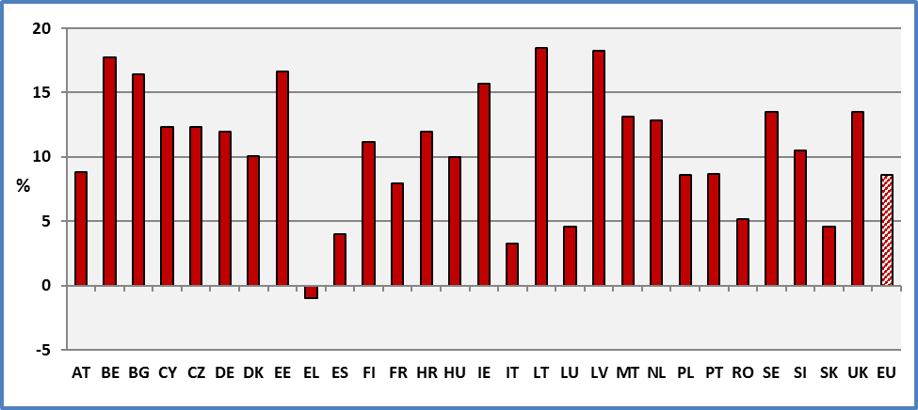

**Data source:** EU-SILC UDB 2014

However, the aggregation of all age groups might be misleading. As noted above in the analysis by age, people aged 16-64 and people aged 65 and over do not follow the same evolutions. Furthermore, the statistical indicator is not the same for both groups. In fact, work intensity plays an important role for persons aged 16 to 59 but is not relevant to retired people. Also, poverty among economically active persons does not require the same policies as for elderly people.

For persons aged 16 to 64, the dominant instrument to take people out of poverty or social exclusion is employment. For persons aged 65 and over, policies concerning retirement pensions are more relevant. For these reasons, we will detail below the situation of persons aged 16 to 64 years and persons aged 65 and over.

2.2 Gender

From a gender point of view, gender differences inside each group (group of disabled and group of non-disabled) are relatively small. At the EU level about 31.0% of women with disabilities are at risk of poverty compared to 28.8% of men without disabilities. The corresponding rates for non-disabled are 22.4% (women without disabilities) and 20.4% (men without disabilities). These rates cover persons aged 16 and over.

The gender gap among disabled persons is 2.2 percentage points compared to 2.0 pp for non-disabled persons. But this is not surprising as the indicator is constructed at the household level and not at the individual level. The same indicator is assigned to all household members.

The following graph presents gender differences among persons with disabilities aged 16 and over. The term ‘Total’ includes both genders and persons with and without limitations. It helps us to visualise the gender (differences between men and women) and the disability gap (difference between disabled and non-disabled).

**Figure 105: Percent of persons with disabilities living in households at-risk-of-poverty or social exclusion by gender, 2014**

Percentage of persons who are either at risk of poverty or severely materially deprived or living in households with very low work intensity. Age 16+.

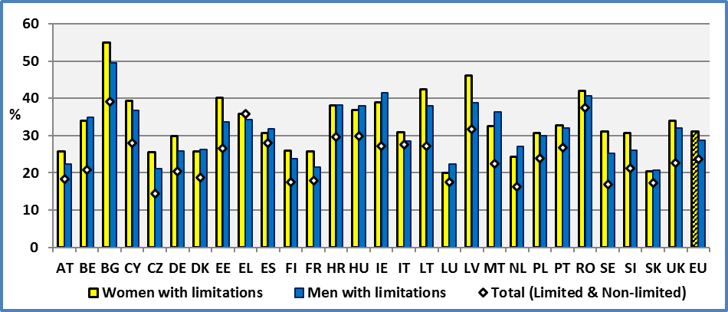

**Data source:** EU-SILC UDB 2014

On the contrary, the disability related gap inside each gender is important. The disability gap among women is 8.6 percentage points and the corresponding gap among men is 8.4 percentage points.

In fact, from a disability point of view, at the EU level about 31.0% of women with disabilities are at risk of poverty compared to 22.4% of women without disabilities. The total rate for women is 25.0%. The corresponding rates for men are 28.8% (men with disabilities) and 20.4% (men without disabilities). The total rate for men is 22.5%. These rates cover persons aged 16 and over

**Figure 106: Percent of persons living in households at-risk-of-poverty or social exclusion by gender and disability, 2014**

Percentage of persons who are either at risk of poverty or severely materially deprived or living in households with very low work intensity. Age 16+.

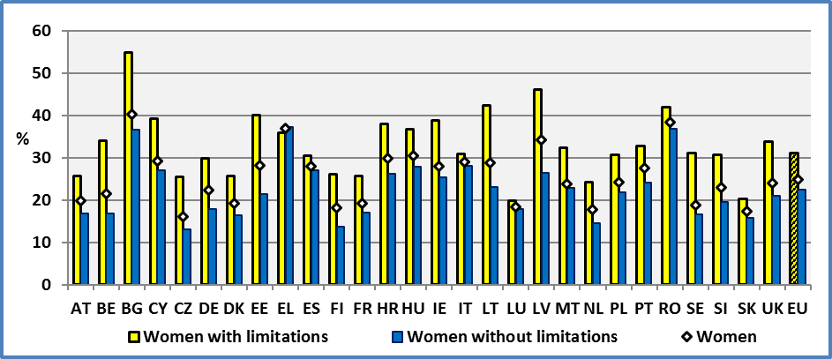

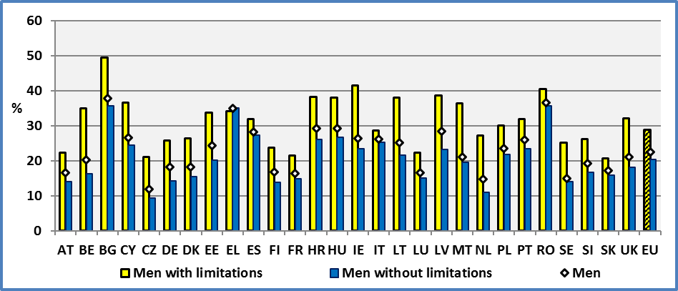

**Data source:** EU-SILC UDB 2014

2.3 Age

There is a big difference between adults (16-64) and elderly people (65 and over). As noted above each group shares different characteristics. Also, the criteria for each age group are not the same. Low work intensity concerns only persons aged less than 60 years.

Poverty among persons aged 16-64

In 2014, at the European level, 38.0% of people with disabilities aged 16 to 64 live in households which are at risk of poverty or social exclusion compared to 22.5% of persons without a disability of the same age group. The percentage for all persons aged 16-64 is 25.5%. Similar rates were reported in previous years.

Concerning people with disabilities aged 16-64, the lowest rates can be found in Slovakia (24.7%), Finland (27.2%) and Austria (28.1%). On the other hand, the highest rates can be found in Hungary (50.4%), Ireland (52.6%) and Bulgaria (53.4%).

**Table 107: Percent of people living in households at-risk-of-poverty or social exclusion, 2014**

Percent of persons who are either at risk of poverty or severely materially deprived or living in households with very low work intensity. Age 16-64.

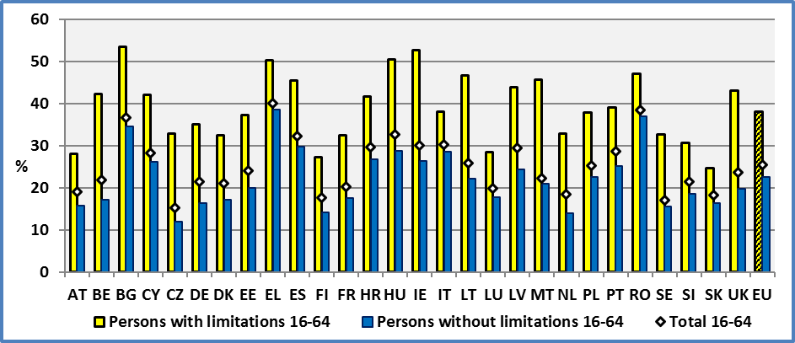

**Data source:** EU-SILC UDB 2014

It is interesting to consider the difference between the rates of persons with and without disabilities. At the EU level, the gap between persons with and without disabilities aged 16-64 is 15.4 percentage points. For comparison, this gap was 8.6 pp for all ages. The situation was similar in previous years. But there are big differences across Member States. The difference varies from 8.4 percentage points in Slovakia to 26.3 percentage points in Ireland.

**Figure 108: The poverty and social exclusion gap between persons with and without disability.**

**Gap**: Percent of persons with disabilities – Percent of persons without disabilities; Age 16-64, 2014

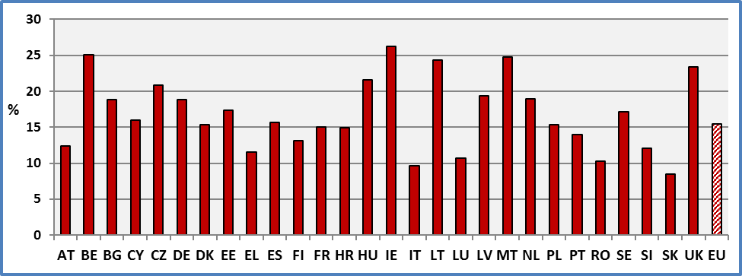

**Data source:** EU-SILC UDB 2014

Poverty among persons aged 65 and over

There are significant differences between younger (16-64) and older persons (65+) with disabilities.

In 2014, at the EU level, 20.3% of people with disabilities aged 65 and over (38.0% for 16-64) live in household which are at risk of poverty or social exclusion compared to 14.4% of persons without a disability of the same age group (22.5% for 16-64). The percentage for all persons aged 65 and over is 17.6% (25.5% for 16-64). But the situation varies across Member States. For elderly disabled, the poverty rate ranges from 5.2% in Luxembourg to 51.9% in Bulgaria.

The disability gap for persons aged 65 and over is 5.9 percentage points at the EU level. The corresponding disability gap for persons aged 16-64 was 15.4 percentage points. The next graph indicates that the national disability gaps are smaller compared to ones for the age group 16-64.

**Figure 109: Percent of persons living in households at-risk-of-poverty or social exclusion aged 65+, 2014**

Percentage of persons who are either at risk of poverty or severely materially deprived.

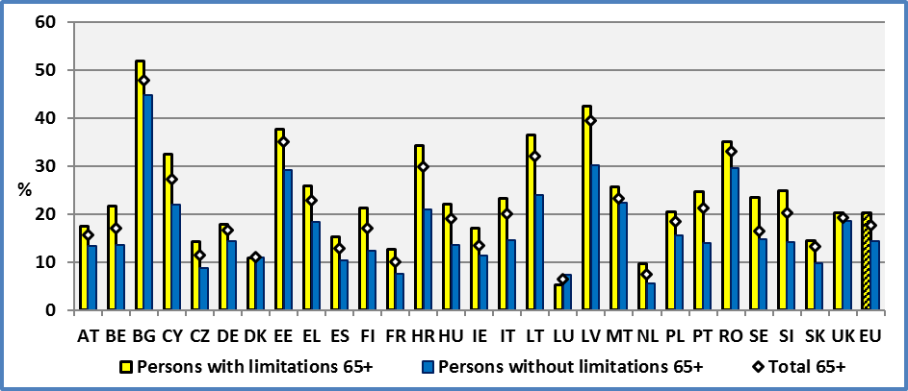

**Data source:** EU-SILC UDB 2014

2.4 Degree of disability

The degree of disability increases significantly the risk of poverty or social exclusion in all Member states. At the EU level, 36.7% of persons with a severe disability aged 16 and over are at risk of poverty or social exclusion. The equivalent rate for persons with a moderate disability is 27.0% and for persons without disabilities, 21.4%.

**Figure 110: Percent of persons living in households at-risk-of-poverty or social exclusion by degree of disability, age: 16+, 2014**

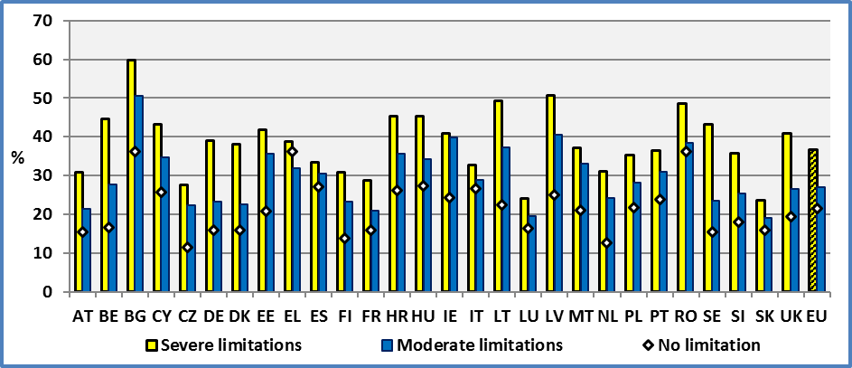

**Data source:** EU-SILC UDB 2014

The situation of elderly persons (aged 65 and over) is different compared to persons aged 16-64. In fact, the difference between elderly persons with a severe disability and elderly persons without disabilities decreases sharply. This is the result of two factors. First, work intensity is not a criterion for elderly persons. Secondly, as noted earlier in the discussion of financial poverty, the social security system governing pension schemes reduces significantly the poverty gap between persons with and without disabilities.

The analysis by age and degree of disability indicates that the disadvantage of persons with a severe disability is continuously increasing till the age of 60. This disadvantage of persons with a severe disability stems mainly from low work intensity. The lack of employment opportunities appears to be one of the main discriminating factors.

2.5 Evolution at the EU level

In order to have a picture of the poverty problem, we present below an estimation of persons in absolute numbers. This covers only persons aged 16 and over living in private households.

**Table 148: Number of persons living in households at-risk-of-poverty or social exclusion. EU 2014**

**in 1 000 000**

|  |  |  |  |  |  |  |  |  |  |
| --- | --- | --- | --- | --- | --- | --- | --- | --- | --- |
| **Age** | **16-64** | | | **65+** | | | **16+** | | |
|  | **Poverty or**  **social exclusion** | |  | **Poverty or**  **social exclusion** | |  | **Poverty or**  **social exclusion** | |  |
| **Limitation** | **No** | **Yes** | **Total** | **No** | **Yes** | **Total** | **No** | **Yes** | **Total** |
| **No limitation** | 198.7 | 57.8 | **256.6** | 34.7 | 5.8 | **40.5** | 233.4 | 63.6 | **297.1** |
| **Moderate** | 29.6 | 14.4 | **44.0** | 25.5 | 6.0 | **31.5** | 55.1 | 20.4 | **75.5** |
| **Severe** | 8.3 | 8.8 | **17.1** | 13.8 | 4.0 | **17.8** | 22.1 | 12.8 | **34.9** |
|  |  |  |  |  |  |  |  |  |  |
| **Total** | **236.6** | **81.0** | **317.6** | **74.0** | **15.8** | **89.8** | **310.6** | **96.8** | **407.5** |

**Note:** Persons living in private households. The estimations are not corrected for missing values.

**Data source:** EU-SILC UDB 2014

As noted above, at the EU level, 36.7% of persons with a severe disability aged 16 and over are at risk of poverty or social exclusion. They represent 12.8 million living in private households. The equivalent rate for persons with a moderate disability is 27.0% (20.4 million persons) and for persons without disabilities 21.4% (63.6 million). The total rate is 23.8% (96.8 million persons).

In the following graph, we present the evolution of the percentage of persons at-risk-of-poverty or social exclusion. We may observe a cyclical fluctuation of the poverty rates. Since 2008/2009, we note an increase with a stabilisation during the last two years. The progression of relative poverty has been higher for persons without disabilities since the financial crisis.

**Figure 111: Percentage of persons living in households at-risk-of-poverty or social exclusion; EU, age: 16+.**

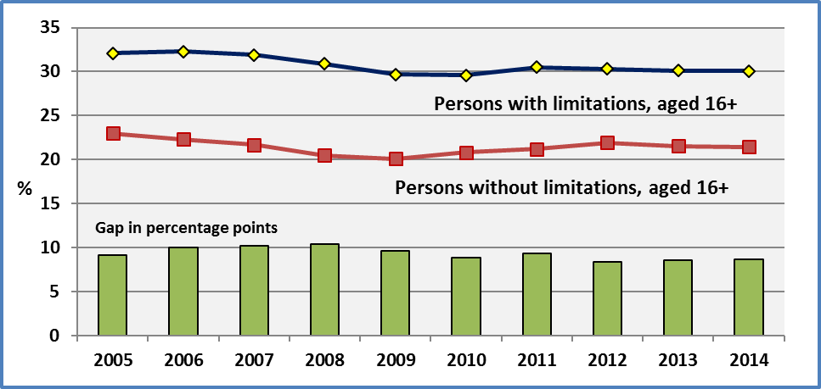

**Data source:** Eurostat and EU-SILC 2014

The relatively lower progression of the rate of persons with disabilities, since the financial crisis of 2008/2009, can be explained by social protection schemes, lower unemployment changes among older workers with disabilities and an age composition effect (pension schemes).

However, as noted above, persons aged 16-64 and persons aged 65 and over do not follow the same evolution through time. Due to the importance of age and given the specific characteristics of elderly persons, we present below the evolution of poverty and social exclusion rates by age group.

Concerning persons aged 16-64, the following figure indicates a continuous deterioration of their situation since 2009 (income relating mainly to 2008). Furthermore, we may observe a persistent gap between persons with and without disabilities aged 16-64 close to 15 percentage points.

**Figure 112: Percentage of persons living in households at-risk-of-poverty or social exclusion; EU.**

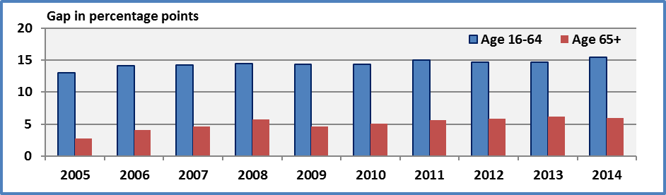

**Data source:** Eurostat and EU-SILC UDB 2014

On the contrary, elderly persons have experienced a relative improvement of their situation. The decrease of the rate of persons at-risk-of-poverty or social exclusion was continuous, notably for persons without limitations.

Pension schemes ensure a relatively lower disability gap among elderly people. But this gap might be underestimated since disability related expenses are treated as an income.

2.6 Evolution at Member States level

The Member States do not follow similar paths. The following figure indicates a deterioration of the situation of persons with disabilities in the majority of Member States but this increase of poverty or social exclusion is relatively small. Globally, at the EU level, there is no change. On the other hand, only Bulgaria experienced a significant decrease of poverty or social exclusion.

**Figure 113: Evolution of the number of persons with disabilities living in households at-risk-of-poverty or social exclusion. Age: 16+**

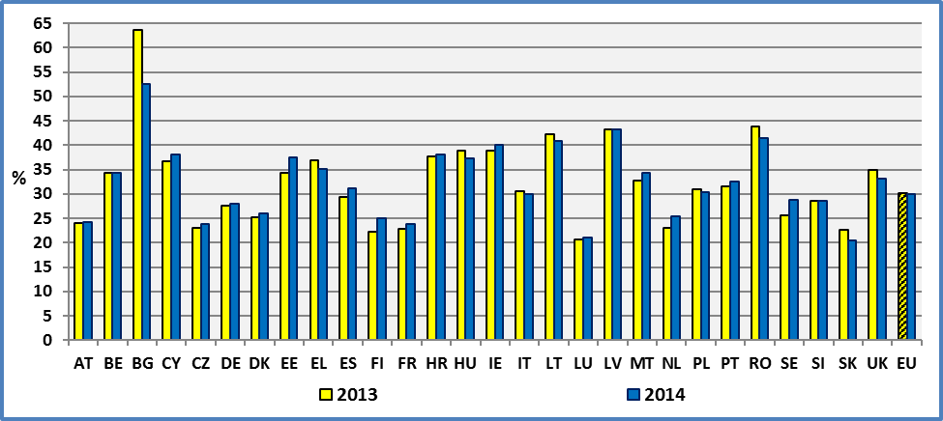

**Data source:** EU-SILC UDB 2013 & 2014

The improvement (reduction of poverty or social exclusion) or deterioration in certain Member States ought to be treated with caution and keep in mind the comments concerning the different indicators presented above, notably those concerning the financial poverty indicator. Furthermore, in several cases, the changes are close to the statistical error.

**Figure 114: Change between 2013 and 2014 of the percentage of persons with disabilities living in households at-risk-of-poverty or social exclusion. Age: 16+.**

% Persons in 2014 - % Persons in 2013

A negative value means an improvement of the situation (reduction of poverty or social exclusion)

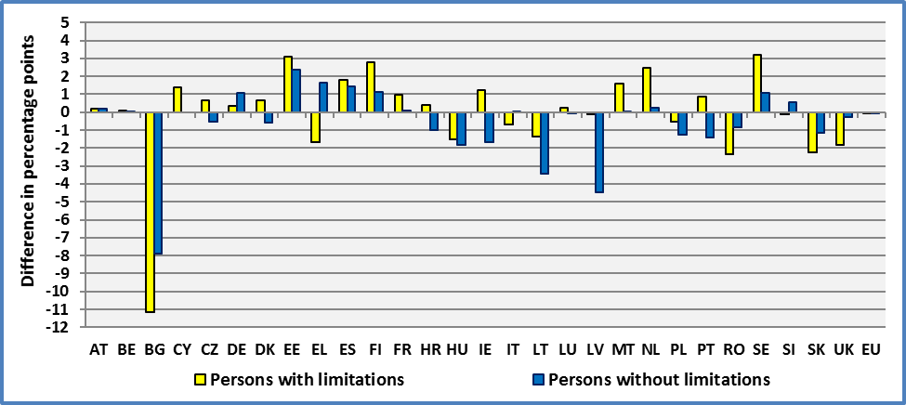

**Data source:** EU-SILC UDB 2014 & 2013

2.6 Characteristics of persons at risk of poverty or social exclusion

In the following, we will focus on the economically active persons. As noted above, elderly people (65 and over) do not share the same characteristics as younger persons (16-64). Also, policy instruments might be different in tackling poverty. Employment and education might be of little help in the case of elderly retired persons.

As expected persons aged 20-64 who are not in employment experience very high rates of poverty or social exclusion. Still among people in employment, we find persons who are at risk of poverty and social exclusion. In all cases, persons with disabilities present higher rates.

**Figure 115: Percent of persons living in households at-risk-of-poverty or social exclusion by employment status. EU 2014. Age: 20-64**

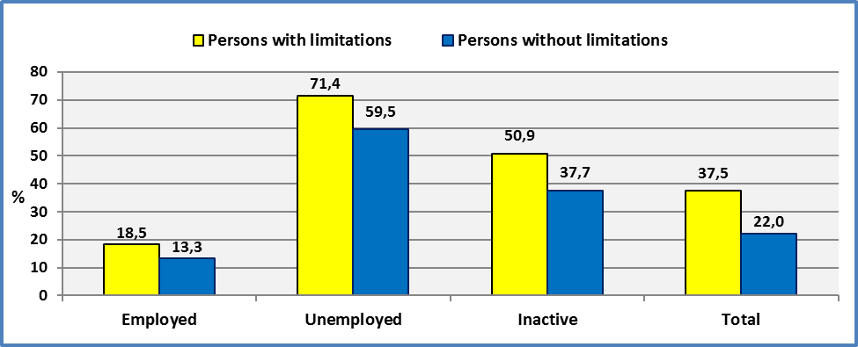

**Data source:** EU-SILC 2014

It might be surprising that 18.5% of employed with disabilities aged 20-64 and 13.3% of employed without disabilities experience a risk of poverty or social exclusion. Similar rates were reported for 2013. A closer analysis indicates that this concerns mainly persons working part-time. In fact, the definition of employment retained by Europe 2020 is very large and includes people working a few hours per week. In our analysis, the economic status is self-defined and includes these persons too.

We may note that persons working less than 10 hours per week present a rate higher than 30 percent. This rate is 43% for persons with limitations. We may note than in previous ANED reports, we have noted that persons with disabilities are over-represented among persons with part-time jobs.

In all cases, persons with limitations experience a higher poverty or social exclusion risk than persons without disabilities.

Education seems to be an important factor for reducing the risk of poverty or social exclusion. As we have noted above, there is a strong positive relation between employment and education and this might explain the role of education as an important factor for increasing employment and reducing poverty.

However, at all educational levels, persons with disabilities present a higher risk of poverty or social exclusion. This might be explained by the need of additional measures to eradicate barriers both social (discrimination) and environmental (access to work, work adaptations, etc.).

Furthermore, a quick inspection of the following graph indicates that the gap between persons with and without disabilities is high at all educational levels. More strikingly, this gap increases as a proportion of the reported level.

**Figure 116: Percent of persons living in households at-risk-of-poverty or social exclusion by education level (attained). EU 2014. Age: 20-64**

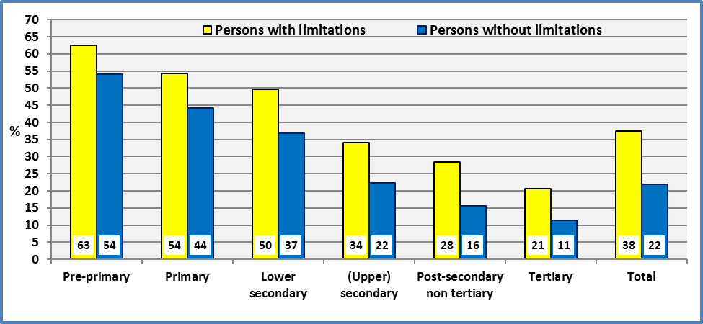

**Data source:** EU-SILC UDB 2014

2.7 Percent of persons living in households at-risk-of-poverty or social exclusion and confidence intervals (95%)

In the following, we present standard error estimates and the resulting confidence intervals for the percentage of persons living in households at-risk-of-poverty or social exclusion aged 16 and over.

The standard error and hence the confidence intervals for persons with disabilities are larger compared to persons without disabilities as the number of sample units concerning persons with limitations is lower compared to persons without limitations. Still the national standard errors for persons with limitations are relatively small in most countries as can be seen in the following graph.

The average of the national standard errors of the indicator for persons with disabilities is 0.8 percentage points (with a maximum of 1.7 for Sweden) and 0.4 percentage point for persons without disabilities (with a maximum of 0.6 for Denmark).

We may note that in all Member States, there is a significant difference between the percentage of persons living in households at-risk-of-poverty or social exclusion of persons with and without limitations aged 16 and over.

It is important to note that the above information covers only persons for which we possess information on disability status.

**Figure 117: Percent of persons living in households at-risk-of-poverty or social exclusion and confidence interval at 95%**

L: Persons with limitations and N: Persons without limitations

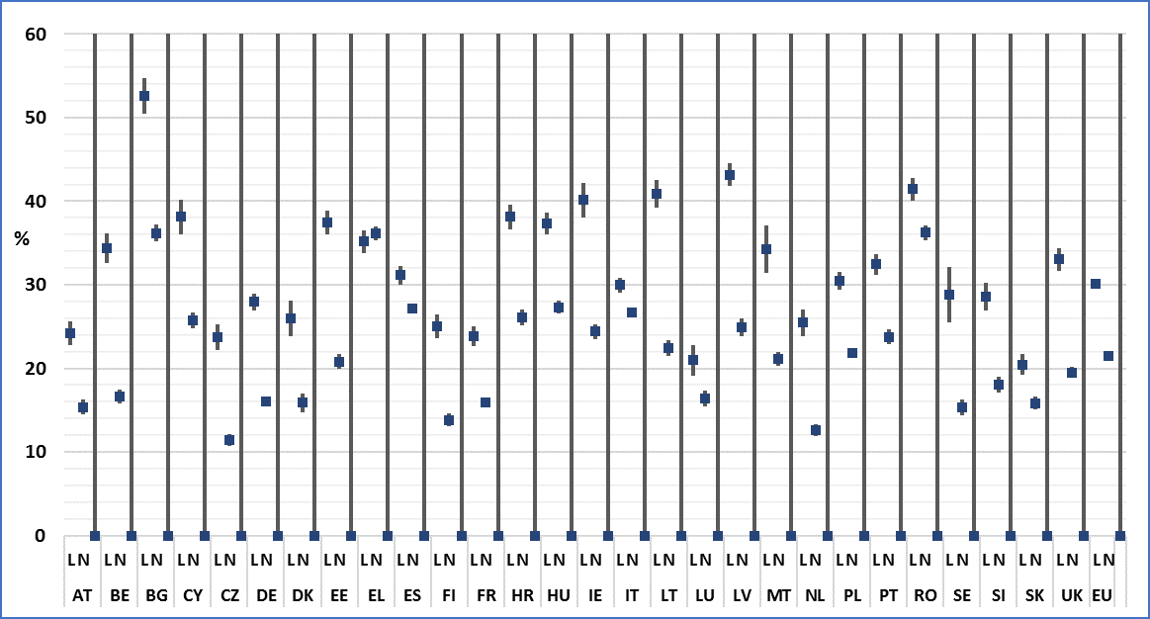

**Data source:** EU-SILC UDB 2014

### 3. Data

**Table 149: Percent of people at-risk-of-poverty or social exclusion by disability and Member State.**

**Age: 16+**

|  |  |  |  |  |
| --- | --- | --- | --- | --- |
|  | **2014** | | | |
|  | **Limitation** | | **Total** | **All** |
|  | **Yes** | **No** |  |  |
| **AT** | 24,2 | 15,4 | **18,3** | 18,3 |
| **BE** | 34,4 | 16,6 | **20,9** | 21,0 |
| **BG** | 52,6 | 36,2 | **39,1** | 39,1 |
| **CY** | 38,1 | 25,8 | **28,0** | 28,0 |
| **CZ** | 23,8 | 11,4 | **14,3** | 14,0 |
| **DE** | 28,0 | 16,0 | **20,3** | 21,0 |
| **DK** | 26,0 | 15,9 | **18,8** | 18,7 |
| **EE** | 37,5 | 20,8 | **26,5** | 26,4 |
| **EL** | 35,2 | 36,2 | **35,9** | 35,9 |
| **ES** | 31,2 | 27,1 | **28,1** | 28,1 |
| **FI** | 25,0 | 13,8 | **17,5** | 17,6 |
| **FR** | 23,9 | 16,0 | **17,9** | 17,9 |
| **HR** | 38,1 | 26,1 | **29,6** | 29,5 |
| **HU** | 37,3 | 27,3 | **30,0** | 30,0 |
| **IE** | 40,1 | 24,4 | **27,2** | 27,2 |
| **IT** | 30,0 | 26,7 | **27,6** | 27,6 |
| **LT** | 40,9 | 22,4 | **27,2** | 27,1 |
| **LU** | 21,0 | 16,4 | **17,5** | 17,5 |
| **LV** | 43,2 | 24,9 | **31,8** | 32,3 |
| **MT** | 34,2 | 21,1 | **22,4** | 22,4 |
| **NL** | 25,5 | 12,6 | **16,3** | 16,4 |
| **PO** | 30,4 | 21,8 | **23,9** | 24,2 |
| **PT** | 32,5 | 23,8 | **26,8** | 26,8 |
| **RO** | 41,4 | 36,2 | **37,5** | 37,5 |
| **SE** | 28,8 | 15,3 | **16,9** | 17,1 |
| **SI** | 28,6 | 18,1 | **21,2** | 21,0 |
| **SK** | 20,5 | 15,9 | **17,3** | 17,4 |
| **UK** | 33,1 | 19,5 | **22,6** | 22,6 |
|  |  |  |  |  |
| **EU** | **30,1** | **21,4** | **23,8** | **23,8** |
|  |  |  |  |  |
| **CH** | 23,3 | 11,6 | **15,3** | 15,2 |
| **IS** | 20,7 | 8,2 | **10,5** | 10,4 |
| **NO** | 24,7 | 11,7 | **13,7** | 13,9 |
| **RS** | 52,9 | 41,3 | **43,2** | 43,2 |

**\* : Total:** It includes only persons for which we do have information on disability status. **ALL:** It includes all persons, including those for which we do not have information on disability status.

**Data source:** EU-SILC UDB 2014

**Table 150: Percent of people at-risk-of-poverty or social exclusion by Member State. Age: 16+**

|  |  |  |  |  |  |  |  |  |  |
| --- | --- | --- | --- | --- | --- | --- | --- | --- | --- |
|  | **Persons with limitations** | | | | | | | | |
|  | **2005** | **2006** | **2007** | **2008** | **2009** | **2010** | **2011** | **2012** | **2013** |
| **AT** | 22,1 | 24,5 | 23,6 | 27,6 | 25,9 | 23,4 | 25,5 | 25,0 | 24,0 |
| **BE** | 34,1 | 36,1 | 36,2 | 33,9 | 32,7 | 32,7 | 33,5 | 35,6 | 34,3 |
| **BG** | : | 81,2 | 80,1 | 63,5 | 64,9 | 67,0 | 64,5 | 61,8 | 63,7 |
| **CY** | 46,1 | 46,9 | 47,1 | 45,0 | 41,8 | 42,2 | 38,2 | 39,9 | 36,7 |
| **CZ** | 24,2 | 25,0 | 23,0 | 23,7 | 23,1 | 20,6 | 22,3 | 24,0 | 23,1 |
| **DE** | 23,6 | 24,4 | 27,2 | 26,0 | 25,9 | 24,7 | 26,1 | 26,3 | 27,6 |
| **DK** | 28,0 | 29,8 | 29,9 | 24,4 | 25,2 | 27,2 | 26,0 | 25,9 | 27,4 |
| **EE** | 33,3 | 30,9 | 34,4 | 38,9 | 36,7 | 28,5 | 30,9 | 33,6 | 34,4 |
| **EL** | 43,0 | 42,1 | 41,3 | 38,9 | 34,0 | 35,5 | 38,2 | 37,5 | 36,8 |
| **ES** | 32,5 | 32,0 | 30,9 | 33,1 | 30,6 | 30,3 | 32,4 | 29,7 | 29,4 |
| **FI** | 24,1 | 24,3 | 27,7 | 26,5 | 25,9 | 23,7 | 25,6 | 24,8 | 22,2 |
| **FR** | 26,9 | 26,7 | 25,3 | 24,1 | 23,3 | 23,3 | 23,8 | 23,2 | 21,8 |
| **HR** | : | : | : | : | : | 47,0 | 49,5 | 44,3 | 37,7 |
| **HU** | 39,5 | 39,0 | 36,3 | 36,5 | 35,3 | 34,6 | 37,3 | 39,5 | 38,8 |
| **IE** | 41,3 | 36,2 | 39,8 | 39,5 | 36,7 | 34,9 | 38,4 | 40,3 | 38,9 |
| **IT** | 32,3 | 32,3 | 31,7 | 30,8 | 28,8 | 27,8 | 31,8 | 31,9 | 30,8 |
| **LT** | 51,8 | 46,7 | 39,6 | 41,2 | 41,1 | 40,7 | 41,4 | 44,7 | 42,3 |
| **LU** | 21,2 | 19,9 | 20,2 | 17,8 | 21,8 | 21,2 | 20,5 | 22,8 | 20,7 |
| **LV** | 58,1 | 54,3 | 50,5 | 52,7 | 55,3 | 46,4 | 46,3 | 45,3 | 43,3 |
| **MT** | 34,6 | 29,8 | 31,5 | 33,2 | 31,9 | 29,0 | 28,7 | 32,8 | 32,7 |
| **NL** | 23,4 | 24,5 | 25,8 | 22,1 | 21,5 | 21,0 | 21,4 | 20,5 | 23,0 |
| **PO** | 55,5 | 47,5 | 41,3 | 38,4 | 35,8 | 35,8 | 35,2 | 34,1 | 30,9 |
| **PT** | 36,4 | 37,3 | 36,4 | 35,8 | 33,9 | 35,2 | 32,8 | 31,4 | 31,6 |
| **RO** | : | : | 59,6 | 52,5 | 49,9 | 47,2 | 44,5 | 44,9 | 43,8 |
| **SE** | 21,9 | 23,0 | 18,9 | 23,4 | 27,0 | 24,4 | 23,8 | 25,1 | 25,6 |
| **SI** | 29,0 | 26,7 | 26,9 | 29,8 | 27,7 | 28,0 | 26,2 | 28,4 | 28,7 |
| **SK** | 35,3 | 30,8 | 27,0 | 26,0 | 24,0 | 24,1 | 23,7 | 23,6 | 22,7 |
| **UK** | 35,2 | 34,8 | 34,3 | 32,7 | 31,0 | 33,5 | 32,3 | 33,8 | 34,9 |
|  |  |  |  |  |  |  |  |  |  |
| **EU** | **32,1** | **32,3** | **31,9** | **30,9** | **29,7** | **29,6** | **30,5** | **30,3** | **30,1** |
|  |  |  |  |  |  |  |  |  |  |
| **CH** | : | : | 23,1 | 24,9 | 25,2 | 23,8 | 25,3 | 26,2 | 22,8 |
| **IS** | 19,4 | 20,4 | 21,5 | 23,3 | 19,5 | 20,0 | 19,4 | 19,3 | 21,6 |
| **NO** | 24,7 | 27,9 | 25,1 | 25,6 | 27,6 | 26,3 | 23,6 | 28,9 | 24,9 |
| **RS** | : | : | : | : | : | : | : | : | 55,1 |

**Data source: 2005-2012:** Eurostat:Extracted on 22.11.15

**2013**: EU-SILC 2013

**Table 151: Percent of people at-risk-of-poverty or social exclusion by Member State. Age: 16+**

|  |  |  |  |  |  |  |  |  |  |
| --- | --- | --- | --- | --- | --- | --- | --- | --- | --- |
|  | **Persons without limitations** | | | | | | | | |
|  | **2005** | **2006** | **2007** | **2008** | **2009** | **2010** | **2011** | **2012** | **2013** |
| **AT** | 14,3 | 14,7 | 13,5 | 14,5 | 13,4 | 13,1 | 12,7 | 15,2 | 15,2 |
| **BE** | 18,5 | 17,3 | 17,3 | 17,0 | 16,4 | 16,3 | 16,4 | 17,4 | 16,6 |
| **BG** | : | 60,5 | 60,2 | 41,0 | 42,2 | 46,0 | 45,5 | 45,9 | 44,1 |
| **CY** | 20,0 | 21,7 | 21,1 | 18,9 | 20,2 | 21,3 | 20,9 | 24,0 | 25,8 |
| **CZ** | 16,6 | 14,8 | 12,9 | 12,6 | 11,1 | 12,4 | 13,3 | 12,7 | 12,0 |
| **DE** | 15,0 | 16,4 | 18,5 | 15,9 | 15,8 | 15,8 | 15,0 | 14,2 | 15,0 |
| **DK** | 15,9 | 14,9 | 15,1 | 14,6 | 16,1 | 16,3 | 17,2 | 17,4 | 16,5 |
| **EE** | 20,7 | 16,7 | 16,5 | 15,0 | 18,0 | 18,5 | 19,0 | 19,2 | 18,5 |
| **EL** | 27,7 | 27,3 | 25,7 | 25,4 | 25,7 | 25,9 | 29,5 | 34,2 | 34,5 |
| **ES** | 21,0 | 20,6 | 19,9 | 20,7 | 21,5 | 24,7 | 25,3 | 26,8 | 25,7 |
| **FI** | 15,4 | 14,9 | 14,8 | 14,2 | 14,1 | 14,8 | 14,9 | 14,0 | 12,7 |
| **FR** | 16,5 | 16,4 | 16,9 | 15,9 | 16,1 | 16,4 | 16,2 | 16,4 | 16,0 |
| **HR** | : | : | : | : | : | 29,0 | 29,3 | 28,6 | 27,1 |
| **HU** | 26,5 | 26,4 | 25,3 | 23,5 | 25,1 | 25,6 | 26,4 | 28,0 | 29,2 |
| **IE** | 19,3 | 18,9 | 18,4 | 18,5 | 21,1 | 23,0 | 26,0 | 27,2 | 26,1 |
| **IT** | 22,9 | 23,5 | 23,0 | 22,2 | 22,0 | 22,7 | 25,9 | 28,1 | 26,4 |
| **LT** | 37,2 | 32,6 | 24,7 | 22,0 | 25,5 | 31,7 | 30,3 | 28,7 | 25,9 |
| **LU** | 14,2 | 14,0 | 13,1 | 13,2 | 15,3 | 14,6 | 14,8 | 15,6 | 16,4 |
| **LV** | 41,0 | 36,0 | 28,4 | 25,6 | 29,5 | 33,4 | 36,3 | 31,7 | 29,4 |
| **MT** | 17,6 | 16,3 | 17,2 | 17,0 | 17,3 | 18,8 | 19,9 | 20,2 | 21,1 |
| **NL** | 13,9 | 13,7 | 12,6 | 11,5 | 11,8 | 12,2 | 13,2 | 12,5 | 12,4 |
| **PO** | 43,0 | 37,3 | 31,6 | 27,8 | 25,3 | 25,0 | 24,4 | 24,0 | 23,1 |
| **PT** | 21,1 | 19,9 | 19,7 | 20,8 | 19,9 | 20,2 | 20,0 | 22,8 | 25,2 |
| **RO** | : | : | 41,8 | 40,6 | 39,0 | 37,4 | 36,6 | 38,3 | 37,1 |
| **SE** | 12,4 | 14,1 | 12,3 | 13,3 | 14,1 | 13,8 | 14,9 | 14,2 | 14,3 |
| **SI** | 15,6 | 14,2 | 14,7 | 15,5 | 14,0 | 13,9 | 16,0 | 15,8 | 17,5 |
| **SK** | 30,2 | 24,1 | 18,3 | 17,0 | 16,2 | 17,7 | 17,7 | 17,6 | 17,0 |
| **UK** | 19,6 | 18,8 | 18,2 | 19,3 | 18,1 | 18,5 | 18,8 | 19,3 | 19,8 |
|  |  |  |  |  |  |  |  |  |  |
| **EU** | **23,0** | **22,3** | **21,7** | **20,5** | **20,1** | **20,8** | **21,2** | **21,9** | **21,5** |
|  |  |  |  |  |  |  |  |  |  |
| **CH** | : | : | 14,5 | 15,6 | 14,9 | 13,7 | 13,8 | 15,3 | 13,7 |
| **IS** | 11,6 | 9,9 | 10,9 | 9,5 | 10,5 | 11,1 | 11,0 | 9,7 | 9,9 |
| **NO** | 14,6 | 14,9 | 14,8 | 13,7 | 13,1 | 12,8 | 12,6 | 11,6 | 12,0 |
| **RS** | : | : | : | : | : | : | : | : | 40,5 |

**Data source: 2005-2012:** Eurostat:Extracted on 22.11.15

**2013**: EU-SILC UDB 2013

**Table 152: Percent of people at-risk-of-poverty or social exclusion by gender, disability and Member State. Age: 16+**

|  |  |  |  |  |  |  |
| --- | --- | --- | --- | --- | --- | --- |
|  | **2014** | | | | | |
|  | **Women** | | | **Men** | | |
|  | **Limitation** | | **Total** | **Limitation** | | **Total** |
|  | **Yes** | **No** |  | **Yes** | **No** |  |
| **AT** | 25,8 | 16,7 | **19,9** | 22,3 | 14,0 | **16,6** |
| **BE** | 34,0 | 16,9 | **21,5** | 34,9 | 16,3 | **20,3** |
| **BG** | 55,0 | 36,7 | **40,3** | 49,4 | 35,6 | **37,9** |
| **CY** | 39,4 | 27,0 | **29,3** | 36,7 | 24,4 | **26,6** |
| **CZ** | 25,5 | 13,1 | **16,2** | 21,1 | 9,3 | **11,8** |
| **DE** | 29,8 | 17,8 | **22,3** | 25,8 | 14,2 | **18,2** |
| **DK** | 25,7 | 16,4 | **19,2** | 26,3 | 15,4 | **18,3** |
| **EE** | 40,2 | 21,5 | **28,3** | 33,7 | 20,1 | **24,3** |
| **EL** | 35,9 | 37,2 | **36,9** | 34,2 | 35,1 | **34,9** |
| **ES** | 30,6 | 27,0 | **27,9** | 31,9 | 27,3 | **28,3** |
| **FI** | 26,0 | 13,8 | **18,2** | 23,7 | 13,9 | **16,8** |
| **FR** | 25,7 | 17,0 | **19,3** | 21,5 | 14,9 | **16,4** |
| **HR** | 38,0 | 26,2 | **29,9** | 38,2 | 26,0 | **29,2** |
| **HU** | 36,8 | 27,9 | **30,6** | 38,1 | 26,7 | **29,3** |
| **IE** | 38,9 | 25,4 | **27,9** | 41,5 | 23,4 | **26,4** |
| **IT** | 31,0 | 28,1 | **29,0** | 28,6 | 25,2 | **26,1** |
| **LT** | 42,5 | 23,1 | **28,8** | 38,1 | 21,7 | **25,1** |
| **LU** | 19,9 | 17,8 | **18,4** | 22,3 | 15,0 | **16,6** |
| **LV** | 46,1 | 26,4 | **34,4** | 38,7 | 23,3 | **28,5** |
| **MT** | 32,4 | 22,8 | **23,9** | 36,4 | 19,5 | **21,0** |
| **NL** | 24,3 | 14,5 | **17,8** | 27,1 | 11,0 | **14,7** |
| **PO** | 30,7 | 21,9 | **24,2** | 30,0 | 21,7 | **23,6** |
| **PT** | 32,8 | 24,1 | **27,6** | 32,0 | 23,4 | **26,0** |
| **RO** | 42,0 | 36,9 | **38,4** | 40,6 | 35,6 | **36,7** |
| **SE** | 31,1 | 16,7 | **18,8** | 25,2 | 14,0 | **15,0** |
| **SI** | 30,7 | 19,5 | **23,0** | 26,1 | 16,6 | **19,3** |
| **SK** | 20,3 | 15,9 | **17,4** | 20,6 | 15,8 | **17,2** |
| **UK** | 33,9 | 21,0 | **24,1** | 32,0 | 18,1 | **21,0** |
|  |  |  |  |  |  |  |
| **EU** | **31,0** | **22,4** | **25,0** | **28,8** | **20,4** | **22,5** |
|  |  |  |  |  |  |  |
| **CH** | 25,0 | 13,7 | **17,7** | 21,0 | 9,7 | **12,8** |
| **IS** | 19,9 | 9,0 | **11,4** | 22,1 | 7,5 | **9,5** |
| **NO** | 25,3 | 12,9 | **15,4** | 23,6 | 10,6 | **12,1** |
| **RS** | 51,3 | 41,0 | **42,8** | 55,0 | 41,6 | **43,6** |

**Data source:** EU-SILC UDB 2014

**Table 153: Percent of people at-risk-of-poverty or social exclusion by gender and Member State. Age: 16+**

|  |  |  |  |  |  |  |  |  |  |
| --- | --- | --- | --- | --- | --- | --- | --- | --- | --- |
|  | **Males with limitations** | | | | | | | | |
|  | **2005** | **2006** | **2007** | **2008** | **2009** | **2010** | **2011** | **2012** | **2013** |
| **AT** | 20,4 | 20,9 | 20,5 | 25,6 | 23,1 | 20,5 | 23,8 | 23,9 | 22,9 |
| **BE** | 33,6 | 32,5 | 35,6 | 33,7 | 33,9 | 35,6 | 34,6 | 36,6 | 35,0 |
| **BG** | : | 81,4 | 83,3 | 62,3 | 62,0 | 64,3 | 62,0 | 60,7 | 60,5 |
| **CY** | 43,4 | 43,4 | 42,3 | 40,4 | 34,7 | 39,6 | 36,5 | 36,5 | 34,7 |
| **CZ** | 22,9 | 23,4 | 21,2 | 20,7 | 19,9 | 16,7 | 19,6 | 20,6 | 21,4 |
| **DE** | 20,3 | 21,7 | 24,6 | 24,9 | 25,5 | 24,8 | 25,7 | 25,1 | 25,8 |
| **DK** | 31,3 | 28,4 | 31,7 | 23,4 | 23,5 | 26,7 | 24,7 | 26,9 | 27,6 |
| **EE** | 29,3 | 28,1 | 29,6 | 33,4 | 31,1 | 28,3 | 32,1 | 33,7 | 31,5 |
| **EL** | 40,1 | 38,9 | 39,8 | 37,8 | 33,1 | 33,6 | 36,2 | 37,0 | 37,4 |
| **ES** | 32,6 | 32,0 | 31,4 | 33,4 | 31,9 | 30,6 | 34,6 | 32,1 | 31,0 |
| **FI** | 22,3 | 22,6 | 25,8 | 23,8 | 22,2 | 23,8 | 23,9 | 23,9 | 22,2 |
| **FR** | 26,7 | 26,1 | 23,9 | 20,6 | 22,0 | 22,5 | 22,3 | 21,6 | 19,8 |
| **HR** | : | : | : | : | : | 45,0 | 46,4 | 43,6 | 37,0 |
| **HU** | 37,8 | 38,2 | 34,6 | 35,6 | 36,5 | 33,4 | 36,4 | 39,0 | 38,4 |
| **IE** | 43,4 | 37,6 | 39,4 | 41,0 | 39,1 | 36,7 | 40,4 | 41,9 | 40,2 |
| **IT** | 30,2 | 31,3 | 28,8 | 28,7 | 26,8 | 25,6 | 30,4 | 30,0 | 30,0 |
| **LT** | 48,7 | 43,4 | 34,4 | 37,5 | 38,8 | 40,9 | 40,3 | 42,8 | 39,8 |
| **LU** | 21,8 | 19,0 | 19,7 | 19,5 | 17,9 | 19,8 | 20,6 | 22,7 | 20,2 |
| **LV** | 54,9 | 49,3 | 45,9 | 48,7 | 52,5 | 44,2 | 46,4 | 45,5 | 42,7 |
| **MT** | 35,2 | 31,7 | 32,8 | 31,2 | 32,3 | 30,0 | 31,8 | 35,9 | 37,2 |
| **NL** | 24,2 | 24,1 | 28,2 | 22,4 | 21,0 | 19,8 | 19,3 | 19,6 | 21,9 |
| **PO** | 55,7 | 48,0 | 40,7 | 38,8 | 34,8 | 35,2 | 35,1 | 33,6 | 29,4 |
| **PT** | 37,3 | 37,1 | 36,7 | 34,8 | 33,7 | 35,4 | 34,5 | 31,2 | 32,0 |
| **RO** | : | : | 59,5 | 50,1 | 47,5 | 45,7 | 40,9 | 42,9 | 41,9 |
| **SE** | 21,3 | 20,1 | 17,3 | 18,8 | 22,8 | 22,8 | 21,4 | 20,9 | 23,1 |
| **SI** | 25,7 | 24,5 | 23,6 | 29,7 | 24,2 | 25,6 | 22,2 | 24,8 | 25,6 |
| **SK** | 32,7 | 28,8 | 24,3 | 23,1 | 21,1 | 22,5 | 22,3 | 21,8 | 22,2 |
| **UK** | 35,9 | 33,1 | 33,5 | 32,4 | 30,9 | 34,4 | 31,6 | 34,4 | 36,9 |
|  |  |  |  |  |  |  |  |  |  |
| **EU** | **30,7** | **30,8** | **30,4** | **29,5** | **28,7** | **28,9** | **29,6** | **29,4** | **29,2** |
|  |  |  |  |  |  |  |  |  |  |
| **CH** | : | : | 18,5 | 22,9 | 21,3 | 22,1 | 23,3 | 24,2 | 21,2 |
| **IS** | 20,8 | 17,9 | 17,9 | 22,4 | 18,1 | 21,2 | 19,7 | 20,0 | 24,0 |
| **NO** | 22,3 | 23,9 | 23,4 | 25,6 | 26,3 | 28,5 | 24,7 | 29,9 | 23,0 |
| **RS** | : | : | : | : | : | : | : | : | 53,7 |

**Data source: 2005-2012:** Eurostat:Extracted on 22.11.15

**2013**: EU-SILC UDB 2013

**Table 154: Percent of people at-risk-of-poverty or social exclusion by gender and Member State. Age: 16+**

|  |  |  |  |  |  |  |  |  |  |
| --- | --- | --- | --- | --- | --- | --- | --- | --- | --- |
|  | **Males without limitations** | | | | | | | | |
|  | **2005** | **2006** | **2007** | **2008** | **2009** | **2010** | **2011** | **2012** | **2013** |
| **AT** | 11,9 | 12,9 | 11,1 | 13,0 | 11,6 | 11,3 | 11,2 | 13,5 | 13,6 |
| **BE** | 17,0 | 15,9 | 15,4 | 15,2 | 14,4 | 15,0 | 15,7 | 16,3 | 16,2 |
| **BG** | : | 60,2 | 58,4 | 39,5 | 40,2 | 44,3 | 44,3 | 44,1 | 43,5 |
| **CY** | 18,8 | 19,9 | 18,8 | 16,4 | 18,1 | 19,2 | 18,6 | 22,0 | 24,9 |
| **CZ** | 14,1 | 13,3 | 10,9 | 10,4 | 8,9 | 10,4 | 11,0 | 11,0 | 9,5 |
| **DE** | 13,3 | 15,1 | 16,6 | 14,5 | 13,9 | 13,8 | 13,7 | 12,7 | 13,2 |
| **DK** | 14,7 | 13,6 | 13,1 | 14,1 | 15,6 | 16,0 | 17,6 | 16,1 | 16,8 |
| **EE** | 19,7 | 14,5 | 14,8 | 13,2 | 16,6 | 18,2 | 19,5 | 18,1 | 17,6 |
| **EL** | 25,2 | 25,4 | 24,3 | 23,4 | 24,2 | 24,3 | 28,4 | 32,8 | 32,6 |
| **ES** | 19,3 | 18,8 | 18,2 | 19,4 | 20,2 | 24,2 | 24,7 | 26,6 | 25,9 |
| **FI** | 14,5 | 14,5 | 14,5 | 13,1 | 13,0 | 13,5 | 14,2 | 13,7 | 12,8 |
| **FR** | 14,9 | 14,7 | 15,5 | 15,0 | 14,6 | 15,4 | 15,2 | 15,7 | 15,2 |
| **HR** | : | : | : | : | : | 28,8 | 27,9 | 28,2 | 27,1 |
| **HU** | 26,3 | 26,2 | 24,9 | 22,9 | 24,0 | 25,3 | 26,2 | 27,6 | 28,6 |
| **IE** | 17,2 | 16,9 | 16,4 | 16,8 | 19,3 | 21,8 | 25,4 | 26,8 | 25,2 |
| **IT** | 20,6 | 21,1 | 20,8 | 20,2 | 20,1 | 20,8 | 23,8 | 26,0 | 24,8 |
| **LT** | 35,3 | 30,9 | 22,7 | 19,0 | 23,3 | 32,1 | 31,4 | 28,8 | 24,1 |
| **LU** | 12,7 | 13,0 | 12,1 | 11,5 | 13,8 | 13,5 | 13,2 | 14,2 | 15,5 |
| **LV** | 38,2 | 33,9 | 26,6 | 23,7 | 28,3 | 33,6 | 36,1 | 30,4 | 28,4 |
| **MT** | 15,2 | 14,0 | 15,1 | 15,3 | 15,3 | 17,1 | 18,1 | 18,7 | 19,3 |
| **NL** | 12,8 | 12,1 | 10,6 | 10,4 | 11,4 | 10,3 | 12,4 | 10,7 | 11,4 |
| **PO** | 42,1 | 36,6 | 30,8 | 26,6 | 24,3 | 23,9 | 23,5 | 23,1 | 22,9 |
| **PT** | 20,5 | 19,4 | 18,6 | 19,8 | 19,1 | 19,7 | 18,9 | 22,4 | 25,3 |
| **RO** | : | : | 41,2 | 39,9 | 38,6 | 37,8 | 37,1 | 37,8 | 36,2 |
| **SE** | 12,1 | 13,8 | 12,5 | 12,4 | 13,1 | 12,6 | 11,7 | 11,9 | 12,2 |
| **SI** | 14,0 | 13,1 | 13,5 | 13,5 | 13,1 | 12,8 | 14,5 | 14,5 | 17,5 |
| **SK** | 29,3 | 23,6 | 16,7 | 16,1 | 15,6 | 17,1 | 17,0 | 17,5 | 16,9 |
| **UK** | 17,4 | 16,9 | 16,3 | 16,9 | 17,3 | 16,5 | 16,8 | 18,4 | 17,9 |
|  |  |  |  |  |  |  |  |  |  |
| **EU** | **21,4** | **20,7** | **20,0** | **19,0** | **18,7** | **19,4** | **20,0** | **20,8** | **20,5** |
|  |  |  |  |  |  |  |  |  |  |
| **CH** | : | : | 12,4 | 13,2 | 12,6 | 11,4 | 11,7 | 13,1 | 11,9 |
| **IS** | 10,6 | 8,7 | 9,6 | 9,0 | 9,8 | 10,2 | 10,3 | 8,8 | 9,1 |
| **NO** | 13,5 | 13,8 | 12,5 | 11,5 | 11,3 | 11,3 | 11,0 | 10,4 | 10,7 |
| **RS** | : | : | : | : | : | : | : | : | 39,8 |

**Data source: 2005-2012:** Eurostat:Extracted on 22.11.15

**2013**: EU-SILC UDB 2013

**Table 155: Percent of people at-risk-of-poverty or social exclusion by gender and Member State. Age: 16+**

|  |  |  |  |  |  |  |  |  |  |
| --- | --- | --- | --- | --- | --- | --- | --- | --- | --- |
|  | **Females with limitations** | | | | | | | | |
|  | **2005** | **2006** | **2007** | **2008** | **2009** | **2010** | **2011** | **2012** | **2013** |
| **AT** | 23,4 | 27,5 | 26,4 | 29,2 | 28,1 | 25,8 | 26,9 | 25,9 | 24,8 |
| **BE** | 34,6 | 38,7 | 36,7 | 34,1 | 31,8 | 30,6 | 32,7 | 34,8 | 33,7 |
| **BG** | : | 81,1 | 77,3 | 64,4 | 67,0 | 68,9 | 66,3 | 62,6 | 66,2 |
| **CY** | 48,2 | 49,7 | 51,0 | 48,6 | 47,5 | 44,1 | 39,6 | 42,8 | 38,4 |
| **CZ** | 25,1 | 26,2 | 24,4 | 26,0 | 25,3 | 23,3 | 24,1 | 26,2 | 24,2 |
| **DE** | 26,3 | 26,4 | 29,2 | 27,0 | 26,1 | 24,7 | 26,5 | 27,5 | 29,1 |
| **DK** | 26,1 | 30,7 | 28,6 | 25,2 | 26,4 | 27,6 | 26,8 | 25,1 | 27,2 |
| **EE** | 36,2 | 32,8 | 37,8 | 42,7 | 40,4 | 28,7 | 30,2 | 33,5 | 36,3 |
| **EL** | 45,3 | 44,6 | 42,5 | 39,6 | 34,6 | 37,0 | 39,7 | 37,9 | 36,4 |
| **ES** | 32,4 | 31,9 | 30,6 | 32,9 | 29,7 | 30,0 | 30,7 | 27,9 | 28,2 |
| **FI** | 25,6 | 25,6 | 29,2 | 28,6 | 28,8 | 23,6 | 27,0 | 25,5 | 22,3 |
| **FR** | 27,0 | 27,1 | 26,4 | 26,8 | 24,2 | 24,0 | 24,9 | 24,4 | 23,3 |
| **HR** | : | : | : | : | : | 48,4 | 51,5 | 44,8 | 38,2 |
| **HU** | 40,7 | 39,6 | 37,5 | 37,1 | 34,5 | 35,4 | 38,0 | 39,8 | 39,2 |
| **IE** | 39,5 | 34,9 | 40,2 | 38,1 | 34,5 | 33,3 | 36,5 | 38,8 | 37,7 |
| **IT** | 33,8 | 33,0 | 33,6 | 32,3 | 30,3 | 29,4 | 32,9 | 33,2 | 31,4 |
| **LT** | 53,7 | 48,9 | 42,8 | 43,4 | 42,4 | 40,5 | 42,1 | 45,8 | 43,7 |
| **LU** | 20,7 | 20,6 | 20,5 | 16,4 | 25,0 | 22,3 | 20,5 | 22,9 | 21,1 |
| **LV** | 60,1 | 57,2 | 53,2 | 55,1 | 57,2 | 47,8 | 46,2 | 45,2 | 43,7 |
| **MT** | 34,1 | 28,3 | 30,4 | 35,0 | 31,6 | 28,2 | 26,2 | 30,4 | 29,2 |
| **NL** | 22,9 | 24,7 | 24,3 | 21,9 | 21,8 | 21,9 | 22,8 | 21,1 | 23,7 |
| **PO** | 55,4 | 47,1 | 41,7 | 38,1 | 36,7 | 36,2 | 35,2 | 34,4 | 32,1 |
| **PT** | 35,8 | 37,5 | 36,1 | 36,4 | 34,1 | 35,1 | 31,6 | 31,6 | 31,3 |
| **RO** | : | : | 59,7 | 54,2 | 51,5 | 48,1 | 46,8 | 46,2 | 44,9 |
| **SE** | 22,4 | 25,2 | 20,1 | 26,6 | 29,7 | 25,4 | 25,4 | 28,1 | 27,5 |
| **SI** | 31,7 | 28,5 | 29,5 | 29,8 | 30,3 | 29,9 | 29,5 | 31,3 | 31,3 |
| **SK** | 37,2 | 32,0 | 28,8 | 27,9 | 26,0 | 25,3 | 24,7 | 24,9 | 23,0 |
| **UK** | 34,7 | 36,1 | 35,0 | 33,0 | 31,0 | 32,8 | 32,8 | 33,4 | 33,2 |
|  |  |  |  |  |  |  |  |  |  |
| **EU** | **33,1** | **33,3** | **33,0** | **32,1** | **30,4** | **30,1** | **31,2** | **31,1** | **30,6** |
|  |  |  |  |  |  |  |  |  |  |
| **CH** | : | : | 26,5 | 26,4 | 27,9 | 24,9 | 26,7 | 27,7 | 24,0 |
| **IS** | 18,4 | 22,2 | 23,8 | 23,8 | 20,5 | 19,2 | 19,2 | 18,9 | 20,2 |
| **NO** | 26,3 | 30,6 | 26,3 | 25,6 | 28,6 | 24,6 | 22,9 | 28,2 | 26,3 |
| **RS** | : | : | : | : | : | : | : | : | 56,0 |

**Data source: 2005-2012:** Eurostat:Extracted on 22.11.15

**2013**: EU-SILC UDB 2013

**Table 156: Percent of people at-risk-of-poverty or social exclusion by gender and Member State. Age: 16+**

|  |  |  |  |  |  |  |  |  |  |
| --- | --- | --- | --- | --- | --- | --- | --- | --- | --- |
|  | **Females without limitations** | | | | | | | | |
|  | **2005** | **2006** | **2007** | **2008** | **2009** | **2010** | **2011** | **2012** | **2013** |
| **AT** | 16,6 | 16,5 | 15,9 | 15,9 | 15,2 | 15,0 | 14,2 | 16,9 | 16,8 |
| **BE** | 20,1 | 18,7 | 19,3 | 18,8 | 18,5 | 17,6 | 17,1 | 18,5 | 17,0 |
| **BG** | : | 60,8 | 61,7 | 42,5 | 44,2 | 47,5 | 46,7 | 47,7 | 44,7 |
| **CY** | 21,4 | 23,5 | 23,4 | 21,4 | 22,2 | 23,4 | 23,1 | 25,9 | 26,6 |
| **CZ** | 18,8 | 16,1 | 14,7 | 14,5 | 13,0 | 14,1 | 15,1 | 14,1 | 13,8 |
| **DE** | 16,7 | 17,7 | 20,5 | 17,4 | 17,6 | 17,8 | 16,3 | 15,8 | 16,7 |
| **DK** | 17,1 | 16,3 | 17,1 | 15,1 | 16,7 | 16,6 | 16,8 | 18,7 | 16,2 |
| **EE** | 21,6 | 18,7 | 17,9 | 16,6 | 19,3 | 18,9 | 18,6 | 20,2 | 19,3 |
| **EL** | 30,1 | 29,2 | 27,2 | 27,4 | 27,3 | 27,4 | 30,7 | 35,6 | 36,4 |
| **ES** | 22,7 | 22,5 | 21,7 | 22,0 | 22,9 | 25,3 | 26,0 | 26,9 | 25,4 |
| **FI** | 16,2 | 15,3 | 15,0 | 15,3 | 15,1 | 16,1 | 15,6 | 14,3 | 12,6 |
| **FR** | 17,9 | 18,1 | 18,2 | 16,8 | 17,6 | 17,5 | 17,3 | 17,1 | 16,9 |
| **HR** | : | : | : | : | : | 29,2 | 30,3 | 29,0 | 27,2 |
| **HU** | 26,8 | 26,5 | 25,7 | 24,0 | 26,1 | 26,0 | 26,6 | 28,3 | 29,7 |
| **IE** | 21,5 | 21,0 | 20,5 | 20,3 | 22,8 | 24,3 | 26,5 | 27,6 | 26,9 |
| **IT** | 25,1 | 25,9 | 25,2 | 24,3 | 23,9 | 24,6 | 28,0 | 30,2 | 28,1 |
| **LT** | 39,0 | 34,2 | 26,5 | 24,4 | 27,3 | 31,3 | 29,3 | 28,6 | 27,4 |
| **LU** | 15,7 | 15,1 | 14,0 | 15,1 | 16,8 | 15,7 | 16,4 | 17,0 | 17,3 |
| **LV** | 43,5 | 37,9 | 30,0 | 27,4 | 30,5 | 33,1 | 36,5 | 32,9 | 30,3 |
| **MT** | 20,1 | 18,7 | 19,3 | 18,8 | 19,2 | 20,6 | 21,7 | 21,7 | 22,9 |
| **NL** | 15,1 | 15,4 | 14,6 | 12,6 | 12,1 | 14,1 | 14,1 | 14,3 | 13,5 |
| **PO** | 43,8 | 38,0 | 32,5 | 29,0 | 26,2 | 25,9 | 25,3 | 24,7 | 23,3 |
| **PT** | 21,7 | 20,5 | 20,8 | 21,8 | 20,7 | 20,8 | 21,2 | 23,2 | 25,0 |
| **RO** | : | : | 42,3 | 41,2 | 39,5 | 37,0 | 36,0 | 38,7 | 38,0 |
| **SE** | 12,7 | 14,3 | 12,1 | 14,2 | 15,1 | 15,0 | 18,3 | 16,7 | 16,4 |
| **SI** | 17,1 | 15,3 | 15,8 | 17,4 | 14,9 | 14,9 | 17,5 | 17,2 | 17,6 |
| **SK** | 30,9 | 24,6 | 19,9 | 17,8 | 16,9 | 18,2 | 18,4 | 17,7 | 17,2 |
| **UK** | 21,7 | 20,7 | 20,0 | 21,5 | 18,9 | 20,5 | 20,8 | 20,2 | 21,7 |
|  |  |  |  |  |  |  |  |  |  |
| **EU** | **24,7** | **23,9** | **23,3** | **21,9** | **21,4** | **22,1** | **22,4** | **23,0** | **22,6** |
|  |  |  |  |  |  |  |  |  |  |
| **CH** | : | : | 16,7 | 18,2 | 17,4 | 16,1 | 16,0 | 17,5 | 15,7 |
| **IS** | 12,6 | 11,2 | 12,3 | 10,1 | 11,2 | 12,1 | 11,7 | 10,6 | 10,7 |
| **NO** | 15,8 | 16,2 | 17,2 | 16,0 | 15,1 | 14,4 | 14,4 | 12,8 | 13,7 |
| **RS** | : | : | : | : | : | : | : | : | 41,0 |

**Data source: 2005-2012:** Eurostat:Extracted on 22.11.15

**2013**: EU-SILC UDB 2013

**Table 157: Percent of people at-risk-of-poverty or social exclusion by age, disability and Member State.**

|  |  |  |  |  |  |  |
| --- | --- | --- | --- | --- | --- | --- |
|  | **2014** | | | | | |
|  | **Age group: 16-64** | | | **Age group: 65+** | | |
|  | **Limitation** | | **Total** | **Limitation** | | **Total** |
|  | **Yes** | **No** |  | **Yes** | **No** |  |
| **AT** | 28,1 | 15,7 | **19,0** | 17,5 | 13,3 | **15,7** |
| **BE** | 42,3 | 17,2 | **21,9** | 21,6 | 13,5 | **17,1** |
| **BG** | 53,4 | 34,5 | **36,6** | 51,9 | 44,8 | **47,8** |
| **CY** | 42,1 | 26,2 | **28,2** | 32,5 | 21,9 | **27,2** |
| **CZ** | 32,8 | 12,0 | **15,3** | 14,2 | 8,8 | **11,4** |
| **DE** | 35,1 | 16,3 | **21,5** | 17,9 | 14,4 | **16,6** |
| **DK** | 32,5 | 17,1 | **21,0** | 10,9 | 11,0 | **11,0** |
| **EE** | 37,3 | 19,9 | **24,1** | 37,7 | 29,1 | **35,1** |
| **EL** | 50,2 | 38,6 | **40,0** | 25,8 | 18,4 | **22,9** |
| **ES** | 45,4 | 29,7 | **32,2** | 15,3 | 10,3 | **12,9** |
| **FI** | 27,2 | 14,1 | **17,6** | 21,3 | 12,4 | **17,0** |
| **FR** | 32,4 | 17,4 | **20,2** | 12,6 | 7,4 | **10,0** |
| **HR** | 41,7 | 26,7 | **29,6** | 34,3 | 20,9 | **29,8** |
| **HU** | 50,4 | 28,8 | **32,6** | 22,1 | 13,6 | **19,0** |
| **IE** | 52,6 | 26,3 | **30,0** | 17,0 | 11,4 | **13,5** |
| **IT** | 38,1 | 28,5 | **30,2** | 23,2 | 14,6 | **20,0** |
| **LT** | 46,6 | 22,2 | **25,8** | 36,3 | 24,0 | **32,1** |
| **LU** | 28,4 | 17,7 | **19,8** | 5,2 | 7,4 | **6,4** |
| **LV** | 43,8 | 24,4 | **29,5** | 42,5 | 30,2 | **39,4** |
| **MT** | 45,6 | 20,9 | **22,2** | 25,6 | 22,4 | **23,3** |
| **NL** | 32,8 | 13,9 | **18,5** | 9,7 | 5,6 | **7,4** |
| **PO** | 37,9 | 22,6 | **25,2** | 20,5 | 15,6 | **18,4** |
| **PT** | 39,1 | 25,1 | **28,6** | 24,6 | 13,9 | **21,1** |
| **RO** | 47,1 | 36,9 | **38,5** | 35,1 | 29,5 | **33,1** |
| **SE** | 32,6 | 15,5 | **17,1** | 23,4 | 14,7 | **16,4** |
| **SI** | 30,7 | 18,6 | **21,4** | 24,8 | 14,2 | **20,2** |
| **SK** | 24,7 | 16,3 | **18,2** | 14,4 | 9,7 | **13,2** |
| **UK** | 43,1 | 19,7 | **23,5** | 20,3 | 18,5 | **19,3** |
|  |  |  |  |  |  |  |
| **EU** | **38,0** | **22,5** | **25,5** | **20,3** | **14,4** | **17,6** |
|  |  |  |  |  |  |  |
| **CH** | 20,1 | 10,0 | **12,7** | 29,9 | 21,2 | **25,6** |
| **IS** | 24,0 | 8,5 | **11,0** | 10,3 | 6,6 | **7,6** |
| **NO** | 27,5 | 12,8 | **14,8** | 18,2 | 7,2 | **9,7** |
| **RS** | 59,8 | 43,2 | **45,0** | 45,9 | 30,9 | **36,6** |

**Data source:** EU-SILC UDB 2014

**Table 158: Percent of people at-risk-of-poverty or social exclusion by age group and Member State**

|  |  |  |  |  |  |  |  |  |  |
| --- | --- | --- | --- | --- | --- | --- | --- | --- | --- |
|  | **Persons with limitations aged 16-64** | | | | | | | | |
|  | **2005** | **2006** | **2007** | **2008** | **2009** | **2010** | **2011** | **2012** | **2013** |
| **AT** | 25,8 | 28,5 | 28,4 | 32,6 | 30,6 | 26,1 | 29,1 | 29,1 | 28,2 |
| **BE** | 38,0 | 40,1 | 40,5 | 38,6 | 36,0 | 38,2 | 38,5 | 44,0 | 41,1 |
| **BG** | : | 80,9 | 85,3 | 57,0 | 58,6 | 62,9 | 62,1 | 58,9 | 63,5 |
| **CY** | 36,6 | 35,3 | 35,3 | 34,5 | 31,0 | 35,7 | 33,0 | 39,2 | 39,0 |
| **CZ** | 28,6 | 31,0 | 28,8 | 30,0 | 28,1 | 26,7 | 28,7 | 31,6 | 31,3 |
| **DE** | 28,7 | 30,6 | 32,9 | 32,3 | 32,3 | 32,1 | 34,1 | 33,1 | 35,1 |
| **DK** | 31,1 | 33,6 | 33,6 | 26,8 | 27,5 | 30,9 | 28,1 | 30,2 | 32,5 |
| **EE** | 34,9 | 30,9 | 32,6 | 33,9 | 34,0 | 34,9 | 39,5 | 40,5 | 38,0 |
| **EL** | 40,1 | 44,4 | 44,9 | 45,6 | 44,4 | 42,1 | 46,6 | 50,8 | 54,4 |
| **ES** | 31,8 | 29,9 | 31,1 | 33,4 | 33,5 | 36,7 | 41,3 | 41,5 | 40,3 |
| **FI** | 24,6 | 23,2 | 27,4 | 25,0 | 24,8 | 23,4 | 26,6 | 24,5 | 23,0 |
| **FR** | 32,5 | 32,8 | 30,7 | 29,7 | 29,2 | 30,4 | 31,7 | 31,0 | 28,8 |
| **HR** | : | : | : | : | : | 45,2 | 50,8 | 48,6 | 39,6 |
| **HU** | 47,1 | 47,3 | 44,8 | 46,1 | 45,8 | 45,1 | 49,5 | 51,6 | 52,2 |
| **IE** | 42,7 | 38,6 | 42,7 | 45,9 | 44,3 | 46,5 | 50,8 | 52,1 | 51,5 |
| **IT** | 35,9 | 37,7 | 35,3 | 34,4 | 32,7 | 34,4 | 37,7 | 37,2 | 36,3 |
| **LT** | 53,7 | 49,0 | 38,2 | 39,8 | 44,5 | 50,5 | 52,1 | 53,0 | 51,4 |
| **LU** | 26,4 | 25,2 | 24,6 | 24,5 | 29,1 | 28,0 | 28,1 | 30,3 | 27,3 |
| **LV** | 57,3 | 53,2 | 46,5 | 43,9 | 50,3 | 50,7 | 55,7 | 52,1 | 47,9 |
| **MT** | 39,2 | 35,8 | 37,0 | 38,5 | 38,7 | 34,9 | 36,4 | 43,6 | 41,6 |
| **NL** | 31,3 | 32,4 | 32,2 | 25,7 | 28,0 | 27,8 | 28,6 | 27,5 | 30,8 |
| **PO** | 64,5 | 55,4 | 49,2 | 44,9 | 41,3 | 41,3 | 39,9 | 39,7 | 37,3 |
| **PT** | 36,5 | 37,8 | 39,1 | 38,7 | 36,7 | 38,8 | 35,9 | 36,4 | 38,8 |
| **RO** | : | : | 57,9 | 53,8 | 53,5 | 49,9 | 48,9 | 49,9 | 48,4 |
| **SE** | 26,0 | 25,2 | 22,7 | 26,1 | 29,4 | 27,4 | 25,5 | 26,5 | 27,8 |
| **SI** | 28,8 | 26,6 | 26,2 | 29,5 | 26,9 | 27,8 | 25,3 | 28,9 | 29,5 |
| **SK** | 38,3 | 32,9 | 29,2 | 27,6 | 25,4 | 27,3 | 28,4 | 27,5 | 27,1 |
| **UK** | 41,4 | 39,1 | 38,1 | 36,3 | 37,9 | 41,3 | 39,4 | 46,2 | 47,2 |
|  |  |  |  |  |  |  |  |  |  |
| **EU** | **35,9** | **36,4** | **35,8** | **34,9** | **34,5** | **35,6** | **36,8** | **37,4** | **37,3** |
|  |  |  |  |  |  |  |  |  |  |
| **CH** | : | : | 21,3 | 21,8 | 21,2 | 20,8 | 23,2 | 22,3 | 18,0 |
| **IS** | 21,7 | 23,5 | 22,3 | 26,8 | 21,2 | 25,6 | 25,3 | 23,9 | 26,7 |
| **NO** | 25,6 | 30,5 | 28,0 | 27,8 | 32,5 | 31,4 | 27,7 | 34,4 | 28,4 |
| **RS** | : | : | : | : | : | : | : | : | 63,3 |

**Data source: 2005-2012:** Eurostat:Extracted on 22.11.15

**2013**: EU-SILC UDB 2013

**Table 159: Percent of people at-risk-of-poverty or social exclusion by age group and Member State**

|  |  |  |  |  |  |  |  |  |  |
| --- | --- | --- | --- | --- | --- | --- | --- | --- | --- |
|  | **Persons without limitations aged 16-64** | | | | | | | | |
|  | **2005** | **2006** | **2007** | **2008** | **2009** | **2010** | **2011** | **2012** | **2013** |
| **AT** | 14,3 | 14,7 | 13,7 | 14,6 | 13,4 | 13,4 | 12,6 | 15,4 | 15,2 |
| **BE** | 18,4 | 16,7 | 16,7 | 16,6 | 15,9 | 16,0 | 16,2 | 17,4 | 16,6 |
| **BG** | : | 57,6 | 57,8 | 37,4 | 38,9 | 43,7 | 43,5 | 44,2 | 42,3 |
| **CY** | 18,5 | 19,4 | 18,9 | 17,0 | 18,1 | 20,2 | 20,1 | 24,0 | 26,5 |
| **CZ** | 17,2 | 15,3 | 13,5 | 12,9 | 11,5 | 13,0 | 14,0 | 13,6 | 12,6 |
| **DE** | 15,3 | 17,1 | 19,1 | 16,7 | 16,2 | 16,5 | 15,7 | 14,6 | 15,5 |
| **DK** | 15,7 | 14,4 | 14,5 | 13,6 | 15,1 | 15,5 | 17,7 | 18,1 | 18,1 |
| **EE** | 20,5 | 16,5 | 15,2 | 13,7 | 17,0 | 18,9 | 19,9 | 19,6 | 17,9 |
| **EL** | 27,0 | 27,0 | 26,0 | 25,9 | 26,0 | 26,7 | 30,3 | 36,6 | 36,8 |
| **ES** | 20,1 | 19,5 | 19,1 | 20,5 | 21,5 | 25,4 | 26,3 | 28,4 | 27,7 |
| **FI** | 15,3 | 14,1 | 14,0 | 13,6 | 13,4 | 14,8 | 14,9 | 14,0 | 12,7 |
| **FR** | 16,5 | 16,7 | 17,5 | 16,8 | 17,0 | 17,6 | 17,4 | 17,6 | 17,4 |
| **HR** | : | : | : | : | : | 28,8 | 29,3 | 29,1 | 27,4 |
| **HU** | 27,4 | 27,2 | 26,1 | 24,6 | 26,4 | 27,1 | 27,9 | 29,4 | 30,9 |
| **IE** | 18,3 | 18,3 | 17,8 | 18,4 | 21,7 | 24,6 | 27,9 | 29,2 | 28,1 |
| **IT** | 23,1 | 23,9 | 23,4 | 22,7 | 22,6 | 23,7 | 26,8 | 29,0 | 27,8 |
| **LT** | 37,0 | 32,1 | 23,6 | 21,0 | 24,8 | 32,3 | 30,6 | 28,3 | 25,8 |
| **LU** | 15,4 | 15,0 | 14,4 | 14,3 | 16,6 | 15,8 | 16,3 | 17,0 | 17,6 |
| **LV** | 40,1 | 35,4 | 26,8 | 23,3 | 27,9 | 34,1 | 37,4 | 32,5 | 29,4 |
| **MT** | 16,6 | 15,6 | 16,8 | 16,2 | 16,8 | 18,6 | 19,8 | 20,0 | 21,5 |
| **NL** | 14,9 | 14,7 | 13,0 | 12,1 | 12,2 | 13,2 | 14,2 | 13,6 | 13,5 |
| **PO** | 43,7 | 38,2 | 32,4 | 28,4 | 25,5 | 25,4 | 24,8 | 24,4 | 23,9 |
| **PT** | 20,5 | 19,5 | 19,3 | 21,1 | 20,2 | 20,6 | 20,5 | 23,6 | 26,6 |
| **RO** | : | : | 40,3 | 39,7 | 39,0 | 37,9 | 37,4 | 39,3 | 37,9 |
| **SE** | 13,0 | 15,0 | 12,8 | 13,2 | 13,7 | 13,7 | 14,3 | 13,7 | 14,4 |
| **SI** | 15,2 | 13,7 | 14,4 | 14,8 | 13,4 | 13,8 | 15,6 | 15,7 | 17,6 |
| **SK** | 30,4 | 24,3 | 18,4 | 17,0 | 16,5 | 18,1 | 18,1 | 17,8 | 17,5 |
| **UK** | 18,5 | 17,5 | 16,5 | 17,5 | 16,9 | 17,8 | 18,0 | 19,8 | 20,2 |
|  |  |  |  |  |  |  |  |  |  |
| **EU** | **22,9** | **22,3** | **21,6** | **20,5** | **20,2** | **21,3** | **21,8** | **22,7** | **22,6** |
|  |  |  |  |  |  |  |  |  |  |
| **CH** | : | : | 13,0 | 13,5 | 12,7 | 11,6 | 11,4 | 12,8 | 11,7 |
| **IS** | 12,2 | 9,6 | 10,3 | 8,6 | 10,3 | 12,1 | 12,0 | 10,6 | 10,9 |
| **NO** | 14,2 | 15,1 | 15,2 | 13,8 | 13,6 | 13,0 | 13,2 | 12,4 | 13,2 |
| **RS** | : | : | : | : | : | : | : | : | 42,7 |

**Data source: 2005-2012:** Eurostat:Extracted on 22.11.15

**2013**: EU-SILC UDB 2013

**Table 160: Percent of people at-risk-of-poverty or social exclusion by age group and Member State**

|  |  |  |  |  |  |  |  |  |  |
| --- | --- | --- | --- | --- | --- | --- | --- | --- | --- |
|  | **Persons with limitations aged 65+** | | | | | | | | |
|  | **2005** | **2006** | **2007** | **2008** | **2009** | **2010** | **2011** | **2012** | **2013** |
| **AT** | 17,0 | 18,8 | 17,1 | 20,2 | 18,9 | 19,4 | 20,1 | 18,4 | 16,9 |
| **BE** | 28,0 | 30,1 | 29,6 | 26,8 | 27,6 | 24,4 | 26,2 | 22,9 | 23,3 |
| **BG** | : | 81,5 | 76,9 | 69,5 | 70,8 | 70,5 | 66,8 | 64,7 | 63,9 |
| **CY** | 60,4 | 63,5 | 65,2 | 58,1 | 56,2 | 50,8 | 45,6 | 40,9 | 33,4 |
| **CZ** | 17,4 | 15,1 | 14,6 | 15,6 | 16,0 | 12,3 | 14,4 | 14,9 | 13,8 |
| **DE** | 15,4 | 15,0 | 18,9 | 17,1 | 17,1 | 15,0 | 15,6 | 17,4 | 17,2 |
| **DK** | 20,6 | 20,3 | 19,6 | 17,2 | 19,1 | 16,7 | 19,4 | 15,3 | 13,8 |
| **EE** | 31,1 | 30,8 | 36,6 | 44,0 | 39,6 | 20,9 | 20,1 | 24,5 | 29,7 |
| **EL** | 45,5 | 40,1 | 38,4 | 33,9 | 29,3 | 32,1 | 33,3 | 28,4 | 26,3 |
| **ES** | 33,4 | 34,7 | 30,6 | 32,7 | 26,8 | 22,8 | 23,4 | 18,4 | 17,0 |
| **FI** | 23,2 | 26,6 | 28,4 | 29,0 | 27,8 | 24,2 | 23,9 | 25,5 | 20,6 |
| **FR** | 20,8 | 19,9 | 18,4 | 17,5 | 16,3 | 14,3 | 13,6 | 13,2 | 12,8 |
| **HR** | : | : | : | : | : | 48,9 | 48,2 | 40,0 | 35,6 |
| **HU** | 26,6 | 27,2 | 23,6 | 20,5 | 20,1 | 19,8 | 21,1 | 24,2 | 22,4 |
| **IE** | 38,6 | 31,5 | 34,0 | 26,3 | 21,1 | 12,9 | 17,8 | 18,7 | 16,4 |
| **IT** | 29,4 | 27,7 | 28,5 | 27,9 | 25,7 | 23,2 | 26,9 | 27,1 | 25,7 |
| **LT** | 48,9 | 43,7 | 41,2 | 42,6 | 38,0 | 32,3 | 32,5 | 37,8 | 34,8 |
| **LU** | 11,4 | 10,1 | 11,9 | 4,2 | 7,5 | 6,6 | 4,9 | 6,4 | 5,9 |
| **LV** | 59,4 | 55,8 | 55,4 | 64,3 | 61,6 | 41,4 | 35,9 | 38,1 | 38,1 |
| **MT** | 29,5 | 24,1 | 26,5 | 29,0 | 24,6 | 23,2 | 21,8 | 24,2 | 25,3 |
| **NL** | 6,3 | 5,6 | 10,8 | 14,0 | 6,9 | 7,0 | 6,4 | 5,9 | 6,3 |
| **PO** | 43,5 | 36,0 | 30,2 | 29,6 | 28,4 | 28,0 | 28,1 | 26,2 | 22,4 |
| **PT** | 36,3 | 36,8 | 33,2 | 32,5 | 30,5 | 30,9 | 29,2 | 25,9 | 23,2 |
| **RO** | : | : | 61,5 | 51,0 | 45,9 | 43,9 | 39,2 | 38,9 | 38,4 |
| **SE** | 14,9 | 17,8 | 10,9 | 19,0 | 23,1 | 19,6 | 21,1 | 22,8 | 21,8 |
| **SI** | 29,2 | 26,7 | 28,3 | 30,3 | 29,3 | 28,4 | 28,2 | 27,4 | 27,3 |
| **SK** | 30,1 | 27,5 | 23,9 | 23,5 | 21,6 | 18,5 | 15,5 | 17,2 | 15,1 |
| **UK** | 25,6 | 28,7 | 28,8 | 27,5 | 21,0 | 22,0 | 21,9 | 17,5 | 18,8 |
|  |  |  |  |  |  |  |  |  |  |
| **EU** | **26,8** | **26,8** | **26,7** | **25,9** | **23,7** | **22,1** | **22,7** | **21,7** | **20,9** |
|  |  |  |  |  |  |  |  |  |  |
| **CH** | : | : | 27,6 | 31,8 | 33,7 | 30,0 | 29,7 | 34,6 | 33,2 |
| **IS** | 13,3 | 11,3 | 18,8 | 15,2 | 15,8 | 5,9 | 3,5 | 7,4 | 5,1 |
| **NO** | 22,4 | 22,1 | 18,4 | 20,2 | 16,6 | 12,0 | 13,7 | 14,2 | 16,4 |
| **RS** | : | : | : | : | : | : | : | : | 46,9 |

**Data source: 2005-2012:** Eurostat:Extracted on 22.11.15

**2013**: EU-SILC UDB 2013

**Table 161: Percent of people at-risk-of-poverty or social exclusion by age group and Member State**

|  |  |  |  |  |  |  |  |  |  |
| --- | --- | --- | --- | --- | --- | --- | --- | --- | --- |
|  | **Persons without limitations aged 65+** | | | | | | | | |
|  | **2005** | **2006** | **2007** | **2008** | **2009** | **2010** | **2011** | **2012** | **2013** |
| **AT** | 14,0 | 15,1 | 12,2 | 13,1 | 13,3 | 11,4 | 13,3 | 14,0 | 15,4 |
| **BE** | 19,2 | 21,0 | 21,1 | 19,6 | 19,6 | 18,0 | 17,4 | 17,1 | 16,6 |
| **BG** | : | 72,5 | 70,4 | 61,5 | 62,5 | 59,4 | 57,0 | 55,1 | 53,4 |
| **CY** | 42,2 | 46,6 | 44,7 | 38,7 | 40,7 | 33,2 | 30,1 | 24,0 | 18,2 |
| **CZ** | 11,3 | 10,4 | 7,7 | 9,9 | 8,6 | 9,1 | 8,8 | 8,1 | 8,6 |
| **DE** | 12,6 | 12,2 | 15,5 | 11,2 | 13,1 | 11,1 | 10,7 | 11,9 | 11,7 |
| **DK** | 16,9 | 17,3 | 17,8 | 19,3 | 21,1 | 19,9 | 15,3 | 14,3 | 10,1 |
| **EE** | 23,6 | 19,4 | 32,0 | 32,2 | 27,6 | 15,1 | 10,4 | 16,0 | 24,2 |
| **EL** | 31,9 | 29,1 | 24,1 | 21,5 | 23,3 | 20,0 | 24,3 | 17,7 | 17,2 |
| **ES** | 26,7 | 27,7 | 25,2 | 22,3 | 21,6 | 20,1 | 18,2 | 14,3 | 11,5 |
| **FI** | 16,3 | 20,6 | 19,9 | 18,3 | 18,2 | 14,6 | 15,0 | 13,9 | 12,7 |
| **FR** | 15,9 | 14,4 | 11,7 | 10,2 | 9,5 | 8,2 | 8,3 | 8,3 | 7,8 |
| **HR** | : | : | : | : | : | 30,2 | 29,6 | 25,0 | 24,8 |
| **HU** | 18,2 | 17,3 | 16,6 | 12,6 | 12,8 | 11,3 | 12,8 | 15,1 | 13,0 |
| **IE** | 28,8 | 24,5 | 24,4 | 19,4 | 15,5 | 10,1 | 11,2 | 12,3 | 11,4 |
| **IT** | 21,6 | 20,8 | 20,0 | 18,4 | 17,2 | 17,2 | 18,9 | 21,6 | 17,0 |
| **LT** | 39,4 | 37,5 | 35,3 | 30,5 | 31,4 | 26,4 | 28,0 | 32,1 | 26,4 |
| **LU** | 5,1 | 6,5 | 3,3 | 6,1 | 5,2 | 5,7 | 4,5 | 5,8 | 7,8 |
| **LV** | 48,2 | 42,3 | 43,1 | 47,3 | 43,4 | 27,1 | 26,0 | 25,7 | 29,4 |
| **MT** | 25,6 | 22,2 | 20,6 | 24,0 | 20,8 | 20,7 | 20,5 | 21,5 | 18,6 |
| **NL** | 7,0 | 7,3 | 10,0 | 7,1 | 9,0 | 5,6 | 6,9 | 6,0 | 6,0 |
| **PO** | 36,8 | 28,9 | 23,4 | 22,8 | 23,3 | 20,4 | 21,2 | 20,1 | 16,2 |
| **PT** | 26,6 | 24,0 | 23,3 | 17,9 | 16,9 | 17,2 | 16,0 | 18,1 | 17,1 |
| **RO** | : | : | 53,9 | 47,5 | 39,7 | 32,2 | 26,3 | 26,5 | 27,9 |
| **SE** | 8,7 | 9,6 | 10,0 | 13,6 | 15,9 | 14,1 | 17,4 | 16,0 | 13,8 |
| **SI** | 18,0 | 17,7 | 16,7 | 20,1 | 18,2 | 14,8 | 19,4 | 16,9 | 17,1 |
| **SK** | 26,5 | 20,4 | 16,4 | 14,8 | 11,7 | 9,2 | 10,4 | 12,6 | 9,0 |
| **UK** | 26,0 | 26,6 | 27,4 | 29,1 | 24,7 | 22,4 | 23,1 | 16,4 | 17,6 |
|  |  |  |  |  |  |  |  |  |  |
| **EU** | **24,1** | **22,7** | **22,1** | **20,2** | **19,1** | **17,0** | **17,1** | **15,9** | **14,7** |
|  |  |  |  |  |  |  |  |  |  |
| **CH** | : | : | 23,7 | 27,7 | 27,5 | 25,5 | 26,7 | 27,7 | 25,4 |
| **IS** | 7,2 | 11,6 | 14,5 | 15,9 | 11,5 | 4,6 | 4,5 | 4,3 | 4,0 |
| **NO** | 16,8 | 14,1 | 12,2 | 13,2 | 10,1 | 11,9 | 10,0 | 7,7 | 7,0 |
| **RS** | : | : | : | : | : | : | : | : | 29,8 |

**Data source: 2005-2012:** Eurostat:Extracted on 22.11.15

**2013**: EU-SILC UDB 2013

**Table 162: Percent of people at-risk-of-poverty or social exclusion by degree of disability**

|  |  |  |  |  |  |  |  |  |
| --- | --- | --- | --- | --- | --- | --- | --- | --- |
|  | **Age: 16+** | | | | | | | |
|  | **2012** | | | | **2013** | | | |
|  | **Severe** | **Moderate** | **No** | **Total** | **Severe** | **Moderate** | **No** | **Total** |
| **AT** | 30,6 | 21,9 | 15,2 | **17,9** | 27,3 | 22,4 | 15,2 | **17,8** |
| **BE** | 43,0 | 31,7 | 17,4 | **21,4** | 41,8 | 30,3 | 16,6 | **20,7** |
| **BG** | 67,7 | 60,2 | 45,9 | **48,8** | 69,0 | 62,3 | 44,1 | **47,5** |
| **CY** | 45,6 | 36,3 | 24,0 | **27,2** | 43,7 | 32,3 | 25,8 | **28,0** |
| **CZ** | 29,4 | 22,1 | 12,7 | **15,4** | 29,1 | 21,0 | 12,0 | **14,7** |
| **DE** | 35,5 | 22,0 | 14,3 | **18,4** | 38,1 | 23,0 | 15,0 | **19,3** |
| **DK** | 43,3 | 20,3 | 17,4 | **19,8** | 40,1 | 23,4 | 16,5 | **19,6** |
| **EE** | 37,3 | 32,0 | 19,2 | **23,9** | 37,5 | 33,2 | 18,5 | **23,7** |
| **EL** | 39,2 | 36,2 | 34,2 | **35,0** | 39,2 | 34,8 | 34,5 | **35,0** |
| **ES** | 32,4 | 28,9 | 26,8 | **27,4** | 32,0 | 28,6 | 25,7 | **26,6** |
| **FI** | 34,2 | 22,3 | 14,0 | **17,7** | 28,7 | 20,6 | 12,7 | **16,7** |
| **FR** | 27,2 | 21,0 | 16,4 | **18,1** | 25,8 | 19,5 | 16,0 | **17,4** |
| **HR** | 49,8 | 43,3 | 28,2 | **32,0** | 48,4 | 33,8 | 27,1 | **30,3** |
| **HU** | 42,9 | 38,0 | 28,0 | **30,9** | 42,6 | 37,3 | 29,2 | **31,7** |
| **IE** | 42,2 | 39,5 | 27,3 | **29,4** | 41,8 | 37,6 | 26,1 | **28,3** |
| **IT** | 34,8 | 30,5 | 28,1 | **29,2** | 34,0 | 29,3 | 26,4 | **27,8** |
| **LT** | 48,9 | 42,7 | 28,7 | **32,8** | 48,7 | 39,2 | 25,9 | **30,1** |
| **LU** | 22,9 | 22,8 | 15,6 | **17,0** | 22,0 | 20,1 | 16,4 | **17,4** |
| **LV** | 52,4 | 43,1 | 31,7 | **35,7** | 51,2 | 40,4 | 29,4 | **34,6** |
| **MT** | 29,7 | 34,0 | 20,2 | **21,5** | 34,2 | 32,1 | 21,1 | **22,4** |
| **NL** | 29,8 | 18,1 | 12,5 | **14,7** | 33,5 | 20,6 | 12,4 | **15,7** |
| **PO** | 37,6 | 32,4 | 24,0 | **26,3** | 35,3 | 28,8 | 23,1 | **25,0** |
| **PT** | 34,7 | 29,6 | 22,8 | **24,9** | 37,1 | 28,5 | 25,2 | **26,8** |
| **RO** | 51,9 | 41,8 | 38,3 | **40,0** | 49,4 | 41,2 | 37,1 | **38,8** |
| **SE** | 30,7 | 21,5 | 14,2 | **15,9** | 30,6 | 23,1 | 14,3 | **16,6** |
| **SI** | 34,8 | 25,1 | 15,8 | **20,0** | 35,0 | 25,7 | 17,5 | **20,8** |
| **SK** | 30,7 | 20,6 | 17,6 | **19,6** | 26,6 | 21,0 | 17,0 | **18,8** |
| **UK** | 39,2 | 28,7 | 19,3 | **22,5** | 40,5 | 29,8 | 19,8 | **23,1** |
|  |  |  |  |  |  |  |  |  |
| **EU** | 36,0 | 27,6 | 21,9 | **24,1** | 36,1 | 27,1 | 21,5 | **23,8** |
|  |  |  |  |  |  |  |  |  |
| **CH** |  |  |  |  | 35,2 | 20,1 | 13,7 | **16,37** |
| **IS** |  |  |  |  | 24,3 | 17,9 | 9,9 | **11,83** |
| **NO** |  |  |  |  | 33,8 | 20,4 | 12,0 | **14,15** |
| **RS** |  |  |  |  | 58,9 | 53,5 | 40,5 | **43,12** |

**Data source:** EU-SILC UDB 2012 & 2013

**Table 163: Percent of people at-risk-of-poverty or social exclusion by degree of disability**

|  |  |  |  |  |  |
| --- | --- | --- | --- | --- | --- |
|  | **Age: 16+** | | | | |
|  | **2014** | | | |
|  | **Severe** | **Moderate** | **No** | **Total** |
| **AT** | 30,8 | 21,4 | 15,4 | **18,3** |
| **BE** | 44,5 | 27,8 | 16,6 | **20,9** |
| **BG** | 59,9 | 50,5 | 36,2 | **39,1** |
| **CY** | 43,2 | 34,8 | 25,8 | **28,0** |
| **CZ** | 27,5 | 22,4 | 11,4 | **14,3** |
| **DE** | 39,1 | 23,2 | 16,0 | **20,3** |
| **DK** | 38,0 | 22,6 | 15,9 | **18,8** |
| **EE** | 41,9 | 35,7 | 20,8 | **26,5** |
| **EL** | 38,7 | 32,0 | 36,2 | **35,9** |
| **ES** | 33,4 | 30,5 | 27,1 | **28,1** |
| **FI** | 30,8 | 23,3 | 13,8 | **17,5** |
| **FR** | 28,7 | 21,0 | 16,0 | **17,9** |
| **HR** | 45,3 | 35,6 | 26,1 | **29,6** |
| **HU** | 45,3 | 34,2 | 27,3 | **30,0** |
| **IE** | 40,8 | 39,8 | 24,4 | **27,2** |
| **IT** | 32,6 | 28,8 | 26,7 | **27,6** |
| **LT** | 49,4 | 37,4 | 22,4 | **27,2** |
| **LU** | 24,0 | 19,5 | 16,4 | **17,5** |
| **LV** | 50,8 | 40,6 | 24,9 | **31,8** |
| **MT** | 37,2 | 33,1 | 21,1 | **22,4** |
| **NL** | 31,1 | 24,1 | 12,6 | **16,3** |
| **PO** | 35,4 | 28,2 | 21,8 | **23,9** |
| **PT** | 36,5 | 31,1 | 23,8 | **26,8** |
| **RO** | 48,5 | 38,4 | 36,2 | **37,5** |
| **SE** | 43,2 | 23,5 | 15,3 | **16,9** |
| **SI** | 35,7 | 25,3 | 18,1 | **21,2** |
| **SK** | 23,6 | 19,0 | 15,9 | **17,3** |
| **UK** | 40,9 | 26,5 | 19,5 | **22,6** |
|  |  |  |  |  |
| **EU** | **36,7** | **27,0** | **21,4** | **23,8** |
|  |  |  |  |  |
| **CH** | 33,7 | 21,2 | 11,6 | **15,3** |
| **IS** | 26,7 | 13,0 | 8,2 | **10,5** |
| **NO** | 33,4 | 20,8 | 11,7 | **13,7** |
| **RS** | 52,1 | 53,3 | 41,3 | **43,2** |

**Data source:** EU-SILC UDB 2014

**Table 164: Percent of people at-risk-of-poverty or social exclusion by age and degree of disability; 2012**

|  |  |  |  |  |  |  |  |  |
| --- | --- | --- | --- | --- | --- | --- | --- | --- |
|  | **Age: 16-64** | | | | **Age: 65+** | | | |
|  | **Disability** | | |  | **Disability** | | |  |
|  | **Severe** | **Moderate** | **No** | **Total** | **Severe** | **Moderate** | **No** | **Total** |
| **AT** | 43,3 | 23,0 | 15,5 | **18,3** | 15,9 | 20,1 | 13,6 | **16,2** |
| **BE** | 55,7 | 38,0 | 17,5 | **21,8** | 24,4 | 22,5 | 16,7 | **19,6** |
| **BG** | 72,9 | 56,4 | 44,1 | **45,9** | 64,9 | 64,4 | 55,2 | **59,1** |
| **CY** | 46,9 | 35,7 | 24,0 | **26,1** | 44,4 | 37,3 | 24,0 | **33,4** |
| **CZ** | 42,5 | 28,5 | 13,6 | **16,5** | 16,7 | 14,1 | 8,0 | **11,4** |
| **DE** | 48,7 | 26,8 | 14,6 | **19,3** | 21,6 | 15,4 | 11,9 | **15,3** |
| **DK** | 52,3 | 22,9 | 18,2 | **21,2** | 16,5 | 14,5 | 13,9 | **14,7** |
| **EE** | 51,4 | 37,4 | 19,5 | **24,4** | 25,9 | 23,5 | 16,7 | **21,9** |
| **EL** | 57,7 | 46,9 | 36,6 | **38,3** | 28,3 | 28,4 | 18,2 | **23,9** |
| **ES** | 53,4 | 39,0 | 28,5 | **30,2** | 19,4 | 18,3 | 14,2 | **16,6** |
| **FI** | 40,2 | 21,1 | 14,1 | **17,0** | 27,2 | 24,8 | 13,5 | **20,2** |
| **FR** | 42,1 | 26,7 | 17,7 | **20,0** | 14,4 | 12,5 | 8,3 | **10,9** |
| **HR** | 58,7 | 47,3 | 28,8 | **31,6** | 44,6 | 39,8 | 24,9 | **33,3** |
| **HU** | 57,7 | 49,6 | 29,4 | **33,2** | 27,9 | 22,3 | 15,2 | **20,5** |
| **IE** | 57,7 | 50,0 | 29,2 | **32,2** | 19,5 | 18,4 | 12,3 | **14,7** |
| **IT** | 45,3 | 35,0 | 29,1 | **30,5** | 29,1 | 25,9 | 21,5 | **25,2** |
| **LT** | 65,9 | 47,9 | 28,3 | **32,0** | 38,0 | 38,2 | 31,5 | **35,8** |
| **LU** | 34,7 | 28,9 | 17,0 | **19,1** | 6,2 | 6,9 | 5,9 | **6,0** |
| **LV** | 65,8 | 49,4 | 32,5 | **36,3** | 44,8 | 35,2 | 25,9 | **33,7** |
| **MT** | 41,4 | 44,2 | 20,0 | **21,4** | 21,5 | 25,8 | 21,6 | **22,4** |
| **NL** | 44,2 | 23,9 | 13,6 | **16,8** | 6,5 | 5,8 | 6,2 | **6,0** |
| **PL** | 47,9 | 36,9 | 24,4 | **26,9** | 27,1 | 25,5 | 19,9 | **23,5** |
| **PT** | 43,6 | 33,9 | 23,7 | **25,8** | 28,8 | 23,8 | 17,9 | **22,1** |
| **RO** | 64,1 | 45,8 | 39,4 | **41,1** | 43,0 | 36,1 | 26,5 | **34,8** |
| **SE** | 36,5 | 20,0 | 13,9 | **15,4** | 20,5 | 23,8 | 15,5 | **17,7** |
| **SI** | 35,3 | 26,1 | 15,7 | **19,3** | 34,0 | 22,9 | 16,7 | **23,4** |
| **SK** | 39,7 | 24,0 | 17,9 | **20,2** | 21,5 | 14,1 | 12,2 | **16,2** |
| **UK** | 58,0 | 35,3 | 19,8 | 24,0 | 15,9 | 18,4 | 16,4 | 16,9 |
|  |  |  |  |  |  |  |  |  |
| **EU** | **49,9** | **32,5** | **22,8** | **25,4** | **23,3** | **20,8** | **15,9** | **19,1** |

**Data source:** EU-SILC UDB 2012

**Table 165: Percent of people at-risk-of-poverty or social exclusion by age and degree of disability; 2013**

|  |  |  |  |  |  |  |  |  |
| --- | --- | --- | --- | --- | --- | --- | --- | --- |
|  | **Age: 16-64** | | | | **Age: 65+** | | | |
|  | **Disability** | | |  | **Disability** | | |  |
|  | **Severe** | **Moderate** | **No** | **Total** | **Severe** | **Moderate** | **No** | **Total** |
| **AT** | 38,4 | 24,3 | 15,2 | **18,2** | 14,9 | 18,4 | 15,4 | **16,2** |
| **BE** | 55,9 | 33,9 | 16,6 | **21,1** | 22,1 | 24,0 | 16,6 | **19,5** |
| **BG** | 74,9 | 61,2 | 42,3 | **44,6** | 65,3 | 63,5 | 53,4 | **57,8** |
| **CY** | 48,5 | 34,1 | 26,5 | **28,3** | 38,5 | 29,1 | 18,2 | **26,1** |
| **CZ** | 44,0 | 27,4 | 12,6 | **15,8** | 15,7 | 13,1 | 8,6 | **11,1** |
| **DE** | 50,9 | 28,7 | 15,5 | **20,6** | 22,4 | 14,7 | 11,7 | **15,0** |
| **DK** | 47,6 | 27,7 | 18,1 | **21,9** | 18,9 | 12,4 | 10,1 | **11,4** |
| **EE** | 47,7 | 35,1 | 17,9 | **22,6** | 28,9 | 30,2 | 24,2 | **28,0** |
| **EL** | 60,7 | 50,0 | 36,8 | **38,8** | 28,4 | 24,2 | 17,2 | **22,8** |
| **ES** | 50,5 | 38,2 | 27,7 | **29,7** | 19,6 | 16,0 | 11,5 | **14,5** |
| **FI** | 31,7 | 21,4 | 12,7 | **16,4** | 25,6 | 18,5 | 12,7 | **17,5** |
| **FR** | 36,0 | 25,3 | 17,4 | **19,4** | 15,4 | 11,0 | 7,8 | **10,3** |
| **HR** | 54,0 | 35,7 | 27,4 | **29,8** | 44,4 | 31,4 | 24,8 | **32,0** |
| **HU** | 60,7 | 49,3 | 30,9 | **34,7** | 26,3 | 20,3 | 13,0 | **18,9** |
| **IE** | 61,6 | 47,5 | 28,1 | **31,2** | 15,5 | 17,0 | 11,4 | **13,3** |
| **IT** | 45,7 | 33,4 | 27,8 | **29,4** | 27,8 | 24,3 | 17,0 | **22,6** |
| **LT** | 62,0 | 47,5 | 25,8 | **29,6** | 40,7 | 31,5 | 26,4 | **31,8** |
| **LU** | 31,1 | 25,5 | 17,6 | **19,4** | 4,6 | 6,7 | 7,8 | **7,0** |
| **LV** | 64,9 | 43,9 | 29,4 | **34,2** | 43,2 | 35,1 | 29,4 | **36,0** |
| **MT** | 45,1 | 40,0 | 21,5 | **22,8** | 24,3 | 25,6 | 18,6 | **20,7** |
| **NL** | 51,3 | 26,9 | 13,5 | **18,1** | 6,3 | 6,3 | 6,0 | **6,1** |
| **PL** | 47,6 | 33,2 | 23,9 | **26,1** | 23,2 | 21,9 | 16,2 | **19,8** |
| **PT** | 50,5 | 33,9 | 26,6 | **28,8** | 26,6 | 20,7 | 17,1 | **20,3** |
| **RO** | 55,8 | 45,8 | 37,9 | **39,7** | 44,2 | 34,9 | 27,9 | **34,9** |
| **SE** | 35,0 | 24,2 | 14,4 | **16,7** | 23,4 | 21,0 | 13,8 | **16,4** |
| **SI** | 37,2 | 26,3 | 17,6 | **20,3** | 32,1 | 24,5 | 17,1 | **23,2** |
| **SK** | 36,2 | 24,2 | 17,5 | **19,8** | 16,5 | 14,3 | 9,0 | **13,6** |
| **UK** | 60,6 | 36,7 | 20,2 | **24,4** | 18,5 | 19,2 | 17,6 | **18,1** |
|  |  |  |  |  |  |  |  |  |
| **EU** | **49,5** | **32,5** | **22,6** | **25,4** | **23,5** | **19,3** | **14,7** | **18,1** |
|  |  |  |  |  |  |  |  |  |
| **CH** | 32,2 | 15,1 | 11,7 | **13,2** | 40,5 | 31,3 | 25,4 | **29,1** |
| **IS** | 31,7 | 20,1 | 10,9 | **13,3** | 2,4 | 9,6 | 4,0 | **4,3** |
| **NO** | 41,8 | 22,6 | 13,2 | **15,4** | 19,9 | 13,8 | 7,0 | **9,2** |
| **RS** | 71,7 | 60,4 | 42,7 | **45,1** | 48,5 | 46,2 | 29,8 | **36,6** |

**Data source:** EU-SILC UDB 2013

**Table 166: Percent of people at-risk-of-poverty or social exclusion by age and degree of disability; 2014**

|  |  |  |  |  |  |  |  |  |
| --- | --- | --- | --- | --- | --- | --- | --- | --- |
|  | **Age: 16-64** | | | | **Age: 65+** | | | |
|  | **Disability** | | |  | **Disability** | | |  |
|  | **Severe** | **Moderate** | **No** | **Total** | **Severe** | **Moderate** | **No** | **Total** |
| **AT** | 43,5 | 23,1 | 15,7 | **19,0** | 16,9 | 17,8 | 13,3 | **15,7** |
| **BE** | 58,8 | 32,4 | 17,2 | **21,9** | 24,1 | 19,8 | 13,5 | **17,1** |
| **BG** | 68,5 | 50,1 | 34,5 | **36,6** | 54,8 | 50,9 | 44,8 | **47,8** |
| **CY** | 49,5 | 38,3 | 26,2 | **28,2** | 36,7 | 28,7 | 21,9 | **27,2** |
| **CZ** | 41,2 | 29,9 | 12,0 | **15,3** | 14,0 | 14,2 | 8,8 | **11,4** |
| **DE** | 53,1 | 27,7 | 16,3 | **21,5** | 20,3 | 16,9 | 14,4 | **16,6** |
| **DK** | 47,3 | 27,9 | 17,1 | **21,0** | 10,6 | 11,0 | 11,0 | **11,0** |
| **EE** | 45,5 | 34,9 | 19,9 | **24,1** | 39,0 | 37,0 | 29,1 | **35,1** |
| **EL** | 55,5 | 45,8 | 38,6 | **40,0** | 28,8 | 23,0 | 18,4 | **22,9** |
| **ES** | 56,5 | 43,0 | 29,7 | **32,2** | 17,8 | 14,3 | 10,3 | **12,9** |
| **FI** | 37,0 | 25,1 | 14,1 | **17,6** | 25,1 | 19,5 | 12,4 | **17,0** |
| **FR** | 41,7 | 27,7 | 17,4 | **20,2** | 14,7 | 11,1 | 7,4 | **10,0** |
| **HR** | 49,5 | 39,8 | 26,7 | **29,6** | 42,7 | 30,0 | 20,9 | **29,8** |
| **HU** | 66,1 | 45,3 | 28,8 | **32,6** | 27,0 | 19,8 | 13,6 | **19,0** |
| **IE** | 56,2 | 50,9 | 26,3 | **30,0** | 15,0 | 18,1 | 11,4 | **13,5** |
| **IT** | 50,5 | 34,4 | 28,5 | **30,2** | 23,7 | 22,8 | 14,6 | **20,0** |
| **LT** | 57,0 | 43,3 | 22,2 | **25,8** | 44,9 | 32,2 | 24,0 | **32,1** |
| **LU** | 34,3 | 25,8 | 17,7 | **19,8** | 5,0 | 5,2 | 7,4 | **6,4** |
| **LV** | 57,6 | 40,9 | 24,4 | **29,5** | 46,9 | 40,0 | 30,2 | **39,4** |
| **MT** | 48,3 | 44,5 | 20,9 | **22,2** | 27,5 | 25,0 | 22,4 | **23,3** |
| **NL** | 43,9 | 30,5 | 13,9 | **18,5** | 10,4 | 9,5 | 5,6 | **7,4** |
| **PL** | 49,7 | 33,5 | 22,6 | **25,2** | 21,5 | 19,9 | 15,6 | **18,4** |
| **PT** | 48,0 | 36,7 | 25,1 | **28,6** | 27,8 | 23,0 | 13,9 | **21,1** |
| **RO** | 56,7 | 44,0 | 36,9 | **38,5** | 42,3 | 30,9 | 29,5 | **33,1** |
| **SE** | 54,7 | 26,0 | 15,5 | **17,1** | 31,8 | 19,2 | 14,7 | **16,4** |
| **SI** | 38,6 | 27,9 | 18,6 | **21,4** | 32,2 | 20,0 | 14,2 | **20,2** |
| **SK** | 31,6 | 22,6 | 16,3 | **18,2** | 17,0 | 12,6 | 9,7 | **13,2** |
| **UK** | 58,6 | 31,4 | 19,7 | **23,5** | 20,9 | 19,7 | 18,5 | **19,3** |
|  |  |  |  |  |  |  |  |  |
| **EU** | **51,5** | **32,7** | **22,5** | **25,5** | **22,5** | **19,0** | **14,4** | **17,6** |
|  |  |  |  |  |  |  |  |  |
| **CH** | 36,6 | 16,9 | 10,0 | **12,7** | 28,4 | 30,2 | 21,2 | **25,6** |
| **IS** | 31,8 | 14,6 | 8,5 | **11,0** | 12,2 | 7,1 | 6,6 | **7,6** |
| **NO** | 42,7 | 21,8 | 12,8 | **14,8** | 18,5 | 17,9 | 7,2 | **9,7** |
| **RS** | 63,6 | 58,3 | 43,2 | **45,0** | 42,8 | 47,5 | 30,9 | **36,6** |

**Data source:** EU-SILC UDB 2014

### 4. Data source

1. EUSILC UDB 2009 – version 3 of March 2011
2. EUSILC UDB 2010 – version 1 of March 2012
3. EUSILC UDB 2011 – version 2 of August 2013
4. EUSILC UDB 2013 – version 2 of August 2015
5. EUSILC UDB 2014 – version 2 of August 2016
6. Eurostat: <http://ec.europa.eu/eurostat/data/database>

### 5. Methodology

This indicator corresponds to the sum of persons who are either:

* At risk of financial poverty, or
* Severely materially deprived, or
* Living in households with very low work intensity.

The total population is however not a simple arithmetic sum of its three components because of overlaps between the populations covered by the three sub-indicators.

Eurostat defines a person at risk-of-poverty as:

1. Persons with an equivalised disposable income below the risk-of-poverty threshold, which is set at 60 % of the national median equivalised disposable income (after social transfers).
2. Material deprivation covers indicators relating to economic strain and durables. Severely materially deprived persons have living conditions severely constrained by a lack of resources, they experience at least 4 out of 9 following deprivations items: cannot afford i) to pay rent or utility bills, ii) keep home adequately warm, iii) face unexpected expenses, iv) eat meat, fish or a protein equivalent every second day, v) a week holiday away from home, vi) a car, vii) a washing machine, viii) a colour TV, or ix) a telephone.
3. People living in households with very low work intensity are those aged 0-59 living in households where the adults (aged 18-59) work less than 20% of their total work potential during the past year.

Persons present in several sub-indicators are counted only once.

Information concerning disability (limitations) is provided for persons aged 16 or more. Consequently, we construct our indicator for the age group 16+.

For estimations distinguishing limited and not limited people in Denmark, Finland, Netherland, Sweden and Slovenia we have used personal cross sectional weights for selected persons (pb060). This holds for Iceland and Norway too.

### 6. Notes

The EU-SILC survey provides information on disability (limitations) for persons aged 16 or more. The data include only persons living in private households.

The poverty or social exclusion indicator is established at the household level. The same value is attributed to all members of the household.

# Methodological note on EU-SILC

The European Statistics of Income and Living Condition (EU-SILC) survey is the EU reference source for comparative statistics on income distribution and social exclusion at European level.

The European Statistics of Income and Living Condition (EU-SILC) survey contains a small module on health, including three questions on general health status.

Definition of disability

The questions on the general health status represent the so called Minimum European Health Module (MEHM) and are proposed to be used in any EU health survey or survey module, in order to link results among surveys. These three (3) questions are: self-perceived health, chronic (longstanding) illnesses or conditions and limitation in activities due to health problems.

The data on limitation in activities due to health problems refer to the auto-evaluation by the respondents of the extent of which they are limited in activities people usually do because of health problems for at least the last 6 months. The exact question (PH030) is “Limitation in activities people usually do because of health problems for at least the last 6 months” and possible answers are:

1. yes, strongly limited
2. yes, limited
3. no, not limited

The EU-SILC term (activity limitation) does not expressly take into account any ‘interactions with barriers’ which is typical of the social model approach. However, Eurostat is running complementary European surveys where increasing efforts are being made to take into account this dimension.

Characteristics of the sample

The survey covers all individuals aged 16 years old and over living in private households. Persons living in collective households and in institutions are generally excluded from the target population.

The EU-SILC UDB 2014 (version 2 of August 2016) personal cross-sectional data included 512,523 observations. The number of observations for the EU 28 countries was 461,734 observations. It includes persons aged 16 and over.

Age

The micro-data present two measures for the age of the respondent. The first concerns age at the date of the interview and the second, age at the end of the income reference period.

We have used “age at the date of interview” for indicators concerning the disability prevalence, labour market and education issues. We have used “age at the end of the income reference” period for income related indicators as well as for labour intensity.

Seasonality

Employment, unemployment and activity rates refer to the situation at the date of interview. For this reason, the data are not seasonally adjusted. On the contrary, the Labour Force Survey (LFS) provides an indicator which is based on annual averages of comparable quarterly data. However, income data presented here are annual (e.g. they cover a twelve-month period preceding the survey period).

**Table 167: EU-SILC UDB 2014 - Sample characteristics**

|  |  |  |  |  |  |  |  |  |
| --- | --- | --- | --- | --- | --- | --- | --- | --- |
| **Country** | **Not-selected** | **Missing** | **Observations** | **Sample** | **Limitations (Question: PH030)** | | | |
|  |  |  |  |  | **No** | **Yes** | **Missing** | **Total** |
|  | Not-weighted | | | | | | | |
| **AT** | 0 | 0 | **10745** | 10745 | 7198 | 3547 | 0 | **10745** |
| **BE** | 0 | 121 | **11340** | 11461 | 8676 | 2664 | 0 | **11340** |
| **BG** | 0 | 3 | **10605** | 10608 | 8404 | 2201 | 0 | **10605** |
| **CY** | 0 | 8 | **9975** | 9983 | 7897 | 2078 | 0 | **9975** |
| **CZ** | 0 | 4026 | **11525** | 15551 | 8533 | 2992 | 0 | **11525** |
| **DE** | 0 | 200 | **22495** | 22695 | 13568 | 8226 | 701 | **22495** |
| **DK** | 5887 | 0 | **5757** | 11644 | 4155 | 1602 | 0 | **5757** |
| **EE** | 0 | 79 | **12415** | 12494 | 7877 | 4538 | 0 | **12415** |
| **EL** | 0 | 0 | **17916** | 17916 | 13057 | 4859 | 0 | **17916** |
| **ES** | 0 | 170 | **26361** | 26531 | 19853 | 6508 | 0 | **26361** |
| **FI** | 10711 | 207 | **10823** | 21741 | 7476 | 3347 | 0 | **10823** |
| **FR** | 0 | 316 | **21098** | 21414 | 15735 | 5363 | 0 | **21098** |
| **HR** | 0 | 157 | **12139** | 12296 | 8077 | 4062 | 0 | **12139** |
| **HU** | 0 | 0 | **19096** | 19096 | 13680 | 5416 | 0 | **19096** |
| **IE** | 0 | 0 | **10629** | 10629 | 8550 | 2079 | 0 | **10629** |
| **IT** | 0 | 1436 | **38844** | 40280 | 27512 | 11332 | 0 | **38844** |
| **LT** | 0 | 167 | **10397** | 10564 | 7137 | 3260 | 0 | **10397** |
| **LU** | 0 | 2 | **8034** | 8036 | 6135 | 1899 | 0 | **8034** |
| **LV** | 0 | 246 | **11683** | 11929 | 6775 | 4908 | 0 | **11683** |
| **MT** | 0 | 2 | **10006** | 10008 | 8924 | 1082 | 0 | **10006** |
| **NL** | 9245 | 20 | **10144** | 19409 | 7323 | 2821 | 0 | **10144** |
| **PL** | 0 | 2231 | **27753** | 29984 | 20591 | 7162 | 0 | **27753** |
| **PT** | 0 | 1 | **14700** | 14701 | 9198 | 5502 | 0 | **14700** |
| **RO** | 0 | 0 | **15656** | 15656 | 10688 | 4968 | 0 | **15656** |
| **SE** | 5477 | 33 | **5767** | 11277 | 5048 | 719 | 0 | **5767** |
| **SI** | 14557 | 0 | **9189** | 23746 | 6239 | 2950 | 0 | **9189** |
| **SK** | 0 | 176 | **13257** | 13433 | 8957 | 4300 | 0 | **13257** |
| **UK** | 0 | 2 | **17905** | 17907 | 13422 | 4483 | 0 | **17905** |
|  |  |  |  |  |  |  |  |  |
| **EU** | 45877 | 9603 | **406254** | 461734 | 290685 | 114868 | 701 | **406254** |
|  |  |  |  |  |  |  |  |  |
| **CH** | 0 | 1406 | **11556** | 12962 | 7805 | 3751 | 0 | **11556** |
| **IS** | 3933 | 14 | **2987** | 6934 | 2434 | 553 | 0 | **2987** |
| **NO** | 7302 | 99 | **7272** | 14673 | 6126 | 1146 | 0 | **7272** |
| **RS** | 0 | 0 | **16220** | 16220 | 13500 | 2720 | 0 | **16220** |
|  |  |  |  |  |  |  |  |  |
| **Total** | 57112 | 11122 | **444289** | 512523 | 320550 | 123038 | 701 | **444289** |

**\*: “**Register countries” select a person per household for certain questions. “Survey countries” interview all members of the household aged 16 and over. Estimations are corrected for not selected.

**Source:** EUSILC UDB 2014 – version 2 of August 2016

Interviews

Four types of data are involved in EU-SILC:

1. variables measured at the household level;
2. information on household composition and basic characteristics of household members;
3. income and ‘basic variables’ (education, basic labour information) measured at the personal level, but normally aggregated to construct household-level variables; and
4. variables collected and analysed at the person-level ‘the detailed variables’ (health, access to health care, detailed labour information, activity history and calendar of activities’).

For set (i)-(ii) variables, a sample of households including all household members is required.

Set (iii) is collected directly at the person level, covering all persons in each sample household.

In most countries, i.e. in the so-called ‘survey countries’, these income variables are collected through personal interviews with all adults aged 16+ in each sample household. By contrast, in ‘register countries’, set (iii) variables are compiled from registers and other administrative sources, thus avoiding the need to interview all members (adults aged 16+) in each sample household.

Set (iv) variables will normally be collected through direct personal interview in all countries.

Concerning disability, ‘the register countries’ select only a representative person per sample household since for these countries interviewing all household members for set (iii) is not involved.

Register countries include Denmark, Finland, Netherland, Sweden and Slovenia. The non-EU countries include Iceland and Norway.

The information included in the EU-SILC project can either be extracted from registers or be collected from interviews. In case of interviews, five modes of data collection are possible: 1. Face-to-face personal interview (PAPI); 2. Face-to-face personal interview (CAPI); 3. Telephone interview (CATI);

4. Self-administered by respondent; 5. Proxy interview. In the EU-SILC legal basis, priority is given to face-to-face personal interviews (PAPI or CAPI) over the other modes of data collection.

Periodicity

The cross-sectional and the longitudinal data are produced annually.

Accessibility of micro-data

At the end of 2016, the latest available micro-data for all Member States accessible to researchers were those of 2014.

Source

European Commission - Eurostat: “Methodological guidelines and description of EU-SILC target variables; 2014 operation (Version September 2013)”; European Commission, Eurostat, Directorate F: Social Statistics, Unit F-4: Quality of life. DocSILC065 (2014 operation).

# Sources of data

European Commission (Eurostat)

1. EU-SILC UDB 2008 - version 3 of March 2011
2. EU-SILC UDB 2009 - version 1 of March 2011
3. EU-SILC UDB 2010 - version 1 of March 2012
4. EU-SILC UDB 2011 - version 2 of August 2013
5. EUSILC UDB 2012 – version 2 of August 2014
6. EUSILC UDB 2013 – version 2 of August 2015
7. EUSILC UDB 2014 – version 2 of August 2016
8. Eurostat: <http://ec.europa.eu/eurostat/data/database>

# List of tables

Table 1: Transition probabilities between year t and t+1 and between different disability status, EU 24 21

Table 2: Percent of people with disabilities by Member State 27

Table 3: Percent of people with disabilities by Member State 28

Table 4: Percent of people with disabilities by Member State and gender: Males 29

Table 5: Percent of people with disabilities by Member State and gender: Females 30

Table 6: Percent of people with disabilities by Member State and by degree: Moderate (Limited) 31

Table 7: Percent of people with disabilities by Member State and by degree: Severe (Strongly limited) 32

Table 8: Percent of people with disabilities by Member State and by age group: age group 16-64 33

Table 9: Percent of people with disabilities by Member State and by age group: age group 65+ 34

Table 10 : Distribution of persons with disabilities by age group 35

Table 11 : Distribution of persons with disabilities by age group 36

Table 12: Number of people with disabilities living in private households by degree. EU 2014 37

Table 13: Percent of persons who consider themselves to be part of a minority in terms of disability and / or have personally having felt discriminated against or harassed on disability; Age: 15+, 2015 37

Table 14: Number of persons aged 20-64 by type of economic status 53

Table 15: Employment rate by disability status and Member State (age 20-64) 57

Table 16: Employment rate by disability status and Member State (age 20-64) 58

Table 17: Employment rate by disability status and Member State (age 20-64) 59

Table 18: Employment rate by disability status and Member State (age 20-64) 60

Table 19: Employment rate by disability status, gender and Member State (age 20-64) 61

Table 20: Employment rate by disability status, gender and Member State (age 20-64) 62

Table 21: Employment rate by disability status, gender and Member State (age 20-64) 63

Table 22: Employment rate by disability status, gender and Member State (age 20-64) 64

Table 23: Employment rate by age group and Member State (age 16-64) 65

Table 24: Employment rate by age group and Member State (age 16-64) 66

Table 25: Employment rate by age group and Member State (age 16-64) 67

Table 26: Employment rate by degree of disability and Member State (age 20-64) 68

Table 27: Employment rate by degree of disability and Member State (age 20-64) 69

Table 28: Employment rate by degree of disability and Member State (age 20-64) 70

Table 29: Employment rate by degree of disability and Member State (age 20-64) 71

Table 30: Employment rate by education level and disability status. Age: 20-64, EU, 2014 72

Table 31: Employment rate by ground of discrimination (age 20-64), EU, 2015 72

Table 32: Economic status of persons living in private households, aged 20-64. EU, 2014 75

Table 33: Unemployment rate by disability status and Member State (age 20-64) 84

Table 34: Unemployment rate by disability status and Member State (age 20-64) 85

Table 35: Unemployment rate by disability status and Member State (age 20-64) 86

Table 36: Unemployment rate by disability status and Member State (age 20-64) 87

Table 37: Unemployment rate by disability status, gender and Member State (age 20-64) 88

Table 38: Unemployment rate by disability status, gender and Member State (age 20-64) 89

Table 39: Unemployment rate by disability status, gender and Member State (age 20-64) 90

Table 40: Unemployment rate by disability status, gender and Member State (age 20-64) 91

Table 41: Unemployment rate by disability status, age group and Member State 92

Table 42: Unemployment rate by disability status, age group and Member State 93

Table 43: Unemployment rate by disability status, age group and Member State 94

Table 44: Unemployment rate by disability status, age group and Member State 95

Table 45: Unemployment rate by disability status, age group and Member State 96

Table 46: Unemployment rate by disability status, age group and Member State 97

Table 47: Unemployment rate by degree of disability and Member State. Age: 20-64, 2010 98

Table 48: Unemployment rate by degree of disability and Member State. Age: 20-64 99

Table 49: Unemployment rate by degree of disability and Member State. Age: 20-64 100

Table 50: Unemployment rate by degree of disability and Member State. Age: 20-64 101

Table 51: Unemployment rate of persons with disabilities by gender and age group, EU, 2014 102

Table 52: Unemployment rate by disability status and education level. EU, age 20-64, 2014 102

Table 53: Activity rate by disability status and Member State (age 20-64) 111

Table 54: Activity rate by disability status and Member State (age 20-64) 112

Table 55: Activity rate by disability status and Member State (age 20-64) 113

Table 56: Activity rate by disability status and Member State (age 20-64) 114

Table 57: Activity rate by year, gender, disability status and Member State (age 20-64) 115

Table 58: Activity rate by year, gender, disability status and Member State (age 20-64) 116

Table 59: Activity rate by year, gender, disability status and Member State (age 20-64) 117

Table 60: Activity rate by year, gender, disability status and Member State (age 20-64) 118

Table 61: Activity rate by age group and Member State 119

Table 62: Activity rate by age group and Member State 120

Table 63: Activity rate by age group and Member State 121

Table 64: Activity rate by age group and Member State 122

Table 65: Activity rate by age group and Member State 123

Table 66: Activity rate by age group and Member State 124

Table 67: Activity rate by degree of disability and Member State. Age: 20-64 125

Table 68: Activity rate by degree of disability and Member State. Age: 20-64 126

Table 69: Activity rate by degree of disability and Member State. Age: 20-64 127

Table 70: Activity rate by degree of disability and Member State. Age: 20-64 128

Table 71: Share of early school leavers (Age 18-24). 144

Table 72: Share of early school leavers (Age 18-24). 145

Table 73: Share of early school leavers (Age 18-24). 146

Table 74: Share of early school leavers (Age 18-24). 147

Table 75: Share of early school leavers (Age 18-29) 148

Table 76: Share of early school leavers (Age 18-29) 149

Table 77: Share of early school leavers by gender (Age 18-24) 150

Table 78: Share of early school leavers by gender (Age 18-24). 151

Table 79: Share of early school leavers by gender (Age 18-24). 152

Table 80: Share of early school leavers by gender (Age 18-24). 153

Table 81: Early school leavers by degree of disability. Age 18-24, EU 154

Table 82: Percent of persons who have completed a tertiary or equivalent education by Member State and disability status (Share of the population of the same age group); Age 30-34. 167

Table 83: Percent of persons who have completed a tertiary or equivalent education by Member State and disability status (Share of the population of the same age group); Age 30-34. 168

Table 84: Percent of persons who have completed a tertiary or equivalent education by Member State and disability status (Share of the population of the same age group); Age 30-34. 169

Table 85: Percent of persons who have completed a tertiary or equivalent education by Member State and disability status (Share of the population of the same age group); Age 30-34. 170

Table 86: Percent of persons who have completed a tertiary or equivalent education by Member State, gender and disability status. The estimations for persons with disabilities are indicative. 171

Table 87: Percent of persons who have completed a tertiary or equivalent education by Member State, gender and disability status. The estimations for persons with disabilities are indicative. 172

Table 88: Percent of persons who have completed a tertiary or equivalent education by Member State, gender and disability status. The estimations for persons with disabilities are indicative. 173

Table 89: Percent of persons who have completed a tertiary or equivalent education by Member State, gender and disability status. The estimations for persons with disabilities are indicative. 174

Table 90: Percent of persons who have completed a tertiary or equivalent education by Member State and disability status (Share of the population of the same age group); Age 30-39. 175

Table 91: Percent of persons who have completed a tertiary or equivalent education by Member State and disability status (Share of the population of the same age group); Age 30-39. 176

Table 92: Percent of persons who have completed a tertiary or equivalent education by Member State and disability status (Share of the population of the same age group); Age 30-39. 177

Table 93: Percent of persons who have completed a tertiary or equivalent education by degree of disability. Age 30-34, EU. 178

Table 94: Percent of persons who are employed by educational level, sex and disability. EU, Age 20-29. 179

Table 95: Percent of persons living in households with very low work intensity (age 16-59) 188

Table 96: Percent of persons living in households with very low work intensity (age 16-59) 189

Table 97: Percent of persons living in households with very low work intensity (age <60)* 190

Table 98: Percent of persons living in households with very low work intensity (age 16-59) 191

Table 99: Percent of persons living in households with very low work intensity by sex (age 16-59) 192

Table 100: Percent of persons living in households with very low work intensity by sex (age 16-59) 193

Table 101: Percent of persons living in households with very low work intensity by sex (age 16-59) 194

Table 102: Percent of persons living in households with very low work intensity by sex (age 16-59) 195

Table 103: Percent of persons living in households with very low work intensity by sex (age 16-59) 196

Table 104: Percent of persons living in households with very low work intensity (age 16-59) 197

Table 105: Percent of persons living in households with very low work intensity (age 16-59) 198

Table 106: Percent of persons living in households with very low work intensity (age 16-59) 199

Table 107: Percent of persons living in households with very low work intensity (age 16-59) 200

Table 108: People at risk of poverty by disability status and Member State; Age 16+ 218

Table 109: People at risk of poverty by disability status and Member State; Age 16+ 219

Table 110: People at risk of poverty by disability status and Member State; Age 16+ 220

Table 111: People at risk of poverty by disability status, gender and Member State; Age 16+ 221

Table 112: People at risk of poverty by disability status, gender and Member State; Age 16+ 222

Table 113: People at risk of poverty by disability status, gender and Member State; Age 16+ 223

Table 114: People at risk of poverty by disability status, gender and Member State; Age 16+ 224

Table 115: People at risk of poverty by disability status, gender and Member State; Age 16+ 225

Table 116: People at risk of poverty by disability status, gender and Member State; Age 16+ 226

Table 117: People at risk of poverty by age, year, disability status and Member State 227

Table 118: People at risk of poverty by age, year, disability status and Member State 228

Table 119: People at risk of poverty by age, year, disability status and Member State 229

Table 120: People at risk of poverty by age, year, disability status and Member State 230

Table 121: People at risk of poverty by age, year, disability status and Member State 231

Table 122: People at risk of poverty by age, year, disability status and Member State 232

Table 123: Percent of persons at risk of poverty by degree of disability. Age: 16+. 233

Table 124: Percent of persons at risk of poverty by degree of disability. Age: 16+. 234

Table 125: Percent of persons at risk of poverty by degree of disability. Age: 16+. 235

Table 126: Percent of persons at risk of poverty by degree of disability. Age: 16+. 236

Table 127: Percent of persons living in households which are severely materially deprived by disability status and Member State 249

Table 128: Percent of persons living in households which are severely materially deprived by disability status and Member State 250

Table 129: Percent of persons living in households which are severely materially deprived by disability status and Member State 251

Table 130: Percent of persons living in households which are severely materially deprived by disability status, gender and Member State 252

Table 131: Percent of persons living in households which are severely materially deprived by disability status, gender and Member State 253

Table 132: Percent of persons living in households which are severely materially deprived by disability status, gender and Member State 254

Table 133: Percent of persons living in households which are severely materially deprived by disability status, gender and Member State 255

Table 134: Percent of persons living in households which are severely materially deprived by disability status, gender and Member State 256

Table 135: Percent of persons living in households which are severely materially deprived by disability status, gender and Member State 257

Table 136: Percent of persons living in households which are severely materially deprived by disability status, age group and Member State 258

Table 137: Percent of persons living in households which are severely materially deprived by disability status, age group and Member State 259

Table 138: Percent of persons living in households which are severely materially deprived by disability status, age group and Member State 260

Table 139: Percent of persons living in households which are severely materially deprived by disability status, age group and Member State 261

Table 140: Percent of persons living in households which are severely materially deprived by disability status, age group and Member State 262

Table 141: Percent of persons living in households which are severely materially deprived by disability status, age group and Member State 263

Table 142: Percent of persons living in households which are severely materially deprived by degree of disability and Member State 264

Table 143: Percent of persons living in households which are severely materially deprived by degree of disability and Member State 265

Table 144: Percent of persons living in households which are severely materially deprived by degree of disability and Member State 266

Table 145: Percent of persons living in households which are severely materially deprived by degree of disability and Member State 267

Table 146: Percent of persons by nature of answer and type of material deprivation item. Age: 16+, EU 2014. Questions at individual level 268

Table 147: Percent of persons who use regularly public transport. Age: 16+, EU 2014. 268

Table 148: Number of persons living in households at-risk-of-poverty or social exclusion. EU 2014 276

Table 149: Percent of people at-risk-of-poverty or social exclusion by disability and Member State. 282

Table 150: Percent of people at-risk-of-poverty or social exclusion by Member State. Age: 16+ 283

Table 151: Percent of people at-risk-of-poverty or social exclusion by Member State. Age: 16+ 284

Table 152: Percent of people at-risk-of-poverty or social exclusion by gender, disability and Member State. Age: 16+ 285

Table 153: Percent of people at-risk-of-poverty or social exclusion by gender and Member State. Age: 16+ 286

Table 154: Percent of people at-risk-of-poverty or social exclusion by gender and Member State. Age: 16+ 287

Table 155: Percent of people at-risk-of-poverty or social exclusion by gender and Member State. Age: 16+ 288

Table 156: Percent of people at-risk-of-poverty or social exclusion by gender and Member State. Age: 16+ 289

Table 157: Percent of people at-risk-of-poverty or social exclusion by age, disability and Member State. 290

Table 158: Percent of people at-risk-of-poverty or social exclusion by age group and Member State 291

Table 159: Percent of people at-risk-of-poverty or social exclusion by age group and Member State 292

Table 160: Percent of people at-risk-of-poverty or social exclusion by age group and Member State 293

Table 161: Percent of people at-risk-of-poverty or social exclusion by age group and Member State 294

Table 162: Percent of people at-risk-of-poverty or social exclusion by degree of disability 295

Table 163: Percent of people at-risk-of-poverty or social exclusion by degree of disability 296

Table 164: Percent of people at-risk-of-poverty or social exclusion by age and degree of disability; 2012 297

Table 165: Percent of people at-risk-of-poverty or social exclusion by age and degree of disability; 2013 298

Table 166: Percent of people at-risk-of-poverty or social exclusion by age and degree of disability; 2014 299

Table 167: EU-SILC UDB 2014 - Sample characteristics 302

1. This does not include persons who exited the sample entirely (for example, those who may have died).
2. United Nations: enable: <http://www.un.org/disabilities/default.asp?id=150>.
3. <http://epp.eurostat.ec.europa.eu/portal/page/portal/europe_2020_indicators/headline_indicators>.
4. <http://ec.europa.eu/justice/discrimination/disabilities/disability-strategy/index_en.htm>

   EUROPEAN COMMISSION: COMMUNICATION FROM THE COMMISSION TO THE EUROPEAN PARLIAMENT, THE COUNCIL, THE EUROPEAN ECONOMIC AND SOCIAL COMMITTEE AND THE COMMITTEE OF THE REGIONS “European Disability Strategy 2010-2020: A Renewed Commitment to a Barrier-Free Europe”; European Commission Brussels, 15.11.2010 COM(2010) 636 final.
5. Eurostat: “European Health and Social Integration Survey (EHSIS): Questionnaire and Interviewer Instructions”; The survey covered: Barriers to mobility, Barriers to transport, Barriers to accessing buildings, Barriers to education and training, Barriers to employment, Barriers to using the Internet, Barriers to social contact, Barriers to leisure, Barriers to paying for the essential things in life, Barriers of perceived discrimination.

   See: <http://ec.europa.eu/eurostat/cache/metadata/en/hlth_dsb_prve_esms.htm>
6. Commission Regulation (EU) No 317/2010 of 16 April 2010 adopting the specifications of the 2011 ad hoc module on employment of disabled people for the labour force sample survey provided for by Council Regulation (EC) No 577/98.

   See: <http://ec.europa.eu/eurostat/cache/metadata/en/hlth_dsb_prv_esms.htm>
7. EUROBAROMETER 83.4: “Special Eurobarometer on discrimination 436 & 437 - BASIC BILINGUAL QUESTIONNAIRE”; TNS OPINION, May-June 2015 ZA 6595 / ICPSR
8. The standard error of national severe disability rates is 2.2 compared to 5.4 of national moderate disability rates.
9. S. Grammenos: “Feasibility Study – Comparable Statistics in the Area of Care of Dependent Adults in the European Union”, Working papers and studies, Eurostat, European Communities, 2003.
10. Gérard Bouvier : « L’enquête Handicap-Santé, Présentation générale » ; Document de travail No F1109, Direction des Statistiques Démographiques et Sociales, Institut National de la Statistique et des Etudes Economiques (INSEE), 2011. More precisely, the survey asks whether the person is limited in his activities due to a health problem or disability (at home, at work, at school …)? <http://www.insee.fr/fr/publications-et-services/docs_doc_travail/F1109.pdf>

    In Spain, the Survey on Disability, Independence and Dependence situations 2008 (Encuesta de Discapacidad, Autonomía Personal y Situaciones de Dependencia 2008) adopts a different definition. It finds that the percentage of persons with some disability or limitation aged 6-15 is 1,8% (<http://www.ine.es/>).
11. Clare M Blackburn, Nick J Spencer and Janet M Read: “Prevalence of childhood disability and the characteristics and circumstances of disabled children in the UK: secondary analysis of the Family Resources Survey”; Blackburn et al. BMC Paediatrics 2010, 10:21. Children were defined as disabled if they met the Disability Discrimination Act (DDA) definition (1995 and 2005).
12. U.S. Department of Commerce Economics and Statistics Administration U.S. CENSUS BUREAU: “School-Aged Children With Disabilities in U.S. Metropolitan Statistical Areas: 2010; American Community Survey Briefs. Issued November 2011. The estimations use the American Community Survey (ACS) data.

    We may note that in a relatively old survey (1990) but which uses a similar definition as the EU-SILC finds that about 7% of all children under 18 were reported as having a disability in the USA. Disability was defined as difficulty with certain functions or abilities (e.g., playing or going to school), due to a physical or mental health impairment. Furthermore, special education services were provided in 1989 to 8.1% of children aged 3-17 (U.S. Department of Health and Human Services,

    Office of Disability, Aging and Long-Term Care Policy: “Disability among children”, ASPE Research Notes 1995).
13. COMMISSION REGULATION (EU) 2016/114 of 28 January 2016 implementing Regulation (EC) No 1177/2003 of the European Parliament and of the Council concerning Community statistics on income and living conditions (EU-SILC) as regards the 2017 list of target secondary variables on health and children's health; Official Journal of the European Union, 29.1.2016.
14. We have used probit regressions where the endogenous variable is the binary variable: person with (1) or without (0) limitations. The explanatory variables are age, gender, education level, family status (married, never married, etc.), economic status (employed, unemployed, inactive), poverty indicators (material and monetary) and the proxy binary variable (direct interview and proxy interview).
15. Iceland and Norway too.
16. COMMUNICATION FROM THE COMMISSION TO THE EUROPEAN PARLIAMENT, THE COUNCIL, THE EUROPEAN ECONOMIC AND SOCIAL COMMITTEE AND THE COMMITTEE OF THE REGIONS, European Disability Strategy 2010-2020: A Renewed Commitment to a Barrier-Free Europe; European Commission Brussels, 15.11.2010 COM(2010) 636 final.
17. EUROPEAN COMMISSION, EUROSTAT: “DESCRIPTION OF TARGET VARIABLES: Cross-sectional and Longitudinal”; 2013 operation (Version May 2013); EU-SILC 065 (2013 operation).
18. Another EU-SILC question (RB210) reports “Basic activity status”. It distinguishes: 1. at work, 2. unemployed, 3. in retirement or early retirement, and 4. other inactive person. The questionnaire notes that a person is at work if he/she works at least 1 hour during the reference week. If the status is not "at work" it is self-defined. According to this definition, about 68.3% of persons aged 20-64 are at work in the EU. For the big majority of Member States, the new estimations are quasi-identical to those provided by a simple self-declaration presented in the annexed tables. However, this definition (based on rb2010) provides a higher employment rate notably for Austria (+2.4 percentage points), Germany (+2.4 pp), and the Czech Republic (+1.3 pp).
19. <http://ec.europa.eu/eurostat/data/database>
20. Similar characteristics were found in 2013.
21. For comparison, although the definition is different, the LFS survey provides an increase of the employment rate between 2013 and 2014 of +0.7 percentage points for all persons aged 20-29 (Eurostat: <http://ec.europa.eu/eurostat/data/database>; Data extracted on 12.10.16). The corresponding rate for the EU-SILC is +1.1 percentage points.
22. For comparison, the LFS adjusted series, using the ILO definition, provide an estimation of 19.7 million unemployed persons aged 25-74 and un unemployment rate of 9.0% for the same age group. Data extracted on 21.10.16. Eurostat: <http://ec.europa.eu/eurostat/data/database>
23. Eurostat (<http://epp.eurostat.ec.europa.eu/portal/page/portal/microdata/>)
24. COMMUNICATION FROM THE COMMISSION TO THE EUROPEAN PARLIAMENT, THE COUNCIL, THE EUROPEAN ECONOMIC AND SOCIAL COMMITTEE AND THE COMMITTEE OF THE REGIONS, European Disability Strategy 2010-2020: A Renewed Commitment to a Barrier-Free Europe; European Commission Brussels, 15.11.2010 COM(2010) 636 final.
25. Eurostat: <http://ec.europa.eu/eurostat/en/data/database>. Extracted on 10.11.2016.
26. COMMUNICATION FROM THE COMMISSION TO THE EUROPEAN PARLIAMENT, THE COUNCIL, THE EUROPEAN ECONOMIC AND SOCIAL COMMITTEE AND THE COMMITTEE OF THE REGIONS, European Disability Strategy 2010-2020: A Renewed Commitment to a Barrier-Free Europe; European Commission Brussels, 15.11.2010 COM(2010) 636 final.
27. Eurostat: <http://ec.europa.eu/eurostat/cache/metadata/EN/t2020_40_esmsip.htm>
28. We use personal cross sectional weights (pb040) as sampling weights. Alternative STATA methods (e.g. importance weights) provide smaller confidence intervals.
29. 1) European Agency for Development in Special Needs Education:

    <https://www.european-agency.org/search/custom/data>

    2) STUDY OF COMPILATION OF DISABILITY STATISTICAL DATA FROM THE ADMINISTRATIVE REGISTERS OF THE MEMBER STATES; APPLICA & CESEP & EUROPEAN CENTRE; FINAL REPORT, NOVEMBER 2007 :

    <http://ec.europa.eu/social/search.jsp?pager.offset=20&langId=en&searchType=null&mode=advancedSubmit&order=&mainCat=0&subCat=0&subCat=0&year=0&country=0&city=0&advSearchKey=administrativedatadisabled>
30. EUROPEAN COMMISSION, EUROSTAT: “EU LABOUR FORCE SURVEY: EXPLANATORY NOTES (TO BE APPLIED FROM 2014Q1 ONWARDS)”; Eurostat Directorate F: Social Statistics and Information Society Unit F-3: Labour market Statistics; Luxembourg September 2013
31. Eurostat: <http://epp.eurostat.ec.europa.eu/portal/page/portal/sdi/files/QP%20People%20living%20in%20households%20with%20very%20work%20intensity.pdf>
32. Extract from “YEAR 2009: CROSS-SECTIONAL DATA; DIFFERENCES BETWEEN DATA COLLECTED (as described in the guidelines) AND ANONYMISED USER DATABASE”; EUROPEAN COMMISSION – EUROSTAT, Directorate F: Social Statistics and Information Society, Unit F-3: Living conditions and social protection.
33. The estimations are not corrected for missing values.
34. National Disability Authority: “Cost of Disability” Research Project, Report submitted to the National Disability Authority by Indecon International Economic Consultants, 2004.
35. Jennifer Hurstfield, Urvashi Parashar and Kerry Schofield: “The costs and benefits of independent living”, A report of research carried out by SQW on behalf of the Office for Disability Issues, Department for Work and Pensions, Published for the Department for Work and Pensions under licence from the Controller of Her Majesty’s Stationery Office by Corporate Document Services, Leeds, 2007. <http://odi.dwp.gov.uk/docs/res/il/costs-benefits-report.pdf>
36. David S. Johnson and Timothy M. Smeeding: “Who are the Poor Elderly? An Examination Using Alternative Poverty Measures” February 2000
37. D. S. Johnson and T. M. Smeeding use the March 1998 Current Population Survey (CPS) in the USA. They find that the subtraction of Medical out-of-pocket (MOOP) expenses from the resource measure almost doubles the poverty rates of elderly people. The official rate among elderly (65+) is about 10% and the experimental about 18%. For information, in 2014, the official poverty threshold for a one person family was 12.071 US$ (Weighted average threshold). For persons under 65 years, it was 12.316 US$, and for persons aged 65 years and over: 11.354 US$. The threshold is updated for inflation. The official poverty definition uses money income before taxes for comparison. The nation’s official poverty rate in 2014 was 14.8 %, which means there were 46,7 million people in poverty.

    (<https://www.census.gov/hhes/www/poverty/about/overview/measure.html>).
38. See: Robert Haveman and Melissa Mullikin “Alternatives to the Official Poverty Measure: Perspectives and Assessment”; University of Wisconsin–Madison. <http://www.irp.wisc.edu/research/method/havemanall.pdf>
39. European Anti-Poverty Network (EAPN): <http://www.eapn.eu/en/what-is-poverty/how-is-poverty-measured>
40. Eurostat presents alternative measures for the total population in its webpage: <http://ec.europa.eu/eurostat/data/database>
41. We have used the HICP (2015 = 100) - annual data (average index). See Eurostat: <http://ec.europa.eu/eurostat/cache/metadata/en/prc_hicp_esms.htm>
42. See: Robert Haveman and Melissa Mullikin “Alternatives to the Official Poverty Measure: Perspectives and Assessment”; University of Wisconsin–Madison. <http://www.irp.wisc.edu/research/method/havemanall.pdf>
43. For a full description see: EUROPEAN COMMISSION – EUROSTAT: Directorate F: Social Statistics and Information Society Unit F-3: Living conditions and social protection statistics; “EU-SILC 065 (2008 operation), DESCRIPTION OF TARGET VARIABLES: Cross-sectional and Longitudinal”; 2008 operation (Version January 2010).
44. European Commission: “Point 05: Future Commission Implementing Regulation on a new basket for material deprivation indicators”; EUROPEAN COMMISSION, EUROSTAT: Directorate F: Social statistics; Doc. DSS/2015/Feb/05. MEETING OF THE EUROPEAN DIRECTORS OF SOCIAL STATISTICS

    LUXEMBOURG, 25-26 FEBRUARY 2015
45. Eurostat: “Methodological guidelines and description of EU-SILC target variables; 2014 operation (Version September 2013)”; European Commission, Eurostat, Directorate F: Social Statistics, Unit F-4: Quality of life. DocSILC065 (2014 operation).
46. Revised data for 2013